INFO8240 Assignment 4 Section X, Team YY

By signing below, I certify that I have fully complied with the INFO8240 Code of Honor.

Student 1: ___________Payal Patel___________________
Student 2: ___________Kesha Pandya_________________
Student 3: ___________Rohan Beldar__________________
Student 4: ___________Aditya Singh___________________

Individual VP Lab (20% of A4 mark for each member / presenter)

Complete the table below after each member has completed their VP lab. Fill out the location (e.g., Zoom, MS Teams) and date & time, where the demo was completed. Members must sign their own name.
Team Member  (Presenter) | Location, Demo Date and Time | Certified By  (Another team Member)
1.Payal Patel | Teams, 06-12-2021 16:30 | Rohan Beldar
2.Rohan Beldar | Teams, 06-12-2021 16:40 | Aditya Singh
3.Aditya Singh | Teams, 06-12-2021 18:20 | Kesha Pandya
4.Kesha Pandya | Teams, 06-12-2021 17:00 | Payal Patel

Team Assignment 4 (80% of A4 mark)

Task 1: No diagrams required

Task 2: CITL Use Case Diagram

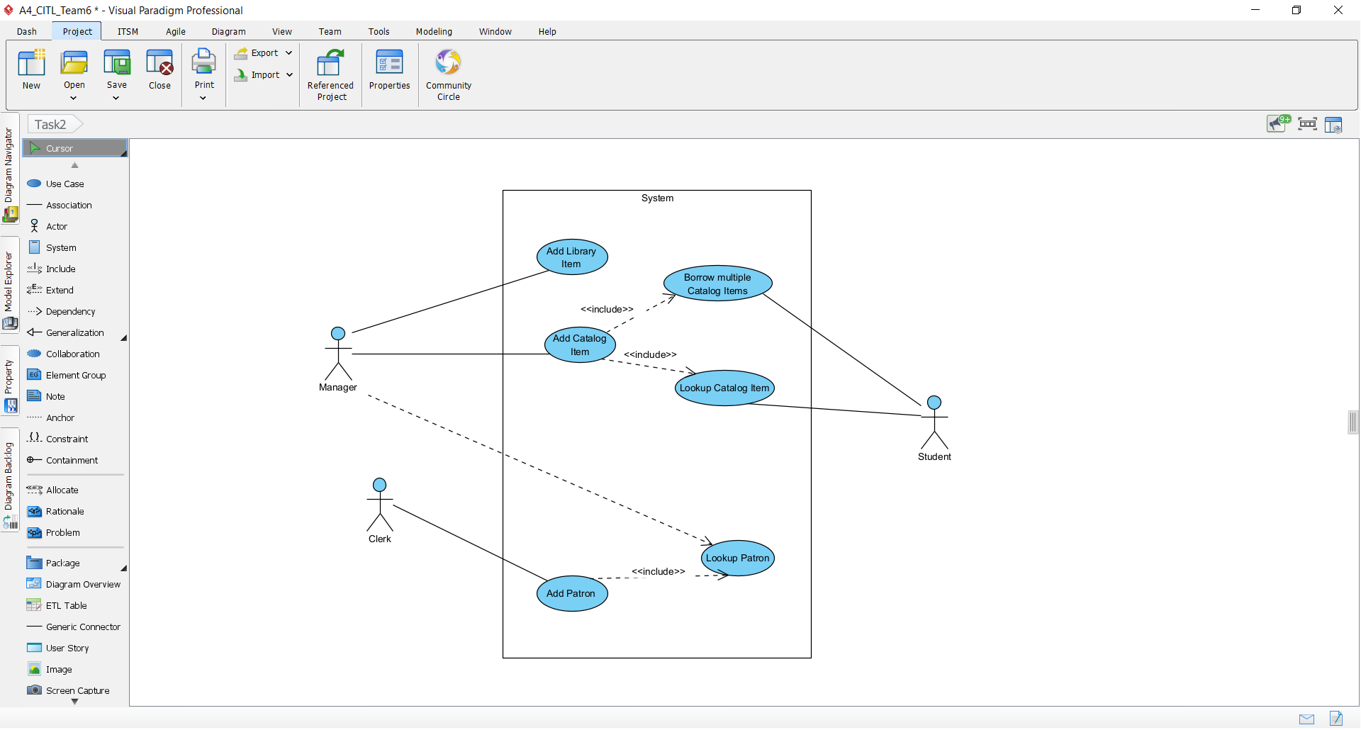

Task 3: Multilayer Design Sequence Diagrams (DSD)

DSD

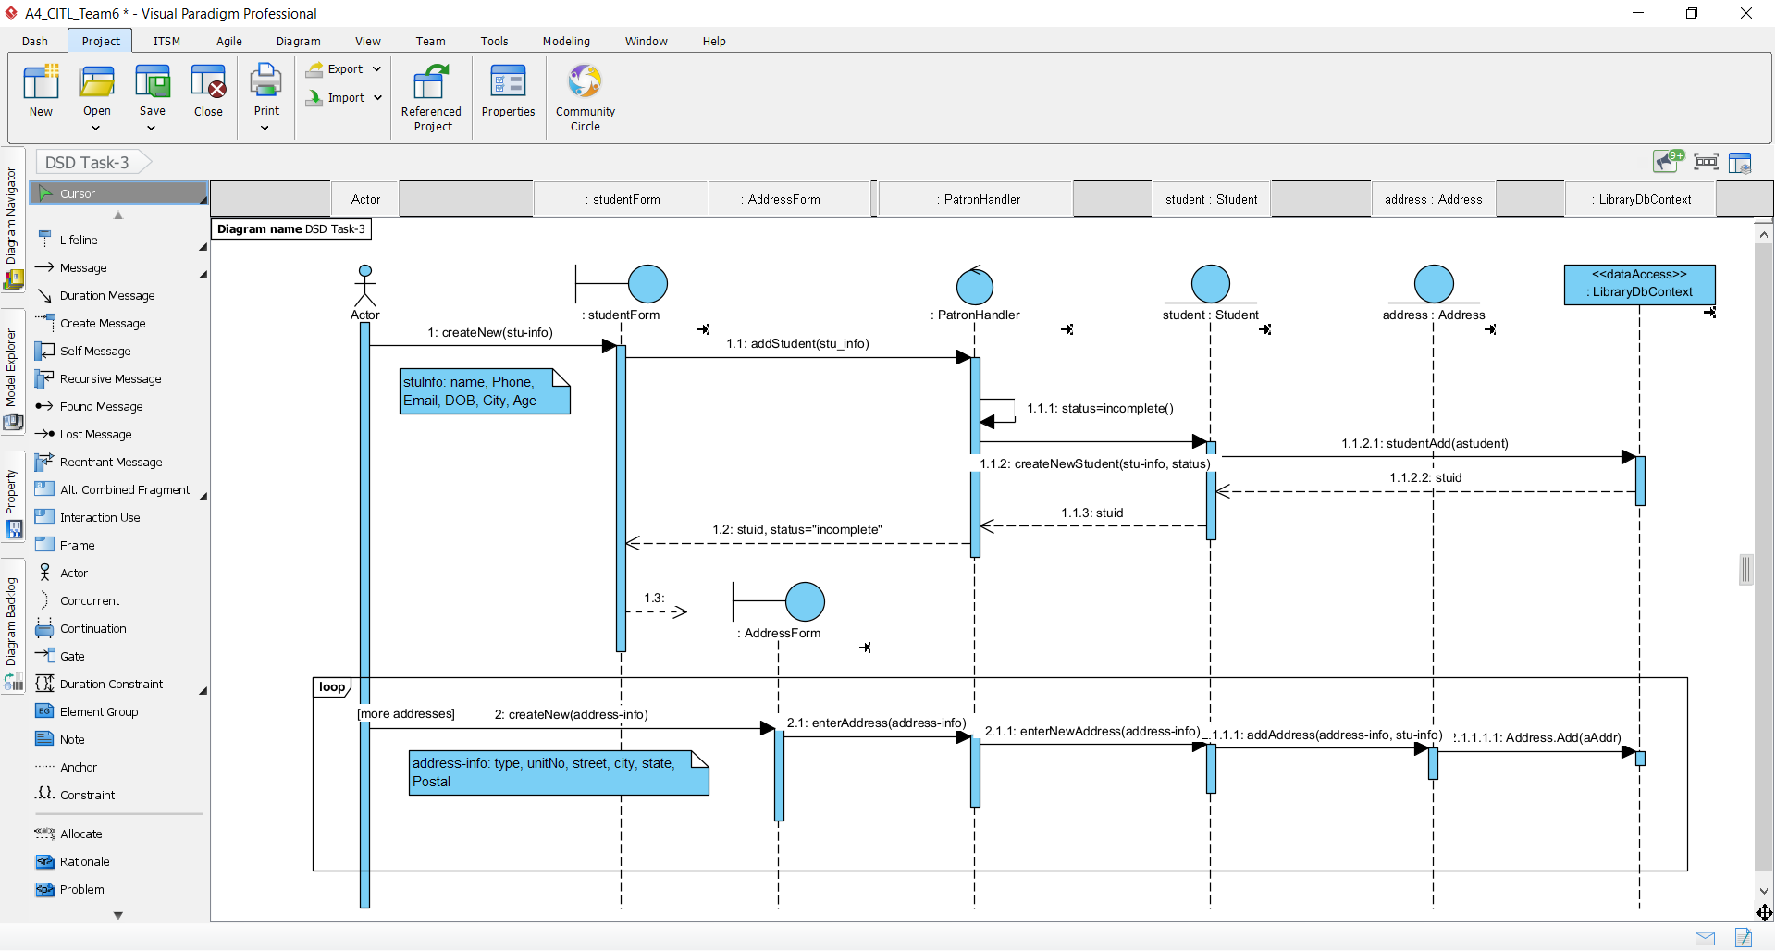

Task 3A:
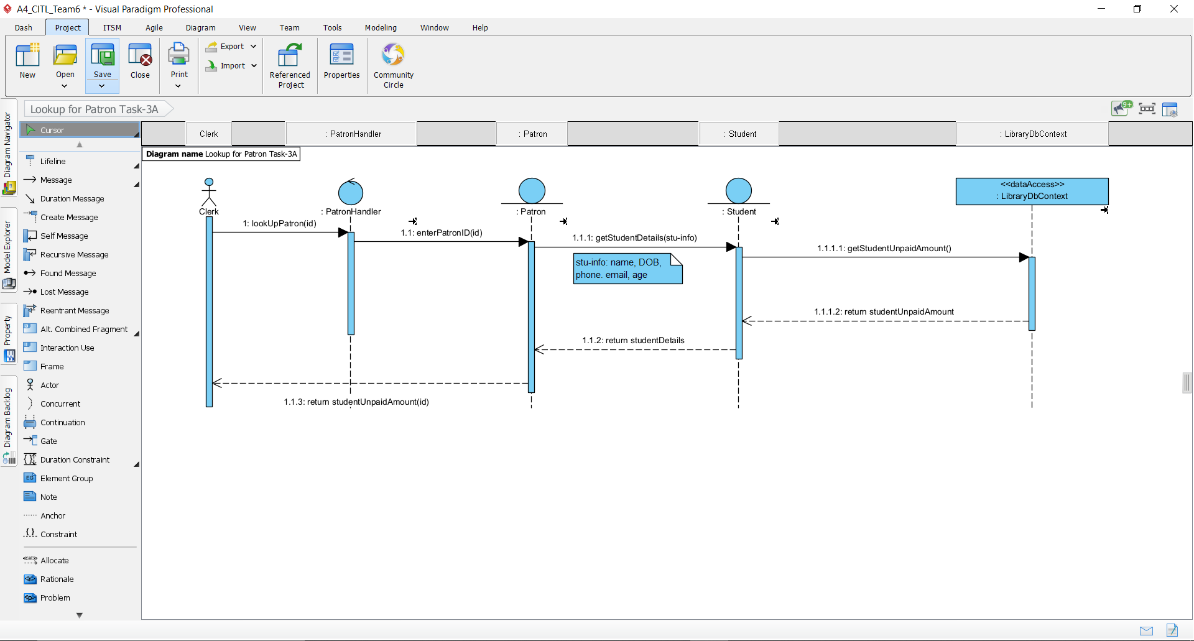
Task 3B:
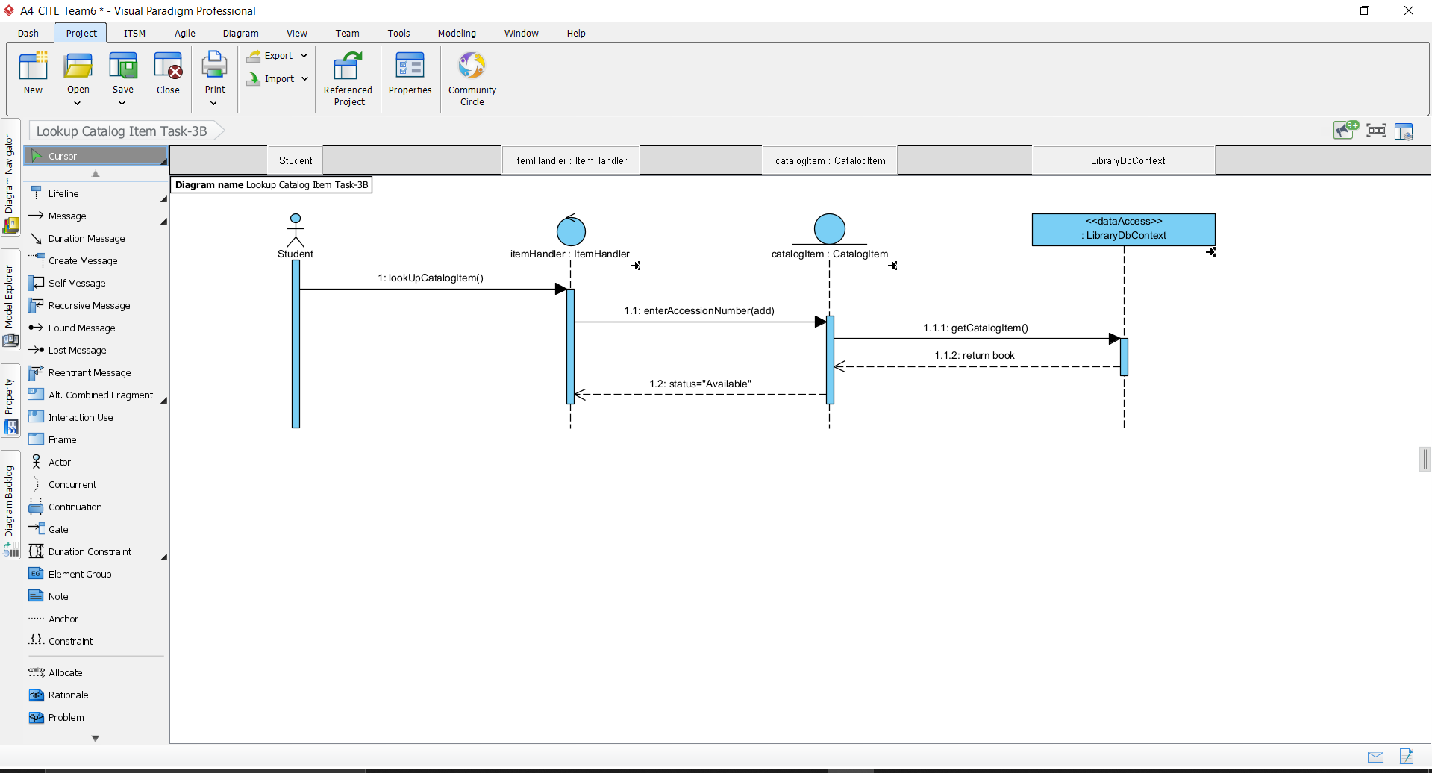
Task 3C:
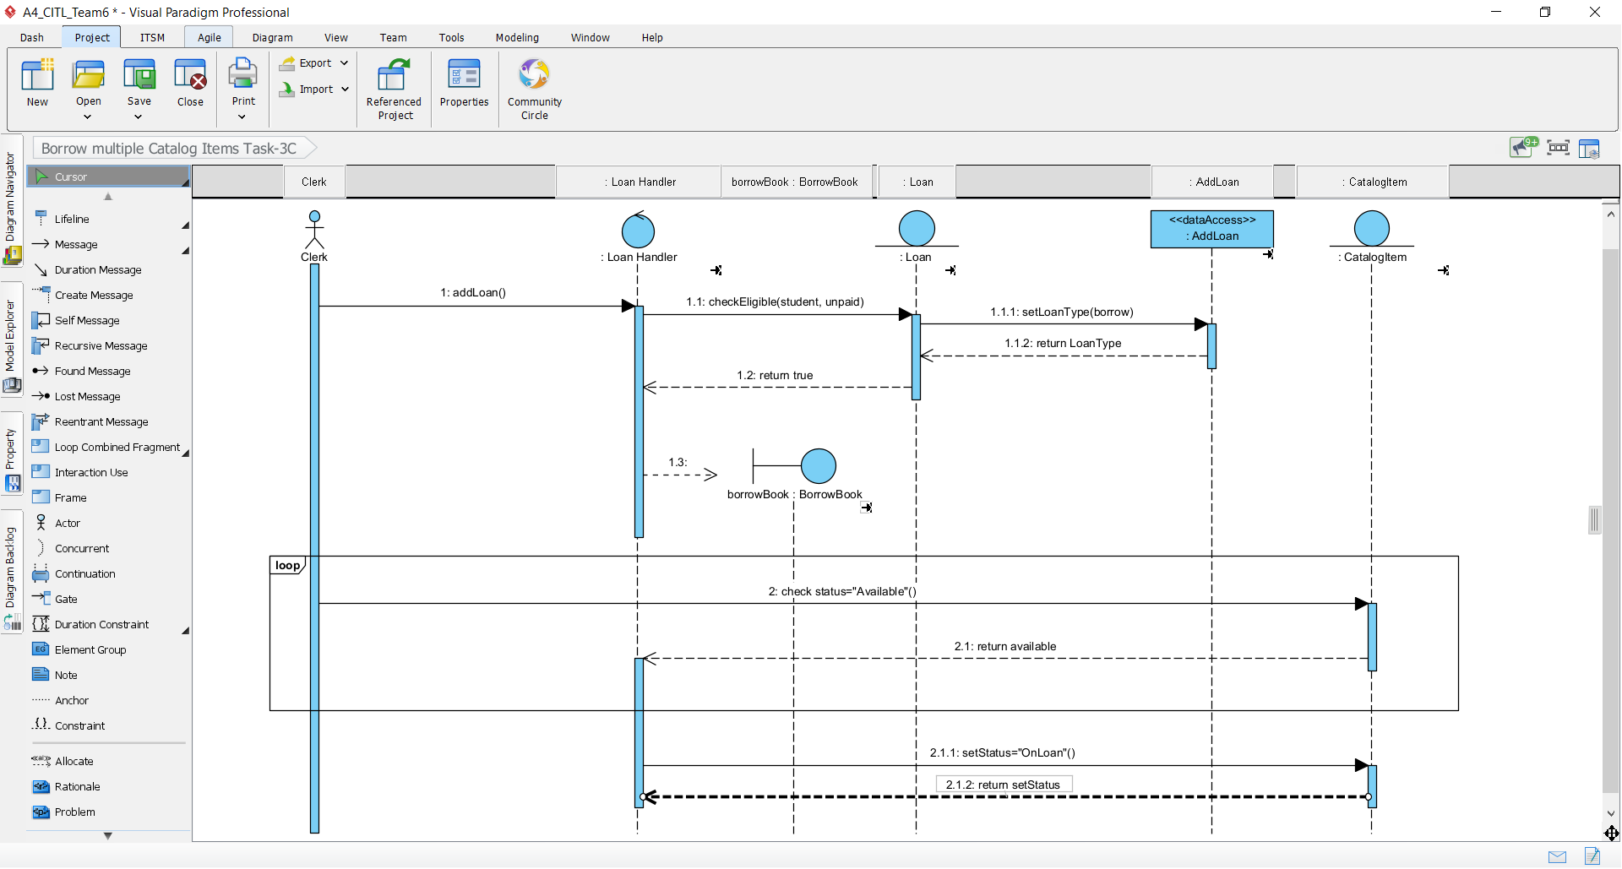

Task 4: Design Class Diagrams (DCD) for Domain Layer

Task 4A:
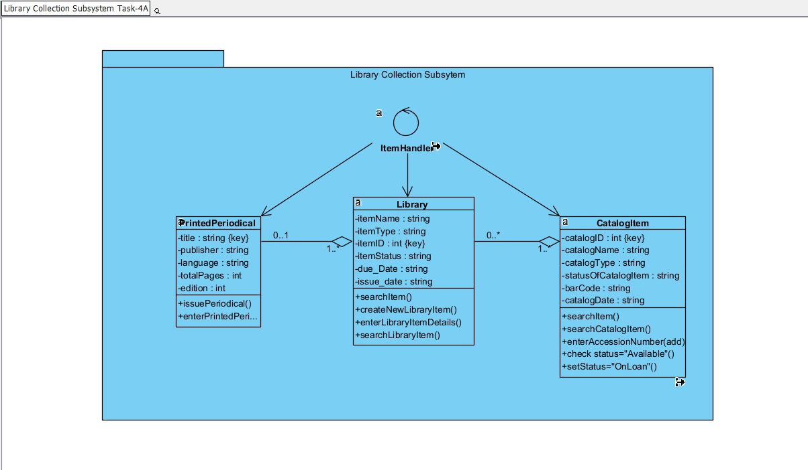

Task 4B:
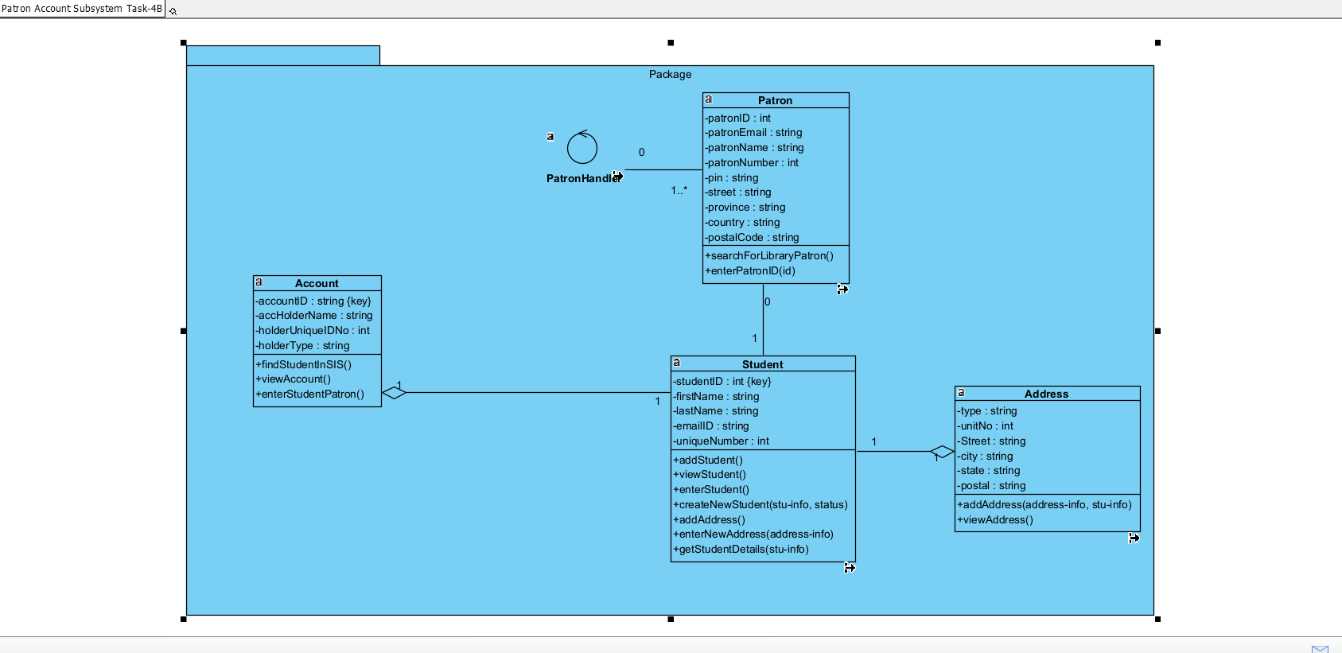
Task 4C:
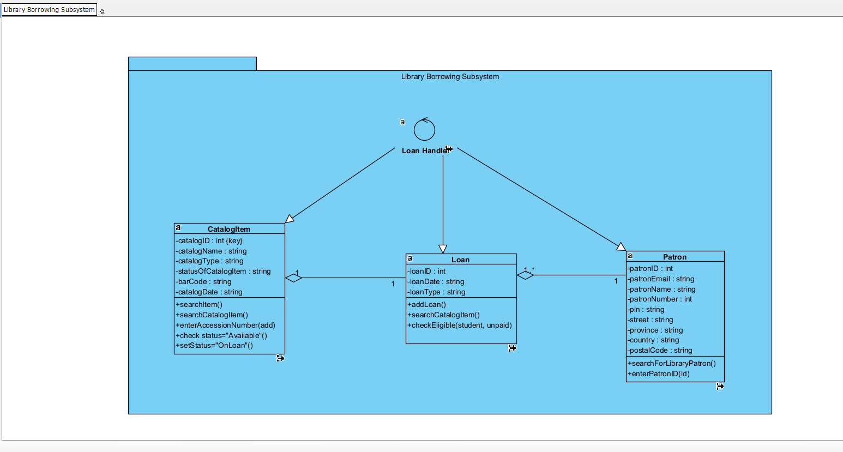
Task 4D:
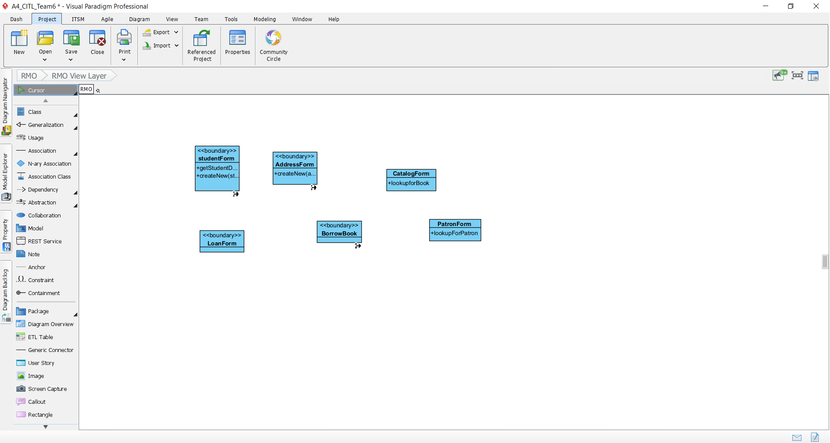

Task 4E:
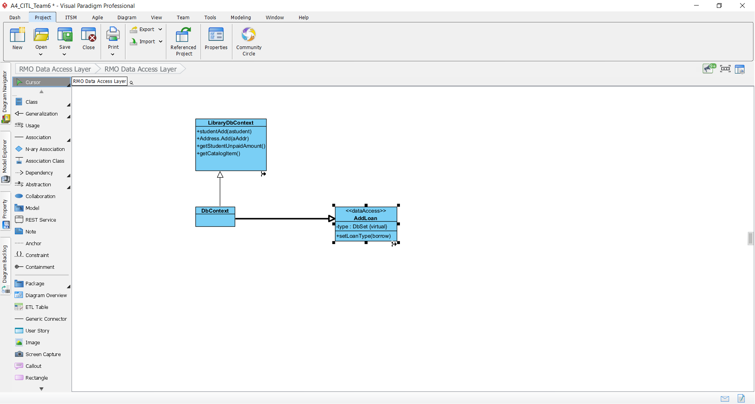

Task 5: CITL UML Package Diagram (PD)
