Rohan Patel - 010745904

Prof. Sanjay Garje

CMPE 281

[EzCloudStore](https://www.ezcloudstore.com/)

[**EzCloudStore**](https://www.ezcloudstore.com/)

EzCloudStore is a 3-tier web application that allows users to upload, download, update, delete, and list files using the Amazon Web Services(AWS) cloud architecture via utilizing distinct AWS tools and services. EzCloudStore users can upload several files one by one with a maximum file size of up to 10 MegaBytes(MB). EzCloudStore users can also modify the contents of the files that they have already uploaded using the update feature which can later be downloaded instantly using the download feature. Users can monitor the timestamps of their uploaded and updated files along with the date of the uploaded and updated file while also mentioning a description in the Description dialog box for the files that they upload and/or update/modify. Whenever users want to delete a file they can delete the file they desire by utilizing the delete button. The EzCloudStore application handles file storage using various AWS cloud services.

* EzCloudStore concentrates on CRUD operations on all the files that are uploaded by the users.
* EzCloudStore allows users to own an individual account for file storage that allows them to access it anywhere, anytime from the cloud as required by them for usage.
* EzCloudStore can be accessed @ [http://www.ezcloudstore.com](http://www.savetothecloud.com/) from any electronic device with the ability to connect to the Internet.

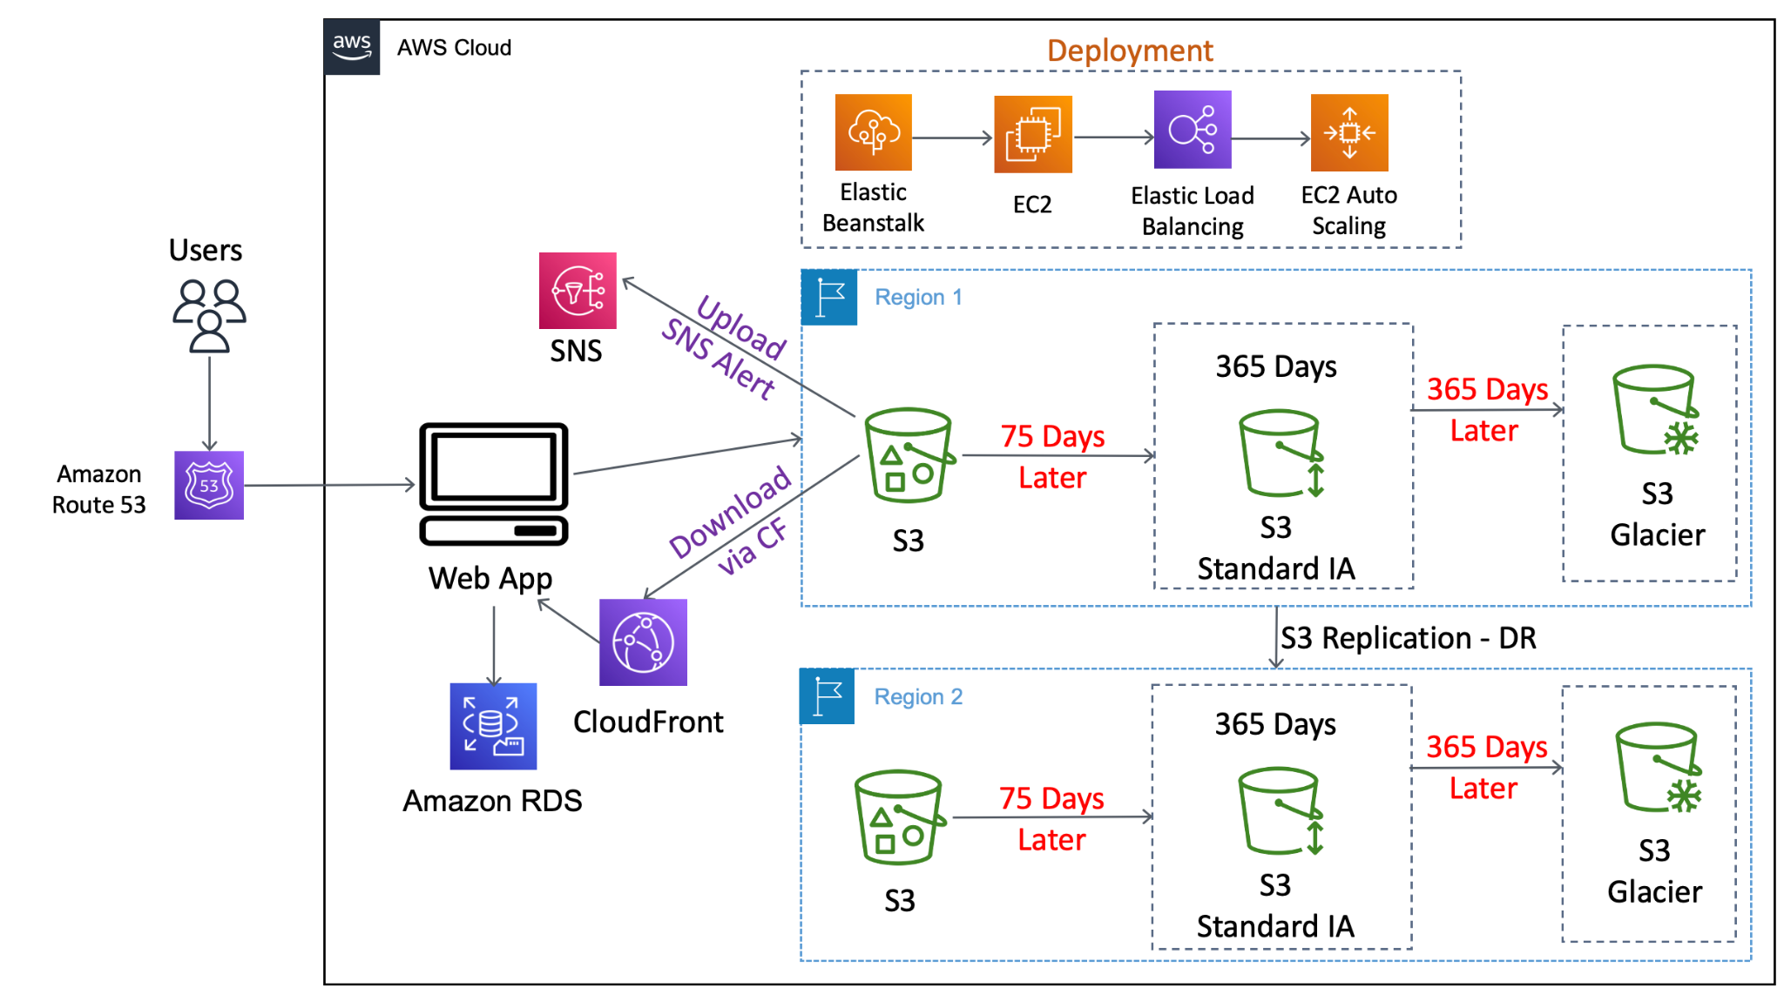

**Architecture Diagram**

**Tech Stack:**

* Java, MySQL RDS with JDBC connection
* Java Server Pages, HTML, CSS, JavaScript
* Server-side programming
* IntelliJ
* Spring Boot
* Apache Maven
* Java 8
* Tomcat 8.5

**EzCloudStore Features:**

* Sign Up
* Sign In/Login
* Upload File
* Browse Files
* Update File
* Download File
* Delete File
* Admin Panel Login

**Sign Up**:

* This feature allows the users to register their accounts by providing the required information that will be consolidated and deposited in the database.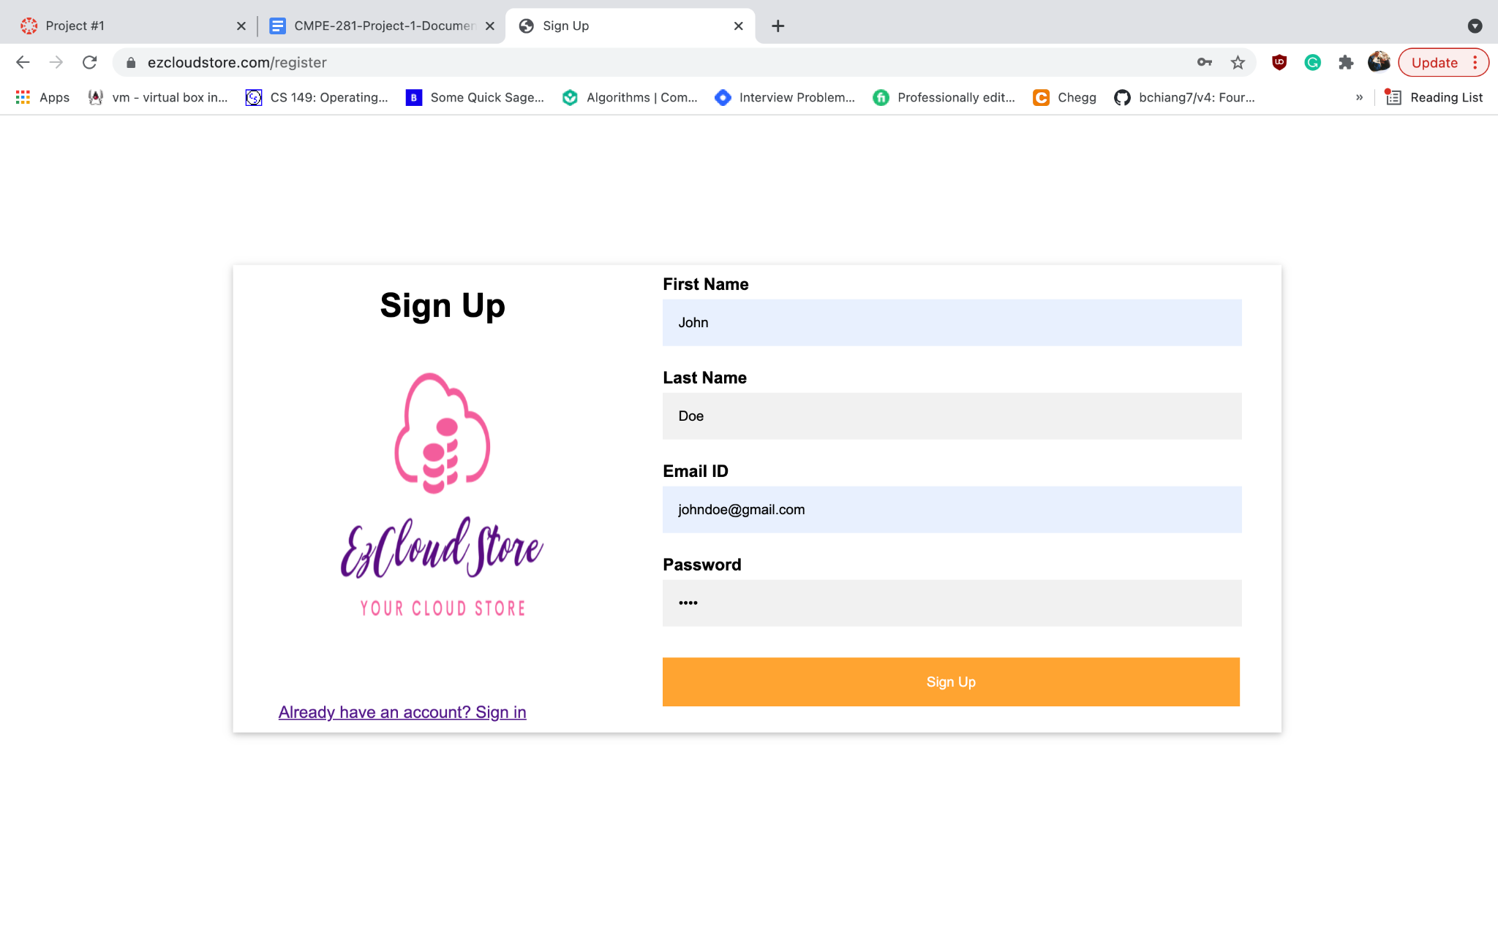

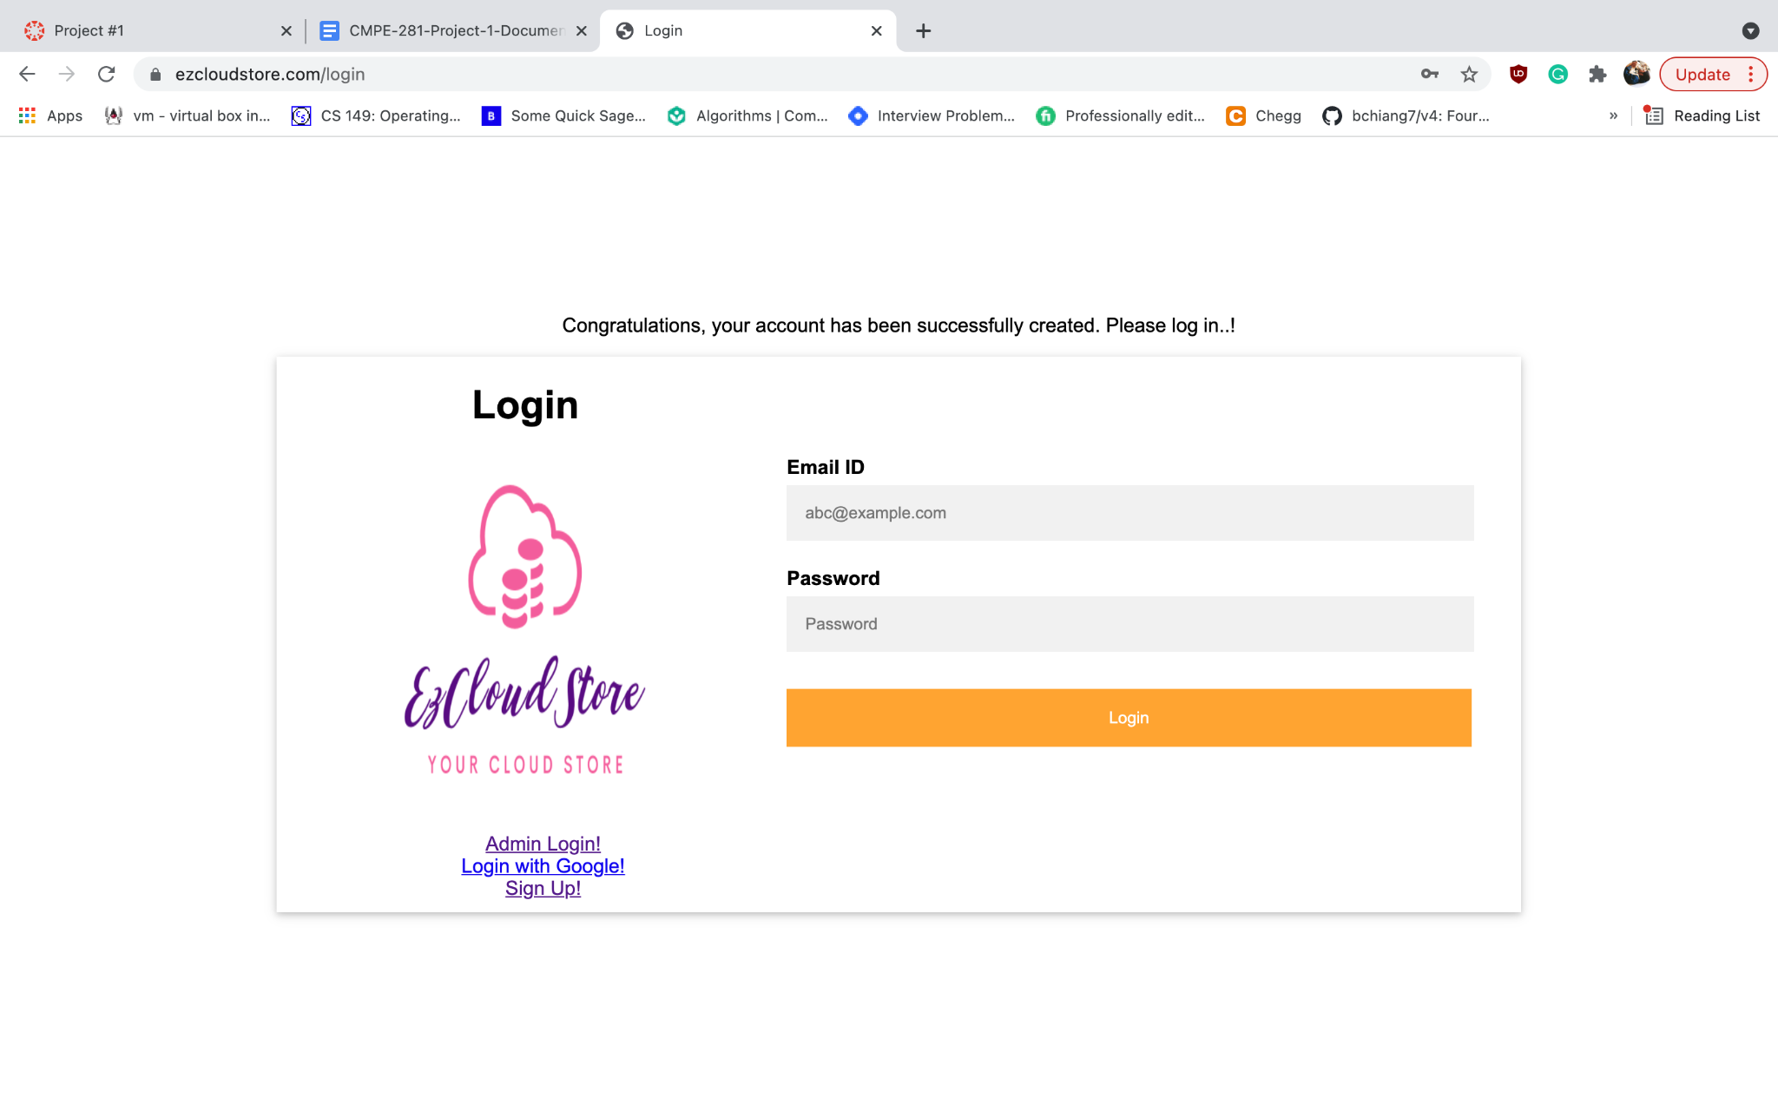

**Sign In:**

* This feature allows the users to sign in to their accounts and access the web application's dashboard by providing the credentials that were used upon registration of their account during the sign-up process.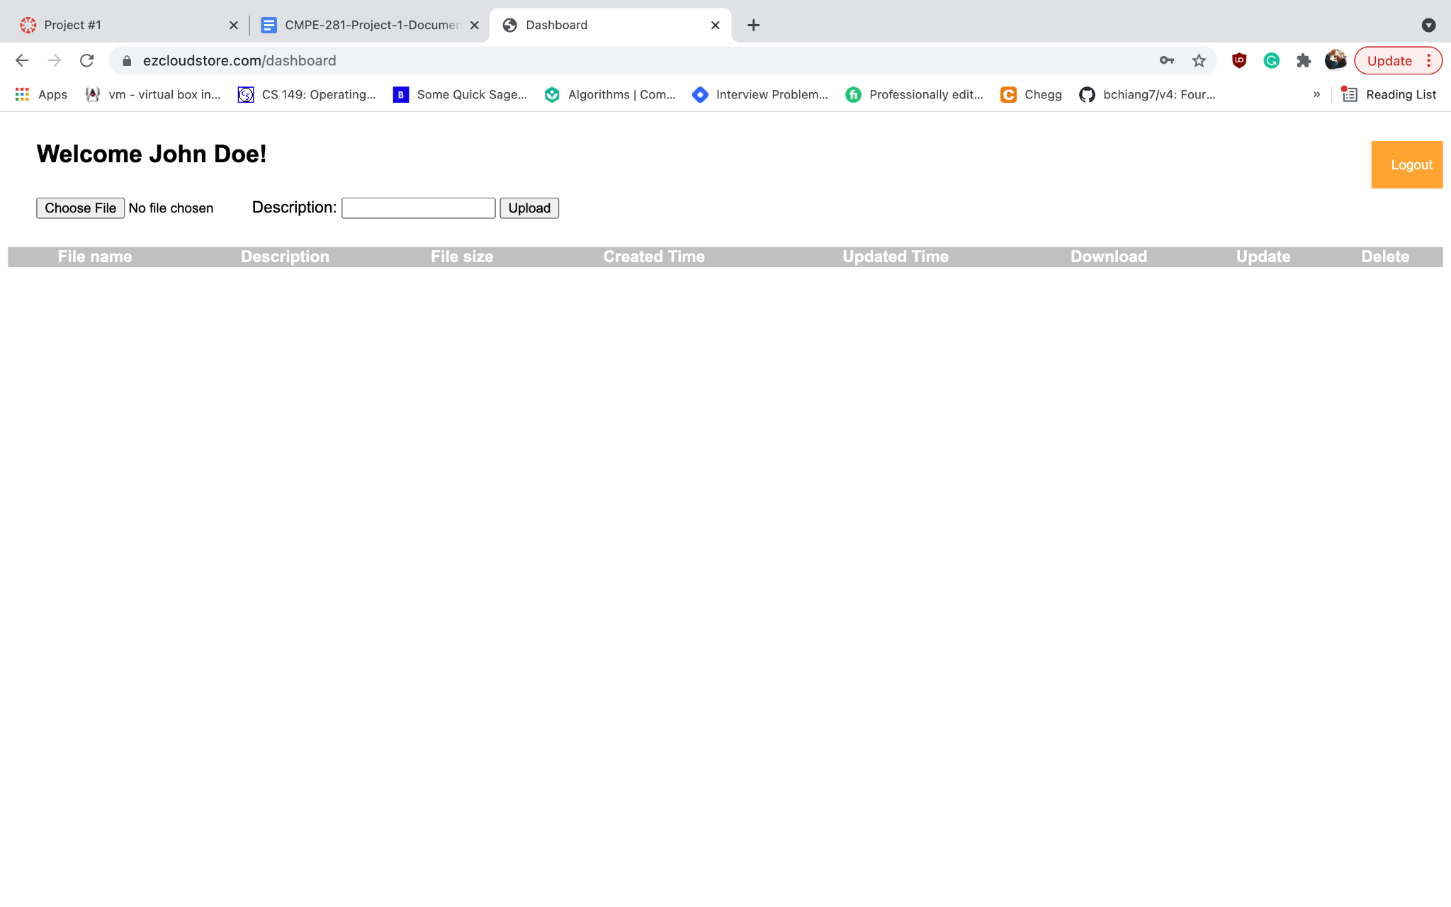

**Upload File:**

* This feature allows the users to upload a new file and store the file in the S3 bucket. The maximum file size that can be allowed to be uploaded is 10MB.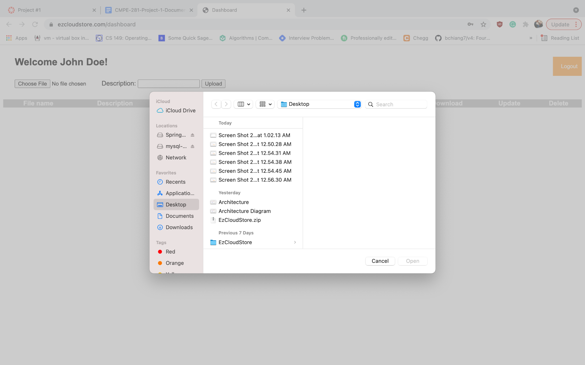

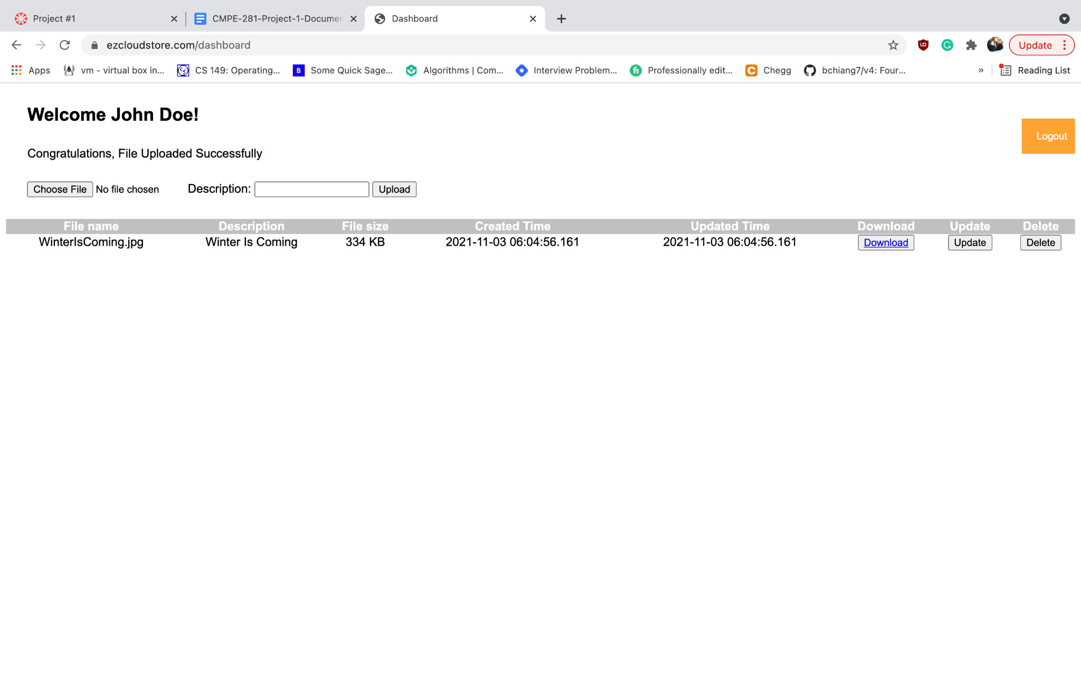

**Browse Files:**

* This feature allows the users to view the list of files that are already uploaded by them on their dashboard.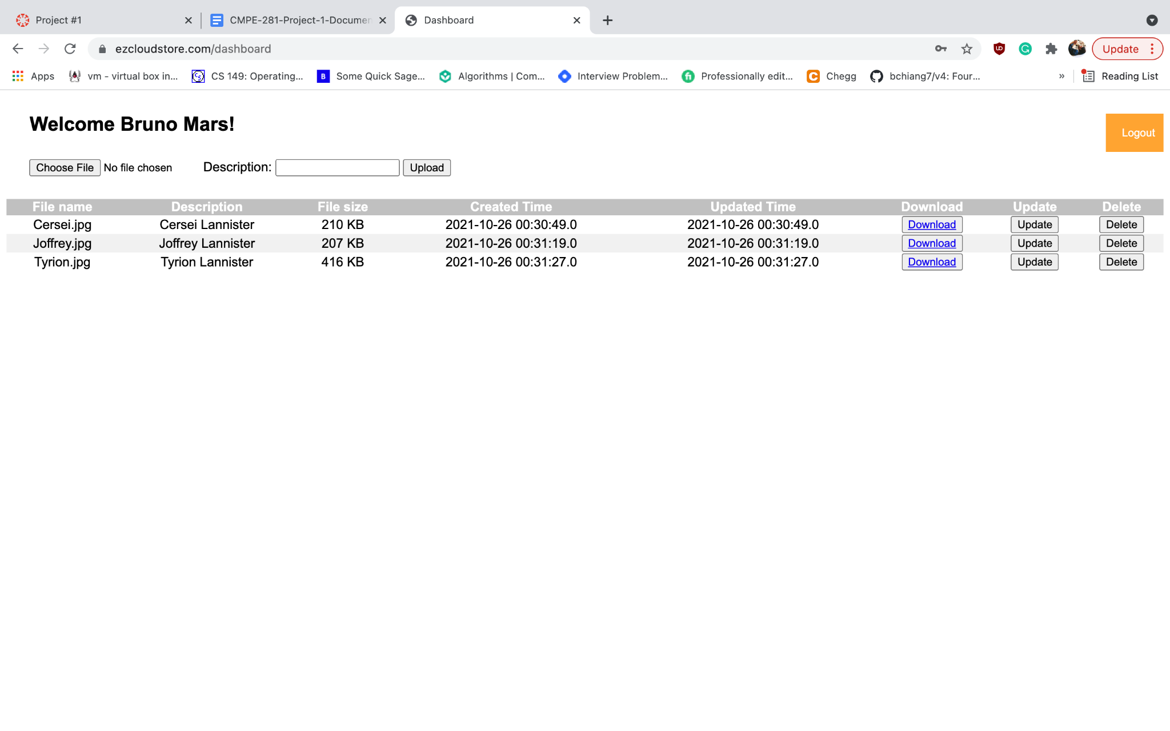

**Update File:**

* This feature allows the users to Update already uploaded files along with a description of the file. Users can track the updated files by monitoring the timestamps of the file creation and file update on their dashboard.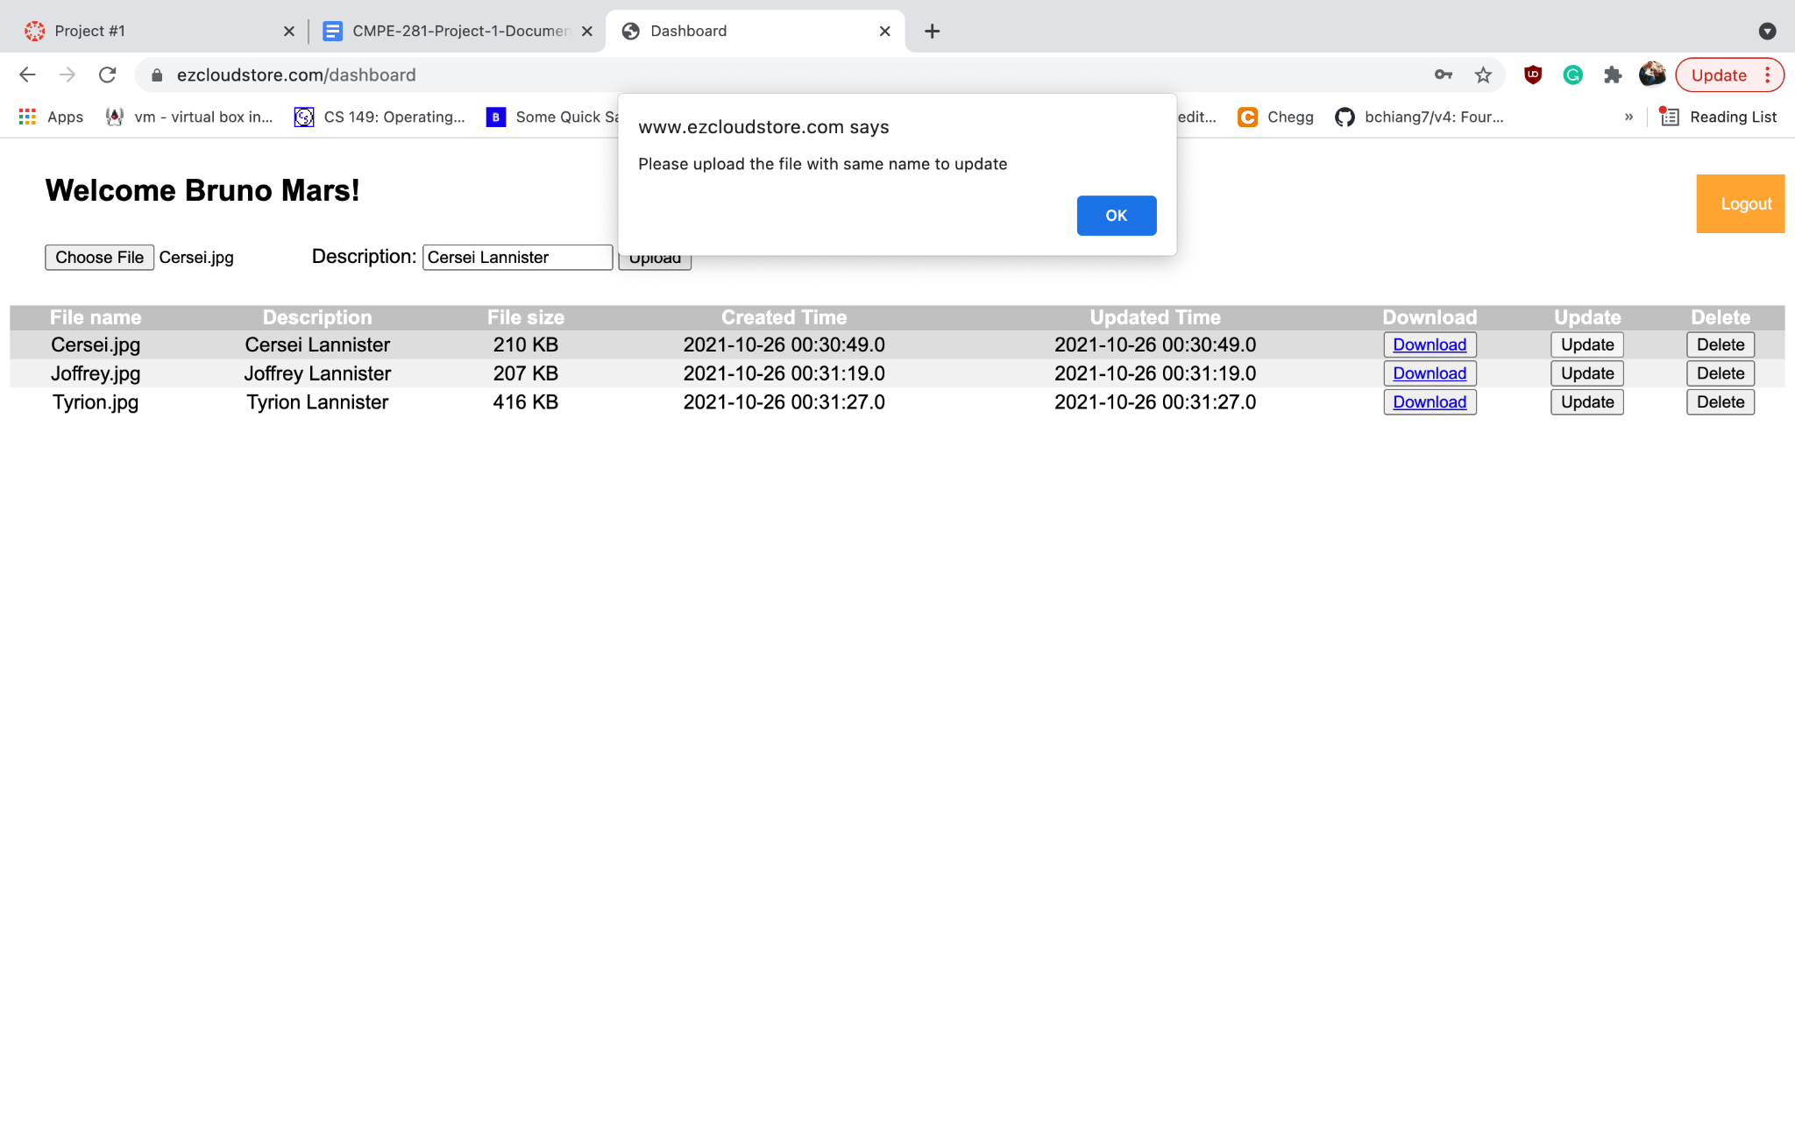

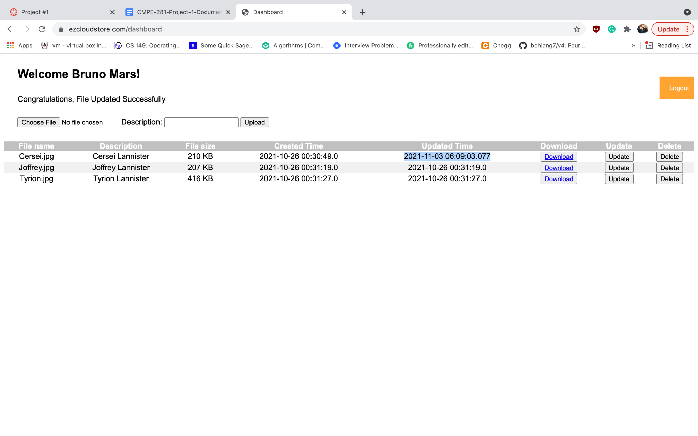

**Download File:**

* This feature allows the users to download the uploaded files with a link to download the file via a URL.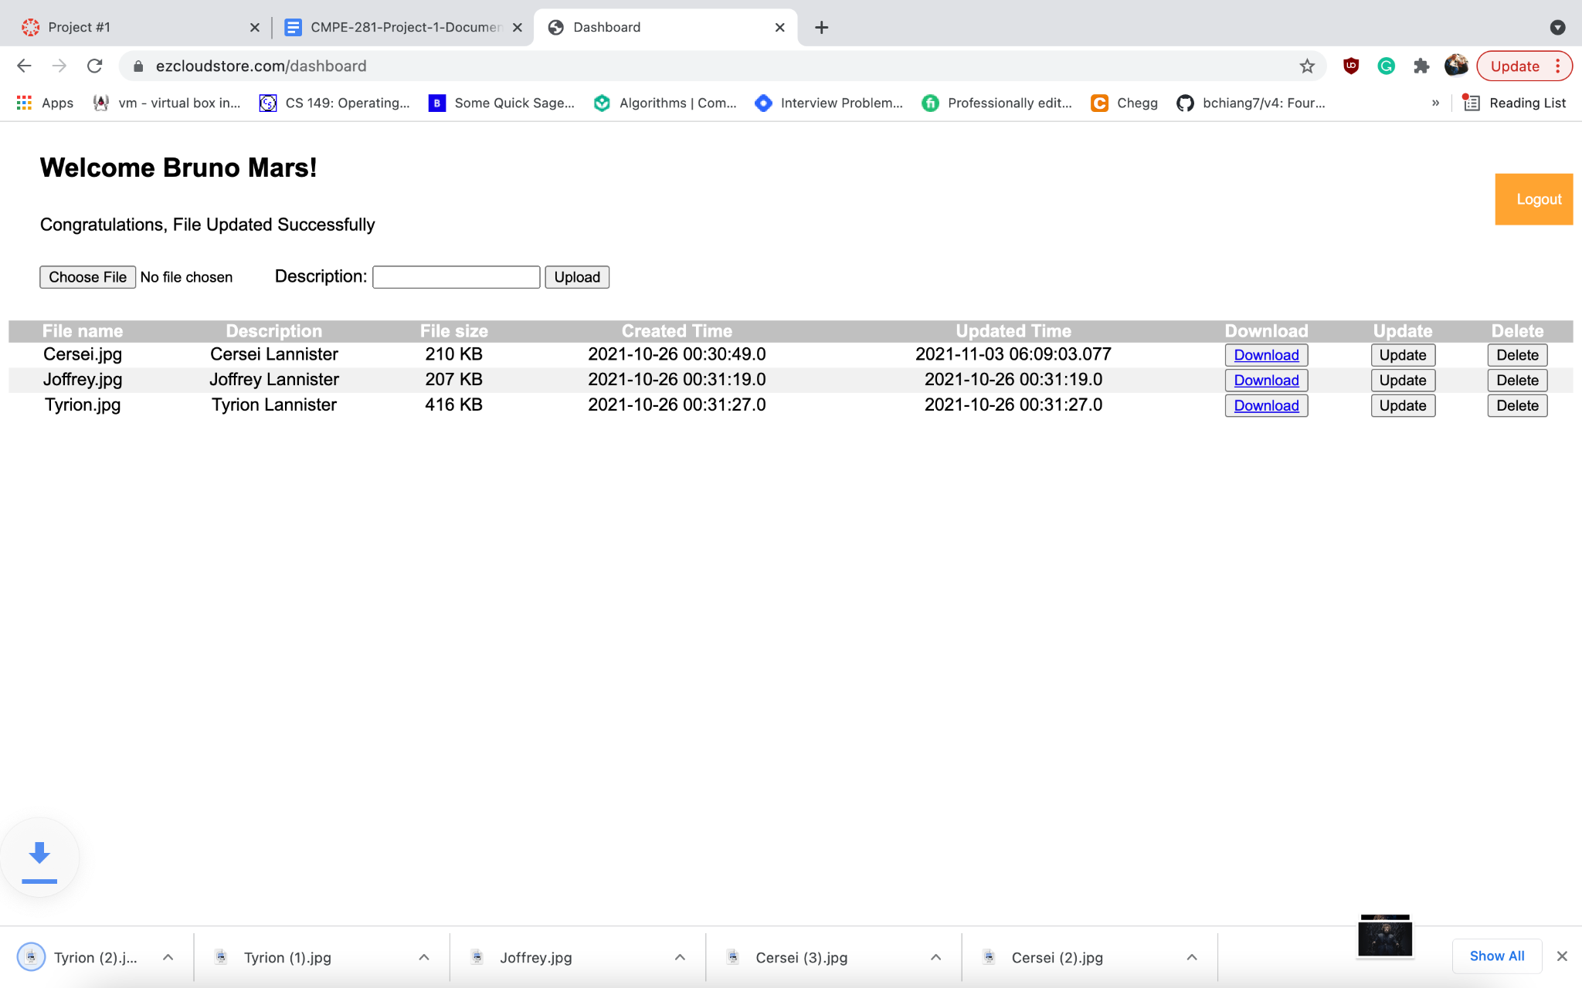

**Delete File:**

* This feature allows the users to delete the files which they do not wish to utilize via the delete button.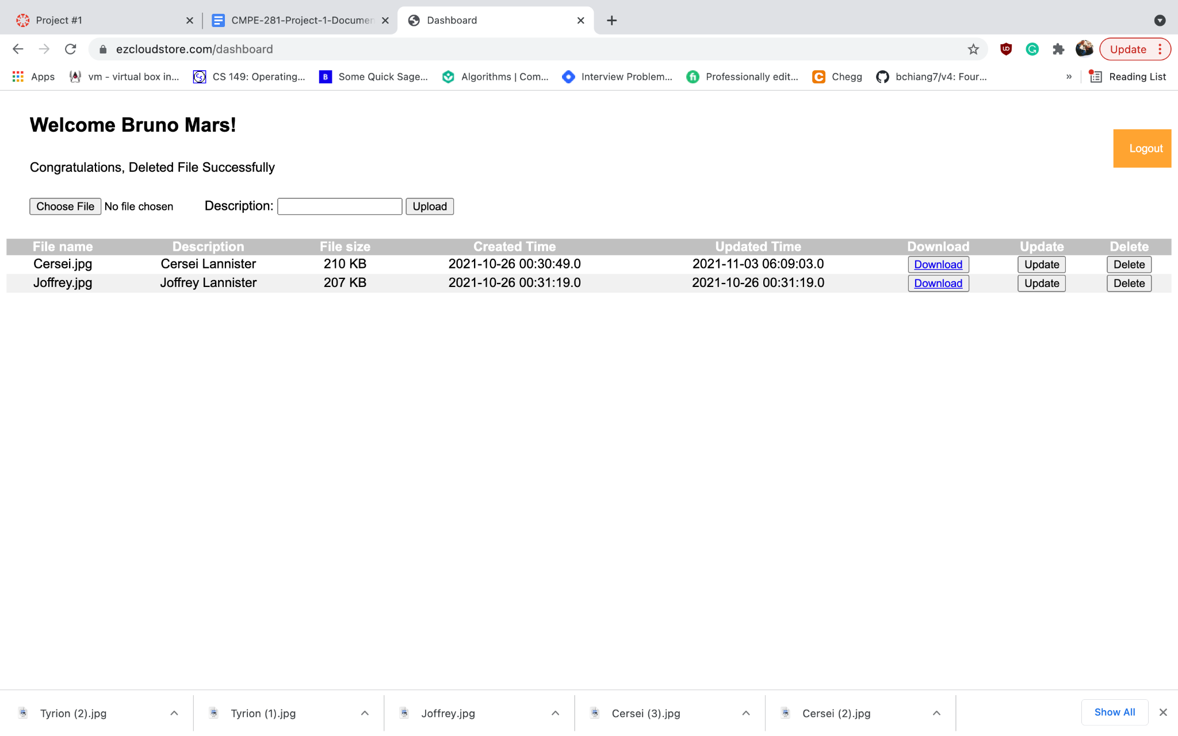

**Admin Panel Login:**

* This feature allows the user with administrator access and credentials to log in to the admin panel where the admin can be able to view the record of all the files that were uploaded by every user on EzCloudStore along with the ability to download as well as delete any particular file uploaded by any user.

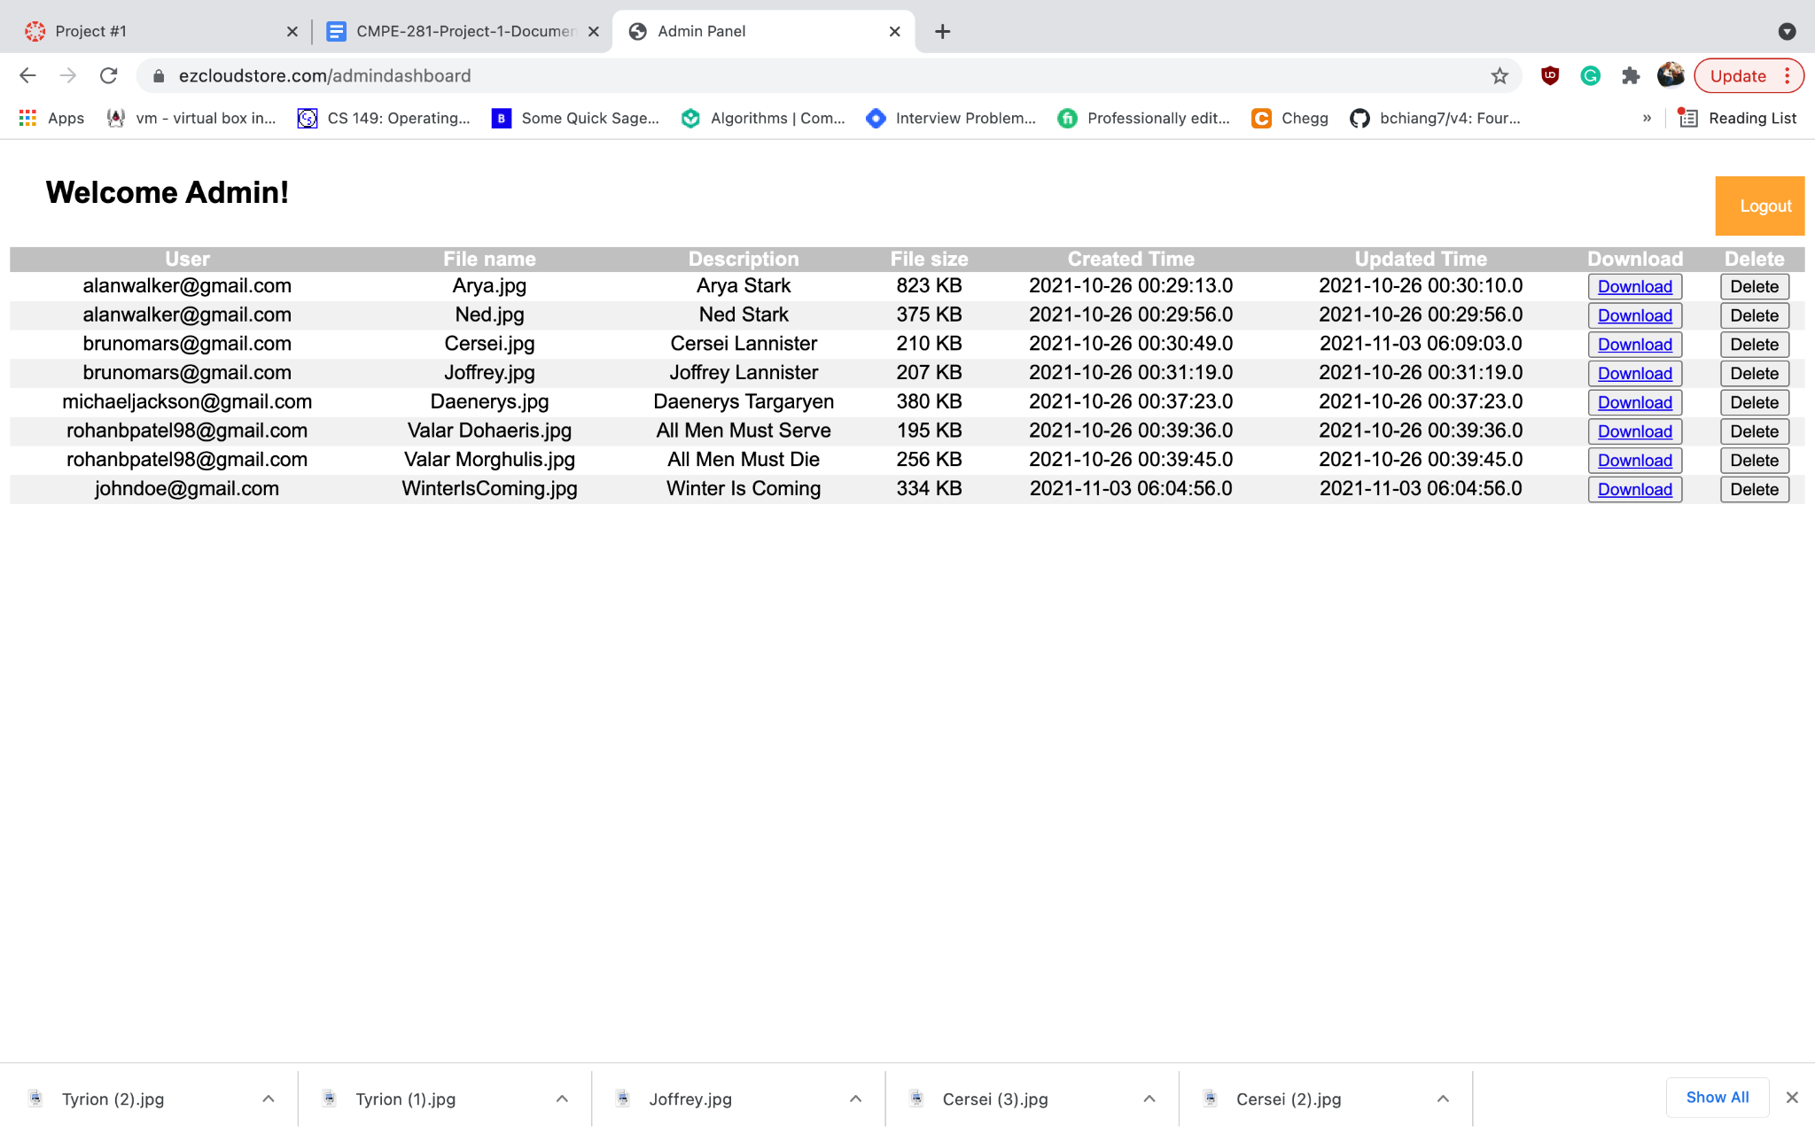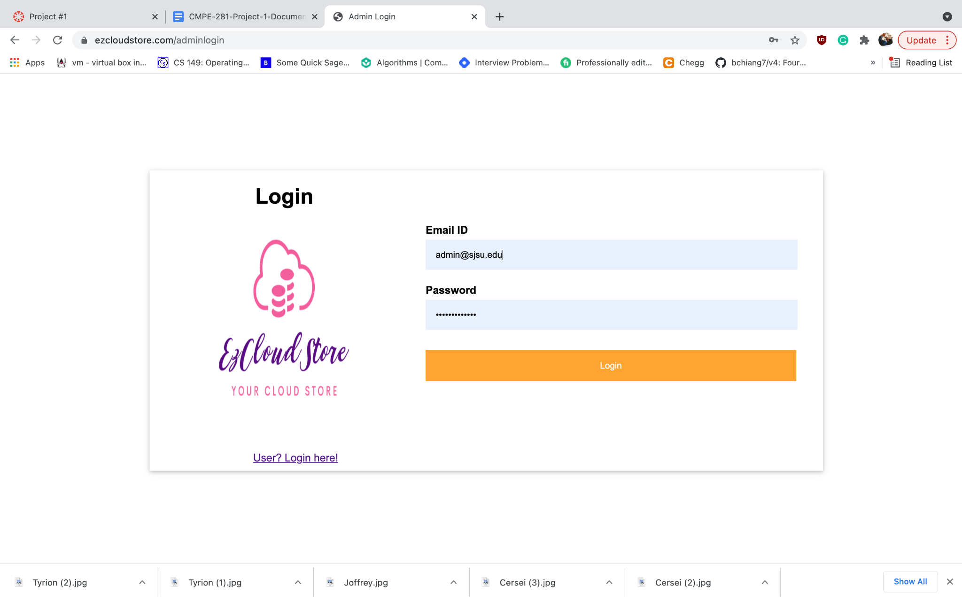

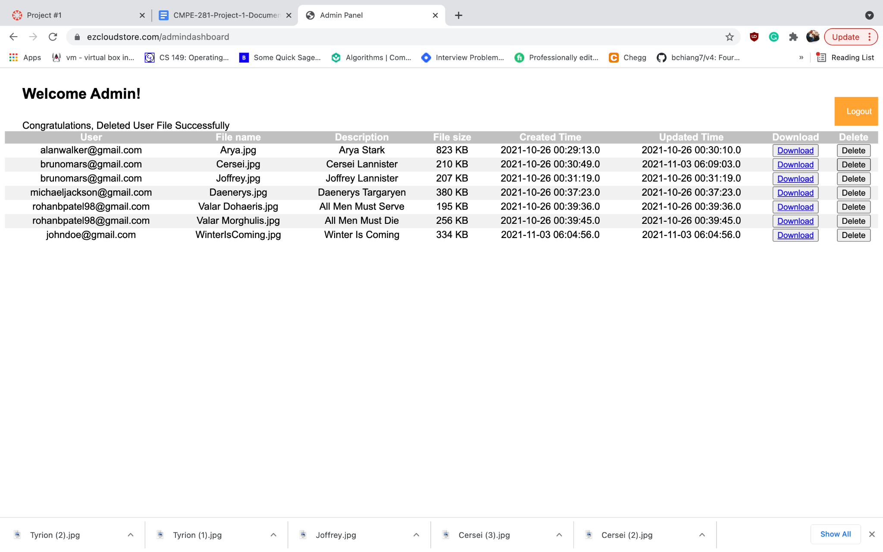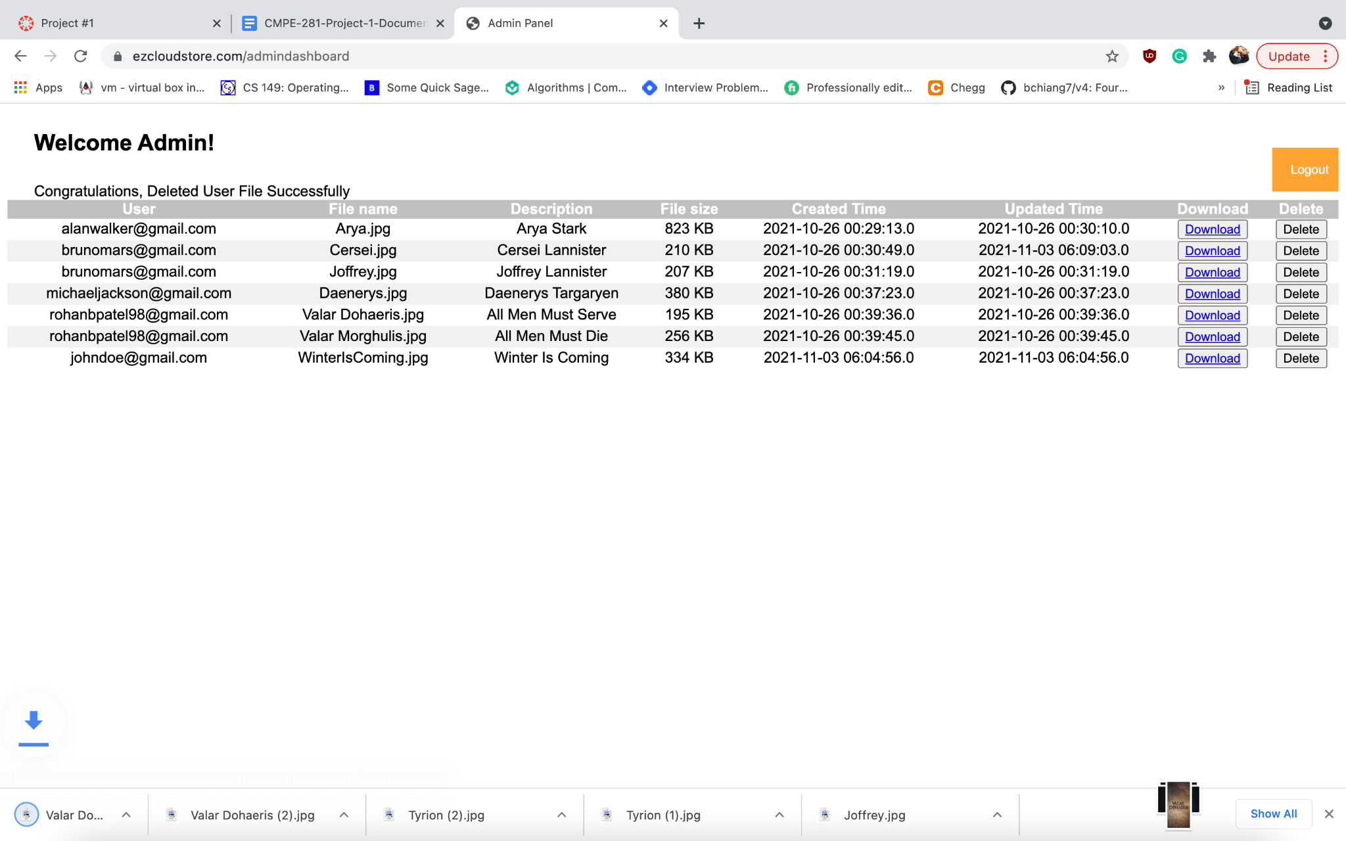

**EzCloudStore Dashboard:**

* File Name
* Description
* File Size
* File Creation Date & Time
* File Update Date & Timez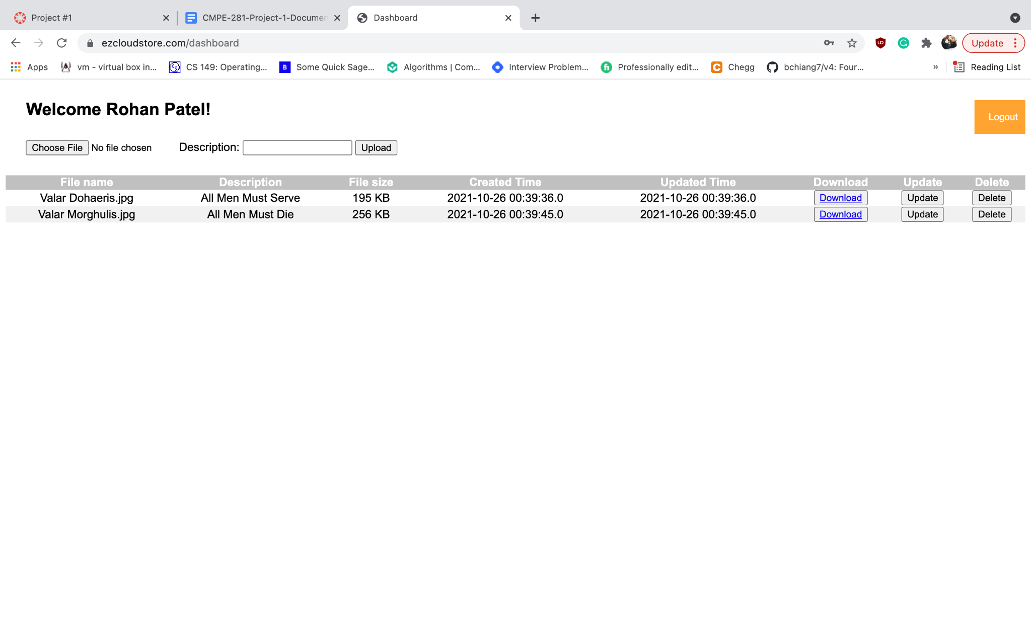

**EzCloudStore Overview:**

* Every user must sign up on the web application to be able to access the features of the EzCloudStore application via their unique email and password. The database consists of two tables that segregate the users from accessing other users' data.
* Upload a file with the max file size of 10MB - an alert is issued to restrain from uploading files with a larger size.
* File data is to be stored on the S3 bucket and in a reserve replica bucket in a different region by utilizing cross-region replication methods.
* Created a lifecycle rule for the project similar to homework #2 assignment. AWS S3 Standard Access is applied for the first 75 days. After 75 days, S3 Standard Access will convert the bucket to S3-Infrequent Access(S3-IA). After one year, the data will be stored on the S3 archive through S3 Glacier and will be kept for one additional year for legal/compliance reasons henceforth, after 730 days the data will be deleted from the system.
* Registered the domain @ [ezcloudstore.com](http://www.ezcloudstore.com) using AWS Route53 and utilized hosted zones from Route53.
* For every instance of CRUD operation, the file data will be transmitted to the Amazon S3 bucket and Amazon RDS MySQL instance to keep track of the files' information.
* AWS tools are correlated in a fashion that users have a more agile way to download any file from the S3 bucket via utilizing the CloudFront distribution service. Also, blocked Cuba region as was done earlier in the homework #2 assignment as per instructions.
* Used Elastic beanstalk to accommodate multiple AZs and regions with high availability for EC2 instances and S3 buckets.
* If a user uploads a file for the initial time it will generate a new directory for the users via their email id for isolation on the S3 bucket.
* Route53 is linked to CloudFront which is linked to Elastic beanstalk.
* Elastic Beanstalk with EC2 and Elastic Load Balancing is implemented with auto-scaling up to four instances along with health checkups.
* Used CloudWatch billing alarm that will trigger exceeding the limit of $1 and will broadcast an email alert to the subscribed user via email or phone.
* Enabled S3 Transfer acceleration to gain more high-speed acceleration for download and upload. Also, enabled bucket versioning.
* EC2 instances are available in different AZs so that in the event of failure of one of the instances, another will spin up by configuring auto-scaling to four instances with an upper threshold of 6000000 that will produce a fresh instance to load balance the application.
* Used the Simple Notification Service(SNS) to relay alerts to the user upon the downloading of a file via the user.

**GitHub:** <https://github.com/rohanbhadreshpatel/EzCloudStore>

**References:**

* <https://docs.aws.amazon.com/>
* <https://www.ezcloudstore.com/>