Toronto Business College

Data Visualization

Assignment (5)

Case study - Tableau charts

|  |  |
| --- | --- |
| **Course** | 2021F-T2 AISC2001 - Data Visualization 01 |
| **Instructor** | Gamal Ali |
| **Students** |  |
|  | Charitha Priya Dongari – 500191110 |
|  | Katterapalli Venkata Satya Narayana Reddy – 500190693 |
|  | Rumana Banu Iliyas Ahmed – 500186725 |
|  | Rohan Bhatt – 500187633 |
|  | Shivam Jolly – 500196452 |

Contents

Introduction 1

Functionality of Tableau 2

Loading Data in Excel into Tableau 2

Map-chart showing global sales and profit filtered by categories at the level of USA stores 3

Adding Sales and Profit 3

Adding Country 4

Adding Category 6

Filter Based on Sub-Categories 7

# Introduction

Before we begin our journey of how we built the analysis of our dataset that was handed to us, we must first learn about the Tableau software on which we would be executing it.

Tableau was developed in 2003 as a result of a Stanford computer science study with the purpose of enhancing the flow of analysis and making data more accessible to people through visualisation. Part of this is making machine learning, statistics, natural language, and smart data prep more useful to assist human ingenuity in analysis. It also offers proven enablement resources to help customers adopt and scale a data-driven culture that delivers resilience and value through compelling outcomes.

# Functionality of Tableau

The tableau has been divided into numerous sections, which we will discuss: -

1. **ShowMe**: It has been a very crucial feature to let us know that after selecting the different dimensions and measure which all graphs could suit to provide us with a beautiful presentation of our data.
2. **Marks**: The marks card in Tableau gives you control over how the data is displayed in the view. The options on this card allow you to change the level of detail and the appearance of the marks without affecting the headers created by fields on Columns and Rows. It comprises of features like color, Label and Size and many more.
3. **Filters**: As the name suggests that it is meant to mark filters on the attributes which we would be using in it like which country to select, which class to select and many more.
4. **Dashboard**: Get any attribute to add different pages to the graphs and let us know how it works and hence combining different pages or sheets to make a dashboard
5. **Data Connection**: Tableau has a unique identity to connect with several types of file and to get it analysed on a large scale.

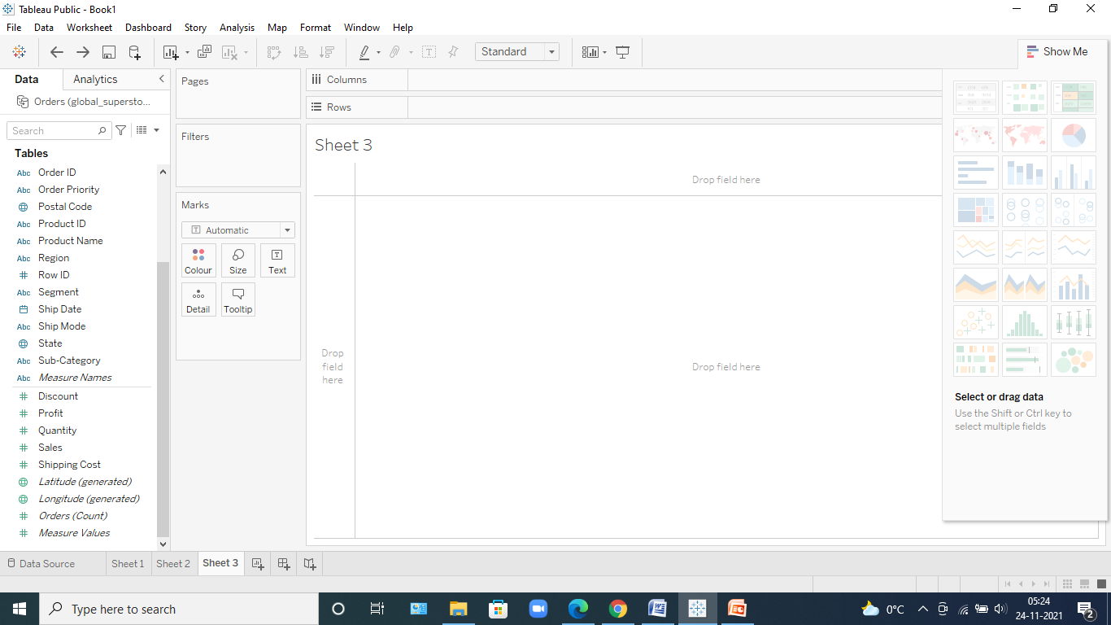

# Loading Data in Excel into Tableau

* Let's get started by downloading the dataset that has been provided to us. We've been given an excel file on global purchases for the year 2016.
* We clicked on the excel sheet and the data got loaded.

// TO DO Screenshot with the data //

* Once the data gets loaded we get to see how many tables are inside it like in this case we can clearly see that we have been provided with nearly about 3 tables and then we have too see whether they need to be joined or not like in this case there is no need to join tables and simply use only one dataset that is the Order table and drag and drop it in the space.
* Now, we can clearly see the data in the dataset, and the rows and columns in it. We can even think about it to see like which is categorical, numerical, Null and many more.

# Map-chart showing global sales and profit filtered by categories at the level of USA stores

Now that we've uploaded the data to the software, let's get right into the Sheet, where we can see the analysis we're going to perform.

* As and when we go inside it, we can clearly see the Dimensions and the Measures in it
* Measure depicts the calculative values and Dimensions are usually the categorical values.

## Adding Sales and Profit

As we have to choose the profit and sales first, we drop it and see what we fine in both cases.

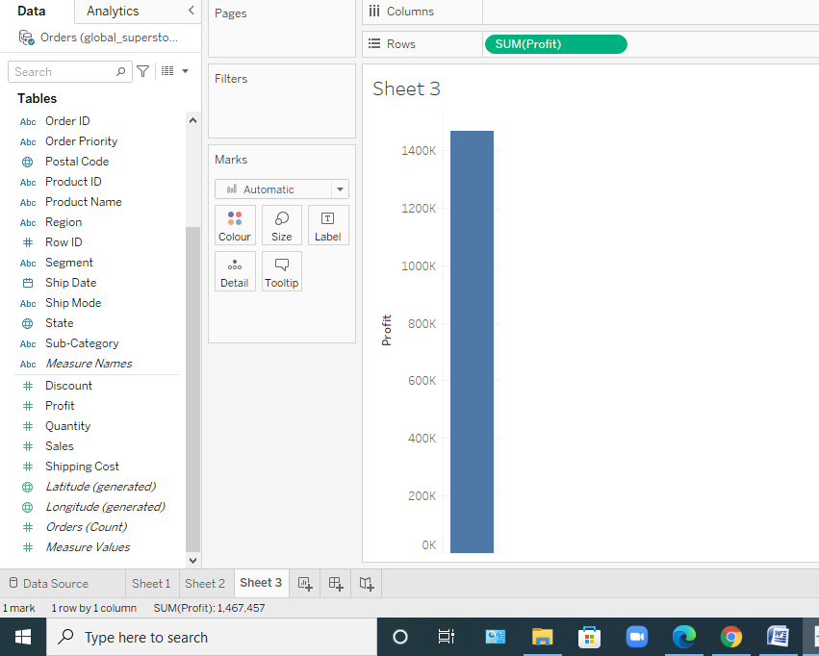

In this screenshot, we can see that we have added the Profit as Rows

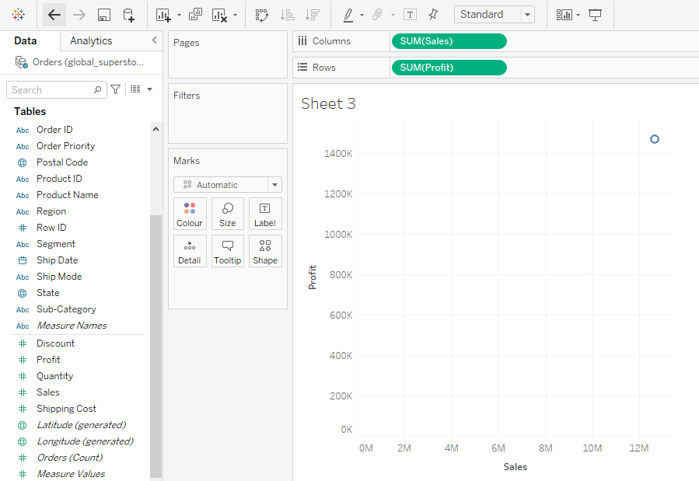

In this screenshot, we can see that we have added the Sales as column.

We can clearly draw no conclusions from it, but since we haven't used the data on which we need to rely, let's verify and link with the country column to learn more about the US market.

## Adding Country

* Now, we chose a country column and attempted to analyse its data using a globe map.
* We obtained a very beautiful insight when we clicked on the show map world Map option, and in the MARK attribute of tableau, the profit and sum sales happened on their own.
* We used the Mark up to add colour and a label to it.

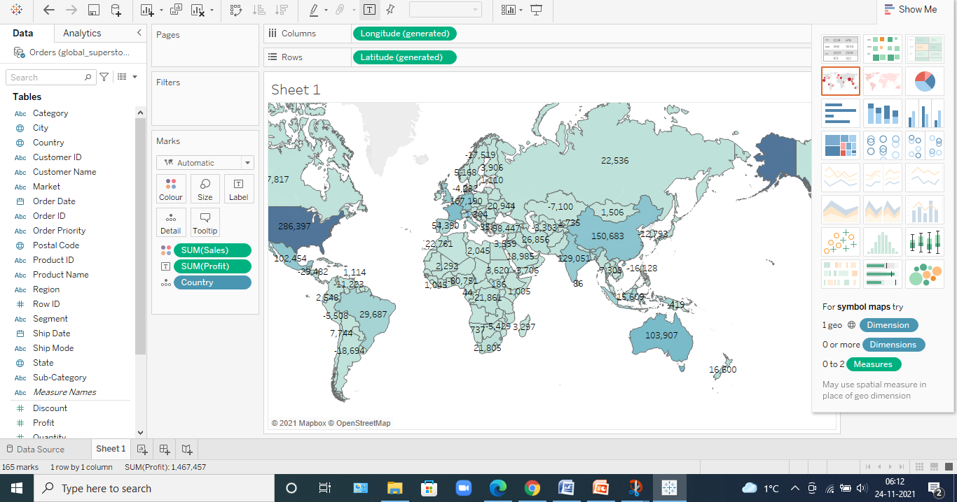

* Now the issue is that we only want the country of the United States, so we dropped our dataset into the filter and chose the USA from the pop-up menu that appeared.

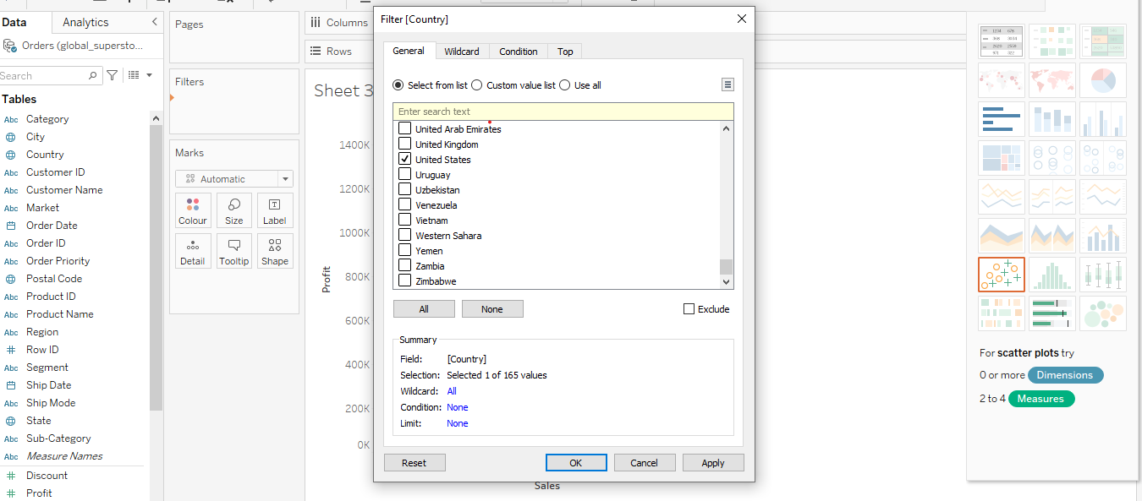

* After that, we must choose a state and search for profit and other items within it. We got it all together now that we've chosen the states
* Next, we wanted to colour it based on profit and sales, so we put profit and sales on the MARK colour palette.
* Furthermore, we attempted to base sales on ts sixe and were successful.

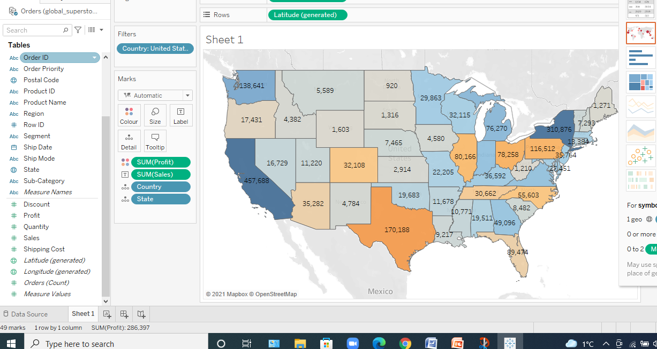

## Adding Category

* The next step is to conduct an analysis based on the categories contained therein.
* We used the category column, placed it within the filter, and then selected all of the subcategories we could, resulting in the subcategory of it.

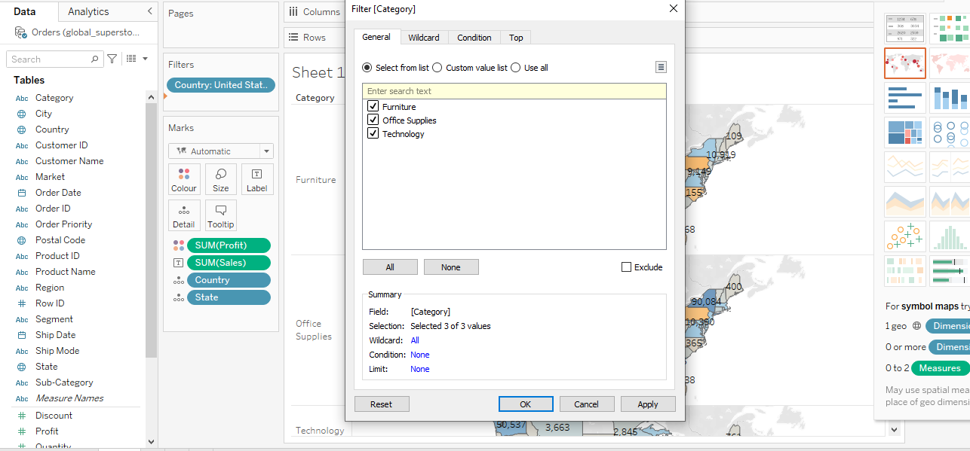

* Without applying subcategories, we get the below analysis.

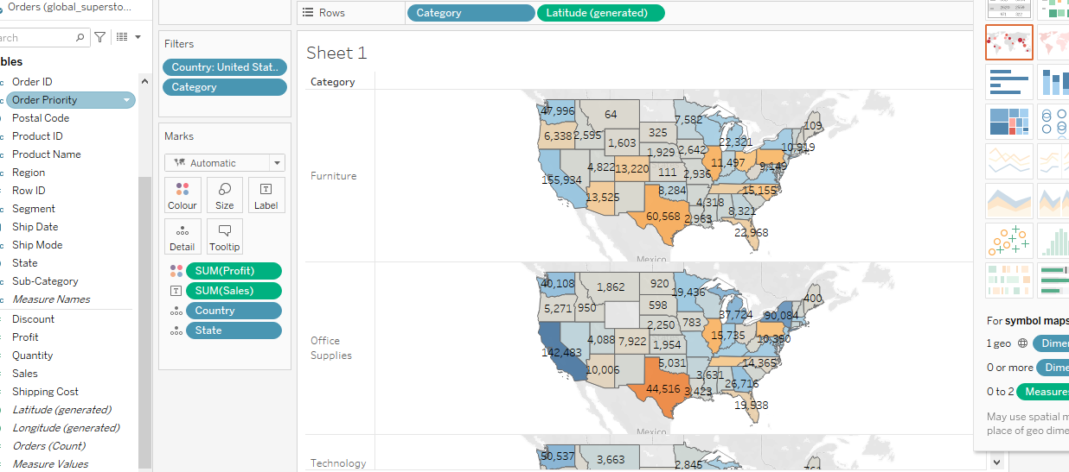

// TODO: Why 2 screenshots?

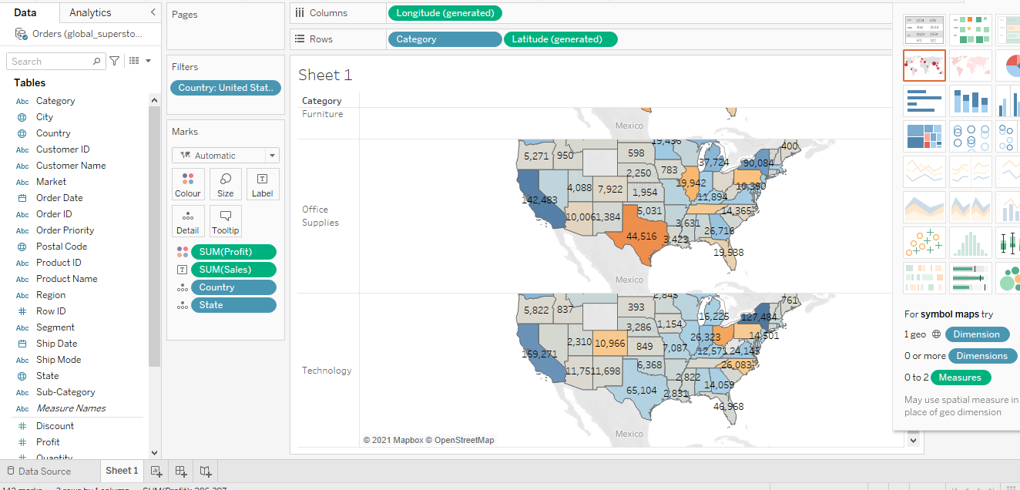

We can see that we have been given three categories – Furniture, Office Supplies and Technology, and as a result, we can drive the maximum or minimum amount of sales and profit earned in these US states. We arrive at a few conclusions as a result of this.

* Technology Sector has been way ahead of other sectors on the basis of sales and profit.
* California is the state that is way ahead from all states in manner of technology.
* Lastly California is the only state that is the best in both cases from other states.

## Filter Based on Sub-Categories

We now apply the sub-categories – Appliances and Bookshelf.

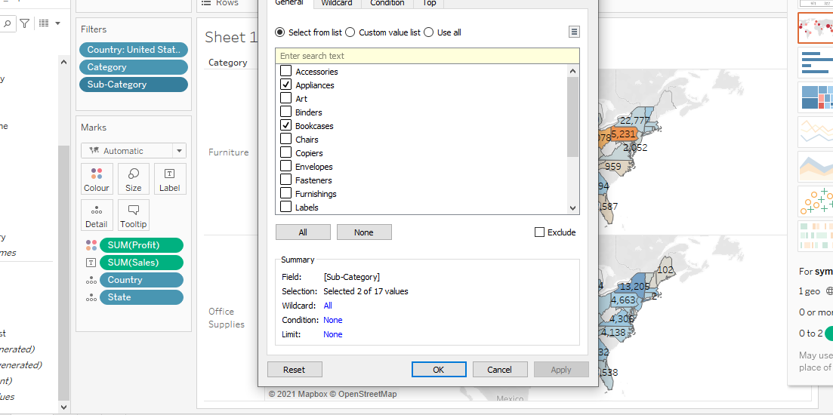

Once the filters are applied, we get the below analysis,

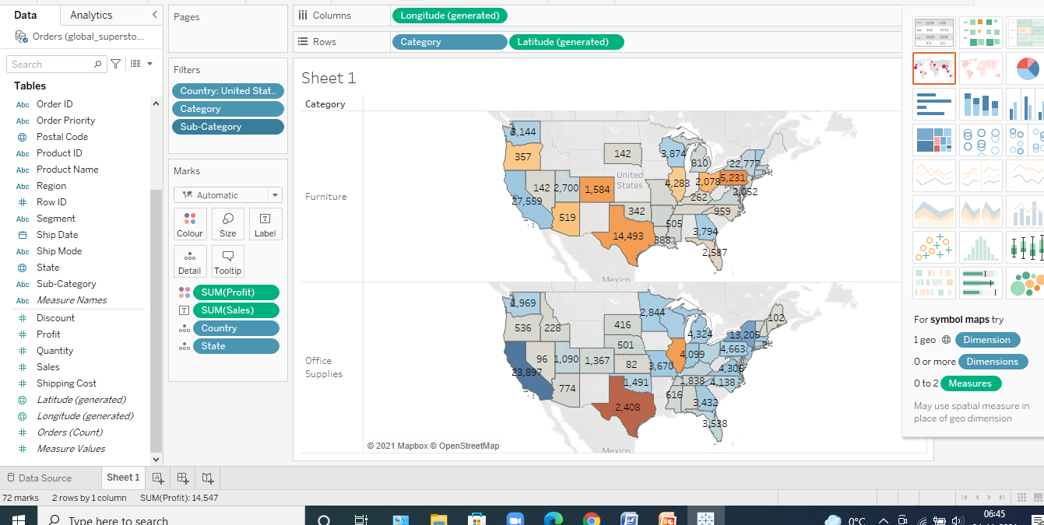

// TODO: Conclusion on above Output //