Developing a Novel Machine Learning Framework for Season-Ahead Prediction of Injured Reserve Placement in Professional Football Wide Receivers and Tight Ends
Rohan Raj Butani, Johns Hopkins University, Baltimore, Maryland
Abstract— Severe injuries leading to injured reserve (IR) placement in the National Football League (NFL) disrupt careers and team strategies, yet no tools exist to forecast these events a season in advance. We compiled six years (2018–2023) of public demographic, workload, travel, surface, combine, and injury-history data into 746 player-season records for wide receivers (WRs) and tight ends (TEs). Four separate machine learning models were trained, and class imbalance handled via SMOTE and weighting. XGBoost achieved the highest balanced accuracy (58.3%), surpassing neural and linear baselines. These findings demonstrate that open-source metrics encode actionable signals for severe injury risk. To our knowledge, this is the first interpretable, position-specific framework for season-ahead IR prediction in professional football.

introduction
Injuries to NFL receivers frequently lead to injured reserve (IR) designations, which remove athletes from competition for extended periods and force teams to alter depth charts, play selection, and contract planning. Wide receivers and tight ends experience repeated high-speed accelerations, abrupt cutting, and mid-air contact, all of which elevate risk for soft-tissue injury and lower-extremity trauma. There has been no season-ahead forecasting framework that targets IR as a clinically meaningful surrogate for severe injury. We address this gap by building an interpretable, position-specific model for wide receivers and tight ends that synthesizes public tracking, workload, demographic, travel, surface, combine, and injury-history features across six seasons.

methods
We constructed a player-season dataset of 746 wide receiver and tight end observations from 2018–2023, integrating demographics, combine metrics, workload, tracking data from Next Gen Stats, injury histories from Pro Sports Transactions, travel mileage, and surface exposure. Missing 40-yard dash values were imputed using K-nearest neighbors, and discrepancies across sources were resolved with fuzzy matching plus manual checks. To address imbalance in the 20.4% positive class, we applied SMOTE during training and used class-weight adjustments where available. Logistic regression, random forest, multilayer perceptron, and Extreme Gradient Boosting (XGBoost) classifiers were trained with five-fold stratified cross-validation, using balanced accuracy as the main metric. Interpretability was provided by SHapley Additive exPlanations (SHAP), which ranked predictors globally to highlight the most influential drivers of IR placement risk.

RESULTS
As shown in Fig. 1, XGBoost achieved the highest balanced accuracy (58.3%), followed by multilayer perceptron (57.0%) and random forest (55.9%). Logistic regression performed poorly (48.1%). SHAP analysis revealed that slower 40-yard dash times, reduced average pre-snap cushion, and higher snap counts most strongly increased IR risk, whereas height, weight, and prior IR history were comparatively weak predictors.
- Model Types and Their Respective Accuracies
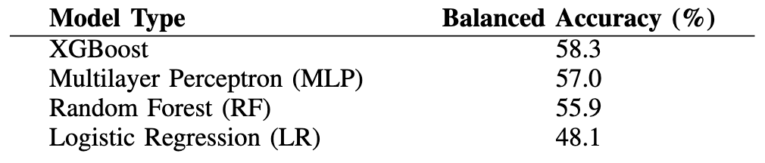

DISCUSSION & CONCLUSION
These results demonstrate the feasibility of season-ahead IR forecasting from public data. The approach highlights interpretable biomechanical and workload factors that can inform medical decision-making and contract planning. Future work should incorporate temporal load measures, larger samples, and player-worn sensors to enhance precision and generalizability.

