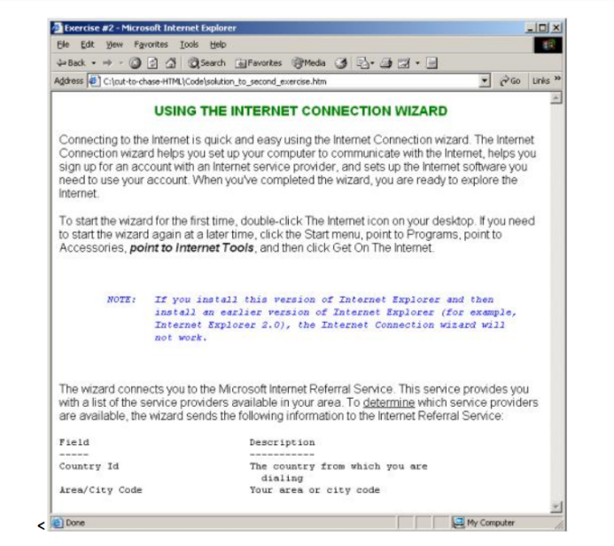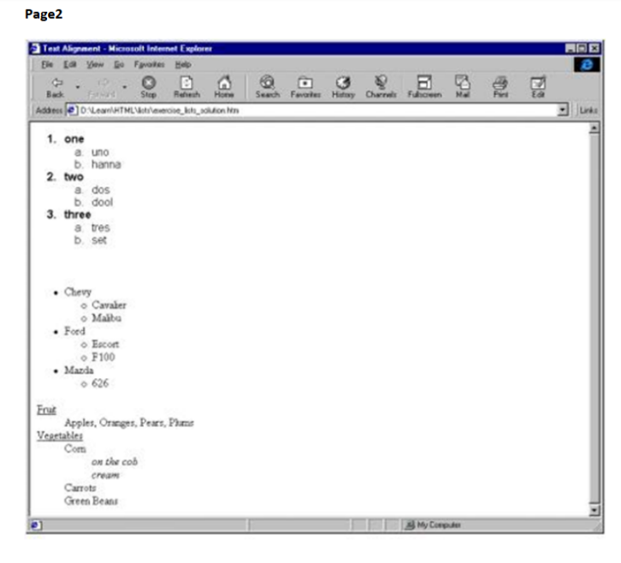 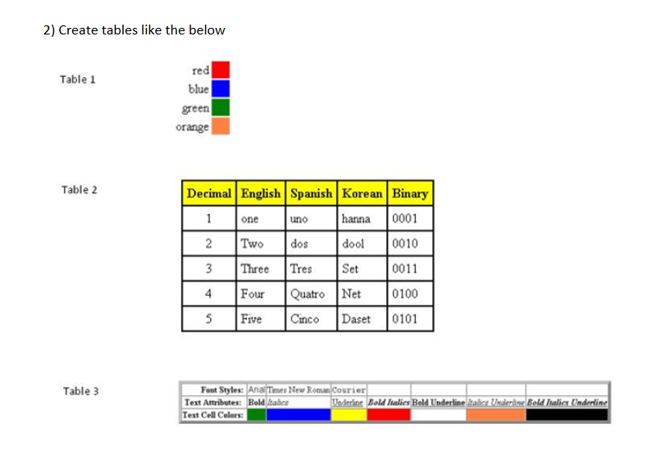

TASK

1. Create a form like the one below, submit button should submit the page and reset button should reset all the fields values entered or selected.

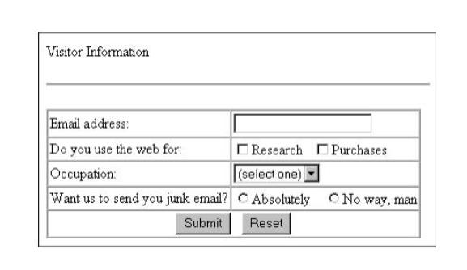

2. With the use of tables and DIV tags create a structure like given below. Create 2 pages, one page with tables and one page with DIV.

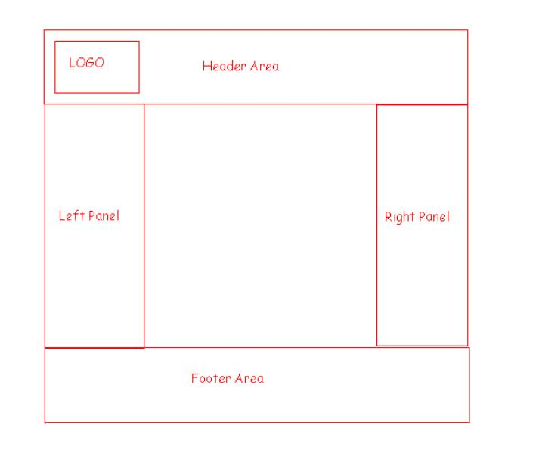

3. Create a HTML menu as shown below



4. Refer the frame and iframe tags and create few of the samples for the same.

video open in iframe: <https://player.vimeo.com/video/998153930?quality=1080p&background=1&autoplay=1&loop=1&byline=0&title=0&muted=1>