

By: Rohan Choudhary ([rohanch98@gmail.com](mailto:rohanch98@gmail.com), 8700977043)

Credicxo Tech Private Limited

Internship assignment report

Preprocessing Steps:

1. The data was checked for any missing value, no missing values were found.
2. Then one set of independent variable X and dependent variable Y were created.
3. The data was split into training and test sets with a 8:2 ratio.

Feature Scaling:

1. **Feature Scaling** is a technique to standardize the independent features present in the data in a fixed range. It is performed during the data pre-processing. The variables may have different units and hence different scales. Differences in the scales may affect the model and won’t produce an apt solution.
2. Hence to standardize the data StandardScalar was used to bring the values to a particular close range, for the model to learn effectively.

Post processing Steps:

1. First a neural network of 4 hidden layers was created with 166 input dimensions 206, 10 and 6 hidden layers with one output node. This couldn’t provide a good model. The output was no where close to the expected outputs.
2. Parameter tuning was also done but the accuracy and loss graphs were very far from the desired ones.
3. Similarly many models were tried and finally the model with 166 input dimension, 120 units in one hidden layer and one output layer was accepted.
4. In the hidden layer, Kernel initializer used was he_uniform with activation function relu.
5. In the output layer, kernel initializer used was glorot_uniform with activation function sigmoid.
6. Adam optimizer was used.
7. Number of epochs = 40

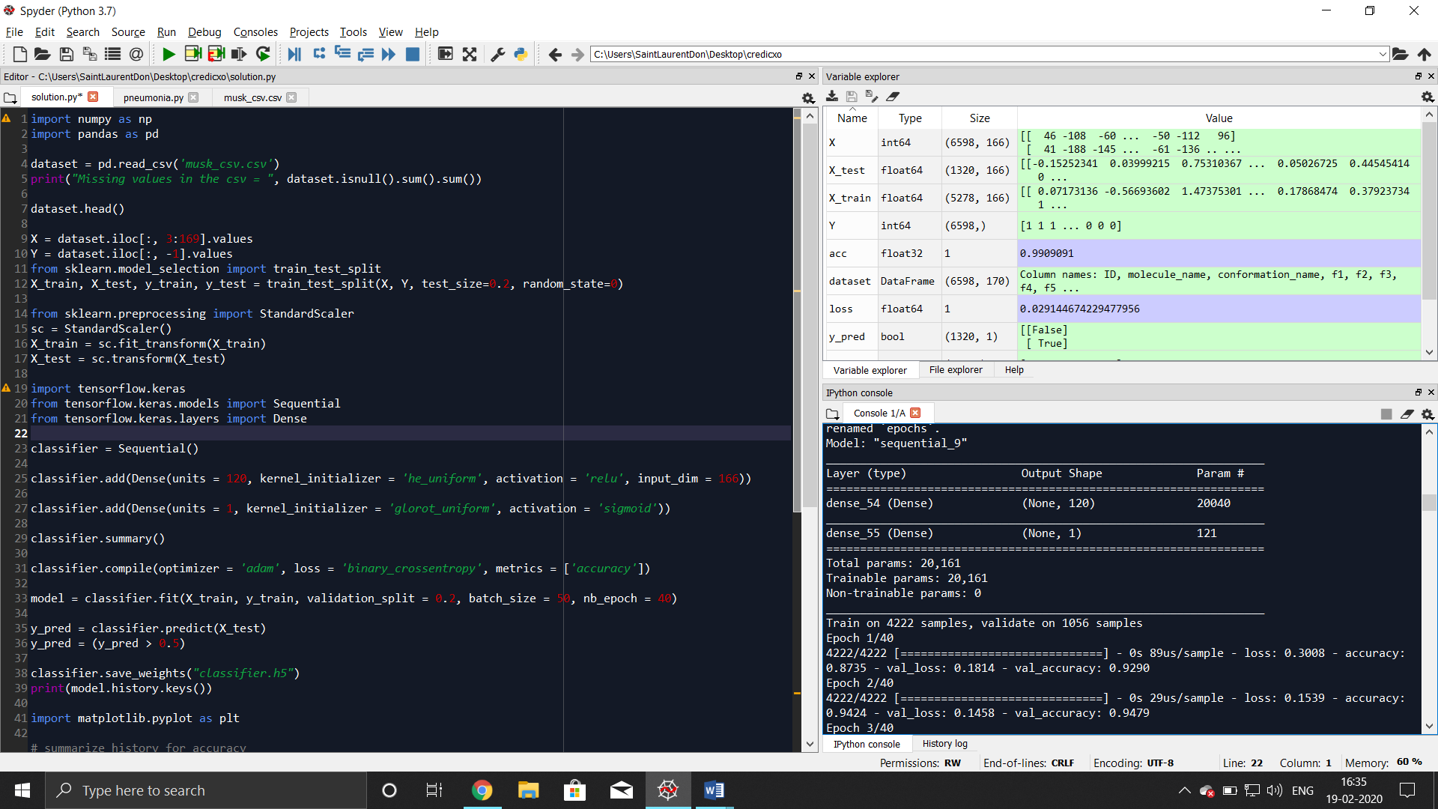

Accuracy and loss graphs:

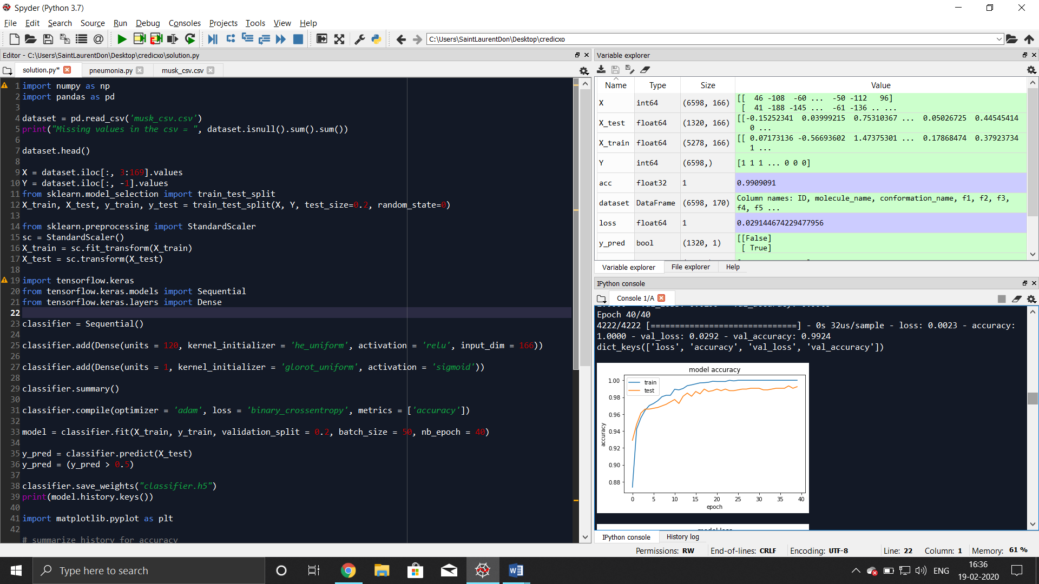

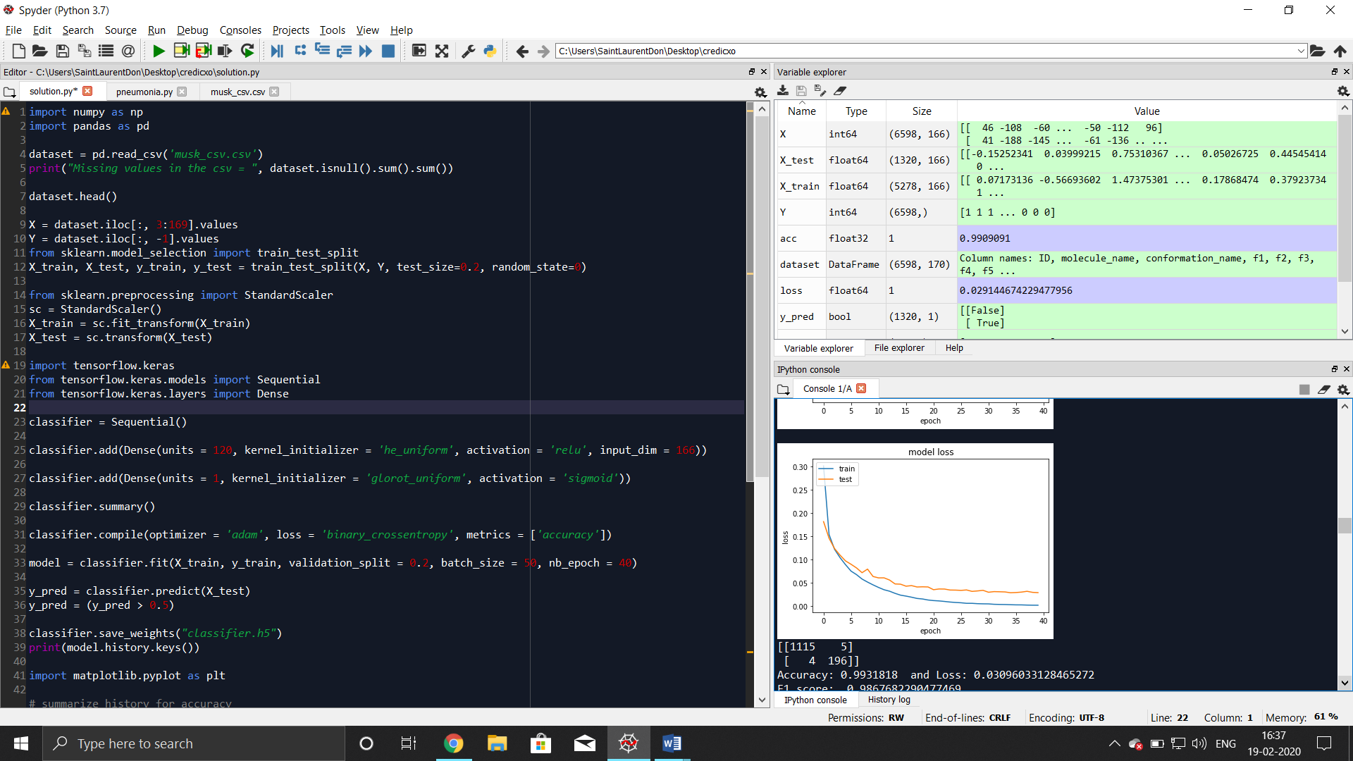

Convolution matrix and Final performance measures:

