Patient Health Record Consent Management System (PHRCMS)
Lab 1 Compilation: Requirements, Use-Case Model & Specifications
Github: https://github.com/rohancodexp/SE-Labs-PES1UG24CS381

Student Reference Number (SRN) | PES1UG24CS381
Lab Scenario Number | Scenario 13
Primary Domain | Healthcare & Telemedicine
Target Actors | Patient, Clinic Doctor, Clinic Administrator

1. Requirements Specification Table
The following table details the functional and non-functional requirements for the Patient Health Record Consent Management System (PHRCMS). Each requirement is defined with an identifier, type, description, priority, acceptance criteria, and rationale.
ID | Type | Description | Priority | Acceptance Criteria | Rationale
FR-001 | Functional | The system shall allow a patient to grant time-bounded access permissions for specific diagnostic records to verified clinic doctors, requiring a valid expiration date and time. | High | Pass: A verified clinic doctor can view the specified diagnostic records within the designated consent time-frame, and the system automatically blocks access immediately after the consent's expiration timestamp. Fail: Clinic accesses records after consent expiration. | Enables patients to share health data temporarily, minimizing data exposure risks.
FR-002 | Functional | The system shall allow a patient to revoke any active consent permission at any time prior to its scheduled expiration. | High | Pass: Upon revocation by the patient, the status of the consent is immediately updated to 'revoked', and any subsequent attempt by the authorized doctor to access the record is blocked. Fail: Doctor can view the record after revocation is submitted. | Gives patients real-time control over their data, aligning with patient-centric consent principles.
FR-003 | Functional | The system shall display a real-time list of all active and expired consent permissions to the logged-in patient, including doctor details, record names, and expiration timestamps. | Medium | Pass: The consent registry page lists all consents, showing doctor name, record ID, status (active/expired/revoked), and remaining duration (or expiry date/time) accurately. Fail: Registry fails to display accurate statuses or remaining durations. | Promotes transparency, allowing patients to audit who has access to their data.
FR-004 | Functional | The system shall permit a verified clinic doctor to view authorized patient diagnostic records only if there is an active, unexpired consent granted by the patient. | High | Pass: If a doctor attempts to access a record, the system grants access if an active consent exists. Fail: Access is granted if consent is missing, expired, or revoked. | Enforces the consent policy, preventing unauthorized data access.
FR-005 | Functional | The system shall allow a Clinic Administrator to register and manage the verification status of clinic doctors in the system. | Medium | Pass: The administrator can add a doctor to the registry and toggle their status as 'verified' or 'unverified'. Unverified doctors cannot be selected by patients for consent grants. Fail: Unverified doctor is eligible for consent grants. | Ensures that patients only grant access to legitimate, authorized medical professionals.
NFR-001 | Nonfunctional | All consent grant, revoke, and access events shall be permanently written to an append-only audit trail. | High | Pass: Every consent action and record-access event creates a log entry with timestamp, actor ID, and action type, which cannot be modified or deleted by any user or administrator. Fail: Log entry can be edited, deleted, or bypassed. | Ensures accountability, data integrity, and compliance with medical privacy audits.
NFR-002 | Nonfunctional | The system shall complete the verification of consent status and authorize or deny a doctor's access request in less than 500 milliseconds. | High | Pass: Under automated performance testing with 50 concurrent requests, the average response time to verify consent status and return the access decision is less than 500 milliseconds. Fail: Average verification latency exceeds 500 milliseconds. | Enforces prompt access decision checks, ensuring doctor workflow is not delayed while maintaining strict security checks.
2. UML Use-Case Diagram
The diagram below illustrates the UML Use-Case model for the PHRCMS. It details the interactions between the system boundary, primary/secondary actors (Patient, Clinic Doctor, Clinic Administrator), and the core use cases.
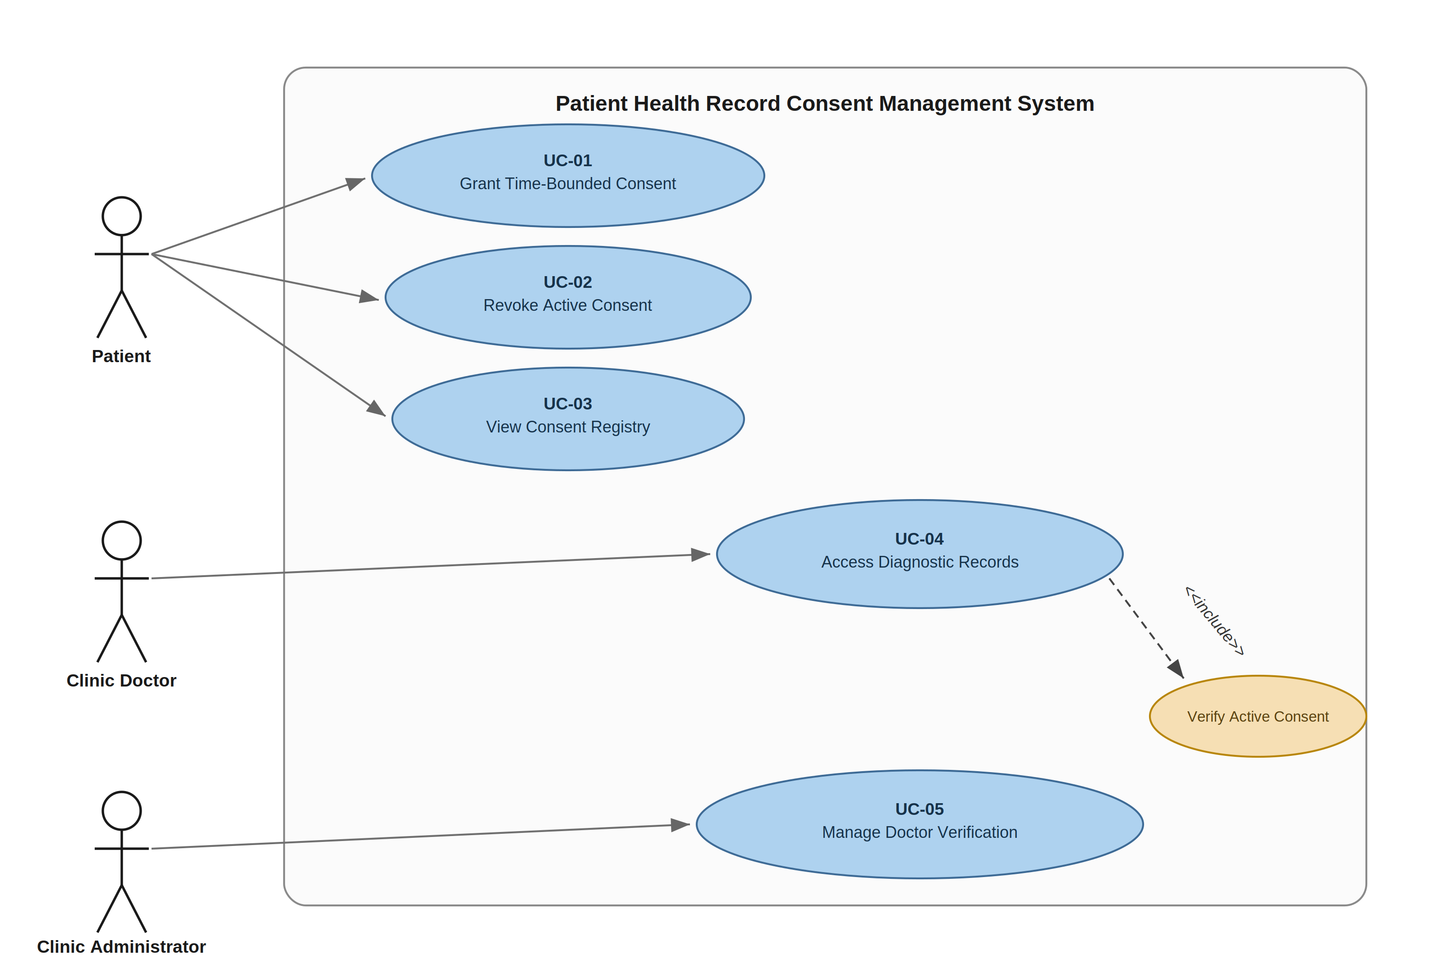
Figure 1: Patient Health Record Consent Management System (PHRCMS) UML Use-Case Diagram

2.1 Requirements Traceability Matrix
Requirement | Use Case | Target Actor | Included Verification / Auditing
FR-001 (Grant Consent) | UC-01: Grant Time-Bounded Consent | Patient | Patient enters verified doctor and future expiration
FR-002 (Revoke Consent) | UC-02: Revoke Active Consent | Patient | Triggers immediate revocation status update
FR-003 (Consent List) | UC-03: View Consent Registry | Patient | Real-time status list (active/expired/revoked)
FR-004 (Access Record) | UC-04: Access Diagnostic Records | Clinic Doctor | Enforces UC-06: Verify Active Consent check
FR-005 (Doctor Verification) | UC-05: Manage Doctor Verification | Clinic Administrator | Verification flag managed by clinic administrator
NFR-001 (Audit Trail) | Logging and Auditing | System | Appends to append-only log on grant, revoke, or access
NFR-002 (Response Latency) | UC-06: Verify Active Consent | System | Consent validation latency is constrained to < 500ms
3. Use-Case Flow Specification: Grant Time-Bounded Consent

1. Preconditions
- The Patient is authenticated and logged into the Patient Health Record Consent Management System.
- The Clinic Doctor is registered in the system and verified by the Clinic Administrator.
- The Patient has one or more diagnostic records linked to their account.

2. Postconditions
- A consent record is stored in the system database containing the Patient ID, Doctor ID, Record IDs, Grant Timestamp, Expiration Timestamp, and Status set to 'Active'.
- A permanent, unmodifiable event entry is written to the append-only audit trail.
- The designated Clinic Doctor is authorized to access the specified diagnostic records until the expiration timestamp is reached.

3. Main Success Scenario
- Patient selects the 'Grant Record Access' option from the dashboard.
- System displays a form requesting selection of a verified doctor, selection of diagnostic records, and a specific expiration date and time.
- Patient searches the verified registry and selects a verified Clinic Doctor.
- Patient selects one or more specific diagnostic records (e.g., 'Blood Lab Report - 2026-08-20') from their medical history.
- Patient enters a valid future date and time for the consent's expiration.
- Patient submits the consent grant request.
- System validates that the selected doctor is verified, the records belong to the patient, and the expiration timestamp is in the future.
- System creates the active consent record with the selected parameters and calculated expiration timestamp.
- System permanently writes the consent grant event (timestamp, Patient ID, Doctor ID, Record IDs, Expiration Timestamp, Action = 'GRANT') to the append-only audit trail.
- System displays a success message confirming that access has been granted to the doctor until the specified expiration date and time.

4. Alternate Flows
3a. Doctor not verified:
- 3a1. System checks the doctor's status and determines they are unverified.
- 3a2. System displays an error: 'The selected doctor is currently unverified. Access can only be granted to verified clinic doctors.'
- 3a3. System prompts the patient to select a different doctor.
- 3a4. Flow returns to step 3 of the Main Success Scenario.
5a. Expiration time in the past or invalid:
- 5a1. System checks the entered expiration timestamp and determines it is in the past or formatted incorrectly.
- 5a2. System displays an error: 'Expiration timestamp must be a valid date and time in the future.'
- 5a3. System prompts the patient to re-enter the expiration date and time.
- 5a4. Flow returns to step 5 of the Main Success Scenario.

