Software Engineering – LAB 2

Name: Rohan M SRN: PES1UG24CS381 Section: G

Student Reference Number (SRN) | PES1UG24CS381
Lab Scenario Number | Scenario 13
Primary Domain | Healthcare & Telemedicine

EPICS

Consent Management. Secure Health Record Access, Doctor Verification

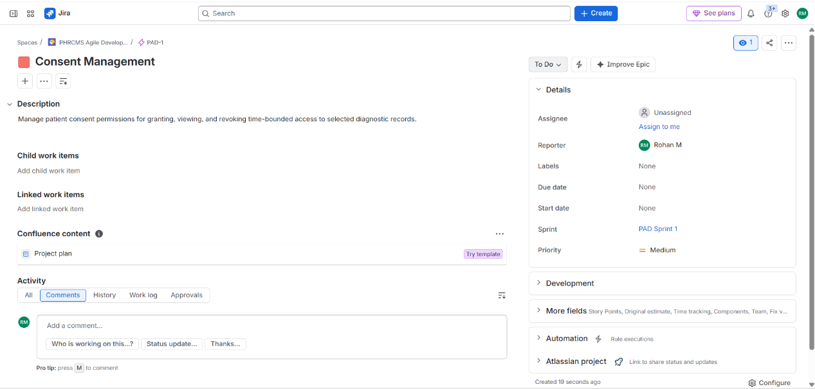
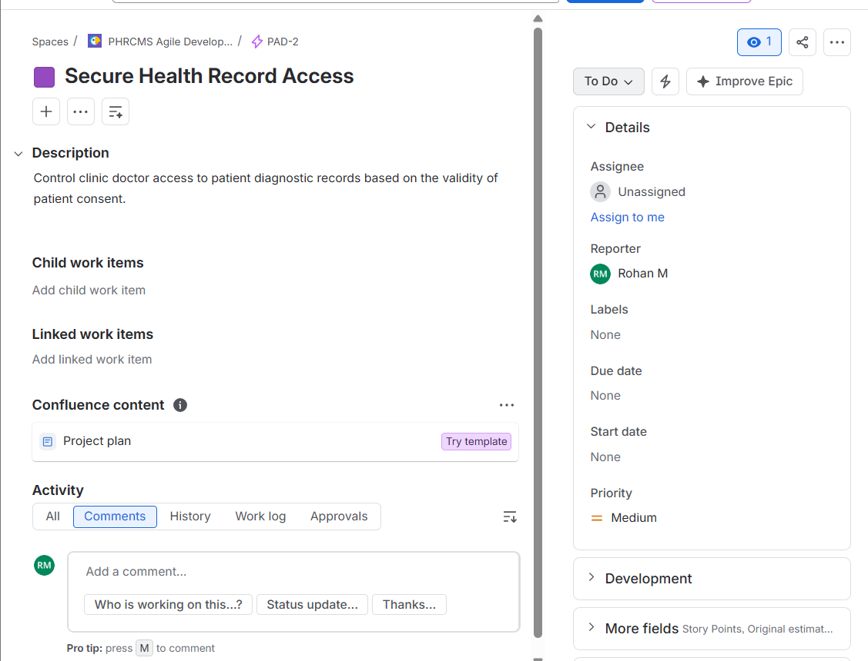

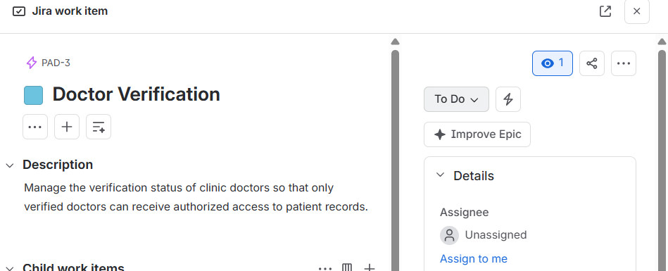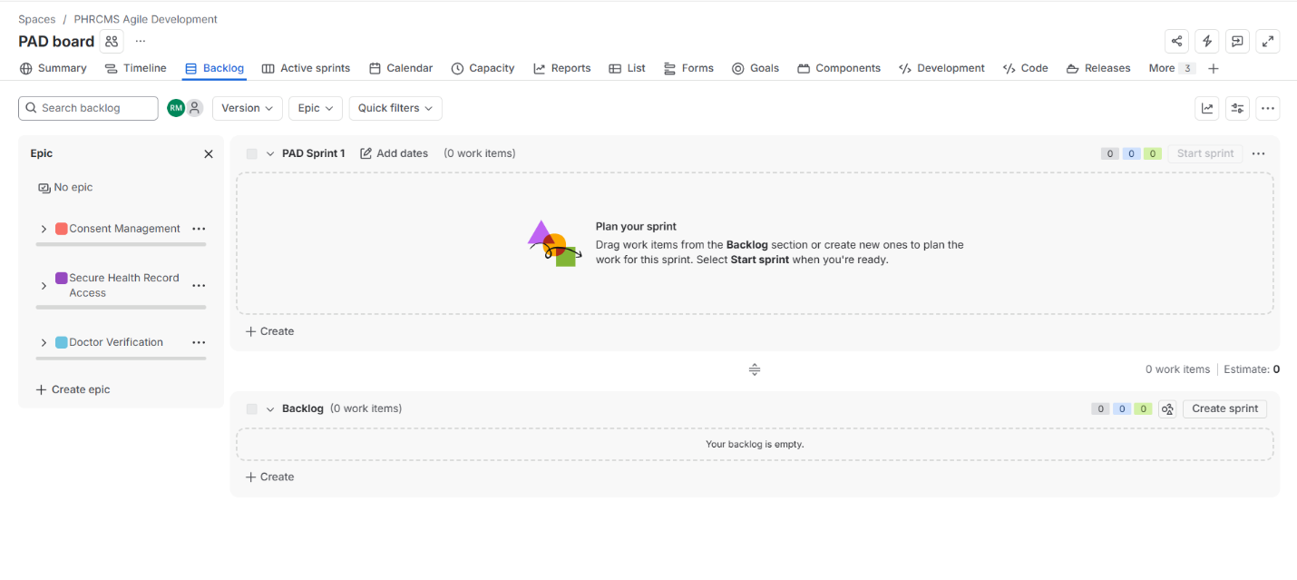
Epics

Complete Backlog

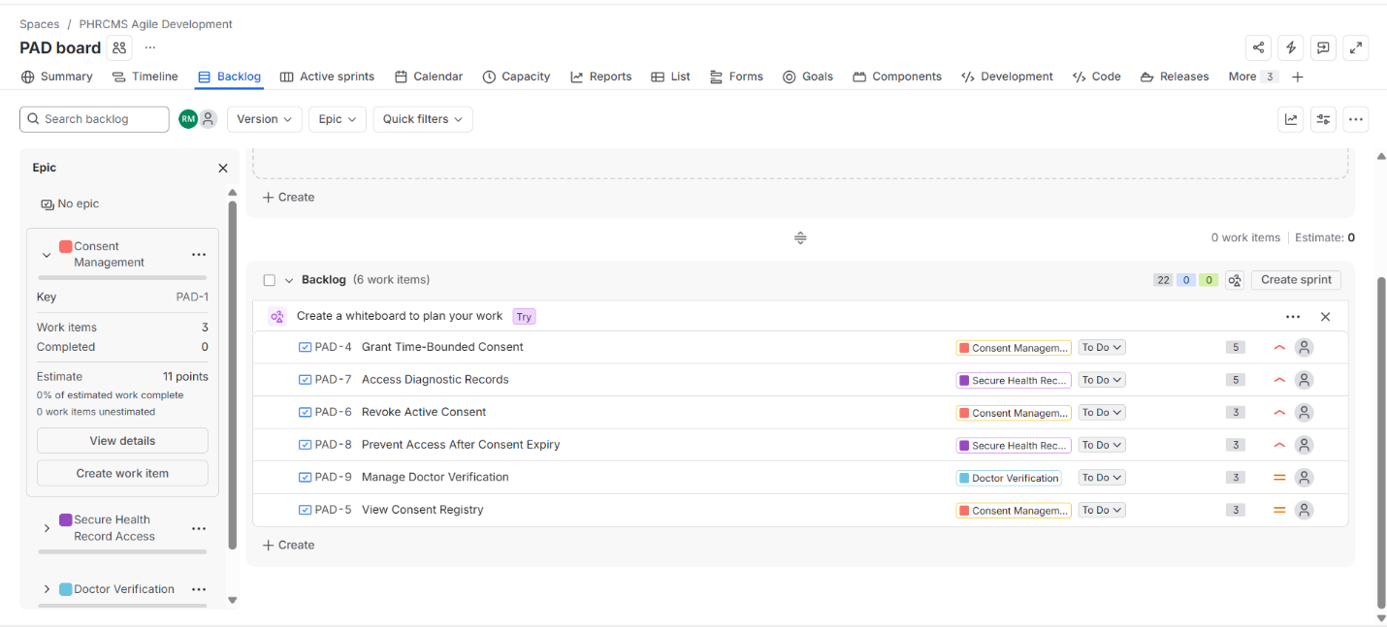

Prioritized Backlog

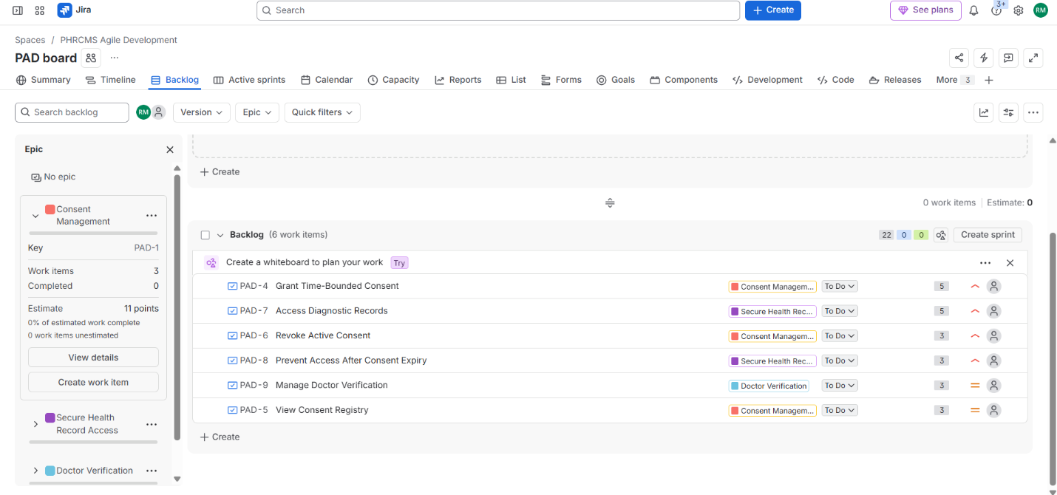

Story Points

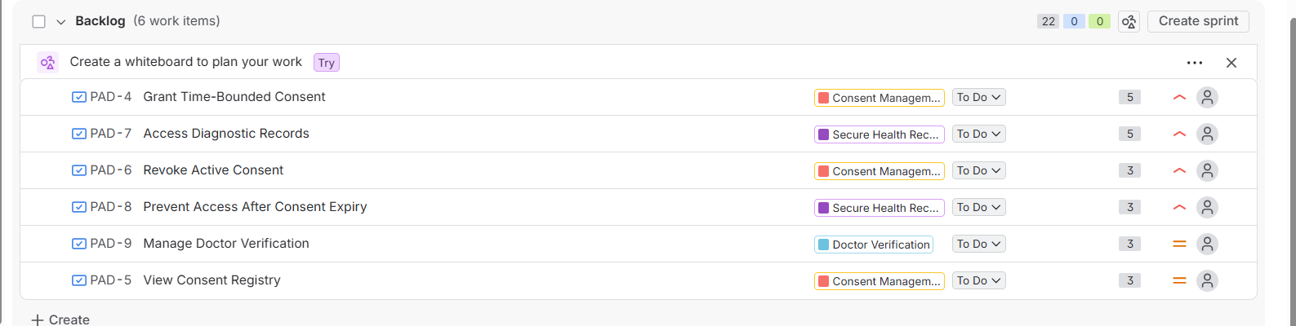

Sprint 1 Planning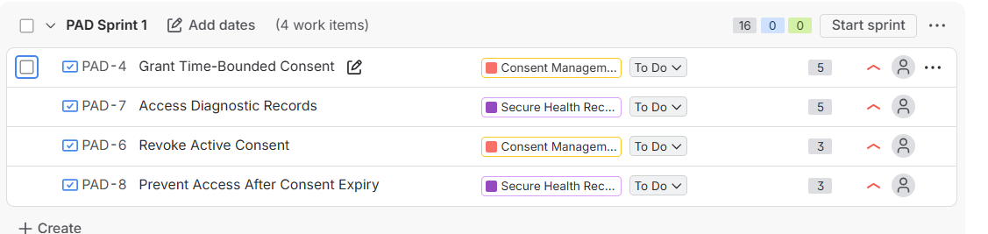

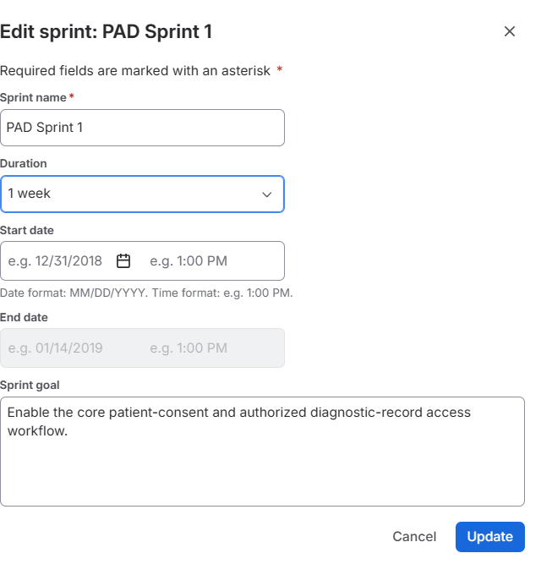
Sprint 1 – To Do

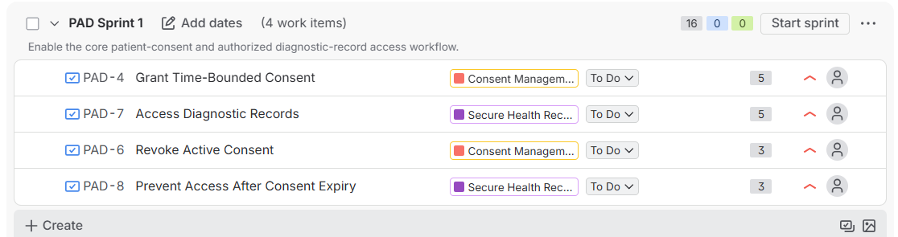

Sprint 1 - Progress
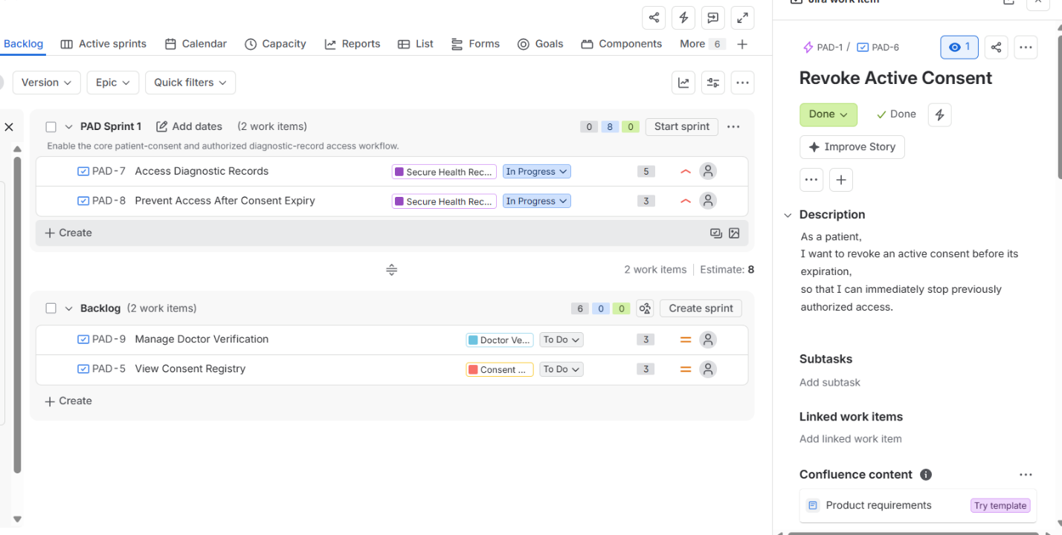

Sprint 1 - Completion
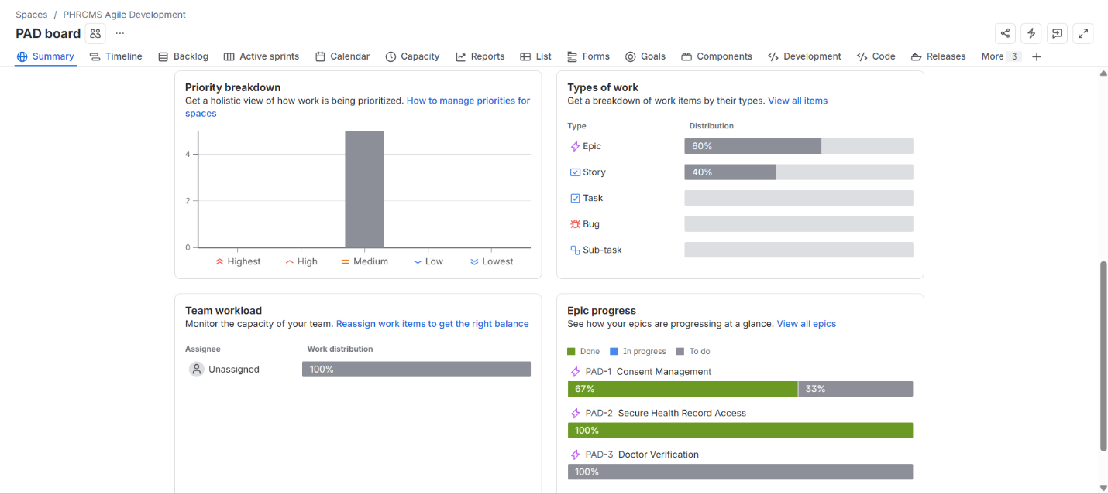

Sprint 2 - Planning

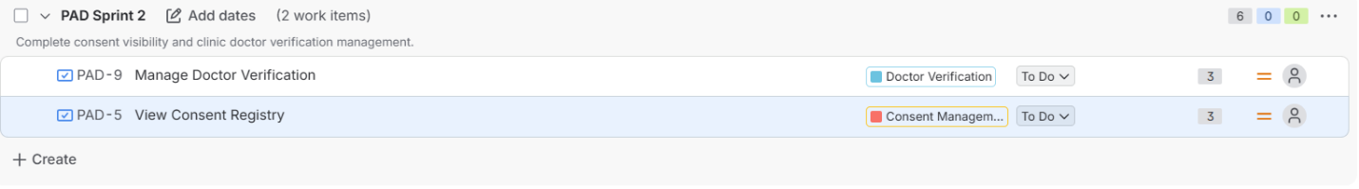

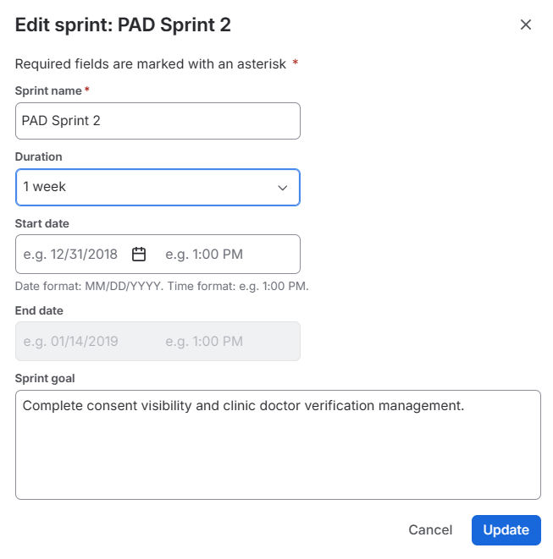
Sprint 2 – To Do

Sprint 2 – Progression

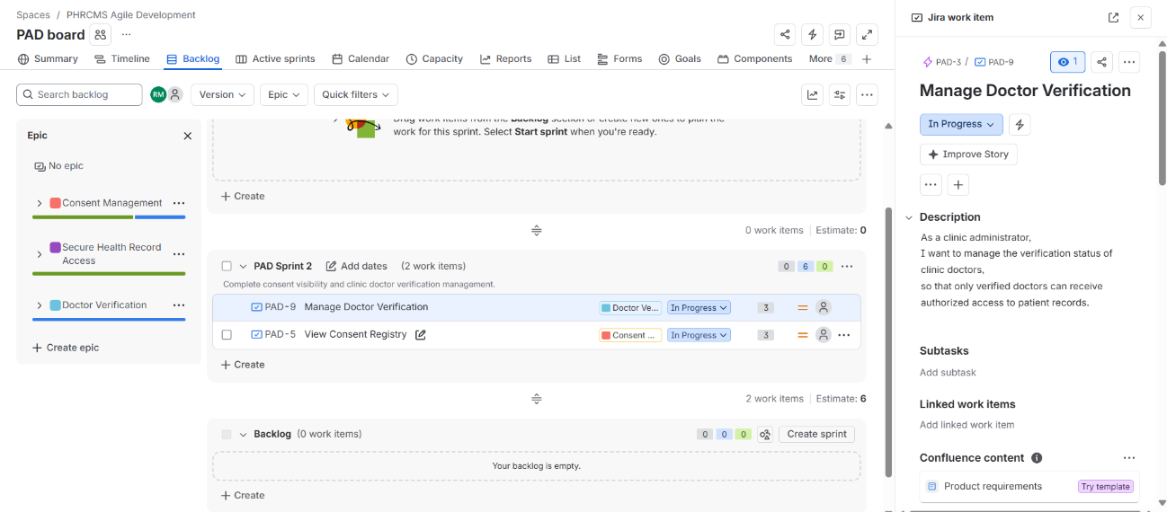

Sprint 2 – Completion
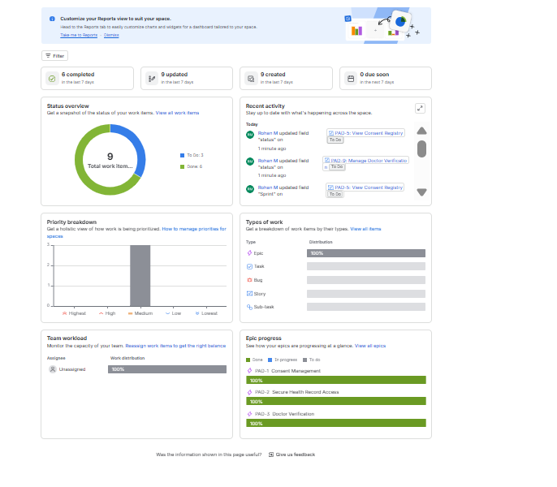

Burndown Chart
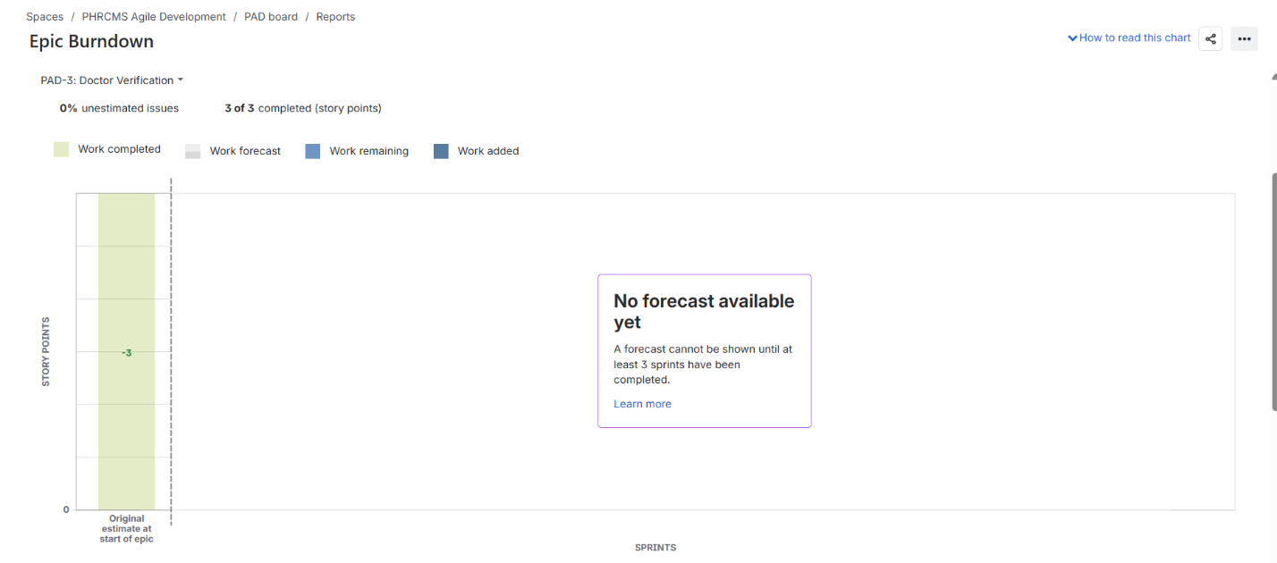

Reflection Questions

1. Did your estimations reflect the actual effort?
The estimates generally reflected the relative complexity of the work. The larger stories, such as granting consent and accessing diagnostic records, were assigned 5 story points because they involve more validation and access-control logic. Smaller stories such as viewing the consent registry and managing doctor verification were assigned 3 points. Since this was a simulated sprint, the story-point estimates were mainly useful for comparing relative effort rather than measuring actual time.

2. Was your backlog well-prioritized?
Suggested answer:
Yes. The backlog prioritized core consent and health-record access functionality first because these functions are central to the system's purpose. Granting consent and accessing diagnostic records were given High priority, followed by revocation and expiry-related access control. Supporting functions such as viewing the consent registry and managing doctor verification were given Medium priority.
3. How did your simulated sprint align with your plan?
Sprint 1 focused on the core consent and record-access workflow and contained 16 story points. Sprint 2 completed the remaining consent visibility and doctor verification functionality with 6 story points. The stories were moved from To Do to In Progress and then Done to simulate the development workflow. Overall, the sprint structure followed the planned backlog prioritization.

4. What insights did the burndown chart give about your team's capacity?
The burndown chart provided a visual representation of how quickly the planned story points were completed during the sprint. It helped compare actual progress with the ideal guideline and showed how the remaining work decreased as stories were completed. Since this was an individual simulated sprint rather than a real team project, the chart provides only a limited indication of capacity, but it demonstrates how Scrum teams can monitor progress and identify deviations from the plan.

