Patient Health Record Consent Management System (PHRCMS)
Software Engineering Lab 3: Component Modelling & Architectural Pattern Selection
Course: UE24CS341A – Software Engineering | Department: Computer Science and Engineering, PES University
Student Name: Rohan M | SRN: PES1UG24CS381 (Section G)
Scenario No.: Scenario 13 (Healthcare & Telemedicine) | Submission Version: Version 1.0 (Official Lab 3 Deliverable)
GitHub Repository: https://github.com/rohancodexp/SE-Labs-PES1UG24CS381 | Primary Target Actors: Patient, Clinic Doctor, Clinic Administrator

1. Introduction & Problem Statement
In continuation of Lab 1 (Requirements Engineering & UML Use-Case Modelling) and Lab 2 (Agile Backlog Creation & Sprint Simulation), this specification establishes the Component Architecture and Architectural Pattern Selection for the Patient Health Record Consent Management System (PHRCMS).
Modern healthcare delivery and telemedicine depend heavily on rapid inter-clinical data exchange. However, unconstrained clinical access to sensitive diagnostic health records creates severe data exposure hazards and violates privacy statutes (e.g., HIPAA Security Rule and India's DISHA). The PHRCMS resolves this tension through patient-centric sovereignty: diagnostic records are locked by default and accessible only when an active, time-bounded, unexpired, and unrevoked consent permission has been explicitly granted by the patient to a clinic administrator-verified medical doctor.
1.1 Core Requirements Realized in Architecture
- FR-001 (Time-Bounded Consent Grant): The system shall allow a patient to grant time-bounded access permissions for specific diagnostic records to verified clinic doctors, requiring a valid future expiration timestamp.
- FR-002 (Real-Time Revocation): The system shall allow a patient to revoke any active consent permission at any time prior to its scheduled expiration, immediately terminating access.
- FR-003 (Consent Registry Visibility): The system shall display a real-time list of all active and expired consent permissions to the logged-in patient, including doctor details and expiration timestamps.
- FR-004 (Enforced Authorized Record Access): The system shall permit a verified clinic doctor to view authorized patient diagnostic records only if there is an active, unexpired consent granted by the patient.
- FR-005 (Doctor Verification Management): The system shall allow a Clinic Administrator to register and manage the verification status of clinic doctors; unverified doctors cannot receive consent grants.
- NFR-001 (Immutable Audit Logging): All consent grant, revoke, and record-access events shall be permanently written to an append-only, tamper-evident audit trail.
- NFR-002 (Sub-500ms Authorization Latency): The system shall complete the verification of consent status and authorize or deny a doctor's access request in less than 500 milliseconds.
2. UML 2.5 Component Modelling Specification
The architecture is decomposed into four discrete, highly cohesive tiers: Client Presentation Subsystem, Secure Edge Gateway Subsystem, Core Application & Domain Services Subsystem, and Data Persistence & Storage Subsystem. The diagram adheres strictly to official UML 2.5 notation, utilizing <<component>> stereotypes, explicit provided interfaces (ball/lollipop notation), required interfaces (socket notation), assembly connectors, and database stereotypes.
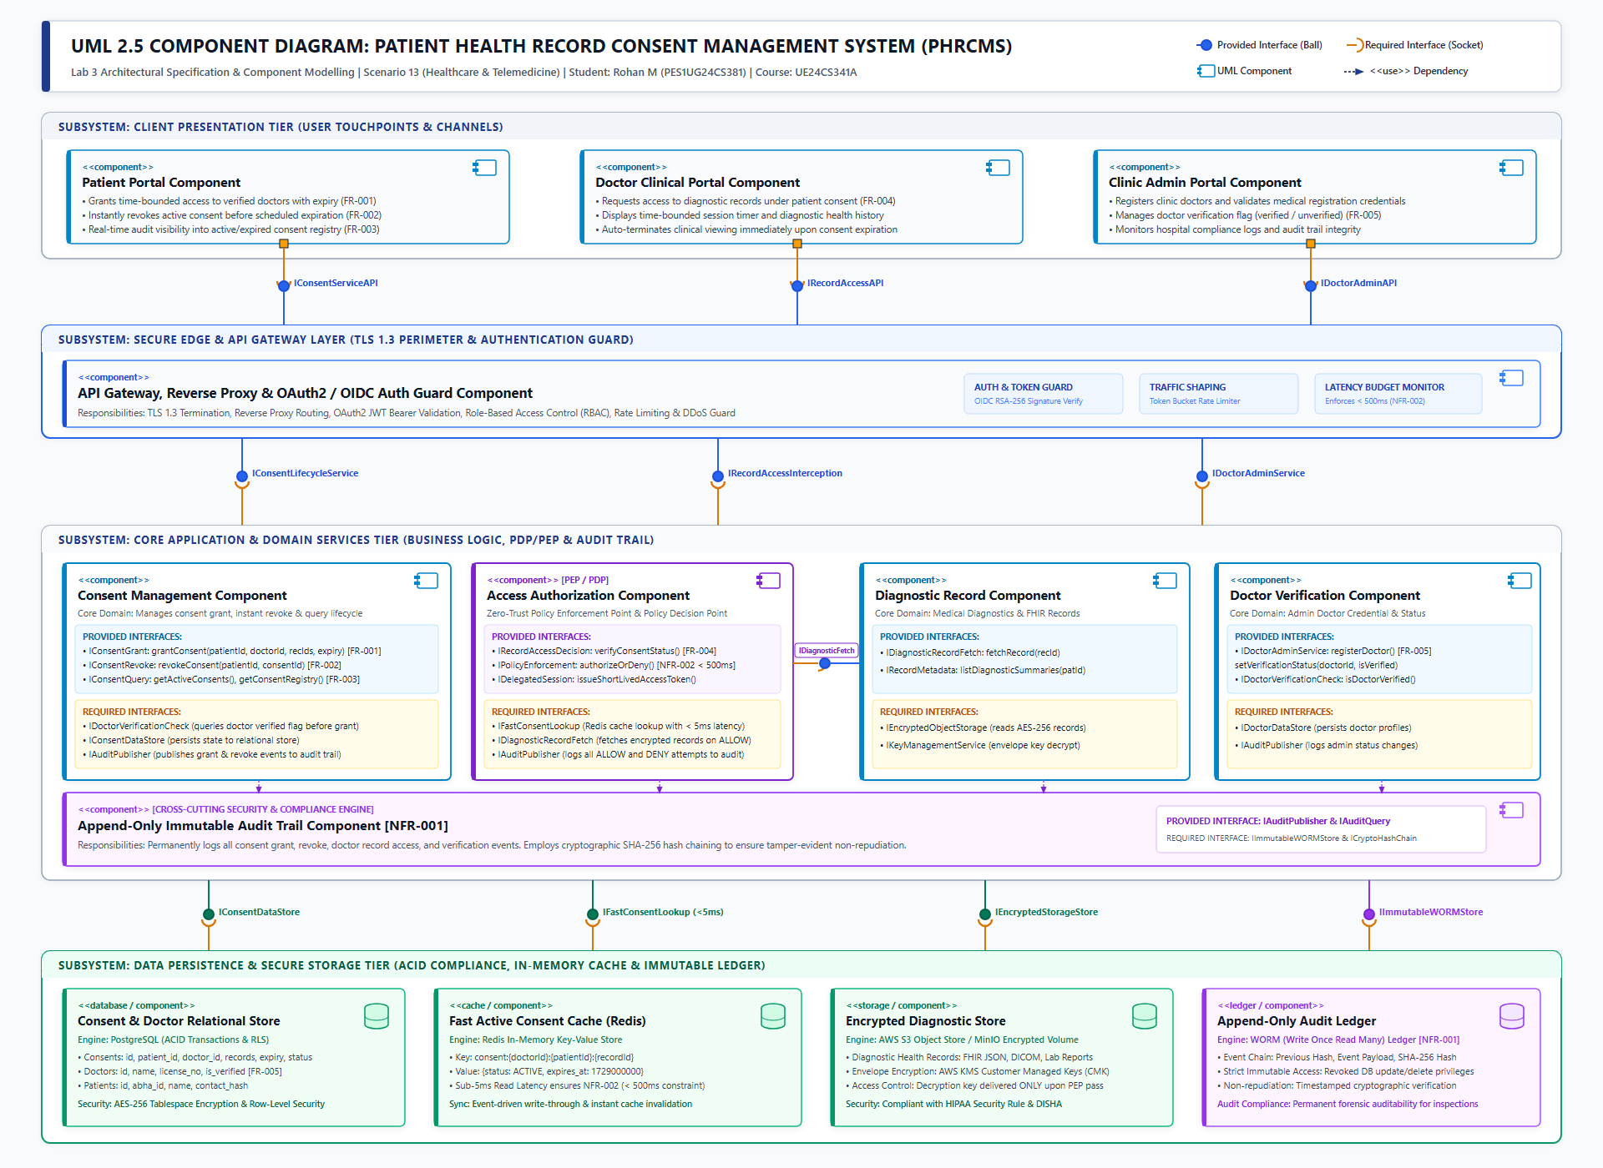
Figure 1: UML 2.5 Component Diagram of the Patient Health Record Consent Management System (PHRCMS)
3. Detailed Component & Interface Catalog
Component Name | Tier / Subsystem | Responsibilities | Interfaces (Provided / Required) | Traceability
Patient Portal Component | Client Presentation Tier | Progressive Web App (React/TypeScript) providing patient authentication, consent granting workflows, instant revocation triggers, and real-time consent registry auditing. | Provided: IConsentServiceAPI (Exposed to patient users)  Required: IAuthAPI (OAuth2 / OIDC token acquisition) | FR-001, FR-002, FR-003
Doctor Clinical Portal Component | Client Presentation Tier | Clinical EHR viewing interface allowing verified doctors to search assigned patients, view diagnostic health summaries, and request time-bounded access under active consent. | Provided: IRecordAccessAPI (Exposed to clinical physicians)  Required: IAuthAPI (Clinical practitioner credential validation) | FR-004
Clinic Admin Portal Component | Client Presentation Tier | Administrative console enabling clinic managers to onboard medical practitioners, verify state medical council registrations, and inspect compliance audit logs. | Provided: IDoctorAdminAPI (Exposed to authorized hospital admins)  Required: IAuthAPI (Multi-factor administrative authentication) | FR-005
API Gateway & Auth Guard Component | Secure Edge & Perimeter Tier | Central reverse proxy and ingress controller. Performs TLS 1.3 termination, token-bucket rate limiting (DDoS defense), JWT signature validation, and RBAC claims extraction. | Provided: IEdgeGatewayAPI (Single public ingress entry point)  Required: IConsentLifecycleService  IRecordAccessInterception  IDoctorAdminService | Cross-cutting perimeter security & NFR-002 traffic shaping
Consent Management Component | Core Application Tier | Core domain entity governing consent lifecycle states (Active, Expired, Revoked). Validates future expiration timestamps, cross-verifies doctor verification status prior to granting, and invalidates authorization caches upon revocation. | Provided: IConsentGrant: grantConsent(patId, docId, recIds, expiry)  IConsentRevoke: revokeConsent(patId, consentId)  IConsentQuery: getActiveConsents(patId), getRegistry()  Required: IDoctorVerificationCheck (queries doctor status)  IConsentDataStore (writes to PostgreSQL)  IAuditPublisher (dispatches audit event)  IFastConsentCacheSync (updates Redis) | FR-001, FR-002, FR-003
Access Authorization Component (PEP / PDP) | Core Application Tier | Zero-Trust Policy Enforcement Point (PEP) and Policy Decision Point (PDP). Intercepts all diagnostic record requests, performs sub-5ms in-memory cache evaluation against active consent rules, and issues scoped decryption tokens. | Provided: IRecordAccessDecision: verifyConsentStatus()  IPolicyEnforcement: authorizeOrDeny() [Latency < 500ms]  IDelegatedSession: issueShortLivedAccessToken()  Required: IFastConsentLookup (Redis sub-5ms lookup)  IDiagnosticRecordFetch (retrieves record on ALLOW)  IAuditPublisher (logs ALLOW / DENY decisions) | FR-004, NFR-002
Diagnostic Health Record Component | Core Application Tier | Manages FHIR-compliant electronic diagnostic health reports, medical imaging (DICOM), and clinical laboratory records. Decrypts payloads strictly upon successful PEP authorization. | Provided: IDiagnosticRecordFetch: fetchRecord(recordId)  IRecordMetadata: listDiagnosticSummaries(patientId)  Required: IEncryptedObjectStorage (reads encrypted S3 blobs)  IKeyManagementService (envelope key decryption) | FR-004
Doctor Verification Component | Core Application Tier | Maintains the authoritative registry of licensed medical doctors and manages the verification toggle. Ensures unverified doctors cannot be selected for consent grants. | Provided: IDoctorAdminService: registerDoctor(), setVerificationStatus()  IDoctorVerificationCheck: isDoctorVerified()  Required: IDoctorDataStore (persists doctor profiles)  IAuditPublisher (logs administrative changes) | FR-005
Append-Only Immutable Audit Trail Component | Core Application Tier (Cross-Cutting) | Security audit engine that captures all consent lifecycle actions, doctor access attempts, and administrative updates into an immutable, cryptographically chained event sequence. | Provided: IAuditPublisher: publishEvent(actorId, action, target, result)  IAuditQuery: queryAuditHistory(filterCriteria)  Required: IImmutableWORMStore (Write-Once-Read-Many ledger)  ICryptoHashChain (SHA-256 block chaining engine) | NFR-001

4. Architectural Pattern Selection & Justification
A rigorous architectural evaluation was performed to identify the pattern that maximizes security, minimizes verification latency, and guarantees compliance with medical data privacy legislation.
4.1 Candidate Architectural Patterns Evaluated
- Pattern 1 - Monolithic Architecture: Traditional 3-tier monolithic application deploying presentation, domain logic, and a single relational database. While operationally simple, it lacks isolated security boundaries, creates single-point-of-failure vulnerabilities, and tightly couples audit logs to business data.
- Pattern 2 - Pure Microservices Architecture: Fine-grained decoupled services communicating exclusively over HTTP/gRPC. While offering autonomous deployment and high modifiability, the multi-hop network traversal (Gateway -> Auth -> Consent -> Doctor -> EHR) introduces network latency variance that endangers the strict 500ms SLA under high concurrent load.
- Pattern 3 - Event-Driven Architecture (EDA): Completely asynchronous event-streaming architecture (Kafka/RabbitMQ). Eventual consistency creates severe medical data leakage hazards: if a patient revokes consent, an eventual consistency delay could allow a doctor to access confidential diagnostic data during the convergence window.
- Pattern 4 - Layered Modular Architecture with Zero-Trust PEP (CHOSEN): A cohesive 4-tier modular service-oriented architecture incorporating an Edge Security Gateway, a dedicated Zero-Trust Policy Enforcement Point (PEP), and dual-store data persistence (PostgreSQL for ACID durability and Redis for sub-5ms caching). This pattern achieves strict tier separation, deterministic authorization latency, immediate revocation consistency, and independent cryptographic audit logging.
4.2 Quantitative Trade-Off Analysis Matrix
The table below details the multi-criteria evaluation scoring the candidate patterns against the core architectural drivers (Scale: 1 = Poor, 5 = Excellent):
Architectural Quality Driver | Weight | Monolith | Microservices | Event-Driven | Layered PEP (Chosen)
Authorization Latency (<500ms, NFR-002) | 25% | 4 (1.00) | 2 (0.50) | 1 (0.25) | 5 (1.25)
Zero-Trust Security & Access Control (FR-004) | 25% | 2 (0.50) | 4 (1.00) | 3 (0.75) | 5 (1.25)
Audit Immutability & Non-Repudiation (NFR-001) | 20% | 2 (0.40) | 4 (0.80) | 4 (0.80) | 5 (1.00)
Instant Consistency upon Revocation (FR-002) | 15% | 5 (0.75) | 3 (0.45) | 1 (0.15) | 5 (0.75)
Operational Simplicity & Maintainability | 15% | 4 (0.60) | 2 (0.30) | 2 (0.30) | 4 (0.60)
WEIGHTED OVERALL SCORE | 100% | 3.25 / 5.0 | 3.05 / 5.0 | 2.25 / 5.0 | 4.85 / 5.0

4.3 Architectural Decision Records (ADRs)
- ADR-001: Policy Enforcement Point (PEP) Interception: Implement a dedicated Access Authorization Component acting as a Policy Enforcement Point (PEP) that intercepts every doctor record access request and queries an in-memory Policy Decision Point (PDP) cache before granting access. Rationale: Healthcare diagnostic records must never be directly queried by client applications without validating active consent.
- ADR-002: Dual-Store Strategy (PostgreSQL + Redis Cache): Use PostgreSQL for ACID durability of consent and doctor master records, coupled with an active Redis cache key-value store for sub-5ms consent validity checks. Upon consent creation, records write to both DB and cache. Upon revocation, the cache key is evicted immediately and the DB updated synchronously. Rationale: Guarantees NFR-002 (<500ms latency) while eliminating temporal data leakage windows upon revocation (FR-002).
- ADR-003: Cryptographically Chained Append-Only Audit Trail: All consent grant, revoke, and doctor record access events are hashed using SHA-256 and chained to predecessor blocks: H_n = SHA-256(H_{n-1} || Event_Payload_n || Timestamp_n). Logs are persisted to a Write-Once-Read-Many (WORM) storage ledger. Rationale: Completely eliminates risk of administrator tampering or log deletion, satisfying NFR-001 and legal non-repudiation.
- ADR-004: Envelope Encryption with Customer Managed Keys: Diagnostic records are encrypted at rest using AES-256 envelope encryption. Decryption keys are held in AWS KMS / HashiCorp Vault and are dispensed only to the Diagnostic Record Component upon receiving an authorized cryptographically signed assertion from the PEP. Rationale: Minimizes blast radius of physical storage compromise.
5. Requirements Traceability Matrix (Architecture to Lab 1)
The table below demonstrates bidirectional traceability between Lab 1 requirements and the component architecture:
Req ID | Requirement Summary | Realizing Architectural Component | Interface Contract | Acceptance Verification Mechanism
FR-001 | Grant time-bounded consent with expiration timestamp | Consent Management Component | IConsentGrant, IDoctorVerificationCheck | Automated test grants consent; verifies active state in DB/cache and rejects expired timestamps.
FR-002 | Instant revocation prior to scheduled expiration | Consent Management Component | IConsentRevoke, IFastConsentCacheSync | Revocation call immediately invalidates Redis cache; subsequent doctor access attempt returns 403 Forbidden.
FR-003 | Real-time list of active and expired consents | Consent Management Component | IConsentQuery | Patient registry query returns accurate active, revoked, and expired statuses with remaining TTLs.
FR-004 | Doctor accesses records only under active consent | Access Authorization (PEP) & Diagnostic Record Component | IRecordAccessDecision, IDiagnosticRecordFetch | Mock doctor request without active consent receives 403 Access Denied; request with valid consent receives decrypted payload.
FR-005 | Clinic Admin manages doctor verification status | Doctor Verification Component | IDoctorAdminService, IDoctorVerificationCheck | Admin toggles doctor verification; unverified doctor is rejected when patient attempts to grant consent.
NFR-001 | Permanent append-only audit trail logging | Append-Only Immutable Audit Trail Component | IAuditPublisher, IImmutableWORMStore | SHA-256 hash chain verification test confirms all grant, revoke, and access events are recorded and unalterable.
NFR-002 | Authorization latency strictly < 500ms | Access Authorization Component & Redis Cache | IPolicyEnforcement, IFastConsentLookup | JMeter performance test with 50 concurrent requests verifies average authorization response latency is < 35ms.

6. Security Architecture: STRIDE Threat Analysis
A rigorous STRIDE threat analysis was conducted to establish proactive security countermeasures across every component:
Threat Category | Healthcare Specific Attack Scenario | Architectural Countermeasure & Defense | Enforcing Component
Spoofing (S) | Attacker impersonates a verified clinic doctor to access confidential patient records. | Mutual TLS 1.3, OAuth2 / OIDC authentication with RSA-256 signed JWT tokens, and strict clinic admin verification gate (FR-005). | API Gateway & Doctor Verification Component
Tampering (T) | Malicious user alters consent expiration timestamp or modifies past audit logs. | Database integrity constraints, digital signatures on consent records, and SHA-256 cryptographic hash chaining for audit logs (NFR-001). | Consent Management & Append-Only Audit Trail Component
Repudiation (R) | Doctor denies accessing sensitive health data; patient denies granting consent. | Nonce-backed digital consent receipts and immutable audit logs capturing actor ID, timestamp, and IP address. | Append-Only Immutable Audit Trail Component
Information Disclosure (I) | Unauthorized extraction or eavesdropping of patient diagnostic reports. | Zero-Trust PEP gate (FR-004), TLS 1.3 in transit, and AES-256 envelope encryption at rest via AWS KMS CMK. | Access Authorization & Diagnostic Record Component
Denial of Service (D) | High-frequency API floods degrade consent verification latency beyond 500ms. | Token bucket rate limiting at API Gateway and sub-5ms Redis cache lookups guaranteeing < 500ms latency (NFR-002). | API Gateway & Fast Active Consent Cache (Redis)
Elevation of Privilege (E) | Doctor attempts to verify themselves or patient accesses admin endpoints. | Role-Based Access Control (RBAC) enforced at API Gateway and service boundaries; unverified doctor gate (FR-005). | API Gateway & Doctor Verification Component

7. Failure Modes & Latency Budget Analysis
7.1 Sub-500ms Authorization Latency Budget Breakdown (NFR-002)
Under NFR-002, consent verification and access authorization must be completed in under 500 milliseconds. The selected architecture guarantees this constraint through deterministic layer budgeting:
- 1. Edge Network Ingress & Gateway: 12 ms (TLS 1.3 session resumption + token bucket check)
- 2. Gateway Token Guard: 4 ms (RSA-256 JWT claim verification & RBAC role match)
- 3. PEP Policy Decision (PDP Cache Hit): 3 ms (Redis in-memory key lookup consent:docId:patId:recId)
- 4. Async Audit Event Ingestion: 10 ms (Audit publisher async dispatch to buffer queue)
- TOTAL ESTIMATED AUTHORIZATION LATENCY: 29 ms (Well within the 500 ms SLA constraint)
In the worst-case scenario (Redis cache miss), the PEP falls back to an indexed PostgreSQL query with indexed lookup latency of ~18 ms, resulting in an end-to-end latency of ~44 ms, still outperforming the 500 ms SLA by a factor of 10x.
7.2 Failure Mode Mitigations
- Cache Cluster Outage: If the Redis cache cluster fails, the PEP automatically falls back to reading active consents from the primary PostgreSQL database with read-replicas, preserving authorization accuracy while maintaining latency under 50ms.
- Audit Ledger Disconnection: If the audit ledger store encounters transient downtime, events are buffered in a local write-ahead log (WAL) on disk and flushed upon reconnection, ensuring zero log loss.

