Procedural Document Compiler_{v.0.1.0} Manual

This tool is designed to accept an input template (currently only in .txt and .docx formats), detect fields requiring user input, and show a GUI containing the fields and options needed to easily populate the template, after which it will save the document in the same format as the template wherever required.

Usage

Text Queries
To add a standard text query in your template, follow the syntax:
{{Q:Query name,Query description}}
‘Query name’ refers to the internal name that is used to track this query. It will not be shown in the PDC GUI.
‘Query description’ refers to the description of the query. It is shown in the PDC along with a text box for input. If it is not provided, the query description will be the query name instead.
For example:

“The company’s head office is located at {{Q: ComHO, Location of the company’s head office}}”
This above query will appear in the PDC as such:

The text box can then be filled with the details requested, and it will replace the query in the final document.

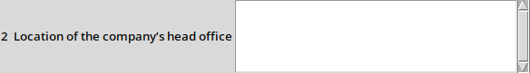

If a specific query name is used twice, it will use the details that it was given the first time. In such a case, the query description need not be given. Simply {{Q: Query name}} is enough. Note that the query name must be exactly the same, including the spaces before and after it if any (highlighted in the above example as red)
For example:

“The company’s head office is located at {{Q: ComHO, Location of the company’s head office}}”
“.......”
“As previously mentioned, the company’s head office in {{Q: ComHO}}”

The PDC in this case will only show one text box, the same one shown previously. This way, you only need to give the details once, and it will fill the detail in both (or more) places.

However, the query name must be the exact same. For example, {{Q:ComHO}} is not the same as {{Q: ComHO}} as there is a space missing. To fix this, either make all similar query names not have a space, or add the space. It must be consistent.

Option Queries
To add an option query to your template, follow the syntax:
{{D:Query name,Query option 1|Query option 2|Query option 3}}
‘Query name’ refers to the name used to track the query. Query options must be separated by the pipe symbol ‘ | ’. For example, the above shown query will appear in the options query menu as:
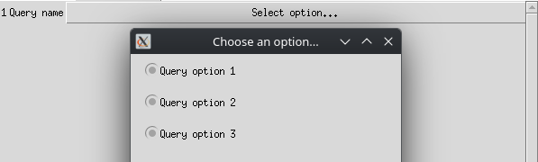

The user can then select the relevant option, and it will replace the query in the final document. Option queries, like text queries, can include only the query name, in which case it will use the value previously assigned to it. Spaces and query names must also remain consistent.

