**Name: Rohan Dhadke  
Roll No. 13136  
Group B: Practical No. 4**

Write a program to implement Mongo DB database connectivity with Front End Language(Java) Implement Database navigation operations (add, delete, edit etc.).

Installing Package

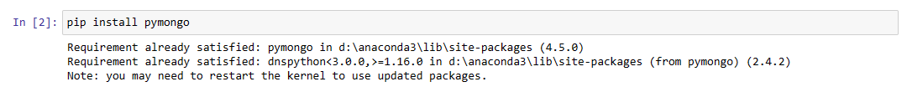

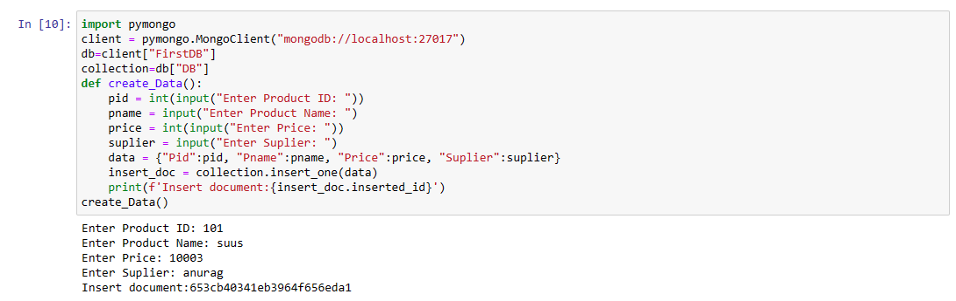

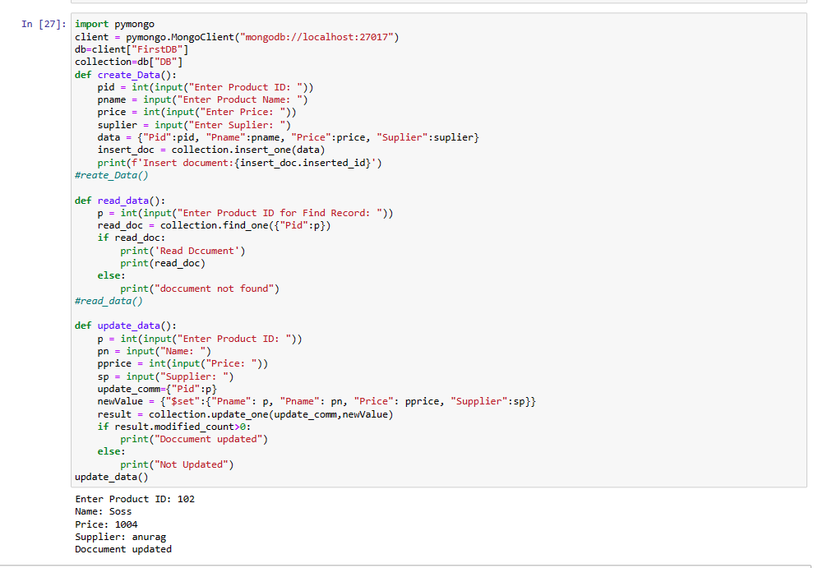

**Python Code:**

def create_Data():

pid = int(input("Enter Product ID: "))

pname = input("Enter Product Name: ")

price = int(input("Enter Price: "))

suplier = input("Enter Suplier: ")

data = {"Pid":pid, "Pname":pname, "Price":price, "Suplier":suplier}

insert_doc = collection.insert_one(data)

print(f'Insert document:{insert_doc.inserted_id}')

# create_Data()

def read_data():

p = int(input("Enter Product ID for Find Record: "))

read_doc = collection.find_one({"Pid":p})

if read_doc:

print('Read Dccument')

print(read_doc)

else:

print("doccument not found")

# read_data()

def update_data():

p = int(input("Enter Product ID: "))

pn = input("Name: ")

pprice = int(input("Price: "))

sp = input("Supplier: ")

update_comm={"Pid":p}

newValue = {"$set":{"Pname": p, "Pname": pn, "Price": pprice, "Supplier":sp}}

result = collection.update_one(update_comm,newValue)

if result.modified_count>0:

print("Doccument updated")

else:

print("Not Updated")

# update_data()

def delete_data():

p = int(input("Enter Product ID: "))

obj = {"Pid":p}

result = collection.delete_one(obj)

if result.deleted_count>0:

print("Record Deleted")

else:

print("Record Not Found")

# delete_data()

while True:

print("Select Your Choice:")

ch = int(input("\n1. INSERT \n 2. UPDATE \n 3. READ \n 4. DELETE \n 5. EXIT"))

if ch == 1:

create_Data()

elif ch == 2:

update_data()

elif ch == 3:

read_data()

elif ch == 4:

delete_data()

elif ch == 5:

break;

else:

print("Invalid Choice!")

**Output:**

