JAVA ASSIGNMENT – 1 ( PART – 1 )
Name :- Rohan Dhanani Jitendrabhai
PRN :- 1132220432
Roll No :- 58

Q-1 ) Write a Java program to print the sum, multiply, subtract, divide and remainder of two numbers.
import java.util.Scanner;

public class Ass1 {

public static void main(String[] args) {
Scanner SC = new Scanner(System.in);

System.out.print("Enter First Variable Value : ");
int n1 = SC.nextInt();

System.out.print("Enter Second Variable Value : " );
int n2 = SC.nextInt();

System.out.println();
System.out.println("Addition Of Two Values : " + (n1 + n2));
System.out.println("Subtraction Of Two Values : " + (n1 - n2));
System.out.println("Multiplication Of Two Values : " + (n1 * n2));
System.out.println("Devision Of Two Values : " + (n1 / n2));
System.out.println("Reminder Of Two Values : " + (n1 % n2));
}
}

Q – 2) Write a Java program that takes five numbers as input to calculate and print the average of the numbers
import java.util.Scanner;

public class Ass2 {
public static void main(String[] args) {

int sum = 0;

for (int i = 1; i <= 5; i++) {
Scanner SC = new Scanner(System.in);
System.out.print("Enter Value Of " + i + " Number : ");
int value = SC.nextInt();
sum += value;
}

int AVG = sum / 5;
System.out.println();
System.out.println("Avrage Of Five Value Is : " + AVG);

}
}

Q – 3) Write a Java program to convert a decimal number to binary numbers
import java.util.*;

public class Ass3 {
public static void main(String[] args) {

int binary[] = new int[100];
int i = 0;

Scanner SC = new Scanner(System.in);
System.out.print("Enter Decimal Number : ");
int decimal = SC.nextInt();

while (decimal > 0) {
binary[i++] = decimal % 2;
decimal = decimal / 2;
}

System.out.print("Binary Value Is : ");
for (int j = i - 1; j >= 0; j--) {
System.out.print(binary[j]);
}
System.out.println();
}
}

Q – 4) Write a Java program to convert a binary number to decimal number
import java.util.*;;

public class Ass4 {
public static void main(String[] args) {

Scanner SC = new Scanner(System.in);
System.out.print("Enter Value Of Binary: ");
String binary = SC.nextLine();

System.out.println("Decimal Number IS : "+Integer.parseInt(binary,2));
}
}

Q – 5) Write a Java program and compute the sum of the digits of an integer.
import java.util.*;

public class Ass5 {
public static void main(String[] args) {
Scanner SC = new Scanner(System.in);
System.out.print("Enter The Integer : ");
long val = SC.nextLong();
System.out.println("The Sum Of The Integer Is : " + sumDigits(val));
}

public static int sumDigits(long num) {
int sum = 0;
while (num != 0) {
sum += num % 10;
num /= 10;
}
return sum;
}
}

Q – 6) Write a Java program to compare two numbers.
import java.util.Scanner;;

public class Ass6 {

public static void main(String[] args) {
Scanner SC = new Scanner(System.in);
System.out.print("Enter Value Of x : ");
int x = SC.nextInt();

System.out.print("Enter Value Of y : ");
int y = SC.nextInt();

System.out.println(Integer.compare(x, y));
}
}

Q – 7) Write a Java program to count the letters, spaces, numbers, and other characters of an input string.
import java.util.Scanner;;

public class Ass7 {
public static void main(String[] args) {

Scanner SC = new Scanner(System.in);
System.out.print("Enter Your String : ");
String value = SC.nextLine();
count(value);
}

public static void count(String x) {
char[] ch = x.toCharArray();
int letter = 0;
int space = 0;
int number = 0;
int otherchat = 0;
for (int i = 0; i < x.length(); i++) {
if (Character.isLetter(ch[i])) {
letter++;
} else if (Character.isDigit(ch[i])) {
number++;
} else if (Character.isSpaceChar(ch[i])) {
space++;
} else {
otherchat++;
}
}
System.out.println("OUTPUT");
System.out.println("letter: " + letter);
System.out.println("space: " + space);
System.out.println("number: " + number);
System.out.println("other: " + otherchat);
}
}

Q-8) Write a Java program to print the even and odd numbers from 1 to 20 by using call to two different methods belongs same super class.
import java.util.Scanner;

class Super {
public void Odd() {
System.out.println("----Even Number From 1 To 20----");
for (int i = 1; i <= 20; i++) {
if (i % 2 != 0) {
System.out.println(i);
}
}
}

public void Even() {
System.out.println("----Odd Number From 1 To 20----");
for (int i = 1; i <= 20; i++) {
if (i % 2 == 0) {
System.out.println(i);
}
}
}
}

public class Ass8 {
public static void main(String[] args) {
Super s1 = new Super();
s1.Even();
s1.Odd();
}
}

Q – 9) Write a Java program to compute the sum of the first 100 prime numbers.
import java.util.*;

public class Ass9 {

boolean isPrime(int n) {
int c = 0;
for (int i = 1; i <= n; i++) {
if (n % i == 0)
c++;
}
if (c == 2) {
return true;
} else {
return false;
}
}

public static void main(String[] args) {

int sum = 0;

Ass9 obj = new Ass9();

for (int i = 0; i <= 100; i++) {
if (obj.isPrime(i) == true) {
sum = sum + i;
}
}
System.out.println("The Sum of Prime Numbers from 1 to 100 is: " + sum);
}
}

Q – 10) Write a Java program to swap the first and last elements of an array and create a new array.
import java.util.*;;

public class Ass10 {
public static void main(String[] args) {

int n;
Scanner SC = new Scanner(System.in);
System.out.print("Enter The Size Of The Array : ");
n = SC.nextInt();

int[] array = new int[n];

System.out.println("Enter The Elements Of The Array : ");
for (int i = 0; i < n; i++) {
array[i] = SC.nextInt();
}

System.out.println("Array Before Swapping: " + Arrays.toString(array));
int x = array[0];
array[0] = array[array.length - 1];
array[array.length - 1] = x;

System.out.println("Array After Swapping: " + Arrays.toString(array));
}
}

Q – 11) Write a Java program to count the number of even and odd elements in a given array.
import java.util.*;;

public class Ass11 {
public static void main(String[] args) {

int n;
Scanner SC = new Scanner(System.in);
System.out.print("Enter The Size Of The Array : ");
n = SC.nextInt();

int[] array = new int[n];

System.out.println("Enter The Elements Of The Array : ");

for (int i = 0; i < n; i++) {
array[i] = SC.nextInt();
}

int even = 0, odd = 0;

for (int i = 0; i < array.length; i++) {
if (array[i] % 2 == 0) {
even++;
} else
odd++;
}
System.out.println("Total Even Number In Array: " + even);
System.out.println("Total Odd Number In Array: " + odd);
}
}

Q – 12) Write a Java program to check if a positive number is a palindrome or not.
import java.util.*;;

public class Ass12 {
public static void main(String[] args) {

Scanner SC = new Scanner(System.in);
System.out.print("Enter Number : ");
int value = SC.nextInt();

int sum = 0, r;
int temp = value;

while (value > 0) {
r = value % 10;
sum = (sum * 10) + r;
value = value / 10;
}

if (temp == sum)
System.out.println("This is a Palindrome number.");
else
System.out.println("This is Not a palindrome number.");
}
}

Q – 13) Write a Java program to add two numbers without using any arithmetic operators.
import java.util.*;;

public class Ass13 {
public static void main(String[] args) {
Scanner SC = new Scanner(System.in);
System.out.print("Enter First Number : ");
int a = SC.nextInt();

System.out.print("Enter Second Number : ");
int b = SC.nextInt();

for (int i = 0; i < b; i++) {
a++;
}
System.out.print("Sum Of Two Number Is : " + a);
}
}

Q – 14) Write a Java program to add all the digits of a given positive integer.
import java.util.*;

public class Ass14 {
public static void main(String[] args) {
Scanner SC = new Scanner(System.in);
System.out.print("Enter Integers : ");
int num = SC.nextInt();

int digit, sum = 0;

while (num > 0) {
digit = num % 10;
sum = sum + digit;
num = num / 10;
}

System.out.println("Sum of All Digits : " + sum);

}
}

( PART – 2 )

Q -1) Write a Java Program to accept two numbers and a character(+,-,*,/) from the command line argument and print the result according to character. (Use switch)
import java.util.*;

public class Ass1 {
public static void main(String[] args) {

if (args.length == 0) {
System.out.println("No arguments are passed");
} else {

int a = Integer.parseInt(args[0]);
char ch = args[1].charAt(0);
int b = Integer.parseInt(args[2]);

switch (ch) {
case '+':
System.out.println("Addition of " + a + " and " + b + " : " + (a + b));
break;

case '-':
System.out.println("Subtraction of " + a + " and " + b + " : " + (a - b));
break;

case '*':
System.out.println("Multiplication of " + a + " and " + b + " : " + (a * b));
break;

case '/':
System.out.println("Division of " + a + " and " + b + " : " + (a / b));
break;

case '%':
System.out.println("Modulo of " + a + " and " + b + " : " + (a % b));
break;

default:
System.out.println("Please Enter '+', '-', '*', '/' & '%' operator only.");
}
}

}
}

Q-2) Accept a number from the command line argument and print the multiplication table of it.
import java.util.*;

public class Ass2 {
public static void main(String[] args) {

Scanner SC = new Scanner(System.in);

System.out.print("Enter The Number For Print Multiplication Table : ");
int n = SC.nextInt();

for (int i = 1; i <= 10; i++) {
System.out.printf("%d * %d = %d \n", n, i, n * i);
}
}
}

Q- 3) Write a Java Program to accept three numbers from the command line argument and print the smallest number.
import java.util.*;;

public class Ass3 {
public static void main(String[] args) {
Scanner SC = new Scanner(System.in);

System.out.print("Enter The First Number : ");
int n1 = SC.nextInt();
System.out.print("Enter The Second Number : ");
int n2 = SC.nextInt();
System.out.print("Enter The Third Number : ");
int n3 = SC.nextInt();

int temp = n1 < n2 ? n1 : n2;
int small = n3 < temp ? n3 : temp;

System.out.println("The Smallest Number : " + small);
}
}

Q – 4) Accept a number from the command line argument and check whether it is prime or not.
import java.util.*;

public class Ass4 {
public static void main(String[] args) {
Scanner SC = new Scanner(System.in);

System.out.print("Enter The Number : ");
int num = SC.nextInt();

boolean flag = false;
for (int i = 2; i <= num / 2; ++i) {
if (num % i == 0) {
flag = true;
break;
}
}

if (!flag)
System.out.println(num + " is a prime number.");
else
System.out.println(num + " is not a prime number.");
}
}

Q- 5) Write a Java program which will accept a number from the command line argument and check whether it is palindrome or not.
import java.util.*;;

public class Ass5 {
public static void main(String[] args) {

Scanner SC = new Scanner(System.in);
System.out.print("Enter Number : ");
int value = SC.nextInt();

int sum = 0, r;
int temp = value;

while (value > 0) {
r = value % 10;
sum = (sum * 10) + r;
value = value / 10;
}

if (temp == sum)
System.out.println(temp + " is a Palindrome number.");
else
System.out.println(temp + " is Not a palindrome number.");
}
}

Q – 6) Define class Staff with data members as name, birth-date, designation and salary. Use constructors and method display () –which will display details of Staff. Create two objects of Staff and Print the name of staff having highest salary.
import java.util.*;

class Ass6 {
Scanner sc = new Scanner(System.in);

String name;
String dob;
String designation;
public float salary;

void input(int i) {

System.out.println("");
System.out.print("Enter " + (i + 1) + " Employee name : ");
name = sc.next();
System.out.print("Enter " + (i + 1) + " Employee dob : ");
dob = sc.next();
System.out.print("Enter " + (i + 1) + " Employee designation : ");
designation = sc.next();
System.out.print("Enter " + (i + 1) + " Employee Salary : ");
salary = sc.nextFloat();
}

void show(int i) {
System.out.println("");
System.out.println((i + 1) + " Employee name : " + name);
System.out.println((i + 1) + " Employee dob : " + dob);
System.out.println((i + 1) + " Employee designation : " + designation);
System.out.println((i + 1) + " Salary is : " + salary);
}

public static void main(String a[])

{
Scanner SC = new Scanner(System.in);
System.out.print("Enter How Many Staff Details You Want To Store : ");
int n = SC.nextInt();

Ass6 e[] = new Ass6[n];
float sal[] = new float[n];
for (int i = 0; i < n; i++) {
e[i] = new Ass6();
e[i].input(i);
sal[i] = e[i].salary;
}

System.out.println("--------Employee Detail--------");

for (int i = 0; i < n; i++) {
e[i].show(i);
}

float max = sal[0];

float arr[] = new float[n];

int j = 0;
for (int i = 0; i < n; i++) {
if (max < sal[i]) {
max = sal[i];
arr[j] = max;
j = i;
}
}
System.out.println("");
System.out.println("-----Employee Having Maximum Salary-----");
e[j].show(j);
}
}

Q – 7) Define class Bank with data members as Cust_name, Ac_no and balance. Use constructors and method withdraw and deposit. Print the balance according to operation.
import java.util.*;

class Bank {
float balance;

public void Bank() {
Scanner SC = new Scanner(System.in);

System.out.println(" Enter Customer Details.");
System.out.print("Enter Your Name : ");
String cust_name = SC.next();
System.out.print("Enter Your Account Number : ");
long ac_no = SC.nextLong();
System.out.print("Enter Your Account Balance : ");
balance = SC.nextFloat();
}

public void withdraw(float with_amt, float balance) {
float con_amt = balance - with_amt;
System.out.println("Your Current Balance Is : " + con_amt);
}

public void deposit(float dep_amt, float balance) {
float con_amt = balance + dep_amt;
System.out.println("Your Current Balance Is : " + con_amt);
}
}

public class Ass7 {
public static void main(String[] args) {

Bank b1 = new Bank();
b1.Bank();

Scanner SC = new Scanner(System.in);

System.out.println("");
System.out.print("Enter 1 For WithDraw And 2 For Deposite : ");
int val = SC.nextInt();
if (val == 1) {
System.out.println("");
System.out.println("Enter WithDraw Amount : ");
int with_amt = SC.nextInt();
if (with_amt > b1.balance) {
System.out.print("Your Balance is Lower Than WithDraw Balance.");
} else {
b1.withdraw(with_amt, b1.balance);
}
} else if (val == 2) {
System.out.println("");
System.out.print("Enter Deposit Amount : ");
int dep_amt = SC.nextInt();
b1.deposit(dep_amt, b1.balance);
} else {
System.out.print("Please Enter Valid Choice. ");
}
}
}

Q – 8) Accept 5 numbers from command line argument and print it in the ascending order. (Use array)
import java.util.*;

public class Ass8 {
public static void main(String[] args) {

Scanner SC = new Scanner(System.in);

System.out.print("Enter Size Of Array : ");
int n = SC.nextInt();

int array[] = new int[n];

System.out.println("Enter Elements Of Array : ");
for (int i = 0; i < n; i++) {
array[i] = SC.nextInt();
}

int temp;
for (int i = 0; i < n; i++) {
for (int j = i + 1; j < n; j++) {
if (array[i] > array[j]) {
temp = array[i];
array[i] = array[j];
array[j] = temp;
}
}
}

System.out.println("");
System.out.println("Array In Ascending Order : ");
for (int i = 0; i < n; i++) {
System.out.print(array[i] + " ");
}

}
}

Q- 9) Write a Java program which will accept 3 X 4 matrix and print the row wise and column-wise addition of numbers.
import java.util.*;

public class Ass9 {
public static void main(String[] args) {
Scanner SC = new Scanner(System.in);

int i, j, row, col, sumRow, sumCol;

System.out.print("Enter Number Of Rows : ");
row = SC.nextInt();
System.out.print("Enter Number Of Columns : ");
col = SC.nextInt();

int[][] mat = new int[row][col];

System.out.println("Enter The Elements Of Matrix : ");
for (i = 0; i < row; i++) {
for (j = 0; j < col; j++) {
mat[i][j] = SC.nextInt();
}
}

System.out.println("");
System.out.println("Elements Of Matrix : ");
for (i = 0; i < row; i++) {
for (j = 0; j < col; j++) {
System.out.print(mat[i][j] + "\t");
}
System.out.println("");
}

System.out.println("");
for (i = 0; i < row; i++) {
sumRow = 0;
for (j = 0; j < col; j++) {
sumRow = sumRow + mat[i][j];
}
System.out.println("Sum of " + (i + 1) + " row of matrix : " + sumRow);

}

System.out.println("");
for (i = 0; i < col; i++) {
sumCol = 0;
for (j = 0; j < row; j++) {
sumCol = sumCol + mat[j][i];
}
System.out.println("Sum of " + (i + 1) + " column of matrix : " + sumCol);
}

}
}
Q – 10) Write a java program to print multiplication ofMatrix.
import java.util.*;

public class Ass10 {
public static void main(String[] args) {
Scanner SC = new Scanner(System.in);

int i, j, row1, col1, row2, col2;

System.out.print("Enter The Row Of First Matrix : ");
row1 = SC.nextInt();
System.out.print("Enter The Columns Of First Matrix : ");
col1 = SC.nextInt();
System.out.print("Enter The Row Of Second Matrix: ");
row2 = SC.nextInt();
System.out.print("Enter The Columns Of Second Matrix : ");
col2 = SC.nextInt();

int[][] mat1 = new int[row1][col1];
int[][] mat2 = new int[row2][col2];
int[][] mat3 = new int[row1][col2];

if (row1 != col2) {
System.out.println(" Multiplication it not possible please give proper matrix.");
} else {
System.out.println("");
System.out.println("Enter The Elements Of First Matrix : ");
for (i = 0; i < row1; i++) {
for (j = 0; j < col1; j++) {
mat1[i][j] = SC.nextInt();
}
}
System.out.println("");
System.out.println("Enter The Elements Of Second Matrix : ");
for (i = 0; i < row2; i++) {
for (j = 0; j < col2; j++) {
mat2[i][j] = SC.nextInt();
}
}

System.out.println("");
System.out.println("Multiplication Of Matrix : ");
for (int k = 0; k < row1; k++) {
for (int k2 = 0; k2 < col2; k2++) {
mat3[k][k2] = 0;
for (int l = 0; l < col1; l++) {
mat3[k][k2] += mat1[k][k2] * mat2[k][k2];
}
System.out.print(mat3[k][k2] + " ");
}
System.out.println("");
}
}
}
}

Q – 11) Create student class having data member (roll no, name, percentage) accept values and display details (use command line argument).
import java.util.*;;

class Student {

Scanner sc = new Scanner(System.in);

int roll_no;
String name;
float per;

public void input(int i) {

System.out.println("");
System.out.print("Enter " + (i + 1) + " Student Roll No : ");
roll_no = sc.nextInt();
System.out.print("Enter " + (i + 1) + " Student Name : ");
name = sc.next();
System.out.print("Enter " + (i + 1) + " Student Percentage : ");
per = sc.nextFloat();

}

void show(int i) {
System.out.println("");
System.out.println((i + 1) + " Student Roll No : " + roll_no);
System.out.println((i + 1) + " Student Name : " + name);
System.out.println((i + 1) + " Student Percentage : " + per);
}
}

public class Ass11 {
public static void main(String[] args) {
Scanner SC = new Scanner(System.in);

System.out.print("Enter Total Number Of Students : ");
int n = SC.nextInt();

Student std[] = new Student[n];

for (int i = 0; i < n; i++) {
std[i] = new Student();
std[i].input(i);
}

System.out.println("");
System.out.println("--------Student Detail--------");

for (int i = 0; i < n; i++) {
std[i].show(i);
}
}
}

Q – 12) Write a java program to create abstract class person derived two classes Employee and Worker from it. Use proper method to accept and display for the same. Employee (eno, ename, address), similar fields are worker.

import java.util.*;

abstract class Person {
abstract void accept();

abstract void display();
}

class Employee extends Person {

int eno;
String ename;
String eadd;

public void accept() {

Scanner sc = new Scanner(System.in);

System.out.println("");
System.out.print("Enter Employee No : ");
eno = sc.nextInt();
System.out.print("Enter Employee Name : ");
ename = sc.next();
System.out.print("Enter Employee Address : ");
eadd = sc.next();

}

public void display() {
System.out.println("");
System.out.println("Employee No : " + eno);
System.out.println("Employee Name : " + ename);
System.out.println("Employee Address : " + eadd);
}
}

class Worker extends Person {

int eno;
String ename;
String eadd;

public void accept() {

Scanner sc = new Scanner(System.in);

System.out.println("");
System.out.print("Enter Worker No : ");
eno = sc.nextInt();
System.out.print("Enter Worker Name : ");
ename = sc.next();
System.out.print("Enter Worker Address : ");
eadd = sc.next();

}

public void display() {
System.out.println("");
System.out.println("Worker No : " + eno);
System.out.println("Worker Name : " + ename);
System.out.println("Worker Address : " + eadd);
}
}

public class Ass12 {
public static void main(String[] args) {

Scanner SC = new Scanner(System.in);

System.out.println("");
System.out.print("Enter 1 For Employee And 2 For Worker : ");
int val = SC.nextInt();
if (val == 1) {
Employee e1 = new Employee();
e1.accept();
e1.display();
} else if (val == 2) {
Worker w1 = new Worker();
w1.accept();
w1.display();
} else {
System.out.print("Please Enter Valid Choice. ");
}
}
}

Q – 13) Define class student with attribute rollno , name. Inherit student class in a class called Marks, with attributes marks of Java Theory and Java Practical. Define method setMark() in Mark class marks and set the total of Java marks in setmark() method, Show the Java Marks in main class called FinalMarks. (Take the Marks from system.)

import java.util.*;

class Student {
int roll_no;
String name;
Scanner sc = new Scanner(System.in);

public void input() {
System.out.print("Enter Student Roll No : ");
roll_no = sc.nextInt();
System.out.print("Enter Student Name : ");
name = sc.next();
}
}

class Marks extends Student {

float java_th, java_prac;

public void setMark() {
System.out.print("Enter Your Java Theory Marks Out Of 100 : ");
java_th = sc.nextFloat();
System.out.print("Enter Your Java Practical Marks Out Of 100 : ");
java_prac = sc.nextFloat();
}

public void display() {
if (java_prac > 100 || java_th > 100) {
System.out.println("Please Enter Currect Marks.");
} else {
System.out.println("");
System.out.println("--------- Student Detail ----------");
System.out.println("Student Roll No : " + roll_no);
System.out.println("Student Name : " + name);
System.out.println("Student Total Marks In Java Subject Out Of 200 : " + (java_th + java_prac));
}
}
}

public class Ass13 {
public static void main(String[] args) {

Marks m1 = new Marks();
m1.input();
m1.setMark();
m1.display();
}
}

Q – 14) Define a class employee having member variable –Emp_No, Emp_Name and Designation. Define another class salary which, has been inherited from class employee, having member variable Basic_Sal. Write appropriate method which will calculate Basic_Sal. Depending on designation and constructor to initialize member variable.
import java.util.*;

class Employee {

int eno;
String ename;
String designation;

public void accept() {

Scanner sc = new Scanner(System.in);

System.out.println("");
System.out.print("Enter Employee No : ");
eno = sc.nextInt();
System.out.print("Enter Employee Name : ");
ename = sc.next();
System.out.print("Enter Employee Designation : ");
designation = sc.next();
}

public void display() {
System.out.println("");
System.out.println("----------Employee Details-----------");
System.out.println("Employee No : " + eno);
System.out.println("Employee Name : " + ename);
System.out.println("Employee Designation : " + designation);
}
}

class Salary extends Employee {

public void basic_sal() {

if (designation.equals("manager")) {
System.out.println("Employee Salary Betweem 200000 To 250000.");
} else if (designation.equals("hr")) {
System.out.println("Employee Salary Betweem 100000 To 150000.");
} else if (designation.equals("tl")) {
System.out.println("Employee Salary Betweem 80000 To 100000.");
} else if (designation.equals("developer")) {
System.out.println("Employee Salary Betweem 20000 To 90000.");
} else {
System.out.println("Please Enter Currect Designation.");
}
}
}

public class Ass14 {
public static void main(String[] args) {
Salary s1 = new Salary();
s1.accept();
s1.display();
s1.basic_sal();
}
}

Q – 15) Write a program to calculate Simple Interest To be Paid based on given schedule.
Principal | Period of deposit | Interest Rate
<= 10000 | <= 2 years | 9 %
<= 10000 | >= 2 years | 10 %
> 10000 | -- | 11 %

import java.util.*;

public class Ass15 {
public static void main(String[] args) {
Scanner sc = new Scanner(System.in);

System.out.print("Enter Principal : ");
float p = sc.nextFloat();
System.out.print("Enter Period Of Deposite : ");
float n = sc.nextFloat();

if (p <= 10000 && n <= 2) {
Float interest = (p * n * 9) / 100;
System.out.println("Simple Interest : " + interest);
} else if (p <= 10000 && n >= 2) {
Float interest = (p * n * 10) / 100;
System.out.println("Simple Interest : " + interest);
} else {
Float interest = (p * n * 11) / 100;
System.out.println("Simple Interest : " + interest);
}
}
}

Q – 16)

Pack 1 – Course.java

package Pack1;
import java.util.*;

public class Course {
String c_name;

public void accept(){
Scanner sc = new Scanner(System.in);

System.out.print("Enter Student Course Name : ");
c_name = sc.next();
}

public void read(){
System.out.println("Student Course Name : " + c_name);
}
}

Pack1 – Student.java

package Pack1;
import java.util.Scanner;

public class Student {
int stud_id;
String name;

public void accept(){
Scanner sc = new Scanner(System.in);

System.out.print("Enter Student Id : ");
stud_id = sc.nextInt();
System.out.print("Enter Student Name : ");
name = sc.next();
}

public void read(){
System.out.println("");
System.out.println("Student Id : " + stud_id);
System.out.println("Student Name : " + name);
}
}

Pack2 – College.java

package Pack2;

import java.util.Scanner;

public class College {
String col_name;

public void accept() {
Scanner sc = new Scanner(System.in);

System.out.print("Enter Student College Name : ");
col_name = sc.next();
}

public void read() {
System.out.println("Student College Name : " + col_name);
}
}

import Pack1.*;
import Pack2.*;

public class Ass16 {
public static void main(String[] args) {

Pack1.Student s1 = new Pack1.Student();
s1.accept();
Pack1.Course c1 = new Pack1.Course();
c1.accept();
Pack2.College co1 = new Pack2.College();
co1.accept();

s1.read();
c1.read();
co1.read();

}
}

Q – 17)

import java.util.*;

abstract class Employee {
abstract void accept();

abstract void display();
}

class Manager extends Employee {

int mid;
String mname;
long phno;

public void accept() {

Scanner sc = new Scanner(System.in);

System.out.println("");
System.out.print("Enter Manager Id : ");
mid = sc.nextInt();
System.out.print("Enter Manager Name : ");
mname = sc.next();
System.out.print("Enter Manager Phone Number : ");
phno = sc.nextLong();

}

public void display() {
System.out.println("");
System.out.println("Manager Id : " + mid);
System.out.println("Manager Name : " + mname);
System.out.println("Manager Phone Number : " + phno);
}
}

class Worker extends Employee {

int wid;
String wname;
long phno;
int hours;

public void accept() {

Scanner sc = new Scanner(System.in);

System.out.println("");
System.out.print("Enter Worker Id : ");
wid = sc.nextInt();
System.out.print("Enter Worker Name : ");
wname = sc.next();
System.out.print("Enter Worker Phone Number : ");
phno = sc.nextLong();
System.out.print("Enter Worker Working Hours : ");
hours = sc.nextInt();

}

public void display() {
System.out.println("");
System.out.println("Worker Id : " + wid);
System.out.println("Worker Name : " + wname);
System.out.println("Worker Phone Number : " + phno);
System.out.println("Worker Working Hours : " + hours);
}
}

public class Ass17 {
public static void main(String[] args) {

Scanner SC = new Scanner(System.in);

System.out.println("");
System.out.print("Enter 1 For Manager And 2 For Worker : ");
int val = SC.nextInt();
if (val == 1) {
Manager e1 = new Manager();
e1.accept();
e1.display();
} else if (val == 2) {
Worker w1 = new Worker();
w1.accept();
w1.display();
} else {
System.out.print("Please Enter Valid Choice. ");
}
}
}

Q – 18)

import java.util.*;

abstract class Order {
int mem_id;
String description;
}

class PurchaseOrder extends Order {

Scanner sc = new Scanner(System.in);
String cust_name;
String ven_name;

public void accept(int i) {
System.out.println("");
System.out.println(" Enter " + (i + 1) + " Member Detail ");
System.out.print("Enter Member Id : ");
mem_id = sc.nextInt();
System.out.print("Enter Description : ");
description = sc.next();
System.out.print("Enter Customer Name : ");
cust_name = sc.next();
System.out.print("Enter Vendor Name : ");
ven_name = sc.next();
}

public void display() {
System.out.println("");
System.out.println("Member Id : " + mem_id);
System.out.println("Description : " + description);
System.out.println("Customer Name : " + cust_name);
System.out.println("Vendor Name : " + ven_name);
}
}

class SalesOrder extends Order {

Scanner sc = new Scanner(System.in);
String cust_name;
String ven_name;

public void accept(int i) {
System.out.println("");
System.out.println(" Enter " + (i + 1) + " Member Detail ");
System.out.print("Enter Member Id : ");
mem_id = sc.nextInt();
System.out.print("Enter Description : ");
description = sc.next();
System.out.print("Enter Customer Name : ");
cust_name = sc.next();
System.out.print("Enter Vendor Name : ");
ven_name = sc.next();
}

public void display() {
System.out.println("");
System.out.println("Member Id : " + mem_id);
System.out.println("Description : " + description);
System.out.println("Customer Name : " + cust_name);
System.out.println("Vendor Name : " + ven_name);
}
}

public class Ass18 {
public static void main(String[] args) {
Scanner SC = new Scanner(System.in);

System.out.println("");
System.out.print("Enter 1 For PurchaseOrder And 2 For SalesOrder : ");
int val = SC.nextInt();

if (val == 1) {
System.out.println("");
System.out.print("Enter How Many Purchase Orders You Want To Store : ");
int n = SC.nextInt();

PurchaseOrder p[] = new PurchaseOrder[n];

for (int i = 0; i < n; i++) {
p[i] = new PurchaseOrder();
p[i].accept(i);
}

System.out.println("");
System.out.println("--------Purchase Orders Details--------");

for (int i = 0; i < n; i++) {
p[i].display();
}
} else if (val == 2) {
System.out.println("");
System.out.print("Enter How Many Sales Orders You Want To Store : ");
int n = SC.nextInt();

SalesOrder s[] = new SalesOrder[n];

for (int i = 0; i < n; i++) {
s[i] = new SalesOrder();
s[i].accept(i);
}

System.out.println("");
System.out.println("--------Sales Orders Details--------");

for (int i = 0; i < n; i++) {
s[i].display();
}
} else {
System.out.print("Please Enter Valid Choice. ");
}
}
}

Student – studentInfo.java

package student;

import java.util.*;

public class studentInfo {

Scanner sc = new Scanner(System.in);
public int roll_no;
public String name;
public String std_class;
public float sub_1;
public float sub_2;
public float sub_3;

public void input() {
System.out.println("");
System.out.println(" Enter Student Detail ");
System.out.print("Enter Student Roll No : ");
roll_no = sc.nextInt();
System.out.print("Enter Student Name : ");
name = sc.next();
System.out.print("Enter Student Class : ");
std_class = sc.next();
System.out.print("Enter First Subject Marks Out Of 100 : ");
sub_1 = sc.nextFloat();
System.out.print("Enter Second Subject Marks Out Of 100 : ");
sub_2 = sc.nextFloat();
System.out.print("Enter Third Subject Marks Out Of 100 : ");
sub_3 = sc.nextFloat();
}

public void display() {
System.out.println("");
System.out.println("Student Roll No : " + roll_no);
System.out.println("Student Name : " + name);
System.out.println("Student Class : " + std_class);
System.out.println("First Subject Marks : " + sub_1);
System.out.println("Second Subject Marks : " + sub_2);
System.out.println("Third Subject Marks : " + sub_3);
}
}

Q – 19)

import java.util.*;
import student.*;
// import student.temp;

class studentPer extends student.studentInfo {
public void percentage() {

student.studentInfo s1 = new student.studentInfo();
s1.input();
float sum = s1.sub_1 + s1.sub_2 + s1.sub_3;
float percentage = (sum * 100) / 300;

s1.display();
System.out.println("");
System.out.println("Student Percentage Is : " + percentage);
}
}

public class Ass19 {
public static void main(String[] args) {
studentPer s2 = new studentPer();
s2.percentage();

}
}

Q – 20) Write a java program to accept n number of city. Insert into array list collection and
display the content of the same array list, remove all thiselement use (clear ()) method

import java.util.*;

public class Ass20 {
public static void main(String[] args) {

Scanner sc = new Scanner(System.in);

ArrayList<String> list = new ArrayList<>();

System.out.print("How MAny City Name You Want To Insert : ");
int n = sc.nextInt();

for (int i = 0; i < n; i++) {

System.out.print("Enter " + i + " City Name : ");
String city = sc.next();
list.add(city);
}

System.out.println(" Your City List Before clear() Method : " + list);

list.clear();

System.out.println(" Your City List After clear() Method : " + list);
}
}

Q – 21) Write a Java program to read the lines from console until the given line is “good bye”. Display those lines which contain the word “India” or “Hello”. Also count the number of lines in which pattern is found.

import java.util.*;

public class Ass21 {
public static void main(String[] args) {
Scanner sc = new Scanner(System.in);

ArrayList<String> ar = new ArrayList<String>();
System.out.println("Enter Lines...");
String str;

do {
int i = 0;
str = sc.nextLine();
ar.add(str);
i++;
} while (!str.equals("good bye"));

int IndiaCount = 0;
int HelloCount = 0;
for (int i = 0; i < ar.size(); i++) {
if (ar.get(i).equals("india")) {
IndiaCount += 1;
} else if (ar.get(i).equals("hello")) {
HelloCount += 1;
}
}

System.out.println("");
System.out.println("Total Number Of Line They Have Word India : " + IndiaCount);
System.out.println("Total Number Of Line They Have Word Hello : " + HelloCount);

}
}

Q – 22) Write an application to define an interface ‘CalculateResult’ with methods
CalculateTotal(), CalculatePercentage() and CalculateGrade(). Write student class with
implementation of ‘CalculateResult’. Create student object and display total marks,
percentage and grade of student.

import java.util.*;

interface CalaculateResult {

public void input();

public void display();

public void CalculateTotal();

public void CalculatePercentage();

public void CalculateGrade();
}

class Student implements CalaculateResult {

Scanner sc = new Scanner(System.in);
public int roll_no;
public String name;
public float sub_1;
public float sub_2;
public float sub_3;
float sum;
float percentage;

public void input() {
System.out.println("");
System.out.println("-------------- Enter Student Detail ---------------");
System.out.print("Enter Student Roll No : ");
roll_no = sc.nextInt();
System.out.print("Enter Student Name : ");
name = sc.next();
System.out.print("Enter First Subject Marks Out Of 100 : ");
sub_1 = sc.nextFloat();
System.out.print("Enter Second Subject Marks Out Of 100 : ");
sub_2 = sc.nextFloat();
System.out.print("Enter Third Subject Marks Out Of 100 : ");
sub_3 = sc.nextFloat();
}

public void display() {
System.out.println("");
System.out.println("Student Roll No : " + roll_no);
System.out.println("Student Name : " + name);
System.out.println("First Subject Marks Out Of 100 : " + sub_1);
System.out.println("Second Subject Marks Out Of 100 : " + sub_2);
System.out.println("Third Subject Marks Out Of 100 : " + sub_3);
}

public void CalculateTotal() {
System.out.println("");
sum = sub_1 + sub_2 + sub_3;
System.out.println("Total Marks Of All 3 Subject : " + sum);
}

public void CalculatePercentage() {
System.out.println("");
percentage = (sum * 100) / 300;
System.out.println("Student Percentage Is : " + percentage);
}

public void CalculateGrade() {
System.out.println("");
if (percentage > 90) {
System.out.println("Student Grade Is A.");
} else if (percentage > 70 && percentage <= 90) {
System.out.println("Student Grade Is B.");
} else if (percentage > 50 && percentage <= 70) {
System.out.println("Student Grade Is C.");
} else if (percentage > 30 && percentage <= 50) {
System.out.println("Student Grade Is D.");
} else {
System.out.println("Student Is Fail.");
}
}
}

public class Ass22 {
public static void main(String[] args) {
Student s1 = new Student();
s1.input();
s1.display();
s1.CalculateTotal();
s1.CalculatePercentage();
s1.CalculateGrade();
}
}

Q – 23) Define Class Employee. Define another two subclasses:
- Temporary Employee Class (b) Permanent Employee Class

- i)Calculate salary for temporary employee depending upon no. of hours per month and overtime hours.
- ii)Calculate salary for permanent employee depending upon no. of days per month.
- iii)Override calcsal() method
- iv)Write appropriate constructors

import java.util.*;

class Employee {

Scanner sc = new Scanner(System.in);
int emp_id;
String name;

public void Employee() {
System.out.println("");
System.out.println("-------------- Enter Employee Detail ---------------");
System.out.print("Enter Employee Id : ");
emp_id = sc.nextInt();
System.out.print("Enter Employee Name : ");
name = sc.next();
}

public void calcal() {
System.out.println("Calculate Salary.");
}
}

class tempEmp extends Employee {

public void calcal() {
System.out.print("Enter Your Total Working Hourse Of Month : ");
int w_hours = sc.nextInt();
System.out.print("Enter Your Total OverTime Working Hourse Of Month : ");
int o_w_hours = sc.nextInt();

float h_charge = 225;

int total = w_hours + o_w_hours;
float total_sal = h_charge * total;
System.out.println("");
System.out.println("Employee Id : " + emp_id);
System.out.println("Employee Name : " + name);
System.out.println("Your Total Salary Is : " + total_sal);
}
}

class perEmp extends Employee {
public void calcal() {
System.out.print("Enter Your Total Number Of Working Days Of Month : ");
int w_days = sc.nextInt();

float d_charge = 950;

float total_sal = d_charge * w_days;

System.out.println("");
System.out.println("Employee Id : " + emp_id);
System.out.println("Employee Name : " + name);
System.out.println("Your Total Salary Is : " + total_sal);
}
}

public class Ass23 {

public static void main(String[] args) {

Scanner sc = new Scanner(System.in);
System.out.print("Enter 1 For Temporary Employee 2 For Permanent Employee.");
int val = sc.nextInt();

if (val == 1) {
tempEmp t1 = new tempEmp();
t1.Employee();
t1.calcal();
} else if (val == 2) {
perEmp p1 = new perEmp();
p1.Employee();
p1.calcal();
} else {
System.out.println("Please Enter Proper Choice.");
}
}
}

Q – 24)
import java.util.*;

interface Manager {
public void details();
}

class HRManager implements Manager {
Scanner sc = new Scanner(System.in);

public void details() {
System.out.println("");
System.out.println("-------------- Enter HR Detail ---------------");

System.out.print("Enter Your Name : ");
String name = sc.next();
System.out.print("Enter Your Qualification : ");
String qual = sc.next();
System.out.print("Enter Your Total Year Of Experience : ");
float ex = sc.nextFloat();
System.out.print("Enter Your BirthDay Date : ");
String dob = sc.next();
System.out.print("Enter Your Phone Number : ");
long ph = sc.nextLong();

System.out.println("");
System.out.println("-------------- Detail Of " + name + " ---------------");
System.out.println("Hr Name Is : " + name);
System.out.println("Hr Qualification Is : " + qual);
System.out.println("Hr Total Year Of Experience Is : " + ex);
System.out.println("Hr BirthDay Date Is : " + dob);
System.out.println("Hr Phone Number Is : " + ph);
}
}

public class Ass24 {
public static void main(String[] args) {
HRManager h1 = new HRManager();
h1.details();
}
}

Q – 25)
import java.util.*;
import java.util.*;

class Voter {
Scanner sc = new Scanner(System.in);

String v_name;
String v_add;
long v_contact;
long v_addhar;

void input(int i) {

System.out.println("");
System.out.print("Enter " + (i + 1) + " Voter Name : ");
v_name = sc.next();
System.out.print("Enter " + (i + 1) + " Voter Address : ");
v_add = sc.next();
System.out.print("Enter " + (i + 1) + " Voter Contact No : ");
v_contact = sc.nextLong();
System.out.print("Enter " + (i + 1) + " Voter Addhar Number : ");
v_addhar = sc.nextLong();
}

void show(int i) {
System.out.println("");
System.out.println((i + 1) + " Voter Name : " + v_name);
System.out.println((i + 1) + " Voter Address : " + v_add);
System.out.println((i + 1) + " Voter Contact No : " + v_contact);
System.out.println((i + 1) + " Voter Addhar Number : " + v_addhar);
}
}

public class Ass25 {
public static void main(String[] args) {

System.out.println("Enter 10 Voter's Details");

Voter e[] = new Voter[10];
for (int i = 0; i < 10; i++) {
e[i] = new Voter();
e[i].input(i);
}

System.out.println("");
System.out.println("--------Voter's Details--------");

for (int i = 0; i < 10; i++) {
e[i].show(i);
}
}
}

Q – 26)

abstract class Staff {

Scanner sc = new Scanner(System.in);
public int no;
public String name;
public int speed;

public void accept() {
System.out.println("");
System.out.print("Enter Your No : ");
no = sc.nextInt();
System.out.print("Enter Your Name : ");
name = sc.next();
System.out.print("Enter Your Speed : ");
speed = sc.nextInt();
}

abstract void salary();
}

class Typist extends Staff {
public void salary() {
if (speed < 40) {
System.out.println("");
System.out.println("Your Salary Is 4000, Because Your Speed Is Less Than 40.");
} else {
System.out.println("");
System.out.println("Your Salary Is 5000, Because Your Speed Is More Than 40.");
}
}
}

public class Ass26 {
public static void main(String[] args) {
Typist t1 = new Typist();
t1.accept();
t1.salary();
}
}

Q – 27)

import java.util.*;

interface cumpoundInterest {

public void calculate();
}

public class Ass27 implements cumpoundInterest {
Scanner sc = new Scanner(System.in);

public void calculate() {

System.out.print("Enter Amount : ");
float p = sc.nextFloat();
System.out.print("Enter No Of Years : ");
float n = sc.nextFloat();
System.out.print("Enter Rate Of Interest : ");
float r = sc.nextFloat();

double cmp_i = p * (Math.pow((1 + r / 100), n)) - p;

System.out.println("");
System.out.println("Your Compounnd Interest Is : " + cmp_i);
}

public static void main(String[] args) {
Ass27 a1 = new Ass27();
a1.calculate();
}
}

Q – 28)
import java.util.*;

class Passenger {
Scanner sc = new Scanner(System.in);

int p_id;
String p_name;
long p_contact;

void input(int i) {

System.out.println("");
System.out.print("Enter " + (i + 1) + " Passenger Id : ");
p_id = sc.nextInt();
System.out.print("Enter " + (i + 1) + " Passenger Name : ");
p_name = sc.next();
System.out.print("Enter " + (i + 1) + " Passenger Contact No : ");
p_contact = sc.nextLong();
}

void show(int i) {
System.out.println("");
System.out.println((i + 1) + " Passenger Id : " + p_id);
System.out.println((i + 1) + " Passenger Name : " + p_name);
System.out.println((i + 1) + " Passenger Contact No : " + p_contact);
}
}

public class Ass28 {
public static void main(String[] args) {

System.out.println("Enter 10 Passenger's Details");

Passenger e[] = new Passenger[10];
for (int i = 0; i < 10; i++) {
e[i] = new Passenger();
e[i].input(i);
}

System.out.println("");
System.out.println("--------Passenger's Details--------");

for (int i = 0; i < 10; i++) {
e[i].show(i);
}
}
}

Q – 29) Write a short note on:1.Method and Constructor Overloading in Java
2.Method and Constructor Overridingin Java
3.Static Keyword in Java
4.Final Class in Java
5.“this”and “final”Keyword in Java
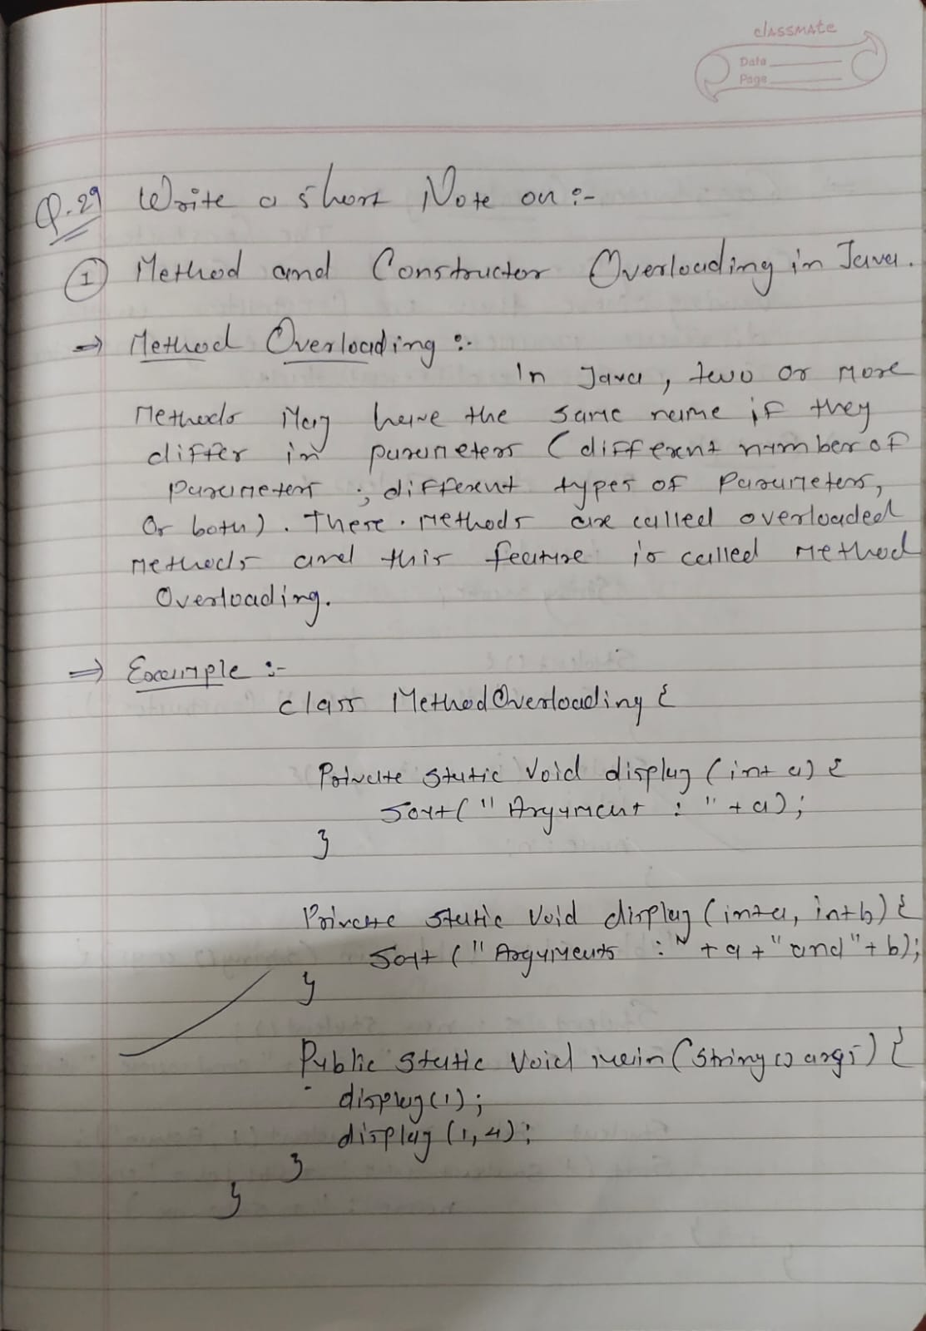
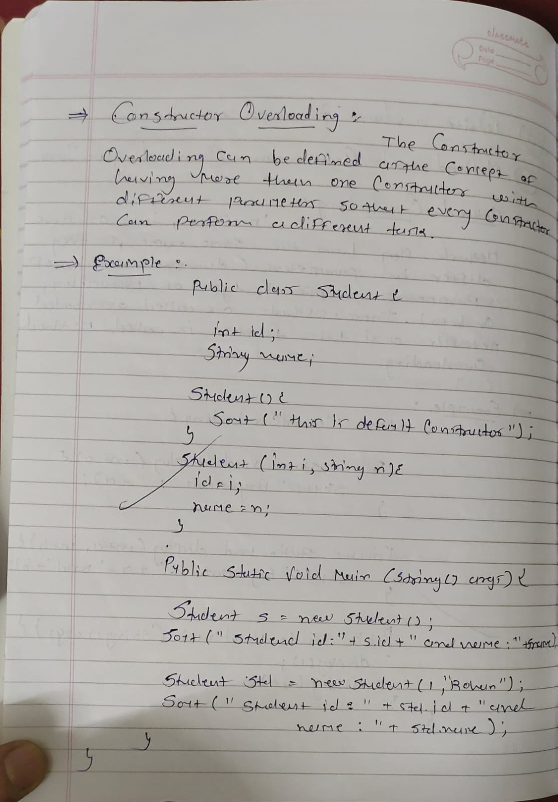

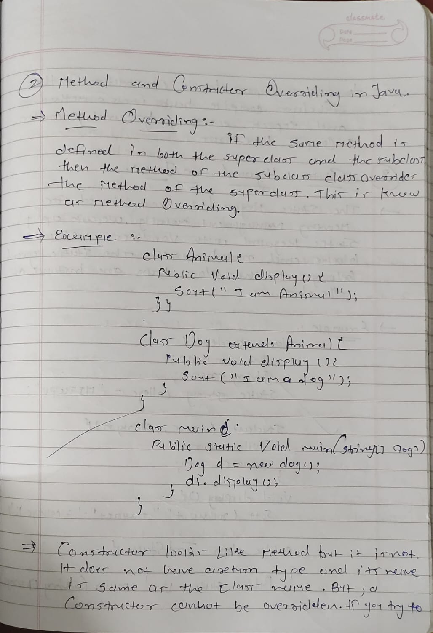
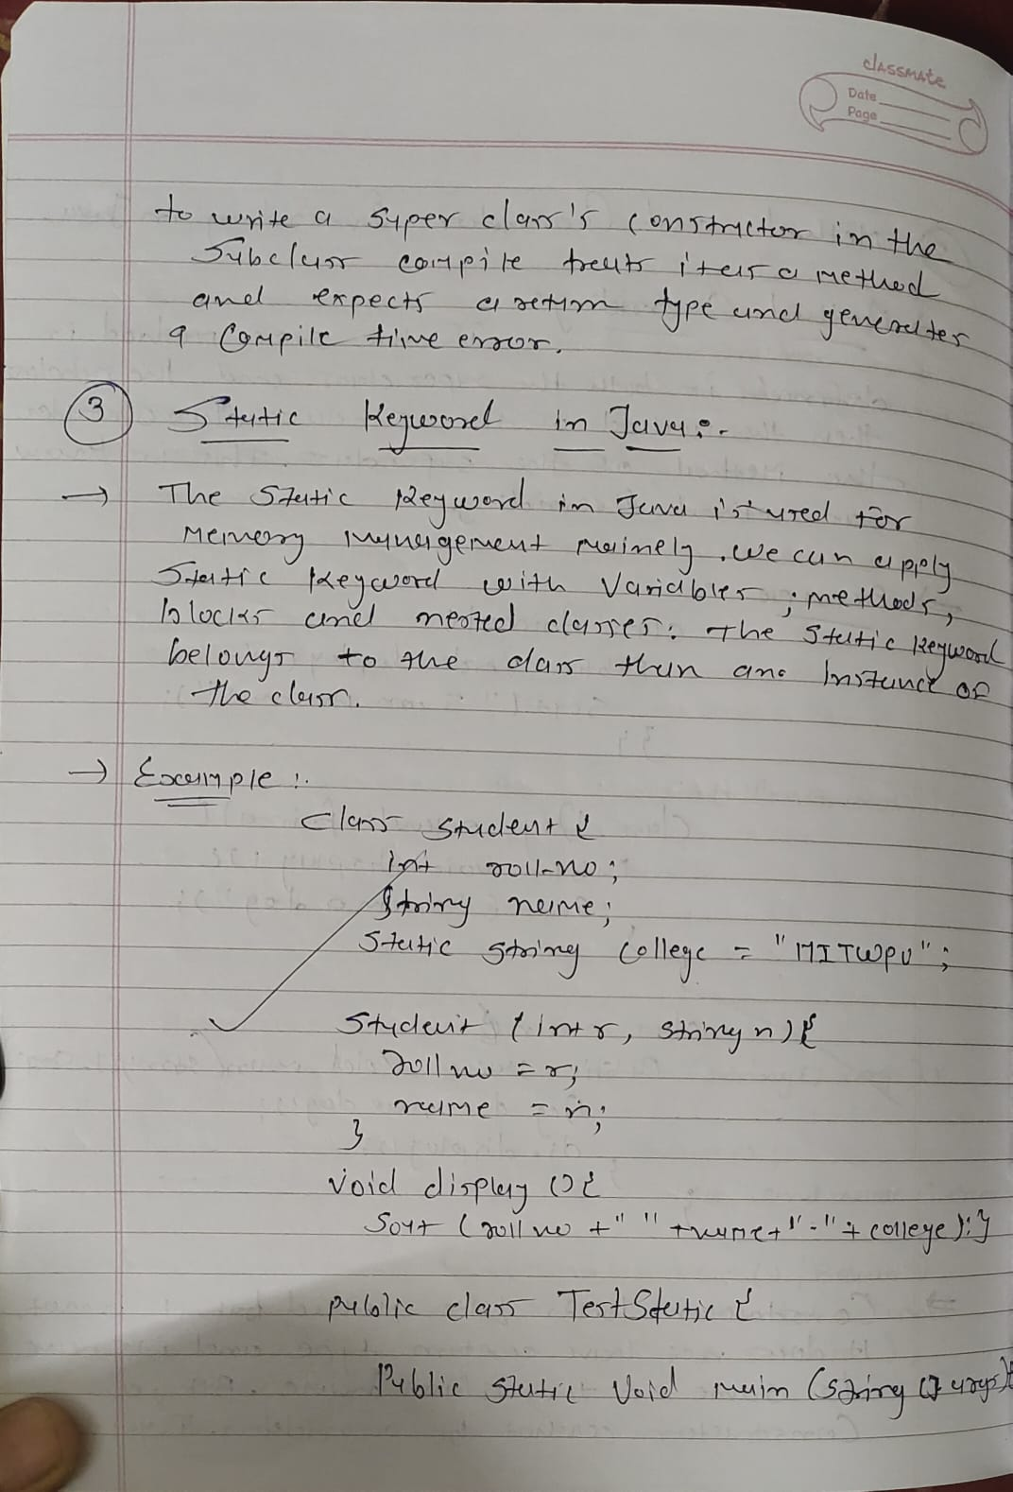
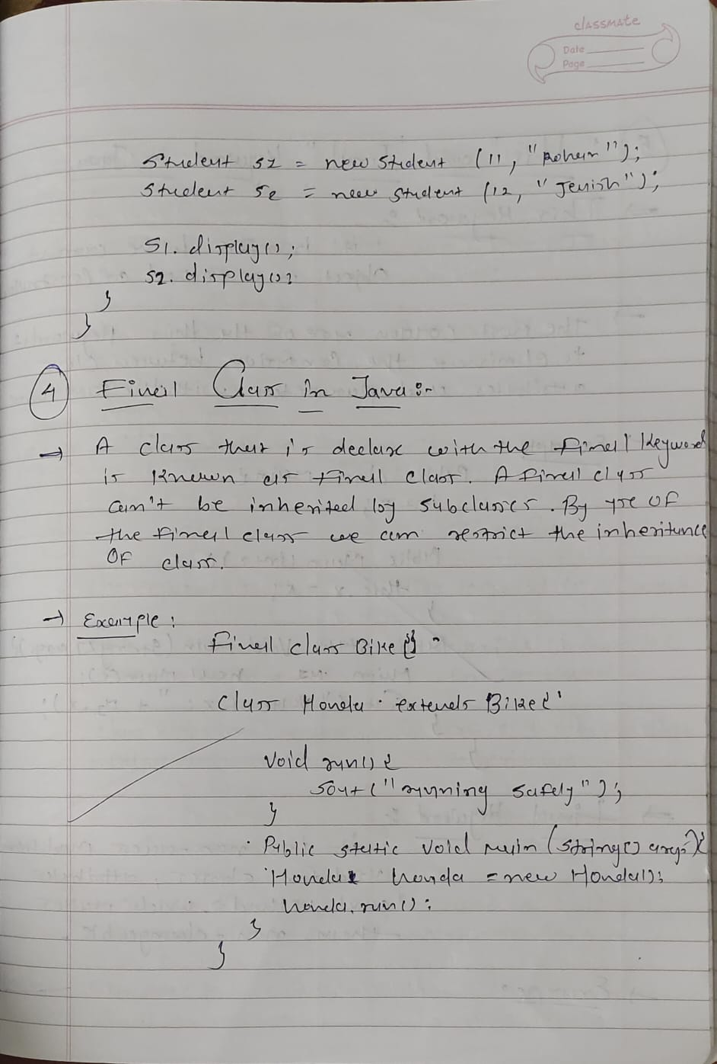
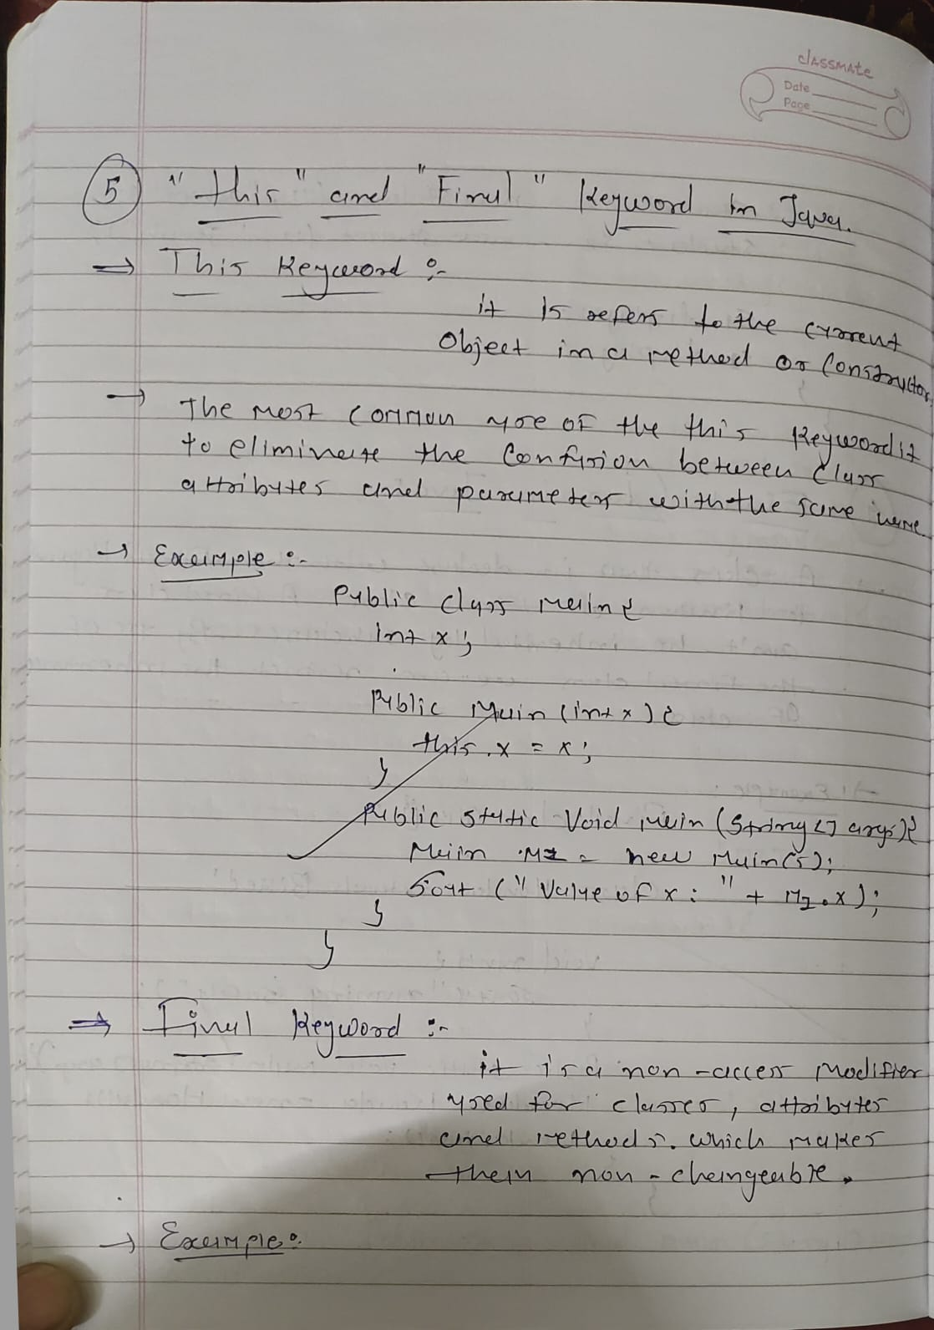
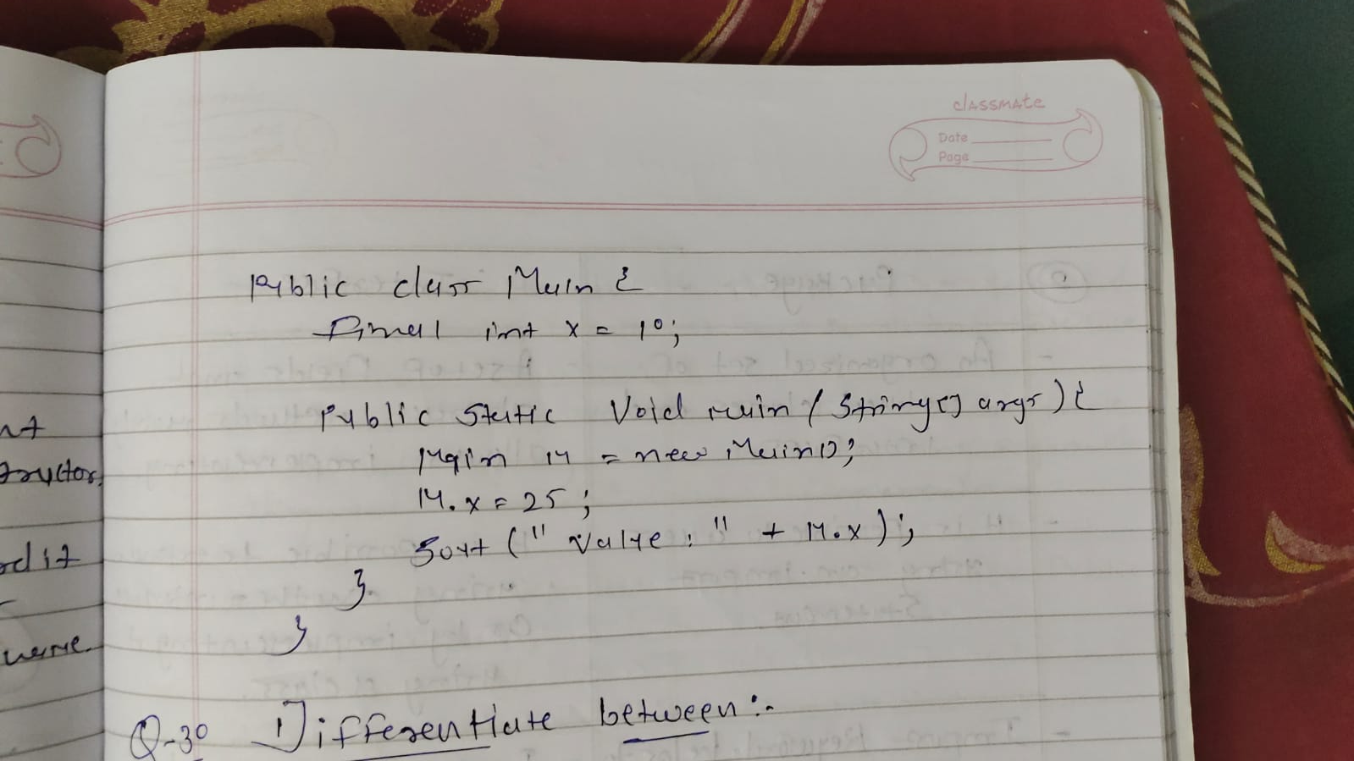

Q – 30) Differentiate between:
1.Class and Interface
2.Interface and Package
3.Abstract Class and Interface

