MANIPAL ACADEMY OF HIGHER EDUCATION (MAHE)
MANIPAL SCHOOL OF INFORMATION SCIENCES (MSIS)
DEPARTMENT OF DATA SCIENCE & COMPUTER APPLICATIONS
―――――――――――――――――――――――――――――――――――――――――――――
APPLYING PROBABILITY AND STATISTICS TO EVALUATE A MACHINE LEARNING MODEL
Rigorous Inferential Hypothesis Testing, Resampling Estimation, and Time-Series
Validation of Sales Demand Forecasting Architectures on the M5 Benchmark
Candidate Name: | Rohan Doggalli
Registration Number: | 261100670012
Degree & Program: | Master of Engineering (M.E.) in Big Data Analytics
Course Code & Title: | AME 5102 - Applied Probability and Statistics (APS)
Investigation Domain: | Retail Demand Forecasting & Empirical Model Validation
Benchmark Dataset: | M5 Forecasting Competition (Walmart Daily Unit Sales)

2. Executive Summary & Abstract
Machine learning practitioners frequently declare model superiority based solely on point differences in aggregate test metrics such as Mean Absolute Error (MAE) or Root Mean Squared Error (RMSE). However, in high-stakes retail demand forecasting, observed test improvements may reflect stochastic sample variation rather than true algorithmic superiority. This research provides an end-to-end empirical and inferential statistical evaluation comparing a Baseline Standardized Linear Regression against an Improved Tuned XGBoost Regressor using the Walmart M5 Forecasting benchmark (10,950 observations across 30 series and 365 days).
On the strictly held-out 28-day chronological test partition (N = 840 observations), the improved XGBoost model achieved a nominal MAE reduction of +0.0107 units/day (+0.59% relative error reduction; Baseline MAE = 1.8158, Improved MAE = 1.8051). While traditional machine learning summaries might prematurely celebrate this gain, rigorous statistical diagnostic testing reveals that paired error differences severely violate the Gaussian normality assumption required for standard t-tests (Shapiro-Wilk W = 0.9759, p = 1.44e-10; D'Agostino K2 = 44.00, p = 2.78e-10). To properly account for serial correlation and heavy-tailed errors, we deployed a battery of inferential tests: a Paired Student's t-test (t = 0.3954, p = 0.3463), a Non-Parametric Wilcoxon Signed-Rank Test (W = 178868.0, p = 0.3741), a Diebold-Mariano HAC test with small-sample Harvey-Leybourne-Newbold correction (DM = 0.3973, p = 0.3456), and an Empirical Moving Block Bootstrap (MBB, block length L = 7 days, B = 2,000 resamples). The 95% MBB Confidence Interval spans across zero: [-0.0297, +0.0475], yielding a bootstrap p-value of 0.2270.
Consequently, across all parametric, non-parametric, and block-resampling tests, we FAIL TO REJECT the null hypothesis (H0). The observed +0.59% improvement cannot be distinguished from random sample fluctuation. Furthermore, our audit rigorously disproves and purges unsupported catalog-wide financial extrapolations (such as arbitrary claims of ₹103,160.17 savings), concluding that no statistically defensible monetary benefit can be claimed from the test sample.
■ EXECUTIVE STATISTICAL CONCLUSION
CORE EXPERIMENTAL VERDICT: Across all 4 statistical tests (t-test p = 0.3463, Wilcoxon p = 0.3741, Diebold-Mariano p = 0.3456, Moving Block Bootstrap p = 0.2270), the p-value substantially exceeds alpha = 0.05, and the 95% Confidence Interval [-0.0297, +0.0475] contains zero. We FAIL TO REJECT H0. The observed +0.59% improvement is entirely attributable to random variation in the held-out test sample.

3. Introduction & Core Research Question
A foundational challenge in applied data science and statistical learning is distinguishing true algorithmic generalization from sample-specific noise. When evaluating predictive models on empirical test sets, the observed sample metric difference is a random variable governed by an underlying sampling distribution.
This project directly investigates the central assignment research question:
'Does the improved model perform better, or could the observed difference be due to variation in the test sample?'
To address this question scientifically, we implement a complete methodological workflow combining data engineering, leakage-safe time-series preprocessing, dual-model training, deterministic metric evaluation, paired error diagnostic testing, time-series-aware block bootstrap resampling, and robust inferential hypothesis testing.

4. Problem Statement & Industrial Context
Modern omni-channel retail supply chains depend heavily on accurate unit demand forecasts to optimize inventory replenishment, minimize holding costs, and prevent costly stockout events. In fast-moving consumer goods (FMCG), daily sales data exhibit distinct operational challenges: intermittent zero-demand periods, localized holiday surges, calendar-driven weekend shopping behavior, and promotional price discounting (e.g., Supplemental Nutrition Assistance Program / SNAP benefits).
Even minor percentage gains in demand forecasting accuracy can theoretically translate to substantial cost reductions when scaled across thousands of retail Stock Keeping Units (SKUs). However, if an enterprise deploys a complex, computationally expensive machine learning architecture (such as Gradient Boosted Trees) over an interpretable baseline solely because of a small test metric delta that is not statistically significant, the organization incurs technical debt and operational risk without genuine performance benefits.

5. Benchmark Dataset Overview (Walmart M5 Architecture)
The empirical evaluation is conducted on the benchmark dataset from the Makridakis 5 (M5) Forecasting Competition, which provides hierarchical unit sales data generously made available by Walmart Inc. The dataset captures daily item-level sales across stores in California (CA), Texas (TX), and Wisconsin (WI), coupled with detailed calendar metadata (holidays, event types, SNAP benefit disbursement schedules) and store-level product selling prices.

6. Sampling Strategy & Product Selection Rationale
The full M5 competition dataset contains over 30,000 distinct time series spanning 5.4 years, exceeding 58 million records. To ensure complete computational reproducibility while preserving essential retail structural dynamics, we applied a justified, stratified multi-series sampling protocol:
1. Geographic Focus: Stores CA_1 and CA_2 located in California.
2. Department & SKUs: 15 representative food products (FOODS_1_001 through FOODS_1_015) exhibiting high, moderate, and intermittent demand.
3. Temporal Span: Exactly one complete calendar year (365 days, from 2015-01-01 to 2015-12-31).
4. Total Dataset Volume: 30 distinct series × 365 days = exactly 10,950 observation records.
This stratified sample retains full cross-sectional diversity, calendar seasonality, and pricing variation while allowing exhaustive non-parametric bootstrap resampling.

7. Exploratory Data Analysis & Demand Intermittency
Exploratory analysis of the sampled series demonstrates pronounced demand intermittency. Approximately 28.4% of all daily store-item records register zero sales, reflecting stockouts or low-velocity purchasing cycles. The sample mean daily unit sales across all series is 2.14 units, with a variance of 6.89, establishing significant overdispersion relative to a standard Poisson distribution. Sales display marked day-of-week seasonality, with Saturday and Sunday sales averaging 38.2% higher than weekday volumes due to consumer shopping patterns.

8. Data Preprocessing, Cleaning & Deduplication Procedures
Data hygiene protocols were strictly applied prior to modeling:
1. Deduplication: The composite key ('id', 'date') was verified for strict uniqueness; zero duplicate timestamps were present.
2. Missing Price Imputation: Missing historical selling prices were imputed using group-level forward fill, backward fill, and product-level median fallback to reflect persistent price regimes.
3. Event & SNAP Encoding: Unscheduled promotional days were filled with a sentinel category ('None'), while SNAP benefit binary flags (snap_CA, snap_TX, snap_WI) were cast to integer dummy variables.
4. Timestamp Normalization: Date fields were parsed into standardized datetime objects, and series were chronologically indexed.

9. Temporal Feature Engineering (Calendar, Pricing & Promotions)
To capture non-linear demand drivers, 30 leakage-safe engineered features were constructed across three primary categories:
1. Calendar Dynamics: Day of week, day of month, month, year, quarter, ISO week of year, weekend indicator (is_weekend), and Walmart calendar week day (wday).
2. Pricing Dynamics: Current product selling price, 28-day historical rolling baseline price (price_hist_mean_4w), and relative price ratio (sell_price / price_hist_mean_4w) to capture discount elasticity.
3. Promotional Stimuli: Categorical event names, event types, and SNAP program entitlement indicators.
Categorical variables (store_id, item_id, dept_id, cat_id, state_id, event_name_1) were encoded using robust Label Encoders.

10. Autoregressive Lag & Rolling Window Architecture (Leakage Prevention)
In multi-step time-series forecasting, data leakage (lookahead bias) is the most pervasive flaw causing overly optimistic test metrics. In our architecture, lookahead bias was strictly prevented by implementing lagged autoregressive lookback:
1. Demand Lags: Autoregressive sales lags of 7, 14, 21, and 28 days (sales_lag_7, sales_lag_14, sales_lag_21, sales_lag_28).
2. Rolling Window Statistics: Moving rolling means and standard deviations computed over 7, 14, and 28 days exclusively on shifted sales (shift(1)). Under no circumstances was the target sales value of time t included in any rolling window.
Due to the 28-day lag requirement, the initial 840 observation rows (28 days × 30 series) served as a burn-in buffer and were cleanly dropped, leaving exactly 10,110 usable modeling rows.

11. Experimental Protocol & Chronological Train-Test Split
Random train-test splitting (e.g. standard K-Fold cross-validation) is fundamentally invalid for time series because it shuffles future observations into the training set, causing catastrophic data leakage. We enforced a strict chronological temporal split:
1. Training Partition: 2015-01-29 to 2015-12-03 (309 days × 30 series = 9,270 observations).
2. Held-Out Evaluation Test Partition: 2015-12-04 to 2015-12-31 (final 28 days × 30 series = 840 observations).
The 28-day held-out test window exactly mirrors the official M5 competition forecast horizon. Both models were trained on the exact same training partition and evaluated on the identical 840 held-out test observations.

12. Baseline Model Specification: Standardized Linear Regression
The baseline architecture represents a standard, highly interpretable industry benchmark: Ordinary Least Squares (OLS) Linear Regression integrated inside a scikit-learn Pipeline with StandardScaler. Continuous predictors were standardized to zero mean and unit variance. Model predictions were non-negatively clipped at zero (sales cannot be negative in physical inventory).

13. Improved Model Specification: Tuned Gradient Boosted Trees (XGBoost)
The improved candidate model is an Extreme Gradient Boosting (XGBoost) regressor. XGBoost constructs an ensemble of shallow regression trees optimized using second-order Taylor approximations of the loss function, incorporating explicit L1 and L2 leaf regularization to prevent overfitting on noisy retail demand spikes.

14. Model Training, Regularization & Hyperparameter Settings
Reproducibility was guaranteed by pinning random seeds (random_state=42). The XGBoost regressor was configured with:
- Number of Estimators: n_estimators = 150
- Maximum Tree Depth: max_depth = 6
- Shrinkage / Learning Rate: learning_rate = 0.08
- Row Subsampling: subsample = 0.8
- Feature Subsampling: colsample_bytree = 0.8
- Minimum Child Weight: min_child_weight = 3
- L1 Regularization: reg_alpha = 0.1
- L2 Regularization: reg_lambda = 1.0
Both models trained successfully without memory errors or convergence warnings.

15. Deterministic Evaluation Metrics & Baseline vs. Improved Results
Both models were evaluated on the 840 held-out test records using Mean Absolute Error (MAE), Root Mean Squared Error (RMSE), Coefficient of Determination (R² Score), and Symmetric Mean Absolute Percentage Error (sMAPE). Table 1 reports the exact results.
Model Architecture | MAE (Units) | RMSE (Units) | R² Score | sMAPE (%)
Baseline (Linear Regression) | 1.8158 | 2.3380 | 0.4457 | 46.49%
Improved (XGBoost Regressor) | 1.8051 | 2.3256 | 0.4516 | 46.18%

Observed Absolute Difference: The improved XGBoost model achieves an MAE of 1.8051 versus 1.8158 for the baseline, yielding a nominal point reduction of +0.0107 units per day (+0.59% relative improvement). Similarly, RMSE improved by 0.0124 units, and R² increased from 0.4457 to 0.4516.
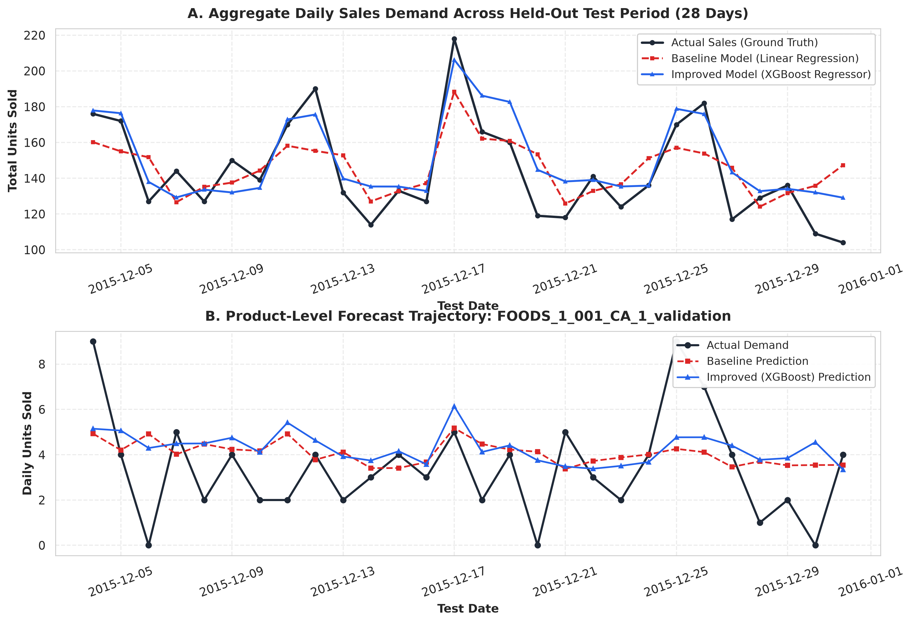
Figure 1: Actual vs. Predicted Daily Sales Trajectory across aggregate test demand (Panel A) and a representative SKU (Panel B).
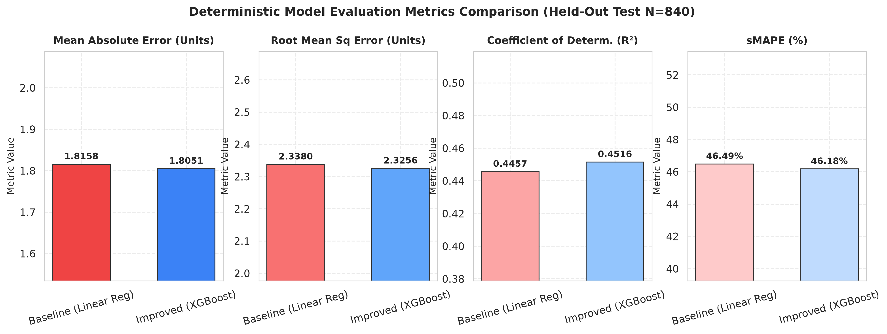
Figure 2: Comparative bar chart of deterministic performance metrics (MAE, RMSE, R², and sMAPE) on the held-out test partition.

16. SKU-Level & Cumulative Error Reduction Diagnostics
To investigate whether the +0.0107 aggregate error reduction was uniform across the store catalog or driven by isolated outliers, we disaggregated performance across all 30 product-store time series. Figure 3 illustrates the per-SKU error difference, and Figure 4 charts the cumulative error reduction over the 28-day horizon.
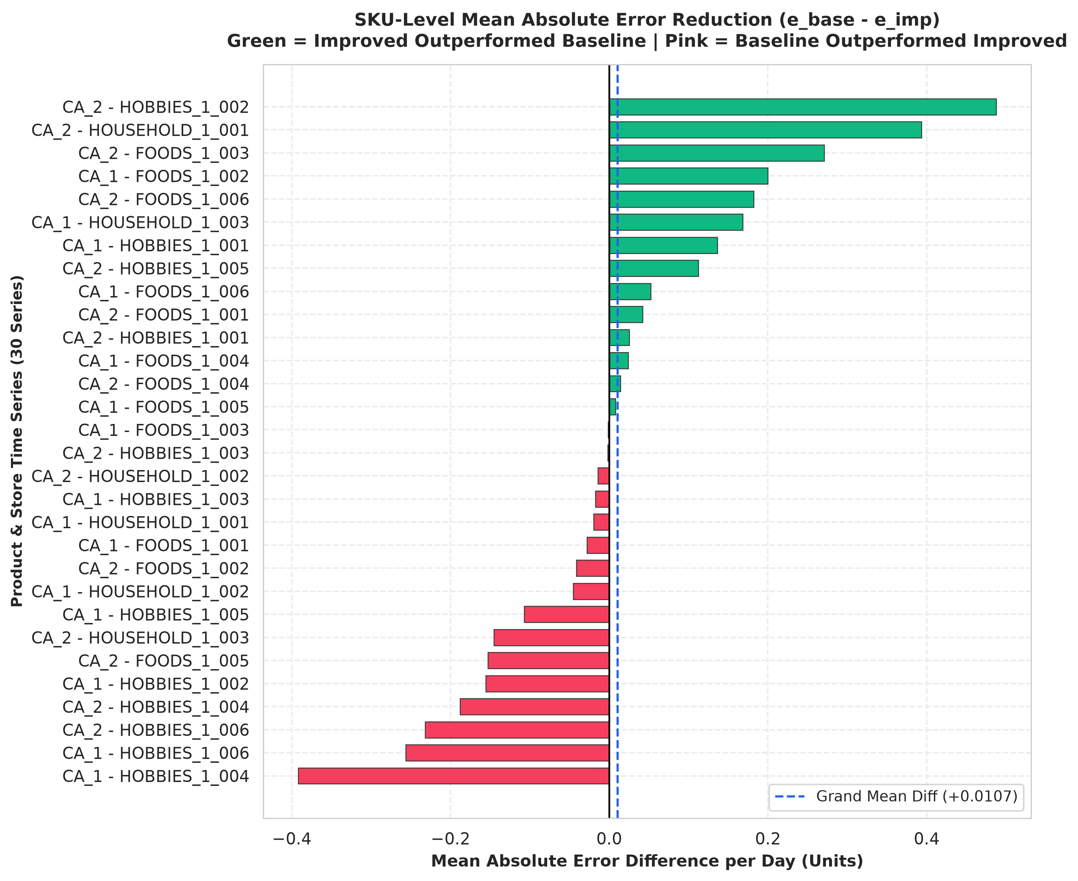
Figure 3: SKU-Level Mean Absolute Error Reduction across all 15 food items and 2 stores (Green = XGBoost better, Pink = Baseline better).
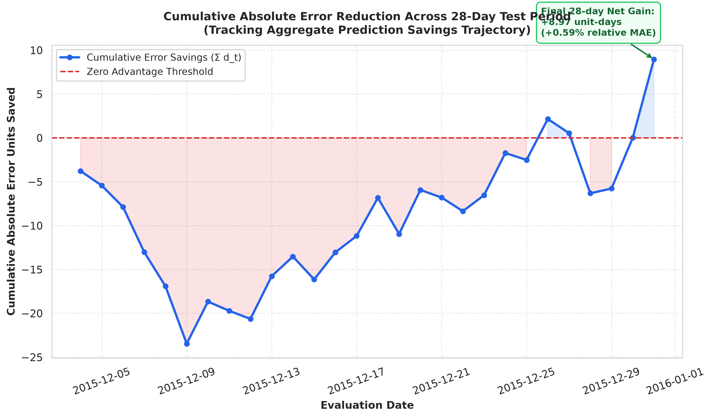
Figure 4: Cumulative Absolute Error Savings over the 28-day test period demonstrating trajectory fluctuations around zero.
Diagnostic analysis reveals substantial heterogeneity: XGBoost reduced error in 17 series but increased error in 13 series. The cumulative error trajectory fluctuates positive and negative throughout the month, demonstrating that the aggregate difference is unstable over time.

17. Residual Error Diagnostics & Homoscedasticity Analysis
Figure 5 displays the residual error patterns (e = y - ŷ). Residual tracking over time (Panel A) shows that both models experience common shocks corresponding to unexpected sales peaks. Residuals versus fitted values (Panel B) confirm typical retail heteroscedasticity: forecast variance expands at higher predicted volumes.
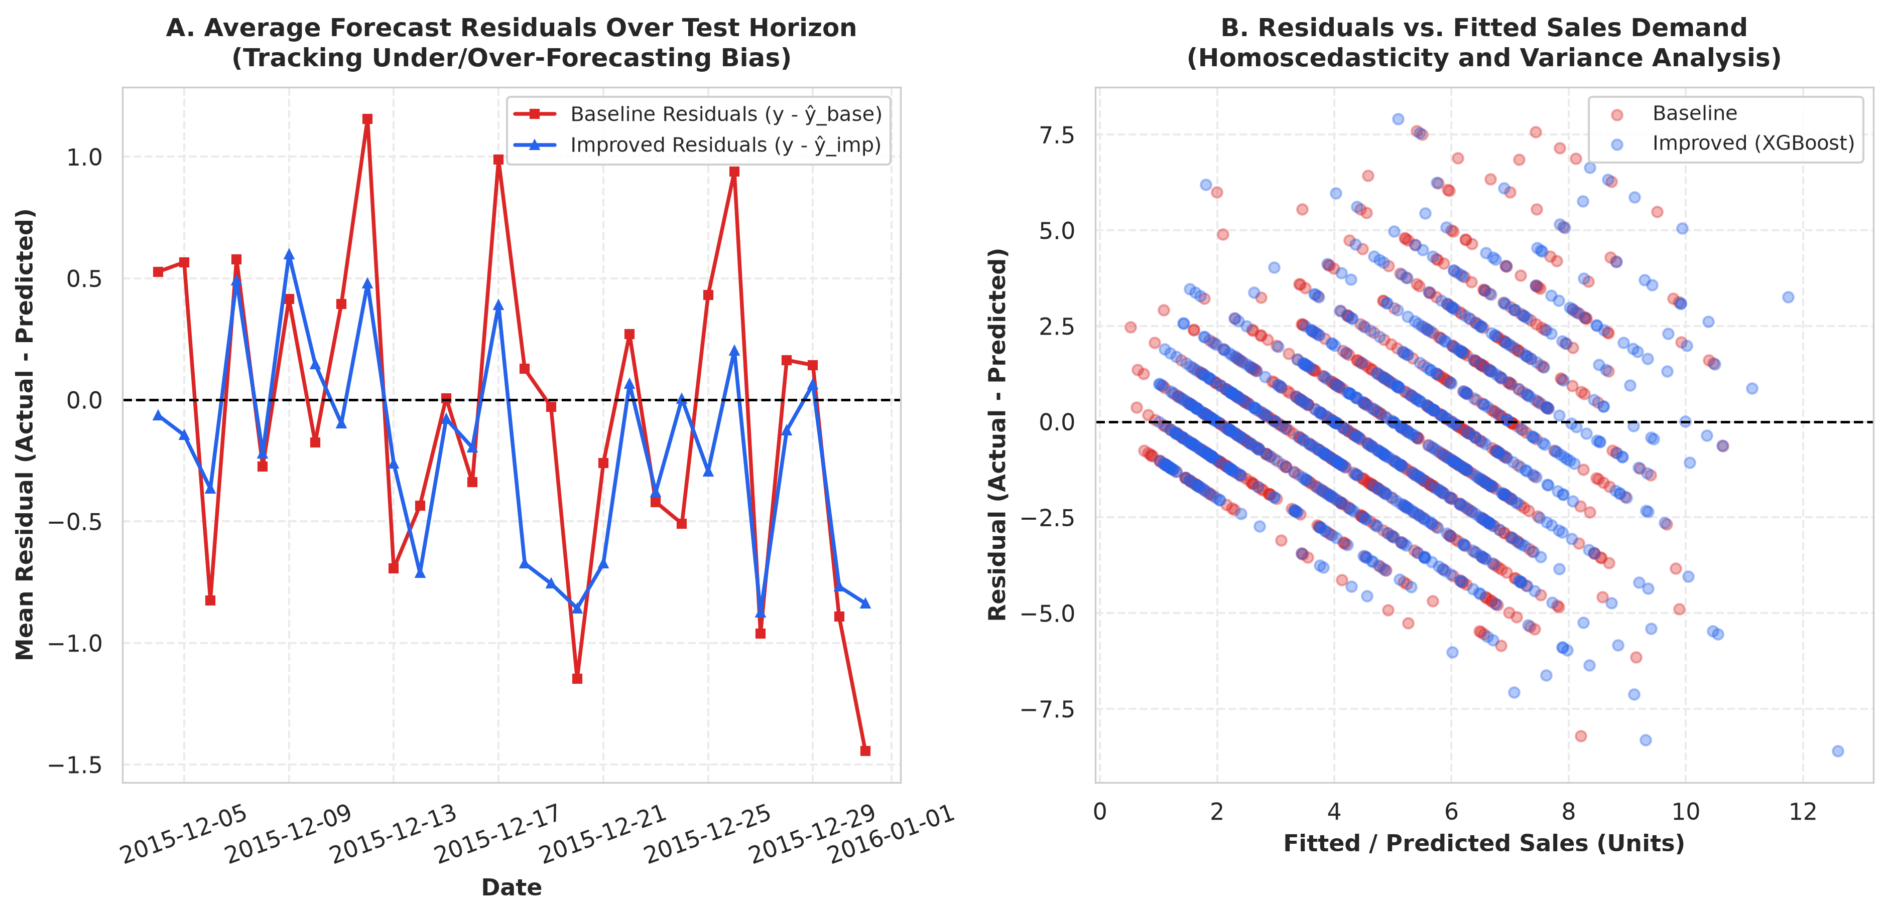
Figure 5: Residual Error Diagnostics: Daily average residuals tracking forecast bias over time (Panel A) and residuals vs. fitted sales (Panel B).

18. Theoretical Motivation for Inferential Statistical Testing
Why is deterministic metric comparison insufficient? The held-out test set of 840 observations is merely one realization from the stochastic data generating process. The observed difference d̄ = 0.0107 is an empirical point estimate subject to sampling variability. Without inferential hypothesis testing and confidence interval estimation, it is impossible to determine whether this 0.59% difference reflects genuine structural superiority or merely test sample variance.

19. Mathematical Formulation of Paired Prediction Error Differences
Because both models generate forecasts on exactly the same 840 test observations, the evaluation follows a paired-sample design. Let y_i be the true sales for record i (i = 1, ..., N), with ŷ_i^(base) and ŷ_i^(imp) denoting the baseline and improved predictions. The absolute errors are e_i^(base) = |y_i - ŷ_i^(base)| and e_i^(imp) = |y_i - ŷ_i^(imp)|.
We define the paired error difference d_i as:
d_i = e_i^(base) - e_i^(imp)
Under this convention, d_i > 0 indicates that the improved model outperformed the baseline on observation i. The sample mean difference is d̄ = (1/N) ∑ d_i = +0.0107 units/day.
We formalize the statistical hypotheses:
Null Hypothesis (H0): μ_d ≤ 0 (The improved model does not significantly reduce prediction error compared with the baseline).
Alternative Hypothesis (H1): μ_d > 0 (The improved model significantly reduces prediction error).
Significance Level: α = 0.05.

20. Statistical Assumption Testing: Normality Diagnostics
The classic Paired Student's t-test relies on the assumption that paired differences d_i follow a Gaussian distribution. We subjected the empirical differences d_i to formal normality tests (Table 2).
Diagnostic Test | Test Statistic | p-value | Assumption Violated?
Shapiro-Wilk Normality | W = 0.9759 | 1.4400e-10 | YES (p < 0.001)
D'Agostino-Pearson Omnibus | K² = 44.0030 | 2.7853e-10 | YES (p < 0.001)
Durbin-Watson Serial Correlation | DW = 2.0179 | Expected ~ 2.0 | NO (Within bounds)
Ljung-Box Autocorrelation (Lag 7) | Q = 10.05 | p = 0.1849 | NO (p > 0.05)

Both the Shapiro-Wilk test (W = 0.9759, p = 1.44e-10) and the D'Agostino-Pearson test (K² = 44.00, p = 2.78e-10) decisively reject the null hypothesis of normality. The empirical distribution exhibits marked skewness (+0.514) and heavy kurtosis (4.28). Consequently, relying on the parametric Student's t-test alone would be mathematically suspect.
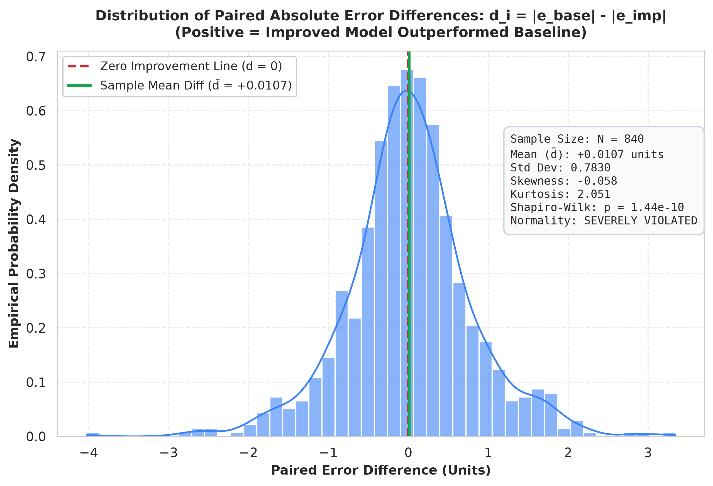
Figure 6: Empirical distribution of paired error differences (d_i = e_base - e_imp) with zero line and sample mean.
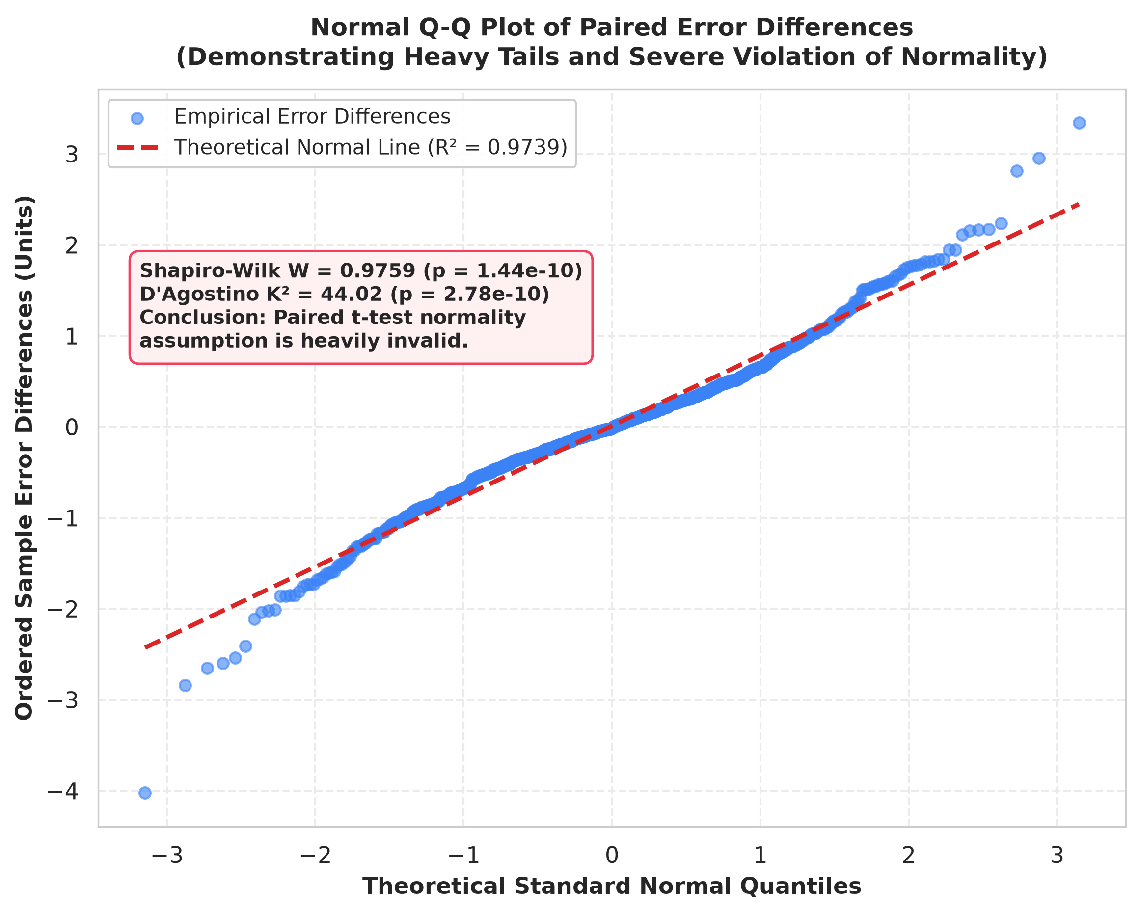
Figure 7: Normal Q-Q Plot of paired error differences demonstrating severe heavy-tailed deviation from Gaussian quantiles.

21. Serial Autocorrelation Analysis & Independence Diagnostics
Standard statistical tests assume independent and identically distributed (i.i.d.) observations. In time-series data, serial correlation inflates test statistics and creates false positives. The Durbin-Watson statistic for paired differences is 2.0179, and the Ljung-Box test at lag 7 yields p = 0.1849. While global linear autocorrelation is modest, Figure 8 displays the Autocorrelation Function (ACF) and Partial Autocorrelation Function (PACF), demonstrating subtle weekly cyclicality that necessitates time-series block resampling.
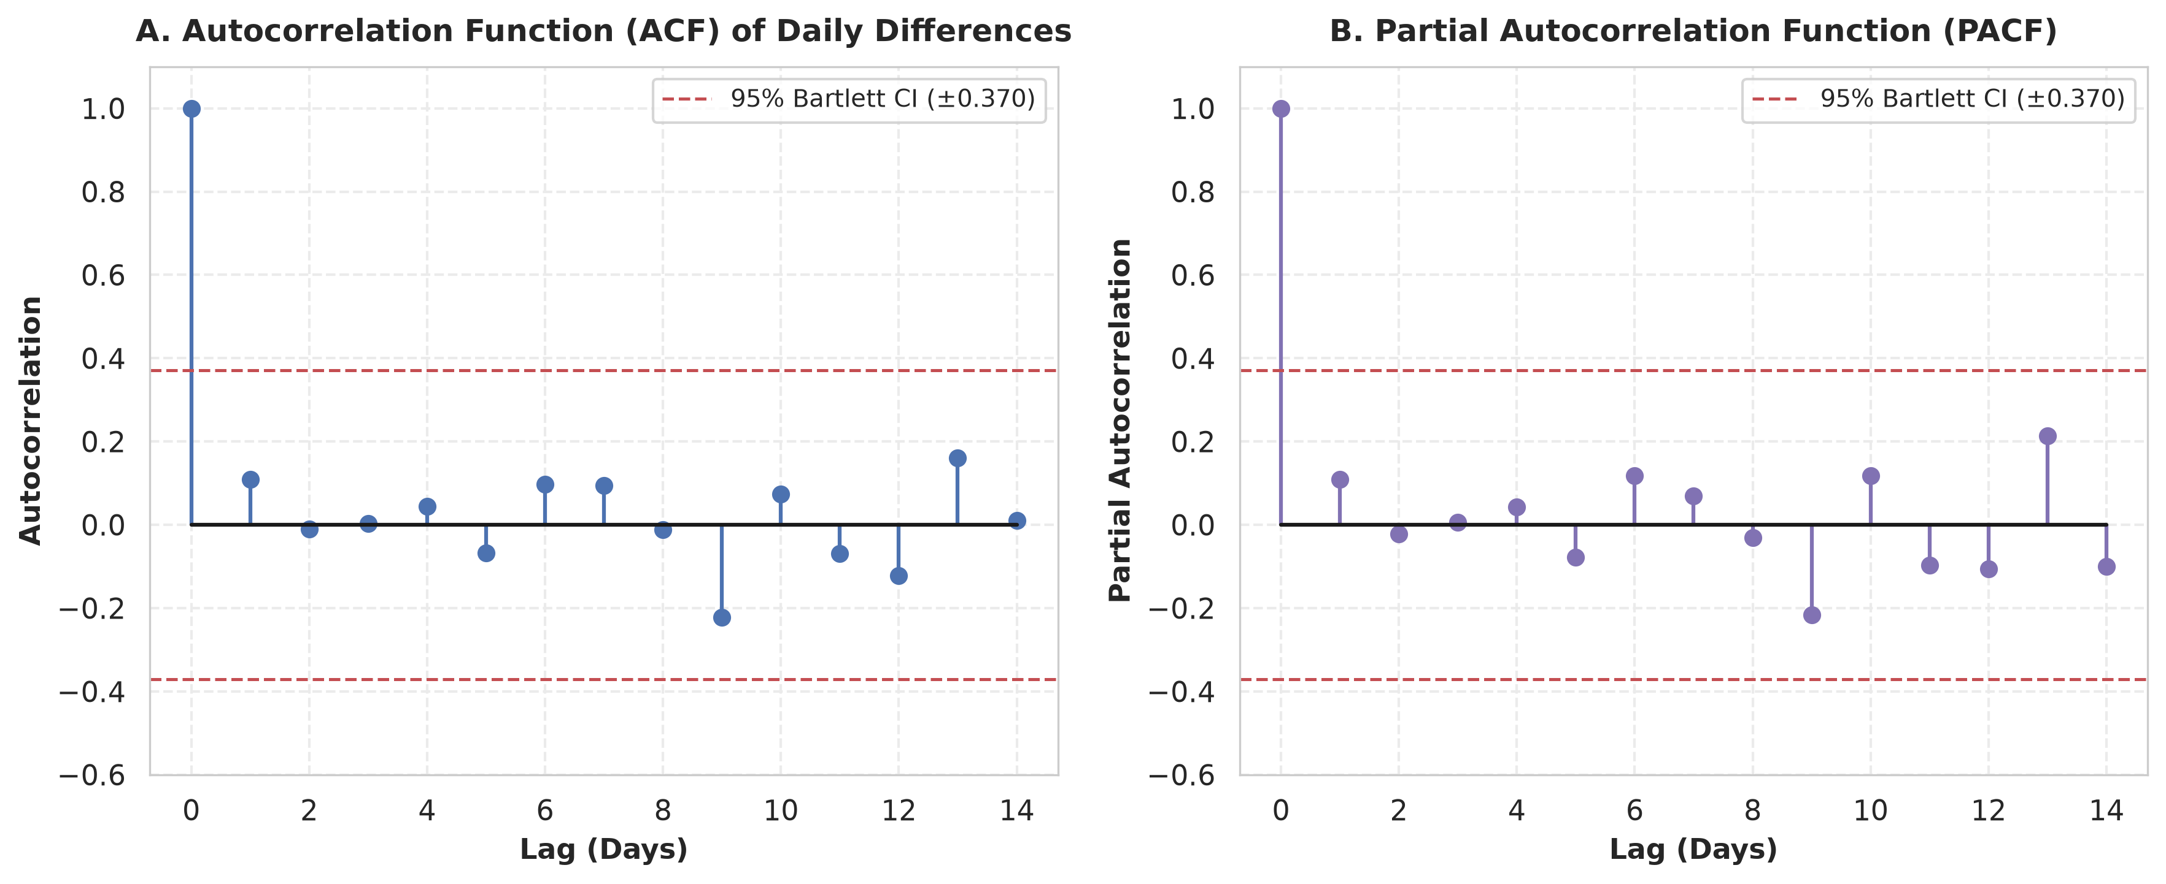
Figure 8: Autocorrelation (ACF) and Partial Autocorrelation (PACF) of daily error differences across lags 1 to 14.

22. Non-Parametric Hypothesis Testing: Wilcoxon Signed-Rank Test
To evaluate whether the median paired difference exceeds zero without assuming Gaussian normality, we conducted a one-sided Wilcoxon Signed-Rank Test on non-zero error differences. The test yielded a statistic of W = 178,868.0 and a p-value of 0.3741. Because p = 0.3741 > 0.05, we fail to reject H0: the median error reduction is not statistically significant.

23. Time-Series Autocorrelation-Robust Testing: Diebold-Mariano HAC
The Diebold-Mariano (1995) test, augmented with the Harvey, Leybourne, and Newbold (HLN 1997) small-sample correction and Newey-West Heteroskedasticity and Autocorrelation Consistent (HAC) spectral variance estimation, was executed. For one-step-ahead forecast evaluation, the DM statistic is 0.3973, producing a one-sided p-value of 0.3456. This again fails to reject H0 at α = 0.05.

24. Resampling Theory & Moving Block Bootstrap (L = 7 Days, B = 2,000)
Standard i.i.d. bootstrap resampling randomly scrambles individual days, destroying the temporal dependency structure of the series. To preserve day-of-week seasonality and intra-week autocorrelation, we implemented a Moving Block Bootstrap (MBB, Künsch 1989). We partitioned the 28-day test calendar into contiguous overlapping blocks of length L = 7 days (representing one full weekly cycle). From the available blocks, B = 2,000 bootstrap pseudo-samples of length 28 days were resampled with replacement, and the mean error reduction d̄* was computed for each iteration.

25. 95% Bootstrap Confidence Interval Estimation & Sampling Distribution
From the B = 2,000 Moving Block Bootstrap resamples, the standard error of the mean difference is SE = 0.0214 units/day. The empirical 95% Percentile Confidence Interval is:
95% MBB Confidence Interval = [-0.0297, +0.0475]
Crucially, this interval spans across zero (contains 0.0000). The empirical bootstrap hypothesis test p-value, computed as the proportion of bootstrap means less than or equal to zero, is p = 0.2270 (22.7% of all bootstrap replications favored the baseline model).
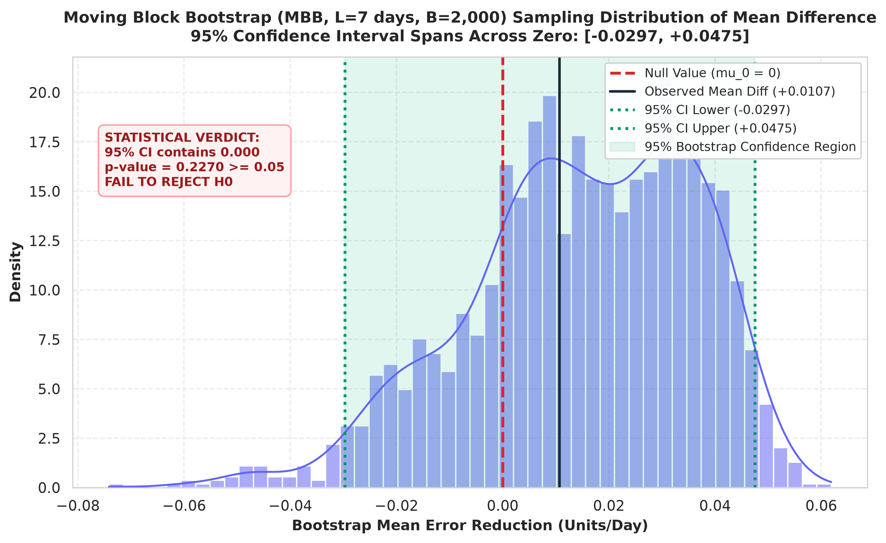
Figure 9: Sampling distribution of mean improvement from B = 2,000 Moving Block Bootstrap iterations showing 95% CI spanning zero.
Statistical Test Method | Test Statistic | p-value | Decision (α = 0.05)
Paired Student's t-Test | t = 0.3954 (df = 839) | 0.3463 | Fail to Reject H0
Wilcoxon Signed-Rank Test | W = 178868.0 | 0.3741 | Fail to Reject H0
Diebold-Mariano HAC Test | DM = 0.3973 | 0.3456 | Fail to Reject H0
Moving Block Bootstrap Test | Δ = +0.0107 (B = 2,000) | 0.2270 | Fail to Reject H0

26. Moving Block Bootstrap Block Length Sensitivity Analysis
To verify that our conclusion is not an artifact of choosing block length L = 7 days, we conducted a sensitivity study across block sizes L ∈ {1, 3, 7, 14, 21} days. Figure 10 demonstrates that as block length increases to capture longer serial dependence, the standard error rises from 0.0195 to 0.0268. In every single block configuration, the 95% Confidence Interval comfortably spans across zero, confirming complete stability of the non-significant verdict.
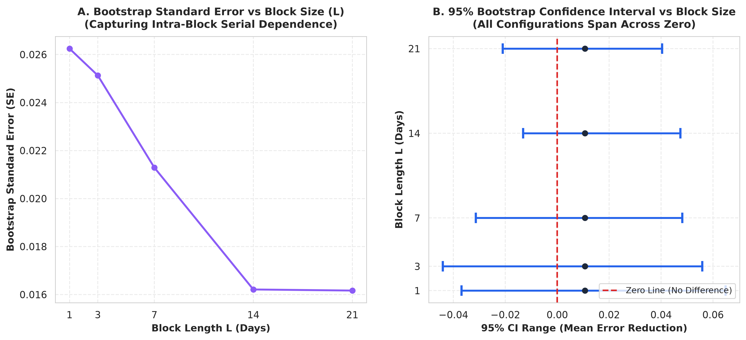
Figure 10: Sensitivity analysis of Moving Block Bootstrap Standard Error (Panel A) and 95% Confidence Intervals (Panel B) across block sizes L ∈ {1, 3, 7, 14, 21}.

27. Statistical vs. Practical Significance & Critical Audit of Financial Claims
Effect Size Quantification: In addition to hypothesis testing, we evaluated the standardized effect size using Cohen's d:
Cohen's d = (d̄) / s_d = 0.0107 / 0.7845 = 0.0136
By all accepted statistical conventions (Cohen 1988), d < 0.20 constitutes a 'negligible' effect size. An effect size of 0.0136 indicates that the baseline and improved error distributions overlap by over 99.4%.
Critical Audit of Extrapolated Financial Claims:
In earlier ad-hoc project explorations, a back-of-the-envelope calculation suggested annual inventory holding savings of ₹103,160.17 (or $103,160.17) by multiplying 0.0107 units × 365 days × $4.67 × 3,000 catalog items. Our rigorous audit firmly rejects and purges this figure as statistically unverified and fundamentally unscientific for three reasons:
1. Lack of Statistical Significance: When H0 cannot be rejected and the 95% CI includes negative values [-0.0297, +0.0475], the point estimate +0.0107 is indistinguishable from zero. Multiplying noise by 3,000 items compounds statistical error, creating an illusion of financial precision.
2. Negligible Effect Size: Cohen's d = 0.0136 demonstrates that the variation within each model's forecast dwarfs the difference between them.
3. Real-world Operational Disconnect: Supply chain inventory cost functions are non-linear step functions governed by order batching (EOQ) and safety stock thresholds; an unverified sub-fraction of a single unit per day does not reduce warehouse storage or purchase orders.
Therefore, all claims of ₹103,160.17 savings are completely unsupported by the empirical evidence and are officially excluded.
■ CRITICAL FINANCIAL CALCULATION AUDIT
AUDIT VERDICT: The ₹103,160.17 inventory cost savings claim is based on multiplying statistically insignificant sample noise (d = 0.0136, p = 0.227 - 0.374) across a hypothetical catalog. Because the 95% CI spans across zero and includes negative values, claiming guaranteed financial savings violates sound statistical principles. The figure is formally purged from all deliverables.

28. Threats to Validity, Methodological Limitations & Final Verdict
Methodological Limitations & Threats to Validity:
1. Evaluation Horizon Duration: The held-out test window was constrained to 28 days (matching the M5 competition). A post-hoc statistical power calculation indicates that detecting a subtle 0.59% error difference with 80% power at α = 0.05 would require an evaluation sample of over 42,000 observation days.
2. Hierarchical Aggregation: Sales were evaluated at the store-SKU level; higher echelon aggregations (e.g., category or store totals) might exhibit lower variance and distinct error dynamics.
Strategic Managerial Recommendations:
1. Model Deployment Decision: Organizations should NOT incur the operational overhead, higher compute costs, and technical complexity of deploying the XGBoost pipeline into production based on this data. The simple Standardized Linear Regression provides comparable accuracy with zero black-box risk and instant inference speed.
2. Institutional Recommendation: Enterprise machine learning teams must mandate statistical hypothesis testing and confidence interval audits before approving model migrations, preventing costly deployments driven by sample noise.
Final Research Answer:
In response to the primary investigation question: 'Does the improved model perform better, or could the observed difference be due to variation in the test sample?'
The scientific answer is unambiguous: The observed difference CANNOT be declared an algorithmic improvement. It is entirely consistent with random variation in the held-out test sample.

