**DOCKER TRAINING**

**Conducted by IIEC RISE 1.0**

**In this file, I am going to discuss about the project I did for the docker training conducted by IIEC RISE 1.0 and taught by the very knowledgeable Mr.Vimal Daga.**

**This project required more of social engineering part than coding part.So,I have decided to write down the steps for the same.**

**PROJECT--**

***PROJECT DESCRIPTION***:

In this project, httpd webserver is used to host a webpage on a specified port locally.

***ABOUT PROJECT***:

Docker technology is used.

We pulled a container using docker technology and hosted our webpage using httpd server.

**Command for pulling the official image**: *docker pull containername*

*You can use OS like Centos,Ubuntu for the same.*

We can run the container in detached mode.

**Command used for running the nginx container:**

*docker run -dit --name containername -p port:portnumber -v /root/iiec_docker:volumelocation*

-dit are flags that specify that the container will run in detached mode and will have an interactive terminal.

--name is the used for giving a suitable name to the container.

-p is to specify and expose the port we want to host the page on.

-v specifies the volume. It means we are providing the container the content of the folder /root/iiec_docker to the **default document root** of the volume folder.

After starting the container, we can see our hosted page by going to any browser and providing the IP Address of the host machine along with the port number.

Example: If IP is 192.168.0.162 and port number is 1122, the typing the following in the URL tab will show the page:

192.168.0.162:1122

Note: The machine in which you are opening the page must have **end to end connection**.

If you are viewing on your own machine where you launched the container then you can also use **localhost:1122**  to view.

Here are some snaps that will help for better understanding:

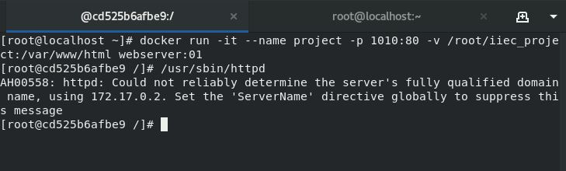

**You can see web page code using curl command-**

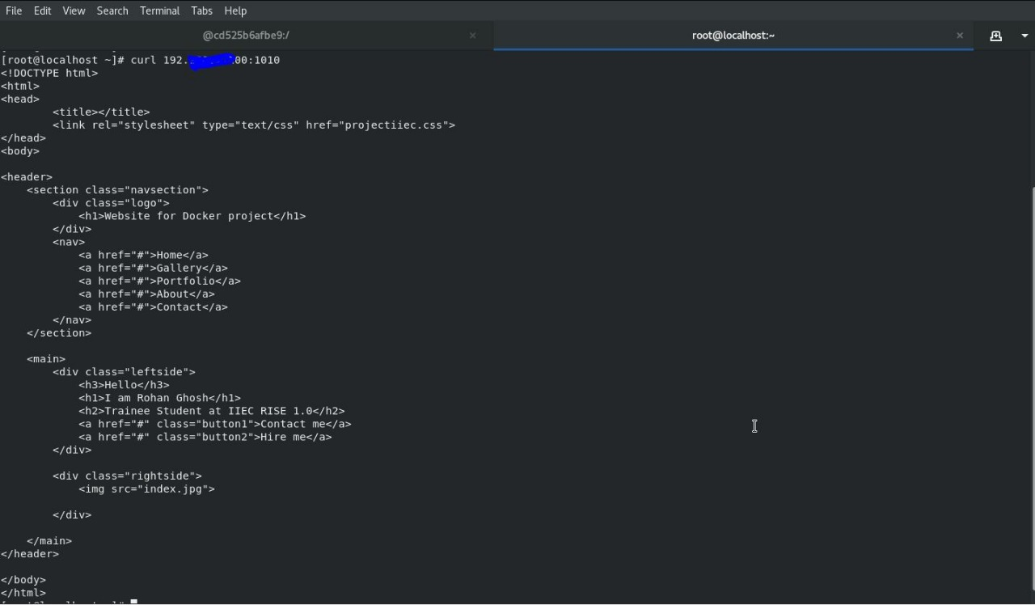

**Here is the webpage made by HTML and CSS—**

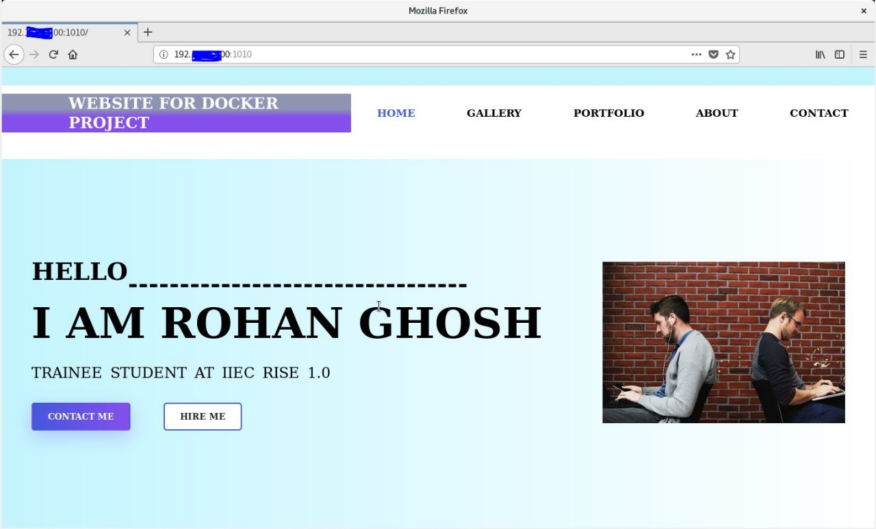

Trainee Name-Rohan Ghosh

Team-DEBUGGERS UNITED

IIEC ID-RISE 2020.44.5.3