

INSTRUCTION MANUAL

**Programming project 2020 Uni Basel**

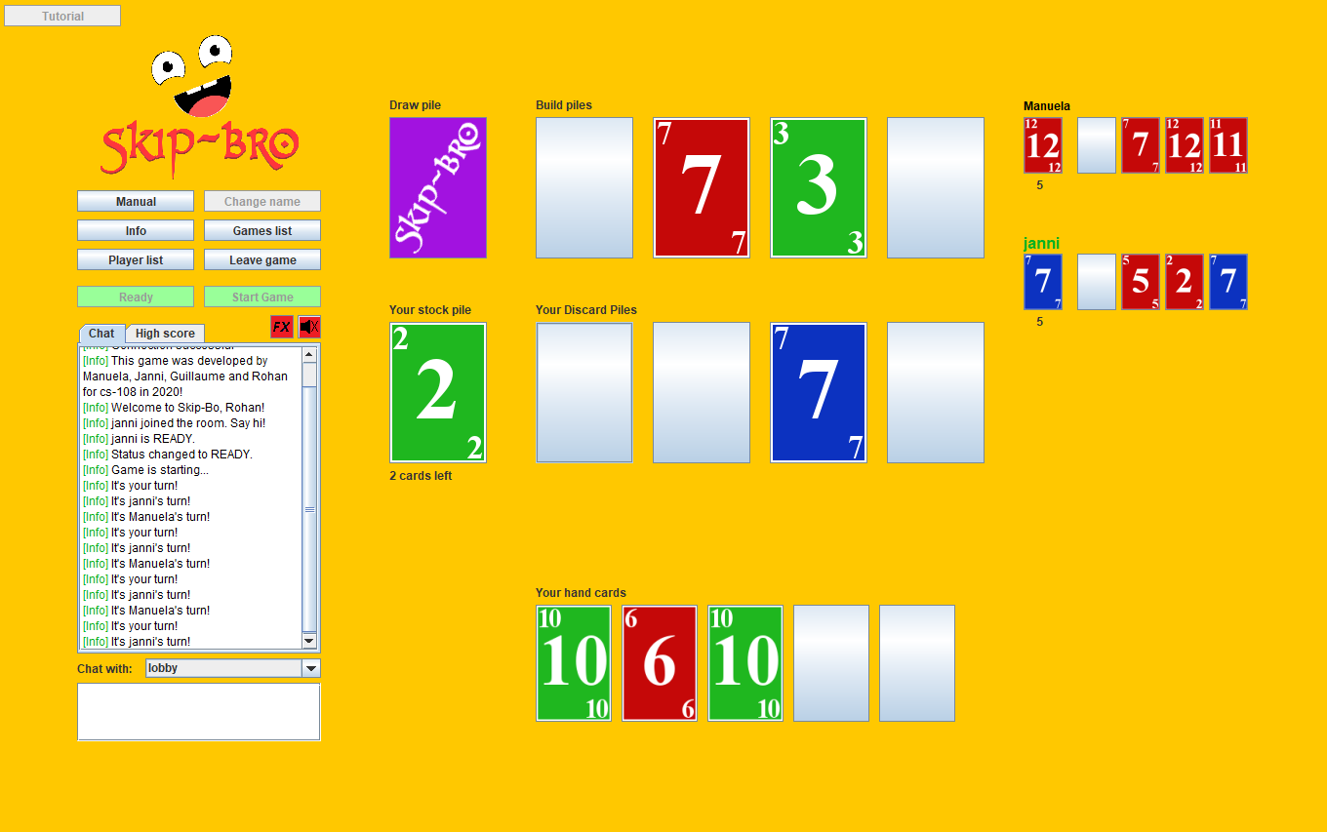

**Gruppe-15 (SKIP-BRO’S)**

**Prepared By:**

**Janni Batsilas, Rohan Girish, Guillaume Joyet, Manuela Wildi**

***Contents***

1 Overview 3

2 Content 3

3 Play Area 3

*3.1* *Different Piles* 3

4 Playing Skip-Bo 4

*4.1* *Beginning of Turn* 4

*4.2* *Playing to different piles* 4

*4.3* *End of Turn* 4

5 End of game 5

6 Commands and Buttons 5

# Overview

This implementation of *Skip-Bo* is a card game intended for two to four players. The goal of the game is to get rid of all the cards in the player’s *Stock pile.* This can be achieved by placing these cards in the middle of the board in numerical order, from 1 to 12. Though the game can be played with more than 4 players, this specific version concentrates on just 4. It is a turn-based game, which means that at any given time, there is only one specific player that can act. Only after their turn can the next player be allowed to play a card.

# Content

The game has 216 cards, ranging through the numbers 1 to 12. Each card is coloured one of three different shades – **red, blue or green.** In addition to these 216 cards, there are 27 *Skip-Bo* cards, which act as jokers. These are coloured in **cyan.** These cards can act as any other card in the deck and can be used to fill gaps. Cards of different colors can be played on top of each other.

Players receive 5 hand cards and can choose between 5, 10, 20 or 30 cards in their stock pile at the beginning of the game and the rest of the cards will be placed in the middle of the board as the *draw pile* for all players.

# Play Area

The playing area consists of space for 4 different *build piles,* and 4 discard piles for each player. In addition to these, every player also has a *stock pile*, the first card of which is turned over. The *draw pile* must also be present in the middle of the playing area, as this is where the hand cards at the start of each turn is drawn from.

## Different Piles

Build piles: There can only be a maximum of four build piles at any given time. Each build pile must be started with the card with number 1 and every following card must be a number higher. If the card with number 12 is laid on top, that particular build pile is removed from the game and can be later reshuffled into the draw pile.

Discard Piles: The discard piles are specific to each player and there are no rules as to what cards can be played to these piles. There is also a maximum of 4 discard piles per player. These piles serve as backup to play cards to the build pile, if there are no valid moves left in your hand cards or the stock pile. Only the top card from each discard pile can be played – one cannot search for a card from the discard and play it to the build pile. As soon as one card is played to the discard pile, the player’s turn ends.

*Stock pile:* This is the main pile of the game. The top card is always turned over, and this is the pile that should be emptied to win the game. All other piles can be modeled to facilitate the playing of each stock card. Only the top card can be played, but there is no limit as to how many cards can be played from the stock pile, if each card move is valid.

*Hand cards:* Players start with 5 hand cards that are visible only to them. These cards can be played to the build piles at any time but playing one of these to the discard ends the player’s turn. When all five cards are played to the build pile, the hand cards will be refilled.

# Playing Skip-Bo

As previously mentioned, the goal of *Skip-Bo* is to play all cards from the stock pile to the build piles in the middle of the board. A card can only be played to the build pile, if the card is one number higher than the card on the build pile. Cards can also be played to the player’s discard pile, which ends their turn, but grants access to that card in later turns. Cards from the hand and discard piles can be used to build piles in the way you need to play the card from the stock pile. The first player to empty their stockpile is the winner of the game.

## Beginning of Turn

At the beginning of each player’s turn, their hand cards are automatically filled up to 5 cards. They can then start playing their cards to the pile of their choice. It’s best to check the cards that are on the build pile and your stock pile, and play your hand cards accordingly, so as to facilitate the playing of the top stock card. If no valid move is allowed, the player must play a card to the discard and end their turn.

## Playing to different piles

The cards can be moved by a 2-click mechanic. By clicking on the card you wish to play, and then clicking on the pile you wish to play to. For example, to play the second card from a hand, the player would click on the second card and then click on the build pile they think the card belongs on. The game checks the validity of this move and moves the card accordingly. The network protocol processes these commands, distributes to the game accordingly and sends back whatever output the game prompts it to.

## End of Turn

The end of turn is signified by the player playing a card to their discard pile. Though there is no rule as to what card can be played to the discard pile, only one card can be played per turn, so that card must be chosen carefully!

## 

# End of game

The game ends when one player played all cards on their stock pile. Since the game can be played with different sizes of the stock pile, the score is calculated with a fair formula: The score equals the turns needed to win divided by the size of the stock pile in the beginning. Therefore lower scores are better than higher scores. If your score is one of the best 10 scores of all games, it will show up in the highscore list.

# Commands and Buttons

All necessairy actions can be initiated via buttons and is self-explanatory. If you want to be able to be pulled into a game, you need to press the “Ready” – button to change your status to “ready”. This can also be reversed by pressing the button again. With the two square buttons you can mute or unmute the background music and the sound effects. There are also two cheats that you can use via commands in the chat:

* ***/cheat joker***   
  *You get four jokers, one on each discard pile. But you will be punished with five additional cards on your stock pile. This command can only be used once.*
* ***/cheat win***

*With this command you win the game instantly but with a score of 100. In addition your name will be changed to “CHEATER” and you can’t change your name anymore. This command can also only be used once.*