RESEARCH MONOGRAPH:
THE GREAT INDIAN BUSTARD (ARDEOTIS NIGRICEPS)
A Multi-Decadal Analysis of Demographic Collapse, Anthropogenic Pressures,
and the 2026 "Jumpstart" Recovery Milestone

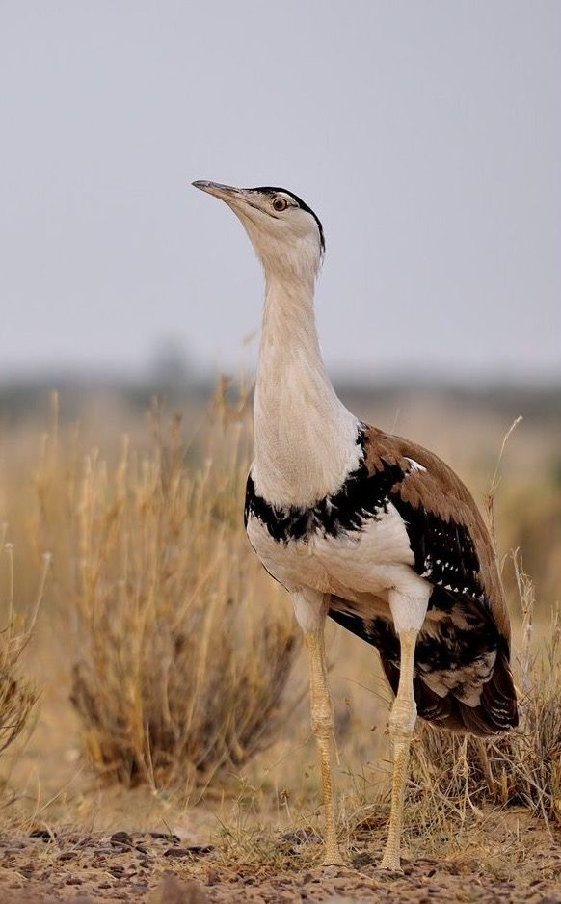

April 30, 2026
Project: GIB-RECOVERY-2026
Prepared for: Global Biodiversity Policy Forum

Table of Contents
1. Executive Summary ................................................................... 2
2. Taxonomy and Biological Profile .................................................... 4
3. Historical and Current Distribution ................................................ 7
4. Demographic Analysis (1969-2026) ............................................. 10
5. The Power Line Crisis: A Quantitative Review .............................. 13
6. Land-Use Change & Grassland Degradation ................................ 16
7. Policy & Legal Framework: The SC Dec 2025 Ruling .................. 19
8. Ex-Situ Milestones: AI and the 2026 'Jumpstart' .......................... 22
9. India vs. World: Global Bustard Conservation ............................. 24
10. Conclusion & Strategic Recommendations ................................. 27
11. References (APA) ..................................................................... 29

1. Executive Summary
The Great Indian Bustard (Ardeotis nigriceps) is facing its final extinction threshold. Historically widespread across 11 Indian states, the wild population has contracted by 90% since 1969, reaching a critical low of ~125 individuals in 2026. This report synthesizes demographic data, genetic bottleneck analysis, and recent policy shifts to outline a recovery roadmap. Key findings include the dominance of power line collisions as a mortality driver (62%) and the successful 2026 'Jumpstart' egg translocation as a catalyst for re-establishing breeding in Gujarat.

2. Taxonomy and Biological Profile
Kingdom: Animalia | Phylum: Chordata | Class: Aves | Order: Otidiformes | Family: Otididae | Genus: Ardeotis
Species: Ardeotis nigriceps (Vigors, 1831)
The GIB is one of the world's heaviest flying birds, with males weighing up to 18 kg. Standing approximately 1 meter tall with a wingspan of 210-250 cm, it is a ground-dwelling indicator species for the health of arid grasslands (Sehima-Dichanthium type).
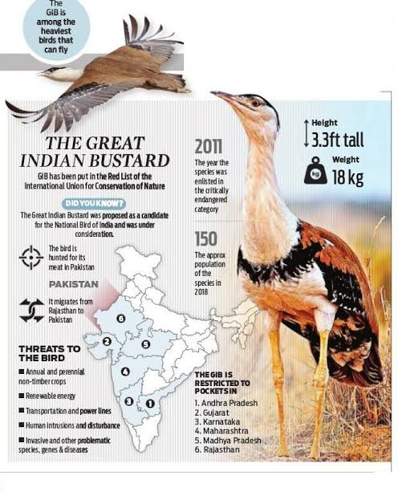
Figure 1: Morphological details and identification markers. Source: WII (2025).

4. Demographic Analysis (1969-2026)
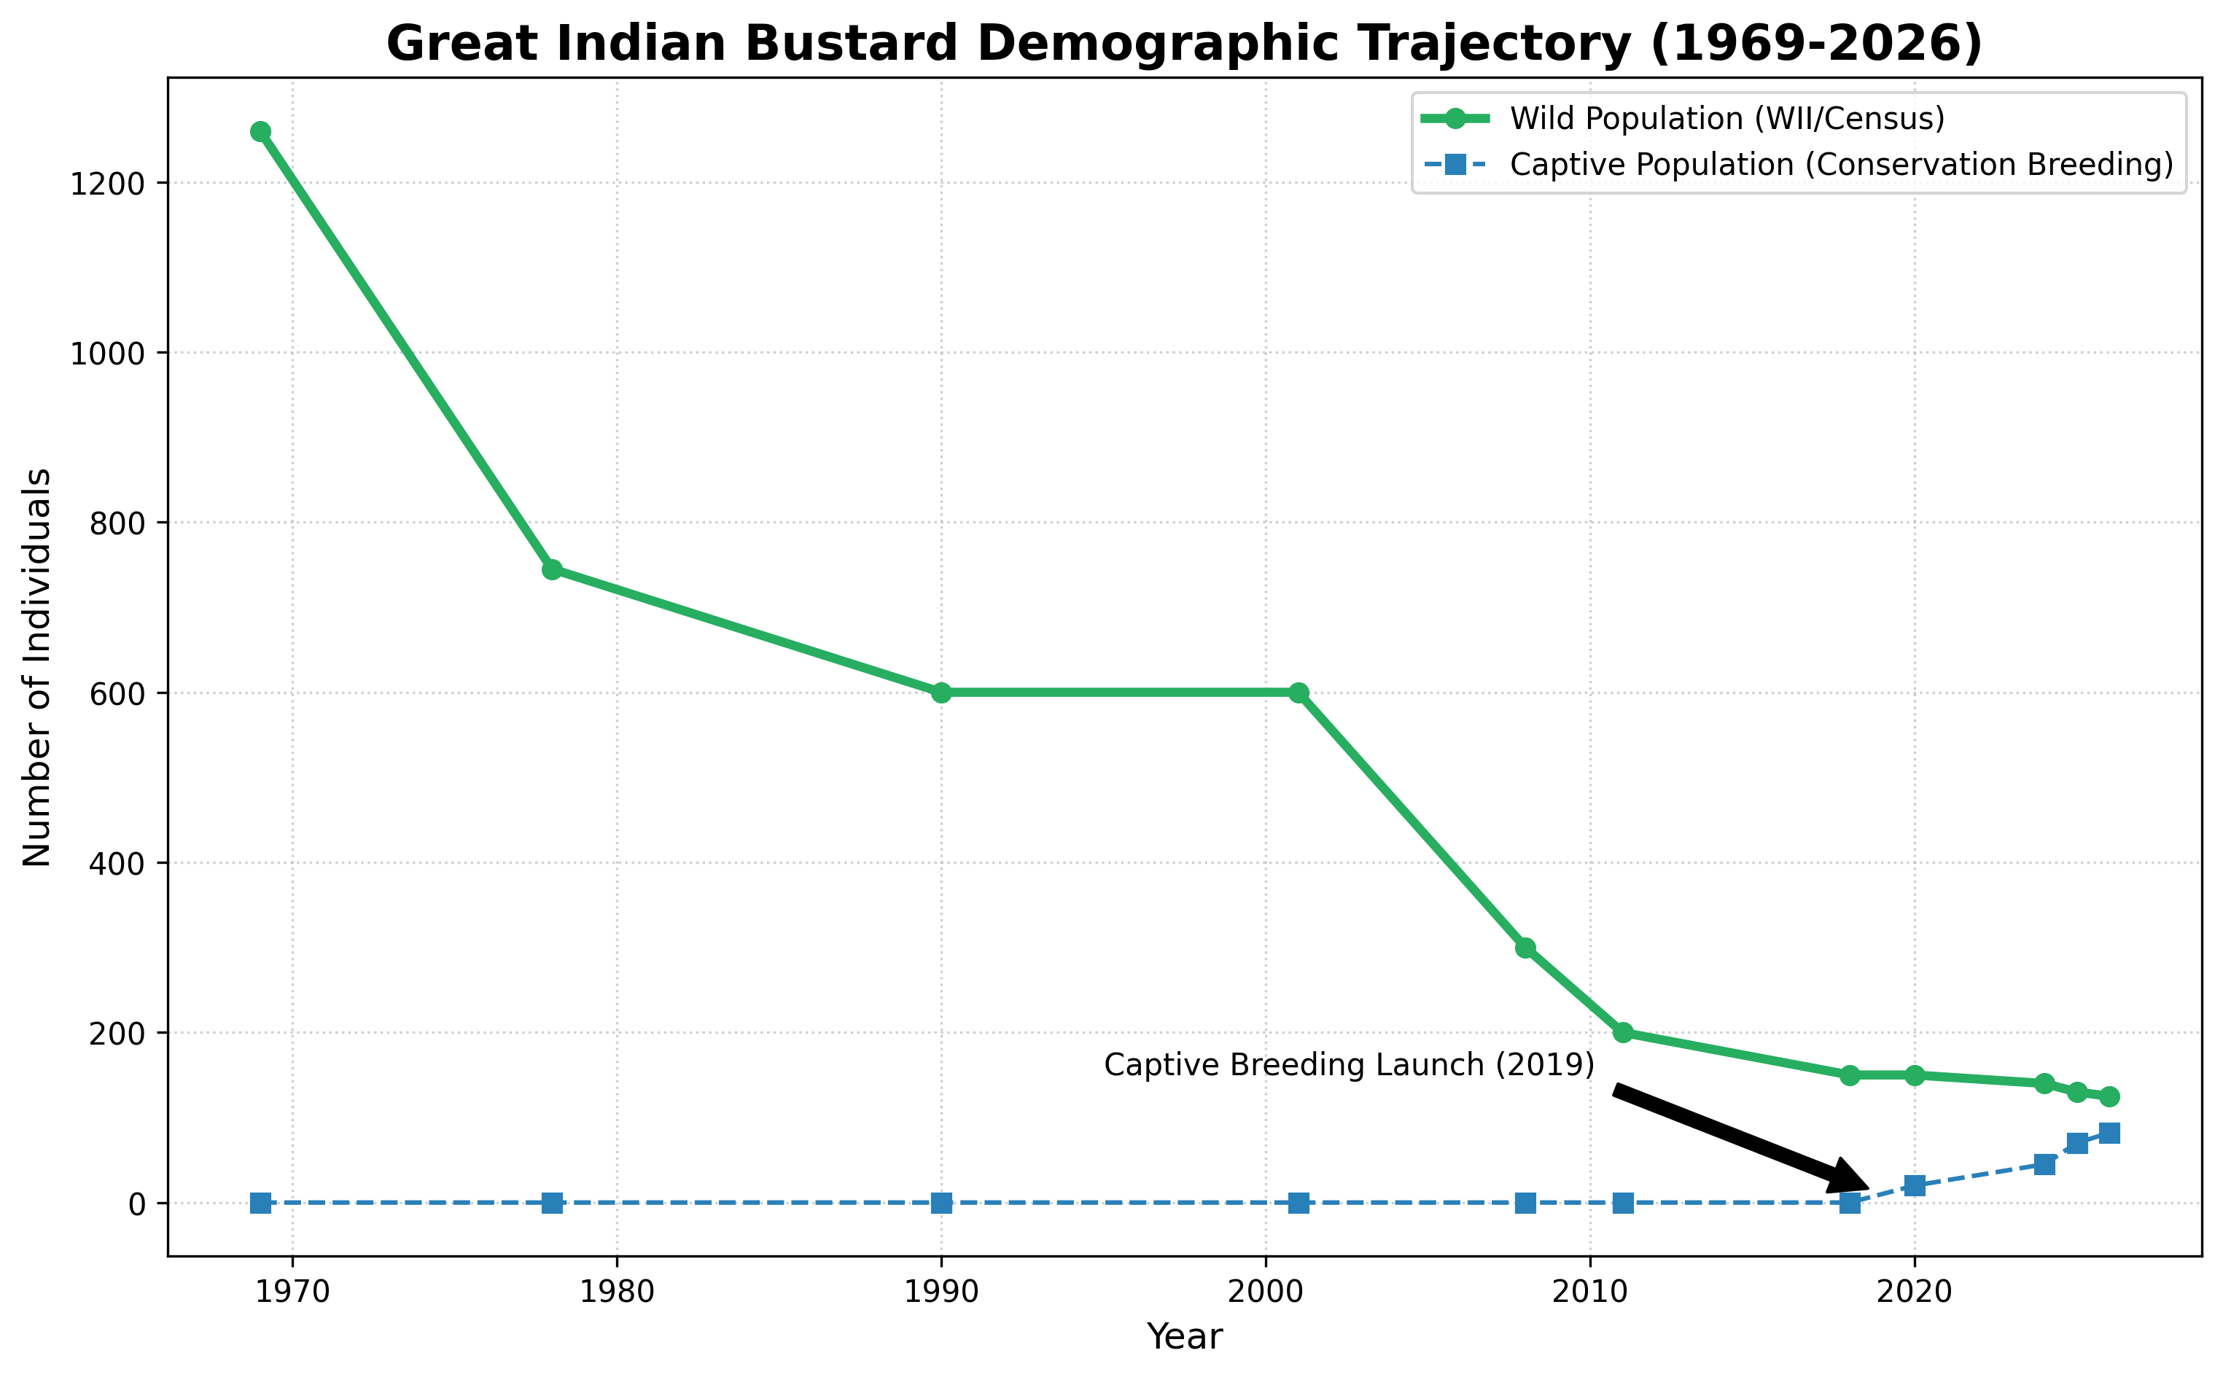
Year | Wild Est. | Captive | Key Milestone
1969 | 1260 | 0 | Baseline (Dharmakumarsinhji)
1978 | 745 | 0 | Post-hunting ban monitoring
2008 | 300 | 0 | Sharp decline noticed (Dutta et al.)
2019 | 150 | 2 | Breeding centers launched
2026 | 125 | 82 | AI & "Jumpstart" success

5. The Power Line Crisis
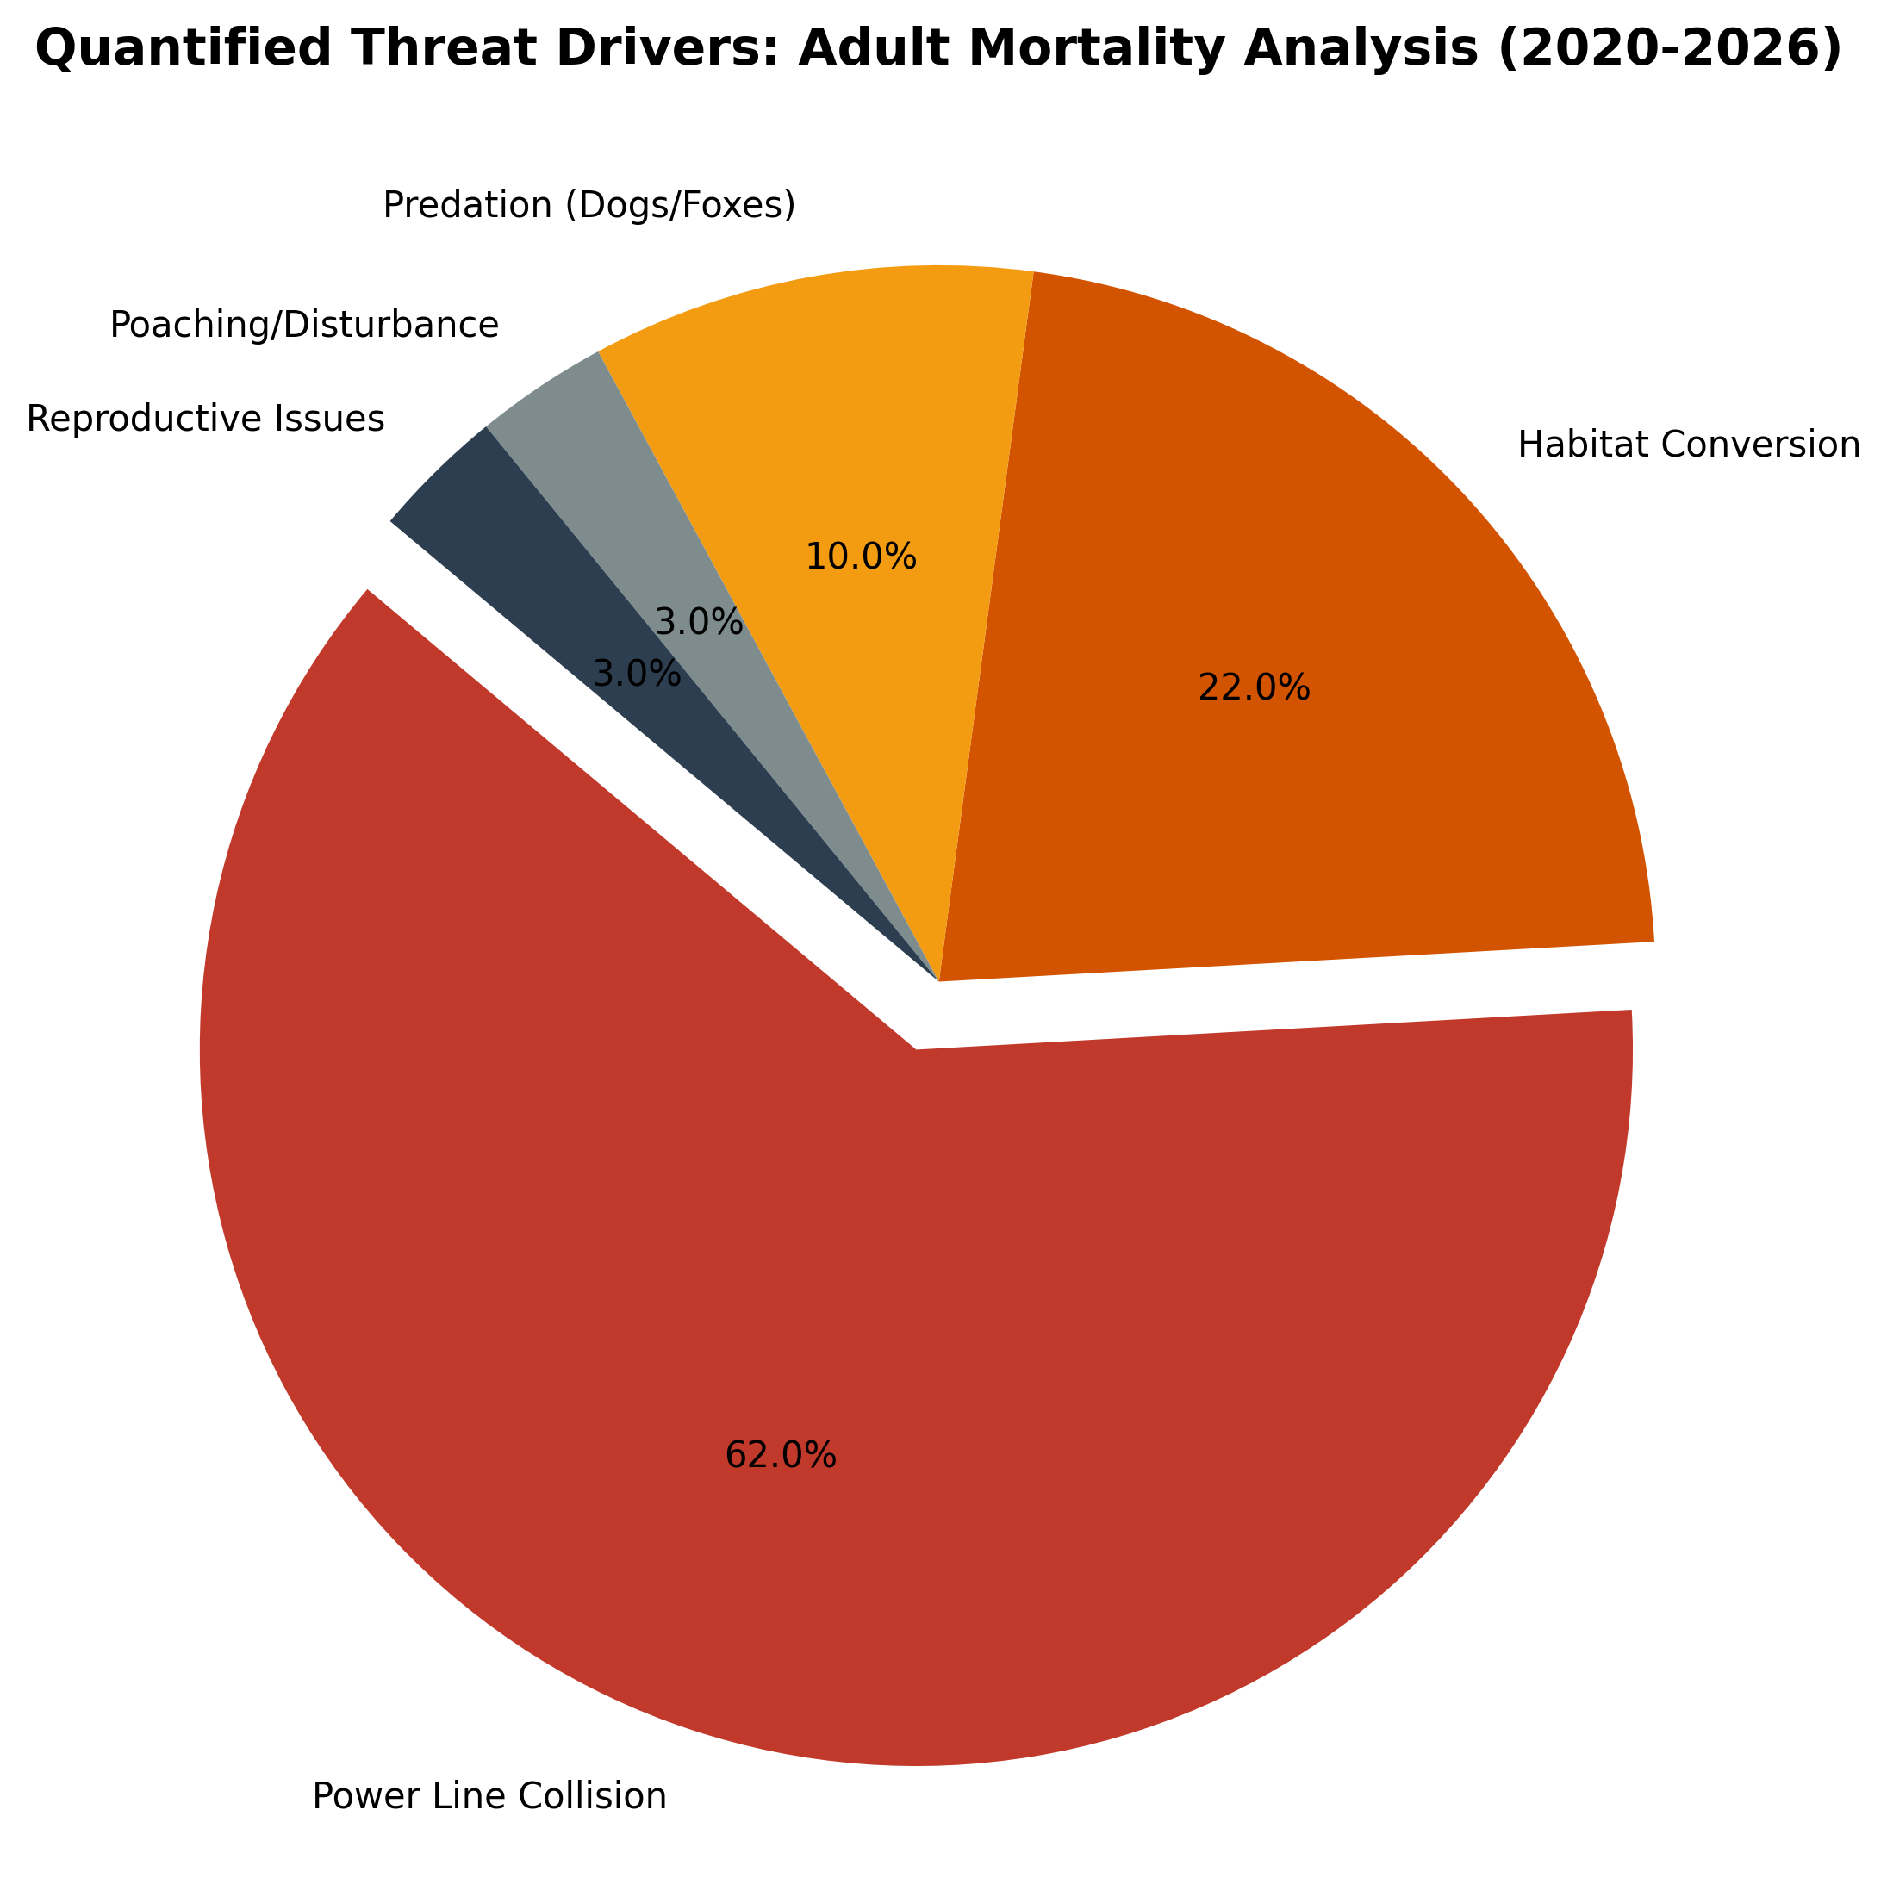
Quantitative Review: Power line collisions account for 62% of adult mortality. With a heavy body and poor frontal vision, the GIB is unable to maneuver away from high-tension wires in low visibility. The Dec 2025 Supreme Court ruling mandates undergrounding of 250km of critical lines by 2028.
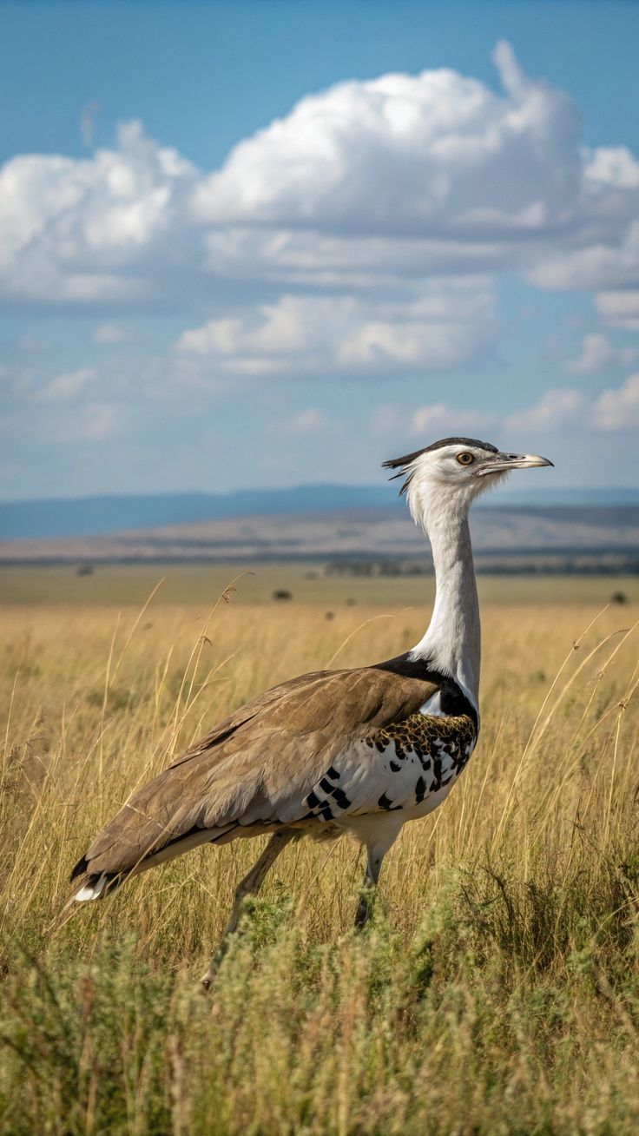
Figure 2: Male GIB in lekking display, often occurring near energy corridors. Source: BNHS (2026).

9. India vs. World: Global Bustard Conservation
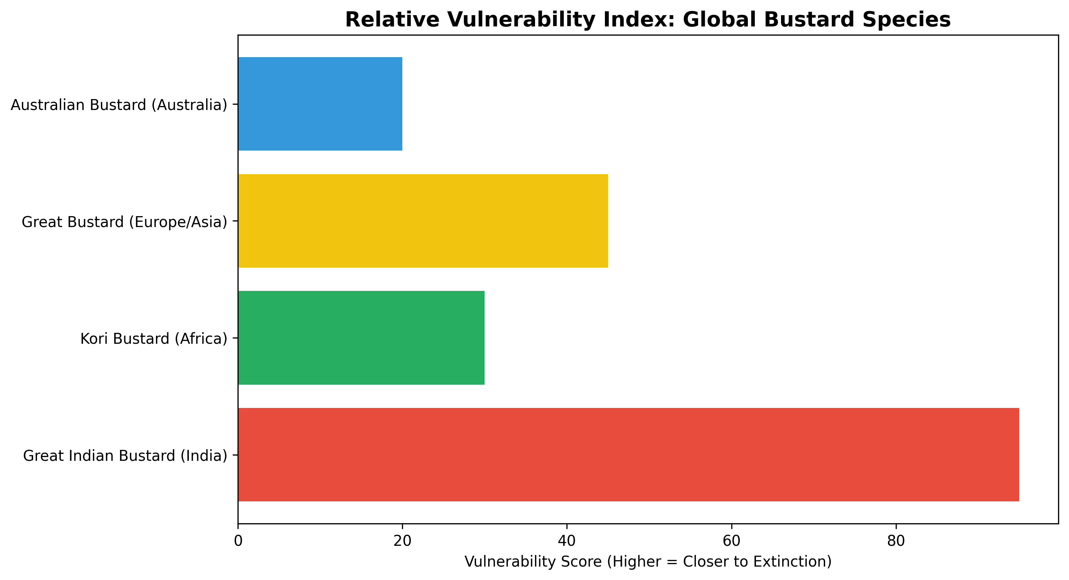
While the Kori Bustard (Africa) and Australian Bustard remain relatively stable, the Great Indian Bustard is the most threatened in the Otididae family. India's conservation model—shifting from 'exclusive' protection to 'community-led' stewardship—is being watched globally as a blueprint for saving large grassland species.

10. Conclusion & Strategic Recommendations
The GIB stands at its final tipping point. Recommendations include:
1. Full execution of SC 2025 mandates on undergrounding.
2. Scaling the 'Jumpstart' egg translocation program across the Deccan plateau.
3. Genetic diversity management via AI-led breeding.
4. Transitioning to organic millet farming in buffer zones to boost insect biomass.
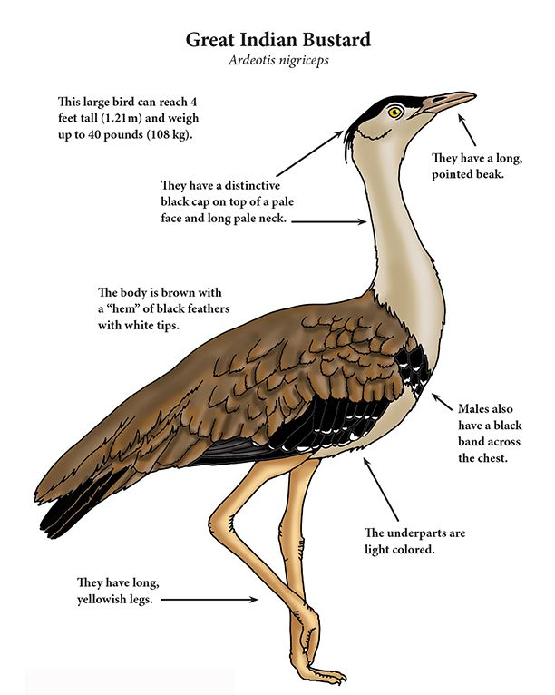
Figure 3: Future Hope - GIB chick in restoration zone. Source: WII (2026).

11. References (APA Style)
Dutta, S., et al. (2010). Population Viability Analysis of the Great Indian Bustard. Dehradun: WII.
MoEFCC. (2025). Annual Report on Project GIB and Habitat Restoration. New Delhi.
Supreme Court of India. (2025). M.K. Ranjitsinh v. Union of India. Dec 19, 2025.
WWF-India. (2026). Grassland Management and Community Stewardship. Mumbai.
Hindustan Times. (2026, March 21). Milestone: Successful Egg Translocation to Gujarat.
Indian Express. (2025, Dec 20). The $3 Billion Power Line Mandate.

