**Rohan Joshi**

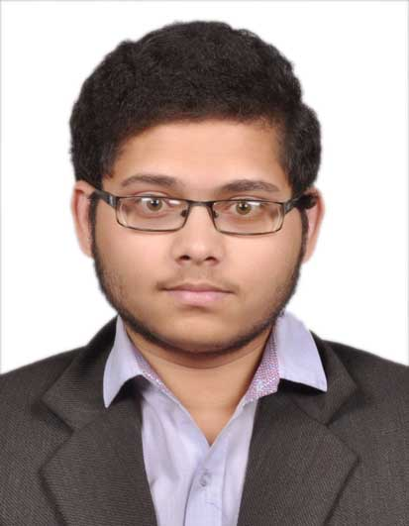

|  |  |
| --- | --- |
| **Title:** | **Analyst/ Software Engineer** |
| **Location:** | **Airoli, Navi Mumbai, Maharashtra, India** |
| **Languages:** | English, Marathi, Hindi |

**KEY SKILLS:**

* **Technical: Core** Java, J2EE, Database Technology

##### 

# Training, Certifications & Affiliations

* PG Diploma in DAC (PG-DAC)