IPL Performance Analytics
A SQL-Driven Power BI Analytical Project
Project Report & Critical Review
Prepared: June 2026

Table of Contents

1. Executive Summary
This project is an end-to-end IPL (Indian Premier League) performance analytics dashboard built on ball-by-ball data, combining a substantial library of advanced SQL analytical queries with a multi-tab Power BI report. The work demonstrates a strong command of analytical SQL — window functions, CTEs, conditional aggregation, ranking, and classification logic — paired with a cohesive dashboard narrative covering powerplay impact, player classification, venue strategy, team dependency, bowler variation, and predictive scoring.
The dashboard is organised into seven tabs that move from descriptive analysis (phase-wise scoring, dot-ball percentages) through diagnostic analysis (classification of batters and bowlers into tactical archetypes, matchup heat maps) to predictive analysis (expected score after powerplay, deviation analysis). This progression — descriptive → diagnostic → predictive — is exactly the structure expected of a mature analytics portfolio piece, and it is well executed here.
Overall, this is a strong, ambitious project that goes well beyond typical "top scorer / top wicket-taker" dashboards. The recommendations below focus on tightening a handful of SQL logic issues, improving statistical framing of the correlation/regression claims, and polishing dashboard readability — refinements that would elevate this from a good project to an excellent, presentation-ready one.

2. Project Architecture & Data Model
The project is built on a single fact table named ipl, structured at ball-by-ball granularity. Key fields inferred from the query set include: match_id, season, innings, over, ball, batter, bowler, batting_team, bowling_team, runs_batter, runs_bowler, runs_total, bowler_wicket, team_wicket, team_runs, team_balls, valid_ball, venue, stage, match_won_by, runs_target, and bat_pos.
This is a sound, normalised-enough structure for ball-level cricket analytics. Almost every metric in the dashboard — strike rates, run rates, dot-ball percentages, phase splits, classifications — is derivable from this single table using aggregation and window functions, which keeps the model simple and the SQL portable. The 18 queries in ipl_all_queries.sql collectively cover batting performance, bowling performance, team strategy, venue strategy, and predictive framing, and feed directly into the seven dashboard tabs.

2.1 Query-to-Dashboard Mapping
SQL Query | Dashboard Tab / Visual | Analytical Purpose
1. False Strike Rate | Batsman tab (boundary %) | Separates boundary-driven SR from running-based SR
2. Phase-wise RR (chases/200+) | Teams tab — Phase-wise run rate | Powerplay/middle/death RR for winning chases & big totals
3. Each team's nemesis | Teams tab — Nemesis report | Top run-scorer and top wicket-taker against each team
4. Chase collapse analysis | Powerplay tab — wickets vs win% | Win% by powerplay wickets lost while chasing
5. Powerplay dot-ball % & SR | Batsman tab — PP ranking | Powerplay aggression/control profile per batter
6. Rolling form analysis | Batsman tab — in-form players | Last-5-innings average vs career average
7. Pressure performance (RRR>10) | Batsman tab — clutch ranking | Runs scored under high required run-rate
8. Momentum shift analysis | (Not directly visualised) | Over-by-over momentum swing index
9. Powerplay runs → win% | Powerplay tab — bar chart | Win% by powerplay run-scoring bracket
10. Death vs career bowling | Bowlers tab — best death bowlers | Economy/SR change in death overs vs career
11. Batsman classification | Batsman tab — scatter | Archetype tagging via stdev/SR/average vs benchmark
12. Bowler classification | Bowlers tab — scatter | Archetype tagging via economy/SR/average vs benchmark
13. Matchup analysis | Bowlers tab — heat map | Batter vs bowler head-to-head average/SR
14. Match control index | (Supports control narrative) | Phase-wise win/lose control flags
15. Defendable target by venue | Venue tab | Average successfully-defended total per venue
16. Conversion of starts | Batsman tab — conversion ranking | 25→50→50+ conversion rates
17. Dependency on one player/season | Teams & Champions tabs | % of team runs from top scorer per season
18. Champion team analysis | Champions / Insights tab | Combined batting+bowling profile of title-winning teams

3. Dashboard Walkthrough

3.1 Tab 1 — Powerplay: Impact of Control and Aggression
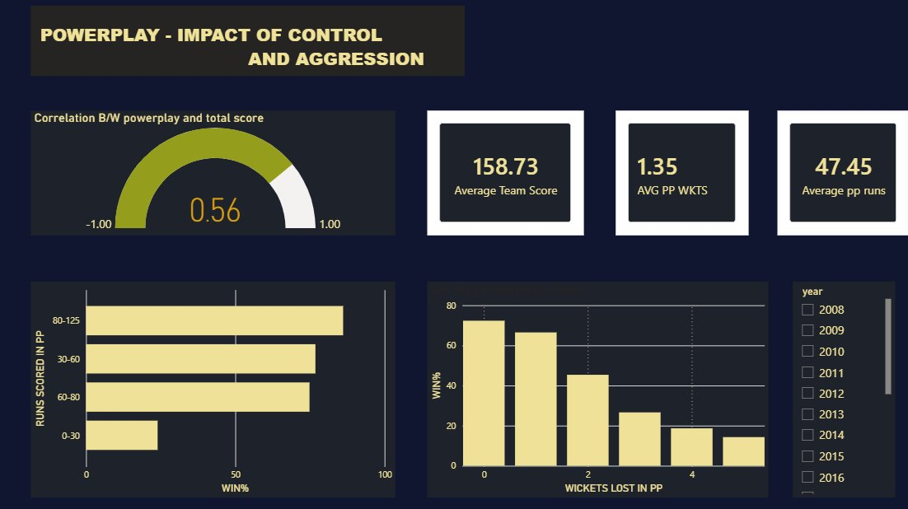
Figure 1: Powerplay impact tab — correlation gauge, KPI cards, run-bracket win%, and wickets-lost win% chart.
This tab opens the story well. The correlation gauge (r = 0.56) between powerplay score and total score immediately frames powerplay as a leading indicator rather than the whole story — a nuanced and accurate framing that the written insight later reinforces.
The KPI cards (average team score 158.73, average powerplay wickets 1.35, average powerplay runs 47.45) give useful league-wide context. The horizontal bar chart shows a clear, intuitive step-up in win% as powerplay scoring bracket increases (0-30 lowest, 80-125 highest), and the wickets-lost chart shows an equally clear and steep decline in chase win% as powerplay wickets lost increases (from roughly 70%+ at zero wickets down to under 20% at four or more).
- Strength: the two charts together make a compelling "runs help, but wickets hurt more" argument, which is a genuinely interesting cricketing insight, not just a vanity stat.
- Observation: a correlation of 0.56 is moderate, not strong — the tab's framing already acknowledges this, which is good practice and should be preserved in any executive summary.
- Suggestion: add a one-line annotation on the wickets-lost chart noting the sample size per bucket, since high-wicket-loss buckets (4+) are likely to be thin and therefore noisier.

3.2 Tab 2 — The Batsman: Clutch and Impact Engine
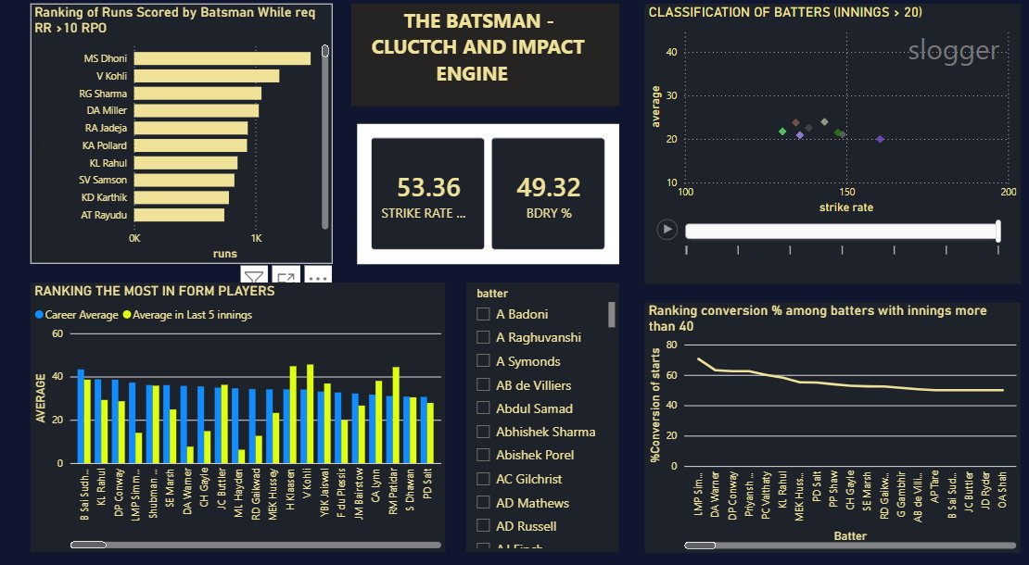
Figure 2: Batsman tab — clutch run rankings, classification scatter, rolling form comparison, and start-conversion ranking.
This is one of the richest tabs in the project. The top-left chart ranks players by runs scored when the required run-rate exceeds 10 — MS Dhoni, Virat Kohli and Rohit Sharma lead, which aligns with their well-documented reputations as finishers/anchors under pressure, lending the metric immediate credibility.
The classification scatter (Query 11) plots strike rate against average for batters with 20+ innings, tagging each into archetypes (elite, anchor, accumulator, slogger, etc.) based on whether each metric sits above or below the cohort average. This is a thoughtful piece of unsupervised-style tagging using simple SQL logic rather than a full ML model, which is appropriate given the dataset size.
The rolling form chart (career average vs last-5-innings average) is an excellent "who's in form right now" view, and the start-conversion chart (Query 16) cleanly shows the well-known cricketing phenomenon of conversion rates declining as more players are included down the ranking.
- Strength: combining career, recent-form, pressure, and conversion metrics on one tab gives a genuinely 360-degree batter profile.
- Observation: the classification scatter currently shows relatively few points (roughly 8-10 visible) despite the 20-innings threshold — worth checking whether the having count(*) >= 20 filter is more restrictive than intended, or whether this is simply because few players meet it across the dataset's seasons.
- Suggestion: label the quadrant boundaries (average lines) directly on the scatter so viewers can immediately see which side is 'above benchmark' without reading the legend.

3.3 Tab 3 — Bowlers: Impact and Variation Analysis Lab
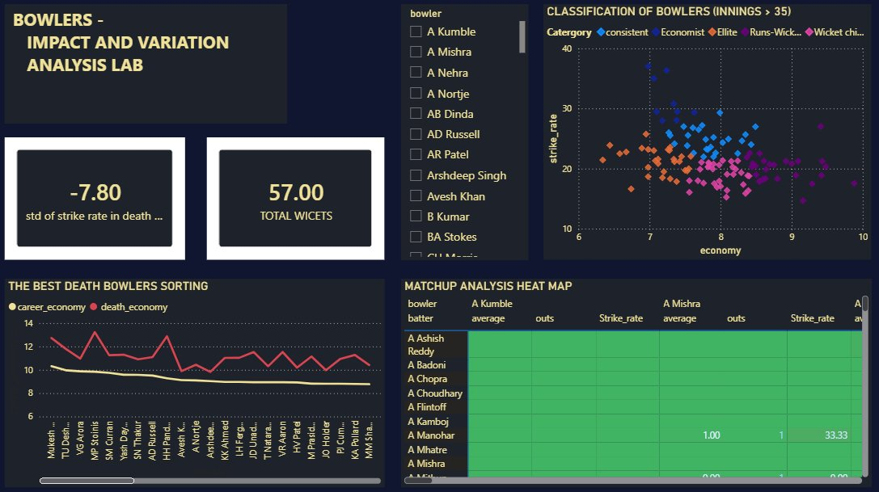
Figure 3: Bowlers tab — death-overs KPI cards, bowler classification scatter, best death bowlers trend, and matchup heat map.
The KPI card showing "-7.80 std of strike rate in death" alongside "57.00 total wickets" suggests a filtered/slicer-driven view (likely filtered to a single bowler or small group), since a league-wide total of 57 wickets is far too low — this should be checked, as it may confuse users expecting a league aggregate by default.
The bowler classification scatter (Query 12) plots strike rate against economy and colour-codes by archetype (consistent, economist, elite, runs-wicket trader, wicket chief, etc.) — a strong visual with good colour separation across roughly 8-10 economy. The 'best death bowlers' line chart comparing career economy vs death economy across many bowlers is one of the most insightful visuals in the project: it clearly shows death economy consistently running 2-4 runs above career economy, visually proving that death bowling is systematically harder, which directly supports the project's stated insight about phase-based execution.
The matchup heat map (Query 13) is an ambitious addition — a full batter-vs-bowler grid coloured by performance — though at this zoom level most cells appear green/empty with sparse populated cells (e.g., A Manohar vs A Mishra).
- Strength: the career-vs-death economy line chart is a standout visual — simple, clear, and analytically meaningful.
- Issue to verify: the SQL for Query 13 joins on tb1.batter=ut.batter without also joining on bowler in the same step, then filters where runs.bowler=ut.bowler afterward — this works but is inefficient and could be rewritten as a single join on (batter, bowler) for clarity and performance on larger datasets.
- Suggestion: the heat map would be far more usable as a 'top 20 matchups by balls faced' table rather than a full sparse matrix, since most batter-bowler pairs have only 1-3 balls and are statistically meaningless.

3.4 Tab 4 — Venue Strategy
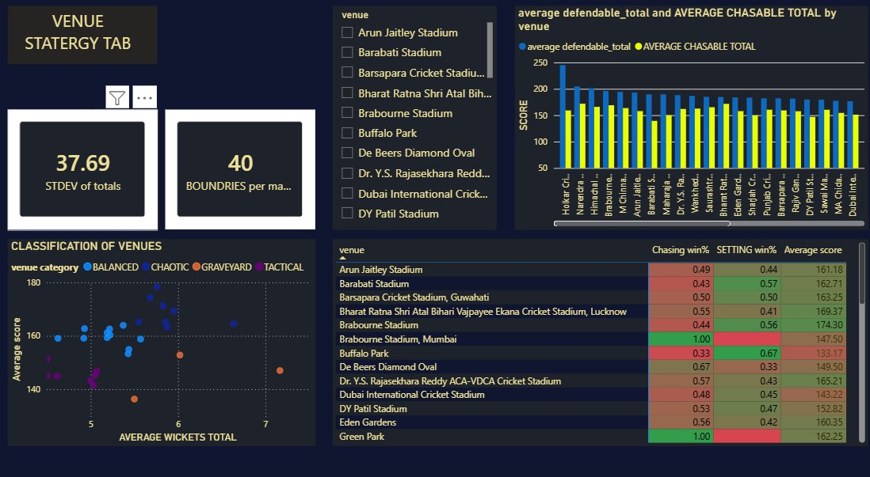
Figure 4: Venue tab — defendable vs chasable totals by venue, venue classification scatter, and chasing/setting win% table.
This tab pairs Query 15 (defendable target by venue) with an equivalent 'chasable total' calculation and a venue classification scatter (balanced / chaotic / graveyard / tactical) based on average score vs average wickets — another well-conceived archetype system, analogous to the batter/bowler classifications but applied to grounds.
The accompanying table (Arun Jaitley, Barabati, Brabourne, etc., with chasing win%, setting win%, and average score) is genuinely useful for toss-decision strategy — e.g., Brabourne Stadium, Mumbai shows a 1.00 chasing win% with a relatively modest average score of 147.50, which is the kind of specific, actionable insight a real team analyst would want.
- Strength: turning venue data into a tactical decision aid (chase vs defend) is one of the most 'real-world useful' parts of the dashboard.
- Caution: several venues (Brabourne Stadium, Buffalo Park, De Beers Diamond Oval, Green Park) show win% values of exactly 0.00, 0.33, or 1.00 — these are almost certainly small-sample venues (1-3 matches), and presenting them with the same visual weight as high-sample venues like Eden Gardens or Wankhede risks overstating their reliability.
- Suggestion: add a match-count column or a minimum-matches filter/slicer so users can distinguish statistically robust venue insights from small-sample noise.

3.5 Tab 5 — Teams: Tactical and Statistical Analysis
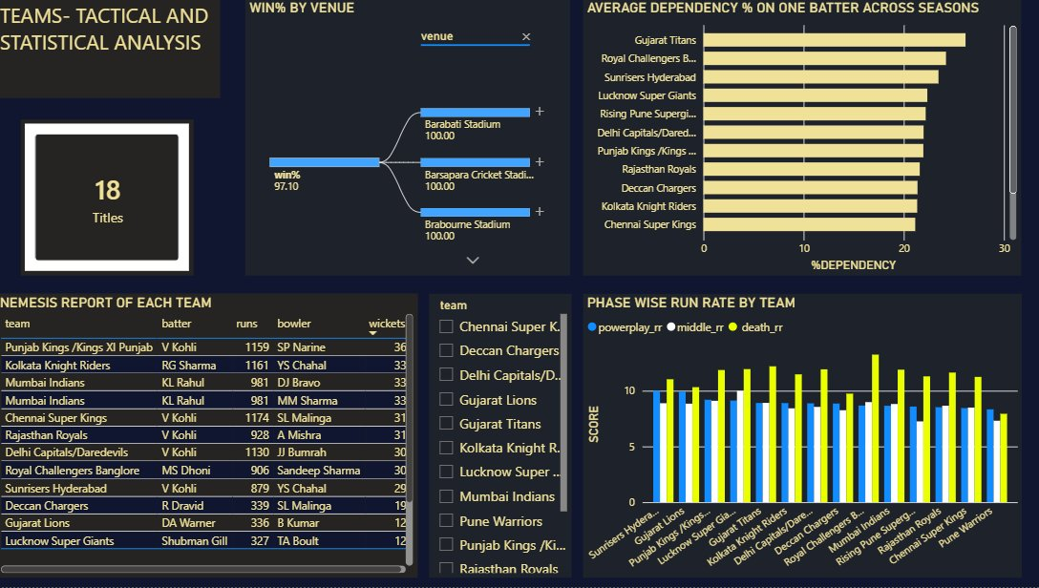
Figure 5: Teams tab — titles KPI, win% by venue decomposition tree, dependency-on-one-batter ranking, nemesis report table, and phase-wise run rate chart.
This tab is the team-level counterpart to the batter/bowler tabs and ties the project together well. The '18 Titles' KPI and the win%-by-venue decomposition tree are a nice interactive touch for exploring team performance geographically.
The 'Average Dependency % on One Batter Across Seasons' chart (Query 17) is conceptually strong — Gujarat Titans and Royal Challengers Bangalore sit highest at roughly 25%+, suggesting these franchises have historically leaned heavily on individual stars, which is a defensible and interesting structural insight about team-building philosophy.
The nemesis report (Query 3) is one of the most engaging tables in the dashboard — pairing each team's most prolific opponent batter with its most successful opponent bowler (e.g., Punjab Kings/Kings XI Punjab's nemesis is V Kohli with 1159 runs, while SP Narine has taken 36 wickets against them) produces immediately shareable, narrative-rich content.
The phase-wise run rate chart at the bottom right (Query 2) compares powerplay, middle, and death run rates across teams in successful chases/200+ innings, and shows death run rates consistently exceeding both powerplay and middle rates — a sensible and expected pattern (teams accelerate at the death) that validates the underlying data.
- Strength: the nemesis report converts raw aggregation into genuinely fun, narrative content — a strong storytelling choice for a sports dashboard.
- Issue to verify: Query 3's join (tb1.bowling_team = tb2.batting_team) pairs each team's 'team that conceded the most runs to a batter' with 'team against which the most wickets were taken by a bowler' — conceptually this correctly identifies, for a given team, its toughest opponent batter and its own most effective bowler against opponents, but the column tb1.bowling_team in the output actually represents the team being analysed (i.e., the team that conceded the runs). Double-check the column header/label in the dashboard table reads 'Team' rather than 'Bowling Team' to avoid confusion, since the screenshot's table header reads 'team' which is correct, but the underlying alias naming is easy to misread when maintaining the query.

3.6 Tab 6 — Insights and Key Findings (Champions)
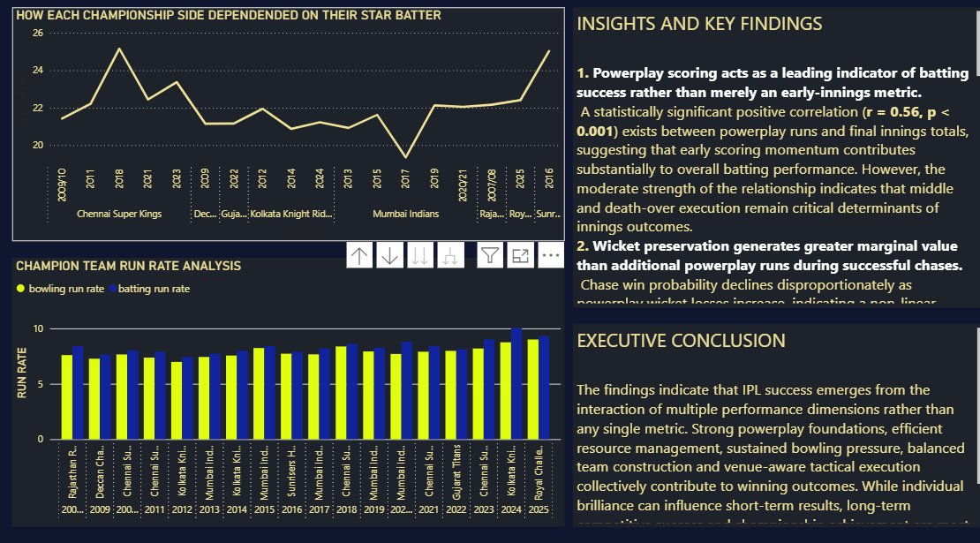
Figure 6: Insights tab — championship-team star-batter dependency trend, champion run-rate comparison, and written executive insights.
This is the project's synthesis tab, and it is well-structured: a trend line of star-batter dependency for championship sides, a grouped bar chart comparing champion teams' batting and bowling run rates season-by-season, and a written narrative tying the analysis together.
The two written insights are well-articulated. The first correctly characterises the r = 0.56 correlation as 'statistically significant' and 'moderate,' and appropriately notes that middle and death execution remain critical — this is good statistical communication and avoids overstating the powerplay finding. The second insight, on chase win probability declining non-linearly with wickets lost, is directly supported by the Tab 1 chart and is one of the project's strongest, most defensible conclusions.
- Strength: explicitly stating 'r = 0.56, p < 0.001' alongside a caveat about moderate effect size shows statistical maturity that many dashboard projects lack.
- Suggestion: the champion run-rate chart's batting/bowling run rates look very close for most seasons (both clustering 7-9), with only Royal Challengers' most recent season showing wider separation — consider adding a 'net run rate' (batting RR minus bowling RR) line as a single clearer summary metric for 'how dominant was the champion that year.'
- Note: the Executive Conclusion text appears truncated in the screenshot ('long-term ... and championship achievement are most strongly associated with...') — ensure this text box is resized so the full conclusion is visible without scrolling.

3.7 Tab 7 — Predictive Analysis: Expected Score After Powerplay
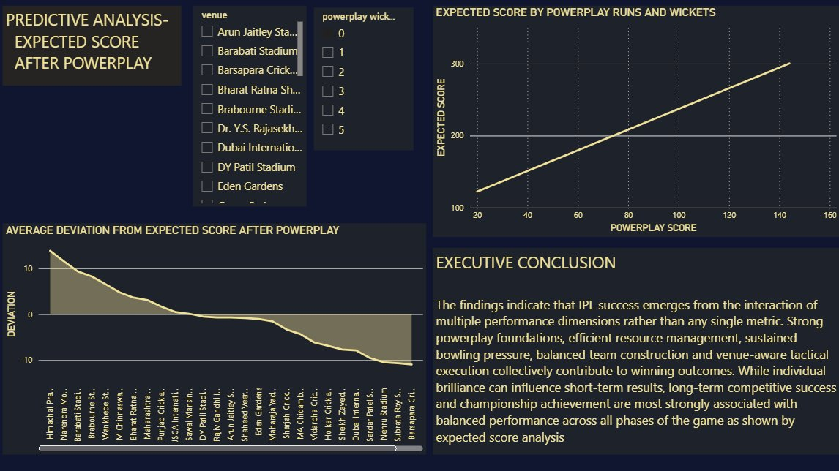
Figure 7: Predictive tab — expected score vs powerplay runs/wickets, and deviation-from-expected-score by venue.
This is the project's predictive capstone and a natural extension of Tab 1's correlation finding. The 'Expected Score by Powerplay Runs and Wickets' chart shows a clean, near-linear relationship — a powerplay score of roughly 20 maps to an expected final total around 120-130, rising to roughly 300 at a powerplay score of around 140-150, with powerplay wickets selectable via the slicer.
The deviation chart below it (venues ranked by average deviation from expected score, from Himachal Pradesh and Narendra Modi Stadium at the top with deviations above +10, down to Sabarpara at the bottom near -10) is a smart addition: it operationalises the regression model by showing which venues consistently over- or under-perform their predicted total, which is the kind of residual analysis that turns a simple trend line into an actual diagnostic tool.
- Strength: pairing a predictive model with a residual/deviation-by-venue view shows an understanding that a single global model won't fit every ground equally — this is genuinely advanced thinking for a BI project.
- Caution on the headline number: given that r = 0.56 for powerplay-vs-total correlation, the implied R-squared is only around 0.31, meaning powerplay runs alone explain roughly 31% of the variance in final score. The near-linear chart from 100 to 300 should therefore be presented as 'expected/average' value with a visible confidence band or error bars, since actual outcomes will vary substantially around this line — without that caveat, viewers may over-trust the line as a precise prediction.
- Suggestion: since the deviation chart already exists, consider adding the standard deviation of the residuals as a KPI card on this tab (e.g., '±X runs typical deviation') to directly communicate the model's precision alongside its trend.

4. SQL Code Review — Strengths and Recommendations
The 18-query script demonstrates a genuinely advanced SQL toolkit: window functions (RANK, LAG OVER), multiple CTEs with cross joins for benchmark-based classification, conditional aggregation (CASE-based bucketing), nested derived tables, and careful use of NULLIF to avoid division-by-zero. The classification queries (11 and 12) in particular are an elegant way to build a rule-based segmentation model entirely in SQL.

4.1 Specific Observations
- Query 1 (False Strike Rate): the filter runs_batter < 4 to compute the 'false strike rate' (strike rate excluding boundaries) is correct in spirit, but note it also excludes 6s scored as part of runs_batter=4 only if exactly 4 — runs_batter values of 4 and 6 are both excluded, which is the intended behaviour for isolating non-boundary strike rate. This is correct; just worth a comment in the script explaining the threshold choice for future readers.
- Query 4 (Chase Collapse): grouping by venue in the inner query but not selecting it in the outer aggregation is fine functionally (it's part of the distinctness key) but slightly wasteful — consider removing venue from the GROUP BY if it isn't needed for distinctness, to simplify the query.
- Query 7 (Pressure Performance): the required-run-rate formula (runs_target-team_runs)/((120-team_balls)/6) will throw a divide-by-zero error when team_balls = 120 (last ball of the innings). Wrap the denominator in NULLIF(...,0) as done elsewhere in the script, for consistency and robustness.
- Query 8 (Momentum Shift): LAG(momentum) OVER() without an ORDER BY clause relies on the database's default row ordering, which is not guaranteed to be deterministic. Add ORDER BY `over` inside the OVER() clause to guarantee the momentum sequence is correctly ordered by over number.
- Query 10 (Death vs Career Bowling): the death-overs filter `over` >= 16 actually corresponds to overs 17-20 (since `over` appears to be 0-indexed elsewhere, e.g., `over` < 6 for the first six overs/powerplay). If 0-indexed, `over` >= 15 (as used correctly in Queries 9 and 14) would represent the last five overs (16-20), making Query 10 one over narrower than the death-overs definition used elsewhere. Recommend standardising on `over` >= 15 across all death-overs queries for consistency.
- Query 13 (Matchup Analysis): as noted in section 3.3, the join condition on(tb1.batter=ut.batter) combined with a later WHERE runs.bowler=ut.bowler produces correct results but performs a larger intermediate join than necessary. Rewriting as ON tb1.batter = ut.batter AND tb1.bowler = ut.bowler would be more efficient and clearer.
- Query 17 (Dependency on One Player): excluding season != 2026 is a reasonable choice if the 2026 season is incomplete, but this should be documented with a comment so future maintainers understand why the most recent season is excluded — otherwise it looks like an arbitrary filter.
- Query 18 (Champion Team Analysis): this is the most complex query in the set, with four levels of nested derived tables. It works, but its depth makes it hard to debug. Recommend refactoring into CTEs (WITH clauses), as already done elegantly in Queries 11 and 12 — this would dramatically improve readability without changing the logic.

5. Statistical Methodology Notes
The project's headline statistical claim — a correlation of r = 0.56 (p < 0.001) between powerplay runs and final innings total — is reported correctly and with an appropriately cautious interpretation ('moderate strength'). Two refinements would strengthen this further for an academic or professional audience:
- Report R-squared alongside r: an r of 0.56 corresponds to R² ≈ 0.31, meaning roughly 31% of the variance in final score is explained by powerplay runs alone. Stating this explicitly makes the 'moderate, not dominant' framing even clearer to non-technical stakeholders.
- Distinguish correlation from the predictive model: the Tab 1 correlation (r=0.56) and the Tab 7 'expected score' line appear to be presented as connected, but if the expected-score line is derived from a simple linear regression, its own R² and residual standard deviation should be reported on Tab 7 directly — this is the number that should anchor the deviation chart's interpretation.
- Sample-size transparency: several venue- and player-level tables (Tabs 4 and 5) include entities with very few matches/innings. A consistent minimum-sample threshold (e.g., 'venues with 5+ matches,' 'players with 20+ innings' — already applied in Queries 11/12) should be applied uniformly across all ranking visuals to avoid small-sample artifacts being presented with full confidence.

6. Dashboard Design & Usability

6.1 Strengths
- Consistent dark theme with a gold/cream accent palette gives the report a cohesive, premium 'broadcast graphics' feel appropriate for a cricket analytics product.
- Logical tab progression from phase-based descriptive analysis through player/team diagnostics to venue strategy and finally predictive modelling mirrors how a real analytics team would structure a season review.
- Reusable visual archetypes — classification scatters (batters, bowlers, venues), phase-split bar/line charts, and ranking tables — give the dashboard a consistent visual language across tabs.
- KPI cards are used purposefully to anchor each tab with a headline number rather than as decoration.

6.2 Areas for Improvement
- Truncated text boxes: the Executive Conclusion appears cut off on at least two tabs (Insights and Predictive Analysis) — resize text boxes or reduce font size slightly so the full narrative is always visible.
- Small-sample indicators: add match/innings counts (or filters) wherever win% or average values are shown for venues/teams with potentially few observations, particularly on the Venue and Teams tabs.
- Heat map readability: the matchup heat map on the Bowlers tab is currently too sparse to be readable at a glance — consider converting it to a filterable top-N matchup table.
- Axis/label clarity: several charts (e.g., the bowler classification scatter, the venue scatter) would benefit from quadrant reference lines and axis titles that explicitly state the benchmark value being compared against.
- Colour-blind accessibility: the gold/cream-on-navy palette is generally high-contrast and accessible, but the multi-colour classification scatters (orange/blue/pink/purple categories) should be checked against a colour-blindness simulator, since red-green and orange-pink distinctions can be hard to separate for some users.

7. Prioritised Recommendations

7.1 High Priority
- Standardise the death-overs definition (`over` >= 15) across Queries 9, 10, and 14 for consistency.
- Add NULLIF protection to Query 7's required-run-rate denominator to prevent divide-by-zero errors.
- Add ORDER BY `over` inside the LAG() OVER() clause in Query 8 to guarantee deterministic momentum sequencing.
- Resize/fix the truncated Executive Conclusion text boxes on the Insights and Predictive Analysis tabs.
- Add minimum-sample-size filters (matches/innings) to venue and team win% visuals to prevent small-sample distortion.

7.2 Medium Priority
- Refactor Query 18 (Champion Team Analysis) into CTEs for maintainability, following the pattern already used in Queries 11 and 12.
- Rewrite Query 13's join to combine on (batter, bowler) directly and convert the matchup heat map into a filtered top-N table.
- Report R² and residual standard deviation alongside r on the Predictive Analysis tab, and add a confidence band to the expected-score line chart.

7.3 Lower Priority / Polish
- Add a 'Net Run Rate' (batting RR − bowling RR) metric to the Champions tab for a single dominance indicator.
- Add quadrant reference lines and clearer axis labels to all classification scatter plots.
- Document non-obvious filters (e.g., season != 2026 in Query 17) with inline SQL comments for future maintainability.

8. Overall Assessment
This project represents a high level of analytical maturity for a sports-data dashboard: it correctly identifies that powerplay performance is a leading-but-not-determining indicator, builds genuinely useful tactical tools (venue chase/defend strategy, batter/bowler/venue archetype classification), and closes the loop with a predictive model and residual analysis. The SQL demonstrates command of window functions, CTEs, and conditional logic well beyond basic reporting queries.
The recommendations above are refinements rather than fundamental redesigns — the core architecture, query logic, and dashboard narrative are sound. Addressing the high-priority items (consistency in over-based filters, divide-by-zero protection, text box sizing, and sample-size transparency) would bring the project to a polished, presentation-ready standard suitable for a portfolio, academic submission, or stakeholder demo.

