Kubernetes and Minikube Practical Implementation on Ubuntu
Internship Practical Report
Environment: intern-ship-3@V520-15IKL2 | Ubuntu 25.04 | Minikube v1.38.1 | kubectl v1.35.2

1. Introduction
This report documents the practical work carried out with Kubernetes and Minikube during the internship. Kubernetes is a container orchestration platform used to deploy, scale, and manage applications that are made up of multiple containers running across a cluster of machines. While Docker is used to build and run individual containers, Kubernetes is used to manage many containers together — restarting them if they fail, scaling them up or down, and letting them discover and communicate with each other by name.
Minikube is a tool that runs a small, single-node Kubernetes cluster on a local machine, which is well suited for learning and practical work. In this environment, Minikube was configured to use the Docker driver, meaning the Kubernetes node itself runs inside a Docker container on the host, and the Kubernetes components (API server, etcd, scheduler, controller-manager, kubelet, kube-proxy, CoreDNS) run inside that node.
This report is organised in the chronological order in which the work was actually carried out: an earlier session in which a working Kubernetes deployment with multiple services was exercised, followed by a later session (after a gap of several months) in which the cluster was found to be unhealthy after being restarted, and a troubleshooting investigation was carried out to identify why the Kubernetes API server was not responding.

2. Objectives
- To understand basic Kubernetes concepts: pods, deployments, services, and namespaces.
- To interact with a running Kubernetes cluster using kubectl (get pods, get deployments, get services, exec).
- To verify the installed versions of kubectl, Minikube, and Docker on the host.
- To check the health of the Minikube cluster using minikube status.
- To investigate and document a Kubernetes API server connectivity problem using minikube logs, docker logs, and crictl.
- To understand the relationship between the Minikube host container (visible via docker ps) and the Kubernetes component containers running inside it (visible via crictl).

3. System Environment
The following tool versions were confirmed directly from the terminal:
Component | Version / Detail
Operating System | Ubuntu 25.04
kubectl (Client) | v1.35.2, Kustomize v5.7.1
Minikube | v1.38.1, commit c93a4cb9311efc66b90d33ea03f75f2c4120e9b0
Docker (host) | 28.2.2, build 28.2.2-0ubuntu1~25.04.1
Minikube node base image | gcr.io/k8s-minikube/kicbase:v0.0.50
Note: when Minikube starts its node with minikube start --driver=docker, the terminal reports "Preparing Kubernetes v1.35.1 on Docker 29.2.1" — this refers to the Kubernetes version and the internal Docker version running inside the Minikube node container itself, and is separate from the host's own Docker installation (28.2.2) shown above. The two are not the same and should not be confused.

4. Kubernetes Architecture (Brief Overview)
Concept | Description
Cluster | A set of machines (nodes) that run containerized applications, managed together by Kubernetes.
Control Plane | The set of components that manage the cluster: the API server, etcd, scheduler, and controller-manager.
Node | A worker machine (physical, virtual, or in this case a Docker container) that runs application pods.
Pod | The smallest deployable unit in Kubernetes — one or more containers that share storage and network.
Deployment | A resource that manages a set of identical pods, keeping the desired number of replicas running.
Service | A stable network endpoint (ClusterIP, NodePort, etc.) used to reach a set of pods by name.
kubelet | The agent on each node that ensures containers described in pod specs are actually running.
API Server | The front door to the cluster — kubectl and all other components talk to it to read/change cluster state.

5. Phase 1 — Working Kubernetes Session (kubectl exercises)
In an earlier session, the Minikube cluster was up and healthy, and several kubectl commands were used to inspect a running deployment consisting of an nginx deployment plus a small two-service application (order-service and product-service) that communicated with each other inside the cluster.

5.1 Listing pods
kubectl get pods
The output listed six pods: three replicas of nginx-deploy (nginx-deploy-8b9dbd8c9-67mq9, -psdb2, -sm7wv), a standalone nginx-pod, an order-deployment pod (2/2 containers ready), and a product-deployment pod (2/2 containers ready). The nginx pods showed READY 1/1 and had each restarted once, 20 hours before the check, with an AGE of 22h. The order and product deployment pods were newer, at 6m26s and 7m17s respectively, with 0 restarts.
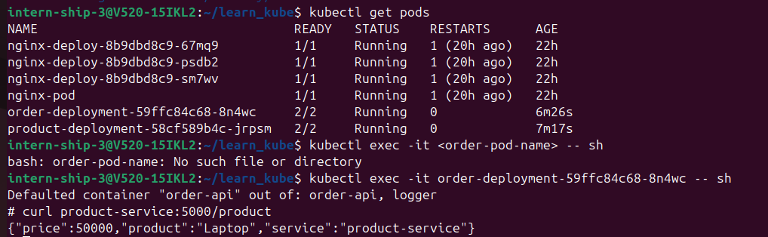
Figure 1: kubectl get pods, followed by a failed and then successful kubectl exec into the order-deployment pod, and a curl to product-service

5.2 Executing a command inside a pod
kubectl exec -it <order-pod-name> -- sh
The first attempt used a literal placeholder <order-pod-name> instead of the actual pod name, which failed with "bash: order-pod-name: No such file or directory" because the shell tried to interpret the angle-bracket text rather than kubectl expanding it.
kubectl exec -it order-deployment-59ffc84c68-8n4wc -- sh
Using the actual pod name succeeded. Kubernetes reported "Defaulted container 'order-api' out of: order-api, logger" because the order-deployment pod runs two containers (order-api and logger), and exec defaulted to the first one. Once inside the container's shell, the following command was run:
curl product-service:5000/product
This returned {"price":50000,"product":"Laptop","service":"product-service"}, confirming that the order-api container was able to reach the product-service Kubernetes Service by its DNS name and port, and that the product-service was responding correctly. This is a practical demonstration of Kubernetes' built-in service discovery — pods can reach each other using the service name as a hostname, without needing to know pod IP addresses.
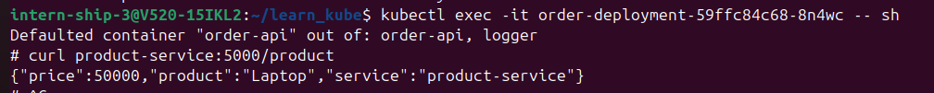
Figure 2: kubectl exec into order-deployment and curl to product-service, confirming internal service-to-service communication

5.3 Checking deployments
kubectl get deployments
nginx-deploy showed READY 3/3, UP-TO-DATE 3, AVAILABLE 3, AGE 22h — a fully healthy deployment. product-deployment showed READY 0/1, UP-TO-DATE 1, AVAILABLE 0, AGE 38s, indicating it had only just been created and its single replica was still starting up (not yet passing readiness checks) at the moment this command was run.
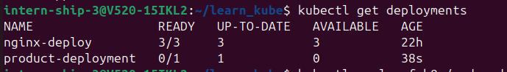
Figure 3: kubectl get deployments — nginx-deploy healthy at 3/3, product-deployment still starting at 0/1

5.4 Checking services
kubectl get services
Three services were listed: the default kubernetes service (ClusterIP 10.96.0.1, port 443/TCP), order-service (ClusterIP 10.108.40.181, port 5001/TCP), and product-service (ClusterIP 10.107.2.236, port 5000/TCP). All were of type ClusterIP, meaning they are only reachable from inside the cluster, which matches how order-api reached product-service in the exec/curl test above.
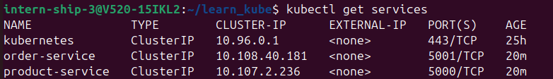
Figure 4: kubectl get services — order-service and product-service as ClusterIP services

6. Phase 2 — Cluster Health Investigation
In a later session, after a gap of time, work resumed on the same Minikube setup. On checking Docker and Kubernetes tooling, the versions were re-confirmed (Docker 28.2.2, and the general system was on Ubuntu 25.04), but running Kubernetes diagnostic commands revealed that the cluster's control plane was not responding.

6.1 Minikube log collection and repeated connection errors
While gathering component logs, minikube's internal log collector attempted to reach the Kubernetes API server to describe the cluster nodes, and to pull logs for kube-apiserver, coredns, kube-proxy, kube-controller-manager, and dmesg. The "describe nodes" step consistently failed with the same underlying error:
The connection to the server localhost:8443 was refused - did you specify the right host or port?
and, in the raw stderr, repeated lines of the form:
E0806 11:44:31.482310 memcache.go:265 "Unhandled Error" err="couldn't get current server API group list: Get \"https://localhost:8443/api?timeout=32s\": dial tcp [::1]:8443: connect: connection refused"
This error means that kubectl (and Minikube's internal tooling, which itself calls kubectl) tried to contact the Kubernetes API server on port 8443 and got no response at all — nothing was listening on that port. Since the API server is the single entry point through which every other Kubernetes command operates, every dependent operation (describing nodes, checking cluster health) failed for the same underlying reason.
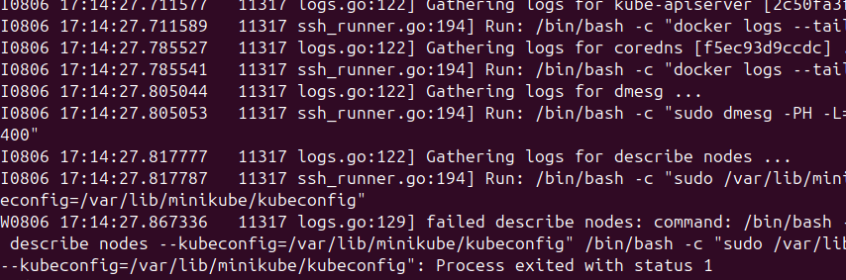
Figure 5: minikube log collection beginning, with the first "describe nodes" failure
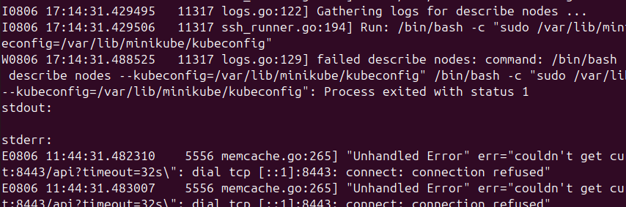
Figure 6: Repeated memcache "Unhandled Error" / connection refused errors while describing nodes
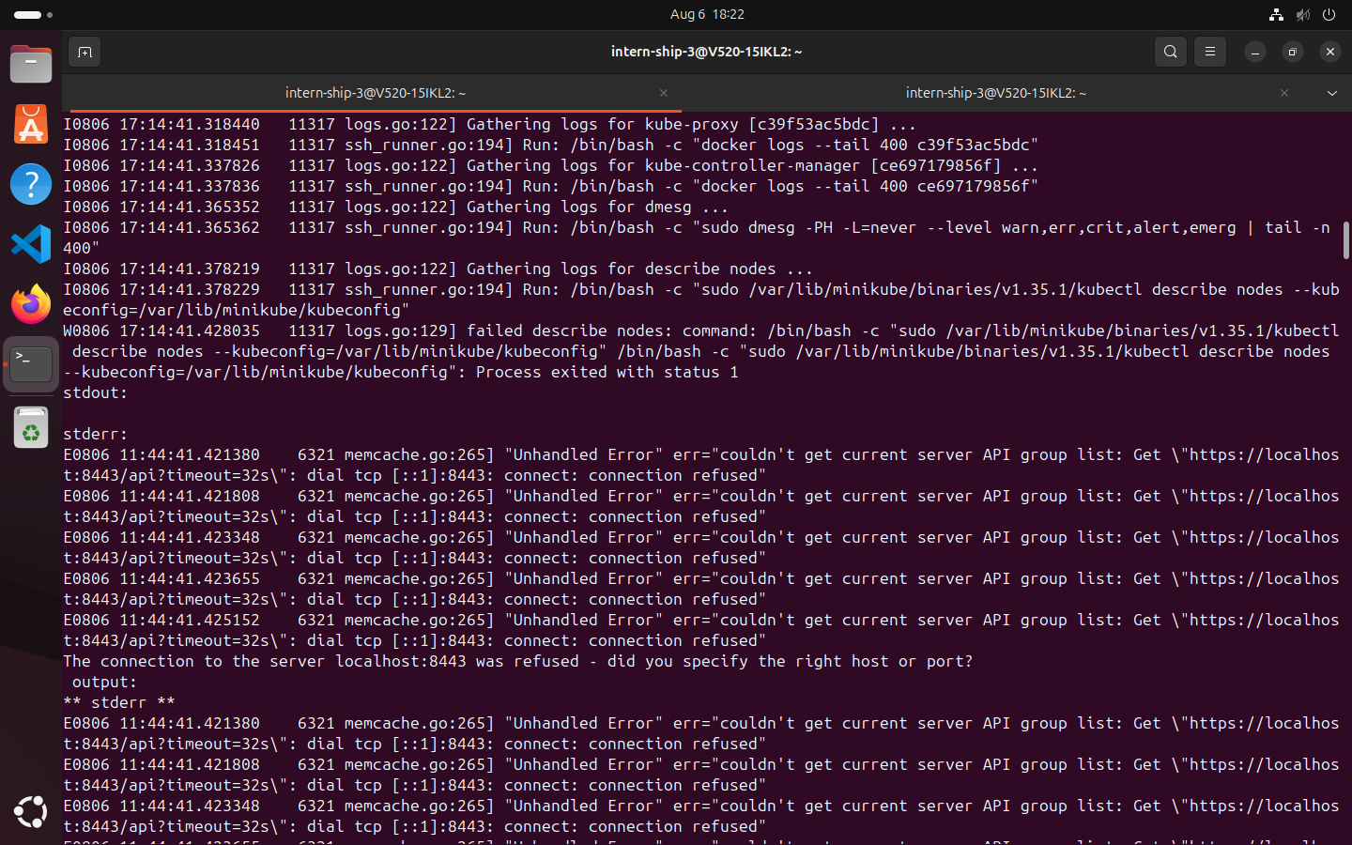
Figure 7: Full-window view of repeated API server connection-refused errors during log gathering, kubectl v1.35.1 used internally by minikube
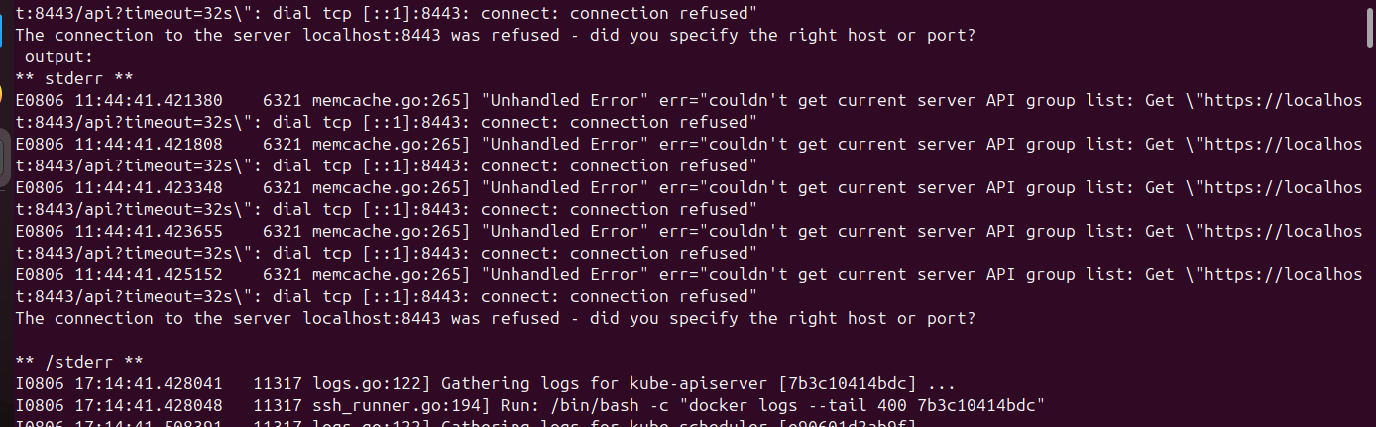
Figure 8: Connection-refused errors continuing while gathering kube-apiserver component logs
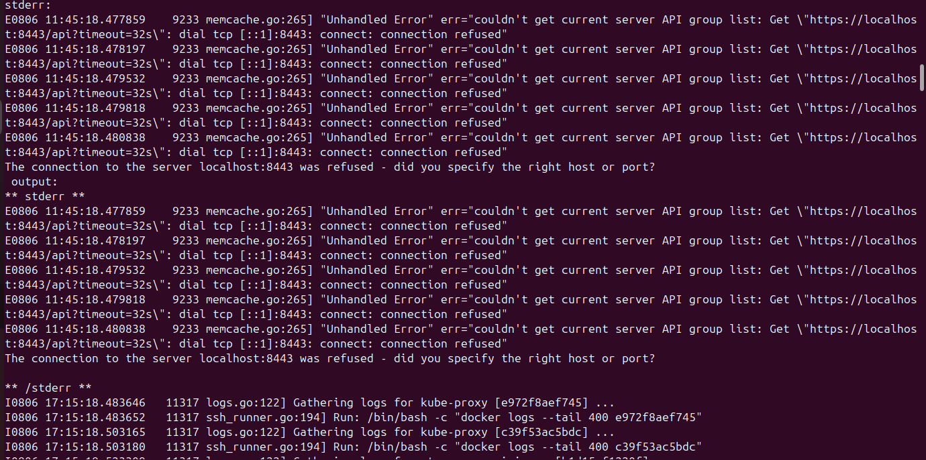
Figure 9: Further connection-refused errors while gathering kube-proxy logs
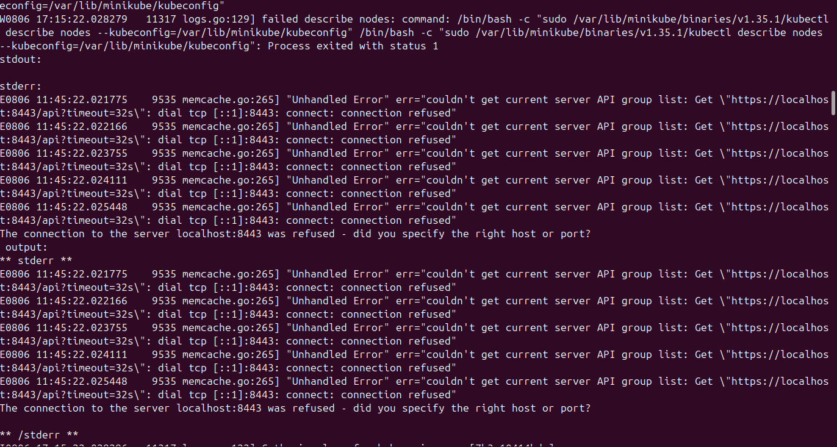
Figure 10: describe nodes failing again with the same memcache error signature

6.2 Docker daemon restart log
The Docker daemon's own journal (inside the Minikube node) showed it restoring containers and re-initializing after a restart: "Restoring containers: start.", clearing stale nftables rules ("Deleting nftables IPv4/IPv6 rules"), loading containers, initializing buildkit, and finally listening on /var/run/docker.sock, [::]:2376, and /run/docker.sock. Shortly afterward, the log showed repeated "Failed to get event" / "error reading from server: EOF" messages for the moby and plugins.moby namespaces, followed by "Stopping docker.service". This indicates the Docker service inside the Minikube node was restarted (or was in the process of restarting) around this time, which is consistent with the API server subsequently being unreachable.
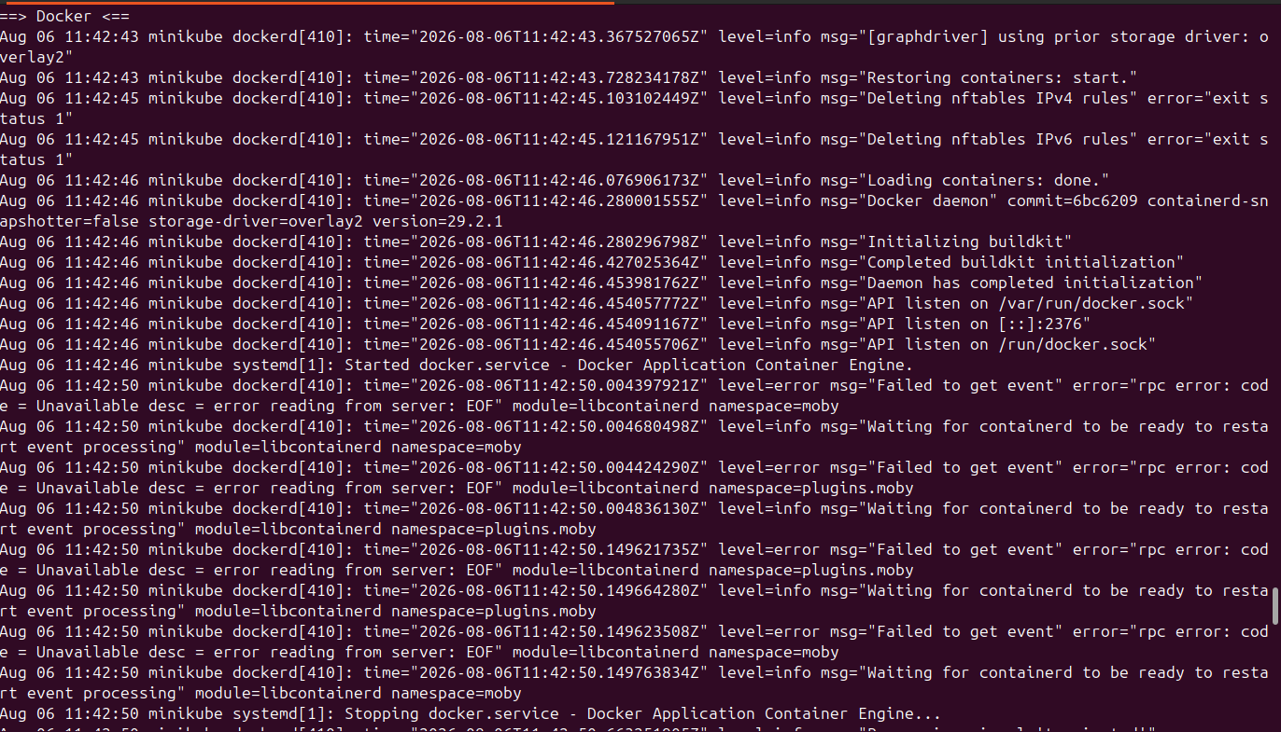
Figure 11: Docker daemon journal inside the Minikube node — restoring containers, initializing buildkit, then event errors and service stop

6.3 Container status inside Minikube
The minikube log bundle's container status table showed every Kubernetes system container — storage-provisioner, kube-controller-manager, the nginx deployment pods, coredns, kube-proxy, etcd, kube-scheduler, and kube-apiserver — in the Exited state, with a "created" age of 4 months. This confirmed that none of the core control-plane containers were currently running.
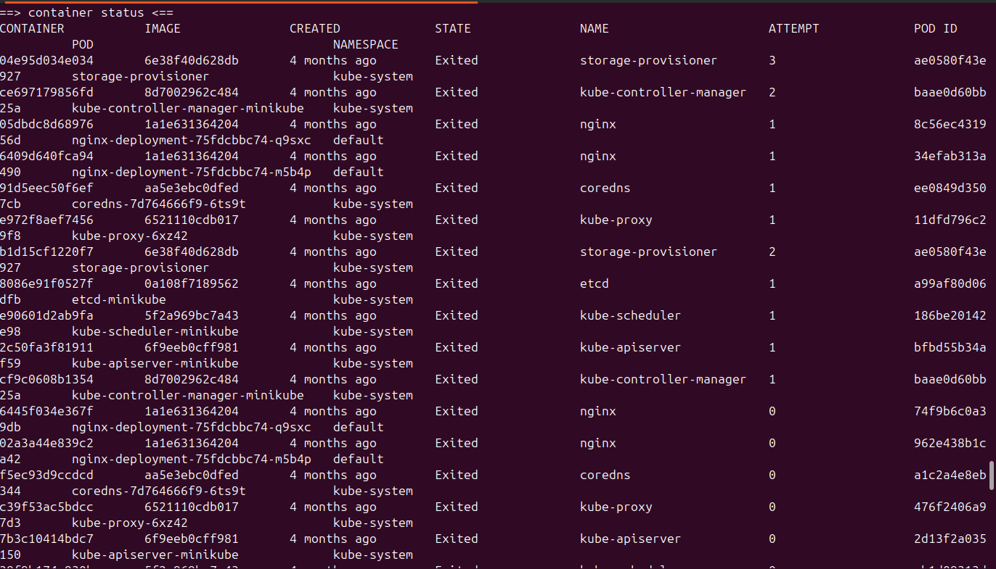
Figure 12: Container status table — all Kubernetes system containers (etcd, kube-apiserver, coredns, kube-scheduler, etc.) shown as Exited, ~4 months old

6.4 CoreDNS logs
The CoreDNS container logs (for containers 91d5eec50f6e and f5ec93d9ccdc) showed CoreDNS-1.13.1 starting up repeatedly with "waiting for Kubernetes API before starting server" and "Plugins not ready: 'kubernetes'", then eventually starting with an unsynced Kubernetes API, followed shortly after by "[ERROR] plugin/kubernetes: Failed to watch" and a SIGTERM shutdown going into lameduck mode. This is consistent with CoreDNS being unable to maintain a connection to an API server that was not reliably available.
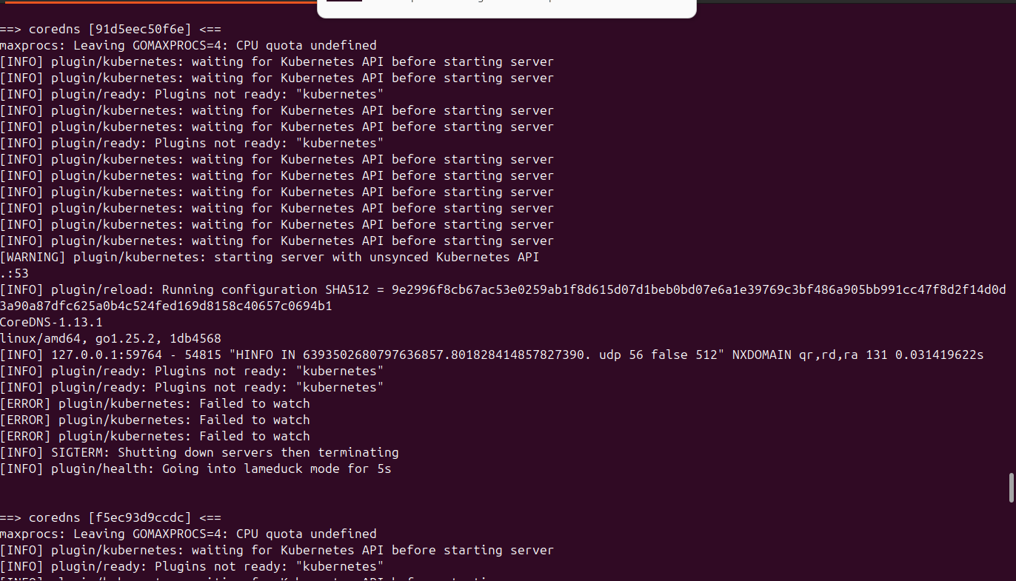
Figure 13: CoreDNS logs — waiting for the Kubernetes API, plugin not ready
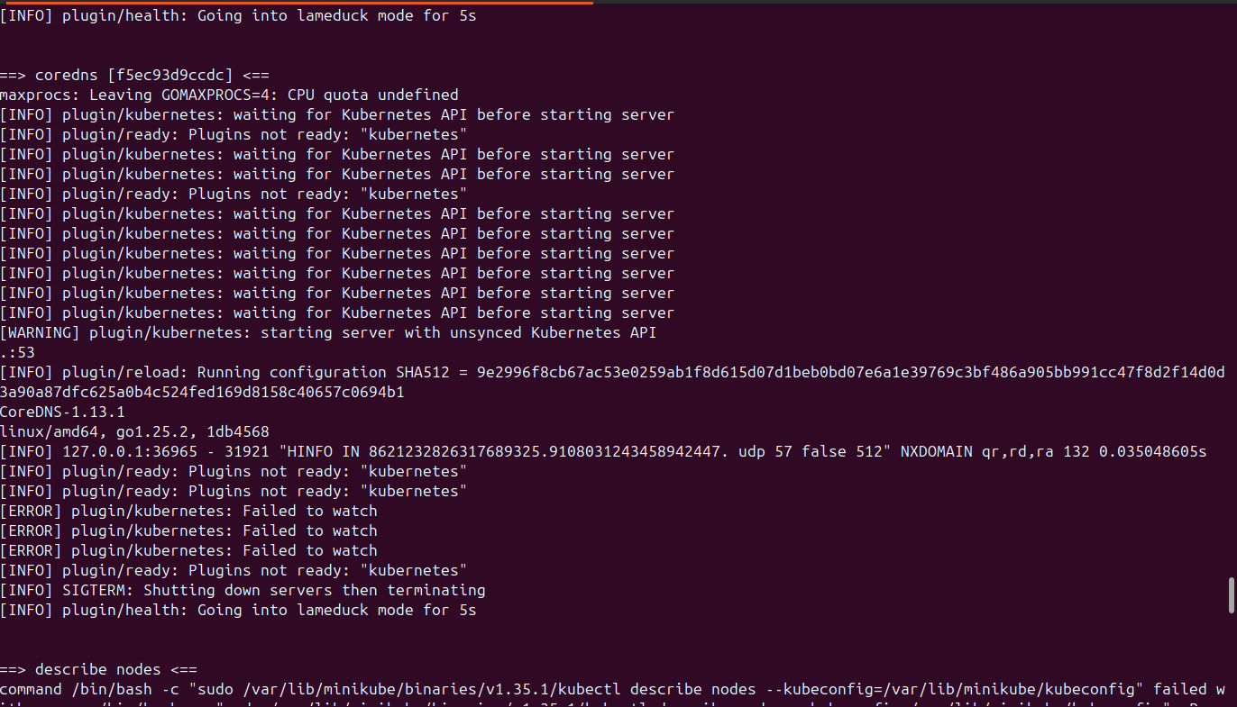
Figure 14: CoreDNS logs continuing into a second container instance, then the start of another "describe nodes" attempt
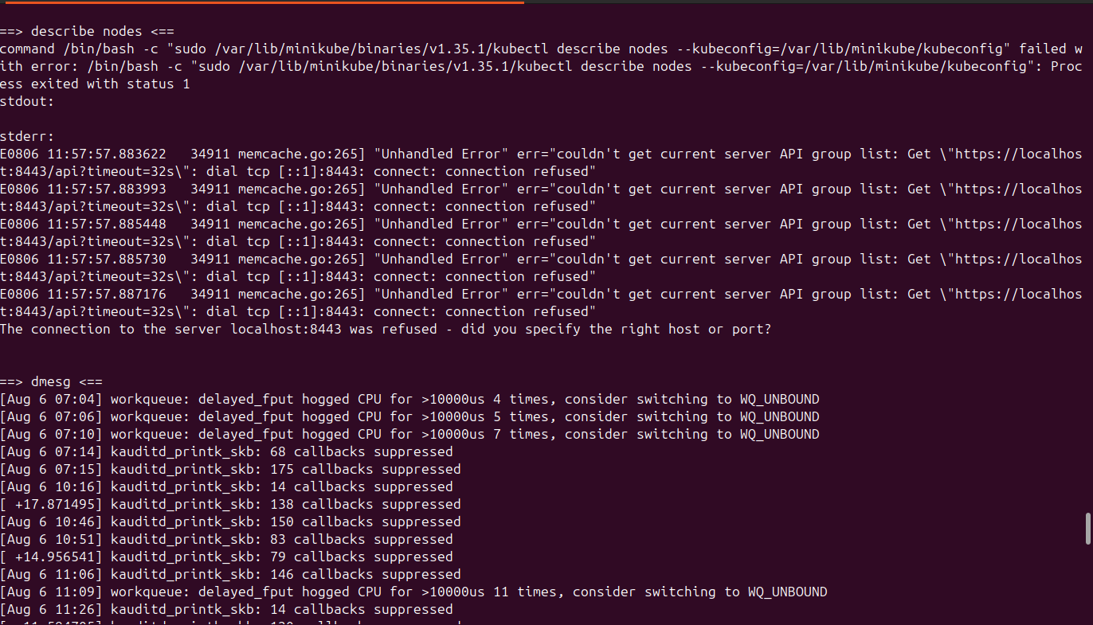
Figure 15: describe nodes failing again, followed by dmesg kernel log entries (workqueue and audit callback warnings)

6.5 etcd trace logs
The etcd component logs (container 42447408debc) showed internal raft transaction traces, several marked as warnings such as "apply request took too long" (around 260–300ms against an expected duration of 100ms) for read-only range requests on keys under /registry/pods/... and /registry/services/endpoints/default/nginx. These are etcd performance/latency warnings from historical activity in the log bundle, not confirmation of the current outage on their own, but they show the etcd instance had been under some load in the period covered by the logs.
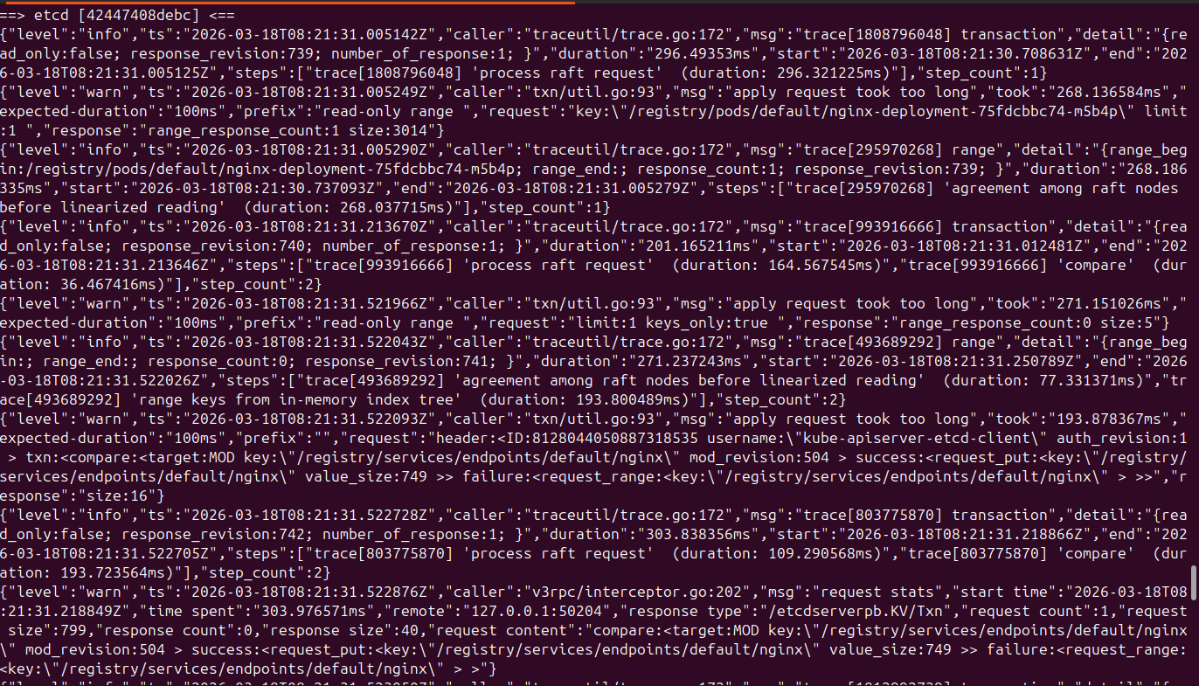
Figure 16: etcd raft/transaction trace logs, including "apply request took too long" warnings

7. Phase 3 — Structured Diagnosis (Version Check, minikube status, docker ps, crictl)
In a further session, a more structured diagnostic pass was carried out: confirming tool versions, checking minikube status directly, inspecting the Minikube node's Docker container from the host, and inspecting the Kubernetes component containers running inside that node using crictl.

7.1 Tool version verification and minikube status
kubectl version --client
minikube version
docker --version
minikube status
The version checks confirmed kubectl Client Version v1.35.2 (Kustomize v5.7.1), Minikube version v1.38.1 (commit c93a4cb9311efc66b90d33ea03f75f2c4120e9b0), and Docker version 28.2.2. minikube status was then run directly, and its output was:
minikube
type: Control Plane
host: Stopped
kubelet: Stopped
apiserver: Stopped
kubeconfig: Stopped
This confirmed, from Minikube's own status check rather than indirect log evidence, that at this point in time the entire control plane was down: the Minikube host itself was Stopped (the node container was not running at all at this moment), kubelet was Stopped, the API server was Stopped, and even kubeconfig was reported as Stopped (meaning Minikube did not consider the cluster configured/reachable at all).
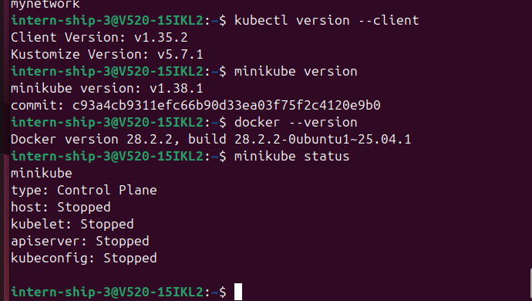
Figure 17: kubectl / minikube / docker version checks, followed by minikube status showing the entire control plane Stopped

7.2 Inspecting the Minikube node's Docker container
docker ps -a --filter name=minikube
This showed the Minikube node container itself: ID 6a9f5231c6a8, image gcr.io/k8s-minikube/kicbase:v0.0.50, created 3 days earlier, and at this point in the check its status was "Up 9 minutes" (i.e. it had since been restarted and was running by the time this check was made), with ports 127.0.0.1:32768->22/tcp, 127.0.0.1:32769->2376/tcp, 127.0.0.1:32770->5000/tcp, 127.0.0.1:32771->8443/tcp, and 127.0.0.1:32772->32443/tcp mapped to the host, named minikube.
This is an important distinction: this single Docker container is the Minikube node itself. The individual Kubernetes components (API server, etcd, scheduler, kubelet, CoreDNS, etc.) are not separate host-level Docker containers — they run as containers managed by a container runtime inside this one node container, and are only visible via tools like crictl run inside the node (see 7.3 below).
docker logs minikube --tail 100
This pulled the last 100 lines of the Minikube node container's own boot log, which showed a normal systemd startup sequence: mounting dev-hugepages, kernel debug and trace filesystems, loading kernel modules (configfs, dm_mod, fuse, loop) via modprobe, and starting systemd-journald and systemd-modules-load, followed by remounting the root filesystem read-write. This confirmed the node container itself was booting normally at the OS level.
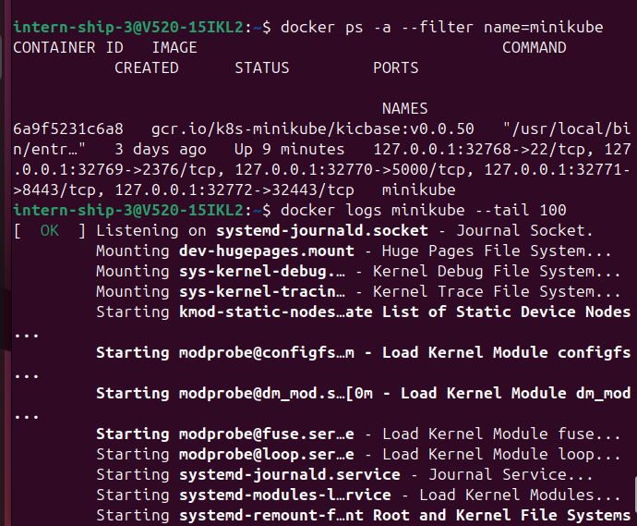
Figure 18: docker ps -a --filter name=minikube (node container Up 9 minutes) and the start of docker logs minikube --tail 100

7.3 Confirming Kubernetes component containers only exist inside the node
docker ps -a --filter name=kube-apiserver
docker ps -a --filter name=etcd
docker ps -a --filter name=kube-controller-manager
docker ps -a --filter name=kube-scheduler
Each of these host-level filtered checks returned an empty result (header row only, no matching containers). This confirmed that kube-apiserver, etcd, kube-controller-manager, and kube-scheduler do not exist as containers on the host's own Docker daemon — they only exist inside the Minikube node, and had to be inspected using crictl over minikube ssh instead.
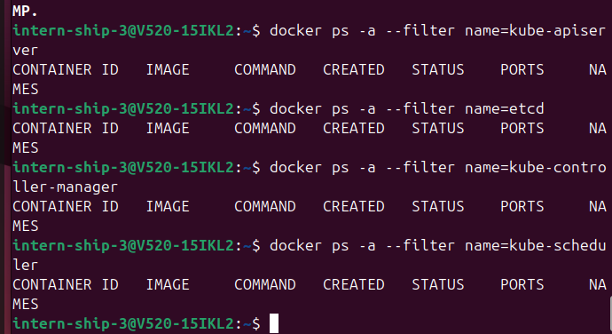
Figure 19: docker ps -a filtered by kube-apiserver, etcd, kube-controller-manager, and kube-scheduler — all empty on the host

7.4 Inspecting Kubernetes containers inside the node with crictl
minikube ssh -- sudo crictl ps -a
This command connects to the Minikube node over SSH and lists all containers known to the node's container runtime (crictl is the CLI for the Container Runtime Interface). The output listed the Kubernetes system containers together with their pod and namespace context, all in the Exited state, all created about 4 months earlier: storage-provisioner (attempt 3, pod storage-provisioner, kube-system), kube-controller-manager (attempt 2, pod kube-controller-manager-minikube, kube-system), nginx (attempt 1, two separate pods nginx-deployment-75fdcbbc74-q9sxc and nginx-deployment-75fdcbbc74-m5b4p, default namespace), coredns (pod coredns-7d764666f9-6ts9t, kube-system), kube-proxy (pod kube-proxy-6xz42, kube-system), a second storage-provisioner entry (attempt 2), etcd (pod etcd-minikube, kube-system), kube-scheduler (pod kube-scheduler-minikube, kube-system), kube-apiserver (container ID beginning 2c50fa3f81911, pod kube-apiserver-minikube, kube-system), and a further kube-controller-manager entry (container ID beginning cf9c0608b1354).
The "~4 months ago" age recorded for these containers is consistent with the earlier working session documented in Phase 1 of this report (which took place in March), suggesting these are the same original control-plane containers that were never successfully recreated in the later sessions — the cluster had been left in a stopped state since then and had not returned to a healthy running state by the time of this check.
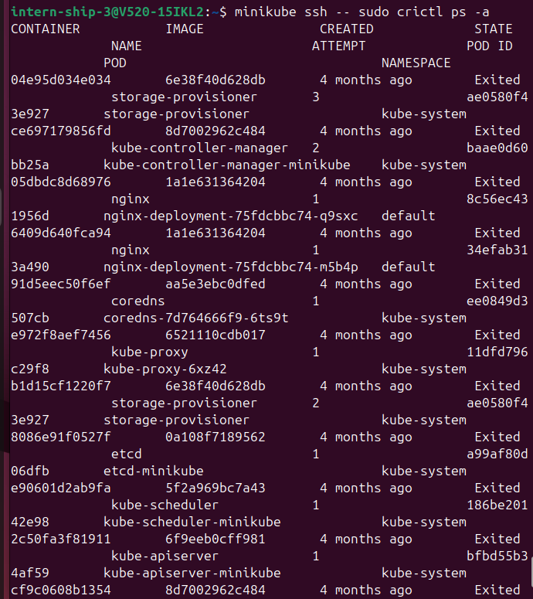
Figure 20: minikube ssh -- sudo crictl ps -a — all Kubernetes system containers listed as Exited, ~4 months old

7.5 A command-usage error while exploring crictl
minikube ssh -- sudo crictl pods -a
This attempt failed with "Incorrect Usage: flag provided but not defined: -a", followed by crictl printing its own usage/help text for the pods sub-command, and exiting with FATA[0000] flag provided but not defined: -a / ssh: Process exited with status 1. Unlike crictl ps, the crictl pods sub-command does not accept a bare -a flag in this version of crictl; the help text listed the valid options instead (--id, --label, --last/-n, --latest/-l, --name, --namespace, --no-trunc, --output/-o, --quiet/-q, --state, --verbose). This was a command-syntax mistake rather than a cluster problem, and was documented here as part of the actual troubleshooting sequence rather than corrected silently.
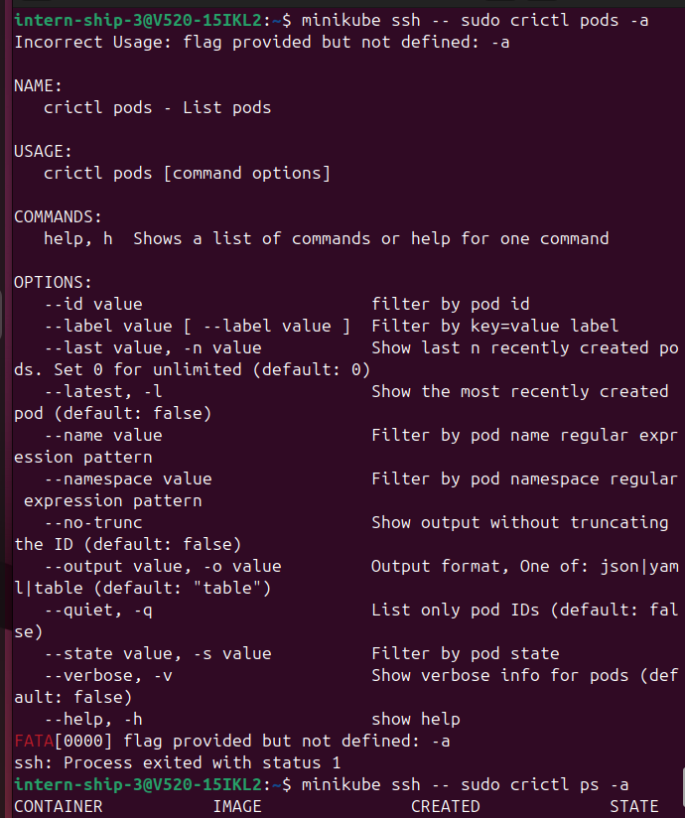
Figure 21: minikube ssh -- sudo crictl pods -a failing with an unrecognised flag, and crictl printing its usage help
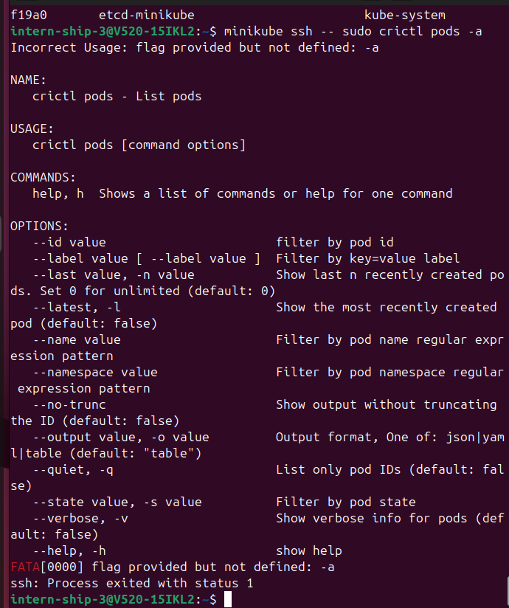
Figure 22: Continuation of the crictl pods -a usage error, with the tail end of the earlier crictl ps -a output visible above (etcd-minikube, kube-system)

8. Troubleshooting Summary

Problem: Kubernetes API server unreachable (connection refused on localhost:8443)
Evidence: Repeated "dial tcp [::1]:8443: connect: connection refused" and "The connection to the server localhost:8443 was refused" errors during minikube log collection and describe nodes attempts (Section 6.1); minikube status directly reporting apiserver: Stopped and kubeconfig: Stopped (Section 7.1); and crictl ps -a showing the kube-apiserver container itself in the Exited state (Section 7.4).
Technical meaning: The Kubernetes API server is the single component every other tool (kubectl, minikube's own log collector, CoreDNS) talks to. When it is not running, port 8443 has nothing listening on it, so every dependent command fails with the same "connection refused" signature.
Investigation performed: minikube logs collection, inspection of the Docker daemon journal inside the node, review of the container status table, CoreDNS and etcd log inspection, direct minikube status check, host-level docker ps filtering to rule out the components being separate host containers, and crictl ps -a inside the node to confirm the actual state of the control-plane containers.
Result: Not resolved within the sessions captured in this report. At the last point checked, minikube status showed the full control plane Stopped, and although the Minikube node's own Docker container was later observed running ("Up 9 minutes" in Section 7.2), the Kubernetes control-plane containers inside it (kube-apiserver, etcd, kube-scheduler, kube-controller-manager) were still shown as Exited by crictl. No screenshot in this set shows minikube status subsequently reporting a healthy, fully Running control plane, so this should be treated as an open issue requiring a minikube start / minikube delete && minikube start attempt in a future session.

Problem: Incorrect crictl flag usage
Evidence: minikube ssh -- sudo crictl pods -a failed with "flag provided but not defined: -a".
Technical meaning: crictl pods does not support the -a flag in the installed crictl version; it is a different sub-command from crictl ps and has its own option set.
Investigation performed: The command's own help output was reviewed to identify the correct available flags.
Result: Command usage corrected for future reference; the correct diagnostic data for this troubleshooting session was instead obtained using crictl ps -a.

9. Docker vs Kubernetes — Practical Comparison
Docker | Kubernetes
Runs individual containers | Orchestrates many containers across a cluster
docker ps shows containers on one host | kubectl get pods shows pods, which may be scheduled on any node
Manual container restart (docker restart) | Deployments automatically recreate failed pods (self-healing)
Port mapping (-p host:container) | Services (ClusterIP/NodePort) provide stable network endpoints
One container = one instance | A Deployment manages a desired number of replica pods
No built-in service discovery | Pods can reach each other by Service name (e.g. product-service:5000)
This distinction was directly observed in this practical: docker ps -a on the host could not see the Kubernetes component containers at all (Section 7.3), because Kubernetes runs its own container runtime and scheduling layer inside the Minikube node, separate from the host's own Docker containers.

10. Learning Outcomes
- Understood the roles of pods, deployments, and services, and observed Kubernetes service discovery working in practice (order-api reaching product-service by name).
- Learned to read kubectl get pods / get deployments / get services output, including interpreting READY, UP-TO-DATE, AVAILABLE, and AGE columns.
- Understood the purpose and meaning of each field in minikube status (host, kubelet, apiserver, kubeconfig).
- Learned to distinguish between the Minikube node itself (a single Docker container on the host, inspected with docker ps) and the Kubernetes components running inside that node (inspected with crictl over minikube ssh).
- Practiced reading and interpreting a "connection refused" API server error and tracing it back through multiple log sources (minikube logs, Docker daemon journal, CoreDNS logs, crictl container status) to build a coherent picture of an unhealthy control plane.
- Learned that Kubernetes system container names such as kube-apiserver or etcd will not appear in a host-level docker ps filter when running under the Minikube Docker driver, since they belong to the runtime inside the node.

11. Conclusion
This practical combined two parts of Kubernetes learning: first, working directly with a healthy cluster using kubectl to inspect pods, deployments, and services and to confirm service-to-service communication inside the cluster; and second, a real troubleshooting exercise after the cluster was found to be unhealthy in a later session. The investigation moved systematically from kubectl-level symptoms (connection refused) through Minikube's own status reporting, into the Docker layer that hosts the Minikube node, and finally into the container runtime inside the node using crictl, in order to correctly localise the problem to the Kubernetes control-plane containers rather than the underlying Docker installation. As of the last screenshot available for this report, the control plane had not yet been confirmed healthy again, and restarting/recreating the Minikube cluster is the logical next troubleshooting step.

12. Command Summary Table
Sr. No. | Command | Purpose | Result
1 | kubectl get pods | List pods in the current namespace | 6 pods listed; nginx pods Running, order/product deployment pods Running
2 | kubectl exec -it <pod> -- sh | Open a shell inside a pod container | Failed with placeholder name, succeeded with actual pod name
3 | curl product-service:5000/product | Test service-to-service communication inside the cluster | Returned product JSON successfully
4 | kubectl get deployments | List deployments and replica status | nginx-deploy 3/3; product-deployment 0/1 (starting)
5 | kubectl get services | List cluster services and their ClusterIPs/ports | kubernetes, order-service, product-service listed
6 | kubectl version --client | Check kubectl client version | v1.35.2
7 | minikube version | Check Minikube version | v1.38.1
8 | docker --version | Check host Docker version | 28.2.2
9 | minikube status | Check cluster/control-plane health | host/kubelet/apiserver/kubeconfig: Stopped
10 | docker ps -a --filter name=minikube | Inspect the Minikube node's Docker container | Node container Up 9 minutes, ports mapped
11 | docker logs minikube --tail 100 | View the Minikube node's own boot log | Normal systemd boot sequence
12 | docker ps -a --filter name=<component> | Check for K8s component containers on the host | Empty for kube-apiserver, etcd, kube-controller-manager, kube-scheduler
13 | minikube ssh -- sudo crictl ps -a | List containers inside the Minikube node runtime | All K8s system containers Exited, ~4 months old
14 | minikube ssh -- sudo crictl pods -a | Attempt to list pods inside the node | Failed — unsupported -a flag; usage help shown

13. Screenshot-to-Command Mapping
Figure | Command / Activity | Result
Figure 1 | kubectl get pods, then kubectl exec (fail then success) | 6 pods listed; exec succeeded on second attempt
Figure 2 | kubectl exec + curl product-service | Product JSON returned
Figure 3 | kubectl get deployments | nginx-deploy 3/3, product-deployment 0/1
Figure 4 | kubectl get services | 3 ClusterIP services listed
Figure 5 | minikube log collection begins | First describe-nodes failure
Figure 6 | describe nodes error detail | Repeated connection-refused errors
Figure 7 | Full-window log gathering | Connection-refused errors continue
Figure 8 | kube-apiserver log gathering | Connection-refused errors
Figure 9 | kube-proxy log gathering | Connection-refused errors
Figure 10 | describe nodes retry | Same memcache error
Figure 11 | Docker daemon journal (node) | Restart / restoring containers sequence
Figure 12 | Container status table | All K8s system containers Exited, 4 months old
Figure 13 | CoreDNS logs | Waiting for Kubernetes API
Figure 14 | CoreDNS logs continued | Second container instance, same pattern
Figure 15 | describe nodes fail + dmesg | Connection refused; kernel warnings
Figure 16 | etcd trace logs | Apply request took too long warnings
Figure 17 | Version checks + minikube status | All versions confirmed; control plane Stopped
Figure 18 | docker ps filter minikube + docker logs | Node container Up 9 minutes; normal boot log
Figure 19 | docker ps filter K8s component names | Empty — components not on host
Figure 20 | crictl ps -a | K8s containers Exited, ~4 months old
Figure 21 | crictl pods -a (fail) | Unsupported flag error + usage help
Figure 22 | crictl pods -a (continued) | Same error, prior ps -a output visible above

14. Questions a Reviewer May Ask
What is Kubernetes?
A container orchestration platform that manages the deployment, scaling, and networking of multiple containers across a cluster, rather than managing one container at a time like plain Docker.
What is Minikube?
A tool that runs a small, single-node Kubernetes cluster locally, useful for learning and development, without needing a full multi-machine cluster.
Why did you use the Docker driver for Minikube?
The Docker driver runs the Minikube node as a Docker container on the host, which is simple to set up and matches the Docker environment already installed and verified on this machine.
What is a Kubernetes control plane?
The set of components — API server, etcd, scheduler, and controller-manager — that together manage the state of the whole cluster.
What is kubelet?
The agent running on a node that makes sure the containers described in a pod's specification are actually running on that node.
What does the API server do?
It is the single entry point for the whole cluster; kubectl and every other component read and write cluster state through it.
Why did "connection refused" on localhost:8443 occur?
Because the kube-apiserver container itself was not running (confirmed later by minikube status and crictl ps -a), so nothing was listening on port 8443 for kubectl or Minikube's tools to connect to.
What is a Pod?
The smallest deployable unit in Kubernetes — one or more containers that share the same network and storage, scheduled together on a node.
What is a Deployment?
A resource that manages a set of identical pod replicas, automatically recreating pods if they fail, to keep the actual state matching the desired state.
What is a Service?
A stable network name and IP that lets other pods reach a set of pods without needing to track individual pod IP addresses, which can change.
What is the difference between Docker and Kubernetes?
Docker builds and runs individual containers on one machine; Kubernetes orchestrates many containers, potentially across many machines, handling scheduling, scaling, networking, and self-healing.
Why did you use crictl?
Because the Kubernetes component containers (API server, etcd, etc.) run inside the Minikube node's own container runtime, not as separate containers on the host's Docker daemon, so crictl (run via minikube ssh) was needed to see their real state.
What is the difference between the Docker CLI and kubectl?
The Docker CLI manages containers directly on a single Docker host; kubectl talks to the Kubernetes API server to manage pods, deployments, and services across the cluster, regardless of which node they run on.
What does minikube status show?
The health of four things: the Minikube node itself (host), the kubelet agent, the API server, and whether kubeconfig is set up — each can be Running, Stopped, or Configured/Misconfigured independently.

