Docker Containerization and Practical Implementation on Ubuntu
Internship Practical Report
Environment: intern-ship-3@V520-15IKL2 | Ubuntu 25.04 (plucky) | Docker 28.2.2

1. Introduction
This report documents the practical work carried out during the Docker training session of the internship. Docker is a containerization platform that allows an application, along with all of its dependencies, to be packaged into a single lightweight, portable unit called a container. Unlike a virtual machine, a container shares the host operating system kernel, which makes it much lighter and faster to start.
During this practical, the Docker Engine was verified on the intern workstation, and hands-on work was carried out with Docker images and containers using the official Docker CLI. The steps below were performed directly on the terminal and are documented here exactly as they were executed, along with the actual output produced by the system.

2. Objectives
- To verify that Docker is correctly installed and running on the system.
- To understand basic Docker CLI help commands and how to use them for reference.
- To understand what a Docker image is and how to search, pull, and list images.
- To create and run a container from the Ubuntu base image and execute commands inside it.
- To understand the difference between running and stopped containers using docker ps.

3. System Environment
The following environment details were observed directly from the terminal during the practical:
Component | Version / Detail
Operating System | Ubuntu 25.04 "plucky" (lsb_release -a)
Docker Client/Server | 28.2.2, build 28.2.2-0ubuntu1~25.04.1
Minikube | v1.38.1 (commit c93a4cb9311efc66b90d33ea03f75f2c4120e9b0)
Cgroup Driver / Version | systemd / 2
Storage Driver | overlay2
Memory (free -h) | Total 15Gi, Used 2.5Gi, Available 12Gi
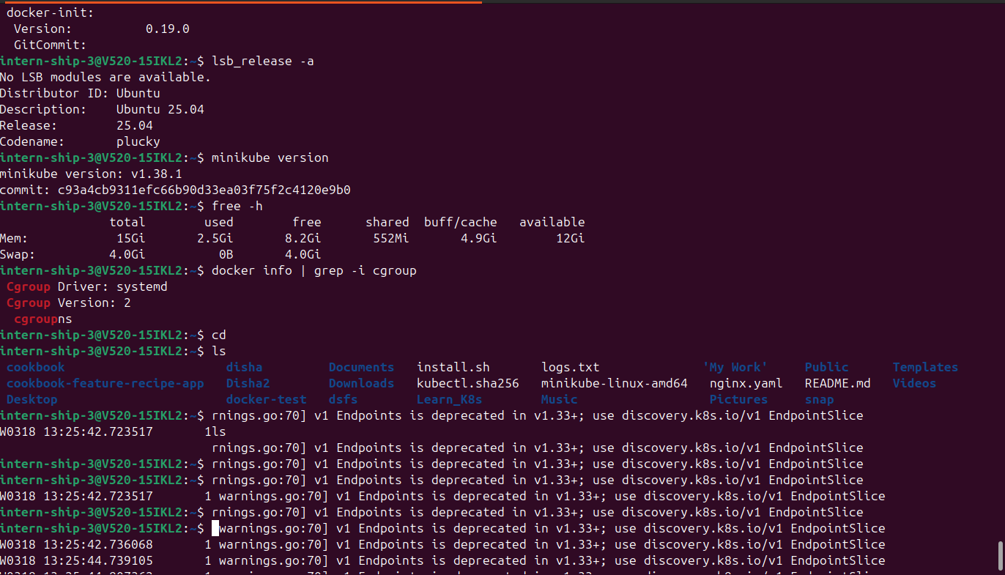
Figure 1: System check — lsb_release -a, minikube version, free -h, docker info | grep -i cgroup, and home directory listing

4. Docker Installation and Verification
Before starting any container work, the Docker installation was verified using the version and info commands, and the Docker service status was checked and enabled so that it starts automatically on boot.

4.1 docker --version
docker --version
The command confirmed Docker Client/Server version 28.2.2 was installed on the system.
Figure 2: Docker version verification

4.2 docker info
docker info
This command gave a detailed system-wide summary of the Docker installation. The output showed the Docker Client version (28.2.2) and Server version (28.2.2), Buildx and Compose plugin versions, and at the time of this check the daemon reported 3 containers (all Stopped, 0 Running) and 5 images. The Storage Driver was overlay2, the Cgroup Driver was systemd (Cgroup Version 2), and the Logging Driver was json-file.
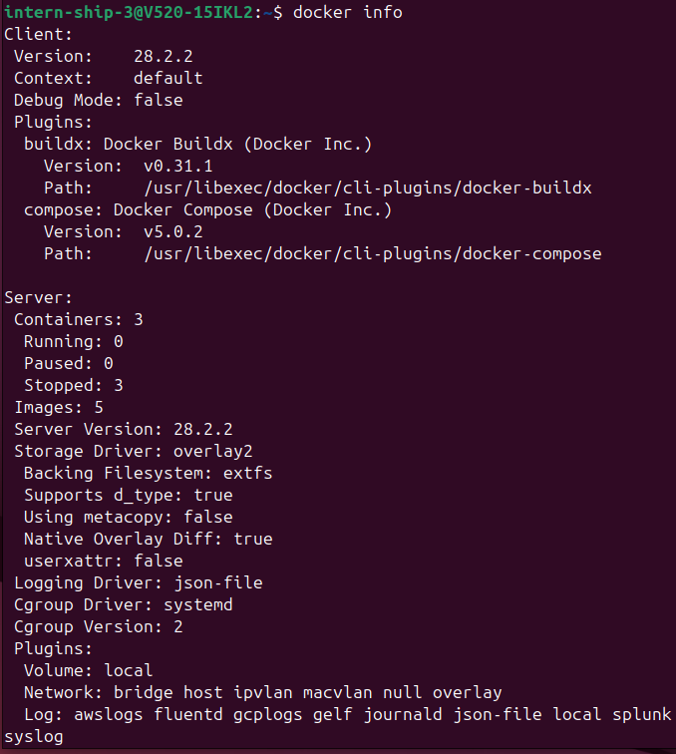
Figure 3: docker info output showing client/server details, storage driver, and cgroup configuration

4.3 Checking and enabling the Docker service
sudo systemctl status docker
The service status confirmed docker.service was active (running) since Mon 2026-08-10 14:10:44 IST, with the main process (dockerd) running under PID 1770. The journal log lines at the bottom confirmed the daemon had started correctly.
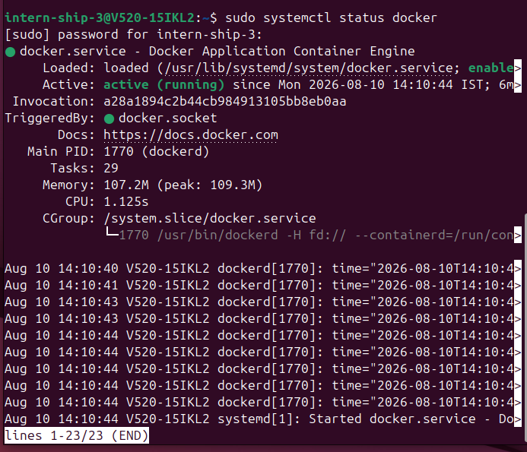
Figure 4: docker.service status — active (running)
sudo systemctl enable docker
This command was used to enable the Docker service so that it starts automatically at every system boot. The output confirmed that the sysv-install script executed successfully to synchronize the service state.
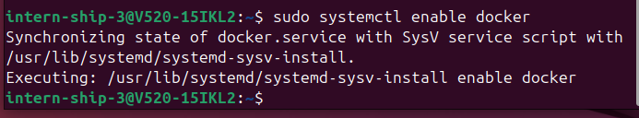
Figure 5: Enabling docker.service to start on boot

4.4 Testing Docker with hello-world
sudo docker run hello-world
The hello-world image is a minimal test image used to confirm that a Docker installation is working correctly end-to-end. Running it exercises the full workflow: the Docker client contacts the daemon, the daemon pulls the hello-world image from Docker Hub, creates a new container from that image, runs it, and streams the container output back to the terminal. The output received began with "Hello from Docker!" and confirmed that the installation was working correctly.
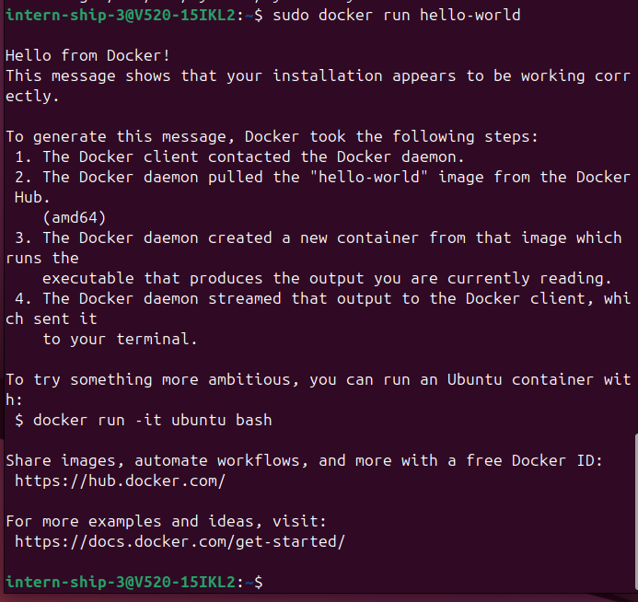
Figure 6: Successful hello-world container run confirming the Docker installation

5. Docker Help Commands
Before working further with images and containers, the built-in help commands were explored. These are useful because they list every available sub-command and option directly from the CLI without needing to refer to external documentation.

5.1 docker --help
docker --help
This listed the top-level Docker command structure, dividing it into Common Commands (run, exec, ps, build, pull, push, images, login, search, version, info) and Management Commands (builder, buildx, compose, container, image, network, plugin, system, trust, volume) as well as Swarm commands.
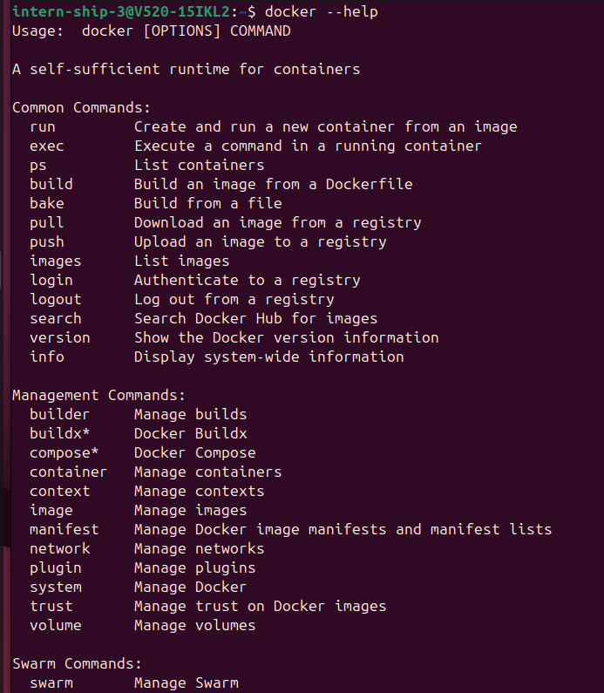
Figure 7: docker --help output

5.2 docker images --help
docker images --help
This displayed the usage and options for listing images, including aliases (docker image ls, docker image list) and flags such as -a (show all images), --digests, -f/--filter, and -q (quiet, only show image IDs).
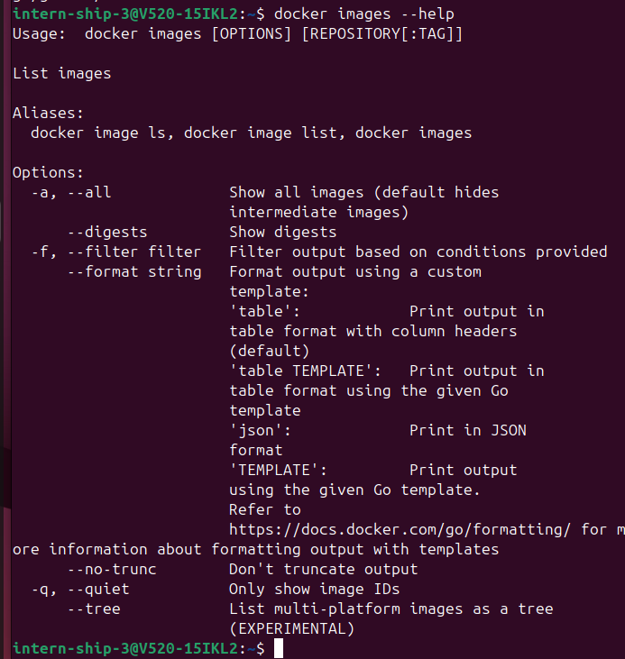
Figure 8: docker images --help output

5.3 docker container --help
docker container --help
This showed the full set of container management sub-commands available under docker container, including create, exec, export, inspect, kill, logs, ls, pause, port, prune, rename, restart, rm, run, start, stats, stop, and top.
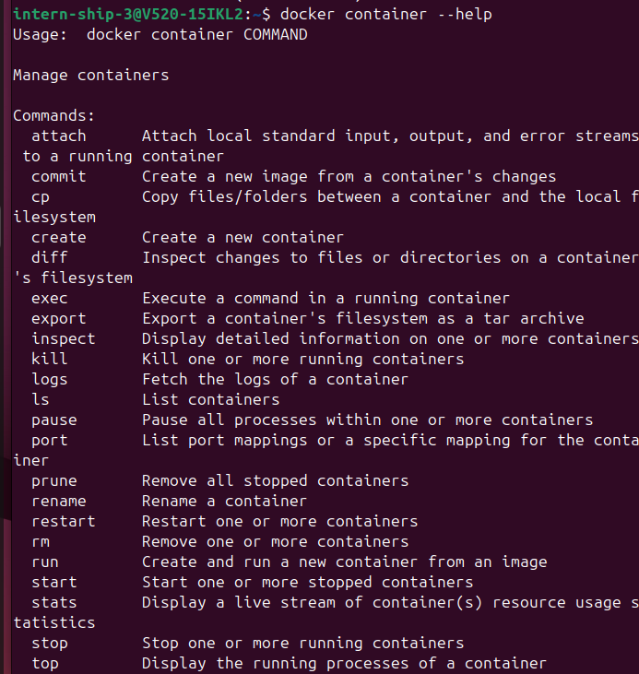
Figure 9: docker container --help output

6. Docker Images
A Docker image is a read-only template that contains the application code, runtime, libraries, and dependencies required to run an application. A container is a running (or stopped) instance created from an image. Multiple containers can be created from the same image, and each container runs in its own isolated environment while sharing the underlying image layers.

6.1 Listing existing images
docker images
docker image ls
Both commands are equivalent (image ls is an alias) and list all locally available images along with their repository name, tag, image ID, and creation date. At this point in the practical, five images were already present on the system: nginx (161MB), myapp (8.42MB), gcr.io/k8s-minikube/kicbase:v0.0.50 (1.37GB, used by minikube), myimage (8.44MB), and hello-world (10.1kB, from the earlier test).
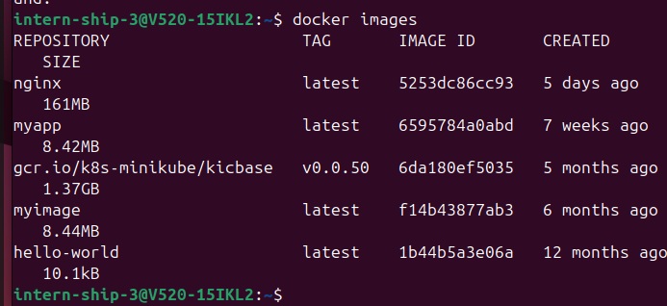
Figure 10: docker images — listing locally available images
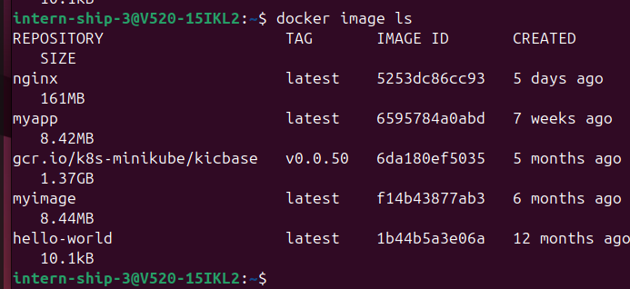
Figure 11: docker image ls — same listing using the alias command

6.2 Searching Docker Hub
docker search ubuntu
This command queried Docker Hub for images related to "ubuntu" without downloading anything. The results listed the official ubuntu image (17,864 stars, marked [OK] for official status) along with a number of community images built on Ubuntu, such as ubuntu/nginx, ubuntu/mysql, ubuntu/postgres, and ubuntu/python.
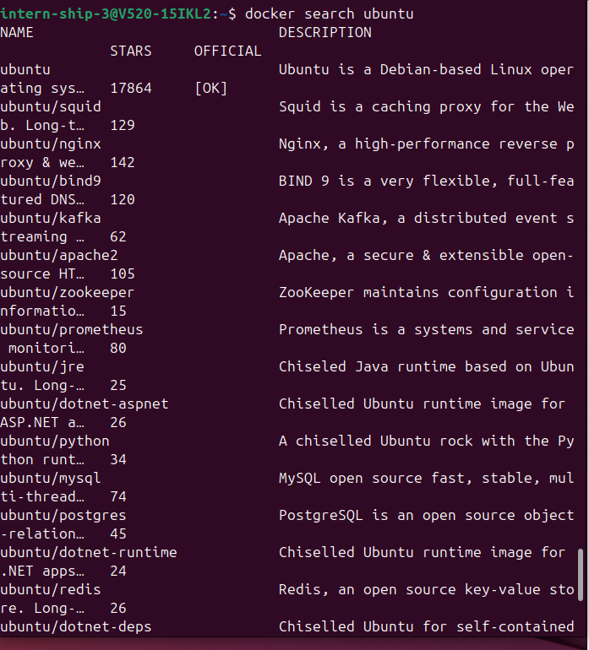
Figure 12: docker search ubuntu — searching Docker Hub for the Ubuntu image

6.3 Pulling images
docker pull ubuntu
This downloaded the ubuntu:latest image from Docker Hub. The output showed two image layers being pulled ("Pull complete"), and confirmed the digest sha256:678c6550cc43645e08669028bc177f50be4e7c5b8cca677067b1914d4afc7a03 was downloaded and tagged as docker.io/library/ubuntu:latest.
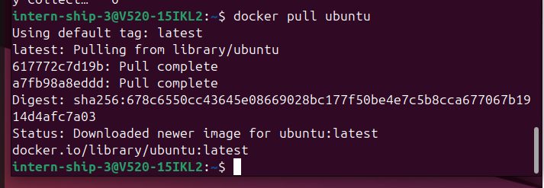
Figure 13: docker pull ubuntu — downloading the Ubuntu image
docker pull nginx
Since the nginx image was already present locally from earlier work, the output reported "Status: Image is up to date for nginx:latest" rather than downloading it again.
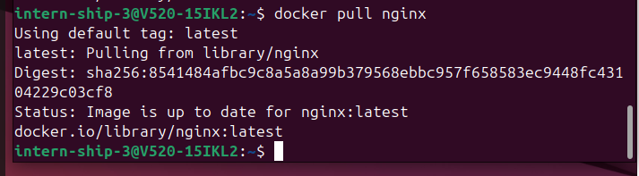
Figure 14: docker pull nginx — image already up to date

6.4 Removing and re-pulling an image
docker rmi ubuntu
This removed the ubuntu image that had just been pulled, along with its underlying layers. The output listed the image tag being untagged (ubuntu:latest) and each of the associated layer digests being deleted.
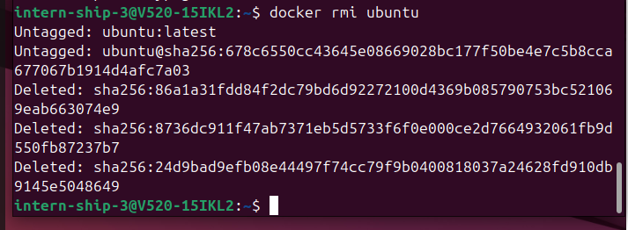
Figure 15: docker rmi ubuntu — removing the Ubuntu image and its layers
docker run ubuntu
Because the ubuntu image had just been removed, running it again produced "Unable to find image 'ubuntu:latest' locally", which triggered an automatic pull from Docker Hub before the container could be created. This demonstrated that docker run will fetch an image automatically if it is not already present on the host.
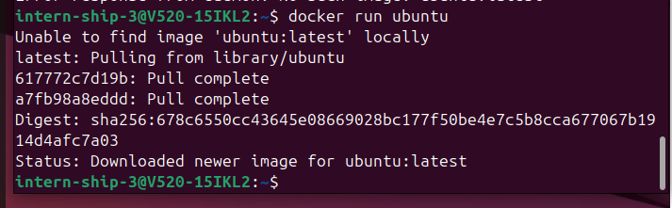
Figure 16: docker run ubuntu automatically re-pulling the image after it was removed

7. First Ubuntu Container (Interactive Mode)
docker run -it ubuntu
This command created and started a new container from the ubuntu image and dropped straight into an interactive shell inside it. The options used were:
- docker run — creates and starts a new container from the specified image.
- -i (interactive) — keeps STDIN open so commands can be typed into the container.
- -t (tty) — allocates a pseudo-terminal, giving a normal terminal-like experience.
- ubuntu — the image to base the container on.
The prompt changed to root@e0a74e2d1078:/#, confirming the shell was now running inside a new container (container ID e0a74e2d1078), logged in as the root user.
Figure 17: docker run -it ubuntu — dropped into an interactive shell inside the new container
Inside the container, the ls command was run to view the root filesystem:
ls
The output showed a standard Linux root directory structure (bin, boot, dev, etc, home, lib, lib64, media, mnt, opt, proc, root, run, sbin, srv, sys, tmp, usr, var), confirming this was a full, isolated Ubuntu filesystem separate from the host system.
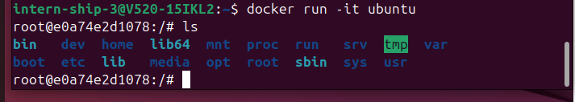
Figure 18: Root filesystem listing inside the running Ubuntu container

8. Container Listing and Management
docker ps
docker ps -a
docker ps lists only currently running containers, while docker ps -a lists all containers regardless of state (running, exited, or created). At the time this was checked, docker ps returned an empty list, meaning no container was running at that moment. docker ps -a, however, showed the full container history on the system, including:
Container ID | Image | Command | Status | Name
e0a74e2d1078 | ubuntu | "/bin/bash" | Exited (0) about a minute ago | strange_borg
0326e17861aa | ubuntu | "/bin/bash" | Exited (0) 3 minutes ago | friendly_saha
f44b92d9b3e9 | hello-world | "/hello" | Exited (0) 7 minutes ago | great_kilby
f303683f6b71 | myapp:latest | "echo 'Hello fr...'" | Exited (0) 2 hours ago | tender_haslett
6a9f5231c6a8 | gcr.io/k8s-minikube/kicbase:v0.0.50 | "/usr/local/bin/entr..." | Exited (130) 3 days ago | minikube
11e963575264 | nginx | "/docker-entrypoint..." | Exited (0) 4 days ago | jolly_nobel
This confirmed that although the Ubuntu container from the previous step had already exited (its shell session had ended), it still existed on disk in an exited state and could be restarted or removed if needed. Docker assigns a random human-readable name (such as strange_borg or friendly_saha) to a container automatically when no --name flag is given.
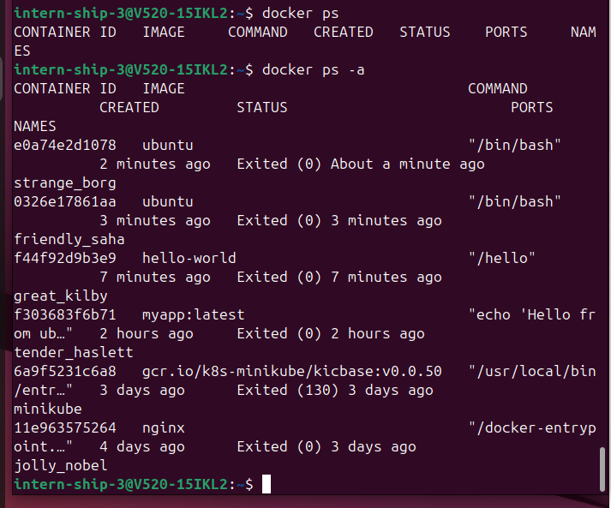
Figure 19: docker ps (empty — no running containers) and docker ps -a (full container history)

8.1 Re-checking images after the practical
docker images
A final images check showed the ubuntu image (86a1a31fdd84, 100MB, created 2 weeks ago based on its build date) now present again in the local image list, alongside nginx, myapp, kicbase, myimage, and hello-world, confirming the earlier pull/remove/re-pull sequence.
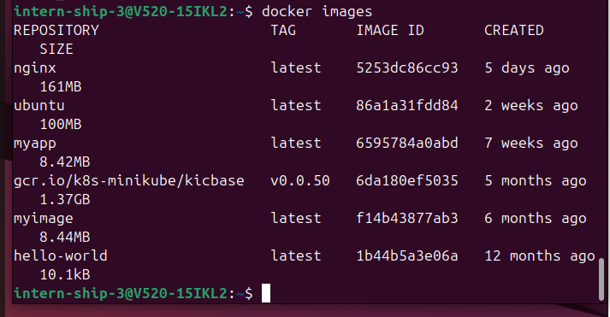
Figure 20: Final docker images listing at the end of the practical, including the re-pulled ubuntu image

9. Problems Encountered

Problem: Image not found when running a removed image
Cause: The ubuntu image had been explicitly removed using docker rmi ubuntu just before running docker run ubuntu again, so Docker could not find it locally.
Solution: No manual fix was needed — Docker automatically detected the missing image and pulled it fresh from Docker Hub before creating the container.
Result: Resolved automatically; the container was created successfully once the image finished downloading.

10. Key Technical Distinctions
Term | Meaning
Image | A read-only template used to create containers (e.g. ubuntu, nginx).
Container | A running or stopped instance created from an image (e.g. the Ubuntu container e0a74e2d1078).
docker ps | Lists only currently running containers.
docker ps -a | Lists all containers, running and exited.
docker pull | Downloads an image from a registry (Docker Hub) without creating a container.
docker run | Creates and starts a container from an image, pulling the image first if it is not already local.

11. Learning Outcomes
- Understood how to verify a Docker installation and confirm the Docker daemon is running using systemctl.
- Learned to use the built-in docker --help system to discover CLI commands and options without external references.
- Understood the distinction between an image and a container, and how docker pull, docker images, and docker run relate to each other.
- Practiced creating an interactive container from the Ubuntu base image and exploring its isolated filesystem.
- Learned to use docker ps and docker ps -a to distinguish between running and exited containers, and understood that exited containers still exist on disk until removed.

12. Conclusion
This practical provided hands-on experience with the core Docker workflow: verifying the installation, exploring CLI help, searching for and pulling images from Docker Hub, running containers in interactive mode, and inspecting container state using docker ps. The hello-world test and the Ubuntu interactive container together confirmed that Docker was installed and functioning correctly on the system, and the container listing commands gave a clear understanding of how Docker tracks container lifecycle state. This forms the foundation for the more advanced Docker topics (networking, volumes, and custom image builds) planned for later sessions.

13. Command Summary Table
Sr. No. | Command | Purpose
1 | docker --version | Check Docker client/server version
2 | docker info | View system-wide Docker information
3 | sudo systemctl status docker | Check whether the Docker service is running
4 | sudo systemctl enable docker | Enable Docker to start automatically on boot
5 | sudo docker run hello-world | Test the Docker installation end-to-end
6 | docker --help | List top-level Docker commands
7 | docker images --help | List options for the images command
8 | docker container --help | List container management sub-commands
9 | docker images / docker image ls | List locally available images
10 | docker search ubuntu | Search Docker Hub for an image
11 | docker pull ubuntu | Download the Ubuntu image from Docker Hub
12 | docker pull nginx | Download/update the Nginx image
13 | docker rmi ubuntu | Remove the Ubuntu image and its layers
14 | docker run ubuntu | Create and run a container, auto-pulling the image if missing
15 | docker run -it ubuntu | Run a container in interactive mode with a terminal
16 | ls (inside container) | View the container's root filesystem
17 | docker ps | List running containers
18 | docker ps -a | List all containers, including exited ones

14. Screenshot-to-Command Mapping
Figure | Command / Activity | Result
Figure 1 | System check (lsb_release, minikube version, free -h, docker info | grep cgroup) | Ubuntu 25.04, systemd/cgroup v2 confirmed
Figure 2 | docker --version | Docker 28.2.2
Figure 3 | docker info | Client/Server 28.2.2, overlay2, 5 images, 3 stopped containers
Figure 4 | sudo systemctl status docker | active (running)
Figure 5 | sudo systemctl enable docker | Enabled successfully
Figure 6 | sudo docker run hello-world | Successful test message
Figure 7 | docker --help | Command list displayed
Figure 8 | docker images --help | Options displayed
Figure 9 | docker container --help | Sub-commands displayed
Figure 10 | docker images | 5 images listed
Figure 11 | docker image ls | Same 5 images (alias)
Figure 12 | docker search ubuntu | Search results returned
Figure 13 | docker pull ubuntu | Image pulled successfully
Figure 14 | docker pull nginx | Already up to date
Figure 15 | docker rmi ubuntu | Image and layers removed
Figure 16 | docker run ubuntu | Auto re-pulled missing image
Figure 17 | docker run -it ubuntu | Interactive shell started (e0a74e2d1078)
Figure 18 | ls inside container | Root filesystem listed
Figure 19 | docker ps / docker ps -a | No running containers; 6 exited containers listed
Figure 20 | docker images (final check) | ubuntu image confirmed present again

