LOHUM Assignment
Task1: Major operations of a mining company:
1. Exploration: Identify mineral-rich areas and assess their economic viability.
2. Development & Construction: Prepare the site for mining operations.
3. Mining: Remove ore or minerals from the Earth.
4. Processing & Refining: Convert raw ore into usable products.
5. Logistics & Distribution: Transporting minerals to buyers
6. Environmental & Safety Management: Waste management and worker safety protocols.

Task2: Major expenses for a mining company:
- Capital & Equipment costs, Maintenance and Repairs
- Labor and Staffing
- Energy and Fuel
- Exploration and Development
- Processing and Refining
- Environmental and Social Obligations
- Financial costs, Royalties, Taxes & compliance
Key Negative Impacts of Deep Mining
- Habitat Destruction & Biodiversity Loss
- Water Contamination & Noise Pollution
- Air Pollution & Climate Change
- Soil Degradation & Erosion
- Geological Instability
- Long-Term Ecosystem Collapse
Solutions
1. Water Management Systems
- Acid mine drainage control: Limestone barriers neutralize acidic water before it reaches groundwater and sealing exposed sulphide rocks with impermeable layers
- Closed-loop Water Recycling: Reuse water within mining operations for cooling, dust suppression, and processing to minimize discharge and reduce freshwater demand.
- Water Diversion and Drainage Control: Surface water diversion channels and underground drainage shafts collect and direct water to treatment facilities
2. Soil Degradation & Erosion
- Modular geotextile covers placed over exposed soil and tailings and can be cut around trees or structures.
- Terracing and benching: Reduce slope steepness to slow erosion and allow vegetation growth.
- Progressive backfilling: Refill mined-out areas with waste rock to stabilize terrain and reduce collapse risk.
3. Habitat Destruction & Biodiversity Loss
- Buffer zones: Leave untouched vegetation strips around mining zones to preserve microhabitats.
- Wildlife corridors: Design safe passageways across mining areas for animal movement.
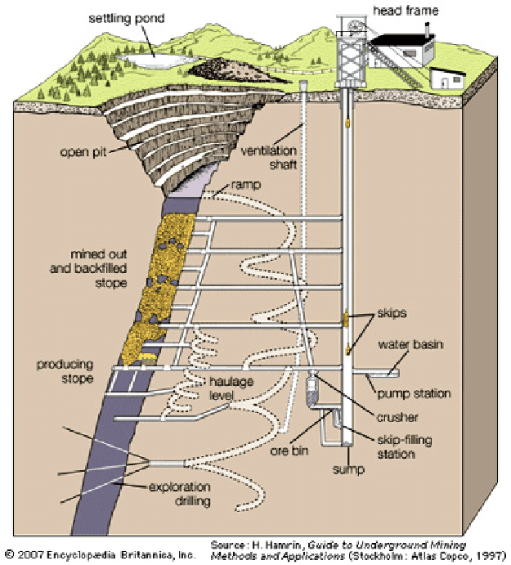
- Dust filtration: Integrate HEPA filters or wet scrubbers into ventilation shafts, use smart sensors to optimize airflow.

3. Task 3: Lohum-assignment-codes/task3.ipynb at main · rohankr21/Lohum-assignment-codes

4. Task 4: Lohum-assignment-codes/task4.ipynb at main · rohankr21/Lohum-assignment-codes

5. Task 5:
1. Choose optimal metals to consider only if supply > demand for first 5 years and growth rate > = 10% for upcoming years
2. Use depth optimisation already done in task 3
3. skip rare earth metals as refining cost is too high
References:
1. Google Books – Guide to Underground Mining by Hans Hamrin
2. 1Library.net – Underground Mining Methods and Applications
3. Geotechpedia – Underground Mining Methods and Applications

