ARCHITECTURE:
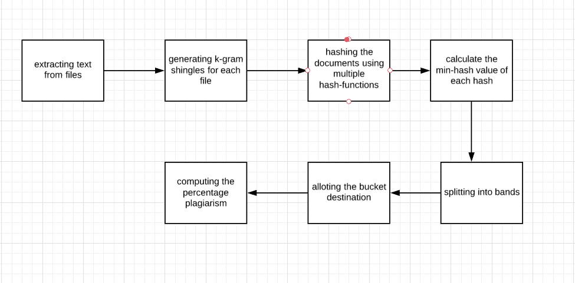

DATA STRUCTURES USED:
The major data structures used include :
- Set and Lists for maintaining shingles and hashed values;
- hash map to maintain the buckets after hashing

RUNNING TIME:
The running time for LSH is:
O(LDK)+O(LDN/2^K)
where L: no.of hash functions
D:no.of dimensions
K:no.of hyperplanes while hashing
N:no.of points in space or documents

