# Pre requisites:

How to use the DOS prompt: Execute following commands and identify the output.

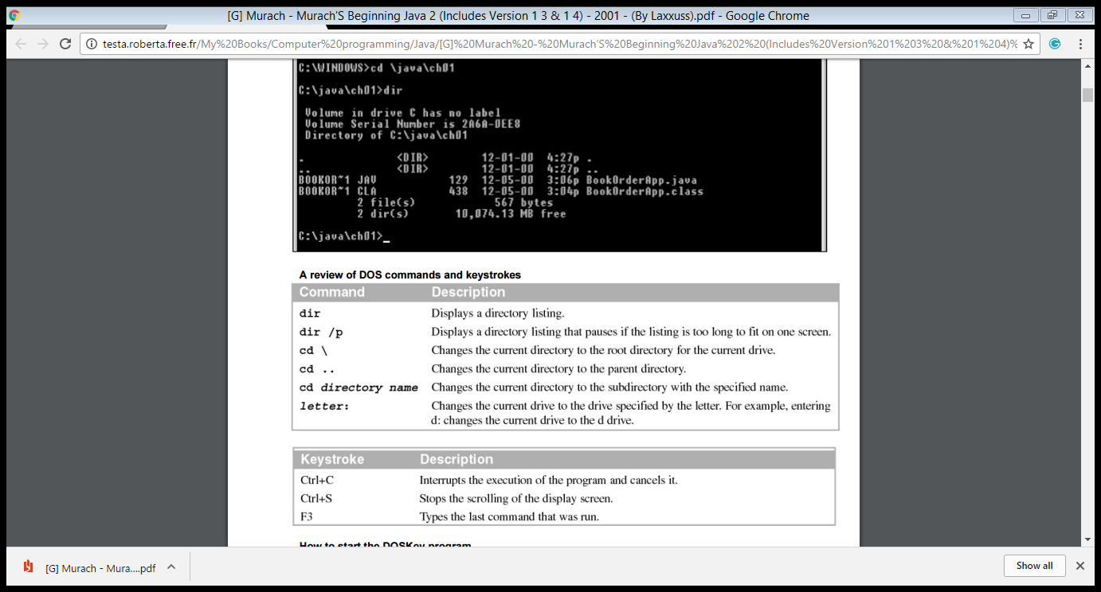

# Task List:

“ The Java compiler translates source code into a platform-independent format known as Java bytecodes. Files that contain Java bytecodes use the class extension.  The Java interpreter executes Java bytecodes. Since Java interpreters exist for all major operating systems, Java bytecodes can be run on most platforms. Any computer with a Java interpreter can be considered an implementation of a Java virtual machine (JVM).”

1. Write and execute the commands that you can use to check:

* Java compiler is installed and running properly
* Java interpreter is installed and running properly
* Java version installed on the machine

1. Write you first java programme to display “Hello World” on the screen. Please use command line (cmd) to execute your code.

“Syntax to save the code in a file "ProgramName.java" ( Typical capitalization for file names). ”

Write down the-

Syntax use to compile the above programme:

Syntax to run the above programme:

1. Write a programme to display your name on the first line and to display your degree programme on the second line on the screen. Please use command line (cmd) to execute your code.
2. Write down a programme to get the following output using a for loop. Repeat the same example by using a while loop.

Executing Loop 0

Executing Loop 1

Executing Loop 2

Executing Loop 3

Executing Loop 4

1. Write a class and insert the following code block into the appropriate place. Execute the code and get the result.

“

int [] numbers = {10, 20, 30, 40, 50};

for(int x : numbers ){

if( x == 30 ){

break;

}

System.out.print( x );

System.out.print("\n");

}

System.out.print(“I’m out of the Loop now"); “

Results:

Repeat the same code using “continue” instead of “break”. Write down the output.

Results:

1. Write a class and insert the following code block into the appropriate place. Execute the code and get the result.
2. char grade =‘A’;
3. switch(grade)
4. {
5. case 'A' :
6. System.out.println("Excellent!");
7. break;
8. case 'D' :
9. System.out.println("You passed");
10. case 'F' :
11. System.out.println("Better try again");
12. break;
13. default :
14. System.out.println("Invalid grade");
15. }
16. System.out.println("Your grade is " + grade);

Results:

Repeat the same removing “break” command at line number 6. Write down the output.

Repeat the same scenario by using if-else-if statement instead of switch case.

1. As of java 5 the enhanced for loop was introduced. This is mainly used for Arrays. Below code contains few mistakes. First execute the code. Then identify the errors printed on the console. Rectify all the errors and execute to get the output:

class TestEnhanceForLoop {

public static void mains(String args[]){

int [] numbers = {10, 20, 30, 40, 50};

**for(int x : numbers ){**

**System.out.print( x );**

**System.out.print(",")**

**}**

System.out.print("\n");

String [] names ={“James”, "Larry", "Tom", "Lacy"}

**for( String name : names ) {**

**System.out.print( name );**

**System.out.print(",");**

Output: