SQL Q3(A): Daily Average Sensor Metrics by Plant

SELECT
Timestamp,
Plant,
ROUND(AVG(Temperature), 2) AS AvgTemperature,
ROUND(AVG(Vibration), 2) AS AvgVibration,
ROUND(AVG(Pressure), 2) AS AvgPressure
FROM machine_health
GROUP BY Timestamp, Plant
ORDER BY Timestamp, Plant;

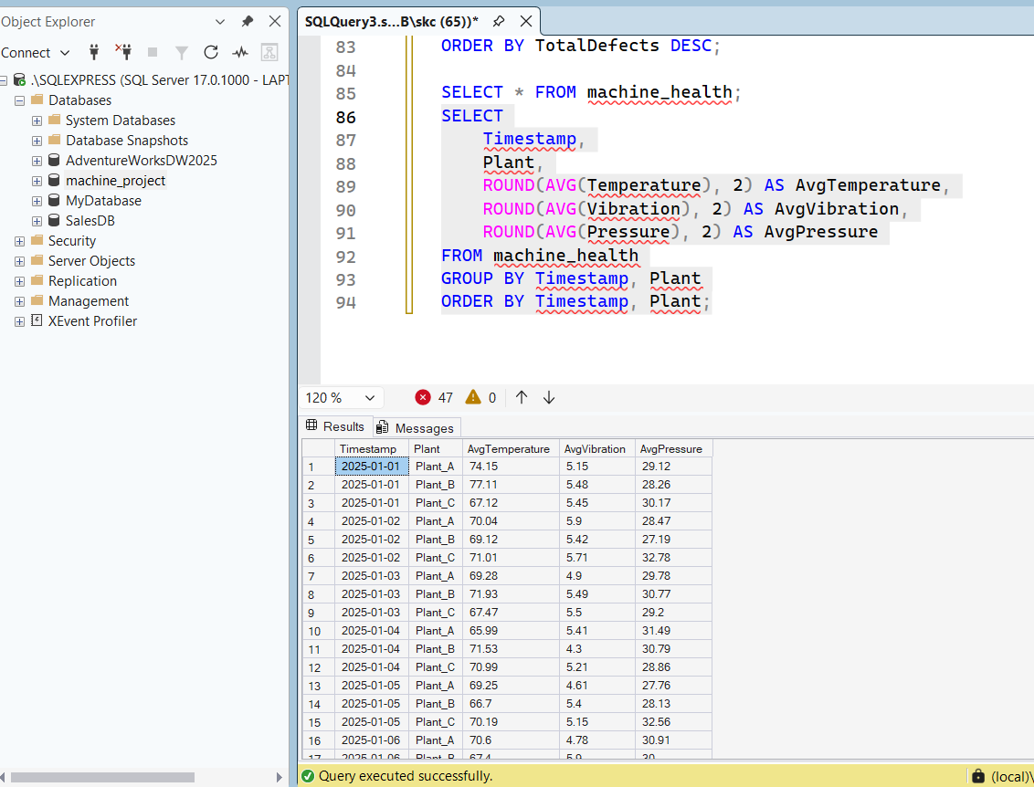

SQL Q3(B) — Top 5 Machines per Plant by Total DefectCount

WITH RankedMachines AS (
SELECT
Plant,
MachineID,
SUM(DefectCount) AS TotalDefects,
ROW_NUMBER() OVER (
PARTITION BY Plant
ORDER BY SUM(DefectCount) DESC
) AS rn
FROM machine_health
GROUP BY Plant, MachineID
)
SELECT Plant,
MachineID,
TotalDefects
FROM RankedMachines
WHERE rn <= 5
ORDER BY Plant, TotalDefects DESC;
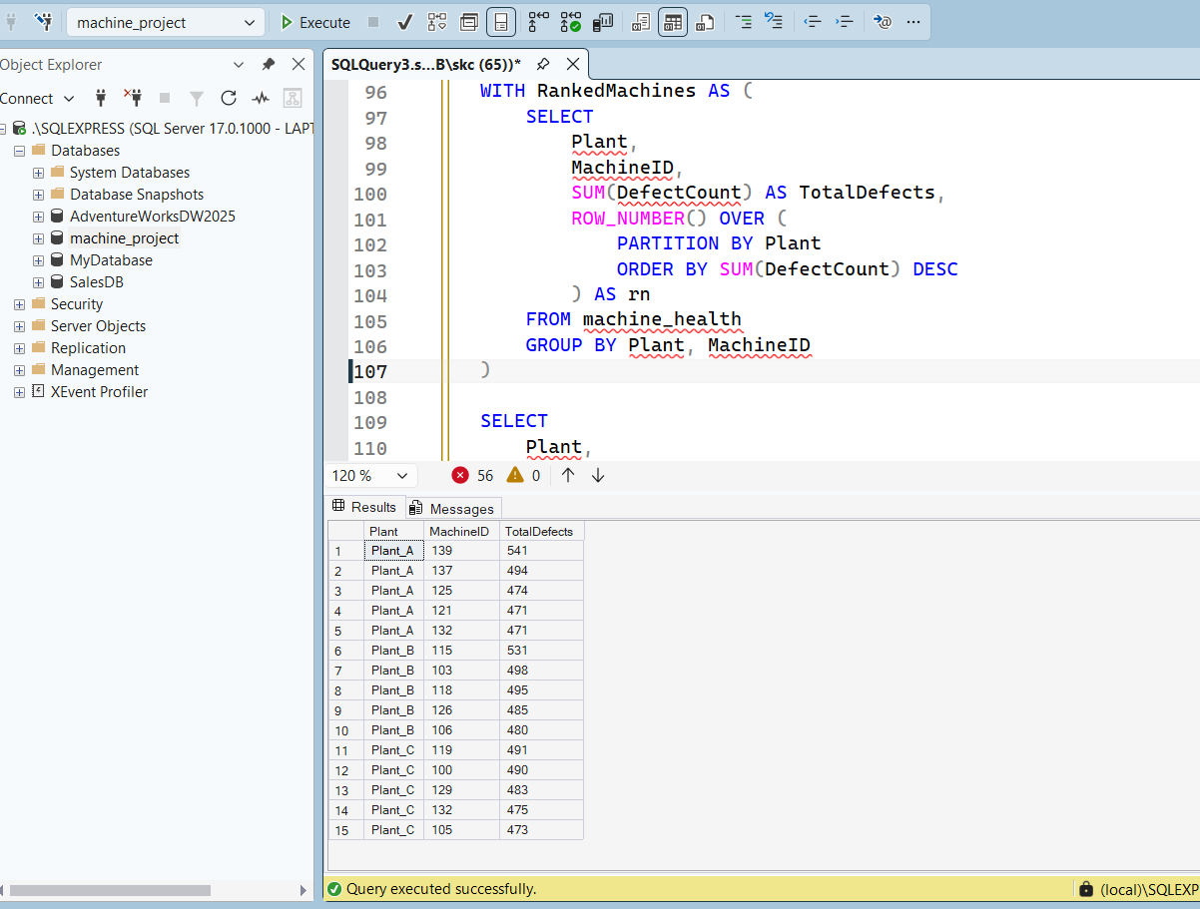
RESULT:

SQL Q4 — Create Machine Risk View

CREATE VIEW machine_risk_2025 AS
SELECT
MachineID,
Plant,
AVG(Temperature) AS AvgTemp,
AVG(Vibration) AS AvgVibration,
AVG(Pressure) AS AvgPressure,
SUM(DefectCount) AS TotalDefects,
SUM(CAST(MaintenanceFlag AS INT)) AS TotalMaintenance,

CASE
WHEN SUM(DefectCount) >= 400 THEN 'HIGH'
WHEN SUM(DefectCount) >= 250 THEN 'MEDIUM'
ELSE 'LOW'
END AS RiskLevel

FROM machine_health
GROUP BY MachineID, Plant;

SELECT *
FROM machine_risk_2025
ORDER BY TotalDefects DESC;

Results:
