Name : Pranali Mahajan

Roll no : 233

**Question 1. LoginScreen Using Linear Layout**

<?xml version="1.0" encoding="utf-8"?>

<LinearLayout xmlns:android="http://schemas.android.com/apk/res/android"

xmlns:app="http://schemas.android.com/apk/res-auto"

xmlns:tools="http://schemas.android.com/tools"

android:layout_width="match_parent"

android:layout_height="match_parent"

android:orientation="vertical"

tools:context=".MainActivity">

<TextView

android:layout_width="match_parent"

android:layout_height="wrap_content"

android:layout_marginBottom="25dp"

android:fontFamily="cursive"

android:paddingVertical="70dp"

android:text="Login"

android:textAlignment="center"

android:textColor="@color/black"

android:textSize="30sp" />

<LinearLayout

android:layout_width="match_parent"

android:layout_height="72dp"

android:layout_marginTop="10dp"

android:background="@color/teal_200"

android:orientation="horizontal">

<TextView

android:layout_width="120dp"

android:layout_height="wrap_content"

android:layout_marginHorizontal="30dp"

android:text="User name"

android:textColor="@color/black" />

<EditText

android:layout_width="169dp"

android:layout_height="40dp"

android:layout_marginHorizontal="30dp"

android:layout_marginBottom="30dp" />

</LinearLayout>

<LinearLayout

android:layout_width="match_parent"

android:layout_height="83dp"

android:layout_marginTop="10dp"

android:background="@color/teal_200"

android:orientation="horizontal">>

<TextView

android:id="@+id/tx1"

android:layout_width="111dp"

android:layout_height="wrap_content"

android:layout_marginHorizontal="30dp"

android:text="Password"

android:textColor="@color/black"

/>

<EditText

android:id="@+id/editText"

android:layout_width="169dp"

android:layout_height="40dp"

android:layout_marginHorizontal="30dp"

android:layout_marginBottom="30dp"

android:layout_weight="1" />

/>

</LinearLayout>

<Button

android:id="@+id/myBt"

android:layout_width="match_parent"

android:layout_height="50dp"

android:layout_marginHorizontal="30dp"

android:layout_marginBottom="30dp"

android:layout_marginVertical="40dp"

android:background="@color/black"

android:text="Login" />

<TextView

android:layout_width="match_parent"

android:layout_height="wrap_content"

android:text="Create New Account ?"

android:textAlignment="center"></TextView>

<Button

android:layout_width="match_parent"

android:layout_height="50dp"

android:layout_marginHorizontal="30dp"

android:layout_marginBottom="30dp"

android:layout_marginVertical="40dp"

android:background="@color/black"

android:text="Login" />

</LinearLayout>

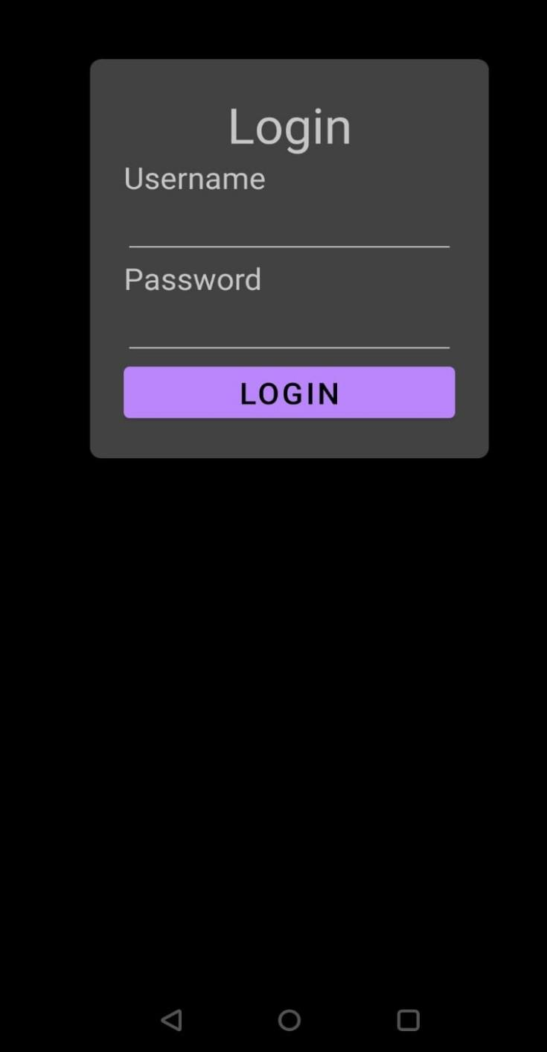

**•Question 2. Registration using**

•<?xml version="1.0" encoding="utf-8"?>

•<ScrollView xmlns:app="http://schemas.android.com/apk/res-auto"

• xmlns:tools="http://schemas.android.com/tools"

• android:layout_width="match_parent"

• android:layout_height="match_parent"

• xmlns:android="http://schemas.android.com/apk/res/android">

•<RelativeLayout

• android:layout_width="match_parent"

• android:layout_height="match_parent"

• android:paddingLeft="20dp"

• android:paddingRight="20dp"

• android:orientation="vertical"

• tools:context=".MainActivity2">

•

• <TextView

• android:layout_width="match_parent"

• android:layout_height="130dp"

• android:layout_marginBottom="25dp"

• android:background="@drawable/mitwpu1"

• android:fontFamily="cursive"

• android:paddingVertical="70dp"

• android:textAlignment="center"

• android:textColor="@color/white"

• android:textSize="30sp" />

•

• <TextView

• android:id="@+id/text2"

• android:layout_width="match_parent"

• android:layout_height="wrap_content"

• android:layout_marginBottom="25dp"

• android:fontFamily="cursive"

• android:paddingVertical="180dp"

• android:text="Registration Form"

• android:textAlignment="center"

• android:textColor="@color/black"

• android:textSize="30sp" />

•

• <TextView

• android:id="@+id/text5"

• android:layout_width="match_parent"

• android:layout_height="wrap_content"

• android:text="Name"

• android:layout_below="@+id/text2"

• android:textColor="@color/black" />

•

• <EditText

• android:id="@+id/text6"

• android:layout_width="match_parent"

• android:layout_height="wrap_content"

• android:layout_below="@+id/text5"

• />

• <TextView

• android:id="@+id/text7"

• android:layout_width="match_parent"

• android:layout_height="wrap_content"

• android:text="Address"

• android:layout_below="@+id/text6"

• android:textColor="@color/black" />

•

• <EditText

• android:id="@+id/text8"

• android:layout_width="match_parent"

• android:layout_height="wrap_content"

• android:layout_below="@+id/text7"

• />

• <TextView

• android:id="@+id/text9"

• android:layout_width="match_parent"

• android:layout_height="wrap_content"

• android:text="Mobile number"

• android:layout_below="@+id/text8"

• android:textColor="@color/black" />

•

• <EditText

• android:id="@+id/text10"

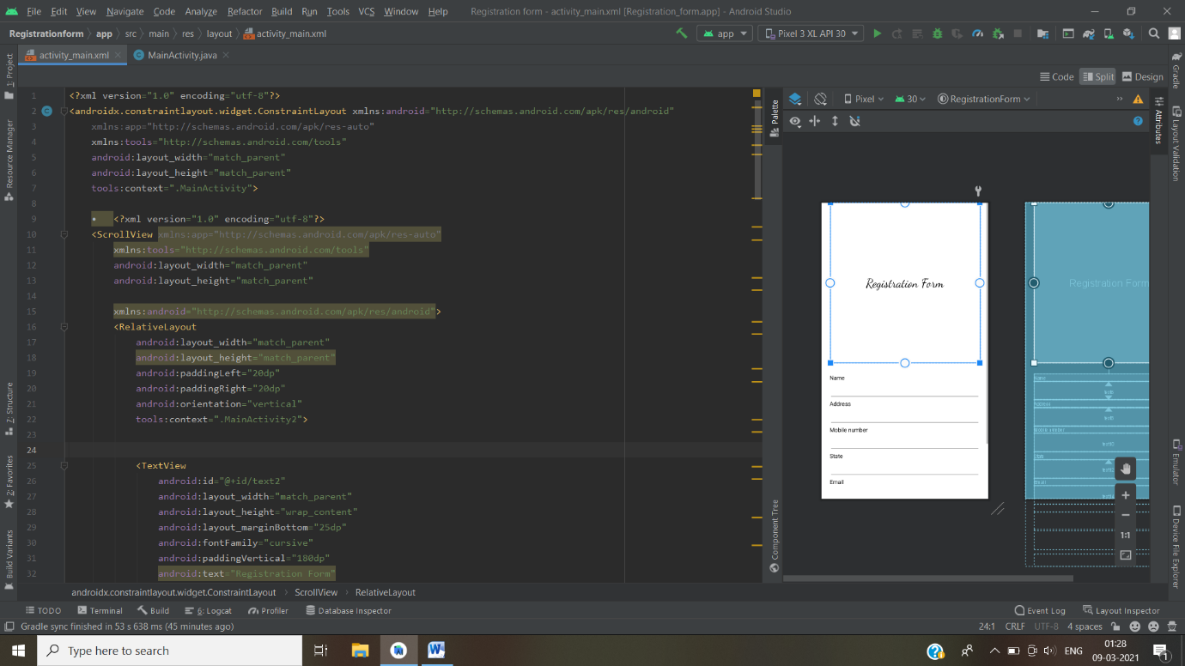

**Question 3. Create an Android Application using Alert Dialog, where when user click on Back Button, It will ask user to "Whether to exit Yes/ No with Yes and No Button".**

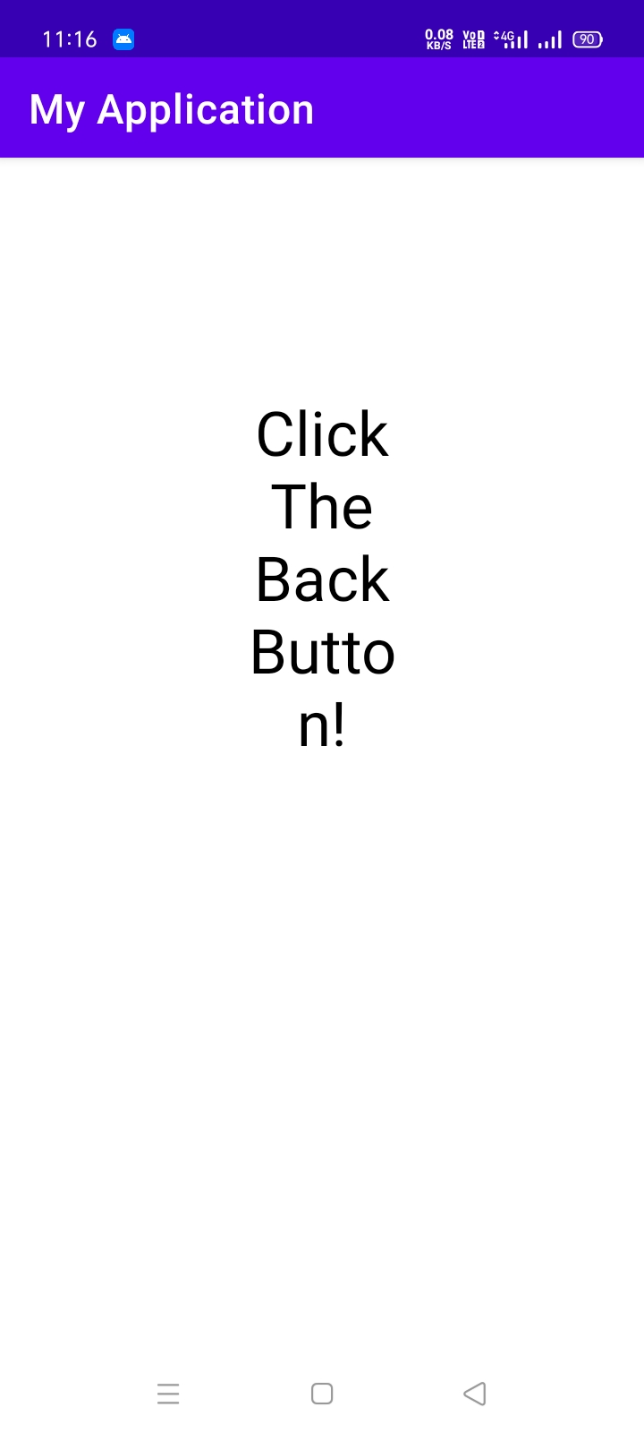

- 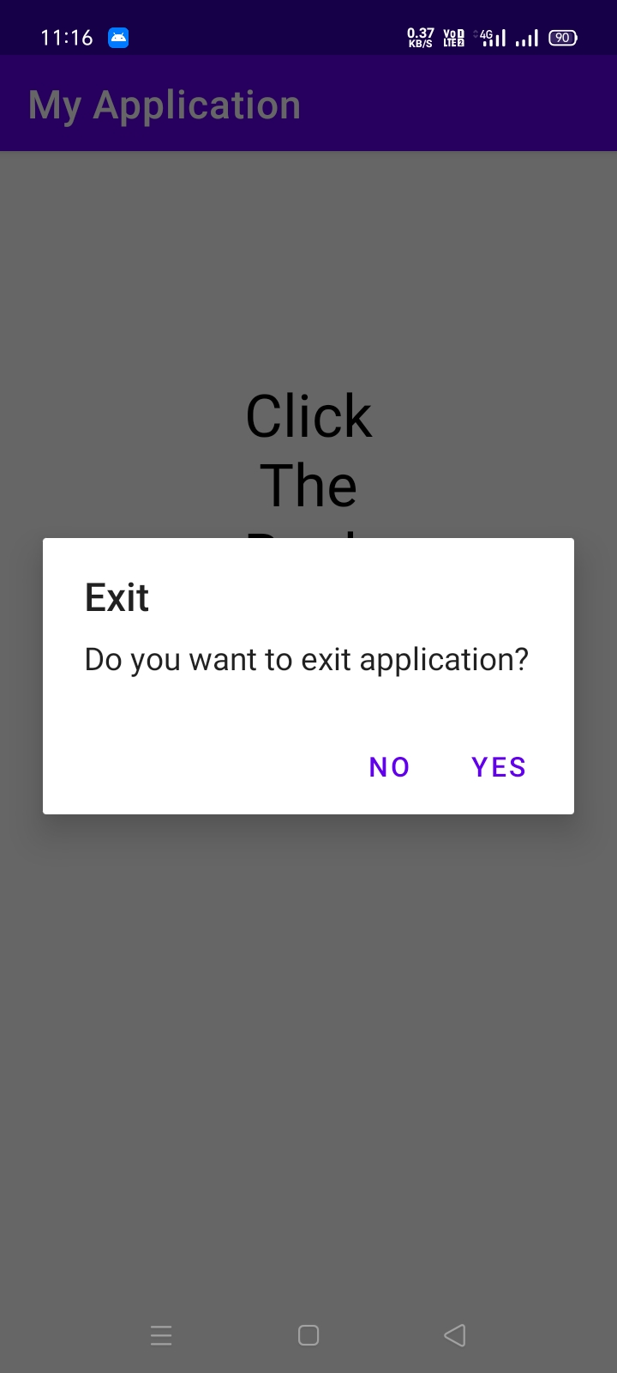

.xml code:-

<?xml version="1.0" encoding="utf-8"?>

<RelativeLayout xmlns:android=<http://schemas.android.com/apk/res/android>

xmlns:app="http://schemas.android.com/apk/res-auto"

xmlns:tools="http://schemas.android.com/tools"

android:layout_width="match_parent"

android:layout_height="match_parent"

tools:context=".AlertDialog">

<TextView

android:layout_width="wrap_content"

android:layout_height="wrap_content"

android:id="@+id/text"

android:layout_margin="130dp"

android:text="Click The Back Button!"

android:textSize="30sp"

android:gravity="center"

android:textColor="@color/black"/>

</RelativeLayout>

.java code:-

package com.example.myapplication;

import androidx.appcompat.app.AppCompatActivity;

import android.content.DialogInterface;

import android.os.Bundle;

import android.view.KeyEvent;

public class AlertDialog extends AppCompatActivity {

@Override

protected void onCreate(Bundle savedInstanceState) {

super.onCreate(savedInstanceState);

setContentView(R.layout.activity_alert_dialog);

}

public boolean onKeyDown(int keyCode, KeyEvent event) {

if (keyCode == KeyEvent.KEYCODE_BACK) {

exitByBackKey();

return true;

}

return super.onKeyDown(keyCode, event);

}

protected void exitByBackKey() {

androidx.appcompat.app.AlertDialog alertbox = new androidx.appcompat.app.AlertDialog.Builder(this)

.setTitle("Exit")

.setMessage("Do you want to exit application?")

.setCancelable(false)

.setPositiveButton("Yes", new DialogInterface.OnClickListener

public void onClick(DialogInterface arg0, int arg1) {

finish();

}

})

.setNegativeButton("No", new DialogInterface.OnClickListener() {

// do something when the button is clicked

public void onClick(DialogInterface arg0, int arg1) {

}

})

.show();

}

}

**Question 4. Clicked on Button and selected time should be displayed on TextView.?**

Ans:-

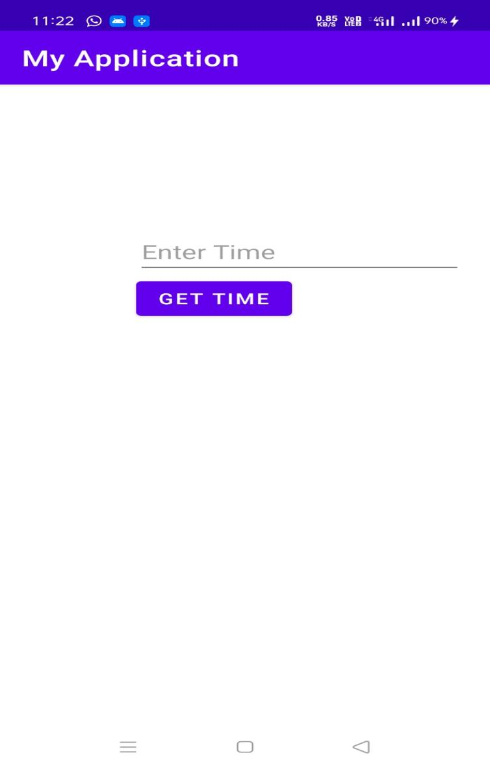

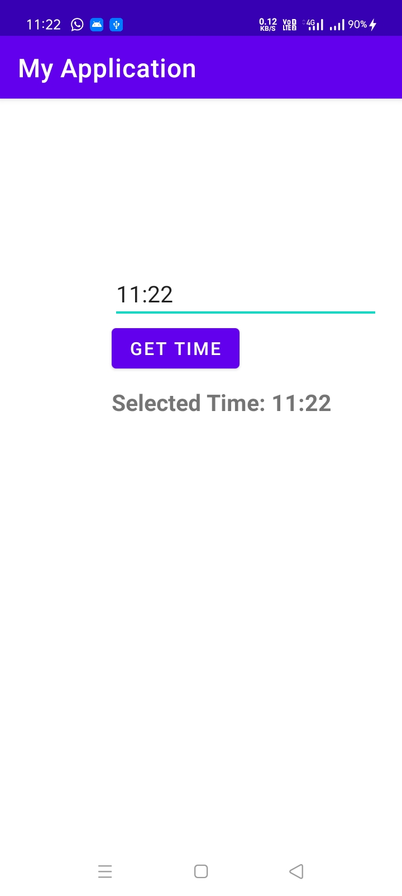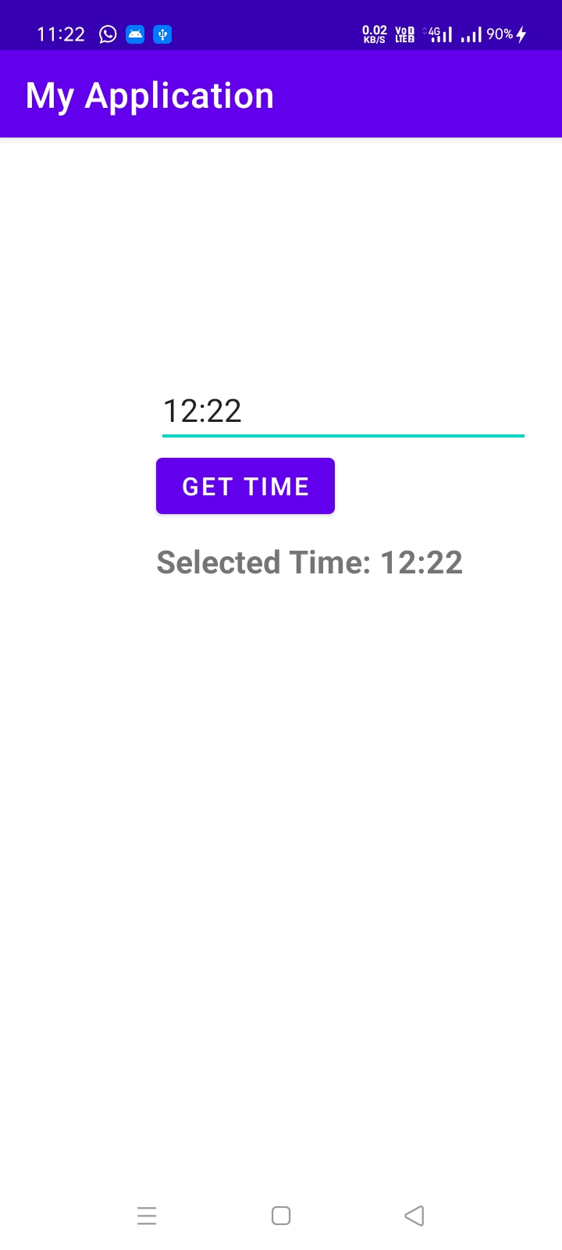

.xml code:-

<?xml version="1.0" encoding="utf-8"?>

<LinearLayout xmlns:android="http://schemas.android.com/apk/res/android"

android:layout_width="match_parent"

android:layout_height="match_parent"

<?xml version="1.0" encoding="utf-8"?>

<RelativeLayout xmlns:android="http://schemas.android.com/apk/res/android"

xmlns:app="http://schemas.android.com/apk/res-auto"

xmlns:tools="http://schemas.android.com/tools"

android:layout_width="match_parent"

android:layout_height="match_parent"

tools:context=".TimePicker">

<EditText

android:id="@+id/editText1"

android:layout_width="wrap_content"

android:layout_height="wrap_content"

android:layout_marginLeft="100dp"

android:layout_marginTop="150dp"

android:ems="10"

android:hint="Enter Time" />

<Button

android:id="@+id/button1"

android:layout_width="wrap_content"

android:layout_height="wrap_content"

android:layout_below="@+id/editText1"

android:layout_marginLeft="100dp"

android:text="Get Time" />

<TextView

android:id="@+id/textView1"

android:layout_width="wrap_content"

android:layout_height="wrap_content"

android:layout_below="@+id/button1"

android:layout_marginLeft="100dp"

android:layout_marginTop="10dp"

android:textStyle="bold"

android:textSize="18sp"/>

</RelativeLayout>

.java code:-

package com.example.myapplication;

import androidx.appcompat.app.AppCompatActivity;

import android.app.TimePickerDialog;

import android.os.Bundle;

import android.text.InputType;

import android.view.View;

import android.widget.Button;

import android.widget.EditText;

import android.widget.TextView;

import java.util.Calendar;

public class TimePicker extends AppCompatActivity {

TimePickerDialog picker;

EditText eText;

Button btnGet;

TextView tvw;

@Override

protected void onCreate(Bundle savedInstanceState) {

super.onCreate(savedInstanceState);

setContentView(R.layout.activity_time_picker);

tvw=(TextView)findViewById(R.id.textView1);

eText=(EditText) findViewById(R.id.editText1);

eText.setInputType(InputType.TYPE_NULL);

eText.setOnClickListener(new View.OnClickListener() {

@Override

public void onClick(View v) {

final Calendar cldr = Calendar.getInstance();

int hour = cldr.get(Calendar.HOUR_OF_DAY);

int minutes = cldr.get(Calendar.MINUTE);

// time picker dialog

picker = new TimePickerDialog(TimePicker.this, new TimePickerDialog.OnTimeSetListener() {

@Override

public void onTimeSet(android.widget.TimePicker tp, int sHour, int sMinute) {

eText.setText(sHour + ":" + sMinute);

}

}, hour, minutes, true);

picker.show();

}

});

btnGet=(Button)findViewById(R.id.button1);

btnGet.setOnClickListener(new View.OnClickListener() {

@Override

public void onClick(View v) {

tvw.setText("Selected Time: "+ eText.getText());

}

});

}

}

**Question 5. Design and Develop Android Application to demonstrate Array Adapter for Spinner having Different States of India in it.**

Xml code:

<?xml version="1.0" encoding="utf-8"?>

<androidx.constraintlayout.widget.ConstraintLayout xmlns:android="http://schemas.android.com/apk/res/android"

xmlns:app="http://schemas.android.com/apk/res-auto"

xmlns:tools="http://schemas.android.com/tools"

android:layout_width="match_parent"

android:layout_height="match_parent"

tools:context=".SpinnerWithArrayAdapter">

<Spinner

android:id="@+id/spinner2"

android:layout_width="wrap_content"

android:layout_height="wrap_content"

tools:layout_editor_absoluteX="186dp" tools:layout_editor_absoluteY="339dp"

app:layout_constraintBottom_toBottomOf="parent"

app:layout_constraintEnd_toEndOf="parent"

app:layout_constraintHorizontal_bias="0.402"

app:layout_constraintStart_toStartOf="parent"

app:layout_constraintTop_toTopOf="parent"

app:layout_constraintVertical_bias="0.112"/>

</androidx.constraintlayout.widget.ConstraintLayout>

Java Code:

package com.myapp.collegeassignments;

import androidx.appcompat.app.AppCompatActivity;

import android.os.Bundle;

import android.view.View;

import android.widget.AdapterView;

import android.widget.ArrayAdapter;

import android.widget.Spinner;

import android.widget.Toast;

public class SpinnerWithArrayAdapter extends AppCompatActivity implements AdapterView.OnItemSelectedListener {

private String[] states = {"Maharashtra","Karnataka","Uttar Pradesh","Tamil Nadu"};

@Override

protected void onCreate(Bundle savedInstanceState) {

super.onCreate(savedInstanceState);

setContentView(R.layout.activity_spinner_with_array_adapter);

Spinner spinner2 = findViewById(R.id.spinner2);

spinner2.setOnItemSelectedListener(this);

ArrayAdapter aa = new ArrayAdapter(this, android.R.layout.simple_spinner_item,states);

aa.setDropDownViewResource(android.R.layout.simple_spinner_dropdown_item);

spinner2.setAdapter(aa);

}

@Override

public void onItemSelected(AdapterView<?> parent, View view, int position, long id) {

Toast.makeText(this, states[position] , Toast.LENGTH_SHORT).show();

}

@Override

public void onNothingSelected(AdapterView<?> parent) {

}

}

Output:

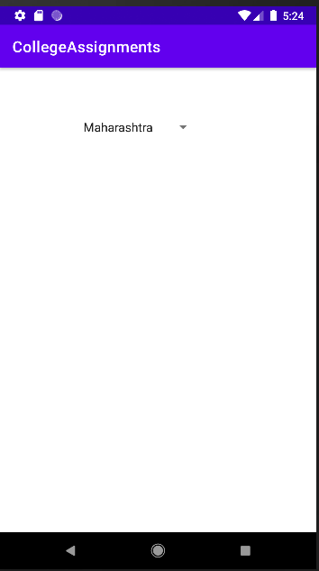 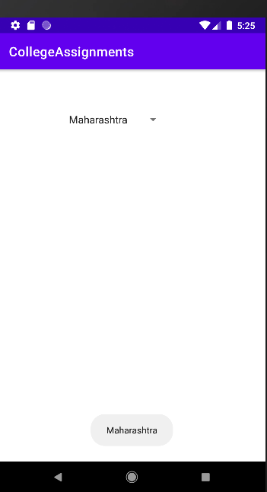

**Question 6. Design and Develop Android Application for Showing Contact List (Person Name and Phone No) using List View.**

Xml Code: activity_list_view

<?xml version="1.0" encoding="utf-8"?>

<LinearLayout xmlns:android="http://schemas.android.com/apk/res/android"

android:layout_width="match_parent"

android:layout_height="match_parent"

android:orientation="vertical">

<ListView

android:id="@+id/ls"

android:layout_width="fill_parent"

android:layout_height="wrap_content"

android:divider="@color/design_default_color_primary_dark"

android:dividerHeight="5dp" />

</LinearLayout>

Xml Code: activity_list_view2

<LinearLayout xmlns:android="http://schemas.android.com/apk/res/android"

android:layout_width="match_parent"

android:layout_height="match_parent"

android:orientation="vertical">

<TextView

android:id="@+id/tv1"

android:layout_width="fill_parent"

android:layout_height="wrap_content"

android:layout_gravity="center"

android:textColor="@color/black" />

<TextView

android:id="@+id/tv2"

android:layout_width="fill_parent"

android:layout_height="wrap_content"

android:layout_gravity="center"

android:textColor="@color/black" />

</LinearLayout>

Java Code:

package com.myapp.collegeassignments;

import androidx.appcompat.app.AppCompatActivity;

import android.content.Context;

import android.os.Bundle;

import android.util.Log;

import android.view.LayoutInflater;

import android.view.View;

import android.view.ViewGroup;

import android.widget.BaseAdapter;

import android.widget.TextView;

public class ListView extends AppCompatActivity {

android.widget.ListView simpleList;

android.widget.ListView simpleList;

String contacts[] = {"Pooja", "Prachi", "Harsh", "Rohit", "Gauri", "Mayur", "Deep", "Deepak", "Harshali", "Sarthak", "Pranjali", "Sanket", "Suraj",

"Monali", "Dipali", "Aarohi", "Nehu", "Sonali"};

String phone[] = {"8769403789", "7895607982", "7895607982" ,"847823947", "9056483092", "847823947", "847823947", "8769403789", "8769403789",

"9870123512", "7895607982", "8769403789", "9567340253", "987654321", "8769403789", "8769403789", "7895607982", "987654321"};

@Override

protected void onCreate(Bundle savedInstanceState) {

super.onCreate(savedInstanceState);

setContentView(R.layout.activity_list_view);

simpleList = findViewById(R.id.ls);

CustomAdapter customAdapter = new CustomAdapter(getApplicationContext(), contacts, phone);

simpleList.setAdapter(customAdapter);

}

private class CustomAdapter extends BaseAdapter {

Context context;

String contacts[];

String phones[];

LayoutInflater inflter;

public CustomAdapter(Context applicationContext, String[] contacts, String[] phones) {

this.context = context;

this.contacts = contacts;

this.phones = phones;

inflter = (LayoutInflater.from(applicationContext));

}

public int getCount() {

@Override

return contacts.length;

}

@Override

public Object getItem(int position) {

return null;

}

@Override

public long getItemId(int position) {

return 0;

}

@Override

public View getView(int position, View view, ViewGroup parent) {

view = inflter.inflate(R.layout.activity_list_view2, null);

TextView tv1 = view.findViewById(R.id.tv1);

TextView tv2 = view.findViewById(R.id.tv2);

Log.d("message", contacts[position]);

tv1.setText(contacts[position]);

tv2.setText(phones[position]);

return view;

}

}

}

Output:

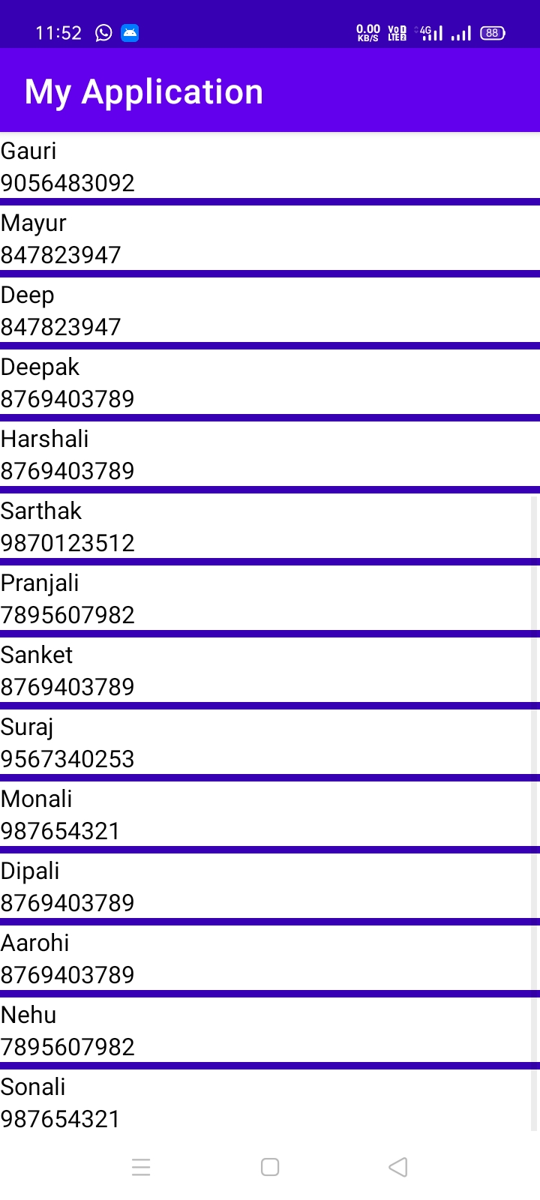

**Question 7. Design and Develop Android Application to demonstrate the concept of Grid View by showing multiple Images in the 4*2 size Gridview.**

activity_main.xml

<?xml version="1.0" encoding="utf-8"?>

<GridView xmlns:android="http://schemas.android.com/apk/res/android"

android:id="@+id/gridview"

android:layout_width="fill_parent"

android:layout_height="fill_parent"

android:columnWidth="90dp"

android:numColumns="auto_fit"

android:verticalSpacing="10dp"

android:horizontalSpacing="10dp"

android:stretchMode="columnWidth"

android:gravity="center"

/>

Strings.xml

<?xml version="1.0" encoding="utf-8"?>

<resources>

<string name="app_name">Question_2</string>

<string name="action_settings">Settings</string>

</resources>

MiainActivity.java

package com.example.question_2;

import android.os.Bundle;

import android.app.Activity;

import android.view.Menu;

import android.widget.GridView;

public class MainActivity extends Activity {

@Override

protected void onCreate(Bundle savedInstanceState) {

super.onCreate(savedInstanceState);

setContentView(R.layout.activity_main);

GridView gridview = (GridView) findViewById(R.id.gridview);

gridview.setAdapter(new ImageAdapter(this));

}

}

ImageAdapter.java

package com.example.question_2;

import android.content.Context;

import android.view.View;

import android.view.ViewGroup;

import android.widget.BaseAdapter;

import android.widget.GridView;

import android.widget.ImageView;

public class ImageAdapter extends BaseAdapter {

private Context mContext;

// Constructor

public ImageAdapter(Context c) {

mContext = c;

}

public int getCount() {

return mThumbIds.length;

}

public Object getItem(int position) {

return null;

}

public long getItemId(int position) {

return 0;

}

// create a new ImageView for each item referenced by the Adapter

public View getView(int position, View convertView, ViewGroup parent) {

ImageView imageView;

if (convertView == null) {

imageView = new ImageView(mContext);

imageView.setLayoutParams(new GridView.LayoutParams(85, 85));

imageView.setScaleType(ImageView.ScaleType.CENTER_CROP);

imageView.setPadding(8, 8, 8, 8);

}

else

{

imageView = (ImageView) convertView;

}

imageView.setImageResource(mThumbIds[position]);

return imageView;

}

// Keep all Images in array

public Integer[] mThumbIds = {

R.drawable.sample_2, R.drawable.sample_3,

R.drawable.sample_4, R.drawable.sample_5,

R.drawable.sample_6, R.drawable.sample_7,

R.drawable.sample_0, R.drawable.sample_1,

R.drawable.sample_2, R.drawable.sample_3,

R.drawable.sample_4, R.drawable.sample_5,

R.drawable.sample_6, R.drawable.sample_7,

R.drawable.sample_0, R.drawable.sample_1,

R.drawable.sample_2, R.drawable.sample_3,

R.drawable.sample_4, R.drawable.sample_5,

R.drawable.sample_6, R.drawable.sample_7

};

}

Output:

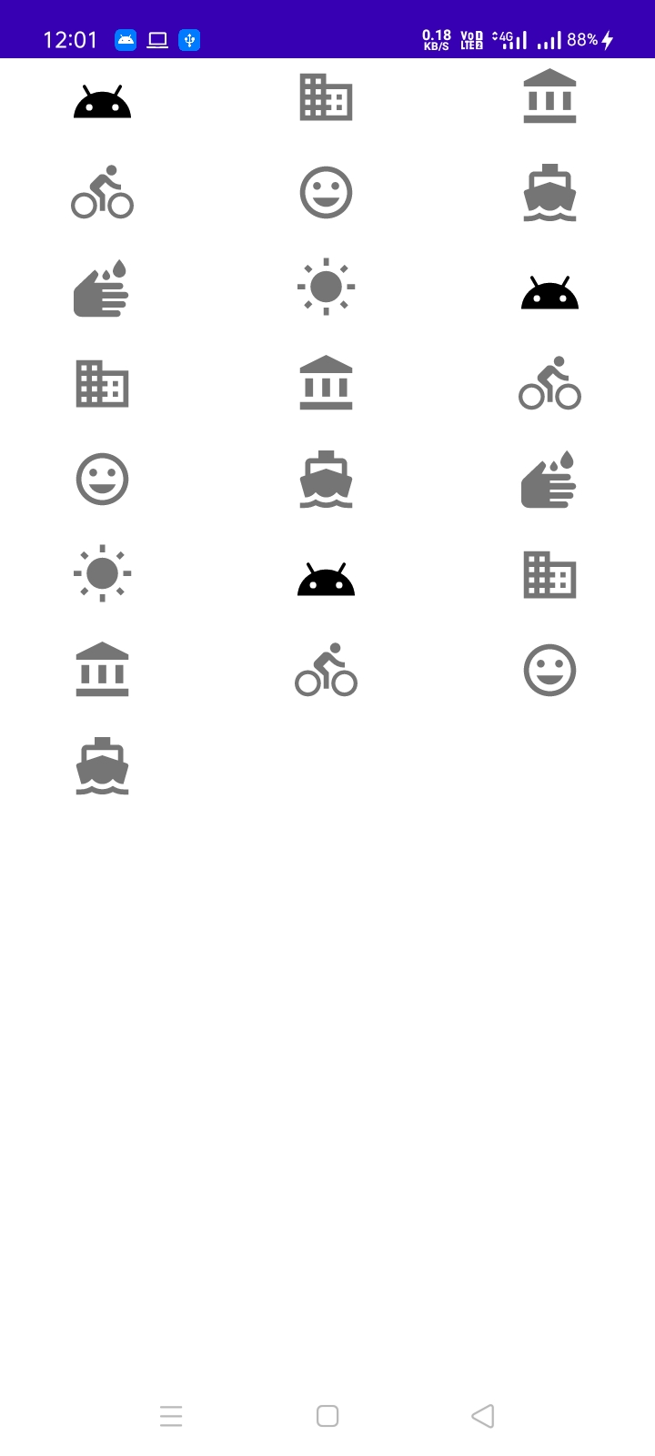

**Question 8. Write an Android Application using Table layout and Scroll View to display following layout.**

<?xml version="1.0" encoding="utf-8"?>

<LinearLayout xmlns:android="http://schemas.android.com/apk/res/android"

xmlns:app="http://schemas.android.com/apk/res-auto"

xmlns:tools="http://schemas.android.com/tools"

android:layout_width="match_parent"

android:layout_height="match_parent"

android:orientation="vertical"

tools:context=".MainActivity">

<TableLayout

android:layout_width="match_parent"

android:layout_height="wrap_content">

<TableRow android:id="@+id/tableRow1"

android:layout_width="wrap_content"

android:layout_height="wrap_content"

android:padding="10dp"

android:background="#0079D6"

>

<TextView

android:layout_width="wrap_content"

android:layout_height="wrap_content"

android:layout_weight="1"

android:textStyle="bold"

android:text="Roll No"

/>

<TextView

android:layout_width="wrap_content"

android:layout_height="wrap_content"

android:layout_weight="1"

android:textStyle="bold"

android:text="Name"

/>

<TextView

android:layout_width="wrap_content"

android:layout_height="wrap_content"

android:layout_weight="1"

android:textStyle="bold"

android:text="City"

/>

<TextView

android:layout_width="wrap_content"

android:layout_height="wrap_content"

android:layout_weight="1"

android:textStyle="bold"

android:text="Graduation Percentage"

/>

</TableRow>

</TableLayout>

<ScrollView

android:layout_width="match_parent"

android:layout_height="wrap_content">

<TableLayout

android:layout_width="match_parent"

android:layout_height="match_parent"

android:id="@+id/scrollView"

android:orientation="vertical"

>

<TableRow

android:padding="10dp"

>

<TextView

android:layout_width="wrap_content"

android:layout_height="wrap_content"

android:layout_weight="1"

android:text="01"

/>

<TextView

android:layout_width="wrap_content"

android:layout_height="wrap_content"

android:layout_weight="1"

android:text="Pratham"

/>

<TextView

android:layout_width="wrap_content"

android:layout_height="wrap_content"

android:layout_weight="1"

android:text="Pune"

/>

<TextView

android:layout_width="wrap_content"

android:layout_height="wrap_content"

android:layout_weight="1"

android:text="95%"

/>

</TableRow>

<TableRow

android:padding="10dp"

>

<TextView

android:layout_width="wrap_content"

android:layout_height="wrap_content"

android:layout_weight="1"

android:text="02"

/>

<TextView

android:layout_width="wrap_content"

android:layout_height="wrap_content"

android:layout_weight="1"

android:text="Aniket"

/>

<TextView

android:layout_width="wrap_content"

android:layout_height="wrap_content"

android:layout_weight="1"

android:text="Sangli"

/>

<TextView

android:layout_width="wrap_content"

android:layout_height="wrap_content"

android:layout_weight="1"

android:text="96%"

/>

</TableRow>

<TableRow

android:padding="10dp"

>

<TextView

android:layout_width="wrap_content"

android:layout_height="wrap_content"

android:layout_weight="1"

android:text="03"

/>

<TextView

android:layout_width="wrap_content"

android:layout_height="wrap_content"

android:layout_weight="1"

android:text="Pranali"

/>

<TextView

android:layout_width="wrap_content"

android:layout_height="wrap_content"

android:layout_weight="1"

android:text="Pune"

/>

<TextView

android:layout_width="wrap_content"

android:layout_height="wrap_content"

android:layout_weight="1"

android:text="98%"

/>

</TableRow>

<TableRow

android:padding="10dp"

>

<TextView

android:layout_width="wrap_content"

android:layout_height="wrap_content"

android:layout_weight="1"

android:text="054"

/>

<TextView

android:layout_width="wrap_content"

android:layout_height="wrap_content"

android:layout_weight="1"

android:text="Pooja"

/>

<TextView

android:layout_width="wrap_content"

android:layout_height="wrap_content"

android:layout_weight="1"

android:text="Kothrud"

/>

<TextView

android:layout_width="wrap_content"

android:layout_height="wrap_content"

android:layout_weight="1"

android:text="95%"

/>

</TableRow>

<TableRow

android:padding="10dp"

>

<TextView

android:layout_width="wrap_content"

android:layout_height="wrap_content"

android:layout_weight="1"

android:text="05"

/>

<TextView

android:layout_width="wrap_content"

android:layout_height="wrap_content"

android:layout_weight="1"

android:text="Manushri"

/>

<TextView

android:layout_width="wrap_content"

android:layout_height="wrap_content"

android:layout_weight="1"

android:text="Ajmer"

/>

<TextView

android:layout_width="wrap_content"

android:layout_height="wrap_content"

android:layout_weight="1"

android:text="99.0%"

/>

</TableRow>

<TableRow

android:padding="10dp"

>

<TextView

android:layout_width="wrap_content"

android:layout_height="wrap_content"

android:layout_weight="1"

android:text="06"

/>

<TextView

android:layout_width="wrap_content"

android:layout_height="wrap_content"

android:layout_weight="1"

android:text="Shubham"

/>

<TextView

android:layout_width="wrap_content"

android:layout_height="wrap_content"

android:layout_weight="1"

android:text="Jabalpur"

/>

<TextView

android:layout_width="wrap_content"

android:layout_height="wrap_content"

android:layout_weight="1"

android:text="99.80%"

/>

</TableRow>

<TableRow

android:padding="10dp"

>

<TextView

android:layout_width="wrap_content"

android:layout_height="wrap_content"

android:layout_weight="1"

android:text="07"

/>

<TextView

android:layout_width="wrap_content"

android:layout_height="wrap_content"

android:layout_weight="1"

android:text="Komal"

/>

<TextView

android:layout_width="wrap_content"

android:layout_height="wrap_content"

android:layout_weight="1"

android:text="Mumbai"

/>

<TextView

android:layout_width="wrap_content"

android:layout_height="wrap_content"

android:layout_weight="1"

android:text="97%"

/>

</TableRow>

<TableRow

android:padding="10dp"

>

<TextView

android:layout_width="wrap_content"

android:layout_height="wrap_content"

android:layout_weight="1"

android:text="08"

/>

<TextView

android:layout_width="wrap_content"

android:layout_height="wrap_content"

android:layout_weight="1"

android:text="Rajeshri"

/>

<TextView

android:layout_width="wrap_content"

android:layout_height="wrap_content"

android:layout_weight="1"

android:text="Busawal"

/>

<TextView

android:layout_width="wrap_content"

android:layout_height="wrap_content"

android:layout_weight="1"

android:text="91%"

/>

</TableRow>

<TableRow

android:padding="10dp"

>

<TextView

android:layout_width="wrap_content"

android:layout_height="wrap_content"

android:layout_weight="1"

android:text="09"

/>

<TextView

android:layout_width="wrap_content"

android:layout_height="wrap_content"

android:layout_weight="1"

android:text="Shubh"

/>

<TextView

android:layout_width="wrap_content"

android:layout_height="wrap_content"

android:layout_weight="1"

android:text="Goa"

/>

<TextView

android:layout_width="wrap_content"

android:layout_height="wrap_content"

android:layout_weight="1"

android:text="91%"

/>

</TableRow>

<TableRow

android:padding="10dp"

>

<TextView

android:layout_width="wrap_content"

android:layout_height="wrap_content"

android:layout_weight="1"

android:text="10"

/>

<TextView

android:layout_width="wrap_content"

android:layout_height="wrap_content"

android:layout_weight="1"

android:text="Anuradha"

/>

<TextView

android:layout_width="wrap_content"

android:layout_height="wrap_content"

android:layout_weight="1"

android:text="Sangli"

/>

<TextView

android:layout_width="wrap_content"

android:layout_height="wrap_content"

android:layout_weight="1"

android:text="96%"

/>

</TableRow>

<TableRow

android:padding="10dp"

>

<TextView

android:layout_width="wrap_content"

android:layout_height="wrap_content"

android:layout_weight="1"

android:text="11"

/>

<TextView

android:layout_width="wrap_content"

android:layout_height="wrap_content"

android:layout_weight="1"

android:text="Hrushikesh"

/>

<TextView

android:layout_width="wrap_content"

android:layout_height="wrap_content"

android:layout_weight="1"

android:text="Pune"

/>

<TextView

android:layout_width="wrap_content"

android:layout_height="wrap_content"

android:layout_weight="1"

android:text="98%"

/>

</TableRow>

<TableRow

android:padding="10dp"

>

<TextView

android:layout_width="wrap_content"

android:layout_height="wrap_content"

android:layout_weight="1"

android:text="12"

/>

<TextView

android:layout_width="wrap_content"

android:layout_height="wrap_content"

android:layout_weight="1"

android:text="Pankaj"

/>

<TextView

android:layout_width="wrap_content"

android:layout_height="wrap_content"

android:layout_weight="1"

android:text="Burhanpur"

/>

<TextView

android:layout_width="wrap_content"

android:layout_height="wrap_content"

android:layout_weight="1"

android:text="96%"

/>

</TableRow>

<TableRow

android:padding="10dp"

>

<TextView

android:layout_width="wrap_content"

android:layout_height="wrap_content"

android:layout_weight="1"

android:text="13"

/>

<TextView

android:layout_width="wrap_content"

android:layout_height="wrap_content"

android:layout_weight="1"

android:text="Nitish"

/>

<TextView

android:layout_width="wrap_content"

android:layout_height="wrap_content"

android:layout_weight="1"

android:text="Burhanpur"

/>

<TextView

android:layout_width="wrap_content"

android:layout_height="wrap_content"

android:layout_weight="1"

android:text="98%"

/>

</TableRow>

<TableRow

android:padding="10dp"

>

<TextView

android:layout_width="wrap_content"

android:layout_height="wrap_content"

android:layout_weight="1"

android:text="14"

/>

<TextView

android:layout_width="wrap_content"

android:layout_height="wrap_content"

android:layout_weight="1"

android:text="Mayur"

/>

<TextView

android:layout_width="wrap_content"

android:layout_height="wrap_content"

android:layout_weight="1"

android:text="Nasik"

/>

<TextView

android:layout_width="wrap_content"

android:layout_height="wrap_content"

android:layout_weight="1"

android:text="96%"

/>

</TableRow>

<TableRow

android:padding="10dp"

>

<TextView

android:layout_width="wrap_content"

android:layout_height="wrap_content"

android:layout_weight="1"

android:text="15"

/>

<TextView

android:layout_width="wrap_content"

android:layout_height="wrap_content"

android:layout_weight="1"

android:text="Darshan"

/>

<TextView

android:layout_width="wrap_content"

android:layout_height="wrap_content"

android:layout_weight="1"

android:text="Nepanagar"

/>

<TextView

android:layout_width="wrap_content"

android:layout_height="wrap_content"

android:layout_weight="1"

android:text="98%"

/>

</TableRow>

<TableRow

android:padding="10dp"

>

<TextView

android:layout_width="wrap_content"

android:layout_height="wrap_content"

android:layout_weight="1"

android:text="16"

/>

<TextView

android:layout_width="wrap_content"

android:layout_height="wrap_content"

android:layout_weight="1"

android:text="Jay"

/>

<TextView

android:layout_width="wrap_content"

android:layout_height="wrap_content"

android:layout_weight="1"

android:text="Indore"

/>

<TextView

android:layout_width="wrap_content"

android:layout_height="wrap_content"

android:layout_weight="1"

android:text="96%"

/>

</TableRow>

<TableRow

android:padding="10dp"

>

<TextView

android:layout_width="wrap_content"

android:layout_height="wrap_content"

android:layout_weight="1"

android:text="17"

/>

<TextView

android:layout_width="wrap_content"

android:layout_height="wrap_content"

android:layout_weight="1"

android:text="Kiran"

/>

<TextView

android:layout_width="wrap_content"

android:layout_height="wrap_content"

android:layout_weight="1"

android:text="Nagpur"

/>

<TextView

android:layout_width="wrap_content"

android:layout_height="wrap_content"

android:layout_weight="1"

android:text="98%"

/>

</TableRow>

<TableRow

android:padding="10dp"

>

<TextView

android:layout_width="wrap_content"

android:layout_height="wrap_content"

android:layout_weight="1"

android:text="18"

/>

<TextView

android:layout_width="wrap_content"

android:layout_height="wrap_content"

android:layout_weight="1"

android:text="Riya"

/>

<TextView

android:layout_width="wrap_content"

android:layout_height="wrap_content"

android:layout_weight="1"

android:text="Jabalpur"

/>

<TextView

android:layout_width="wrap_content"

android:layout_height="wrap_content"

android:layout_weight="1"

android:text="96%"

/>

</TableRow>

<TableRow

android:padding="10dp"

>

<TextView

android:layout_width="wrap_content"

android:layout_height="wrap_content"

android:layout_weight="1"

android:text="19"

/>

<TextView

android:layout_width="wrap_content"

android:layout_height="wrap_content"

android:layout_weight="1"

android:text="Shweta"

/>

<TextView

android:layout_width="wrap_content"

android:layout_height="wrap_content"

android:layout_weight="1"

android:text="Indore"

/>

<TextView

android:layout_width="wrap_content"

android:layout_height="wrap_content"

android:layout_weight="1"

android:text="98%"

/>

</TableRow>

<TableRow

android:padding="10dp"

>

<TextView

android:layout_width="wrap_content"

android:layout_height="wrap_content"

android:layout_weight="1"

android:text="20"

/>

<TextView

android:layout_width="wrap_content"

android:layout_height="wrap_content"

android:layout_weight="1"

android:text="Lolita"

/>

<TextView

android:layout_width="wrap_content"

android:layout_height="wrap_content"

android:layout_weight="1"

android:text="Ajmer"

/>

<TextView

android:layout_width="wrap_content"

android:layout_height="wrap_content"

android:layout_weight="1"

android:text="96%"

/>

</TableRow>

<TableRow

android:padding="10dp"

>

<TextView

android:layout_width="wrap_content"

android:layout_height="wrap_content"

android:layout_weight="1"

android:text="21"

/>

<TextView

android:layout_width="wrap_content"

android:layout_height="wrap_content"

android:layout_weight="1"

android:text="kesri"

/>

<TextView

android:layout_width="wrap_content"

android:layout_height="wrap_content"

android:layout_weight="1"

android:text="Pune"

/>

<TextView

android:layout_width="wrap_content"

android:layout_height="wrap_content"

android:layout_weight="1"

android:text="98%"

/>

</TableRow>

</TableLayout>

</ScrollView>

</LinearLayout>

Output:-

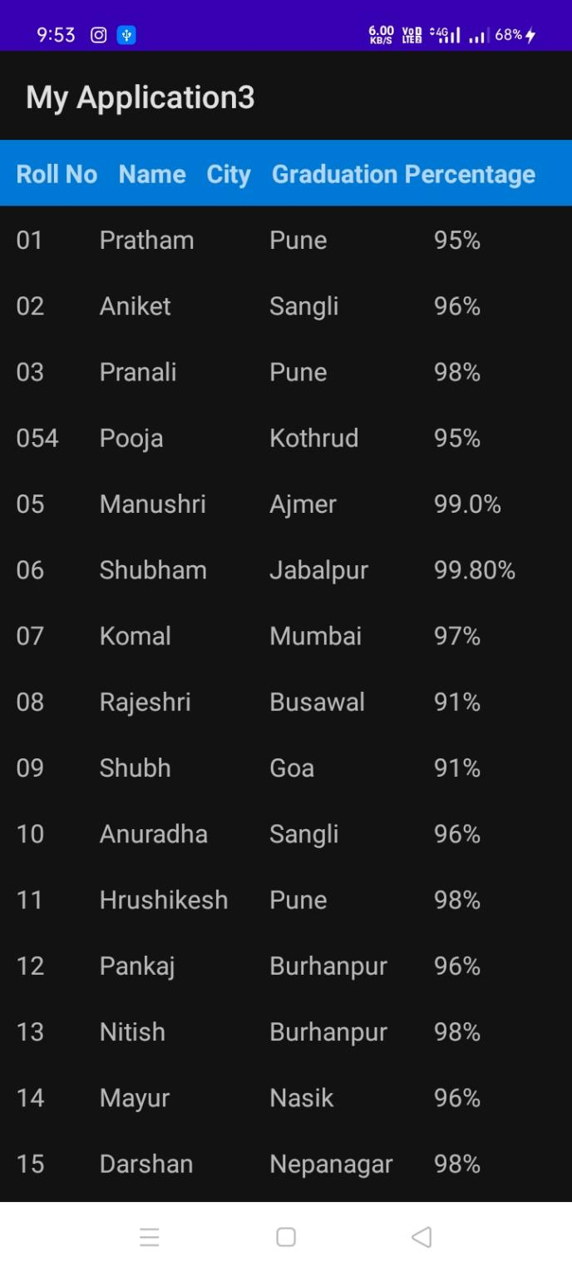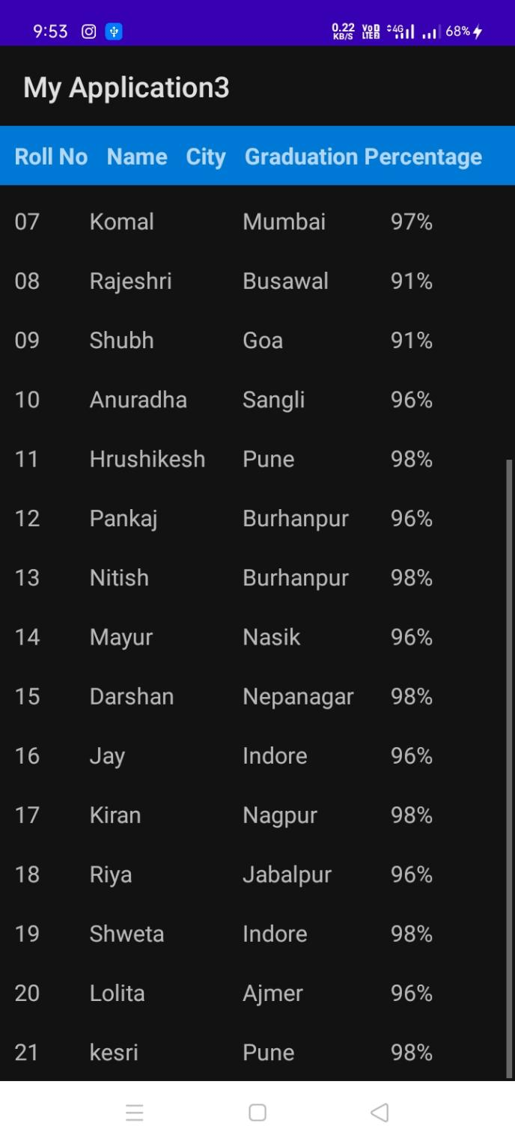

**Question 9. Write an Android Program to show Three heckbox and one button , on button click show selected checkbox name on TextView with TextColor Red.**

package com.example.checkbox;  
  
import androidx.appcompat.app.AppCompatActivity;  
  
import android.graphics.Color;  
import android.os.Bundle;  
import android.view.View;  
import android.widget.Button;  
import android.widget.CheckBox;  
  
public class MainActivity extends AppCompatActivity {  
  
 @Override  
 protected void onCreate(Bundle savedInstanceState) {  
 super.onCreate(savedInstanceState);  
 setContentView(R.layout.*activity_main*);  
 Button b1=findViewById(R.id.*button*);  
 CheckBox c1=findViewById(R.id.*checkbox1*);  
 CheckBox c2=findViewById(R.id.*checkbox2*);  
 CheckBox c3=findViewById(R.id.*checkbox3*);  
  
 b1.setOnClickListener(new View.OnClickListener() {  
 @Override  
 public void onClick(View v) {  
 if(c1.isChecked())  
 {  
 c1.setTextColor(Color.*RED*);  
 }  
 if(c2.isChecked())  
 {  
 c2.setTextColor(Color.*RED*);  
 }  
 if(c3.isChecked())  
 {  
 c3.setTextColor(Color.*RED*);  
 }  
 }  
 });  
 }  
  
}

*<?*xml version="1.0" encoding="utf-8"*?>*<androidx.constraintlayout.widget.ConstraintLayout xmlns:android="http://schemas.android.com/apk/res/android"  
 xmlns:app="http://schemas.android.com/apk/res-auto"  
 xmlns:tools="http://schemas.android.com/tools"  
 android:layout_width="match_parent"  
 android:layout_height="match_parent"  
 tools:context=".MainActivity">  
  
 <TextView  
 android:layout_width="wrap_content"  
 android:layout_height="wrap_content"  
 android:text="CheckBox"  
 app:layout_constraintBottom_toBottomOf="parent"  
 app:layout_constraintHorizontal_bias="0.458"  
 app:layout_constraintLeft_toLeftOf="parent"  
 app:layout_constraintRight_toRightOf="parent"  
 app:layout_constraintTop_toTopOf="parent"  
 app:layout_constraintVertical_bias="0.042" />  
  
 <CheckBox  
 android:layout_width="wrap_content"  
 android:id="@+id/checkbox1"  
 android:layout_height="wrap_content"  
 app:layout_constraintStart_toStartOf="parent"  
 android:layout_marginTop="128dp"  
 android:layout_marginLeft="144dp"  
 android:text="Bhopal"  
 android:textSize="25dp"  
  
 app:layout_constraintTop_toTopOf="parent" />  
  
 <CheckBox  
 android:layout_width="wrap_content"  
 android:id="@+id/checkbox2"  
 android:layout_height="wrap_content"  
 app:layout_constraintStart_toStartOf="parent"  
 android:layout_marginTop="168dp"  
 android:layout_marginLeft="144dp"  
 android:text="Jaipur"  
 android:textSize="25dp"  
  
 app:layout_constraintTop_toTopOf="parent" />  
  
 <CheckBox  
 android:layout_width="wrap_content"  
 android:id="@+id/checkbox3"  
 android:layout_height="wrap_content"  
 app:layout_constraintStart_toStartOf="parent"  
 android:layout_marginTop="208dp"  
 android:layout_marginLeft="144dp"  
 android:text="Mumbai"  
 android:textSize="25dp"  
 app:layout_constraintTop_toTopOf="parent" />  
 <Button  
 android:id="@+id/button"  
 android:layout_width="wrap_content"  
 android:layout_height="wrap_content"  
 android:layout_marginTop="248dp"  
 android:layout_marginLeft="144dp"  
 android:textSize="25dp"  
 android:text="Click Me"  
 app:layout_constraintStart_toStartOf="parent"  
 app:layout_constraintTop_toTopOf="parent" />  
  
  
</androidx.constraintlayout.widget.ConstraintLayout>

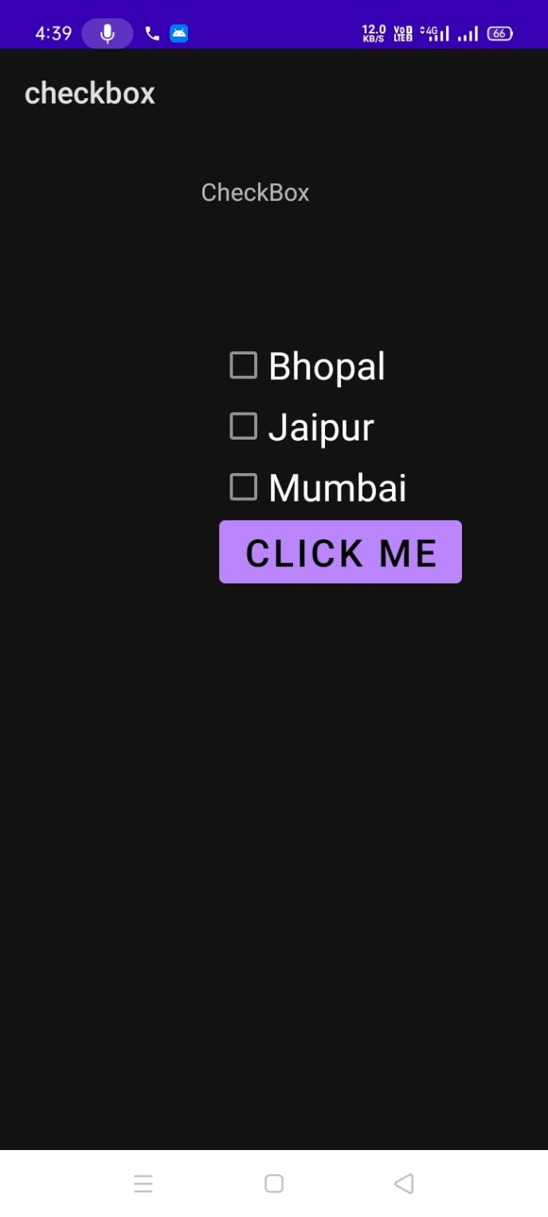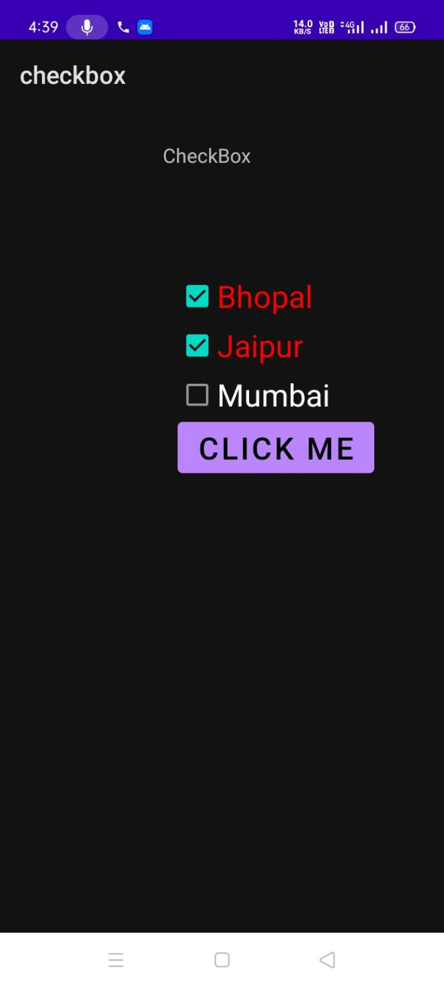

**Question 10.Write an Android program for Fibonacci Series, in which number has to be entered into EditText and its Fibonacci Series need to be printed on the TextView when Button was clicked.**

package com.example.checkbox_eg;  
  
import androidx.appcompat.app.AppCompatActivity;  
  
import android.os.Bundle;  
import android.view.View;  
import android.widget.Button;  
import android.widget.EditText;  
import android.widget.TextView;  
  
public class MainActivity extends AppCompatActivity {  
  
 @Override  
 protected void onCreate(Bundle savedInstanceState) {  
 super.onCreate(savedInstanceState);  
 setContentView(R.layout.*activity_main*);  
 Button b1=findViewById(R.id.*button*);  
 EditText e1=findViewById(R.id.*edit*);  
 TextView t1=findViewById(R.id.*series*);  
 b1.setOnClickListener(new View.OnClickListener() {  
 @Override  
 public void onClick(View v) {  
 int f1=0,f=0,i;  
 int f2=1;  
 int sum=0;  
 int num=Integer.*parseInt*(e1.getText().toString());  
 String text=" "+f1+","+f2+",";  
 for(i=0;i<num-2;i++)  
 {  
 f=f1+f2;  
 f1=f2;  
 f2=f;  
 text +=f+",";  
 }  
 t1.setText("Fibonacci Series is: "+text);  
 }  
 });  
 }  
}

*<?*xml version="1.0" encoding="utf-8"*?>*<androidx.constraintlayout.widget.ConstraintLayout xmlns:android="http://schemas.android.com/apk/res/android"  
 xmlns:app="http://schemas.android.com/apk/res-auto"  
 xmlns:tools="http://schemas.android.com/tools"  
 android:layout_width="match_parent"  
 android:layout_height="match_parent"  
 tools:context=".MainActivity">  
  
 <TextView  
 android:layout_width="wrap_content"  
 android:layout_height="wrap_content"  
 android:text="Fibonacci Series"  
 android:textSize="20dp"  
 android:textColor="@color/teal_700"  
 android:layout_marginLeft="10dp"  
 app:layout_constraintBottom_toBottomOf="parent"  
 app:layout_constraintHorizontal_bias="0.438"  
 app:layout_constraintLeft_toLeftOf="parent"  
 app:layout_constraintRight_toRightOf="parent"  
 app:layout_constraintTop_toTopOf="parent"  
 app:layout_constraintVertical_bias="0.078" />  
 <TextView  
 android:layout_width="wrap_content"  
 android:layout_height="wrap_content"  
 app:layout_constraintTop_toTopOf="parent"  
 app:layout_constraintStart_toStartOf="parent"  
 android:layout_marginTop="100dp"  
 android:layout_marginLeft="10dp"  
 android:textSize="20dp"  
 android:text="Enter Number"/>  
  
 <EditText  
 android:id="@+id/edit"  
 android:layout_width="370dp"  
 android:layout_height="80dp"  
 app:layout_constraintTop_toTopOf="parent"  
 app:layout_constraintStart_toStartOf="parent"  
 android:layout_marginLeft="10dp"  
 android:layout_marginTop="140dp"/>  
  
 <Button  
 android:layout_width="wrap_content"  
 android:layout_marginLeft="10dp"  
 android:id="@+id/button"  
 android:layout_height="wrap_content"  
 app:layout_constraintTop_toTopOf="parent"  
 android:text="Submit"  
 app:layout_constraintStart_toStartOf="parent"  
 android:layout_marginTop="220dp"/>  
  
  
 <TextView  
 android:id="@+id/series"  
 android:layout_width="wrap_content"  
 android:layout_height="wrap_content"  
 app:layout_constraintTop_toTopOf="parent"  
 app:layout_constraintStart_toStartOf="parent"  
 android:layout_marginTop="290dp"  
 android:textSize="20dp"  
 android:layout_marginLeft="10dp"  
  
 />  
  
</androidx.constraintlayout.widget.ConstraintLayout>

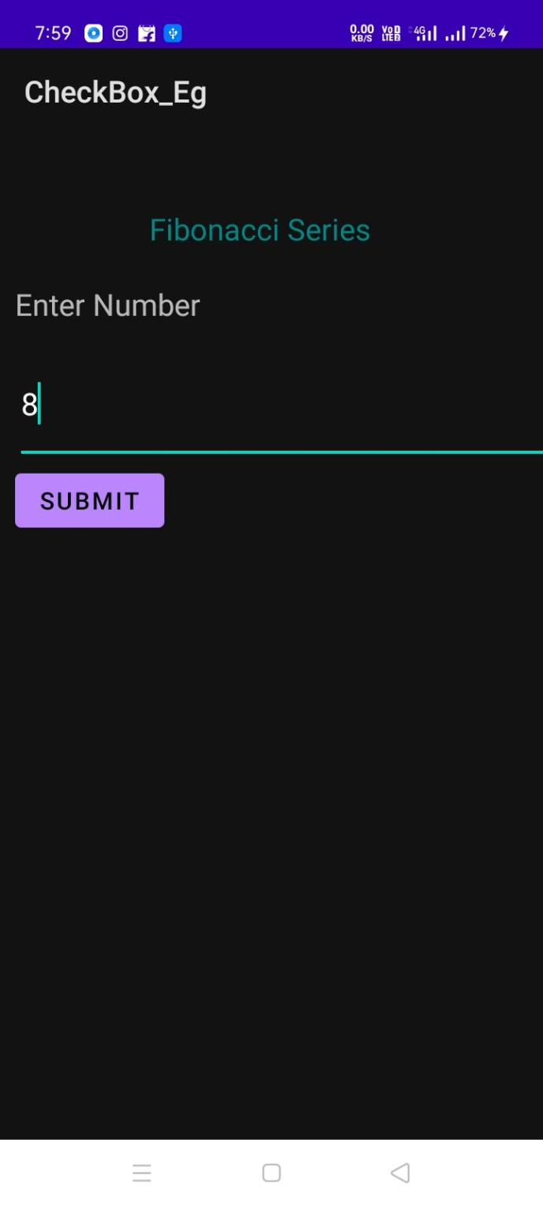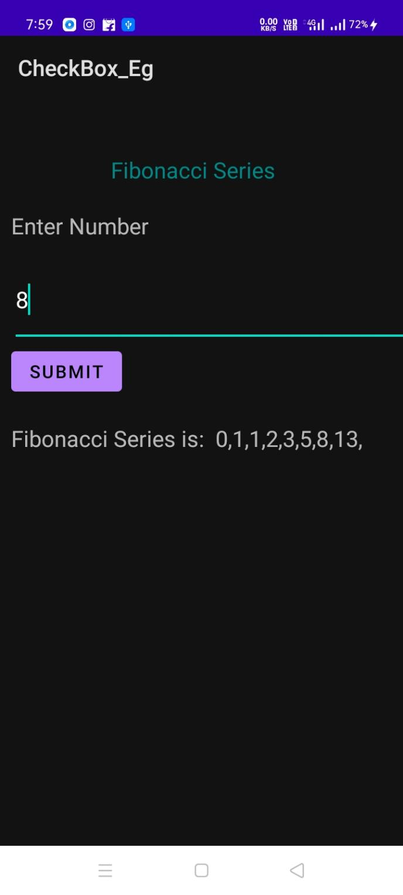

**Question 11. Create an Android Application using context Menu, which have following Menu items to change the Textview Text Properties to make it Bold, Italic, Color change etc.**

Answer:

.xml

<?xml version="1.0" encoding="utf-8"?>

<androidx.constraintlayout.widget.ConstraintLayout xmlns:android[="http://schemas.android.com/apk/res/android"](http://schemas.android.com/apk/res/android)

xmlns:app[="http://schemas.android.com/apk/res](http://schemas.android.com/apk/res-auto)-[auto"](http://schemas.android.com/apk/res-auto) xmlns:tools[="http://schemas.android.com/tools"](http://schemas.android.com/tools) android:layout_width="match_parent" android:layout_height="match_parent" tools:context=".contectmenu">

<RelativeLayout xmlns:android[="http://schemas.android.com/apk/res/android"](http://schemas.android.com/apk/res/android) xmlns:tools[="http://schemas.android.com/tools"](http://schemas.android.com/tools) xmlns:app[="http://schemas.android.com/apk/res](http://schemas.android.com/apk/res-auto)-[auto"](http://schemas.android.com/apk/res-auto) android:layout_width="wrap_content" android:layout_height="wrap_content" android:id="@+id/relLayout" tools:context=".MainActivity21">

<TextView

android:id="@+id/rangeen" android:layout_width="match_parent" android:layout_height="match_parent" android:gravity="center" android:text="Someshwar Sharma" android:textSize="30sp" app:layout_constraintBottom_toBottomOf="parent" app:layout_constraintLeft_toLeftOf="parent" app:layout_constraintRight_toRightOf="parent" app:layout_constraintTop_toTopOf="parent" />

</RelativeLayout>

</androidx.constraintlayout.widget.ConstraintLayout>

.java

package com.example.tablescroll;

import androidx.appcompat.app.AppCompatActivity;

import android.graphics.Color;

import android.graphics.Typeface; import android.os.Bundle;

import android.view.ContextMenu; import android.view.MenuInflater; import android.view.MenuItem; import android.view.View;

import android.widget.RelativeLayout; import android.widget.TextView;

public class contectmenu extends AppCompatActivity { TextView textView;

RelativeLayout relativeLayout;

@Override

protected void onCreate(Bundle savedInstanceState) { super.onCreate(savedInstanceState); setContentView(R.layout.activity_contectmenu); textView= findViewById(R.id.rangeen); relativeLayout = (RelativeLayout)

findViewById(R.id.relLayout); registerForContextMenu(textView);

}

@Override

public void onCreateContextMenu(ContextMenu menu, View v, ContextMenu.ContextMenuInfo menuInfo) {

super.onCreateContextMenu(menu, v, menuInfo); MenuInflater inflater = getMenuInflater(); inflater.inflate(R.menu.menu, menu); menu.setHeaderTitle("Select Action ");

TextView tv = (TextView)findViewById(R.id.rangeen);

}

@Override

public boolean onContextItemSelected(MenuItem item) {

if (item.getItemId() == R.id.bold) { textView.setTypeface(textView.getTypeface(),

Typeface.BOLD);

} else if (item.getItemId() == R.id.italic) { textView.setTypeface(textView.getTypeface(),

Typeface.ITALIC);

}

else if (item.getItemId() == R.id.yellow) { textView.setBackgroundColor(Color.YELLOW);

} else if (item.getItemId() == R.id.size_decrease) { textView.setBackgroundColor(Color.BLUE);

}

return true;

}

}

Output

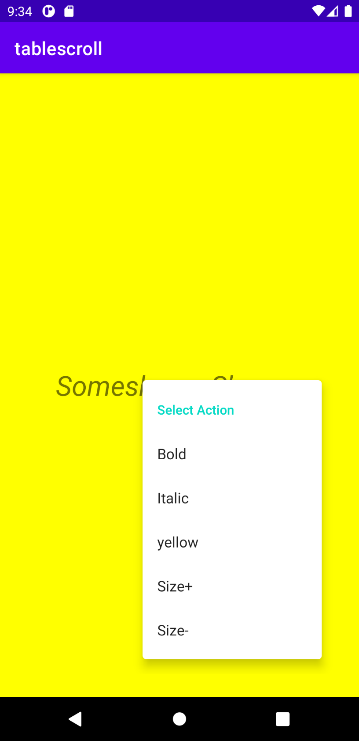

**Question 12.Design and Develop an Android Application to Stream Audio and Video File.**

**Audio Player:**

**XML:**

<?xml version="1.0" encoding="utf-8"?>

<LinearLayout xmlns:android="http://schemas.android.com/apk/res/android"

xmlns:app="http://schemas.android.com/apk/res-auto"

xmlns:tools="http://schemas.android.com/tools"

android:layout_width="match_parent"

android:layout_height="match_parent"

tools:context=“MainActivity">

<Imageview android:id= “@+id/textView1”

android:layout_width="wrap_content"

android:layout_height="wrap_content“

android:layout_gravity= “center”

android:text=“Audio Controller“

android:src=“@drawables/speakers“/>

<LinearLayout android:layout_width=“wrap_content"

android:layout_height=“wrap_content“

android:layout_margin=“20dp”android:orientation=“horizontal“>

<ImageButton android:id= “@+id/btnplay”

android:layout_width="wrap_content"

android:layout_height="wrap_content“

android:layout_margin=“20dp”

android:src=“@drawables/play“/>

<ImageButton android:id= “@+id/btnpause”

android:layout_width="wrap_content"

android:layout_height="wrap_content“

android:layout_margin=“20dp”

android:src=“@drawables/pause“/>

<ImageButton android:id= “@+id/btnstop”

android:layout_width="wrap_content"

android:layout_height="wrap_content“

android:layout_margin=“20dp”a

ndroid:src=“@drawables/stop“/>

</LinearLayout>

</LinearLayout>

**Java:**

package com.example.streamapp;

import android.media.MediaPlayer;

import android.os.Bundle;

import android.view.View;

import android.widget.ImageButton;

import androidx.appcompat.app.AppCompatActivity;

public class MainActivity extends AppCompatActivity {

ImageButton btnplay, btnpause, btnstop;

boolean playing = false;

@Override

protected void onCreate(Bundle savedInstanceState)

{

super.onCreate(savedInstanceState);

setContentView(R.layout.activity_main);

btnplay= (ImageButton) findViewById(R.id.btnplay);

btnpause= (ImageButton) findViewById(R.id.btnpause);

btnstop= (ImageButton) findViewById(R.id.btnstop);

final MediaPlayer mp= MediaPlayer.create(this,R.raw.audio);

btnplay.setOnClickListener(new View.OnClickListener(){

@Override

public void onClick(View v){

if(!playing){

mp.start();playing=true;

}

}

}

);

btnpause.setOnClickListener(new View.OnClickListener(){

@Override

public void onClick(View v){

if(playing)

{

mp.pause();

playing=false;}

}

}

);

btnstop.setOnClickListener(new View.OnClickListner(){

@Override

public void onClick(View v){

if(playing){

mp.stop();

playing=false;

}

}

}

);

}

}

**Video Player:**

**XML:**

<?xml version="1.0"encoding="utf-8"?>

<RelativeLayout

xmlns:android="<http://schemas.android.com/apk/res/android>

"android:layout_width="match_parent"

android:layout_height="match_parent"

android:paddingLeft="10dp"

android:paddingRight="10dp">

<VideoView

android:id="@+id/vdVw"

android:layout_width="match_parent"

android:layout_height="match_parent"

android:layout_gravity="center"/>

</RelativeLayout>

**Java:**

package com.example.myapplication;  
  
import androidx.appcompat.app.AppCompatActivity;  
import android.net.Uri;  
import android.os.Bundle;  
import android.widget.MediaController;  
import android.widget.VideoView;  
  
public class VideoStream extends AppCompatActivity {  
  
 @Override  
 protected void onCreate(Bundle savedInstanceState) {  
 super.onCreate(savedInstanceState);  
 setContentView(R.layout.activity_video_stream);  
 VideoView videoView = (VideoView)findViewById(R.id.vdVw);  
 MediaController mediaController = new MediaController(this);  
 mediaController.setAnchorView(videoView);  
 Uri uri = Uri.parse("android.resource://"+getPackageName()+"/"+R.raw.video);  
 videoView.setMediaController(mediaController);  
 videoView.setVideoURI(uri);  
 videoView.requestFocus();  
 videoView.start();  
 }  
}

**Question 12. Design and Develop an Android Application which lists all sensors available on your mobile Phone. (Run your application in Physical device).**

**Java:**

package com.example.sensorapp;

import androidx.appcompat.app.AppCompatActivity;

import android.content.Context;

import android.hardware.Sensor;

import android.hardware.SensorManager;

import android.os.Bundle;

import android.view.View;

import android.widget.TextView;

import java.util.List;

public class MainActivity extends AppCompatActivity {

private SensorManager mgr;

private TextView txtList;

@Override

protected void onCreate(Bundle savedInstanceState)

{

super.onCreate(savedInstanceState);

setContentView(R.layout.activity_main);

mgr= (SensorManager)getSystemService(Context.SENSOR_SERVICE);

txtList= (TextView)findViewById(R.id.sensorslist);

List<Sensor> sensorList=mgr.getSensorList(Sensor.TYPE_ALL);

StringBuilder strBuilder=new StringBuilder();

for(Sensor s: sensorList)

{

strBuilder.append(s.getName()+"\n");

}

txtList.setVisibility(View.VISIBLE);

txtList.setText(strBuilder);

}

}

**XML:**

<?xml version="1.0" encoding="utf-8"?>

<LinearLayout

xmlns:android="http://schemas.android.com/apk/res/android"

android:orientation="vertical"

android:layout_width="match_parent"

android:layout_height="match_parent"

android:paddingLeft="10dp"

android:paddingRight="10dp">

<TextView

android:id="@+id/sensorslist"

android:layout_width="wrap_content"

android:layout_height="wrap_content"

android:layout_marginTop="80dp"

android:text="Sensors"

android:textSize="20dp"

android:textStyle="bold"

android:layout_gravity="center"

android:visibility="gone"/>

</LinearLayout>

**Output:**

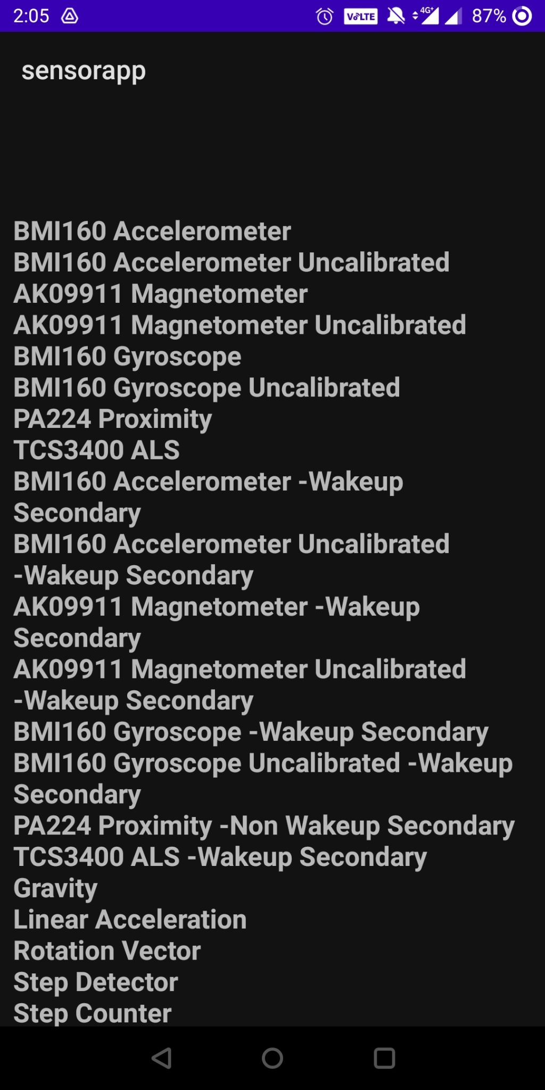

**Qustion 13. Design and Develop an Android Application which lists Phone details of your mobile Phone. (Run your application in Physical device).**

**XML:**

<?xml version="1.0" encoding="utf-8"?>

<RelativeLayout xmlns:android="http://schemas.android.com/apk/res/android"

xmlns:app="http://schemas.android.com/apk/res-auto"

xmlns:tools="http://schemas.android.com/tools"

android:layout_width="match_parent"

android:layout_height="match_parent"

tools:context=".MainActivity">

<TextView

android:id="@+id/textView"

android:layout_width="329dp"

android:layout_height="wrap_content"

android:layout_alignParentStart="true"

android:layout_alignParentTop="true"

android:layout_alignParentEnd="true"

android:layout_marginStart="39dp"

android:layout_marginTop="12dp"

android:layout_marginEnd="43dp"

android:textSize="35dp" />

<TextView

android:id="@+id/textView1"

android:layout_width="wrap_content"

android:layout_height="wrap_content"

android:layout_alignParentLeft="true"

android:layout_alignParentTop="true"

android:layout_alignParentEnd="true"

android:layout_marginLeft="162dp"

android:layout_marginTop="69dp"

android:layout_marginEnd="163dp"

android:text="PhoneDetails:" />

</RelativeLayout>

**Java:**

package com.example.phonedetails;

import androidx.appcompat.app.AppCompatActivity;

import androidx.core.app.ActivityCompat;

import androidx.core.content.ContextCompat;

import android.Manifest;

import android.content.Context;

import android.content.pm.PackageManager;

import android.os.Bundle;

import android.provider.Settings;

import android.telephony.TelephonyManager;

import android.widget.TextView;

import android.widget.Toast;

public class MainActivity extends AppCompatActivity {

TextView textview1;

private static final int MY_PERMISSIONS_REQUEST_READ = 0;

TelephonyManager ss1;

@Override

protected void onCreate(Bundle savedInstanceState) {

super.onCreate(savedInstanceState);

setContentView(R.layout.activity_main);

textview1 = (TextView) findViewById(R.id.textView1);

String unique_id;

if(ContextCompat.checkSelfPermission(this, Manifest.permission.READ_PHONE_STATE)!= PackageManager.PERMISSION_GRANTED)

{

if (ActivityCompat.shouldShowRequestPermissionRationale(this, Manifest.permission.READ_PHONE_STATE))

{

}

else {

ActivityCompat.requestPermissions(this, new String[]{Manifest.permission.READ_PHONE_STATE}, MY_PERMISSIONS_REQUEST_READ);

}

}

else {

ss1 = (TelephonyManager) getSystemService(Context.TELEPHONY_SERVICE);

}

String networkCountryISO= ss1.getNetworkCountryIso();

String softwareVersion= ss1.getDeviceSoftwareVersion();

String voiceMailNumber= ss1.getVoiceMailNumber();

String strphoneType= " ";

int phoneType= ss1.getPhoneType();

switch (phoneType)

{

case (TelephonyManager.PHONE_TYPE_CDMA):

strphoneType= "CDMA";

break;

case (TelephonyManager.PHONE_TYPE_GSM):

strphoneType= "GSM";

break;

case(TelephonyManager.PHONE_TYPE_NONE):

strphoneType= "NONE";

break;

}

boolean isRoaming= ss1.isNetworkRoaming();

String info = "Phone Details:\n";

info += "\n Network Country ISO " + networkCountryISO;

info += "\nSoftwareVersion " + softwareVersion;

info += "\n Voice Mail Number " + voiceMailNumber;

info += "\n Phone network type " + strphoneType;

info += "\n Roaming " + isRoaming;

textview1.setText(info);

unique_id= Settings.Secure.getString(this.getContentResolver(),Settings.Secure.ANDROID_ID);

textview1.setText(info);

Toast.makeText(this, "Already Granted", Toast.LENGTH_SHORT).show();

}

}

**Output:**

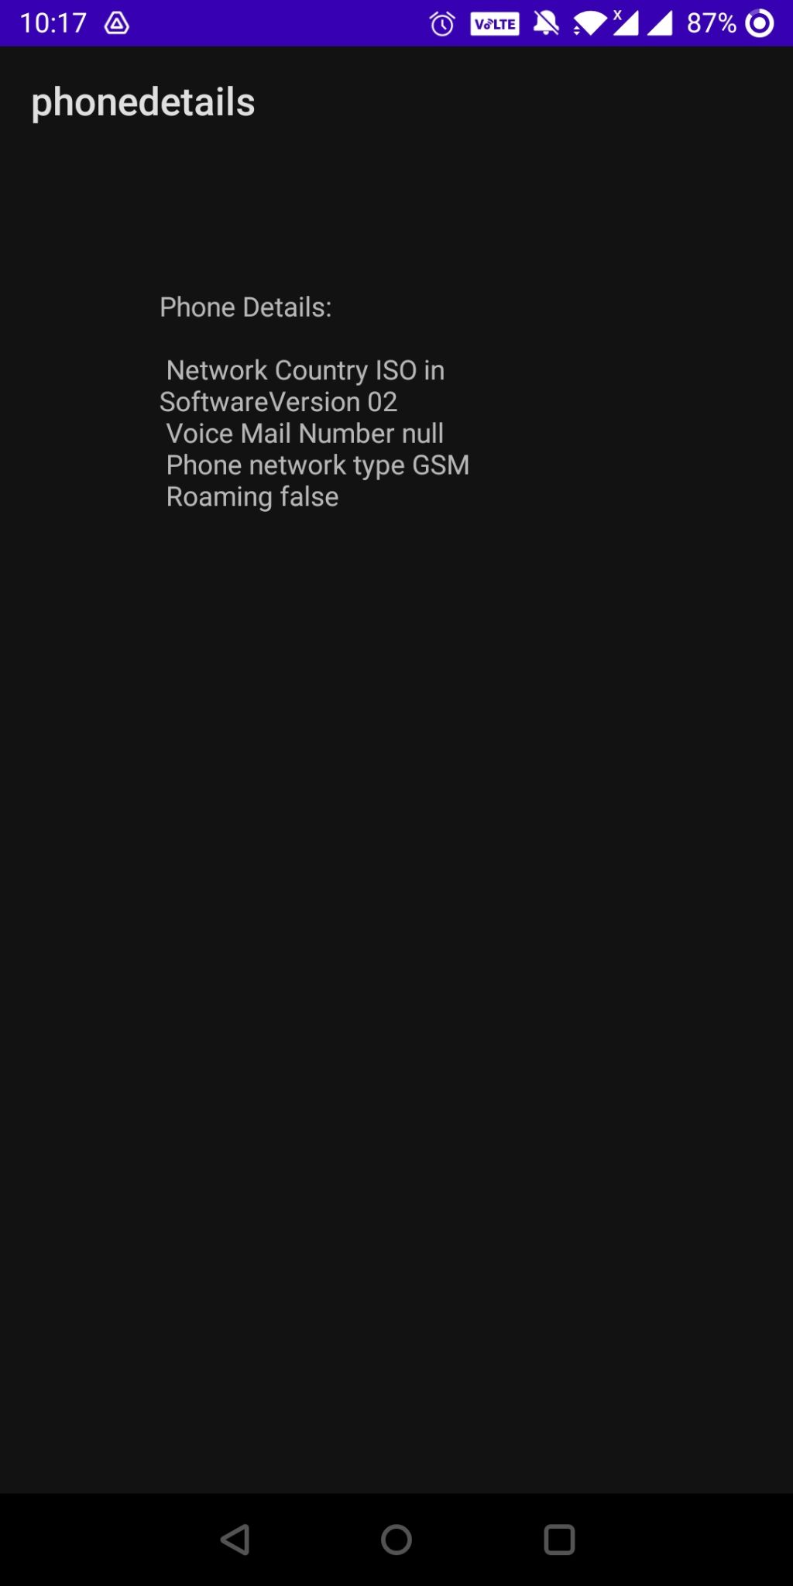

**Question 14. Design and Develop an Android Application for Enabling and Disabling Bluetooth using Switch On and Switch Off Buttons. (Run this application on your Physical device)?**

Bluetooth.xml

<?xml version="1.0" encoding="utf-8"?>

<androidx.constraintlayout.widget.ConstraintLayout xmlns:android="http://schemas.android.com/apk/res/android"

xmlns:app="http://schemas.android.com/apk/res-auto"

xmlns:tools="http://schemas.android.com/tools"

android:layout_width="match_parent"

android:layout_height="match_parent"

tools:context=".bluetooth">

<Button

android:id="@+id/btnOn"

android:layout_width="wrap_content"

android:layout_height="wrap_content"

android:layout_marginTop="260dp"

android:layout_marginEnd="68dp"

android:text="Turn On"

app:layout_constraintEnd_toEndOf="parent"

app:layout_constraintTop_toTopOf="parent" />

<Button

android:id="@+id/btnOFF"

android:layout_width="wrap_content"

android:layout_height="wrap_content"

android:layout_alignBottom="@+id/btnOn"

android:layout_marginStart="44dp"

android:layout_marginTop="260dp"

android:layout_toRightOf="@+id/btnOn"

android:text="Turn OFF"

app:layout_constraintStart_toStartOf="parent"

app:layout_constraintTop_toTopOf="parent" />

</androidx.constraintlayout.widget.ConstraintLayout>

Bluethooth.java

package com.example.tablescroll;

import androidx.appcompat.app.AppCompatActivity;

import android.bluetooth.BluetoothAdapter;

import android.content.Intent;

import android.os.Bundle;

import android.view.View;

import android.widget.Button;

import android.widget.Toast;

public class bluetooth extends AppCompatActivity {

@Override

protected void onCreate(Bundle savedInstanceState) {

super.onCreate(savedInstanceState);

setContentView(R.layout.activity_bluetooth);

Button btntOn = (Button)findViewById(R.id.btnOn);

Button btntOff = (Button)findViewById(R.id.btnOFF);

final BluetoothAdapter bAdapter = BluetoothAdapter.getDefaultAdapter();

btntOn.setOnClickListener(new View.OnClickListener() {

@Override

public void onClick(View v) {

if(bAdapter == null)

{

Toast.makeText(getApplicationContext(),"Bluetooth Not Supported",Toast.LENGTH_SHORT).show();

}

else{

if(!bAdapter.isEnabled()){

startActivityForResult(new Intent(BluetoothAdapter.ACTION_REQUEST_ENABLE),1);

Toast.makeText(getApplicationContext(),"Bluetooth Turned ON", Toast.LENGTH_SHORT).show();

}

}

}

});

btntOff.setOnClickListener(new View.OnClickListener() {

@Override

public void onClick(View v) {

bAdapter.disable();

Toast.makeText(getApplicationContext(),"Bluetooth Turned OFF", Toast.LENGTH_SHORT).show();

}

});

}

}

Output

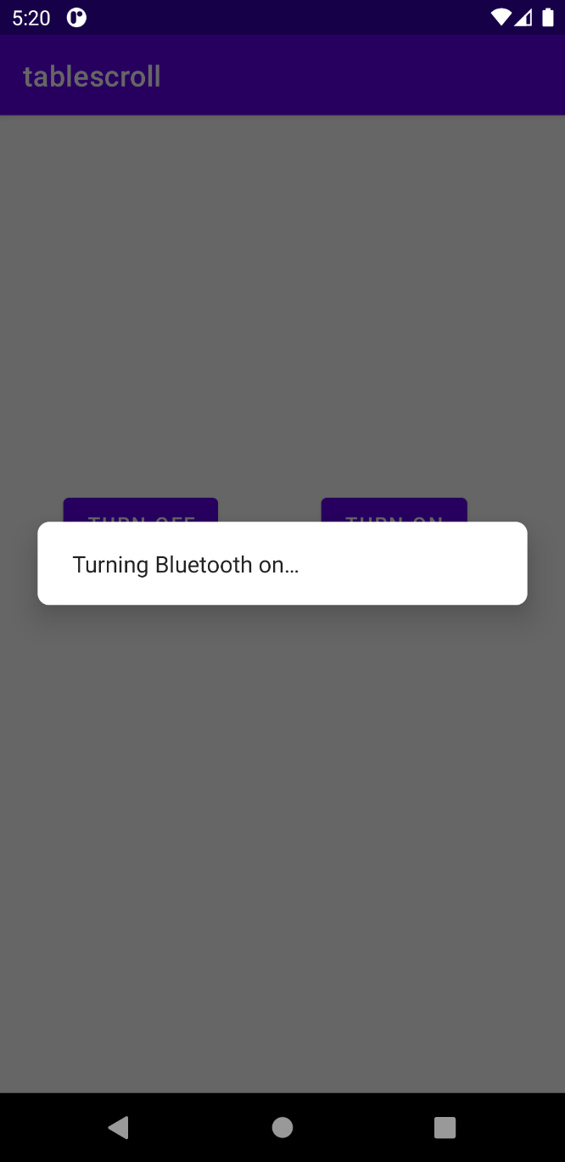 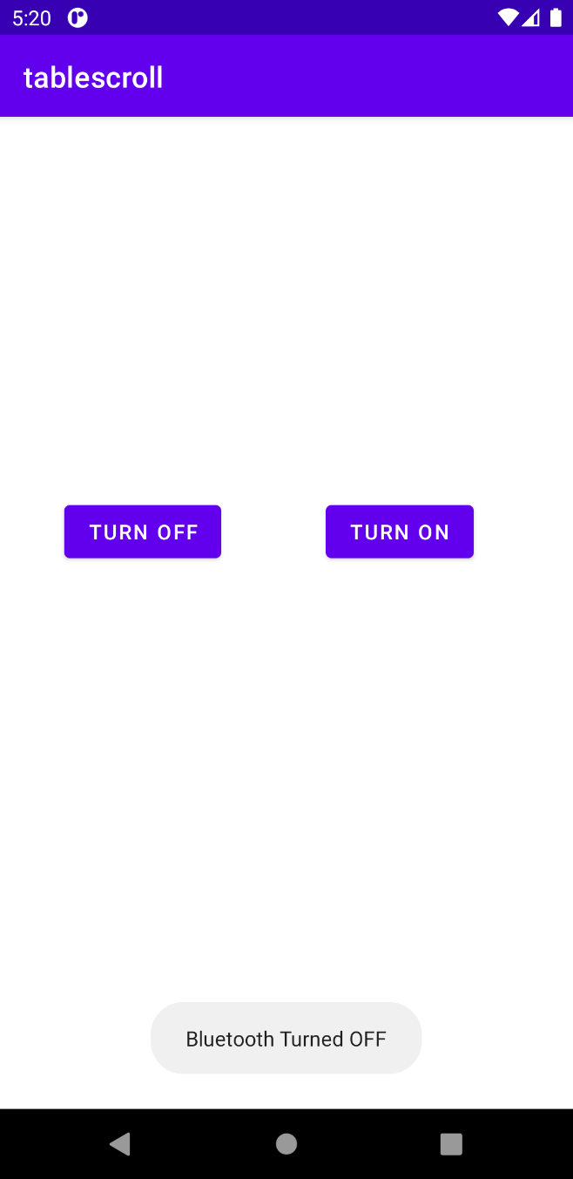

**Question 15. Design and Develop an Android Application to Switch ON and Switch OFF Wi-Fi using Implicit Intent?**

Wifi.java

package com.example.tablescroll;

import androidx.appcompat.app.AppCompatActivity;

import android.content.Context;

import android.net.wifi.WifiManager;

import android.os.Bundle;

import android.view.View;

import android.widget.Button;

import android.widget.Toast;

public class wifi extends AppCompatActivity {

Button enableButton,disableButton;

@Override

protected void onCreate(Bundle savedInstanceState) {

super.onCreate(savedInstanceState);

setContentView(R.layout.activity_wifi);

enableButton=(Button)findViewById(R.id.button1);

disableButton=(Button)findViewById(R.id.button2);

enableButton.setOnClickListener(new View.OnClickListener(){

public void onClick(View v){

WifiManager wifi = (WifiManager) getSystemService(Context.WIFI_SERVICE);

wifi.setWifiEnabled(true);

Toast.makeText(getApplicationContext(),"Wifi Turned ON", Toast.LENGTH_SHORT).show();

}

});

disableButton.setOnClickListener(new View.OnClickListener(){

public void onClick(View v){

WifiManager wifi = (WifiManager) getSystemService(Context.WIFI_SERVICE);

wifi.setWifiEnabled(false);

Toast.makeText(getApplicationContext(),"Wifi Turned ON", Toast.LENGTH_SHORT).show();

}

});

}

}

wifi.xml

<?xml version="1.0" encoding="utf-8"?>

<androidx.constraintlayout.widget.ConstraintLayout xmlns:android="http://schemas.android.com/apk/res/android"

xmlns:app="http://schemas.android.com/apk/res-auto"

xmlns:tools="http://schemas.android.com/tools"

android:layout_width="match_parent"

android:layout_height="match_parent"

tools:context=".wifi">

<Button

android:id="@+id/button1"

android:layout_width="wrap_content"

android:layout_height="wrap_content"

android:layout_alignBottom="@+id/button2"

android:layout_alignParentStart="true"

android:layout_marginEnd="148dp"

android:layout_marginBottom="152dp"

android:text="Enable Wifi"

app:layout_constraintBottom_toTopOf="@+id/button2"

app:layout_constraintEnd_toEndOf="parent" />

<Button

android:id="@+id/button2"

android:layout_width="wrap_content"

android:layout_height="wrap_content"

android:layout_alignParentEnd="true"

android:layout_alignParentBottom="true"

android:layout_marginTop="396dp"

android:layout_marginEnd="144dp"

android:text="Disable Wifi"

app:layout_constraintEnd_toEndOf="parent"

app:layout_constraintTop_toTopOf="parent" />

</androidx.constraintlayout.widget.ConstraintLayout>

Output

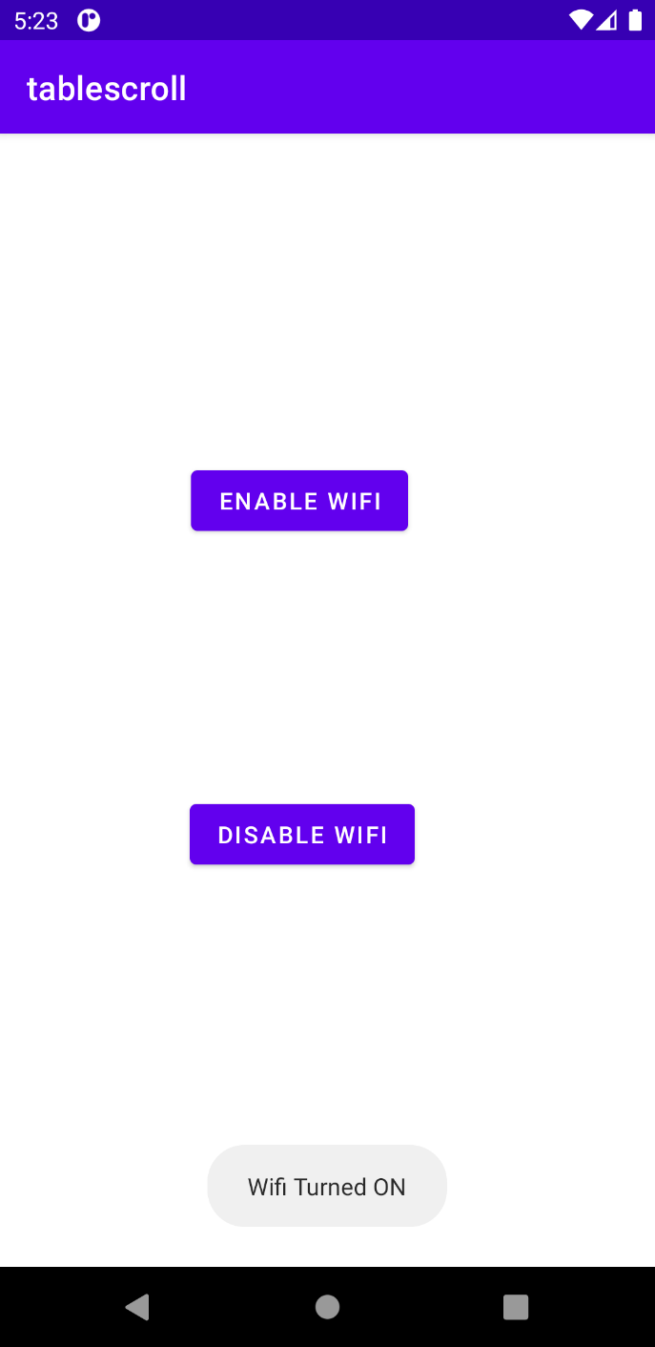 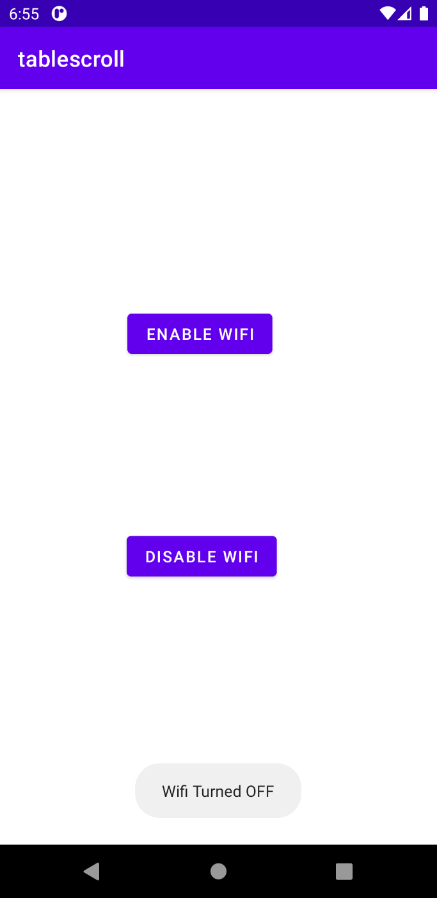

Question 16.

<?xml version="1.0" encoding="utf-8"?>

<androidx.constraintlayout.widget.ConstraintLayout xmlns:android="http://schemas.android.com/apk/res/android"

xmlns:app="http://schemas.android.com/apk/res-auto"

xmlns:tools="http://schemas.android.com/tools"

android:layout_width="match_parent"

android:layout_height="match_parent"

tools:context=".MainActivity1">

<SeekBar

android:id="@+id/seekBar"

android:layout_width="match_parent"

android:layout_height="wrap_content"

android:layout_marginStart="8dp"

android:layout_marginEnd="8dp"

app:layout_constraintBottom_toBottomOf="parent"

app:layout_constraintEnd_toEndOf="parent"

app:layout_constraintHorizontal_bias="0.0"

app:layout_constraintStart_toStartOf="parent"

app:layout_constraintTop_toTopOf="parent"

app:layout_constraintVertical_bias="0.316" />

<ProgressBar

android:id="@+id/pBar"

style="?android:attr/progressBarStyleHorizontal"

android:layout_width="wrap_content"

android:layout_height="wrap_content"

android:indeterminate="false"

android:max="100"

android:minWidth="200dp"

android:minHeight="50dp"

android:progress="0"

app:layout_constraintEnd_toEndOf="parent"

app:layout_constraintHorizontal_bias="0.497"

app:layout_constraintStart_toStartOf="parent"

tools:layout_editor_absoluteY="290dp"

tools:ignore="MissingConstraints" />

<TextView

android:id="@+id/tView"

android:layout_width="wrap_content"

android:layout_height="wrap_content"

android:layout_below="@+id/pBar"

android:layout_alignLeft="@+id/pBar"

app:layout_constraintBottom_toBottomOf="parent"

app:layout_constraintEnd_toEndOf="parent"

app:layout_constraintHorizontal_bias="0.498"

app:layout_constraintStart_toStartOf="parent"

app:layout_constraintTop_toBottomOf="@+id/btnShow"

tools:ignore="MissingConstraints" />

<Button

android:id="@+id/btnShow"

android:layout_width="wrap_content"

android:layout_height="wrap_content"

android:layout_below="@+id/tView"

android:text="Start Progress"

app:layout_constraintBottom_toBottomOf="parent"

app:layout_constraintEnd_toEndOf="parent"

app:layout_constraintStart_toStartOf="parent"

app:layout_constraintTop_toBottomOf="@+id/pBar"

app:layout_constraintVertical_bias="0.204" />/

</androidx.constraintlayout.widget.ConstraintLayout>

package com.example.checkbox_eg;

import androidx.appcompat.app.AppCompatActivity;

import android.os.Bundle;

import android.widget.SeekBar;

import android.widget.Toast;

import android.view.View;

import android.widget.Button;

import android.widget.ProgressBar;

import android.widget.TextView;

import android.os.Handler;

public class MainActivity1 extends AppCompatActivity {

SeekBar seekBar;

private ProgressBar pgsBar;

private int i = 0;

private TextView txtView;

private Handler hdlr = new Handler();

@Override

protected void onCreate(Bundle savedInstanceState) {

super.onCreate(savedInstanceState);

setContentView(R.layout.activity_main1);

//Progress Bar Code

pgsBar = (ProgressBar) findViewById(R.id.pBar);

txtView = (TextView) findViewById(R.id.tView);

Button btn = (Button)findViewById(R.id.btnShow);

btn.setOnClickListener(new View.OnClickListener() {

@Override

public void onClick(View v) {

i = pgsBar.getProgress();

new Thread(new Runnable() {

public void run() {

while (i < 100) {

i += 1;

// Update the progress bar and display the current value in text view

hdlr.post(new Runnable() {

public void run() {

pgsBar.setProgress(i);

txtView.setText(i+"/"+pgsBar.getMax());

}

});

try {

// Sleep for 100 milliseconds to show the progress slowly.

Thread.sleep(100);

} catch (InterruptedException e) {

e.printStackTrace();

}

}

}

}).start();

}

});

seekBar=(SeekBar)findViewById(R.id.seekBar);

seekBar.setOnSeekBarChangeListener(new SeekBar.OnSeekBarChangeListener() {

@Override

public void onProgressChanged(SeekBar seekBar, int progress,

boolean fromUser) {

Toast.makeText(getApplicationContext(),"seekbar progress: "+progress, Toast.LENGTH_SHORT).show();

}

@Override

public void onStartTrackingTouch(SeekBar seekBar) {

Toast.makeText(getApplicationContext(),"seekbar touch started!", Toast.LENGTH_SHORT).show();

}

@Override

public void onStopTrackingTouch(SeekBar seekBar) {

Toast.makeText(getApplicationContext(),"seekbar touch stopped!", Toast.LENGTH_SHORT).show();

}

});

}

}

<?xml version="1.0" encoding="utf-8"?>

<androidx.constraintlayout.widget.ConstraintLayout xmlns:android="http://schemas.android.com/apk/res/android"

xmlns:app="http://schemas.android.com/apk/res-auto"

xmlns:tools="http://schemas.android.com/tools"

android:layout_width="match_parent"

android:layout_height="match_parent"

android:padding="30dp"

tools:context=".MainActivity2">

<DatePicker

android:id="@+id/datepicker"

android:layout_width="match_parent"

android:layout_height="wrap_content"

android:layout_marginTop="16dp"

android:datePickerMode="calendar"

app:layout_constraintEnd_toEndOf="parent"

app:layout_constraintHorizontal_bias="1.0"

app:layout_constraintStart_toStartOf="parent"

app:layout_constraintTop_toTopOf="parent" />

<Button

android:id="@+id/button"

android:layout_width="wrap_content"

android:layout_height="wrap_content"

android:layout_marginTop="68dp"

android:backgroundTint="@color/teal_700"

android:text="Button"

app:layout_constraintEnd_toEndOf="parent"

app:layout_constraintStart_toStartOf="parent"

app:layout_constraintTop_toBottomOf="@+id/datepicker" />

</androidx.constraintlayout.widget.ConstraintLayout>

package com.example.checkbox_eg;

import androidx.appcompat.app.AppCompatActivity;

import android.os.Bundle;

import android.view.View;

import android.widget.Button;

import android.widget.TextView;

import android.widget.Toast;

import java.util.Calendar;

public class MainActivity2 extends AppCompatActivity {

android.widget.DatePicker picker;

Button btnGet;

@Override

protected void onCreate(Bundle savedInstanceState) {

super.onCreate(savedInstanceState);

setContentView(R.layout.activity_main2);

picker=findViewById(R.id.datepicker);

btnGet=(Button)findViewById(R.id.button);

btnGet.setOnClickListener(new View.OnClickListener() {

@Override

public void onClick(View v) {

int y=picker.getYear();

int year= Calendar.getInstance().get(Calendar.YEAR);

int age= year - y;

Toast.makeText(MainActivity2.this, age+" years", Toast.LENGTH_LONG).show();

}

});

}

}