1. **List the employee number, last name, first name, sex, and salary of each employee.**

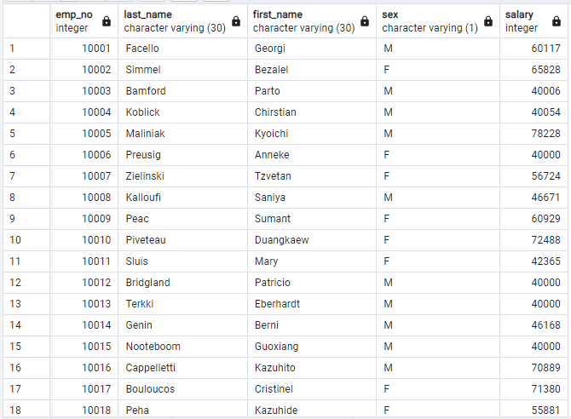

1. **List the first name, last name, and hire date for the employees who were hired in 1986.**

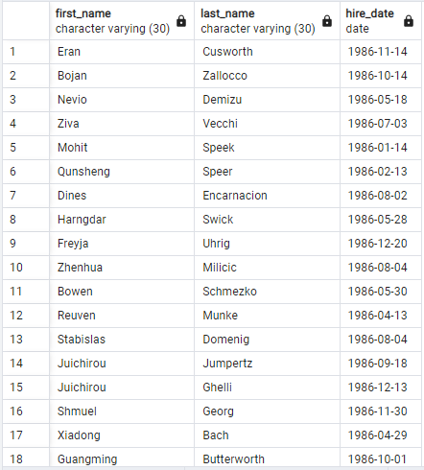

1. **List the manager of each department along with their department number, department name, employee number, last name, and first name.**

1. **List the department number for each employee along with that employee’s employee number, last name, first name, and department name.**

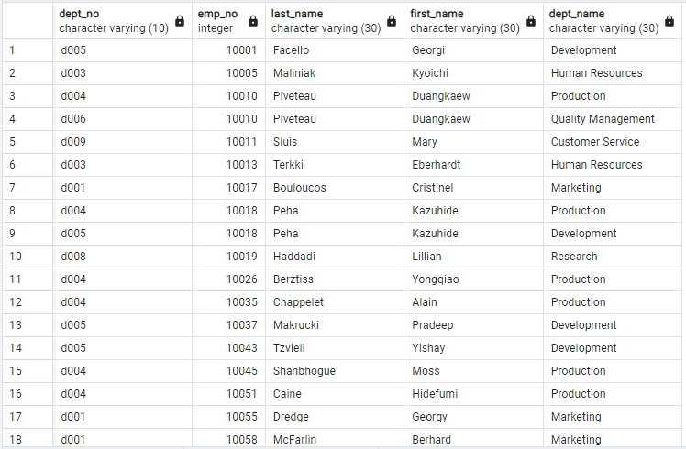

5. **List the first name, last name, and sex of each employee whose first name is Hercules and whose last name begins with the letter B**

6**. List each employee in the Sales department, including their employee number, last name, and first name.**

7. List each employee in the Sales and Development departments, including their employee number, last name, first name, and department name.

8. **List the frequency counts, in descending order, of all the employee last names (that is, how many employees share each last name).**

