***SALESFORCE GUIDED PROJECT***



Build An Employee Travel Approval Application For Corporates using Salesforce Developer Org.

***SUBMITTED BY:***

***ROHAN RAVINDRA MALI***

***UNDER***

***Virtual Internship – Salesforce Administrator***

## CHAPTER I: INTRODUCTION ABSTRACT

**Customer Relationship Management (CRM)** is a system that helps organizations manage and track customer interactions. **CRM** can be used to track sales leads, customer interactions, and customer support issues. **CRM** can also be used to track employee performance and to manage marketing campaigns. In this paper, we propose a method for implementing **CRM** for Employee Travel Approval Application For Corporates using **Salesforce Developer Org**.

**Salesforce Developer Org** is a free, cloud-based CRM platform that can be used to develop and test **CRM** applications. Our proposed method uses **Salesforce Developer Org** to create a **CRM** system that can be used to track the results of a candidate's performance on internal marks. The **CRM** system will track the candidate's scores on each internal mark, as well as the candidate's overall performance. The **CRM** system will also track the candidate's progress towards their goals.

The proposed method has several advantages:

➔**First**, it is a cost-effective way to implement **CRM** for Employee Travel Approval Application For Corporates.

➔**Second**, it is a scalable solution that can be used to track the approval requests of multiple candidates.

➔**Third**, it is a flexible solution that can be customized to meet the specific needs of the organization.

The proposed method has been implemented in a real-world setting and has been shown to be effective. The results of this implementation have shown that the proposed method is a cost-effective, scalable, and flexible solution for implementing **CRM** for Employee Travel Approval Application For Corporates.

## OBJECTIVE

The main aim of this project is to create Departments, Employee Details, Trip Details. CEO and Mangers should be the only persons with ability to Approve Travel for employees.

## PRIMARY GOALS

The goals of this project are listed as follows:

➔**Choose the right CRM system:** The first step is to choose the right **CRM** system. There are many different **CRM** systems available, so it is important to choose one that meets the needs of the company.

➔**Customize the CRM system:** Once the **CRM** system has been chosen, it is important to customize it to meet the needs of the company. This includes adding fields, creating reports, and configuring settings.

➔**Train employees on how to use the CRM system:** It is important to train employees on how to use the **CRM** system. This will ensure that everyone is using the system effectively.

➔**Use the CRM system for travel approval :** The **CRM** system can be used to approve travel requests of emplyees on the basis of company policies. This will help the company to improve efficiency and accuracy, and it will help the company to get travel data of every employee and can be analyzed in any period of time.

## PURPOSE

The application saves time for both the employee and the travel manager by automating the travel request and approval process. The application ensures that travel requests comply with the company’s travel policies, which reduces the risk of non-compliant expenses and unnecessary travel.

## OVERVIEW

Corporate travel is an integral part of the business world, as companies need to travel to meet clients, attend conferences and meetings, and explore new markets. However, managing employee travel can be a cumbersome task for the HR and travel departments. That’s why many corporates have started using employee travel approval applications to streamline the process.

## INTRODUCTION TO SALESFORCE

**Salesforce** is a cloud-based **Customer Relationship Management (CRM)** platform that helps businesses of all sizes connect with their customers. **Salesforce** provides a suite of tools that businesses can use to manage their sales, marketing, and customer service operations. **Salesforce** was founded in 1999 by Marc Benioff, Parker Harris, and Frank Dominguez. The company is headquartered in San Francisco, California, and has over 19,000 employees. **Salesforce** is the world's leading **CRM** platform, with over 150,000 customers in more than 190 countries. **Salesforce** offers a variety of features that help businesses to improve their customer relationships.

These features include:

➔**Lead Management: Salesforce** helps businesses to track and manage leads, from the initial contact to the close of the deal.

➔**Sales Forecasting: Salesforce** helps businesses to forecast sales and identify opportunities.

➔**Marketing Automation: Salesforce** helps businesses to automate marketing tasks, such as email campaigns and lead nurturing.

➔**Customer Service: Salesforce** helps businesses to provide excellent customer service, from answering questions to resolving issues.

**Salesforce** is a powerful **CRM** platform that can help businesses of all sizes to improve their customer relationships. **Salesforce** is easy to use and scalable, making it a good choice for businesses of all sizes.

Here are some of the benefits of using **Salesforce**:

➔**Increased efficiency: Salesforce** can help businesses to save time and money by automating tasks and providing a central repository for customer data.

➔**Improved customer relationships: Salesforce** can help businesses to build stronger relationships with their customers by providing a more personalized experience.

➔**Increased sales: Salesforce** can help businesses to close more deals by providing a better understanding of their customers and their needs.

➔**Improved customer service: Salesforce** can help businesses to provide better customer service by providing a more efficient way to manage customer interactions.

If anyone is looking for a **CRM** platform that can help you to improve your customer relationships, **Salesforce** is a good option to consider. **Salesforce** is a powerful and scalable platform that can help businesses of all sizes to achieve their goals

## CHAPTER II: TECHNICAL REQUIREMENTS SOFTWARE

The Software package is developed using **Salesforce CRM Cloud**.

➔Operating System: Windows 10/11

➔Software: **Salesforce Developer Org**

## HARDWARE

➔RAM: 4 GB RAM and above

➔ROM: 200 GB ROM and above

## CHAPTER III: IMPLEMENTATION & DESIGNING SALESFORCE DEVELOPER ORG

A **Salesforce Developer Edition** is a free, fully-functional **Salesforce** org that is designed for developers to learn about, explore, and build on the Salesforce platform. It includes all of the features and functionality of a production org, but it is not associated with any data or users, so you can experiment and learn without affecting any live data.

Developer Editions are a great way to get started with **Salesforce** development. They give you access to all of the tools and resources you need to learn about the platform, and they allow you to build and test your own applications without having to worry about affecting any live data.

To create a **Salesforce Developer Edition**, you can sign up for a free account on the **Salesforce** website. Once you have created an account, you will be able to access your Developer Edition from the **Salesforce App Cloud**.

➔**Salesforce Developer Edition Sign Up Page:** [**https://developer.salesforce.com/signup**](https://developer.salesforce.com/signup)

Benefits of using a **Salesforce Developer Edition**:

➔**Free:** Developer Editions are free to create and use.

➔**Fully-functional:** Developer Editions include all of the features and functionality of a production org.

➔**Easy to create:** You can create a Developer Edition in just a few minutes.

➔**Easy to use:** Developer Editions are easy to use and navigate.

## CREATING DEVELOPER ORG

Creating a developer org in salesforce.

1. Go to developers.salesforce.com/
2. Click on sign up.
3. On the sign up form, enter the following details:
   1. First name & Last name
   2. Email
   3. Role: Developer
   4. Company: College Name
   5. County: India
   6. Postal Code: pin code
   7. Username: should be a combination of your name and company This need not be an actual email id; you can give anything in the format: [username@organization.com](mailto:username@organization.com)

Click on sign up after filling these.

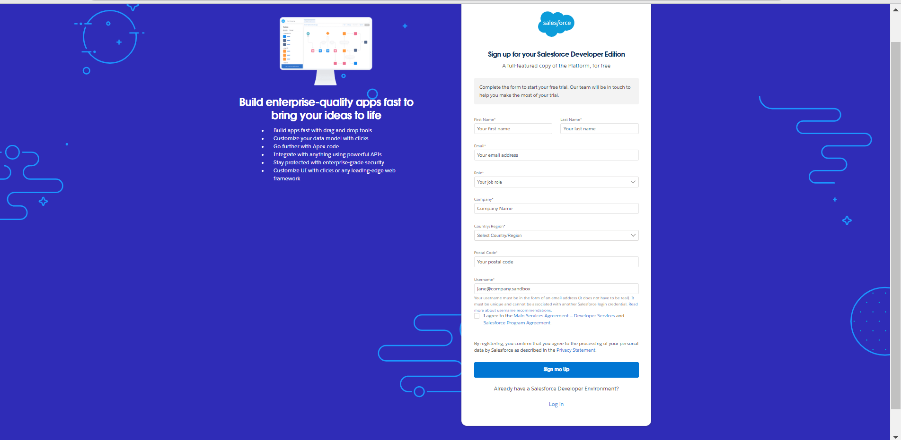

#### Account Activation:

Go to the inbox of the email that you used while signing up. Click on the verify account to activate your account. The email may take 5-10 minutes.

# Login to Your Salesforce Account:

1. Go to [**salesforce.com**](https://login.salesforce.com/) and click on login.
2. Enter the username and password that you just created. 3.After login this is the home page which you will see.

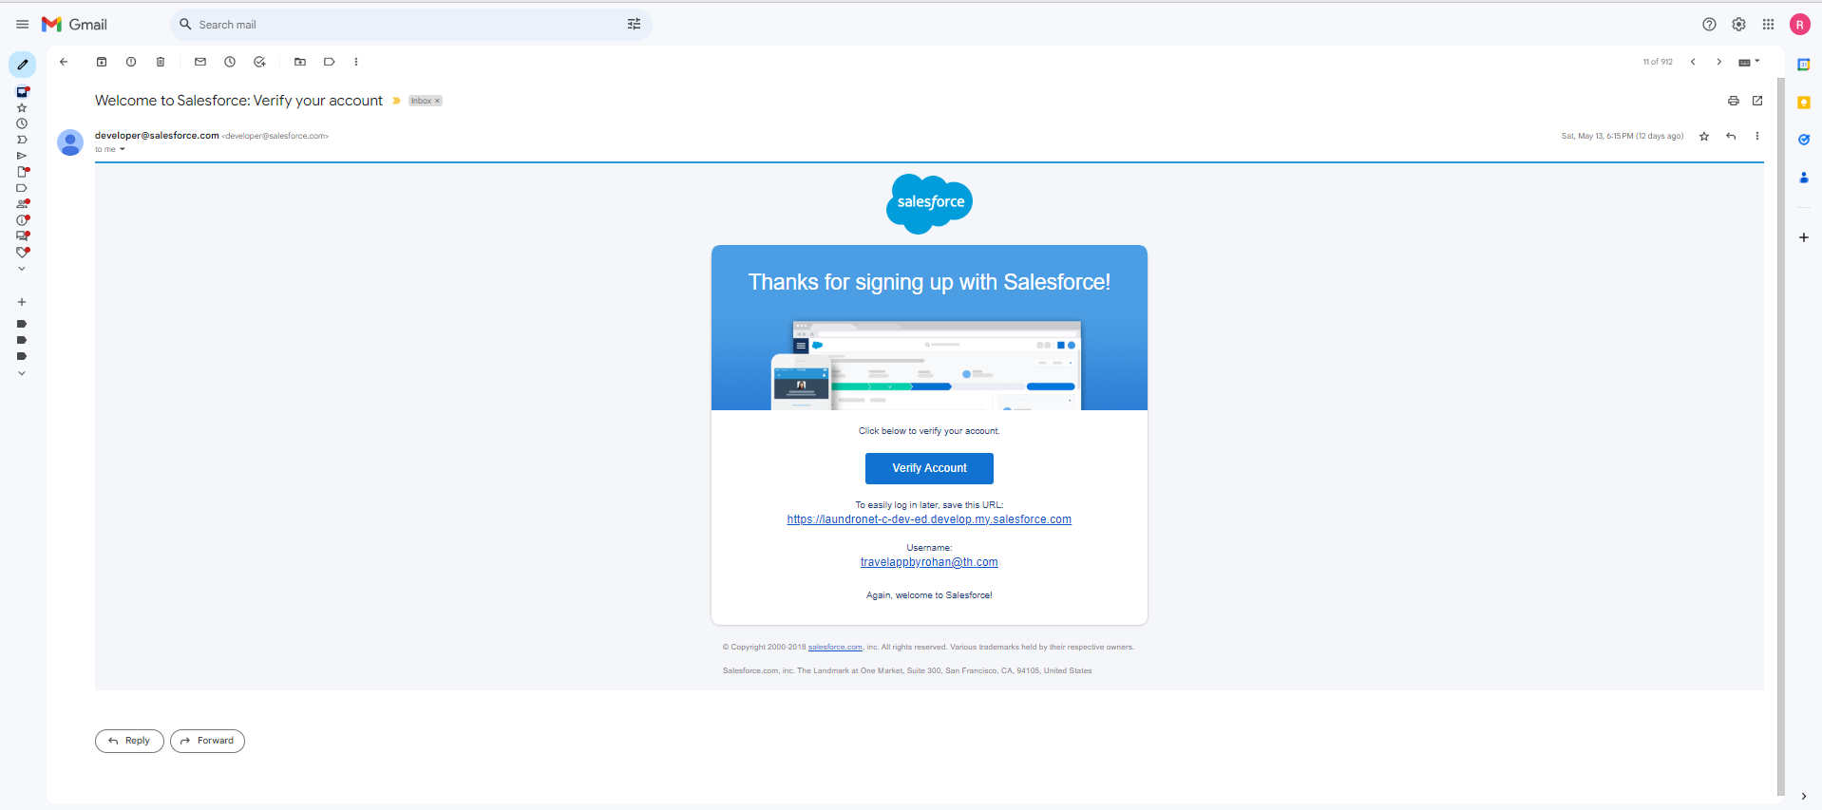

**Salesforce Login:** [**https://login.salesforce.com/**](https://login.salesforce.com/)

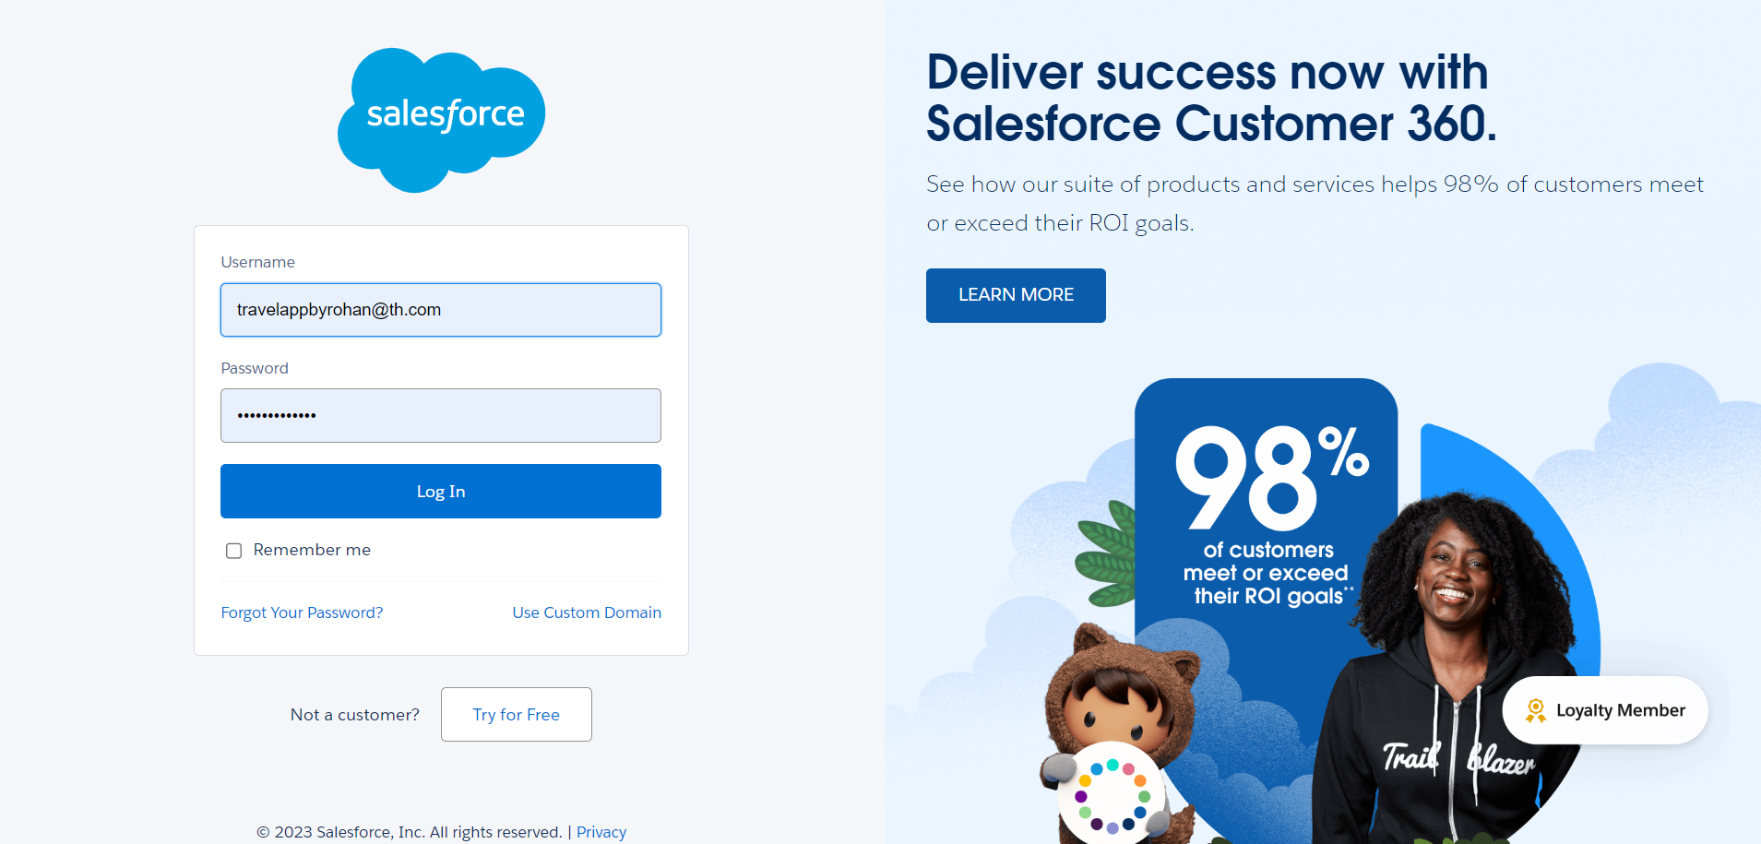

## OBJECTS

**Salesforce objects** are database tables that permit you to store data that is specific to an organization. **Salesforce** objects are of two types:

1. **Standard Objects:** Standard objects are the kind of objects that are provided bysalesforce.com such as users, contracts, reports, dashboards, etc.
2. **Custom Objects:** Custom objects are those objects that are created by users. They supply information that is unique and essential to their organization. They are the heart of any application and provide a structure for sharing data.

## CREATION OF CUSTOM OBJECTS

A **Custom Object** is a type of object that you can create in **Salesforce** to store data that is specific to your organization. Custom objects can be used to track anything from products to customers to leads.

To create a custom object, you will need to specify the following information:

➔**Object name:** The name of the custom object.

➔**Object type:** The type of data that the custom object will store.

➔**Fields:** The fields that will be used to store data in the custom object.

➔**Relationships:** The relationships between the custom object and other objects in **Salesforce**.

Once you have created a custom object, you can start adding data to it. You can also create reports and dashboards to view and analyse the data in your custom objects. Custom objects are a powerful way to extend the functionality of Salesforce and to store data that is specific to your organization. If you need to track data that is not already stored in a standard object, then you should consider creating a custom object.

Benefits of using custom objects:

➔**Flexibility:** Custom objects can be used to store any type of data that is specific to your organization.

➔**Customization:** You can customize the fields and relationships of custom objects to meet the needs of your organization.

➔**Integration:** Custom objects can be integrated with other Salesforce objects and with third-party applications.

➔**Scalability:** Custom objects can be scaled to meet the needs of your growing organization.

## CREATION OF DEPARTMENT OBJECT

1. Click on the gear icon and then select Setup.
2. Click on the object manager tab just beside the home tab.
3. After the above steps, have a look on the extreme right you will find a create drop down click on that and select Custom Object.
4. On the Custom Object Definition page, create the object as follows:
5. Label: Department
6. Plural Label: Departments 7.Record Name: Department Name

8.Check the Allow Reports 9.Check the Allow Search 10.Click Save.

In the same way create **4** more objects as **Employee Detail, Expense, Expense Items, and Travel Approval .**

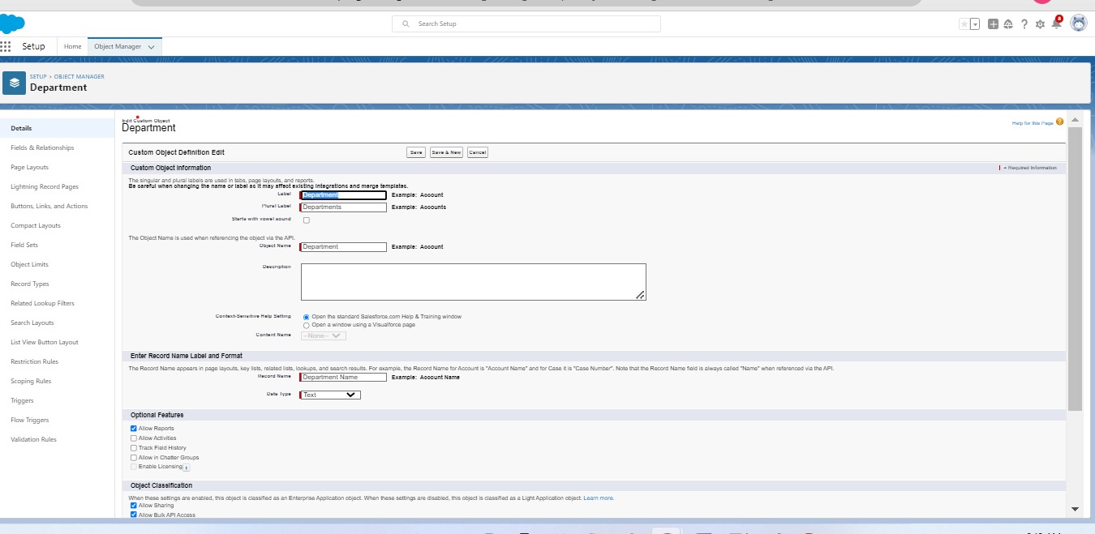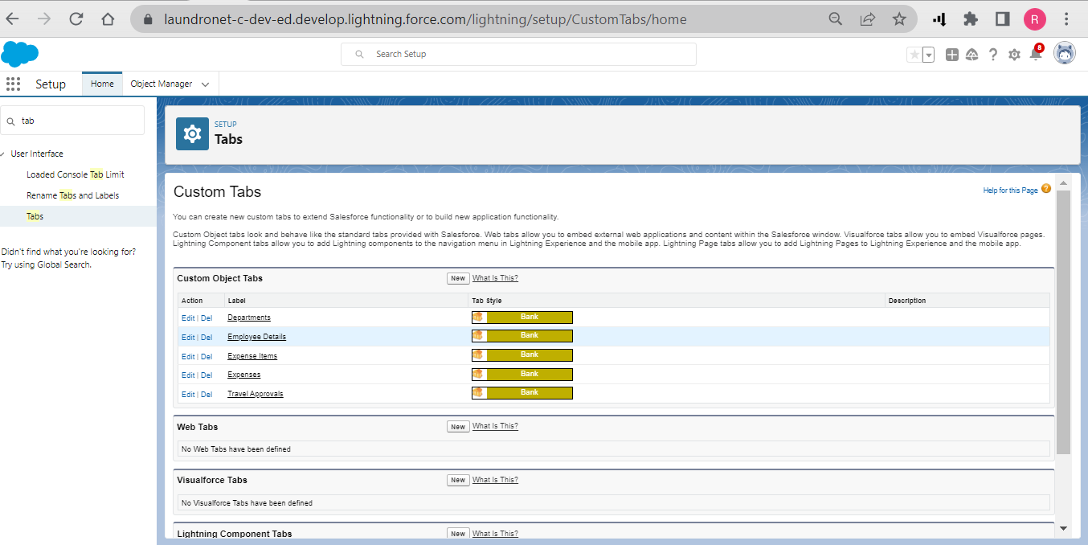

## TABS

A **Tab** in **Salesforce** is a link to a page or object. Tabs can be added to the navigation bar, the home page, or a Lightning App. Tabs can be used to organize your **Salesforce** data and to make it easier to find the information you need. You can create tabs for custom objects, standard objects, reports, dashboards, and other pages. To create a tab, you will need to specify the following information:

➔**Tab name:** The name of the tab.

➔**Tab type:** The type of tab.

➔**Tab location:** The location of the tab.

➔**Tab icon:** The icon that will be displayed for the tab.

Once you have created a tab, you can add it to the navigation bar, the home page, or a Lightning App.

Benefits of using Tabs:

➔**Organization:** Tabs can be used to organize your Salesforce data and to make it easier to find the information you need.

➔**Efficiency:** Tabs can help you to work more efficiently by providing quick access to the information you need.

➔**Customization:** You can customize tabs to match the look and feel of your organization.

➔**Integration:** Tabs can be integrated with other Salesforce objects and with third-party applications.

5 Types of **Tabs** available in **Salesforce**:

➔**Standard tabs:** Standard tabs are tabs that are included with Salesforce. They provide access to standard objects, reports, dashboards, and other pages.

➔**Custom tabs:** Custom tabs are tabs that you create. They can provide access to custom objects, reports, dashboards, and other pages.

➔**Web tabs:** Web tabs are tabs that open a web page in a new window.

➔**Visualforce tabs:** Visualforce tabs are tabs that open a Visualforce page in a new window.

➔**Lightning tabs:** Lightning tabs are tabs that open a Lightning component in a new window.

Tabs can be used to organize your Salesforce data and to make it easier to find the information you need. They are a powerful tool that can help you to work more efficiently and effectively.

## CREATION OF DEPARTMENT TAB

Now create a custom tab. Click the Home tab. 1.Enter Tabs in Quick Find and select Tabs.

2.Under Custom Object Tabs, click New. 3.For Object, select Department.

1. For Tab Style, select any icon.
2. Leave all defaults as is. Click Next, Next, and Save

In the same way create Tabs for all Custom Objects - **Employee Detail, Expense, Expense Items, and Travel Approval .**



## LIGHTNING APPS

**Salesforce Lightning Apps** are a type of application that can be used to extend and customize the Salesforce platform. They are built on the Lightning Component Framework, which makes them easy to create and use. Lightning Apps can be used to create a variety of applications, including:

#### ➔Custom home pages

➔**Custom navigation**

#### ➔Custom dashboards

➔**Custom reports**

#### ➔Custom forms

➔**Custom workflows**

#### ➔Custom field types

➔**Custom objects**

Lightning Apps are a powerful way to extend the functionality of Salesforce and to create custom solutions that meet the needs of your organization. They are easy to create and use, and they can be integrated with other Salesforce objects and with third-party applications.

Benefits of using **Lightning Apps**:

➔**Flexibility:** Lightning Apps can be used to create a variety of applications that meet the specific needs of your organization.

➔**Customization:** You can customize Lightning Apps to match the look and feel of your organization.

➔**Integration:** Lightning Apps can be integrated with other Salesforce objects and with third-party applications.

➔**Scalability:** Lightning Apps can be scaled to meet the needs of your growing organization.

Key features of Lightning Apps:

➔**Lightning App Builder:** The Lightning App Builder is a point-and-click tool that makes it easy to create Lightning Apps.

➔**Lightning App Catalogue:** The Lightning App Catalogue is a repository of Lightning Apps that you can install and use.

➔**Lightning App Exchange:** The Lightning App Exchange is a marketplace where you can buy and sell Lightning Apps.

Lightning Apps are a powerful way to extend the functionality of Salesforce and to create custom solutions that meet the needs of your organization. They are easy to create and use, and they can be integrated with other Salesforce objects and with third-party applications.

## CREATE THE TRAVEL APPROVAL APP

1. From Setup, enter App Manager in the Quick Find and select App Manager.
2. Click New Lightning App.
3. Enter **Travel Approval App** as the App Name, then click next
4. Under App Options, leave the default selections and click next.
5. Under Utility Items, leave as is and click Next.

From Available Items, select **Department, Employee Detail, Expense, Expense Items, and Travel Approval, Reports and Dashboards** and move them to Selected Items.

1. Click Next from Available Profiles, select System Administrator and move it to Selected Profiles. Click Save & Finish.

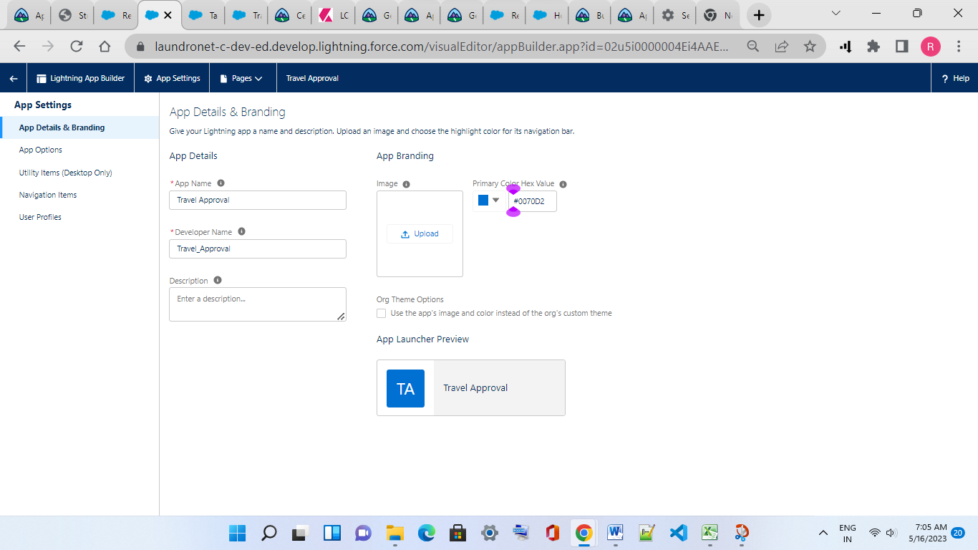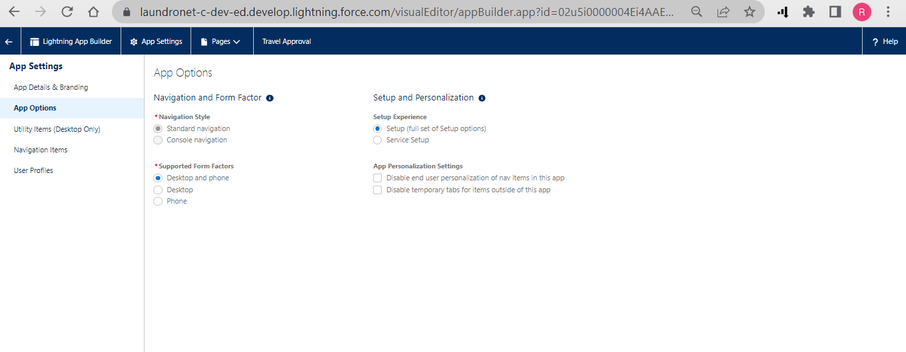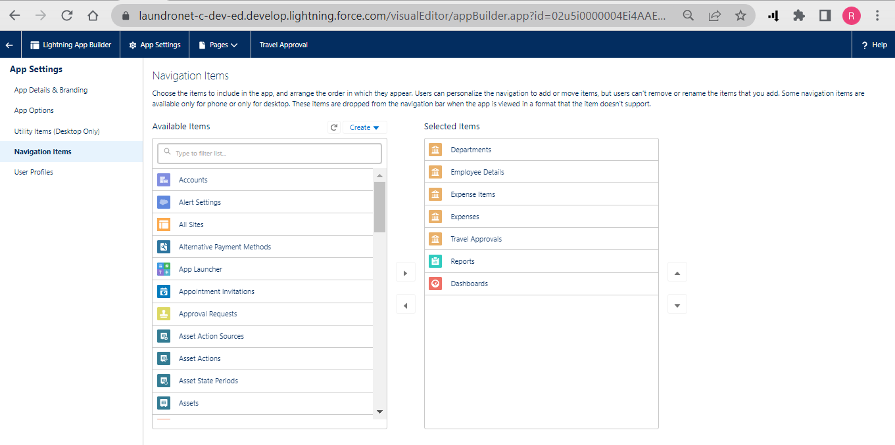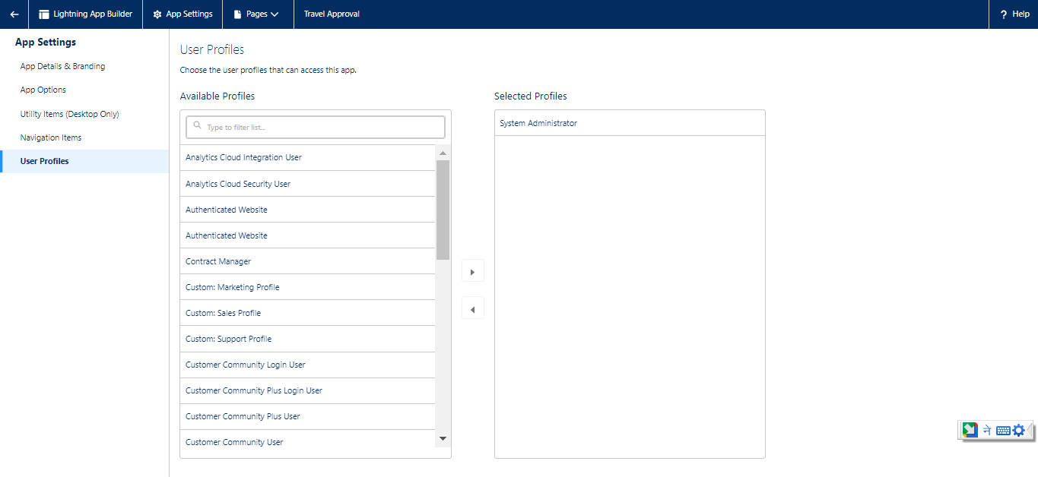

## FIELDS & RELATIONSHIPS

**Fields and Relationships** are two of the most important concepts in **Salesforce**. Fields are used to store data, and relationships are used to connect different pieces of data. Fields are the basic building blocks of **Salesforce Objects**. They can store a variety of data types, including text, numbers, dates, and lists. Fields can be required or optional, and they can be used to filter, sort, and search data.

Relationships are used to connect different objects together. They can be one-to- one, one-to-many, or many-to-many. One-to-one relationships connect two objects where each record in one object can only be associated with one record in the other object. One-to-many relationships connect two objects where each record in one object can be associated with multiple records in the other object. Many-to-many relationships connect two objects where each record in one object can be associated with multiple records in the other object, and vice versa.

Fields and relationships are essential for storing, organizing, and managing data in **Salesforce**. They allow you to create a system that is tailored to the specific needs of your organization.

Benefits of using fields and relationships:

➔**Flexibility:** Fields and relationships can be used to store a variety of data types and to connect different objects together.

➔**Customization:** You can customize fields and relationships to meet the specific needs of your organization.

➔**Integration:** Fields and relationships can be integrated with other Salesforce objects and with third-party applications.

➔**Scalability:** Fields and relationships can be scaled to meet the needs of your growing organization.

Most Common Types of **Fields** in **Salesforce**:

➔**Text fields:** Text fields store text data.

➔**Number fields:** Number fields store numeric data.

➔**Date fields:** Date fields store date data.

➔**Time fields:** Time fields store time data.

➔**Currency fields:** Currency fields store currency data.

➔**Picklist fields:** Picklist fields store a list of values that a user can select from.

➔**Multi-select picklist fields:** Multi-select picklist fields store a list of values that a user can select multiple values from.

➔**Lookup fields:** Lookup fields store a reference to another object.

➔**Formula fields:** Formula fields calculate a value based on other fields.

➔**Auto-number fields:** Auto-number fields automatically generate a unique number for each record.

Most Common Types of **Relationships** in **Salesforce**:

➔**One-to-one relationships:** One-to-one relationships connect two objects where each record in one object can only be associated with one record in the other object.

➔**One-to-many relationships:** One-to-many relationships connect two objects where each record in one object can be associated with multiple records in the other object.

➔**Many-to-many relationships:** Many-to-many relationships connect two objects where each record in one object can be associated with multiple records in the other object, and vice versa.

**Fields and Relationships** are essential for storing, organizing, and managing data in Salesforce. They allow you to create a system that is tailored to the specific needs of your organization.

### Creation Of Fields For The Department Object :

1.Click the gear icon and select Setup. This launches Setup in a new tab.   
2.Click the Object Manager tab next to Home.   
3.Select Department   
4.Select Fields & Relationships from the left navigation   
5.Click New   
6.Select the Text as the Data Type, click Next.   
7.For Field Label, enter Department Code and enter 5 in Length.   
8.Click Next, Next, then Save & New.   
9.Follow above steps and create two more Text type field - District & State.   
10.Also, Provide Length 40 for both District and State field.   
11.Create URL type field & give “School website” as the field label.

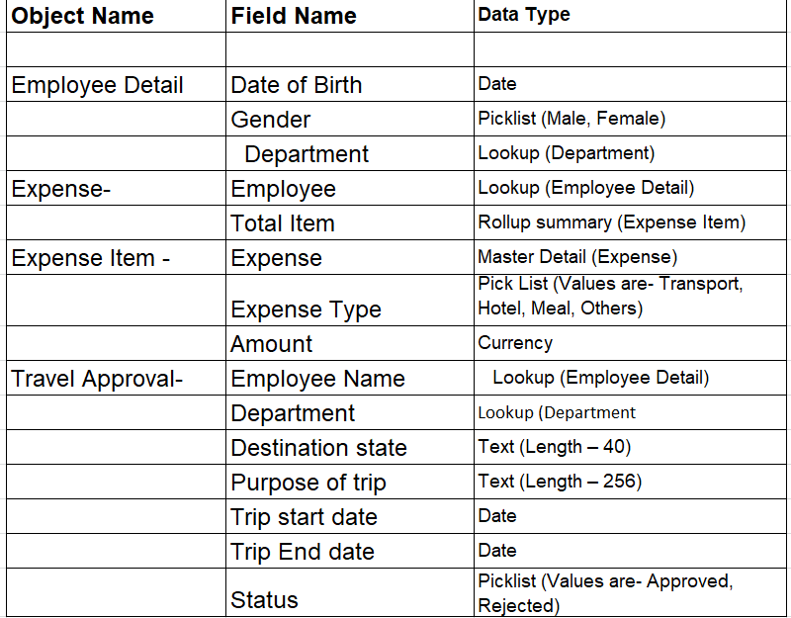

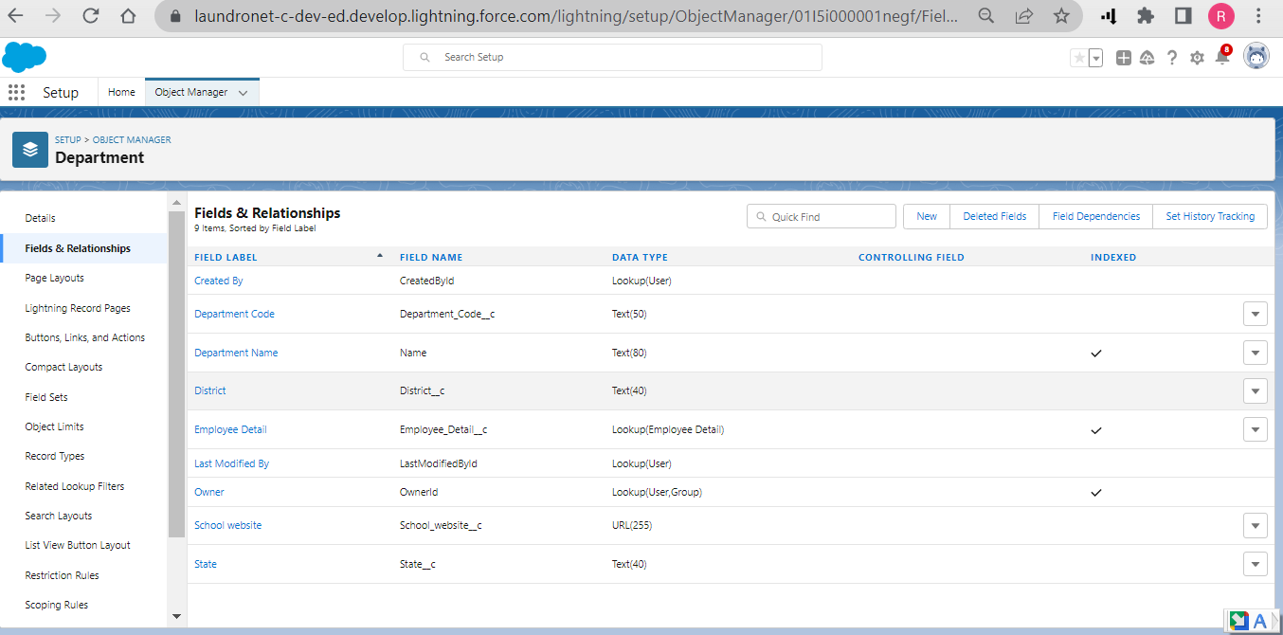 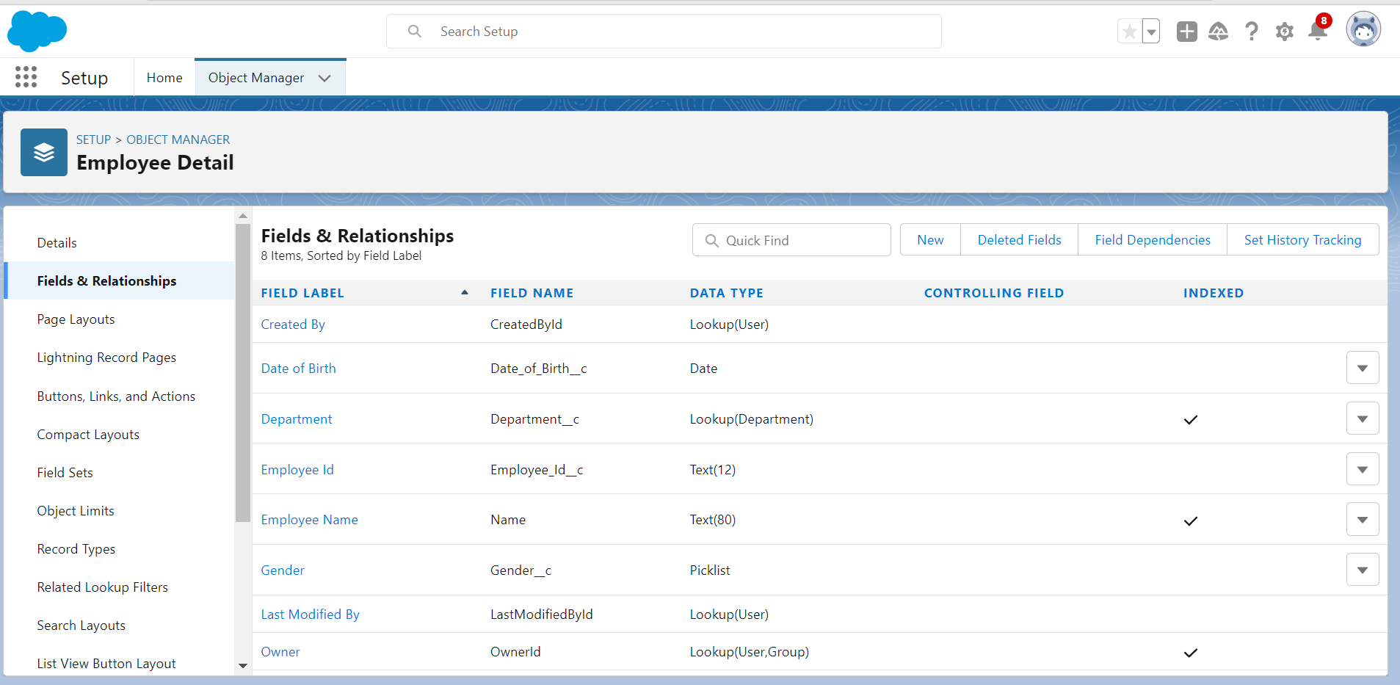 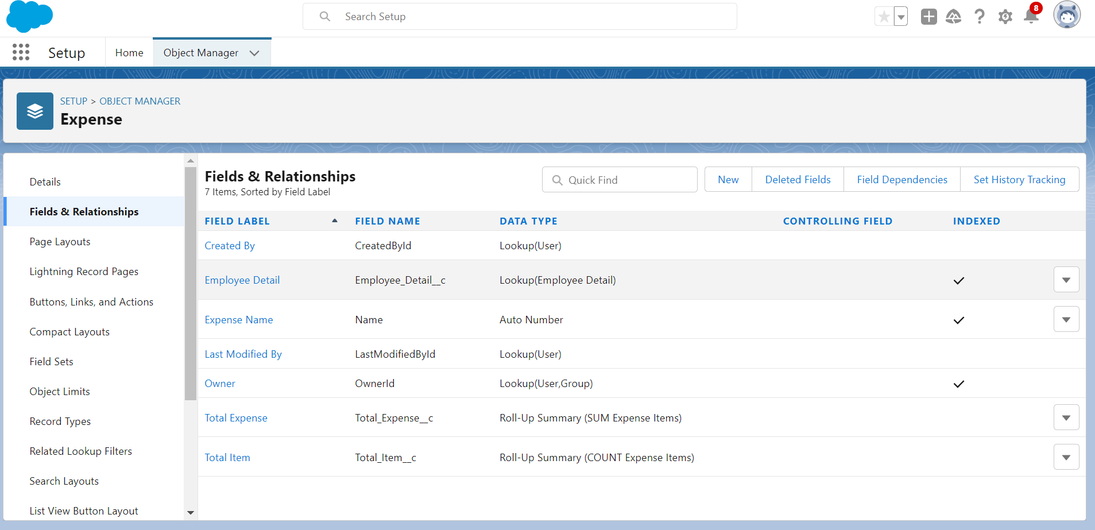 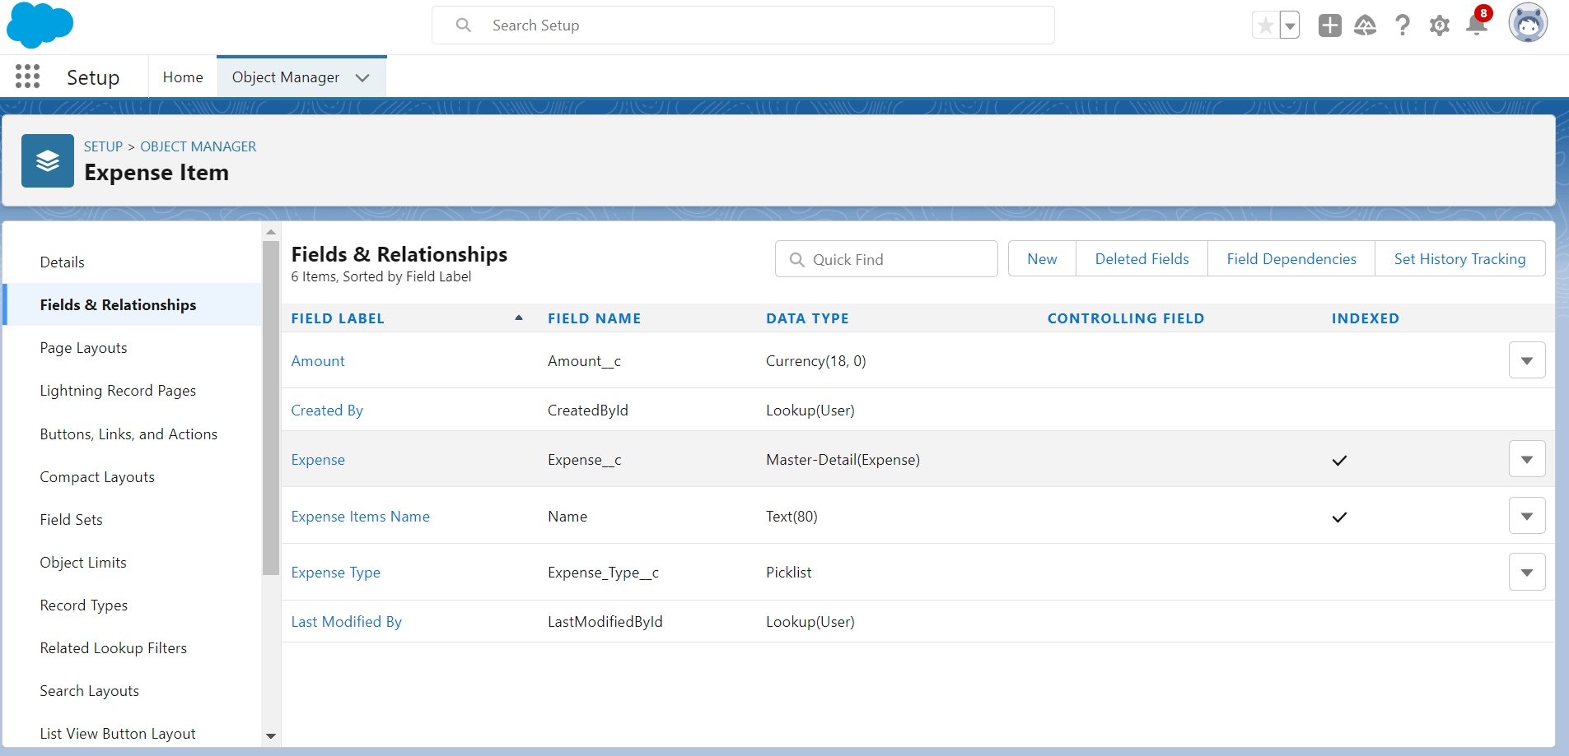 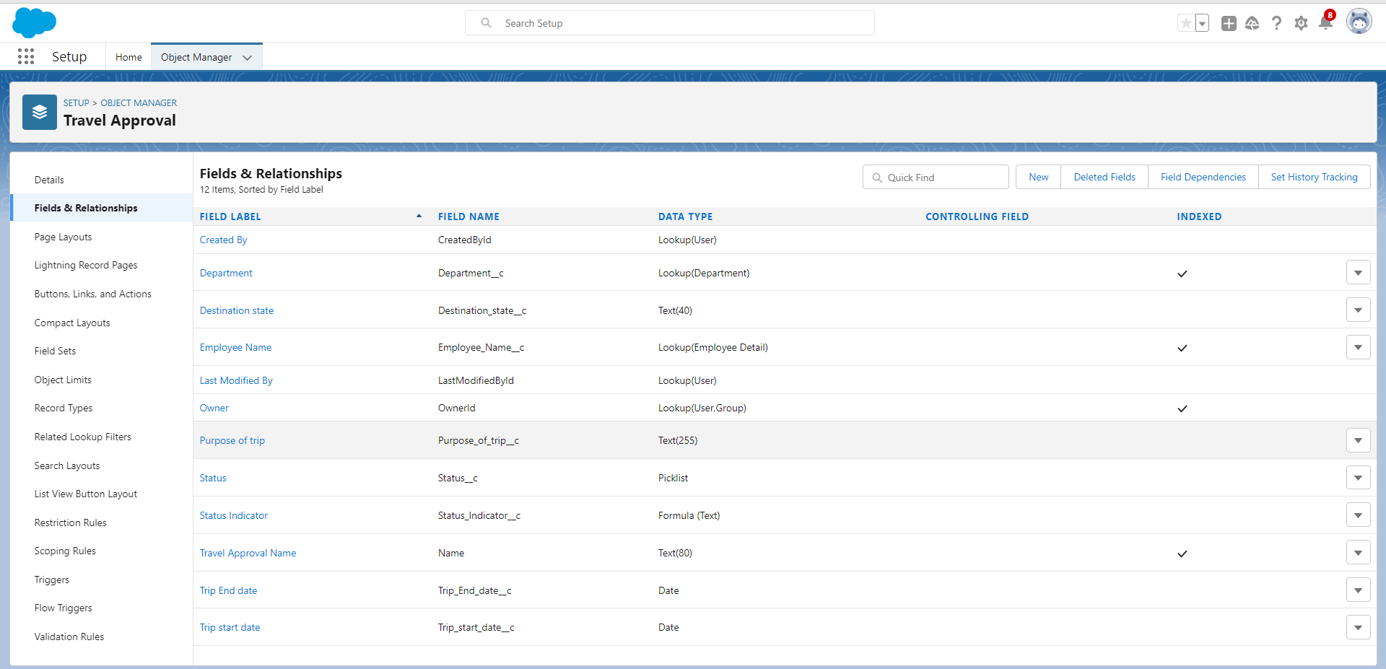

***DATA IMPORT***

Data Import lets you upload data from external sources and combine it with data you collect via Analytics. You can then use Analytics to organize and analyze all of your data in ways that better reflect your business.    
   
The Data Import Wizard is a Tool that makes it easy to import data for many standard Salesforce objects, including accounts, contacts, leads, solutions, campaign members, and person accounts. You can also import data for custom objects.

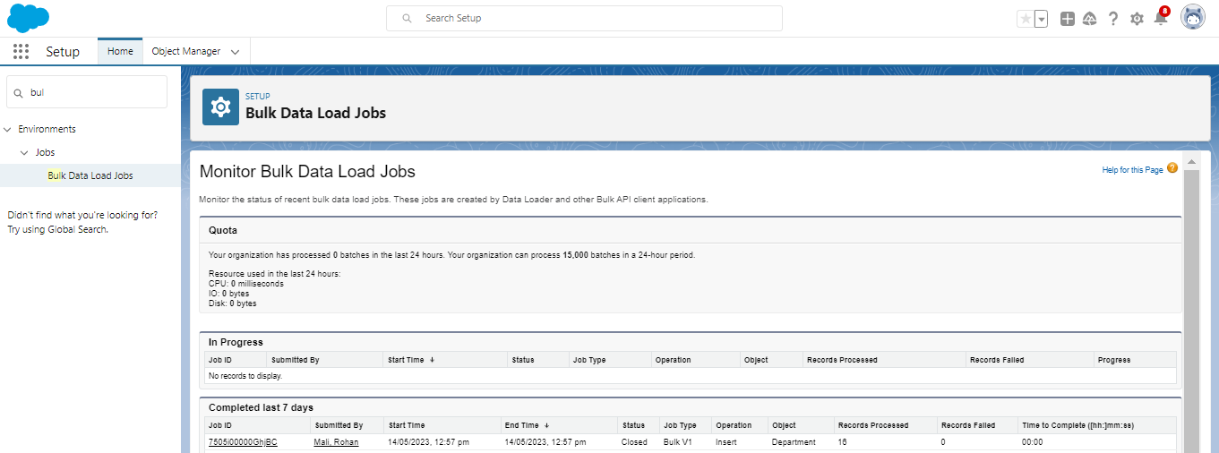

### USERS

**Salesforce Users** are individuals who have been granted access to Salesforce. They can be employees, partners, or customers. Salesforce Users can access Salesforce to view, create, update, and delete records. They can also use Salesforce to run reports, create dashboards, and automate tasks.

Each Salesforce User has a unique username and password. They can also have a profile, which determines their permissions in Salesforce. Profiles can be customized to give users access to different features and records.

Salesforce Users can be added to Salesforce in a variety of ways. They can be added manually by an administrator, or they can be imported from a spreadsheet or other file. Salesforce Users can also be created by third-party applications that integrate with Salesforce.

Once a Salesforce User has been created, they can log in to Salesforce and start using the platform. They can access their account information, view and edit records, and run reports. Salesforce Users can also collaborate with other users, share files, and participate in discussions.

Salesforce Users are an essential part of Salesforce. They are the ones who use Salesforce to manage their data, run their businesses, and connect with their customers.

Benefits of having Salesforce Users:

➔**Increased productivity:** Salesforce Users can access Salesforce from anywhere, at any time. This allows them to work more efficiently and get more done.

➔**Improved collaboration:** Salesforce Users can collaborate with each other on projects and tasks. This helps to improve communication and coordination.

➔**Enhanced customer service:** Salesforce Users can use Salesforce to provide better customer service. They can access customer records, track interactions, and resolve issues quickly and efficiently.

➔**Increased security:** Salesforce Users can help to protect Salesforce data by following security best practices. They can also use Salesforce to monitor and track user activity.

A **Salesforce User** is anyone who logs in to **Salesforce**. Users are employees at your company, such as sales reps, managers, and IT specialists, who need access to the company's records. Every user in **Salesforce** has a user account.

### CREATING A USER

1.From Setup, in the Quick Find box, enter Users.

2.Select Users.

1. Click New User.
2. Enter the First Name, **Travel Aproval**, Last Name, **Manager** and (own) email address and a unique username in the form of an email address. By default, the username is the same as the email address.
3. Select a User License as salesforce.

**NOTE**- As **Salesforce** license can only be used by 2 Users at a time in Dev Org, so If you don’t find **salesforce** license then deactivate a user who has salesforce license

Or change the license type from Salesforce to any other. 6.Select a profile as Standard user.

7.Check Generate new password and notify the user immediately to have the user’s login name and a temporary password emailed to your email.

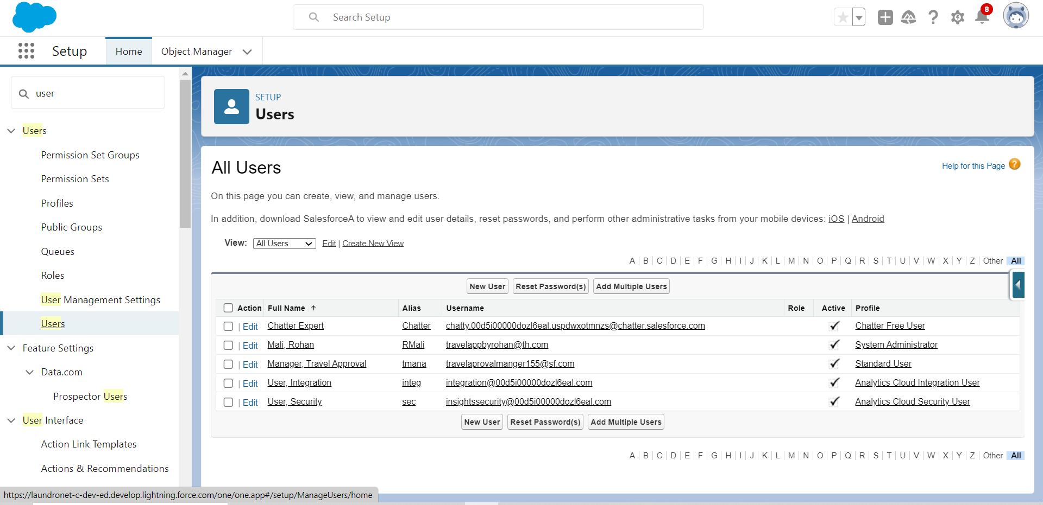

### Use Customization

Customization refers to custom software development and coding to add robust features to your CRM platform. These features can be integrated with your business to have a scalable impact.

### Customize Travel Approval Object Page Layout

1. From the Object Manager, search for the Travel approval object.  
2. click on page layouts and  click Travel Approval Layout   
3. Drag the Section from the top pane to the lower pane directly below the Information section. When dragging over the page, you get a visual indicator of where you can drop the new section.   
4. Name the section Trip Info, leave the rest of the settings at their default values, and    
5. Then click on OK.   
6. Drag Trip Start Date and Trip End Date, Status from the top pane into the left-hand column of the Trip Info   
  section.   
7. Drag the Destination State and Purpose of a trip from, department the top pane into the right-hand column of the Trip   
  Info section.   
8. Click Save.

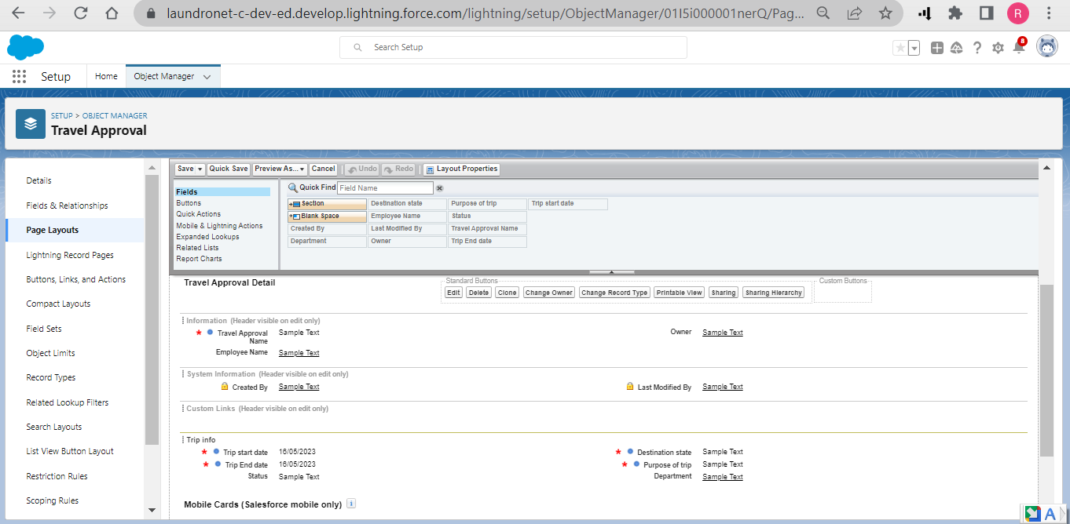

### Add Business Logic To Travel App

**Validation Rule** - It can contain a formula or expression that evaluates the data in one or more fields & returns a value of true or false. Validation Rules also include an error message to display to the user when the rule returns a value true due to an invalid value/data.

### Create Validation Rule

Search for the travel approval object from the object manager and open the object.  
1)Click on validation rules and click new on the left corner  
2)Give your rule name Date _Validation and make sure that the rule is set to active.  
3)In the error condition formula enter Trip_End_Date c < Trip_Start_Date   c  
NOTE- Make sure that there is no syntax error after you input this error condition  
  
Give the Error message – “Trip end date must be the date greater than the Trip start date” &  
For error location select the field and pick the Trip end date as the location for error.  
Click save

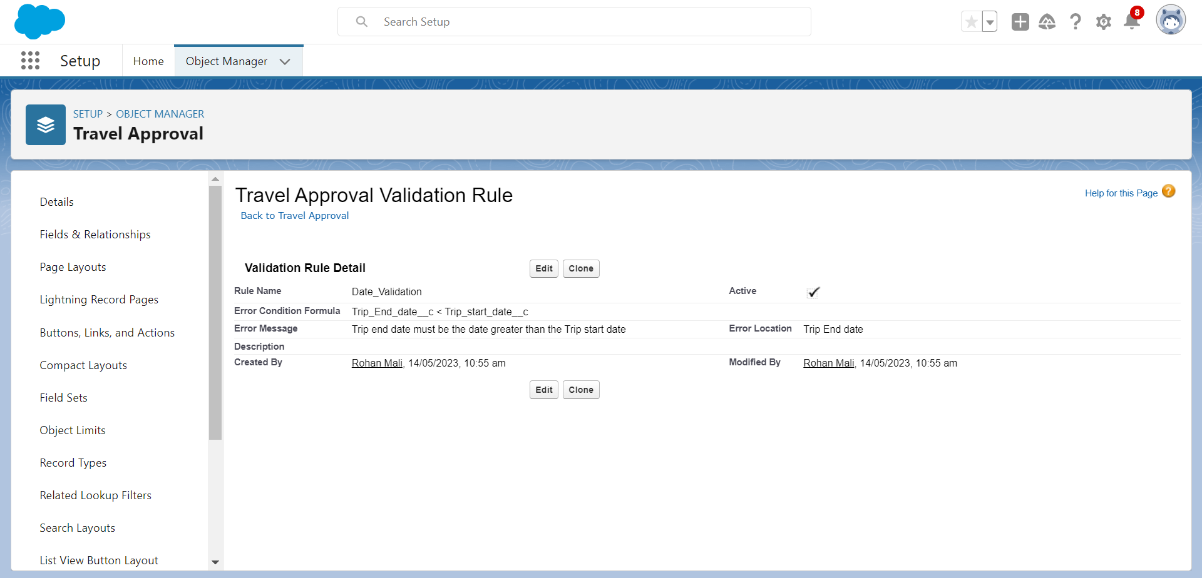

### Create Formulae Fields

Create Formula Fields  
1)First, we need to upload a zip file to your Salesforce environment that contains all the images we use. You should have 2)a file titled StatusImages.zip.  
3)Click the setup  
4)Click Static Resources in Quick Find & Click New.  
5)Enter the following values for your static resource

|  |  |
| --- | --- |
| Parameter | Value |
| Name | StatusImages |
| File | StatusImages.zip |
| Cache-Control | Private |

1.Now select the travel approval object.  
2.Select Fields & Relationships, Click New  
3.Select Formula data type, and Click Next.  
4.Enter the following values:  
5.Field Label: Status Indicatorhttps://lh3.googleusercontent.com/Busxh46uqlCxPIcQuukFe6CXTgBn_9IgstYAvTQGOZUXmhPg8bU1-HyhakT1F7Gqfn_iahs_fdKrBrxqA0WCtbdCeHHSX35E-vAZprNj479F5O0FGFKvmlPQobQVErUHK21CXArZ0DVzNlfsYT79  
6.Field Name: Status_Indicator (This automatically gets sent when you tab out of the Field Label field)https://lh3.googleusercontent.com/Busxh46uqlCxPIcQuukFe6CXTgBn_9IgstYAvTQGOZUXmhPg8bU1-HyhakT1F7Gqfn_iahs_fdKrBrxqA0WCtbdCeHHSX35E-vAZprNj479F5O0FGFKvmlPQobQVErUHK21CXArZ0DVzNlfsYT79  
7.Formula Return Type: Text

8.Click next & Copy and paste the following formula into the formula editor.

IF( ISPICKVAL( Status__c, 'Approved'), IMAGE("/resource/StatusImages/thumbs-up.png", "Accepted", 20, 20),  
IF ( ISPICKVAL( Status__c, 'Rejected'), IMAGE("/resource/StatusImages/thumbs-down.png", "Rejected", 20, 20), IMAGE("/resource/StatusImages/draft.png", "In-Process", 20, 20)))  
  
9.Click Next, Next, Save.

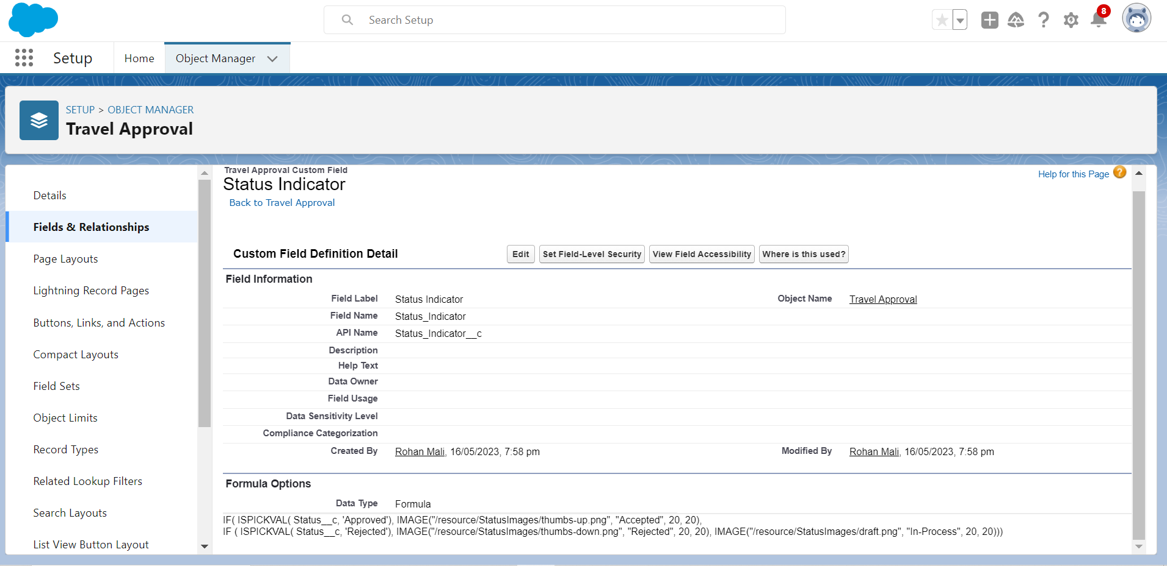

### USER ADOPTIONS (RECORDS) CREATE RECORD (TRAVEL APPROVAL)

Click App Launcher and select Travel Approval App  
1)Click reports tab  
2)Click New Report.  
3)Click the report type as Travel approval with Departments Click Start report.  
4)Customize your report, in group rows select - Department Name  
5)Click refresh  
6)Click save and run  
7)Give report name – Travel Approval Report  
8)Click Save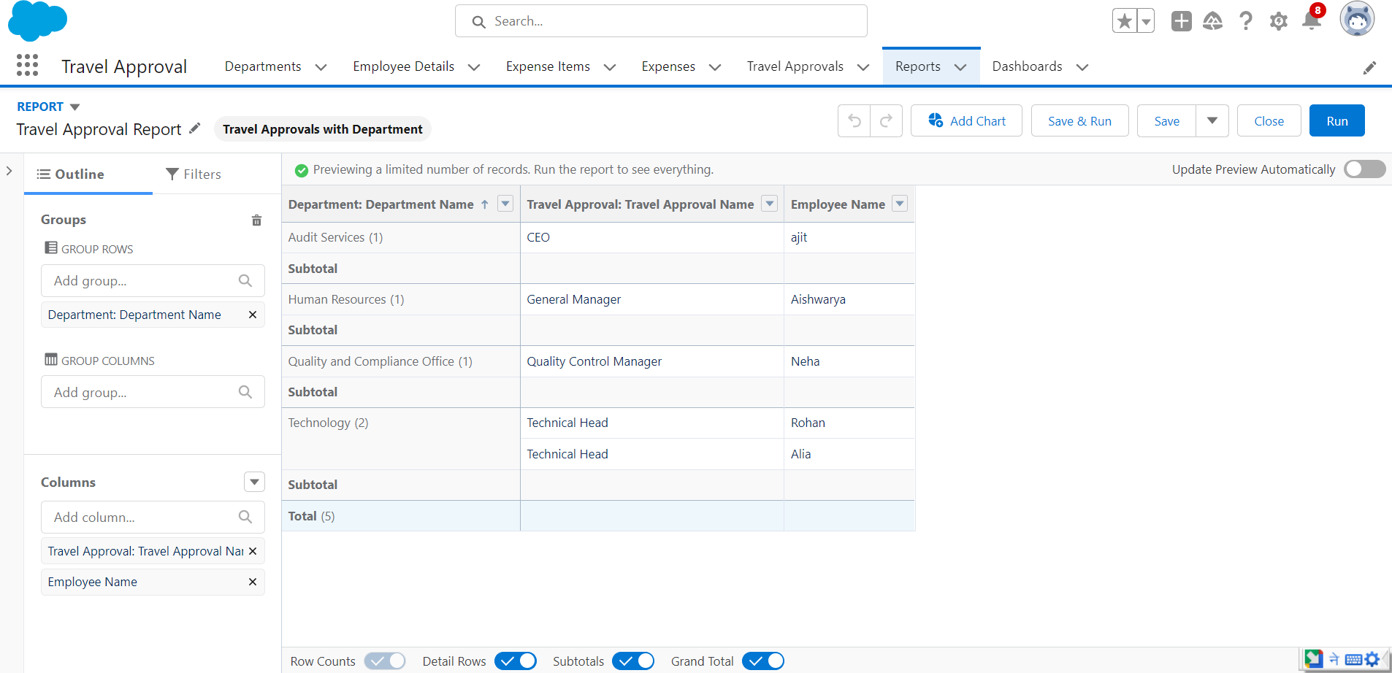

### VIEW RECORD (COURSE DETAILS)

1. Click on App Launcher on left side of screen.
2. Search **Travel Approval** & click on it.

3.Click on **Departments** Tab.

4.Click on any record name. you can see the details of the Departments.

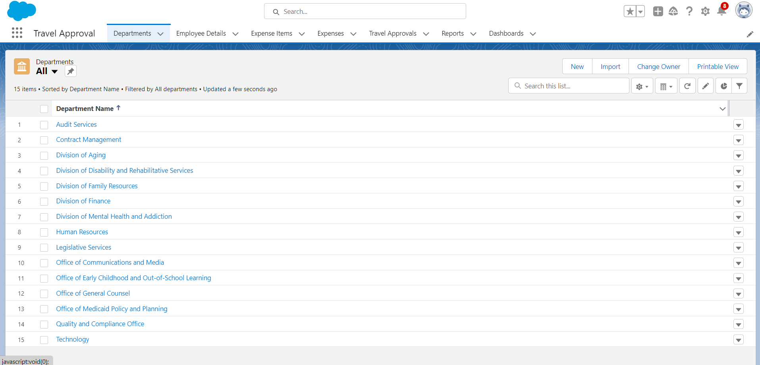

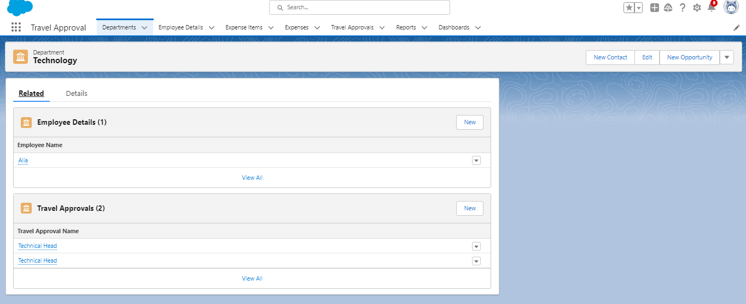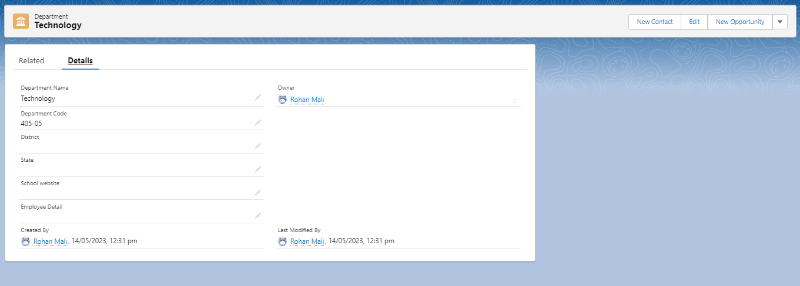

### DELETE RECORD (COURSE DETAILS)

1. Click on App Launcher on left side of screen.
2. Search **Candidate Internal Result Card** & click on it. 3.Click on **Course Details** Tab.

4.Click on Arrow at right hand side on that Particular record. 5.Click delete and delete again.

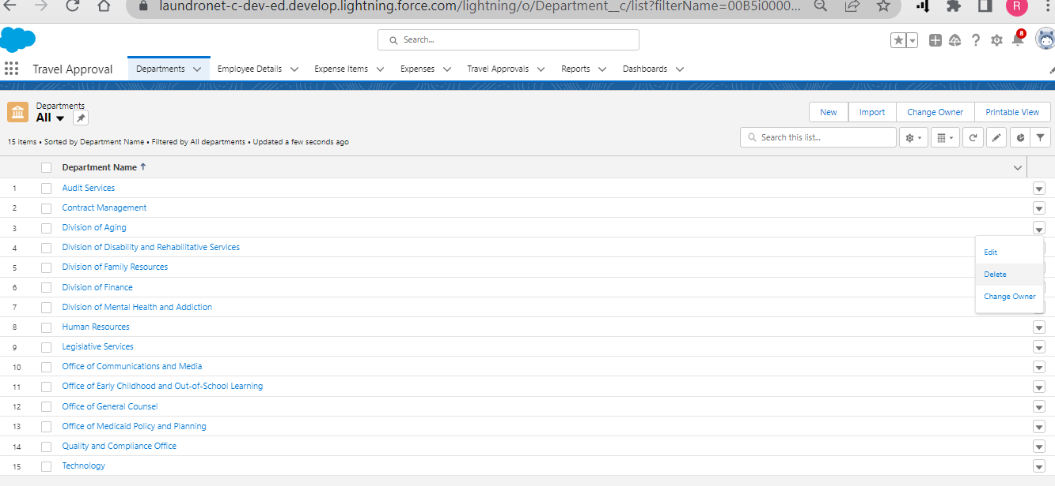

### REPORTS

**Reports** in **Salesforce** is a list of records that meet a particular criterion which gives an answer to a particular question. These records are displayed as a table that can be filtered or grouped based on any field.

There are 4 types of report formats in Salesforce:

#### Tabular Reports:

This is the most basic report format. It just displays the row of records in a table with a grand total. While easy to set up they can’t be used to create groups of data or charts and also cannot be used in Dashboards. They are mainly used to generate a simple list or a list with a grand total.

#### Summary Reports:

It is the most commonly used type of report. It allows grouping of rows of data, view subtotal, and create charts.

#### Matrix Reports:

It is the most complex report format. Matrix report summarizes information in a grid format. It allows records to be grouped by both columns and rows. It can also be used to generate dashboards. Charts can be added to this type of report.

#### Joined Reports:

These types of reports let us create different views of data from multiple report types. The data is joined reports are organized in blocks. Each block acts as a sub report with its own fields, columns, sorting, and filtering. They are used to group and show data from multiple report types in different views.

#### Report Types:

Report Type determines which set of records will be available in a report. Every report is based on a particular report type. The report type is selected first when we create a report. Every report type has a primary object and one or more related objects. All these objects must be linked together either directly or indirectly.

#### 1.A Report type cannot include more than 4 objects.

**2.Once a report is created its report type cannot be changed.**

#### Types of Report Types: 1.Standard Report Types:

Standard Report Types are automatically included with standard objects and also with custom objects where “Allow Reports” is checked.

Standard report types cannot be customized and automatically include standard and custom fields for each object within the report type. Standard report types get created when an object is created, also when a relationship is created.

Note: Standard report types always have inner joins.

#### 2.Custom Report Types:

Custom report types are reporting templates created to streamline the reporting

process. Custom Reports are created by an administrator or User with “Manage Custom Report Types” permission. Custom report types are created when standard report types cannot specify which records will be available on reports. In custom report types we can specify objects which will be available in a particular report.

The primary object must have a relationship with other objects present in a report type either directly or indirectly.

#### Types of Access Levels of Folders:

1. **Viewer:**

With this access level, users can see the data in a report but cannot make any changes except cloning it into a new report.

#### Editor:

With this access level, users can view and modify the reports it contains and can also move them to/from any other folders they have access level as Editor or Manager.

#### Manager:

With this access level, users can do everything Viewers & Editors can do, plus they can also control other user’s access levels to this folder. Also, users with Manager Access levels can delete the report.

### CREATE REPORT

1. Click App Launcher
2. Select Travel Approval App

3.Click reports tab

1. Click New Report.
2. Click the report type as Travel Approval with Departments Click Start report.
3. Customize your report, in group rows select – Department Name
4. Click refresh

8.Click save and run

1. Give report name – **Travel Approval Report**
2. Click Save

### View Report

1.Click on App Launcher on left side of screen.   
2.Search Travel Approval App & click on it.   
3.Click on Reports Tab.   
4.Click on Travel Approval Report and see records.

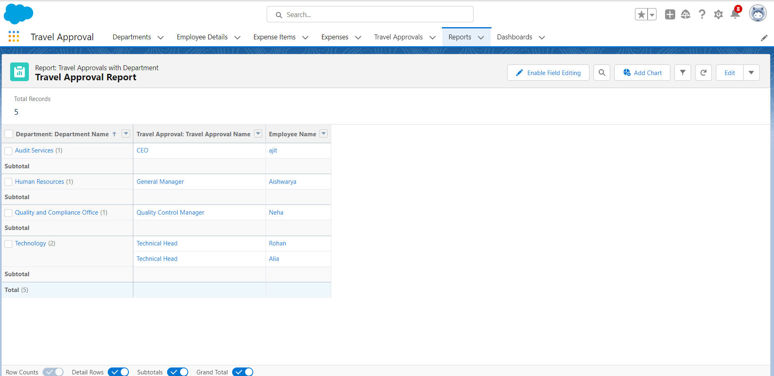

### DASHBOARDS

**Salesforce Dashboards** are a powerful way to visualize your data and track your progress. They can be used to display data from Salesforce reports, custom objects, and even third-party data sources. Dashboards can be customized to fit your specific needs, and they can be shared with other users.

Benefits of using **Salesforce Dashboards**:

➔**Increased visibility:** Dashboards make it easy to see key metrics and trends at a glance. This can help you to identify areas of improvement and make better decisions.

➔**Improved collaboration:** Dashboards can be shared with other users, which can help to improve communication and collaboration. This can lead to better decision-making and faster problem-solving.

➔**Increased productivity:** Dashboards can help you to save time by providing a central location to view your data. This can free you up to focus on other tasks.

➔**Improved decision-making:** Dashboards can help you to make better decisions by providing you with a visual representation of your data. This can help you to identify trends and patterns that you might not be able to see from a report or spreadsheet.

Tips for creating effective **Salesforce Dashboards**:

➔**Choose the right data:** The first step in creating an effective dashboard is to choose the right data. You want to include data that is relevant to your goals and that will help you to track your progress.

➔**Use visuals:** Dashboards are all about visualization. Use charts, graphs, and other visuals to make your data easy to understand.

➔**Keep it simple:** Don't overload your dashboard with too much data. Too much information can be overwhelming and make it difficult to see the trends.

➔**Customize it:** Dashboards should be customized to fit your specific needs. Change the colours, fonts, and layout to make your dashboard look the way you want it to.

➔**Share it:** Once you've created your dashboard, share it with other users. This can help to improve communication and collaboration.

### CREATE DASHBOARD

1. Click on Dashboards tab from the Travel Approval application.
2. Click on new dashboard.
3. Give name- **Travel Approval**
4. Click create
5. Give your dashboard a name and click on +component

6.Select the Travel Approval Report which i created.

1. For the data visualization select any of the chart, table etc. as per my choice/requirement.
2. Click add. 9.Click save.

### View Dashboard

1.Click on App Launcher on left side of screen.   
2.Search Travel Approval App & click on it.   
3.Click on Dashboard Tab.   
4.Click on Travel Approval and see graph view of records

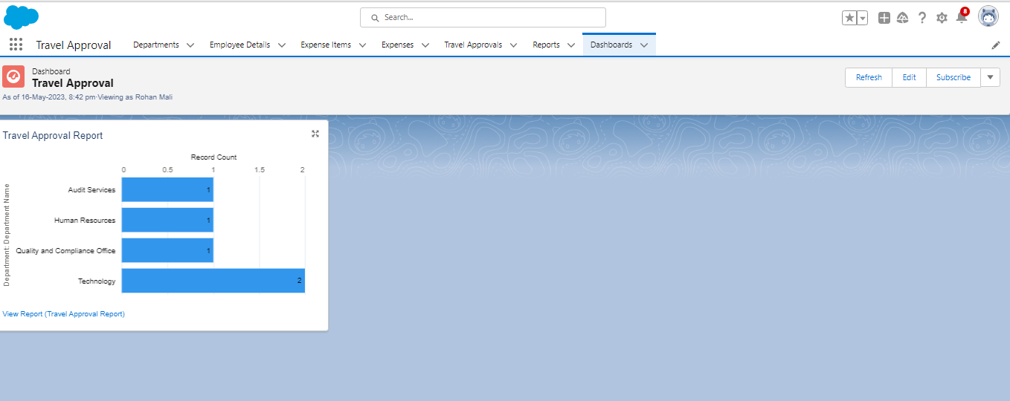

## CHAPTER IV: CONCLUSION & FUTURE SCOPE EXPECTED OUTCOME

***CONCLUSION***

In conclusion, **Implementing CRM for Employee Travel Approval Application For Corporates** can be a valuable way to improve the efficiency and effectiveness of the process. By using a CRM system, organizations can track the Travel Approval Records for each employee in any period of time.

An employee travel approval application is a valuable tool for corporate travel management.

It streamlines the travel request and approval process ensures policy compliance, and provides transparency to all parties involved.

A well-designed application can save time and money, making it an essential tool for corporate that frequently travel for business.

## FUTURE SCOPE

#### Tips for Implementing CRM for Employee Travel Approval Application For Corporates:

➔**Choose the right CRM system:** There are many different CRM systems available, so it is important to choose one that is right for your needs.

➔**Train your staff:** Once you have chosen a CRM system, it is important to train your staff on how to use it. This will help to ensure that they are able to use the system effectively.

➔**Customize the system:** CRM systems can be customized to fit the specific needs of your organization. This will help to ensure that you are getting the most out of the system.

* In future it will be really a useful one in the application of travel approval.
* It is trusted to be in future everyone will utilize this.
* The customer will set good service and make it trustworthy.
* Hope it would fulfill all the needs of the users

## CHAPTER V: URLS & ACCOUNT IDS GITHUB URL

## <https://github.com/rohanmali15/Guided-Projects>

## ACCOUNT IDS

#### Smart Internz Registered Mail Id: [rohanmali15@gmail.com](mailto:rohanmali15@gmail.com)

#### My Trailhead Profile Link : [*https://trailblazer.me/id/rohan15*](https://trailblazer.me/id/rohan15)