VIT IIoT Lab
ESP-32 Simulation Project
Machine Health Monitoring System
Vidyalankar Institute of Technology | Academic Year 2025 to 2026

Project  Machine Health Monitoring System | Simulation Tool  Wokwi Online ESP32 Simulator

Group  Group 5 | Date of Submission  June 10, 2026

1.0 Name of Project

Machine Health Monitoring System
This project implements a real-time condition monitoring system for industrial machines using an ESP32 microcontroller. The system keeps a continuous watch on two critical parameters: ambient temperature around the machine and mechanical vibration. When either parameter crosses a preset safety threshold, the system triggers an immediate visual and audible alert through a red LED and a buzzer. The idea is straightforward but genuinely useful: catch a machine anomaly before it becomes a breakdown.

2.0 Names of Participants

Team Member | Details
Devyani Gaikwad | Roll No. 21
Pushkar Shelar | Roll No. 16
Divyam Mundra | Roll No. 05
Rohan Mundhe | Roll No. 19

3.0 Tool Used for Simulation

Primary Simulation Platform: Wokwi Online Simulator (https://wokwi.com)
Project Reference: https://wokwi.com/projects/305569599398609473

Wokwi was chosen as the simulation environment because it supports the ESP32 DevKit V1, the DHT22 temperature and humidity sensor, and the MPU6050 accelerometer and gyroscope module out of the box. No physical hardware was needed. The platform allows real Arduino libraries to run inside the browser, so the actual code compiled and executed exactly as it would on a real board.
The wokwi-project.txt file records the original project download link, and the diagram.json file describes the complete circuit topology including all component types, positions, and wire connections. The libraries.txt file lists the three library dependencies: DHT sensor library, Adafruit MPU6050, and Adafruit Unified Sensor.

4.0 Procedure for Drawing the Circuit and Simulation

The following steps describe how the circuit was built and simulated inside Wokwi.
- Open the Wokwi simulator at wokwi.com and select a new ESP32 DevKit V1 project.
- Add a DHT22 sensor from the component panel. Connect its VCC pin to the ESP32 3.3V rail, GND to common ground, and the DATA pin to GPIO 4 using a green wire as shown in the diagram.
- Add an MPU6050 module. Connect VCC to 3.3V and GND to ground. Wire the SDA pin to GPIO 21 (blue wire) and the SCL pin to GPIO 22 (yellow wire). The ESP32 communicates with this sensor over I2C.
- Add a red LED and a 220-ohm current-limiting resistor in series. Connect the anode side of the resistor chain to GPIO 18. The cathode of the LED connects to GND. This protects the ESP32's output pin from excessive current draw.
- Add a passive buzzer. Connect pin 1 to GPIO 19 (purple wire) and pin 2 to GND. Wokwi supports buzzer audio output in the simulation, so the alert can actually be heard during the test run.
- Open the code editor and paste the complete Arduino sketch (see Section 5). Include the DHT sensor library, Adafruit MPU6050, and Adafruit Unified Sensor in the libraries panel.
- Click the green Start Simulation button. Open the Serial Monitor in Wokwi to watch live temperature and vibration readings scroll in real time.
- To test the alert logic, use the Wokwi component attribute panel to manually raise the DHT22 temperature above 50°C or tilt the MPU6050 aggressively to spike the vibration magnitude above 15 m/s². The LED and buzzer should activate immediately.

5.0 Circuit Diagram and Its Explanation

The circuit revolves around the ESP32 DevKit V1 which acts as the central processing unit. Two sensors feed data into it, and two output devices respond when thresholds are crossed.

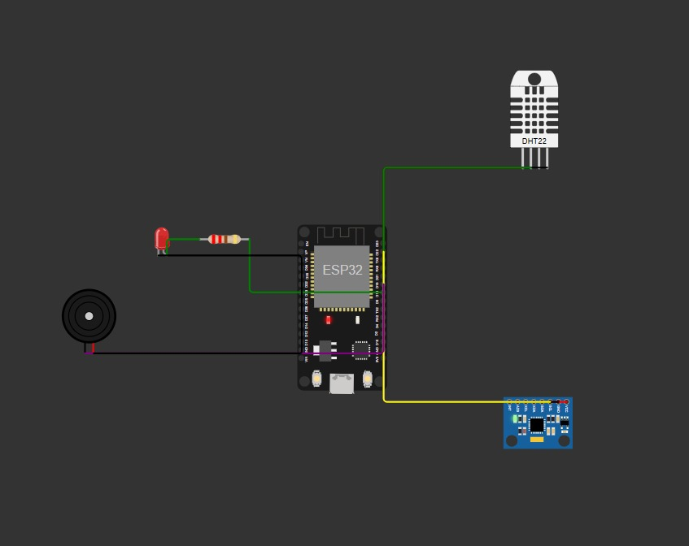
Fig. 1 | Circuit assembled in Wokwi simulator
The DHT22 is a single-wire digital sensor that measures both temperature and relative humidity. In this project only the temperature reading is used. It sits on GPIO 4 and pulls data every second. The DHT22 was preferred over the older DHT11 because of its higher accuracy and wider measurement range, which matters when you are trying to detect the kind of gradual heat buildup that precedes equipment failure.
The MPU6050 is a six-axis inertial measurement unit combining a 3-axis accelerometer and a 3-axis gyroscope on a single chip. The code reads only the accelerometer values (X, Y, Z) and computes the resultant magnitude using the formula: vibration = sqrt(ax² + ay² + az²). This gives a single scalar representing the intensity of movement regardless of direction.
The alert output circuit uses a standard LED with a 220-ohm series resistor connected to GPIO 18, which limits current to a safe level for the ESP32 output driver. The passive buzzer on GPIO 19 provides an audible signal. Both devices switch ON simultaneously whenever the alert condition is true, and switch OFF immediately when conditions return to normal.

Pin Assignment Summary
Component Pin | ESP32 Pin / Connection | Purpose
DHT22 VCC | 3.3V | Power supply for DHT22
DHT22 GND | GND | Ground reference
DHT22 DATA | GPIO 4 | Temperature/humidity data line
MPU6050 VCC | 3.3V | Power supply for MPU6050
MPU6050 GND | GND | Ground reference
MPU6050 SDA | GPIO 21 | I2C data line
MPU6050 SCL | GPIO 22 | I2C clock line
Red LED (A) | GPIO 18 → 220Ω → LED → GND | Visual alert output
Buzzer (+) | GPIO 19 | Audible alert output
Buzzer (−) | GND | Buzzer ground

Arduino Sketch (wifi-scan.ino)
● ● ● wifi-scan.ino
#include <Wire.h>
#include <DHT.h>
#include <Adafruit_MPU6050.h>
#include <Adafruit_Sensor.h>

#define DHTPIN 4
#define DHTTYPE DHT22
#define LED_PIN 18
#define BUZZER_PIN 19

DHT dht(DHTPIN, DHTTYPE);
Adafruit_MPU6050 mpu;

void setup() {
Serial.begin(115200);
pinMode(LED_PIN, OUTPUT);
pinMode(BUZZER_PIN, OUTPUT);
dht.begin();
Wire.begin(21, 22);
if (!mpu.begin()) {
Serial.println("MPU6050 not found!");
while (1);
}
Serial.println("System Started");
}

void loop() {
float temp = dht.readTemperature();
sensors_event_t a, g, t;
mpu.getEvent(&a, &g, &t);
float vibration = sqrt(
a.acceleration.x * a.acceleration.x +
a.acceleration.y * a.acceleration.y +
a.acceleration.z * a.acceleration.z
);
Serial.print("Temperature: "); Serial.println(temp);
Serial.print("Vibration: "); Serial.println(vibration);
if (temp > 50 || vibration > 15) {
digitalWrite(LED_PIN, HIGH);
digitalWrite(BUZZER_PIN, HIGH);
Serial.println("WARNING: MACHINE DAMAGE DETECTED");
} else {
digitalWrite(LED_PIN, LOW);
digitalWrite(BUZZER_PIN, LOW);
Serial.println("Machine Healthy");
}
delay(1000);
}

6.0 Simulation Results

After pressing the Start button in Wokwi, the simulation initialised successfully and printed System Started to the Serial Monitor. The loop then began executing at one-second intervals. The following describes what was observed during the simulation run.

Normal Operating State
Under default Wokwi sensor values, the DHT22 reported a temperature of around 24°C and the MPU6050 reported a vibration magnitude close to 9.8 m/s² (which is the expected resting value due to Earth's gravitational acceleration acting on the accelerometer Z-axis). Both values were comfortably below their respective thresholds. The Serial Monitor displayed:

● ● ● Serial Monitor — Normal State
System Started
Temperature: 24.00
Vibration: 9.81
Machine Healthy
Temperature: 24.00
Vibration: 9.81
Machine Healthy

Alert Triggered: High Temperature
When the DHT22 temperature attribute was manually increased above 50°C in the Wokwi component panel, the ESP32 immediately detected the breach on the next polling cycle. GPIO 18 was set HIGH (LED turned on, visible in the simulation), GPIO 19 was set HIGH (buzzer activated), and the warning message was printed to the Serial Monitor:

● ● ● Serial Monitor — High Temperature Alert
Temperature: 55.00
Vibration: 9.81
WARNING: MACHINE DAMAGE DETECTED

Alert Triggered: High Vibration
When the MPU6050 was rotated or shaken in Wokwi to produce a vibration magnitude exceeding 15 m/s², the same alert sequence fired even with temperature within the normal range. This confirmed that the OR logic in the code functions as expected | either parameter alone is sufficient to trigger the alert.

● ● ● Serial Monitor — High Vibration Alert
Temperature: 24.00
Vibration: 18.43
WARNING: MACHINE DAMAGE DETECTED

Recovery Behaviour
Once the temperature was lowered back below 50°C and the vibration settled back under 15 m/s², the system automatically returned to the healthy state within one polling cycle. The LED switched off and the buzzer fell silent. No manual reset was required, which is the correct behaviour for a continuous monitoring system.

The full simulation run has been recorded and is available at the shared Google Drive folder link provided by the group. The video demonstrates both the normal operation and the alert trigger scenario in real time.
Video Reference: https://drive.google.com/drive/folders/1cPV9a2DH77zrRaHJrEBdiN2OWzFraEaA?usp=sharing

7.0 Inferences Drawn from Simulations

Working through this simulation gave the group a practical sense of how condition-based monitoring actually operates at the hardware level, beyond just the theory covered in lectures. Below are the key takeaways.

# | Observation | Explanation
1 | Temperature threshold at 50°C | If temperature exceeds 50°C, the ESP32 immediately sets GPIO 18 and GPIO 19 HIGH, activating both the red LED and the buzzer. This tells an operator something is overheating before physical damage occurs.
2 | Vibration magnitude calculation | The MPU6050 provides raw X, Y, Z acceleration values. The code computes the vector magnitude using the Euclidean formula. A threshold of 15 m/s² was selected because it corresponds to sudden mechanical shock | normal operation stays well below this.
3 | Dual-trigger alert logic | The system uses an OR condition: if either temperature OR vibration crosses its threshold, the alert fires. This makes the design fault-tolerant | a single faulty sensor won't leave the system blind.
4 | I2C communication | The MPU6050 communicates over I2C with SDA on GPIO 21 and SCL on GPIO 22. Wire.begin(21, 22) is called explicitly to override the default pin assignment in ESP32 Arduino core, ensuring reliable sensor discovery.
5 | 1-second polling loop | The delay(1000) at the end of loop() creates a 1 Hz reading cycle. This is adequate for slow thermal changes while keeping serial output readable. For faster vibration events, a shorter delay would be needed in production.
6 | Serial Monitor as output channel | Since Wokwi does not have physical displays, all status messages go to the Serial Monitor at 115200 baud. The output clearly labels each reading and prints WARNING or Machine Healthy based on conditions.

The broader takeaway from this project is that the ESP32 is a genuinely capable edge-computing platform. It handled I2C communication, digital I/O, floating-point math, and serial output simultaneously without any visible performance issues in the simulator. A real-world version of this system could easily add Wi-Fi-based alerting | the ESP32 has that radio built in | which would allow a remote dashboard to receive machine health updates without any additional hardware. That is a natural extension of this project that the team would like to explore going forward.

