Code: forestFeatureSelection.py

Input file: /Users/rohanmurde/Desktop/Capstone/Datasets/fromPEMM_after_mean_addDX.csv

Results:

Feature ranking including cognitive markers (ADAS13, MMSE, CDMEMORY):

1. feature 2 (0.206522) = CDMEMORY

2. feature 1 (0.078465) = MMSE

3. feature 0 (0.078444) = ADAS13

4. feature 16 (0.051381) = SUMMARYSUVR_WHOLECEREBNORM

5. feature 3 (0.045564) = IPCA

6. feature 12 (0.037802) = FRONTAL

7. feature 10 (0.037076) = BRAINSTEM

8. feature 6 (0.036422) = PTAU

9. feature 5 (0.036203) = TAU

10. feature 4 (0.035015) = ABETA

11. feature 14 (0.034455) = PARIETAL

12. feature 15 (0.034138) = TEMPORAL

13. feature 11 (0.033035) = WHOLECEREBELLUM

14. feature 20 (0.031661) = BRAINVOL

15. feature 21 (0.031339) = VENTVOL

16. feature 13 (0.030488) = CINGULATE

17. feature 18 (0.029883) = DBCBBSI

18. feature 19 (0.029232) = VBSI

19. feature 17 (0.028819) = BBSI

20. feature 9 (0.026978) = CEREBELLUMGREYMATTER

21. feature 7 (0.023992) = AB40

22. feature 8 (0.023086) = AB42

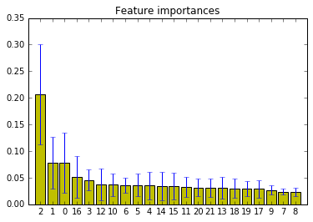

Cognitive markers (ADAS13, MMSE, CDMEMORY) indeed are strong markers and have less % of missing values but they focus on observable dementia symptoms rather than early detection.

Feature ranking excluding cognitive markers:

1. feature 13 (0.083000) = SUMMARYSUVR_WHOLECEREBNORM

2. feature 7 (0.066049) = BRAINSTEM

3. feature 0 (0.064160) = IPCA

4. feature 9 (0.062734) = FRONTAL

5. feature 11 (0.056995) = PARIETAL

6. feature 18 (0.056495)

7. feature 2 (0.056471)

8. feature 3 (0.056455)

9. feature 12 (0.054225)

10. feature 1 (0.051234)

11. feature 17 (0.050462)

12. feature 8 (0.050243)

13. feature 10 (0.049791)

14. feature 16 (0.049314)

15. feature 15 (0.044908)

16. feature 14 (0.041938)

17. feature 6 (0.039671)

18. feature 4 (0.033307)

19. feature 5 (0.032547)

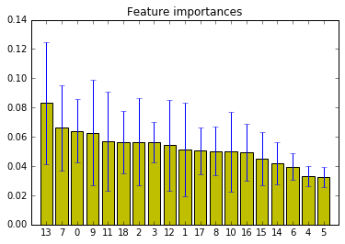

Code: compareClassifiers.py

Input file: /Users/rohanmurde/Desktop/Capstone/Datasets/selectedAttsExcludesCogMarkers.csv

Result:

This is class_index: ['AD' 'MCI' 'NL']

Nearest Neighbors : Accuracy= 70.6896551724 %

Linear SVM : Accuracy= 71.8390804598 %

RBF SVM : Accuracy= 72.4137931034 %

Decision Tree : Accuracy= 68.3908045977 %

Random Forest : Accuracy= 70.9770114943 %

AdaBoost : Accuracy= 67.5287356322 %

Naive Bayes : Accuracy= 65.5172413793 %

LDA : Accuracy= 70.6896551724 %

QDA : Accuracy= 71.5517241379 %

TODO

Compare with entire dataset

Try 5fold cv. Log likehood.

Graphs based on att to show the trend.

Web interface.

Use db.

Create patient list before reading view so that doctor can select patients.

From Readings navigate to maps.

<http://www.appcoda.com/ios-charts-api-tutorial/>

<https://www.cocoacontrols.com/controls/swiftcharts>

<http://www.ioscookies.com/charts>

Have one doctor see patients of another doctor in case of absence.