SEPM ASSIGNMENT
Shaikh Sadaf Noor 224A9068

Q1.What is RMMM? Explain in Detail
RMMM Plan :
A risk management technique is usually seen in the software Project plan. This can be divided into Risk Mitigation, Monitoring, and Management Plan (RMMM). In this plan, all works are done as part of risk analysis. As part of the overall project plan project manager generally uses this RMMM plan.
In some software teams, risk is documented with the help of a Risk Information Sheet (RIS). This RIS is controlled by using a database system for easier management of information i.e creation, priority ordering, searching, and other analysis. After documentation of RMMM and start of a project, risk mitigation and monitoring steps will start.
Risk Mitigation :
It is an activity used to avoid problems (Risk Avoidance).
Steps for mitigating the risks as follows.
- Finding out the risk.
- Removing causes that are the reason for risk creation.
- Controlling the corresponding documents from time to time.
- Conducting timely reviews to speed up the work.
Risk Monitoring :
It is an activity used for project tracking.
It has the following primary objectives as follows.
- To check if predicted risks occur or not.
- To ensure proper application of risk aversion steps defined for risk.
- To collect data for future risk analysis.
- To allocate what problems are caused by which risks throughout the project.
Risk Management and planning :
It assumes that the mitigation activity failed and the risk is a reality. This task is done by Project manager when risk becomes reality and causes severe problems. If the project manager effectively uses project mitigation to remove risks successfully then it is easier to manage the risks. This shows that the response that will be taken for each risk by a manager. The main objective of the risk management plan is the risk register. This risk register describes and focuses on the predicted threats to a software project.

Example:
Let us understand RMMM with the help of an example of high staff turnover.
Risk Mitigation:
To mitigate this risk, project management must develop a strategy for reducing turnover. The possible steps to be taken are:
- Meet the current staff to determine causes for turnover (e.g., poor working conditions, low pay, competitive job market).
- Mitigate those causes that are under our control before the project starts.
- Once the project commences, assume turnover will occur and develop techniques to ensure continuity when people leave.
- Organize project teams so that information about each development activity is widely dispersed.
- Define documentation standards and establish mechanisms to ensure that documents are developed in a timely manner.
- Assign a backup staff member for every critical technologist.
Risk Monitoring:
As the project proceeds, risk monitoring activities commence. The project manager monitors factors that may provide an indication of whether the risk is becoming more or less likely. In the case of high staff turnover, the following factors can be monitored:
- General attitude of team members based on project pressures.
- Interpersonal relationships among team members.
- Potential problems with compensation and benefits.
- The availability of jobs within the company and outside it.
Risk Management:
Risk management and contingency planning assumes that mitigation efforts have failed and that the risk has become a reality. Continuing the example, the project is well underway, and a number of people announce that they will be leaving. If the mitigation strategy has been followed, backup is available, information is documented, and knowledge has been dispersed across the team. In addition, the project manager may temporarily refocus resources (and readjust the project schedule) to those functions that are fully staffed, enabling newcomers who must be added to the team to "get up to the speed".

Q2. Write a short note on SCM repositories.
Whenever software is built, there is always scope for improvement and those improvements bring picture changes. Changes may be required to modify or update any existing solution or to create a new solution for a problem. Requirements keep on changing daily so we need to keep on upgrading our systems based on the current requirements and needs to meet desired outputs. Changes should be analyzed before they are made to the existing system, recorded before they are implemented, reported to have details of before and after, and controlled in a manner that will improve quality and reduce error. This is where the need for System Configuration Management comes. System Configuration Management (SCM) is an arrangement of exercises that controls change by recognizing the items for change, setting up connections between those things, making/characterizing instruments for overseeing diverse variants, controlling the changes being executed in the current framework, inspecting and revealing/reporting on the changes made. It is essential to control the changes because if the changes are not checked legitimately then they may wind up undermining a well-run programming. In this way, SCM is a fundamental piece of all project management activities.
Processes involved in SCM - Configuration management provides a disciplined environment for smooth control of work products. It involves the following activities:
- Identification and Establishment - Identifying the configuration items from products that compose baselines at given points in time (a baseline is a set of mutually consistent Configuration Items, which has been formally reviewed and agreed upon, and serves as the basis of further development). Establishing relationships among items, creating a mechanism to manage multiple levels of control and procedure for the change management system.
- Version control - Creating versions/specifications of the existing product to build new products with the help of the SCM system. A description of the version is given below: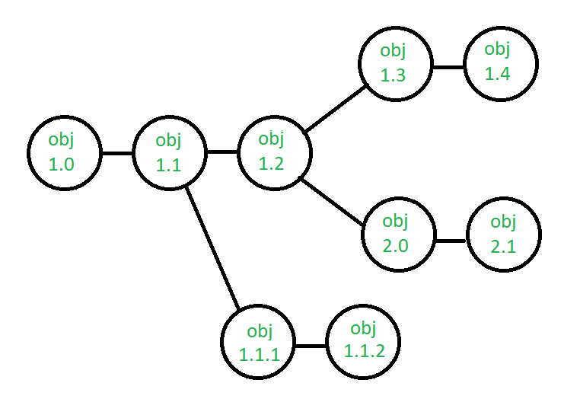
- Suppose after some changes, the version of the configuration object changes from 1.0 to 1.1. Minor corrections and changes result in versions 1.1.1 and 1.1.2, which is followed by a major update that is object 1.2. The development of object 1.0 continues through 1.3 and 1.4, but finally, a noteworthy change to the object results in a new evolutionary path, version 2.0. Both versions are currently supported.
- Change control - Controlling changes to Configuration items (CI). The change control process is explained in Figure below: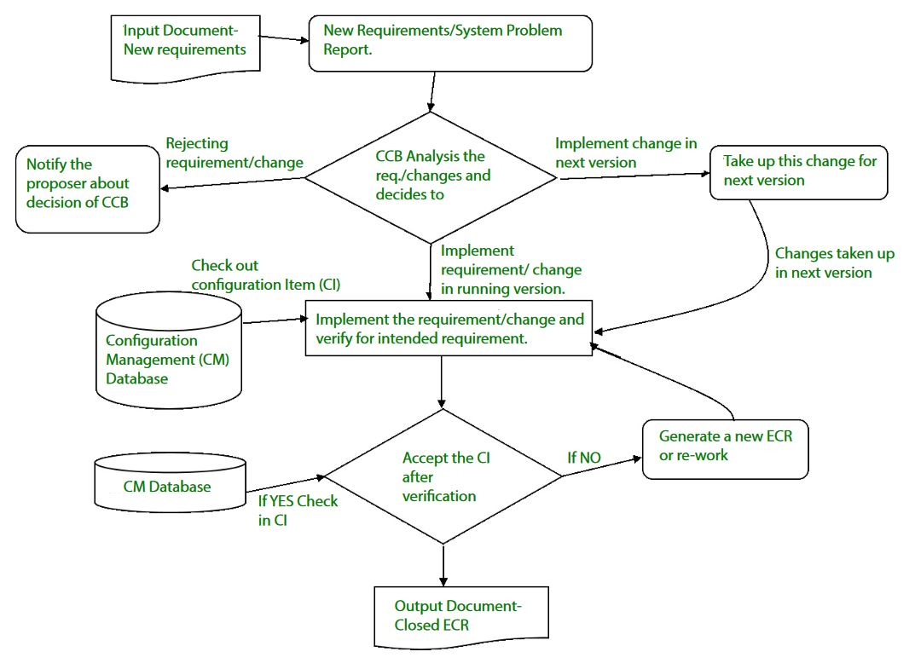A change request (CR) is submitted and evaluated to assess technical merit, potential side effects, the overall impact on other configuration objects and system functions, and the projected cost of the change. The results of the evaluation are presented as a change report, which is used by a change control board (CCB) —a person or group who makes a final decision on the status and priority of the change. An engineering change Request (ECR) is generated for each approved change. Also, CCB notifies the developer in case the change is rejected with proper reason. The ECR describes the change to be made, the constraints that must be respected, and the criteria for review and audit. The object to be changed is "checked out" of the project database, the change is made, and then the object is tested again. The object is then "checked in" to the database and appropriate version control mechanisms are used to create the next version of the software.
- Configuration auditing - A software configuration audit complements the formal technical review of the process and product. It focuses on the technical correctness of the configuration object that has been modified. The audit confirms the completeness, correctness, and consistency of items in the SCM system and tracks action items from the audit to closure.
- Reporting - Providing accurate status and current configuration data to developers, testers, end users, customers, and stakeholders through admin guides, user guides, FAQs, Release notes, Memos, Installation Guide, Configuration guides, etc.
System Configuration Management (SCM) is a software engineering practice that focuses on managing the configuration of software systems and ensuring that software components are properly controlled, tracked, and stored. It is a critical aspect of software development, as it helps to ensure that changes made to a software system are properly coordinated and that the system is always in a known and stable state.
Q3. Define Software Reliability
Software reliability is the probability that a software system will operate without failure for a specific time in a defined environment. It indicates the trustworthiness and quality of software, differing from hardware as it does not "wear out" but fails due to design or implementation defects, with reliability increasing as bugs are removed.
Key Aspects of Software Reliability:
- Definition: Probability of failure-free operation in a given environment for a specified time.
- Failure vs. Fault: A fault (bug) is a defect in the code, while a failure is the manifestation of that fault, leading to incorrect system operation.
- Key Metrics:
  - ROCOF (Rate of Occurrence of Failure): Frequency of unexpected behavior.
  - MTTF (Mean Time To Failure): Average time between failures.
  - MTTR (Mean Time To Repair): Average time taken to fix a failure.
  - Availability: Probability that the system is operational at a given time
Factors Influencing Reliability:
- Complexity: Larger, more complex code generally has lower reliability.
- Development Process: Using formal methods, thorough testing, and experienced developers increases reliability.
- Operating Environment: The actual usage scenarios might differ from the test scenarios, affecting reliability

Q4. Explain in detail about FTR (Formal Technical Review)
Formal Technical Review (FTR) is a software quality control activity performed by software engineers. It is an organized, methodical procedure for assessing and raising the standard of any technical paper, including software objects. Finding flaws, making sure standards are followed, and improving the product or document under review's overall quality are the main objectives of a formal technical review (FTR). Although FTRs are frequently utilized in software development, other technical fields can also employ the concept.

Objectives of formal technical review (FTR)

Detect Identification: Identify defects in technical objects by finding and fixing mistakes, inconsistencies, and deviations.
Quality Assurance: To ensure high-quality deliverables, and confirm compliance with project specifications and standards.
Risk Mitigation: To stop risks from getting worse, proactively identify and manage possible threats.
Knowledge Sharing: Encourage team members to work together and build a common knowledge base.
Consistency and Compliance: Verify that all procedures, coding standards, and policies are followed.
Learning and Training: Give team members the chance to improve their abilities through learning opportunities.
In addition, the purpose of FTR is to enable junior engineers to observe the analysis, design, coding, and testing approach more closely. FTR also works to promote backup and continuity to become familiar with parts of the software they might not have seen otherwise. FTR is a class of reviews that include walkthroughs, inspections, round-robin reviews, and other small-group technical assessments of software. Each FTR is conducted as a meeting and is considered successful only if it is properly planned, controlled, and attended.

Example
Suppose during the development of the software without FTR design cost 10 units, coding cost 15 units and testing cost 10 units then the total cost till now is 35 units without maintenance but there was a quality issue because of bad design so to fix it we have to redesign the software and final cost will become 70 units. that is why FTR is so helpful while developing the software.

The Review Meeting
Each review meeting should be held considering the following constraints- Involvement of people:
- Between 3, 4, and 5 people should be involved in the review.
- preparation should occur, but it should be very short that is at the most 2 hours of work for every person.
- The short duration of the review meeting should be less than two hours. Given these constraints, it should be clear that an FTR focuses on specific (and small) parts of the overall software.
At the end of the review, all attendees of FTR must decide what to do.
- Accept the product without any modification.
- Reject the project due to serious error (Once corrected, another app needs to be reviewed), or Accept the product provisional (minor errors are encountered and should be corrected, but no additional review will be required).
The decision was made, with all FTR attendees completing a sign indicating their participation in the review and their agreement with the findings of the review team.

Review reporting and record-keeping:
- During the FTR, the reviewer actively records all issues that have been raised.
- At the end of the meeting all these issues raised are consolidated and a review list is prepared.
- Finally, a formal technical review summary report is prepared.

A review summary report answers three questions:
- What was reviewed?
- Who reviewed it?
- What were the findings and conclusions?

Review Guidelines
Guidelines for the conducting of formal technical reviews should be established in advance. These guidelines must be distributed to all reviewers, agreed upon, and then followed. An unregistered review can often be worse than a review that does not minimum set of guidelines for FTR.
- Review the product, not the manufacturer (producer): FTR includes people and egos. while properly conducted FTR will give all participants a good feeling of accomplishment, and when conducted improperly, the FTR team will be pointed out clearly. the meeting tone will be only loose and constructive, the review team leader will ensure that the proper way of communication will be happening or not into the team or it will get out of control.
- Set an agenda and maintain it: one of the measure keys in the meeting is drift. FTR will always keep on track and schedule. the review leader is making and maintaining the meeting schedule and should not be afraid that many people drift sets in.
- Limit debate and rebuttal: whenever the issue is raised by the reviewer there will not be an impact on a universal agreement. rather than spending time with the questions, then issues will be further discussed off-line.
- Enunciate problem areas, but don't attempt to solve every problem noted: A review is not a problem-solving session. The solution to a problem can often be accomplished for the producer alone or with the help of only one other individual. problem-solving should be postponed for a while until after the review meeting.
- Take written notes (record purpose): it is a good idea to take notes on the wallboard so that will be wording, and priorities can be assessed by other reviewers as information is recorded.
- Limit the number of participants and insist upon preparation: two heads are better than one, but 14 are not needed to be better than 4. We will keep the number of people involved to a minimum, all review teams must prepare in advance, and written comments will be requested by the review leader.
- Develop a checklist for each product that is likely to be reviewed: A checklist will help to structure of Review meeting and for the review leader and help to focus the reviewer on the important issues. checklist should be developed by the analysis, design, code, and even test documents.
- Allocate resources and schedule for FTRs to maintain schedule: it's effective to review, they should be effective and it should be a task during the software engineering process. In addition, the time should be scheduled for modification that occurs as a result of an FTR.
- Conduct meaningful training for all reviewers to make reviews effective: To be effective for all the reviews at first some have received formal training. it will stress both process-related and the human psychological side of the reviews. for every person who is to participate in reviews which is a one-month learning curve of 20 people.
- Review earlier reviews that serve as the base for the current review being conducted: it can be beneficial in uncovering problems with the review process itself. the first product to be reviewed should be the guidelines themselves because many variables have a successful review, a software organization should experiment to find approaches that work best in a local context. porter and his colleagues provide excellent guidance for this type of experiment.

Q5. How to Identify Risk and plan for assessment
Identifying risks in software engineering involves brainstorming technical, operational, and compliance threats, then ranking them by likelihood and impact using a risk matrix (1-10 scale). Planning for assessment includes creating a risk management plan, conducting regular audits, and defining mitigation strategies (avoid, reduce, transfer, or accept).
1. Identify Software Risks
Gather the team to identify risks early, focusing on areas like technology, budget, and timeline. Common techniques include:
- Brainstorming & Checklists: Review historical data from past projects to identify common pitfalls.
- SWOT Analysis: Identify Strengths, Weaknesses, Opportunities, and Threats within the project.
- Assumption Analysis: Identify potential risks as initial project assumptions.
- Categorization: Classify risks into technical (new technology, architecture), operational (staffing, scheduling), and compliance.
2. Risk Assessment Plan
Plan the assessment by structuring how risks will be analyzed and monitored:
- Probability & Impact Analysis: Assign a score (e.g., 1–5 or 1-10) to each risk based on how likely it is to occur and how severe its impact will be on cost and schedule.
- Risk Exposure Formula: Use a formula to calculate risk exposure, such as
- Prioritization: Rank risks, focusing efforts on those with the highest probability and impact.
- Documentation: Maintain a Risk Register to track identified risks, assessments, and mitigation strategies.
3. Risk Mitigation & Management
Create actionable plans for handling risks:
- Avoid: Change plans or requirements to eliminate the threat.
- Mitigate/Reduce: Take steps to lower the probability or impact (e.g., training, prototypes).
- Transfer: Shift risk to a third party (e.g., outsourcing, insurance).
- Accept: Formally acknowledge the risk and establish contingency reserves (budget/time buffer) for if it occurs.

