CREATE TABLE

create table employees( employee_id varchar(10) ,

first_name varchar(30) not null ,

last_name varchar(30) not null ,

salary integer not null ,

department_id integer ) ;

CREATE SEQUENCE

create sequence emp_seq increment by 1 start with 100 minvalue 100 maxvalue 200 ;

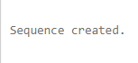

VALUES FOR TABLE

insert into employees(employee_id ,first_name , last_name , salary , department_id)values(emp_seq.nextval , 'tony' , 'jackson' , 80000 , 111) ;

insert into employees(employee_id ,first_name , last_name , salary , department_id)values(emp_seq.nextval , 'steve' , 'stark' , 60000 , 222) ;

insert into employees(employee_id ,first_name , last_name , salary , department_id)values(emp_seq.nextval , 'jack' , 'stark' , 50000 , 333) ;

insert into employees(employee_id ,first_name , last_name , salary , department_id)values(emp_seq.nextval , 'rajat' , 'sharma' , 80000 , 444) ;

insert into employees(employee_id ,first_name , last_name , salary , department_id)values(emp_seq.nextval , 'animesh' , 'sundriyal' , 40000 , 555) ;

insert into employees(employee_id ,first_name , last_name , salary , department_id)values(emp_seq.nextval , 'digvijay' , 'jackson' , 70000 , 666) ;

select * from employees ;

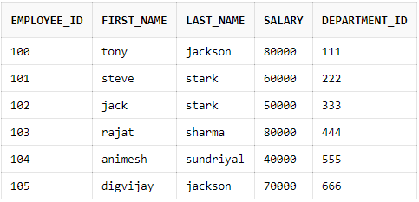

select emp_seq.nextval from employees ;

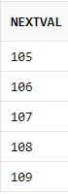

select emp_seq.currval from employees ;

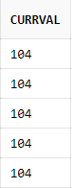

CHANGING FORMAT

Alter sequence emp_seq cycle cache 20;

Alter sequence emp_seq maxvalue 1000;

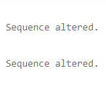

DELETE SEQUENCE

drop sequence emp_seq ;

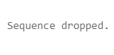

REVERSE

Create sequence reverse start with 10000 maxvalue 10000

minvalue 1000 increment by -5 ;

