## **NAME: ROHAN NYATI**

## **BATCH :5**

## **ROLL NO: R177219148**

## **SAPID: 500075940**

**EXPERIMENT-3**

**Title: 3. To understand and use SQL Sub-Query**

**Objective:** To understand the use of sql subquery.

**1. Create the following table.**

Supplier-(scode,sname,scity,turnover)

Part-(pcode,weigh,color,cost,sellingprice)

Supplier_Part-(scode,pcode,qty)

**2. Populate the table**

**3. Write appropriate SQL Statement for the following:**

1. Get the supplier number and part number in ascending order of supplier number.

2. Get the details of supplier who operate from Bombay with turnover 50.

3. Get the total number of supplier.

4. Get the part number weighing between 25 and 35.

5. Get the supplier number whose turnover is null.

6. Get the part number that cost 20, 30 or 40 rupees.

7. Get the total quantity of part 2 that is supplied.

8. Get the name of supplier who supply part 2.

9. Get the part number whose cost is greater than the average cost.

10. Get the supplier number and turnover in descending order of turnover.

## **ADBMS LAB EXPERIMENT – 3**

1. A)

create table supplier(scode varchar(5) primary key,sname varchar(30),scity varchar(10),turnover integer);

OUTPUT

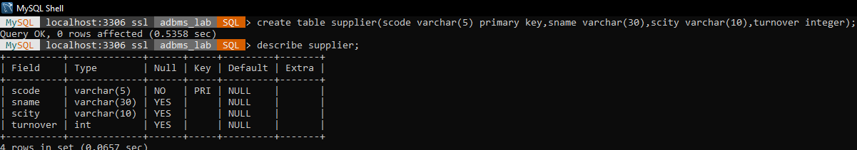

B)

create table part(pcode varchar(5) primary key,weigh decimal(8,2),color varchar(10),cost decimal(8,2),sellingprice decimal(8,2));

OUTPUT

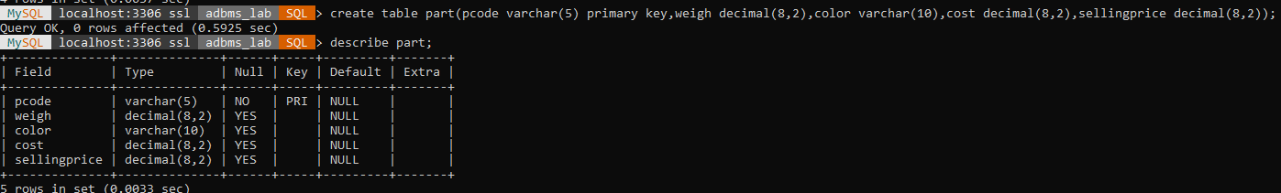

C)

create table supplier_part(scode varchar(5),pcode varchar(5),qty integer,primary key(scode,pcode),foreign key (scode) references supplier(scode),foreign key (pcode) references part(pcode));

OUTPUT

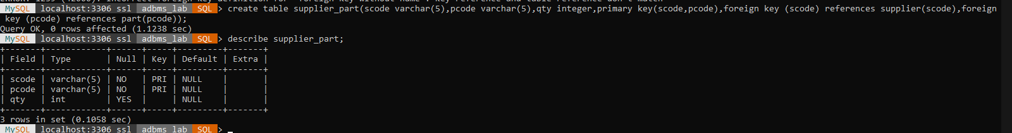

1. A)

insert into supplier values('S0001','IVAN','MUMBAI',15000);

insert into supplier values('S0002','MAMTA','MADRAS',50);

insert into supplier values('S0003','CHHAYA','MUMBAI',150);

insert into supplier values('S0004','ASHWINI','JAIPUR',5000);

insert into supplier values('S0005','AISH','JAIPUR',1000);

insert into supplier values('S0006','MAYANK','DELHI',100);

insert into supplier values('S0007','MEHAK','BIKANER',800);

insert into supplier values('S0008','SAKSHI','BANGALORE',8000);

insert into supplier values('S0009','MUSKAN','DEHRADUN',80);

insert into supplier values('S0010','ANUSHKA','KOTA',9000);

insert into supplier values('S0011','NAVEEN','LUCKNOW',900);

insert into supplier values('S0012','HARSH','GURAGON',90);

insert into supplier values('S0013','KAUSTUBH','GURAGON',900);

insert into supplier values('S0014','SURBHI','MUMBAI',300);

insert into supplier values('S0015','JANVI','KOLKATA',3000);

OUTPUT

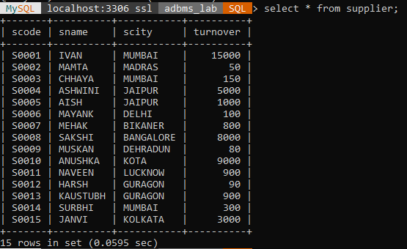

B)

insert into part values('P0001',50,'BLACK',500,800);

insert into part values('P0002',500,'BLUE',50,100);

insert into part values('P0003',200,'BLACK',800,1500);

insert into part values('P0004',600,'BLACK',700,1500);

insert into part values('P0005',400,'BLACK',900,2000);

insert into part values('P0006',400,'BLUE',900,2000);

insert into part values('P0007',300,'BLUE',300,800);

insert into part values('P0008',300,'BLACK',300,800);

insert into part values('P0009',700,'BLACK',300,800);

insert into part values('P0010',70,'BLACK',30,80);

insert into part values('P0011',70,'BLUE',30,80);

insert into part values('P0012',950,'BLUE',3000,8000);

insert into part values('P0013',950,'BLACK',3000,8000);

insert into part values('P0014',750,'BLACK',3000,8000);

insert into part values('P0015',550,'BLACK',3000,8000);

OUTPUT

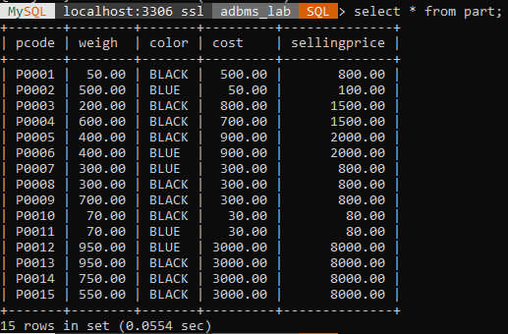

C)

insert into supplier_part values('S0001','P0001',50);

insert into supplier_part values('S0002','P0002',500);

insert into supplier_part values('S0003','P0003',300);

insert into supplier_part values('S0004','P0004',30);

insert into supplier_part values('S0005','P0005',50);

insert into supplier_part values('S0006','P0006',10);

insert into supplier_part values('S0007','P0007',100);

insert into supplier_part values('S0008','P0008',1000);

insert into supplier_part values('S0009','P0009',700);

insert into supplier_part values('S0010','P0010',70);

insert into supplier_part values('S0011','P0011',70);

insert into supplier_part values('S0012','P0012',80);

insert into supplier_part values('S0013','P0013',800);

insert into supplier_part values('S0014','P0014',8000);

insert into supplier_part values('S0015','P0015',90);

OUTPUT

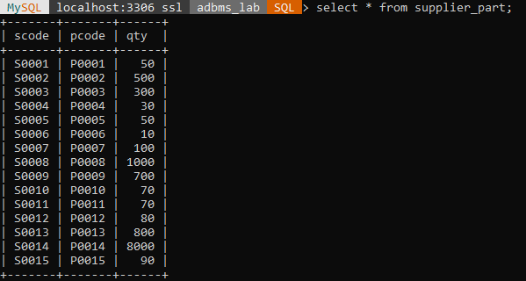

1. 1) select scode,pcode from supplier,part order by scode;

OUTPUT

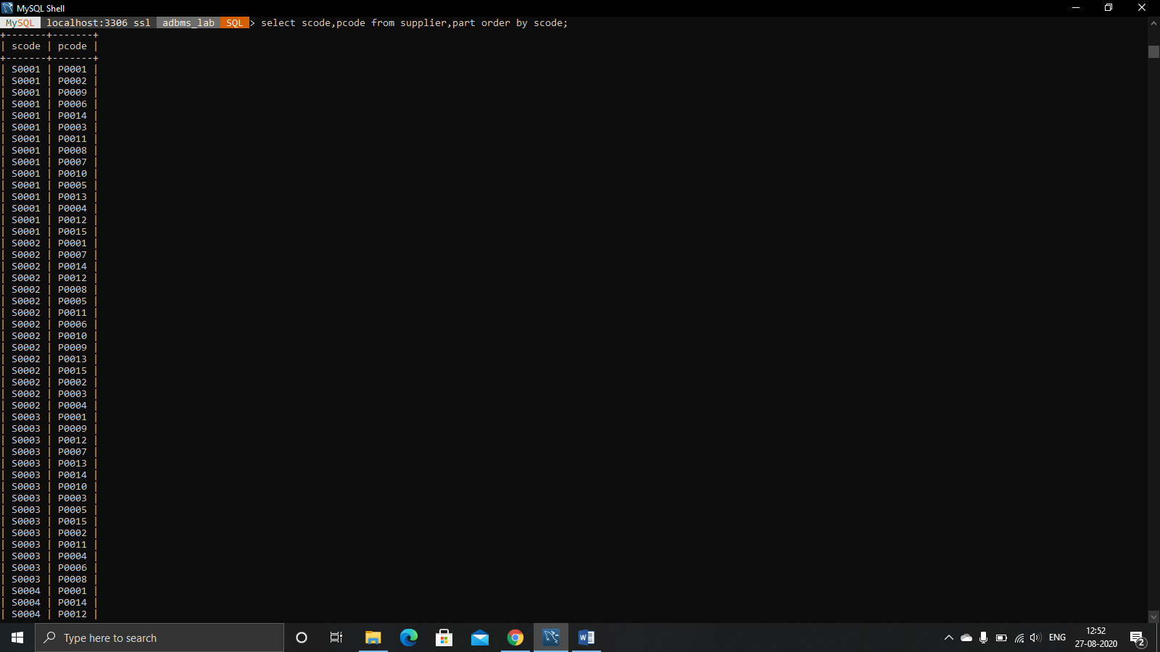

2) select * from supplier where scity='MUMBAI' AND turnover=50;

OUTPUT

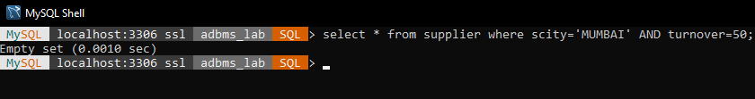

3) select count(scode) from supplier;

OUTPUT

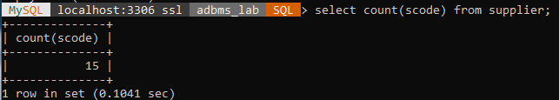

4) select pcode from part where weigh between 25 and 35;

OUTPUT

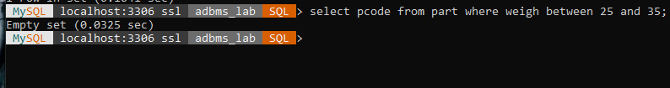

5) select scode from supplier where turnover is null;

OUTPUT

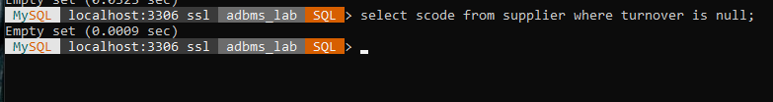

6) select pcode from part where cost in(20,30,40);

OUTPUT

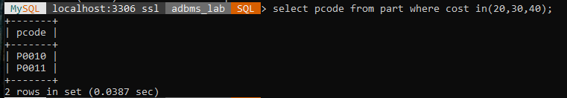

7) select qty from supplier_part where pcode='P0002';

OUTPUT

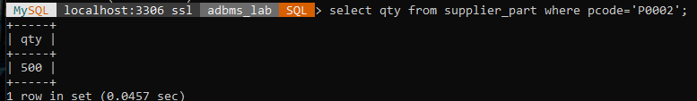

8) select sname from supplier,supplier_part where supplier.scode = supplier_part.scode and pcode='P0002';

OUTPUT

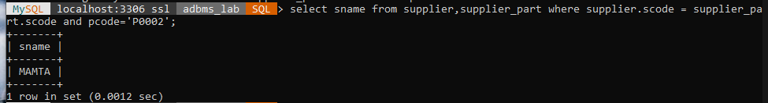

9) select pcode from part where cost > (select avg(cost) from part);

OUTPUT

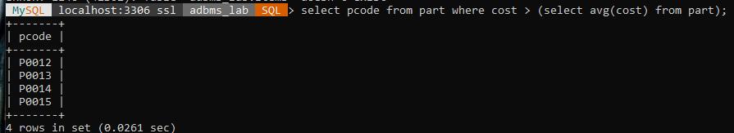

10) select scode,turnover from supplier order by turnover desc;

OUTPUT

