## **NAME: ROHAN NYATI**

## **BATCH :5**

## **ROLL NO: R177219148**

## **SAPID: 500075940**

**EXPERIMENT-6**

**Title: 6. To understand the concepts of Views.**

**Objective:** Students will be able to implement the concept of views.

**1. Create table of table name: EMPLOYEES and add 6 rows**

|  |  |  |  |
| --- | --- | --- | --- |
| Column Name | Data Type | Width | Attributes |
| Employee_id | Character | 10 | PK |
| First_Name | Character | 30 | NN |
| Last_Name | Character | 30 | NN |
| DOB | Date |  |  |
| Salary | Number | 25 | NN |
| Department_id | Character | 10 |  |

**2. Execute the following view related queries:**

1. Create View of name emp_view and the column would be Employee_id, Last_Name, salary and department_id only.:
2. Insert values into view(remove the NOT NULL constraint and then insert values):
3. Modify, delete and drop operations are performed on view.:
4. Creates a view  named salary_view. The view shows the employees in department 20 and their annual salary.

SOLUTION:

1. create table employees(employee_id varchar(10) primary key,first_name varchar(30) not null,last_name varchar(30) not null,dob date,salary int not null,department_id varchar(10));

OUTPUT:

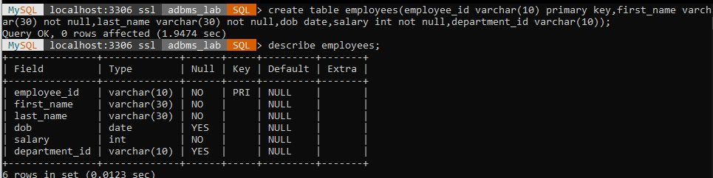

insert into employees values('E001','ANA','NAS','2002-04-08',23000,'D001');

insert into employees values('E002','ARAV','SHARMA','1998-10-02',10000,'D002');

insert into employees values('E003','HIMANSHU','SINGH','2000-05-25',45000,'D003');

insert into employees values('E004','SHREYA','GOEL','2004-01-05',67000,'D004');

insert into employees values('E005','SANDEEP','MISHRA','2001-09-13',75000,'D005');

insert into employees values('E006','POOJA','GUPTA','2000-05-24',51000,'D006');

OUTPUT:

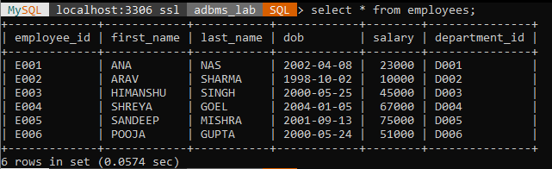

1. create view emp_view as select employees.employee_id,employees.last_name,employees.salary,employees.department_id from employees;

OUTPUT:

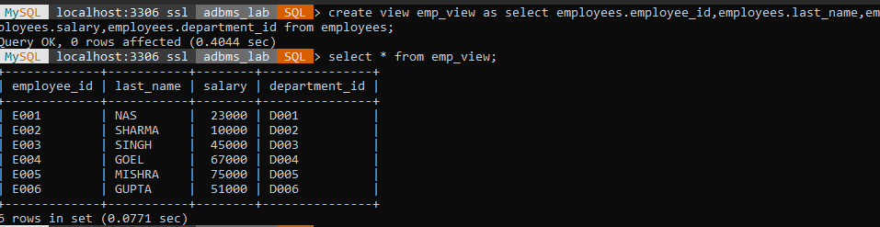

1. alter table employees modify first_name varchar(30) null;

insert into emp_view values('E007','ARORA',50000,'D007');

insert into emp_view values('E008','GIRIDHAR',10000,'D008');

insert into emp_view values('E009','DHAM',19000,'D009');

OUTPUT:

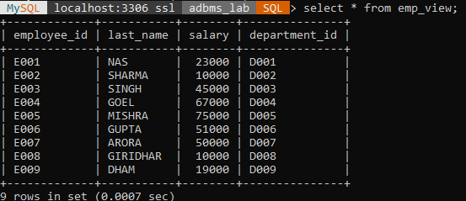

1. update emp_view set salary = 70000 where last_name = 'MISHRA';

delete from emp_view where employee_id = 'E007';

OUTPUT:

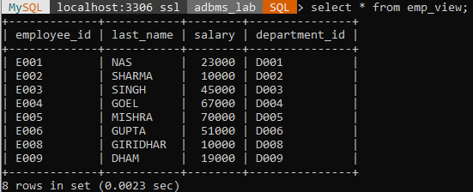

drop view emp_view;

OUTPUT:

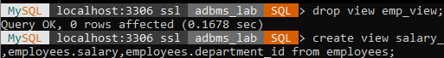

1. create view salary_view as select employees.employee_id,employees.last_name,employees.salary,employees.department_id from employees;

select employee_id,last_name,12*salary from salary_view where department_id='D004';

OUTPUT:

