## **NAME: ROHAN NYATI**

## **BATCH :5**

## **ROLL NO: R177219148**

## **SAPID: 500075940**

**EXPERIMENT-5**

**Title: 5. Use of different SQL clauses and join**

**Objective:** To understand the use of group by and having clause and execute the SQL commands using JOIN

**Ques.1**

Write the SQL Queries for the following queries (use emp_table and dept_table of Experiment 4).

1. List the Deptno where there are no emps.

select dept_no from dept where dept_no not in (select dept.dept_no from dept right join emp on emp.dept_no = dept.dept_no);

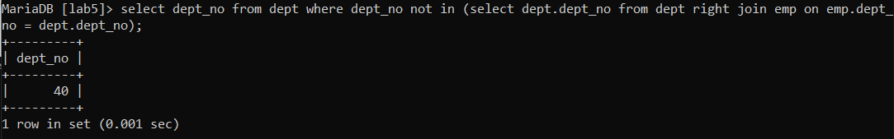

2. List the No.of emp’s and Avg salary within each department for each job.

select count(e_name), avg(sal) from emp right join dept on dept.dept_no = emp.dept_no group by dept.d_name;

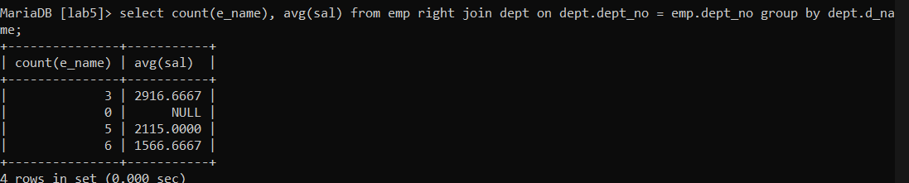

3. Find the maximum average salary drawn for each job except for ‘President’.

select avg(sal) from emp right join dept on emp.dept_no = dept.dept_no and job != 'President' group by job order by avg(sal) desc LIMIT 1;

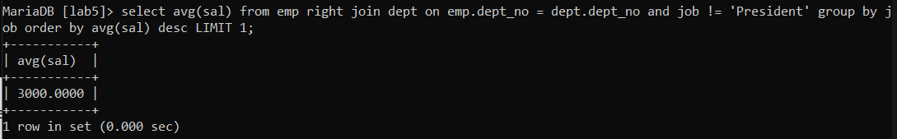

4. List the department details where at least two emps are working.

select * from dept right join emp on emp.dept_no = dept.dept_no group by d_name having count(d_name) >= 2;

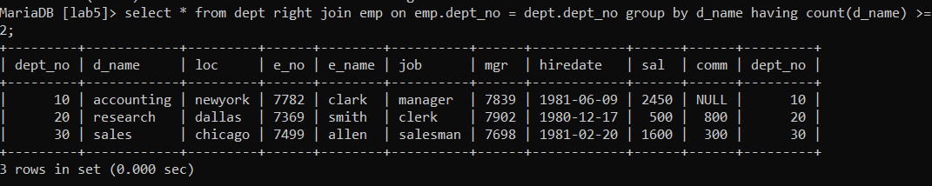

5. List the no. of emps in each department where the no. is more than 3.

select count(*), dept.d_name from dept right join emp on emp.dept_no = dept.dept_no group by d_name having count(d_name) > 3;

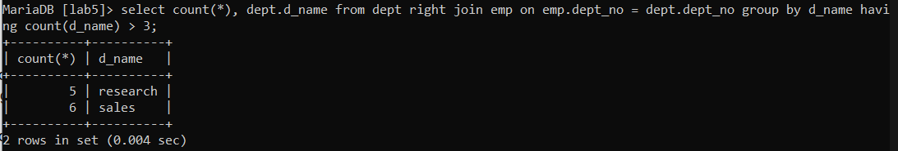

6. List the names of the emps who are getting the highest sal dept wise.

select e_name, d_name, max(sal) from emp right join dept on emp.dept_no = dept.dept_no group by d_name;

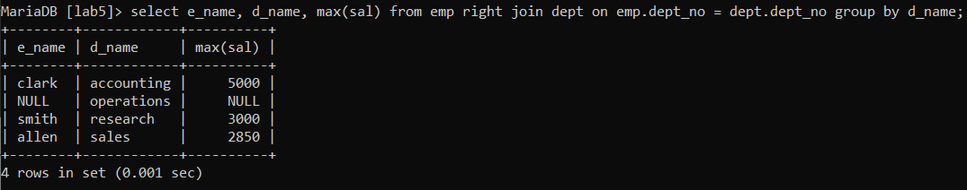

7. List the Deptno and their average salaries for dept with the average salary less than the averages for all departments.

select dept.dept_no, avg(sal) from emp right join dept on dept.dept_no = emp.dept_no group by dept_no having avg(sal) < (select avg(sal) from emp);

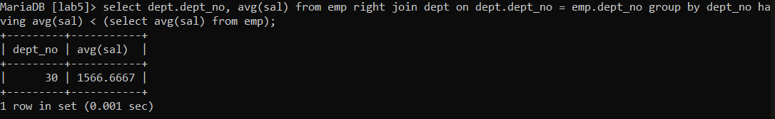

**Ques.2**

Execute the experiment 4 using sql join.

1. List the details of the emps whose Salaries more than the employee BLAKE.

select * from emp right join dept on emp.dept_no = dept.dept_no where sal > (select sal from emp where e_name = 'Blake');

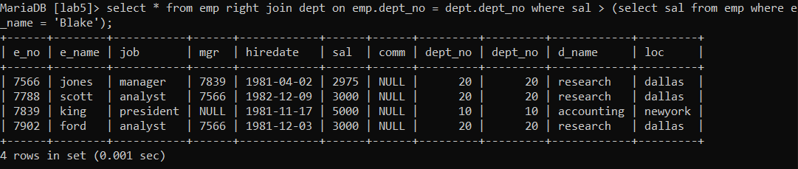

2. List the emps whose Jobs are the same as ALLEN.

select e_name from emp right join dept on emp.dept_no = dept.dept_no where job = (select job from emp where e_name = 'Allen');

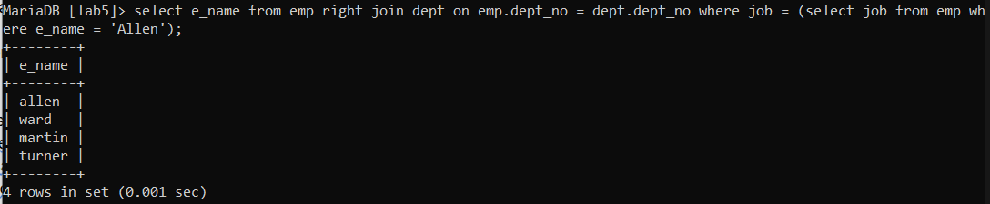

3. List the Emps whose Sal is same as FORD or SMITH in desc order of Names.

select e_name from emp right join dept on emp.dept_no = dept.dept_no where sal in (select sal from emp where (e_name = 'ford' or e_name = 'smith'))  order by e_name desc;

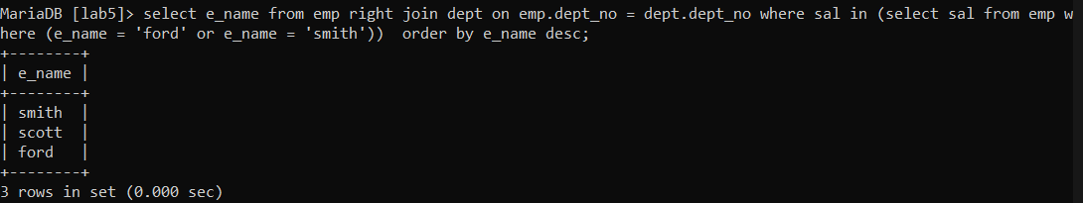

4. List the emps whose Jobs are the same as MILLER or Sal is more than ALLEN.

select * from emp right join dept on dept.dept_no = emp.dept_no where job = (select job from emp where e_name = 'miller') or sal > (select sal from emp where e_name = 'allen');

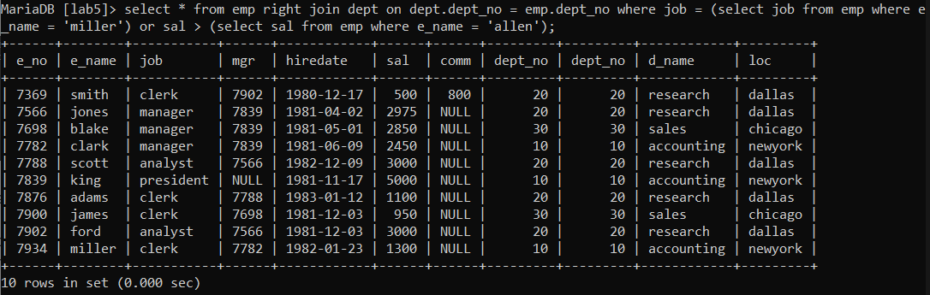

5. Find the highest paid employee of the sales department.

select e_name from emp right join dept on dept.dept_no = emp.dept_no where sal = (select max(sal) from emp where dept_no = (select dept_no from dept where d_name = 'sales'));

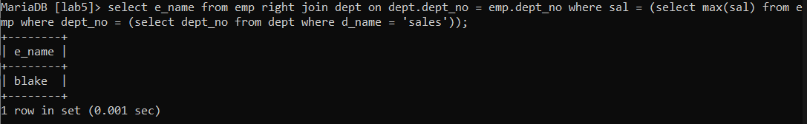

6. List the employees who are senior to the most recently hired employee working under king.

select e_name from emp right join dept on dept.dept_no = emp.dept_no where hiredate < (select max(hiredate) from emp where mgr in (select e_no from emp where e_name = 'king'));

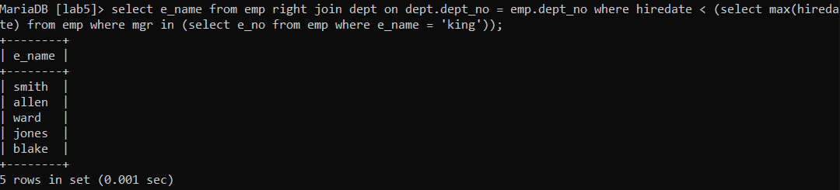

7. List the names of the emps who are getting the highest sal dept wise.

select e_name, dept.dept_no from emp right join dept on dept.dept_no = emp.dept_no where sal in (select max(sal) from emp group by dept_no);

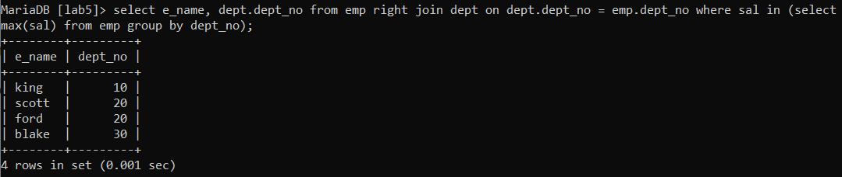

8. List the emps whose sal is equal to the average of max and minimum

select * from emp right join dept on emp.dept_no = dept.dept_no where sal = (select (max(sal)+min(sal))/2 from emp);



9. List the emps who joined the company on the same date.

select * from emp temp right join dept on temp.dept_no = dept.dept_no where hiredate in (select hiredate from emp where temp.e_name <> e_name);

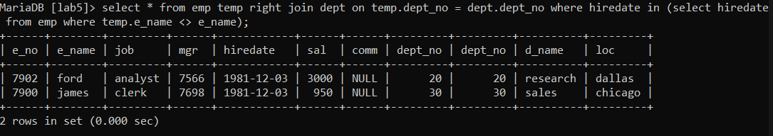

10. Find out the emps who joined in the company before their Managers.

select * from emp e right join dept on e.dept_no = dept.dept_no where hiredate < (select hiredate from emp where e_no = e.mgr);

