## **NAME: ROHAN NYATI**

## **BATCH :5**

## **ROLL NO: R177219148**

## **SAPID: 500075940**

**EXPERIMENT-9**

**Title: 9. To understand the concepts of PL/SQL programming.**

**Objective:** Students will be able to implement the basic concepts of Pl/SQL.

1. Write a PL/SQL code to accept the value of A, B & C display which is greater.
2. Using PL/SQL Statements create a simple loop that display message “Welcome to PL/SQL Programming” 20 times.
3. Write a PL/SQL code block to find the factorial of a number.
4. Write a PL/SQL program to generate Fibonacci series.
5. Write a PL/SQL code to fund the sum of first N numbers
6. Declare

--numbers getting intialised(declared)

a number:= 5;

b number:= 6;

c number:= 2;

begin

--start of the main body of the program

if (a>b and a>c) then

dbms_output.put_line('a is greater '||''||a);

elsif b>c then

dbms_output.put_line('b is greater '||''||b);

else

dbms_output.put_line('c is greater '||''||c);

end if;

end;

OUTPUT:

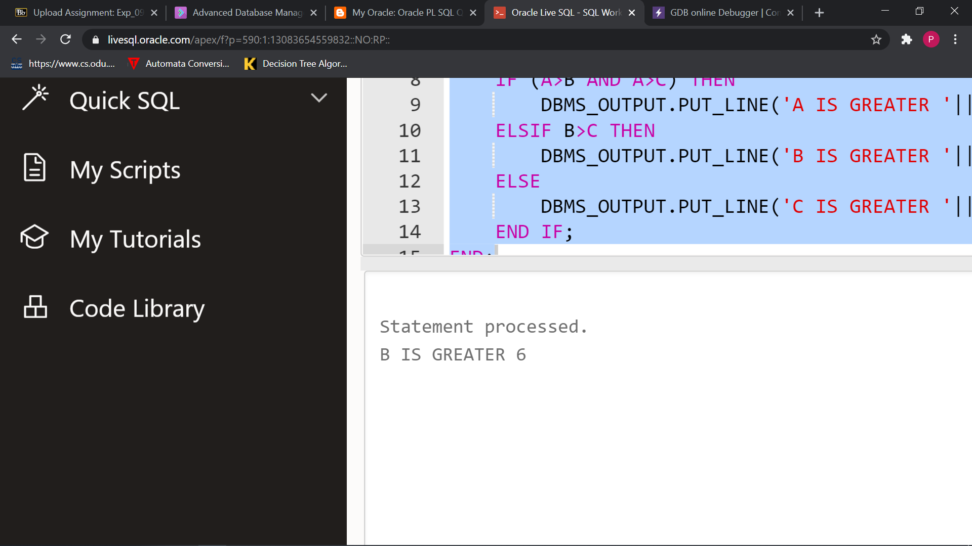

1. Declare

n number(3):=1;

BEGIN

while n<=20

loop

DBMS_OUTPUT.PUT_LINE('WELCOME TO PL/SQL PROGRAMMING');

n:=n+1;

end loop;

END;

OUTPUT:

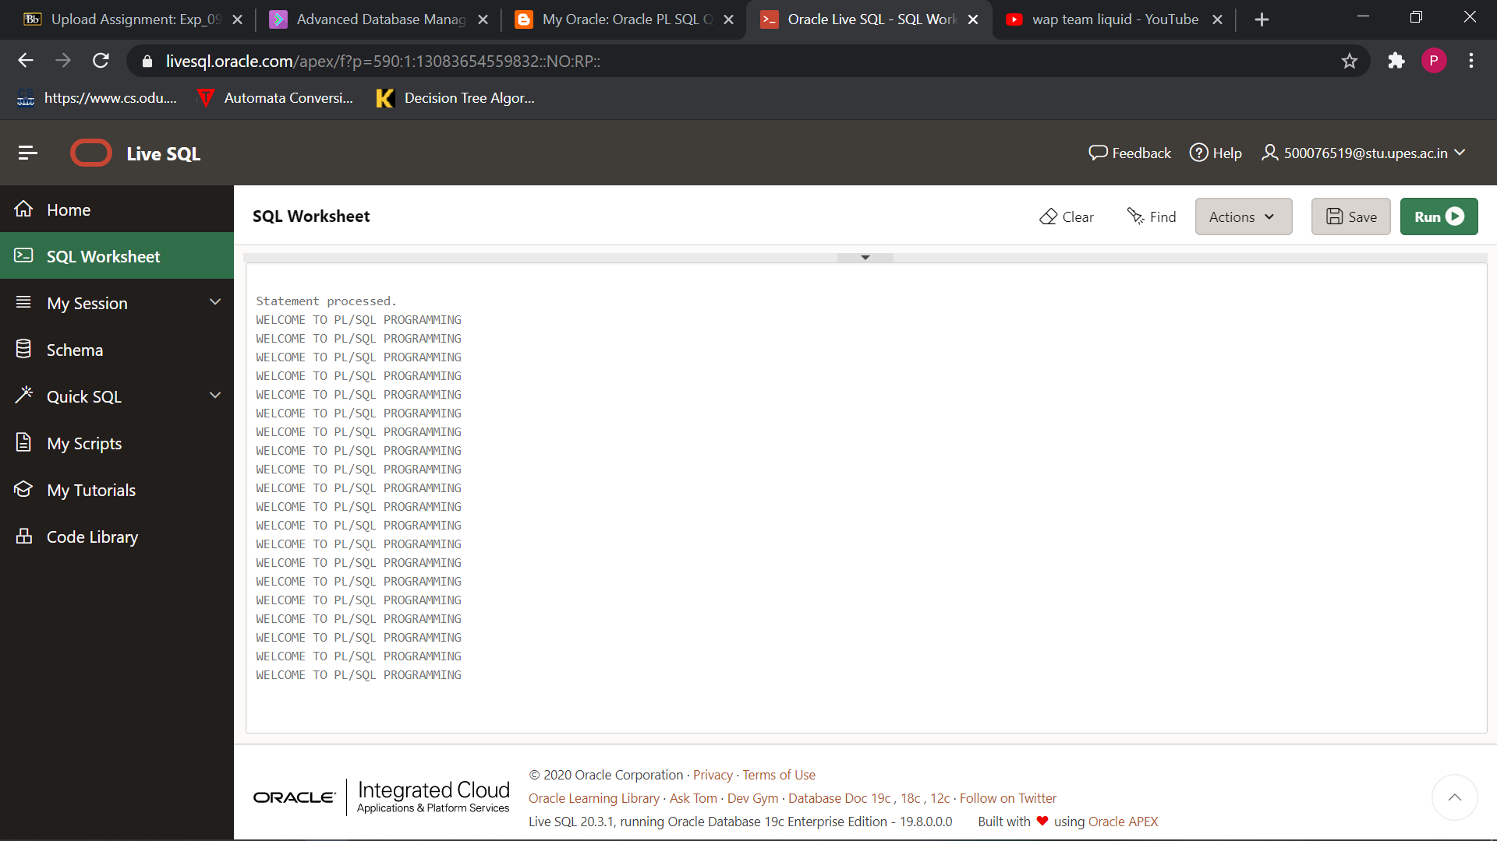

1. DECLARE

fact number :=1;

n number := 5;

BEGIN

while n > 0

loop

fact:=n*fact;

n:=n-1;

end loop;

dbms_output.put_line(fact);

END;

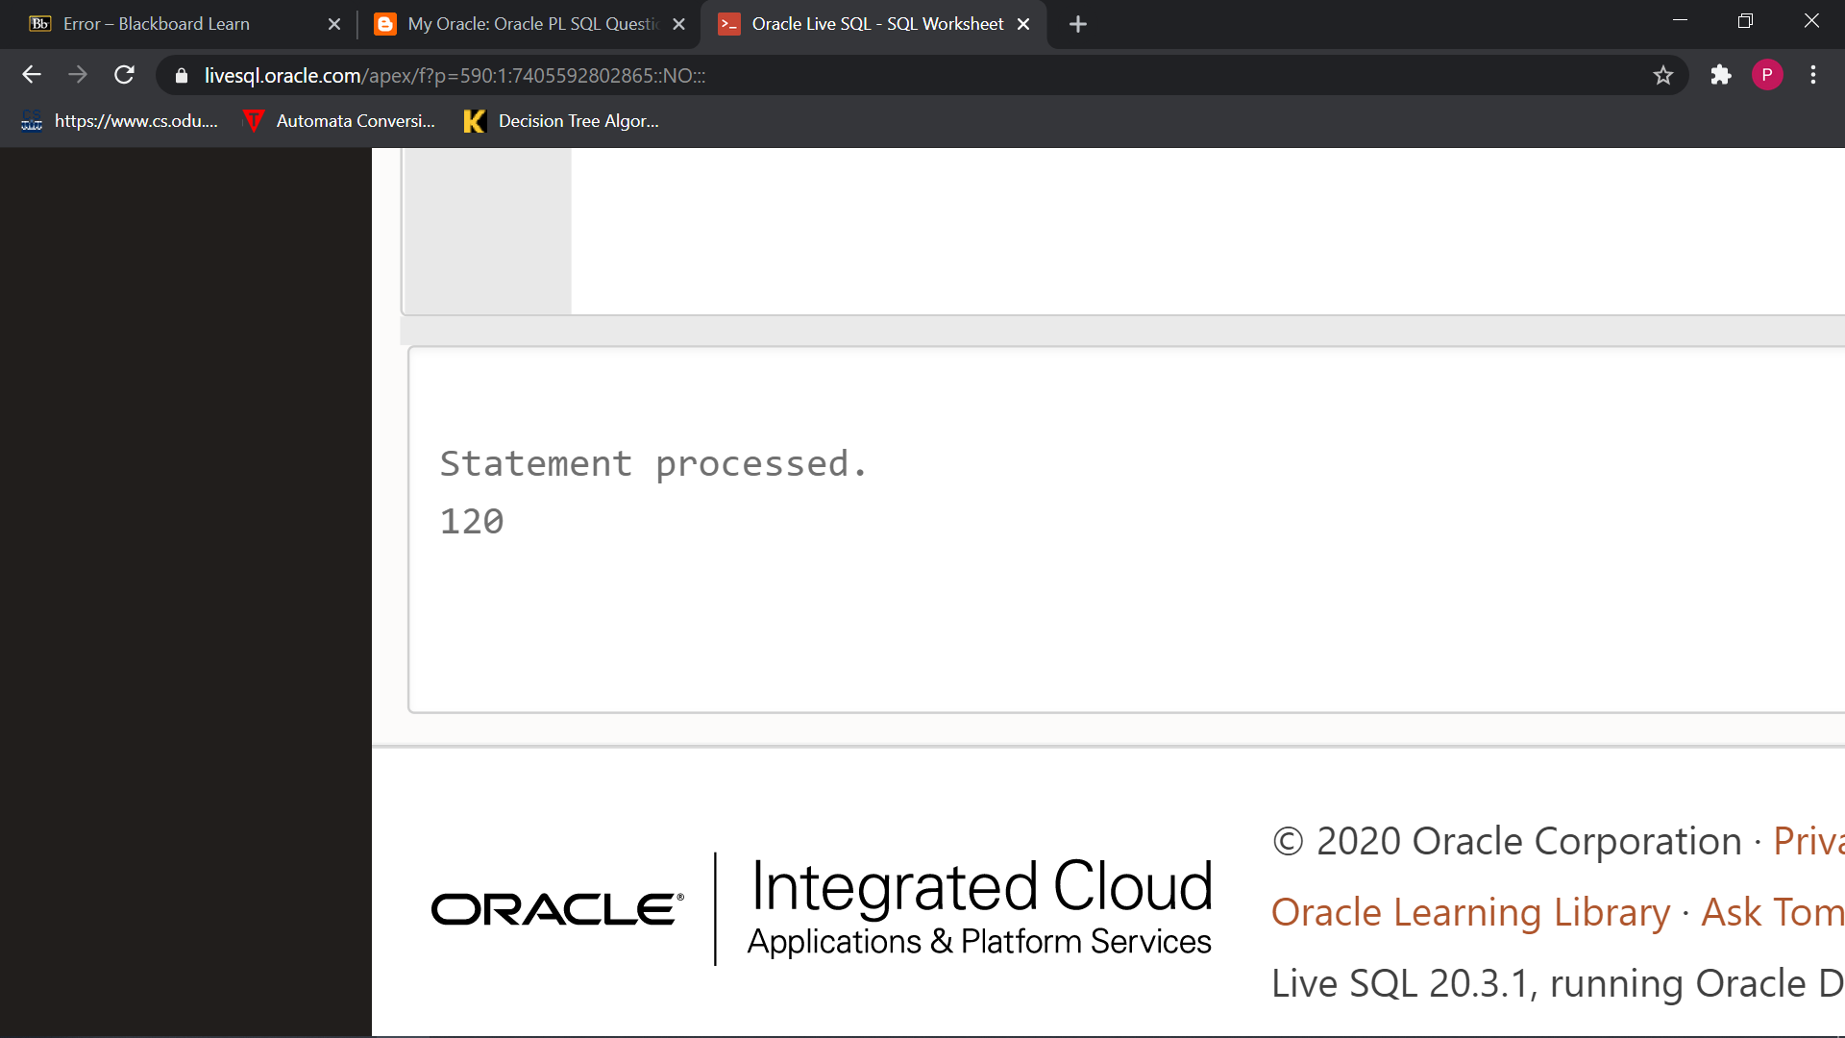

1. declare

first number:=0;

second number:=1;

third number;

n number:=10;

--(***putting direct values as & is giving errors)***

i number;

begin

dbms_output.put_line('FIBONACCI SERIES : ');

dbms_output.put_line(first);

dbms_output.put_line(second);

for i in 2..n

loop

third:=first+second;

first:=second;

second:=third;

dbms_output.put_line(third);

end loop;

end;

OUTPUT:

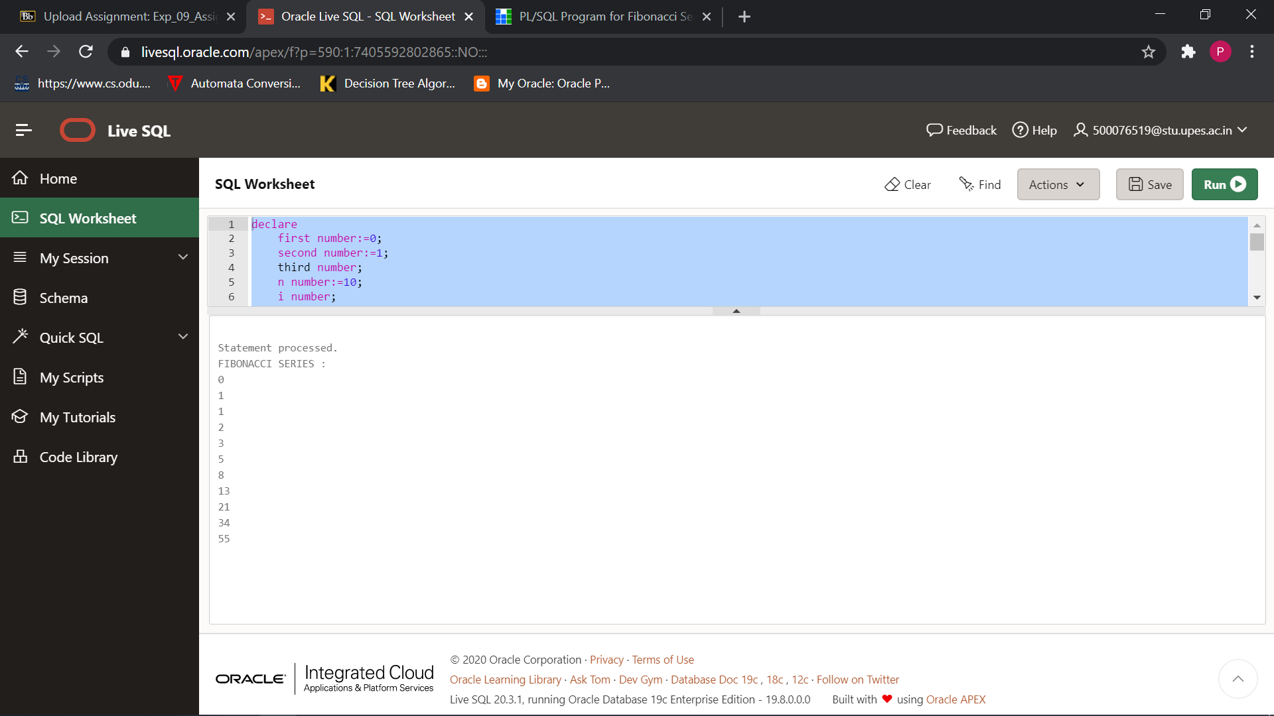

1. Declare

i number:=0;

n number;

sum1 number:=0;

Begin

n:=10;

***(--again the syntax ‘&value’ showing error so assumed N=10)***

for i in 1..n

loop

sum1:=sum1+i;

dbms_output.put_line(i);

end loop;

dbms_output.put_line('The sum is:'||sum1);

End;

OUTPUT:

