**Name : Rohan Nyati**

**Sap id : 500075940**

**Roll no. : R177219148**

**Batch : 5**

#1. Python Program to Print name

name=input("enter your name:")

print(name)

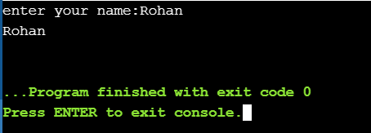

#2. Python Program to Add Two Numbers

a=int(input("enter the 1st number:"))

b=int(input("enter the 2nd number:"))

print("sum of both is =", a+b)

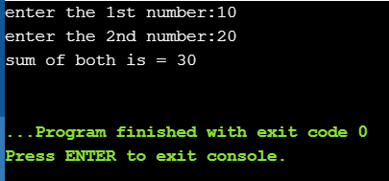

#3. Python Program to Swap Two Variables

x=int(input("enter the 1st number:"))

y=int(input("enter the 2nd number:"))

print("values of x & y:",x ,y)

temp=x

x=y

y=temp

print("New values of x & y:",x ,y)

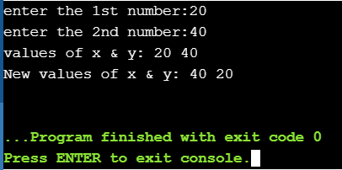

#4. Python Program to Check if a Number is Odd or Even

num=int(input("enter a number:"))

if num%2==0:

print("input number is even")

else:

print("input number is odd")

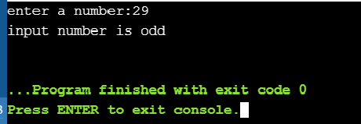

#5. Python Program to Check Prime Number

num=int(input("enter the number:"))

count=0

for x in range(2,num//2):

if num%x==0:

count+=1

if count==0:

print("the number is prime")

else:

print("the number is composite")

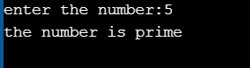

#6. Python Program to Display the multiplication Table

x=int(input("enter the number: "))

for y in range(1,11):

mult=x*y

str="{} x {} = {}"

print(str.format(x,y,mult))

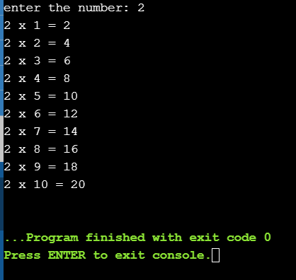

#7. Python Program to Make a Simple Calculator

print("1. Addition\n2. Subtraction\n3. Multiplication\n4. Division\n")

c=input("do you want to use the calculator:")

while c=='yes' and c!='no':

choice=int(input("What you want to do?"))

x=int(input("1st number: "))

y=int(input("2nd number: "))

if choice==1:

print("answer=", x+y)

elif choice==2:

print("answer=",(x-y))

elif choice==3:

print("answer=",x*y)

elif choice==4:

print("answer=",x/y)

else:

print("wrong choice!!!!")

c=input("do you want more operations?")

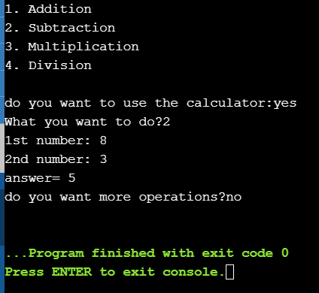

#8. Python Program to Display Fibonacci Sequence Using Recursion

def fib(num):

if num<=1:

return num

else:

return fib(num-2)+fib(num-1)

num=int(input("enter the length of the series: "))

for i in range(num):

print(fib(i),end=' ')

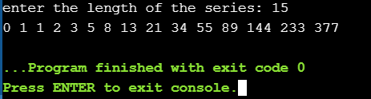

9. Python Program to Add Two Matrices

import numpy as np

a=np.array([(1,2,3),(4,5,6)])

b=np.array([(1,2,3),(4,5,6)])

c= a+b

print("c = ",c)

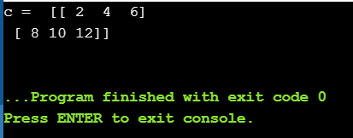

#10.Python Program to Count the Number of Each Vowel

string=input("Enter string:")

vowels=0

for i in string:

if(i=='a' or i=='e' or i=='i' or i=='o' or i=='u' or i=='A' or i=='E' or i=='I' or i=='O' or i=='U'):

vowels=vowels+1

print("Number of vowels are:")

print(vowels)

