Name: - Rohan Nyati

Roll No. : - R177219148

Batch: - 5

**Objective:** To understand the concept of designing issue related to the database with creating, populating the tables. Also familiarize students with different ways of manipulation in database.

**Q1. Create the tables described below.**

1. **Table name: CLIENT_MASTER Description:** used to store client information.

|  |  |  |
| --- | --- | --- |
| **Column name** | **data type** | **Size** |
| CLIENTNO | Varchar | 6 |
| NAME | Varchar | 20 |
| ADDRESS 1 | Varchar | 30 |
| ADDRESS 2 | Varchar | 30 |
| CITY | Varchar | 15 |
| PINCODE | Integer |  |
| STATE | Varchar | 15 |
| BALDUE | Decimal | 10,2 |
|  |  |  |

1. **Table Name: PRODUCT_MASTER Description:** used to store product information

|  |  |  |
| --- | --- | --- |
| **Column name** | **data type** | **Size** |
| PRODUCTNO | Varchar | 6 |
| DESCRIPTION | Varchar | 15 |
| PROFITPERCENT | Decimal | 4,2 |
| UNIT MEASURE | Varchar | 10 |
| QTYONHAND | Integer |  |
| REORDERL VL | Integer |  |
| SELLPRICE | Decimal | 8,2 |
| COSTPRICE | Decimal | 8,2 |

1. **Table Name: SALESMAN_MASTER**

**Description:** Used to store salesman information working for the company.

|  |  |  |
| --- | --- | --- |
| **Column name** | **data type** | **Size** |
| SALESMANNO | Varchar | 6 |
| SALESMANNAME | Varchar | 20 |
| ADDRESS 1 | Varchar | 30 |
| ADDRESS 2 | Varchar | 30 |
| CITY | Varchar | 20 |
| PINCODE | Integer |  |
| STATE | Varchar | 20 |
| SALAMT | Real |  |
| TGTTOGET | Decimal |  |
| YTDSALES | Double | 6,2 |
| REMARKS | Varchar | 60 |
|  |  |  |

**ANS 1**

1. Create table CLIENT_MASTER(CLIENTNO varchar(6) primary key,Name varchar(20),ADDRESS_1 varchar(30),ADDRESS_2 varchar(30),CITY varchar(15),PINCODE integer,STATE varchar(15),BALDUE decimal(10,2));

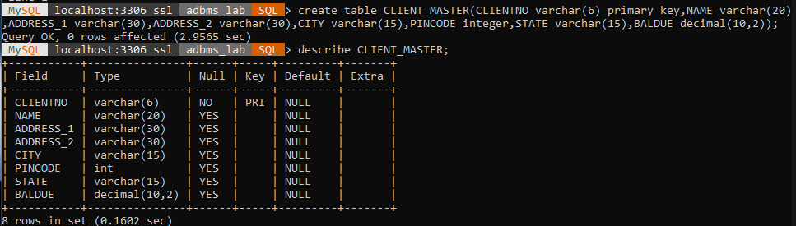

1. Create table PRODUCT_MASTER(PRODUCTNO varchar(6) primary key,DESCRIPTION varchar(15),PROFITPERCENT decimal(4,2),UNITMEASURE varchar(10),QTYONHAND integer,SELLPRICE decimal(8,2),COSTPRICE decimal(8,2));

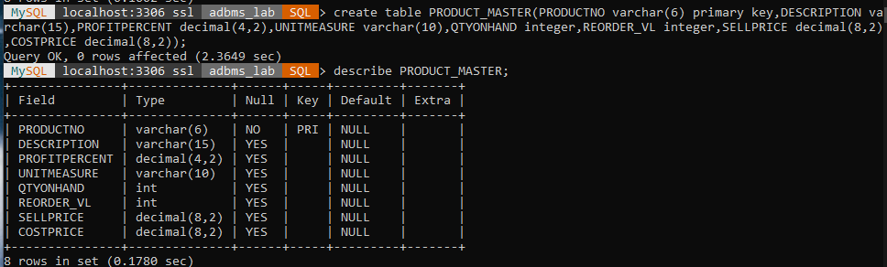

1. Create table SALESMAN_MASTER(SALESMANNO varchar(6) primary key,SALESMANNAME varchar(20),ADDRESS_1 varchar(30),ADDRESS_2 varchar(30),CITY varchar(20),PINCODE integer,STATE varchar(20),SALAMT integer,TGTTOGET integer,YTDSALES decimal(6,2),REMARKS varchar(60));

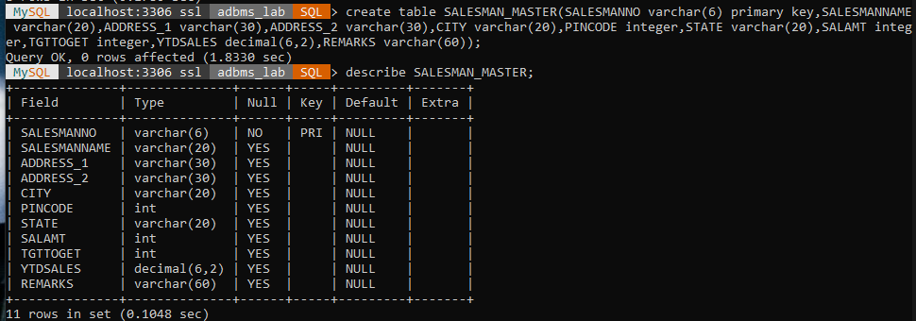

1. **Q2. Insert the following data into their respective tables:**
2. Data for **CLIENT_MASTER** table:

|  |  |  |  |  |  |
| --- | --- | --- | --- | --- | --- |
| Client no | Name | City | Pincode | State | BalDue |
| C00001 | Ivan bayross | Mumbai | 400054 | Maharashtra | 15000 |
| C00002 | Mamta muzumdar | Madras | 780001 | Tamil nadu | 0 |
| C00003 | Chhaya bankar | Mumbai | 400057 | Maharashtra | 5000 |
| C00004 | Ashwini joshi | Bangalore | 560001 | Karnataka | 0 |
| C00005 | Hansel colaco | Mumbai | 400060 | Maharashtra | 2000 |
| C00006 | Deepak sharma | Mangalore | 560050 | Karnataka | 0 |

1. Data for **PRODUCT**_**MASTER** table:

|  |  |  |  |  |  |  |  |
| --- | --- | --- | --- | --- | --- | --- | --- |
| Product  No | Description | Profit percent | Unit measure | Quantity  On  hand | Recorder  Level | Sell  Price | Cost  Price |
| P00001 | T-Shirt | 5 | Piece | 200 | 50 | 350 | 250 |
| P0345 | Shirts | 6 | Piece | 150 | 50 | 500 | 350 |
| P06734 | Cotton jeans | 5 | Piece | 100 | 20 | 600 | 450 |
| P07865 | Jeans | 5 | Piece | 100 | 20 | 750 | 500 |
| P07868 | Trousers | 2 | Piece | 150 | 50 | 850 | 550 |
| P07885 | Pull Overs | 2.5 | Piece | 80 | 30 | 700 | 450 |
| P07965 | Denim jeans | 4 | Piece | 100 | 40 | 350 | 250 |
| P07975 | Lycra tops | 5 | Piece | 70 | 30 | 300 | 175 |
| P08865 | Skirts | 5 | Piece | 75 | 30 | 450 | 300 |

1. Data for **SALESMAN_MASTER**  table:

|  |  |  |  |  |  |  |
| --- | --- | --- | --- | --- | --- | --- |
| **Salesman No** | **Name** | **Address1** | **Address2** | **City** | **Pin Code** | **State** |
| S00001 | Aman | A/14 | Worli | Mumbai | 400002 | Maharashtra |
| S00002 | Omkar | 65 | Nariman | Mumbai | 400001 | Maharashtra |
| S00003 | Raj | P-7 | Bandra | Mumbai | 400032 | Maharashtra |
| S00004 | Ashish | A/5 | Juhu | Mumbai | 400044 | Maharashtr(a |

**Ans 2**

1. Insert into CLIENT_MASTER values(‘C00001’,’Ivan bayross’,NULL,NULL,’Mumbai’,400054,’Maharashtra’,15000);

insert into CLIENT_MASTER values('C00002','Mamta muzumdar',NULL,NULL,'Madras',780001,'Tamil nadu',0);

insert into CLIENT_MASTER values('C00003','Chhaya bankar',NULL,NULL,'Mumbai',400057,'Maharashtra',5000);

insert into CLIENT_MASTER values('C00004','Ashwini joshi',NULL,NULL,'Bangalore',560001,'Karnataka',0);

insert into CLIENT_MASTER values('C00005','Hansel colaco',NULL,NULL,'Mumbai',400060,'Maharashtra',2000);

insert into CLIENT_MASTER values('C00006','Deepak Sharma',NULL,NULL,'Mangalore',560050,'Karnataka',0);

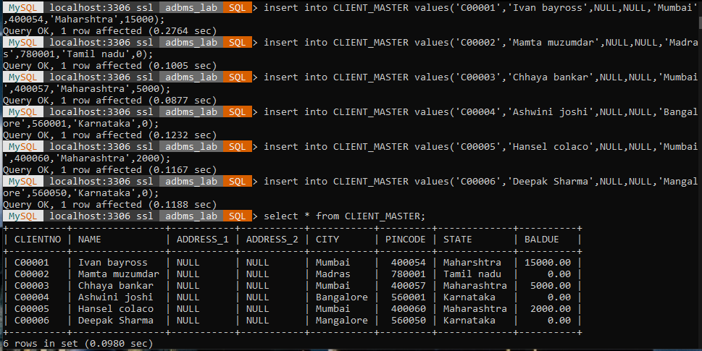

1. insert into PRODUCT_MASTER values('P00001','T-shirt',5,'Piece',200,50,350,250);

insert into PRODUCT_MASTER values('P0345','Shirts',6,'Piece',150,50,500,350);

insert into PRODUCT_MASTER values('P06734','Cotton jeans',5,'Piece',100,20,600,450);

insert into PRODUCT_MASTER values('P07865','Jeans',5,'Piece',100,20,750,500);

insert into PRODUCT_MASTER values('P07868','Trousers',2,'Piece',150,50,850,550);

insert into PRODUCT_MASTER values('P07885','Pull Overs',2.5,'Piece',80,30,700,450);

insert into PRODUCT_MASTER values('P07965','Denim jeans',4,'Piece',100,40,350,250);

insert into PRODUCT_MASTER values('P07975','Lycra tops',5,'Piece',70,30,300,175);

insert into PRODUCT_MASTER values('P08865','Skirts',5,'Piece',75,30,450,300);

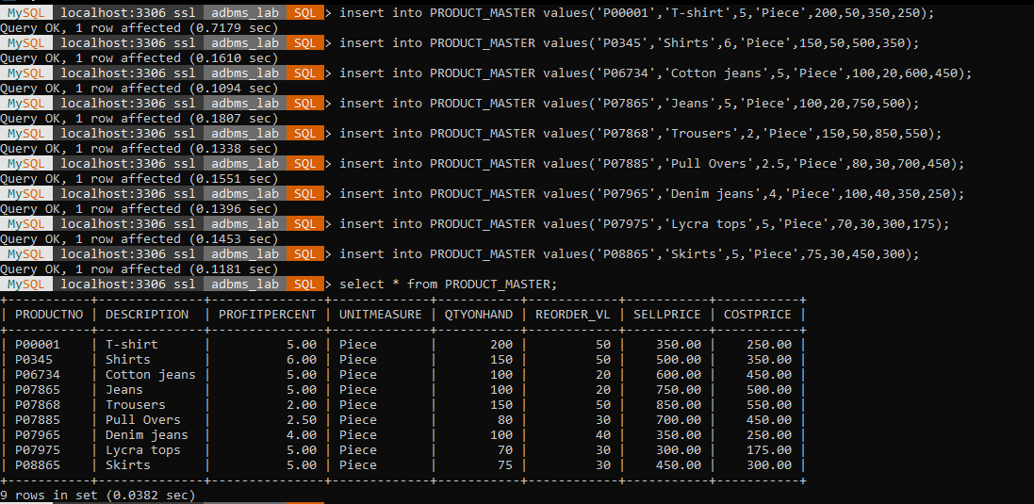

1. insert into SALESMAN_MASTER values('S00001','Aman','A/14','Worli','Mumbai',400002,'Maharashtra',NULL,NULL,NULL,NULL);

insert into SALESMAN_MASTER values('S00002','Omkar','65','Nariman','Mumbai',400001,'Maharashtra',NULL,NULL,NULL,NULL);

insert into SALESMAN_MASTER values('S00003','Raj','P-7','Bandra','Mumbai',400032,'Maharashtra',NULL,NULL,NULL,NULL);

insert into SALESMAN_MASTER values('S00004','Ashish','A/5','Juhu','Mumbai',400044,'Maharashtra',NULL,NULL,NULL,NULL);

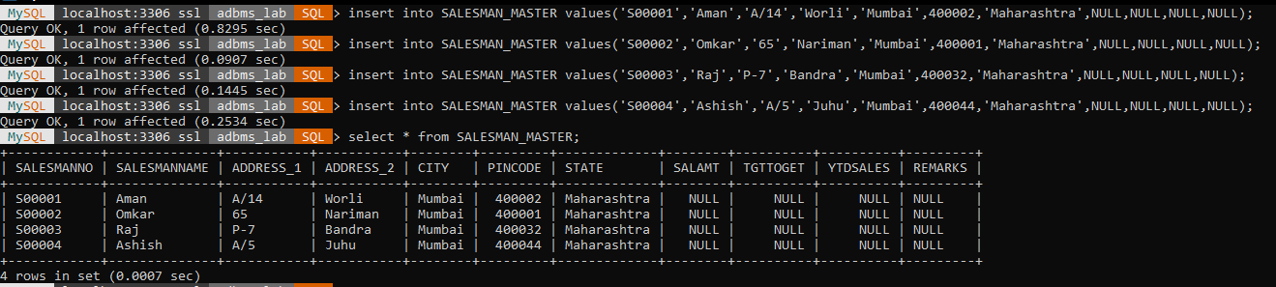

**Q3. Exercise on retrieving records from a table.**

a. Find out the names of all the clients.  
b. Retrieve the entire contents of the Client_Master table.  
c. Retrieve the list of names, city and the state of all the clients.  
d. List the various products available from the Product_Master table.  
e. List all the clients who are located in Mumbai.  
f. Find the names of salesman who have a salary equal to Rs.3000.

Ans 3

1. select NAME from CLIENT_MASTER;

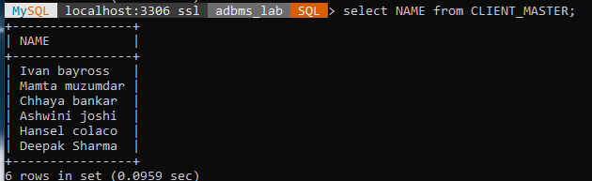

1. select * from CLIENT_MASTER;

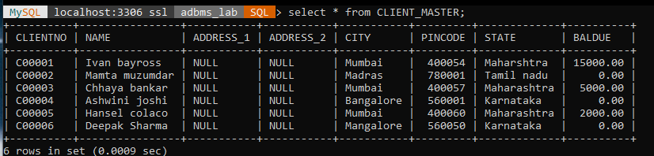

1. select NAME,CITY,STATE from CLIENT_MASTER;

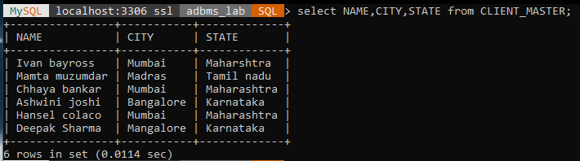

1. select distinct DESCRIPTION from PRODUCT_MASTER;

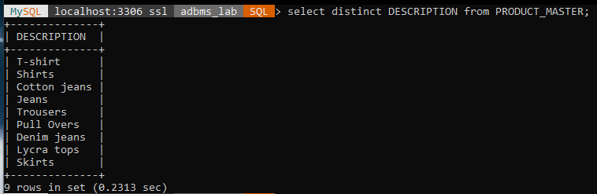

1. select NAME from CLIENT_MASTER where CITY='Mumbai';

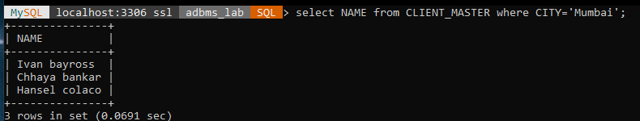

1. select SALESMANNAME from SALESMAN_MASTER where SALAMT=3000;

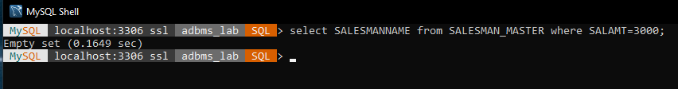

**Q4. Exercise on updating records in a table**  
a. Change the city of ClientNo ‘C00005’ to ‘Bangalore’.  
b. Change the BalDue of ClientNo ‘C00001’ to Rs.1000.  
c. Change the cost price of ‘Trousers’ to rs.950.00.  
d. Change the city of the salesman to Pune

**Ans 4**

1. update CLIENT_MASTER set CITY='Bangalore' where CLIENTNO='C00005';

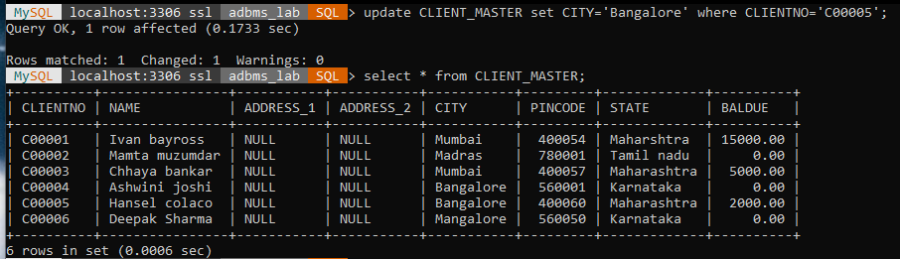

1. update CLIENT_MASTER set BALDUE=1000 where CLIENTNO='C00001';

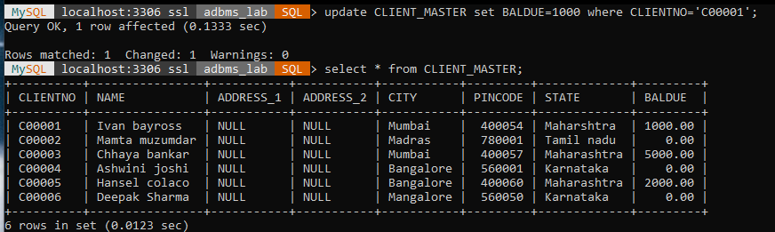

1. update PRODUCT_MASTER set COSTPRICE=950 where DESCRIPTION='Trousers';



1. update SALESMAN_MASTER set CITY='Pune';

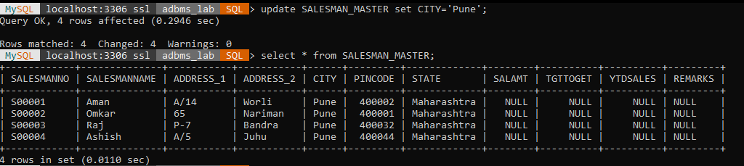

**Q5. Exercise on deleting records in a table**  
a. Delete all salesman from the Salesman_Master whose salaries are equal to Rs.3500.

b. Delete all products from Product_Master where the quantity on hand is equal to 100.  
c. Delete from Client_Master where the column state holds the value ‘Tamil Nadu’.

**Ans 5**

1. delete from SALESMAN_MASTER where SALAMT=3500;

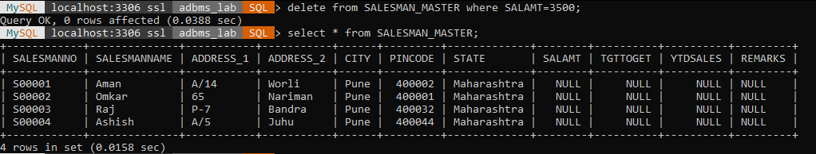

1. delete from PRODUCT_MASTER where QTYONHAND=100;

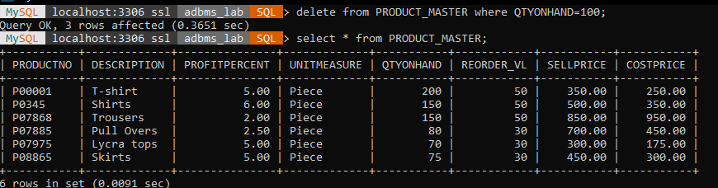

1. delete from CLIENT_MASTER where STATE='Tamil Nadu';

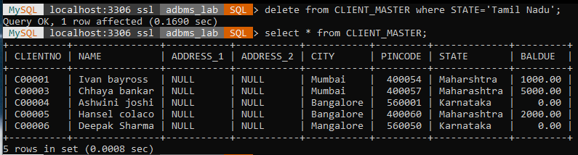

**Q6. Exercise on altering the table structure**  
a. Add a column called ‘Telephone’ of data type integer to the Client_Master table.  
b. Change the size off SellPrice column in Product _Master to 10, 2.

**Ans 6**

1. alter table CLIENT_MASTER add TELEPHONE integer;

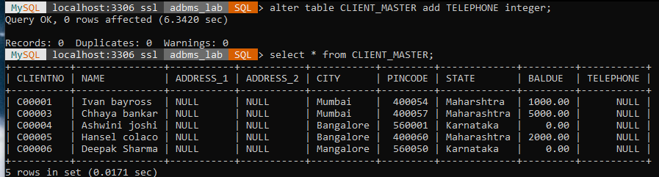

1. alter table PRODUCT_MASTER modify SELLPRICE decimal(10,2);

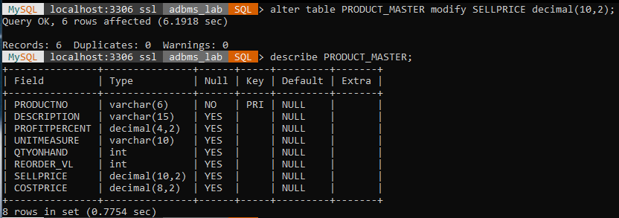

**Q7. Exercise on deleting the table structure along with the data**  
a. Destroy the table Client_Master along with its data.

**Ans 7**

1. drop table CLIENT_MASTER;

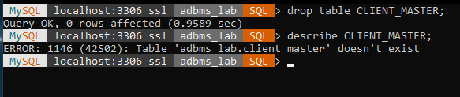

**Q8. Exercise on renaming the table**  
a. Change the name of the Salesman_Master to sman_mast.

**Ans 8**

1. alter table SALESMAN_MASTER rename to sman_mast;

