**NAME:ROHAN NYATI**

**SAP ID:500075940**

**ROLL NO. : R177219148**

**BATCH-5(AI&ML)**

**EXPERIMENT-7**

**Title: 7.** To understand the concepts of Index.

**Objective:** Students will be able to implement the concept of index.

**1.** Execute the following index related queries:

1) Create an index of name employee_idx on EMPLOYEES with column Last_Name, Department_id 2) Find the ROWID for the above table and create a unique index on employee_id column of the EMPLOYEES.

3) Create a reverse index on employee_id column of the EMPLOYEES.

4) Create a unique and composite index on employee_id and check whether there is duplicity of tuples or not.

5) Create Function-based indexes defined on the SQL functions UPPER(column_name) or LOWER(column_name) to facilitate case-insensitive searches(on column Last_Name).

6) Drop the function based index on column Last_Name.

**TABLE:**

create table employees( employee_id varchar(10) ,

first_name varchar(30) not null ,

last_name varchar(30) not null ,

salary integer not null ,

department_id number(5));

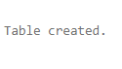

**DATA:**

insert into employees(employee_id ,first_name , last_name , salary , department_id)values('e101' , 'tony' , 'jackson' , 80000 , 111) ;

insert into employees(employee_id ,first_name , last_name , salary , department_id)values('e102' , 'steve' , 'stark' , 60000 , 222) ;

insert into employees(employee_id ,first_name , last_name , salary , department_id)values('e103' , 'jack' , 'stark' , 50000 , 333) ;

insert into employees(employee_id ,first_name , last_name , salary , department_id)values('e104' , 'rajat' , 'sharma' , 80000 , 444) ;

insert into employees(employee_id ,first_name , last_name , salary , department_id)values('e106' , 'animesh' , 'sundriyal' , 40000 , 555) ;

insert into employees(employee_id ,first_name , last_name , salary , department_id)values('e107' , 'digvijay' , 'jackson' , 70000 , 666) ;

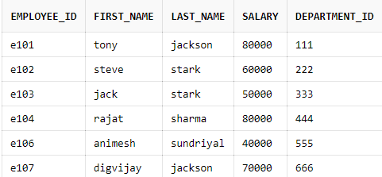

**ANSWERS:**

create index employee_idx on employees(last_name , department_id) ;



select ROWID , employee_id , first_name , last_name

from employees

where last_name = 'stark' ;

create unique index unique_idx on employees(employee_id) ;

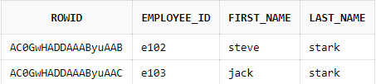



create index reverse_idx on employees(employee_id) REVERSE ;



insert into employees(employee_id ,first_name , last_name , salary , department_id)values('e106' , 'animesh' , 'sundriyal' , 40000 , 555) ;

create unique index uni_idx on employees(employee_id);

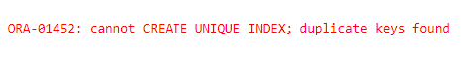Create index emp_idx ON employees (UPPER(last_name));

drop index emp_idx ;

