## **NAME: ROHAN NYATI**

## **BATCH :5**

## **ROLL NO: R177219148**

## **SAPID: 500075940**

**EXPERIMENT-8**

**Title:** 8. To understand the concepts of Sequence.

**Objective:** Students will be able to implement the concept of sequence.

1) Create a sequence by name EMPID_SEQ starting with value 100 with an interval of 1.

2) Write a SQL command for finding the current and the next status of EMPID_SEQ.

3) Change the Cache value of the sequence EMPID_SEQ to 20 and maxvalue to 1000.

4) Insert values in employees table using sequences for employee_id column.

5) Drop sequence EMPID_SEQ.

6) Create a sequence called REVERSE to generate numbers in the descending order from 10000 to 1000 with a decrement of 5.

CREATE TABLE

create table employees( employee_id varchar(10) ,

first_name varchar(30) not null ,

last_name varchar(30) not null ,

salary integer not null ,

department_id integer ) ;

CREATE SEQUENCE

create sequence emp_seq increment by 1 start with 100 minvalue 100 maxvalue 200 ;

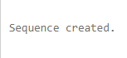

VALUES FOR TABLE

insert into employees(employee_id ,first_name , last_name , salary , department_id)values(emp_seq.nextval , 'tony' , 'jackson' , 80000 , 111) ;

insert into employees(employee_id ,first_name , last_name , salary , department_id)values(emp_seq.nextval , 'steve' , 'stark' , 60000 , 222) ;

insert into employees(employee_id ,first_name , last_name , salary , department_id)values(emp_seq.nextval , 'jack' , 'stark' , 50000 , 333) ;

insert into employees(employee_id ,first_name , last_name , salary , department_id)values(emp_seq.nextval , 'rajat' , 'sharma' , 80000 , 444) ;

insert into employees(employee_id ,first_name , last_name , salary , department_id)values(emp_seq.nextval , 'animesh' , 'sundriyal' , 40000 , 555) ;

insert into employees(employee_id ,first_name , last_name , salary , department_id)values(emp_seq.nextval , 'digvijay' , 'jackson' , 70000 , 666) ;

select * from employees ;

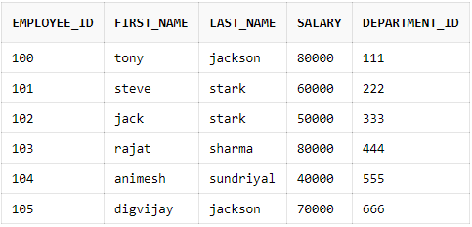

select emp_seq.nextval from employees ;

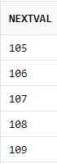

select emp_seq.currval from employees ;

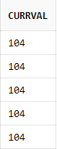

CHANGING FORMAT

Alter sequence emp_seq cycle cache 20;

Alter sequence emp_seq maxvalue 1000;

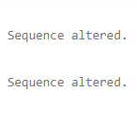

DELETE SEQUENCE

drop sequence emp_seq ;

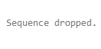

REVERSE

Create sequence reverse start with 10000 maxvalue 10000

minvalue 1000 increment by -5 ;

