## **NAME: ROHAN NYATI**

## **BATCH :5**

## **ROLL NO: R177219148**

## **SAPID: 500075940**

# **ASSIGNMENT – 1**

**ANS 1** We do not use RDBMS when there’s no requirement for ad-hoc queries, when the data is structured as a hierarchy or a graph (network) of arbitrary depth and when the typical access pattern emphasizes reading over writing.

**ANS 2** To understand the concept of data independence we use a three-schema architecture. Three-schema architecture has three levels. It divides the database into three parts. The three parts are internal, conceptual and external level. It separates the user applications and physical database.

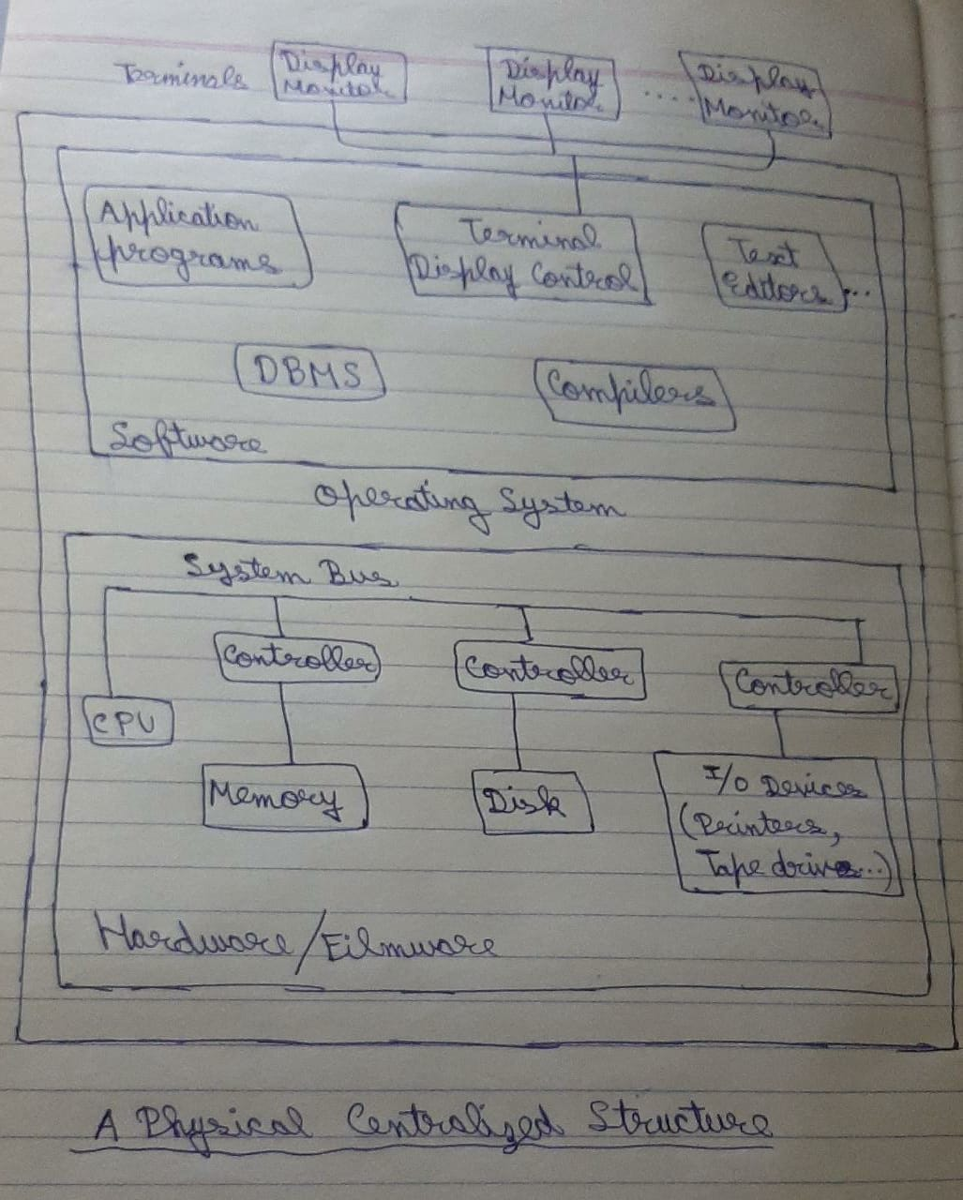

In data independence we can change the database at any level without making any changes at another level. We can separate the data from the programs because of it.

**ANS 3** In centralized dbms we mix everything into single system like hardware, dbms software, application programs etc in which user can still be connected by a remote terminal.

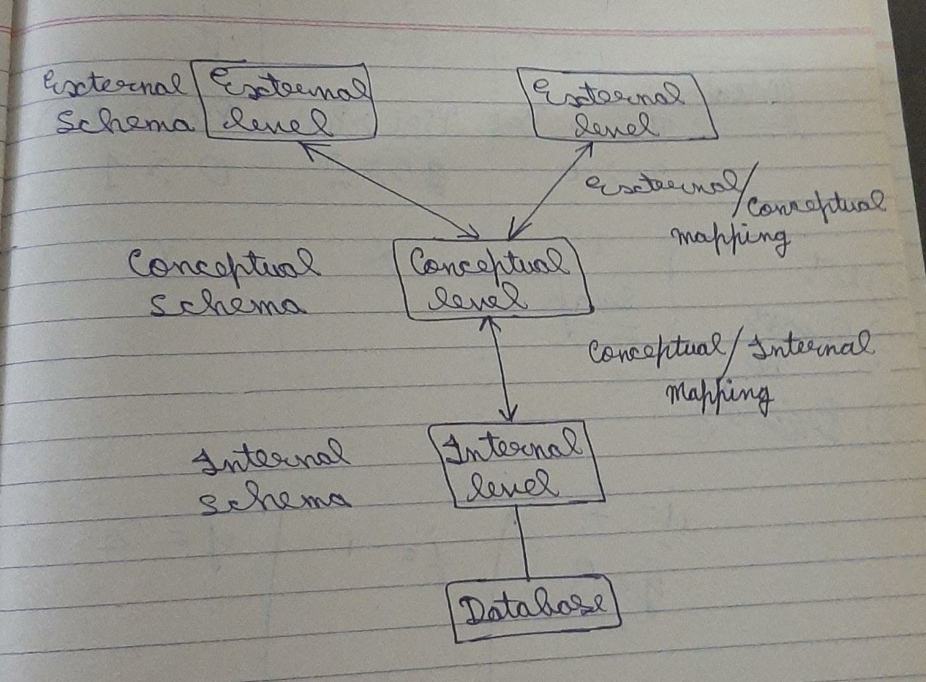

In client server dbms architecture the client machines access either one or more server machines. In this architecture the system shares computing resources.

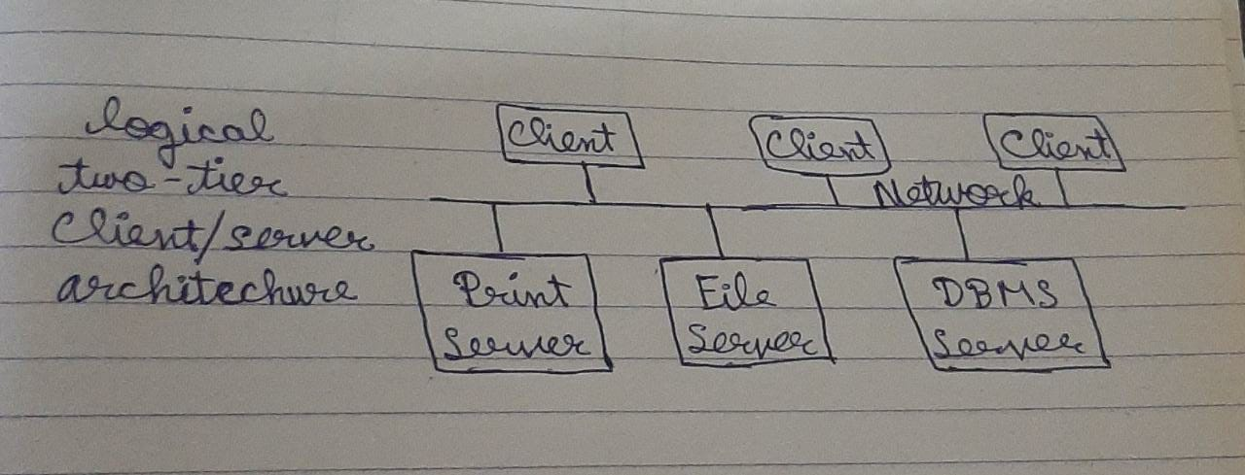

**ANS 4** In relational model the data is interconnected by rows and columns. In which columns are known as attributes while rows are known as records. It basically stores the data in the form of relations.

Constraints are the rules which are applied on the columns of the table to maintain the data consistency.

The different types of constraints are as follows:

* Primary key-: Once a column is made as primary key then duplicate values and null values are not allowed.
* Not Null-: In this duplicate values are allowed while null values are not allowed.
* Unique-: In this null values are allowed while duplicate values are not allowed.
* ENUM-: It is a string object with the value chosen from your list of permitted values. They are enumerated explicitly in the column specification at a time of table creation.
* Set-: A set can have zero or more values. Each of the values must be chosen from a list of permitted values.
* Default-: In MySQL each column must contain a value. While inserting data into a table, if no values is given to a column then the column gets the values which is set as default.
* Foreign Key-: A foreign key in one table points to a primary key in another table. It is used to maintain referential integrity between two tables.
* Referential Integrity-: It is a property which ensures that no entry in foreign key column of a table can be made unless it matches primary key values in the corresponding column of the related table.

To view constraints-: Describe constraint is use to view constraints as well as structure of table.

We can add, drop & modify constraint by using alter command.

A database is a collection of interrelated data files or structures. So, a relational database schema is an arrangement of relation states in such a manner that every relational database state fulfills the integrity constraints set on a relational database schema.