**NAME:ROHAN NYATI**

**SAP ID:500075940**

**ROLL NO. : R177219148**

**BATCH-5(AI&ML)**

**Assignment - 2**

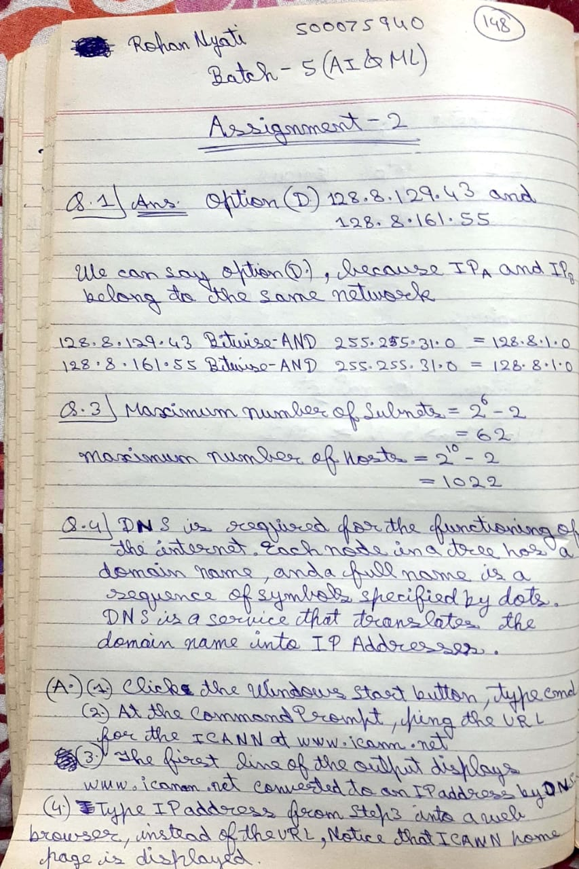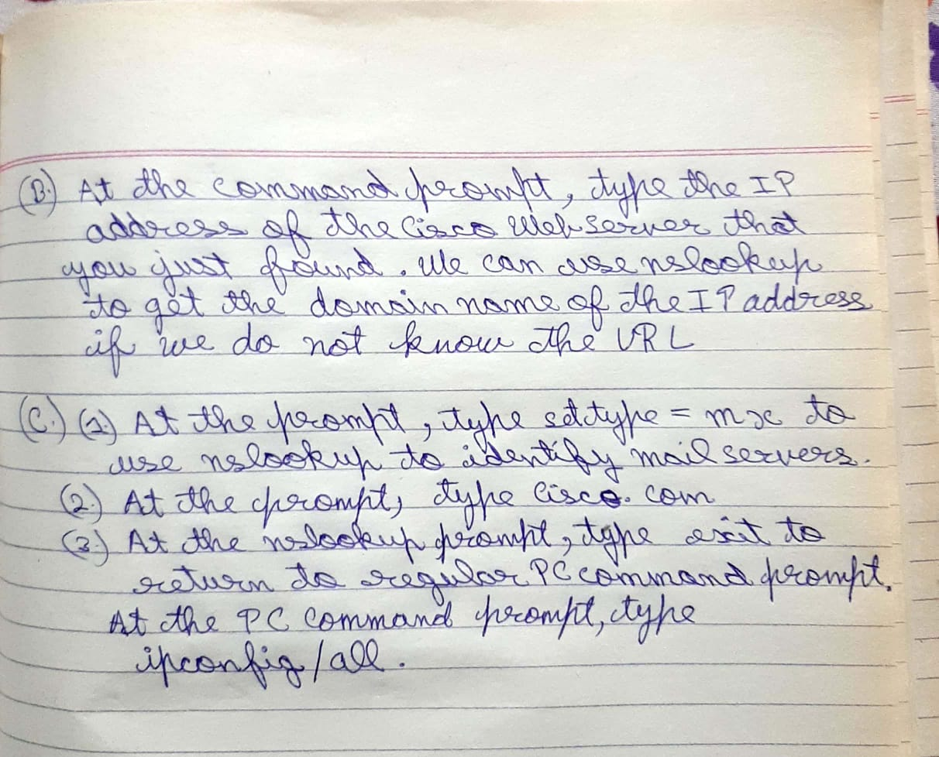

Q.2

A)

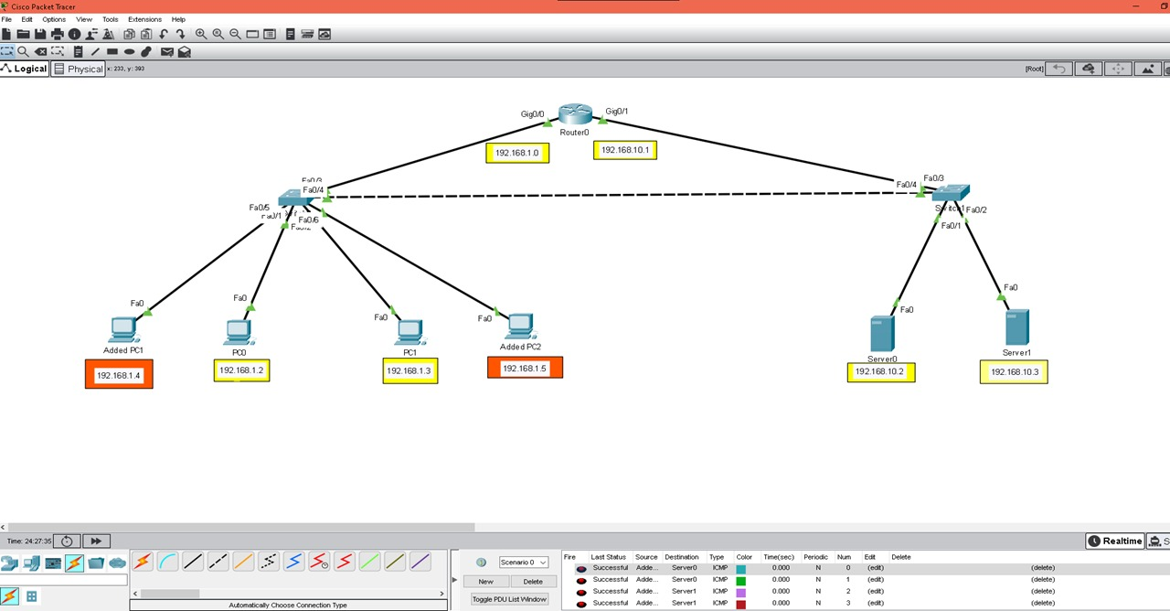

B)



C)



D)



E)

