**NAME:ROHAN NYATI**

**SAP ID:500075940**

**ROLL NO. : R177219148**

**BATCH-5(AI&ML)**

Experiment-5&6 (HUB & Switch)

Aim : to study basic of HUB and Switch

Difference btw hub and switch:--

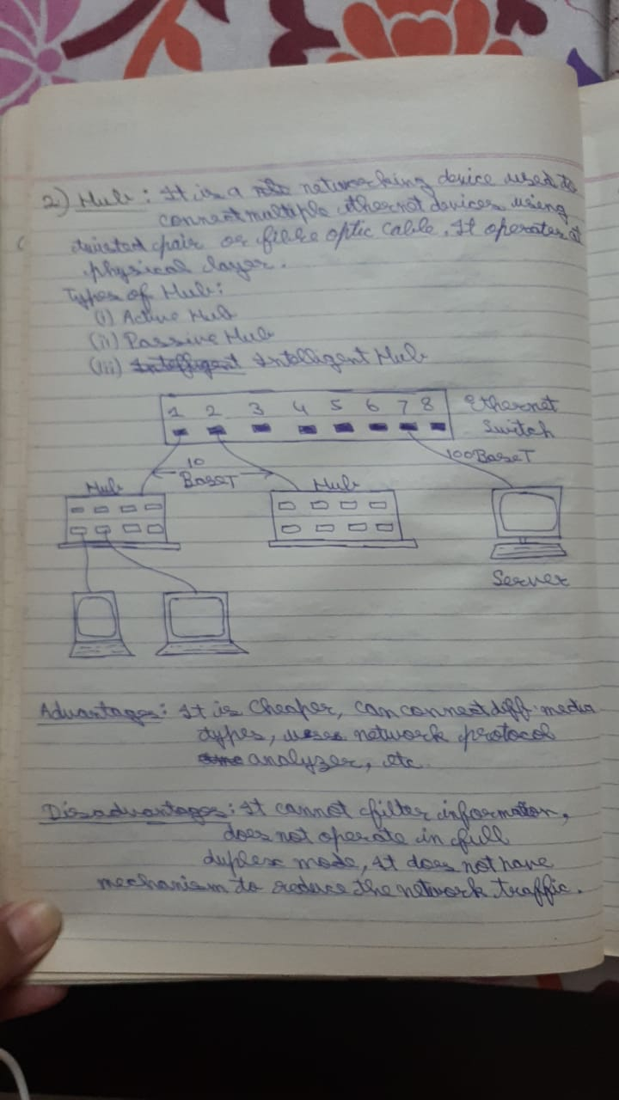

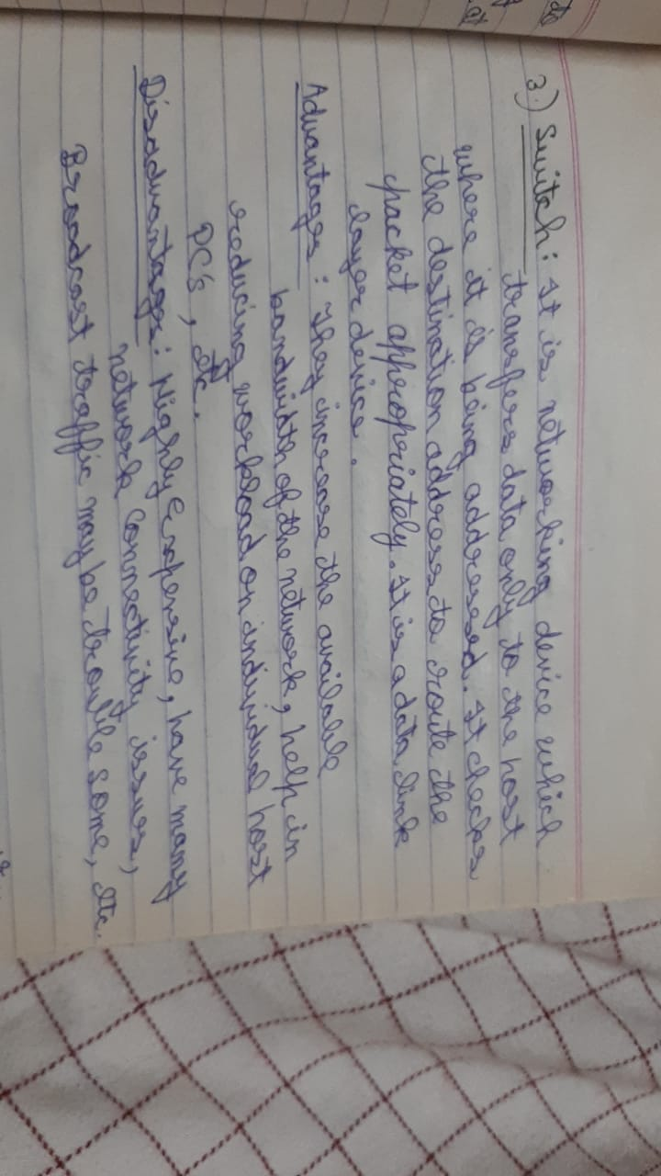

**HUB :**

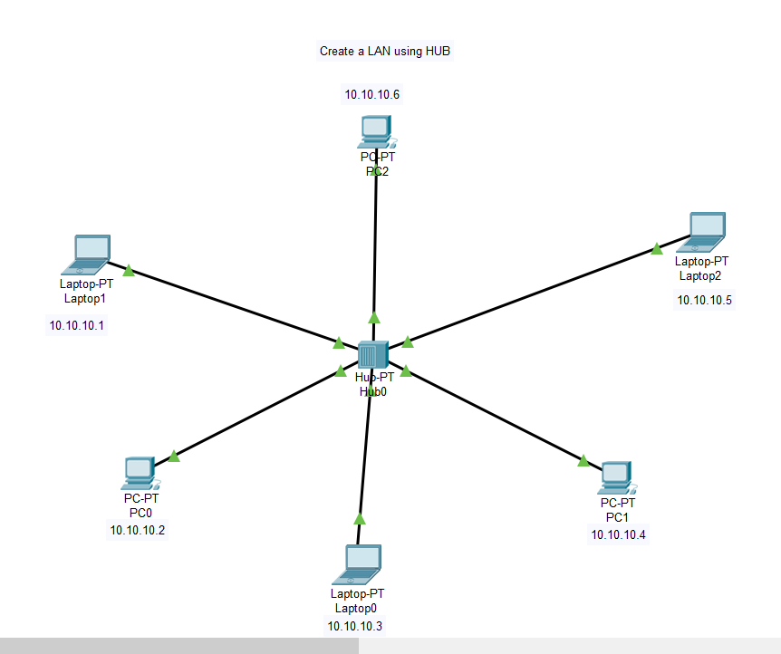

Message is send from Laptop1 to Laptop0

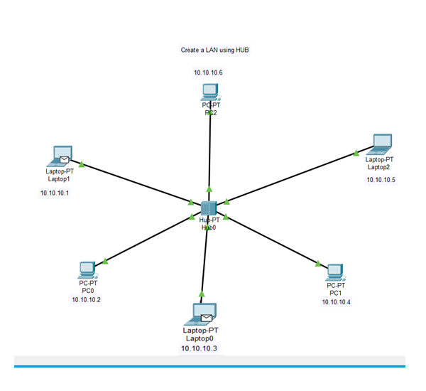

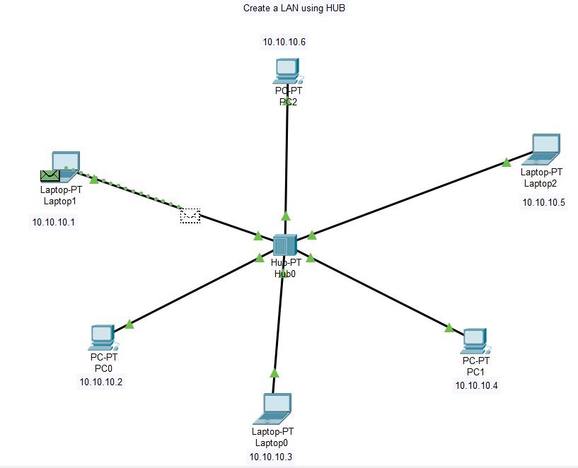

Message is broadcasted to all the devices in the LAN

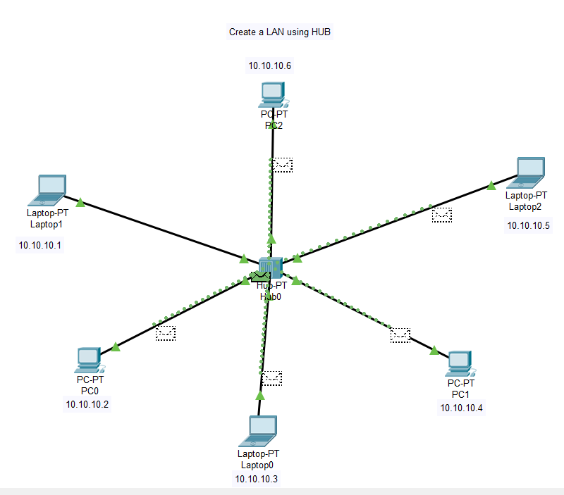

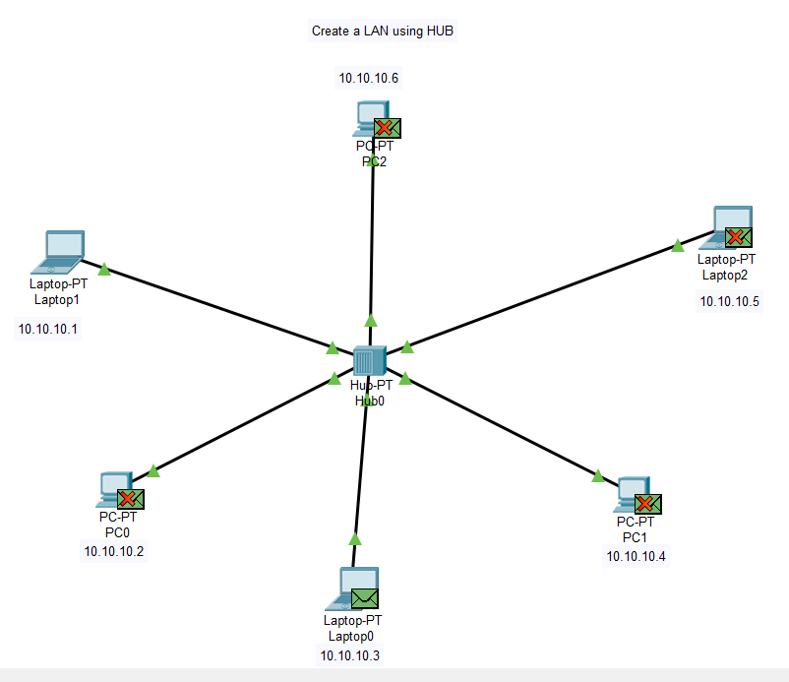

**Switch :**

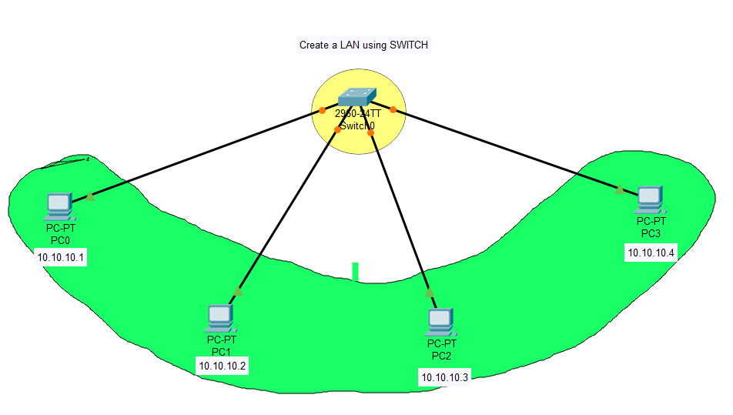

Message is sent from PC0 to PC2

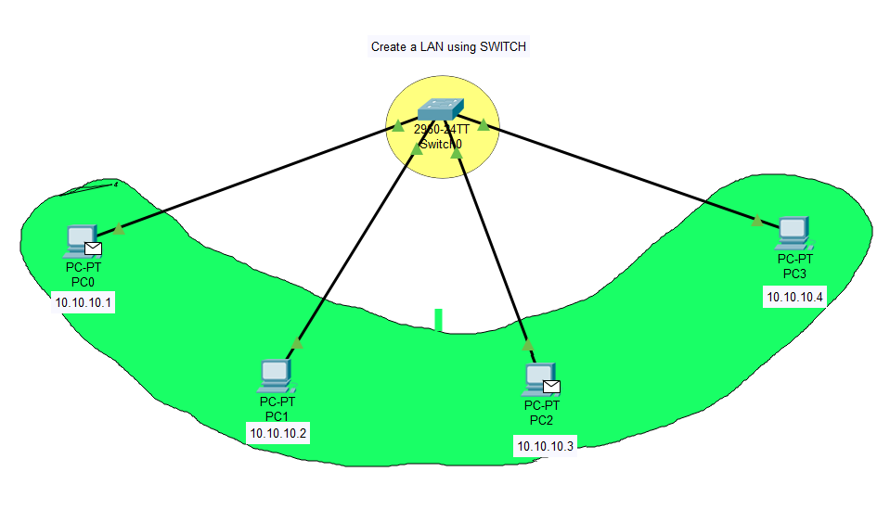

Message is sent by PC0

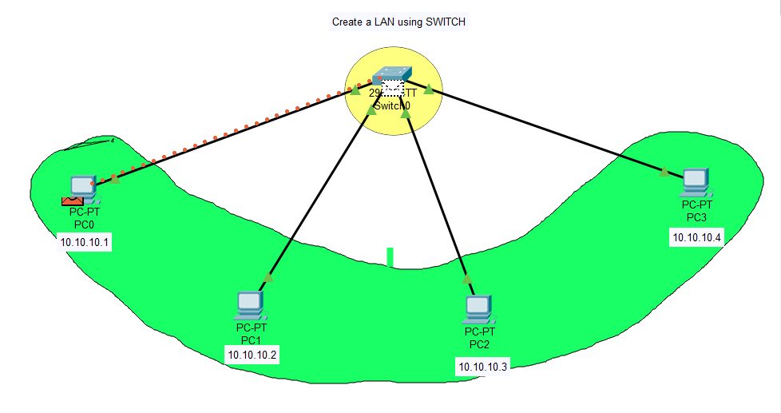

Message is received by PC2

