**NAME:ROHAN NYATI**

**SAP ID:500075940**

**ROLL NO. : R177219148**

**BATCH-5(AI&ML)**

Experiment-6

Aim : to study basic of Routing

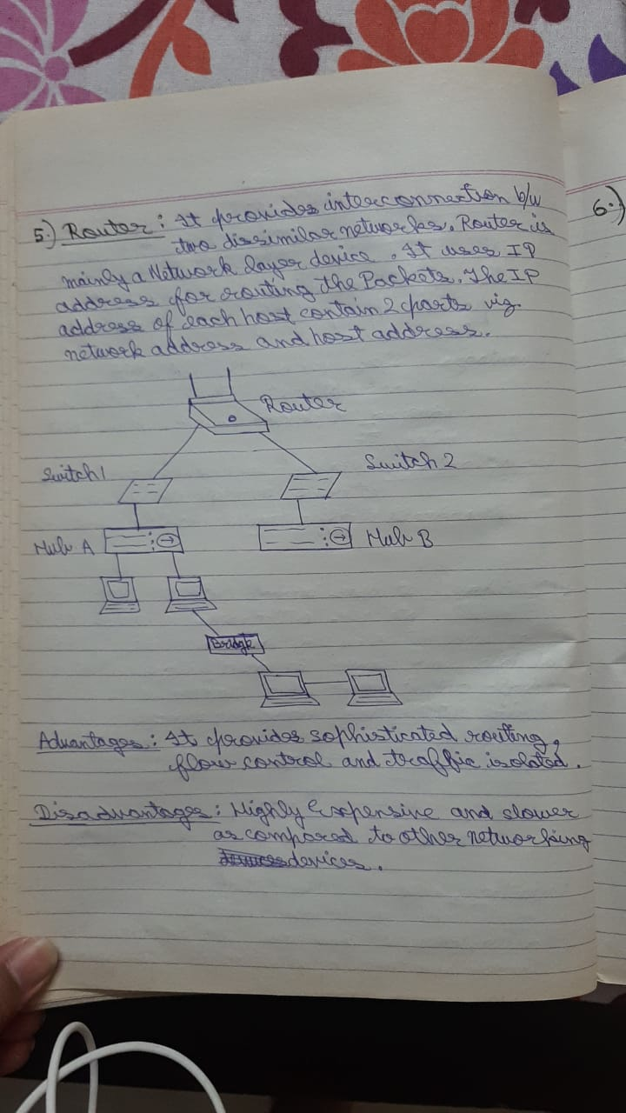

When we use one Router:-

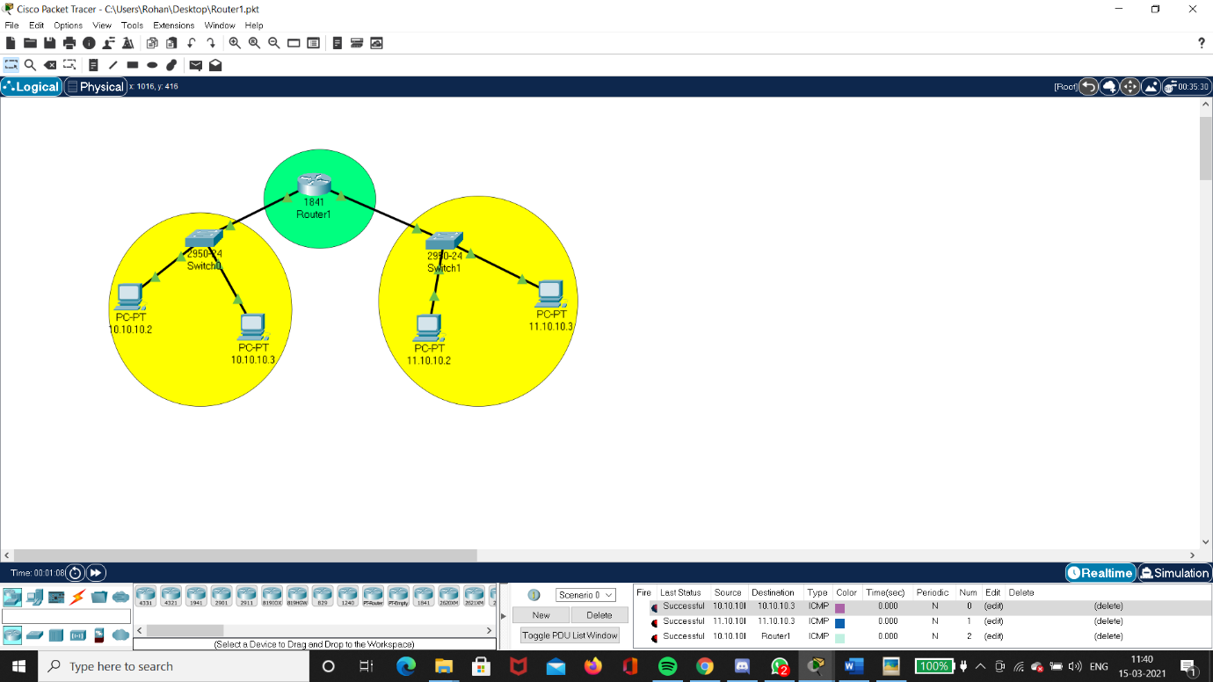

When we use two Router:-

