Assignment 1

Algorithm for Intelligent System and Robotics

Ans 1

The Simultaneous Localization and Mapping (SLAM) problem asks if it is possible for a mobile robot to be placed at an unknown location in an unknown environment and for the robot to incrementally build a consistent map of this environment while simultaneously determining its location within this map. A solution to the SLAM problem has been seen as a ‘holy grail’ for the mobile robotics community as it would provide the means to make a robot truly autonomous.

Ans 2

Robot Operating System (ROS or ros) is an open source [robotics middleware](https://en.wikipedia.org/wiki/Robotics_middleware) suite. Although ROS is not an [operating system](https://en.wikipedia.org/wiki/Operating_system) but a collection of [software frameworks](https://en.wikipedia.org/wiki/Software_framework) for [robot](https://en.wikipedia.org/wiki/Robot) software development, it provides services designed for a heterogeneous [computer cluster](https://en.wikipedia.org/wiki/Computer_cluster) such as [hardware abstraction](https://en.wikipedia.org/wiki/Hardware_abstraction), low-level [device control](https://en.wikipedia.org/wiki/Device_driver), implementation of commonly used functionality, [message-passing between processes](https://en.wikipedia.org/wiki/Inter-process_communication), and package management. Running sets of ROS-based processes are represented in a [graph](https://en.wikipedia.org/wiki/Graph_theory) architecture where processing takes place in nodes that may receive, post and multiplex sensor data, control, state, planning, actuator, and other messages. Despite the importance of reactivity and [low latency](https://en.wikipedia.org/wiki/Low_latency) in robot control, ROS itself is not a [real-time OS](https://en.wikipedia.org/wiki/Real-time_operating_system) (RTOS). It is possible, however, to integrate ROS with real-time code. The lack of support for real-time systems has been addressed in the creation of ROS 2.0, a major revision of the ROS API which will take advantage of modern libraries and technologies for core ROS functionality and add support for real-time code and [embedded hardware](https://en.wikipedia.org/wiki/Embedded_system)

The filesystem level concepts mainly cover ROS resources that you encounter on disk, such as:

* [Packages](http://wiki.ros.org/Packages): Packages are the main unit for organizing software in ROS. A package may contain ROS runtime processes , a ROS-dependent library, datasets, configuration files, or anything else that is usefully organized together. Packages are the most atomic build item and release item in ROS. Meaning that the most granular thing you can build and release is a package.
* [Metapackages](http://wiki.ros.org/Metapackages): Metapackages are specialized Packages which only serve to represent a group of related other packages. Most commonly metapackages are used as a backwards compatible place holder for converted [rosbuild](http://wiki.ros.org/rosbuild) [Stacks](http://wiki.ros.org/rosbuild/ROS/Concepts#Stacks).
* [Package Manifests](http://wiki.ros.org/catkin/package.xml): Manifests (package.xml) provide metadata about a package, including its name, version, description, license information, dependencies, and other meta information like exported packages. The package.xml package manifest is defined in [REP-0127](http://www.ros.org/reps/rep-0127.html).
* **Repositories**: A collection of packages which share a common VCS system. Packages which share a VCS share the same version and can be released together using the catkin release automation tool [bloom](http://wiki.ros.org/bloom). Often these repositories will map to converted [rosbuild](http://wiki.ros.org/rosbuild) [Stacks](http://wiki.ros.org/rosbuild/ROS/Concepts#Stacks). Repositories can also contain only one package.
* [Message (msg) types](http://wiki.ros.org/msg): Message descriptions, stored in my_package/msg/MyMessageType.msg, define the data structures for [messages](http://wiki.ros.org/Messages) sent in ROS.
* [Service (srv) types](http://wiki.ros.org/srv): Service descriptions, stored in my_package/srv/MyServiceType.srv, define the request and response data structures for [services](http://wiki.ros.org/Services) in ROS.

Ans 3

Combines reaction with deliberation – Reactive layer

● Low level control, tight sensor-action coupling – Executive layer

● Glue between reactive and deliberate layer

● Integrates sensor information into the world model

● Sequences directives by the deliberate layer for the reactive layer – Deliberate layer

● Generate global solutions to complex tasks by planning

● Works on models (pre-supplied or learned)

Hybrid Architectures: Three Layer Evaluation

Advantages

● Combines advantages from hierarchical and reactive paradigm

● Reacts to unexpected circumstances

● World model to plan global solutions

Disadvantages

● Expensive regarding performance

Ans 4

SONAR sends sound waves under the water in oceans. It sends pulses of sound waves under the water. The phenomenon of reflected waves from the object is shown below:

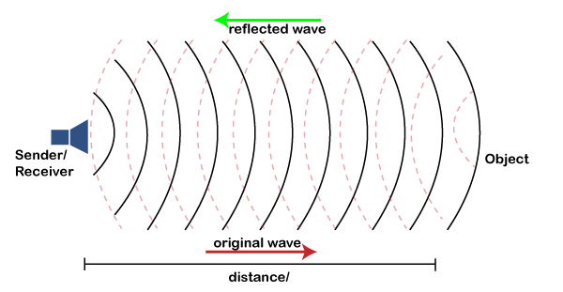

The concept of SONAR is based on a similar phenomenon as shown above.

When these sound waves hit any object, such as whales, fish, submarines, etc., it reflects the source. Thus, the sound waves emitted by the source (SONAR) can be called a transmitter. It also acts as a receiver as it receives the sound waves reflected from the object. SONAR calculated the time difference between the sending and receiving of sound waves. With the help of time, the distance is calculated between the SONAR and the detected object.

The speed of sound is already known. Hence, SONAR can easily calculate the distance with the help of time between

Types of SONAR

SONAR uses either a transducer or acoustic waves to detect the objects underwater.

The process of detection of the objects is similar to the radar system. SONAR is categorized into two types, namely Active SONAR and passive SONAR.

Active SONAR

The active Sound Navigation Ranging system uses transducers as the source for emitting sound waves. The transducers emit acoustic sound waves in the form of signals or pulses.

These waves pass under the water. As soon as the wave reaches the object, it reflects. The reflected wave from the object reaches the transducer. The speed of sound waves pulses is fixed. SONAR measures the time between the sending and receiving of sound waves. It helps in calculating the distance between the SONAR and the object. In similar ways, the depth of oceans, etc., can be easily calculated with the help of SONAR.

It is shown below:

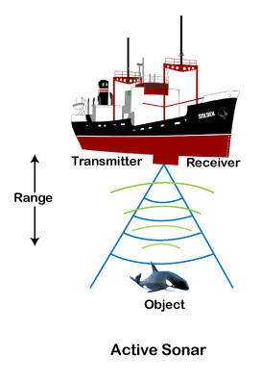

Passive SONAR

Passive SONAR does not emit its own sound waves like Active SONAR. Thus, passive SONAR is commonly used for scientific research and military applications. Such applications do want their signal or waves to be found by others. Passive SONAR listens to the acoustic signals transmitted by the external sources.

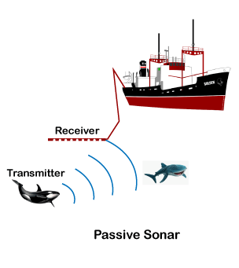

The passive SONAR detects the upcoming sound waves from the object under water in the oceans. It can only measure the range if it is used in combination with the other passive listening devices.

SONAR Concept

The concept of Sound Navigation and Ranging systems arises from bat or whales. The bats emit echolocation sound waves at night. It helps them to catch the prey. The echoes transmitted by the bats reflect after striking the object (particularly insects). The reflected echoes help bats to determine the distance of the insect. Such a process is also known as bio-SONAR.

Sound waves have less attenuation in the water. Sound waves are also considered mechanical waves, which do not lose any energy inside the water.

Ans 5

The three levels of hierarchical intelligent control architecture are the Execution Level, the Coordination Level, and the Management or Organization Level. The architecture has three levels. At the lowest level, the Execution Level, there is the interface to the vehicle and its environment (the process in the figure) via the sensors and actuators. At the highest level, the Management or Organization Level, there is the interface to the pilot and crew, ground station, or onboard systems. The middle level, called the Coordination Level, provides the link between the Execution Level and the Management Level. 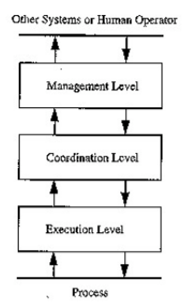

Ans 6

The successful application of machine vision technology involves an intricately and carefully balanced mix of a variety of elements. While the hardware components that perform the tasks of image formation, acquisition, component control, and interfacing are decidedly critical to the solution, machine vision software is the engine “under the hood” that supports and drives the imaging, processing, and ultimately the results.

In contrast to smart cameras, other commonly implemented machine vision systems have a completely open architecture where a general-purpose imaging device (that is, a camera or sensor appropriate to the needs of the application) is linked to a standard computing platform running a commercial operating system. The interface from camera to computer most often uses one of several industry-standard image transfer physical protocols.

