**NAME:ROHAN NYATI**

**SAP ID:500075940**

**ROLL NO. : R177219148**

**BATCH-5(AI&ML)**

**Experiment-2,3**

1. **Write a program to find the largest of 3 numbers.**

**Code ->**

**public** **class** Largest_No{

**public** **static** **void** main(String[] args) {

**int** num1 = 8, num2 = 24, num3 = 29;

**if**( num1 >= num2 && num1 >= num3)

System.***out***.println(num1+" is the largest Number");

**else** **if** (num2 >= num1 && num2 >= num3)

System.***out***.println(num2+" is the largest Number");

**else**

System.***out***.println(num3+" is the largest Number");

}

}

**Output ->**



1. **Write a program to add two number using command line arguments.**

**Code ->**

**public** **class** CommandLineArg

{

**public** **static** **void** main(String[] args)

{

**int** x,y,s;

x=Integer.*parseInt*(args[0]);

y=Integer.*parseInt*(args[1]);

s=x+y;

System.***out***.println("sum of " + x + " and " + y +" is " +s);

}

}

**Output ->**

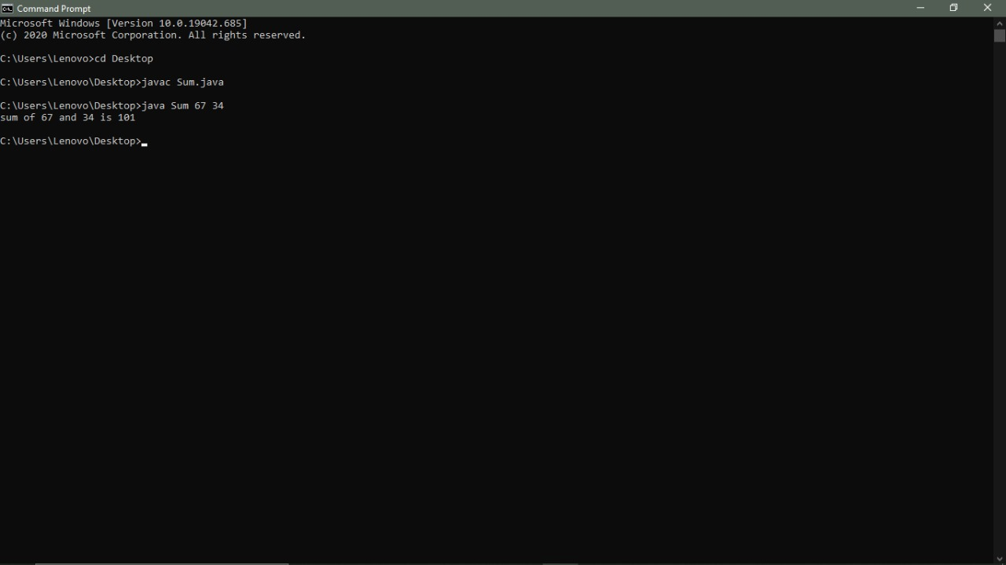

1. **Write a program to print Fibonacci series using loop.**

**Code ->**

**public** **class** Fibonacci {

**public** **static** **void** main(String[] args) {

**int** count = 15, num1 = 0, num2 = 1;

System.***out***.print("Fibonacci Series of "+count+" numbers:");

**for** (**int** i = 1; i <= count; ++i)

{

System.***out***.print(num1+" ");

**int** sumOfPrevTwo = num1 + num2;

num1 = num2;

num2 = sumOfPrevTwo;

}

}

}

**Output ->**



1. **Write a program to implement a command line calculator.**

**Code ->**

**import** java.util.Scanner;

**public** **class** Calculator {

**public** **static** **void** main(String[] args) {

Scanner reader = **new** Scanner(System.***in***);

System.***out***.print("Enter two numbers: ");

**double** first = reader.nextDouble();

**double** second = reader.nextDouble();

System.***out***.print("Enter an operator (+, -, *, /): ");

**char** operator = reader.next().charAt(0);

**double** result;

**switch** (operator) {

**case** '+':

result = first + second;

**break**;

**case** '-':

result = first - second;

**break**;

**case** '*':

result = first * second;

**break**;

**case** '/':

result = first / second;

**break**;

**default**:

System.***out***.printf("Error! operator is not correct");

**return**;

}

System.***out***.println(first + " " + operator + " " + second + " = " + result);

}

}

**Output ->**

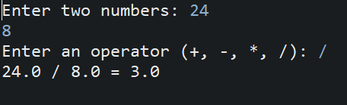

1. **Write a program using classes and object in java.**

**Code ->**

**public** **class** ClassesObject

{

String name;

String breed;

**int** age;

String color;

**public** ClassesObject(String name, String breed, **int** age, String color)

{

**this**.name = name;

**this**.breed = breed;

**this**.age = age;

**this**.color = color;

}

**public** String getName()

{

**return** name;

}

**public** String getBreed()

{

**return** breed;

}

**public** **int** getAge()

{

**return** age;

}

**public** String getColor()

{

**return** color;

}

//Override

**public** String toString()

{

**return**("Hello my name is "+ **this**.getName()+

".\nMy breed,age and color are " +

**this**.getBreed()+"," + **this**.getAge()+

","+ **this**.getColor());

}

**public** **static** **void** main(String[] args)

{

ClassesObject Rook = **new** ClassesObject("Rook","German Shepherd", 4, "Brown");

System.***out***.println(Rook.toString());

}

}

**Output ->**

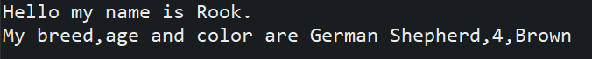

1. **Write a program to accept 10 student’s marks in an array, arrange it into ascending order, convert into the following grades and print marks and grades in the tabular form. Between 40 and 50: PASS Between 51 and 75: MERIT and above: DISTINCTION**

**Code ->**

**import** java.util.Scanner;

**class** Grades

{

**public** **static** **void** main( String [] args )

{

Scanner key = **new** Scanner(System.***in***);

System.***out***.println("Enter the number of students");

**int** n = key.nextInt();

Student student_list[] = **new** Student[ n ];

System.***out***.println("Enter the name and score of --- ");

**for**( **int** i = 0 ; i < n ; i++ )

{

System.***out***.println("Student - " + (i+1));

String name = key.next();

**int** score = key.nextInt();

student_list[i] = **new** Student( name , score );

}

**for**( **int** i = 0 ; i < n - 1 ; i++ )

{

**for**( **int** j = 0 ; j < n - i - 1 ; j++ )

{

**if**( student_list[j+1].score < student_list[j].score )

{

Student temp = student_list[j+1];

student_list[j+1] = student_list[j];

student_list[j] = temp ;

}

}

}

System.***out***.print("\nSorted List ---> \n" );

**for**( **int** i = 0 ; i < n ; i++ )

{

student_list[i].printInformation();

}

String status[]= { "Pass" , "Merit" , "Distinction" };

**int** current = 0 ;

System.***out***.print("\nFail - ");

**for**( **int** i = 0 ; i < n ; i++ )

{

**if**( (student_list[i].score >=40 && current == 0) || (student_list[i].score >=51 && current == 1 ) ||

(student_list[i].score >=75 && current == 2))

System.***out***.print("\n" + status[current++] + " - ");

System.***out***.print(" " + student_list[i].name);

}

System.***out***.println();

}

}

**class** Student

{

**int** score ;

String name;

**public** Student( String name , **int** score )

{

**this**.score = score ;

**this**.name = name;

}

**void** printInformation ()

{

System.***out***.println("name - " + **this**.name + " grade --> "+ **this**.score);

}

}

**Output ->**

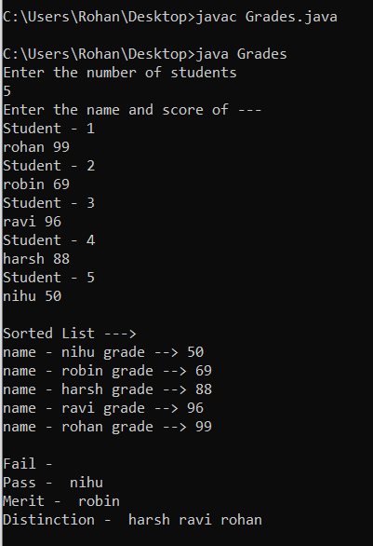

1. **Write a program to accept three digits (i.e. 0 - 9) and print all its possible combinations. (For example, if the three digits are 1, 2, 3 than all possible combinations are: 123, 132, 213, 231, 312, 321.)**

**Code ->**

**import** java.util.Scanner;

**class** PossibleCombinations

{

**public** **static** **void** main( String [] args )

{

Scanner key = **new** Scanner( System.in );

System.out.println("Enter the three digits");

**char** a = key.next().charAt(0);

**char** b = key.next().charAt(0);

**char** c = key.next().charAt(0);

**char** arr[] = {a,b,c};

System.out.println("Output:");

**for**(**int** i = 0 ; i<3 ; i++){

**for**(**int** j = 0 ; j<3 ; j++){

**for**(**int** k = 0 ; k<3 ; k++){

**if**(i!=j && j!=k && k!=i)

System.out.println(arr[i]+" "+arr[j]+" "+arr[k]);

}

}

}

}

}

**Output ->**

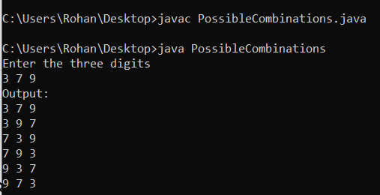

**8) Write a Java Program to accept 10 numbers in an array and compute the square of each number. Print the sum of these numbers.**

**Code ->**

**import** java.util.Scanner;

**class** SumOfSquares

{

**public** **static** **void** main(String[] args)

{

**int** n=10,sum=0;

Scanner s = **new** Scanner(System.***in***);

**int** a[] = **new** **int**[n];

**for**(**int** i=0; i <n; i++){

a[i] = s.nextInt();

sum = sum + (a[i] * a[i]);

}

System.***out***.println("Sum : "+sum);

}

}

**Output ->**

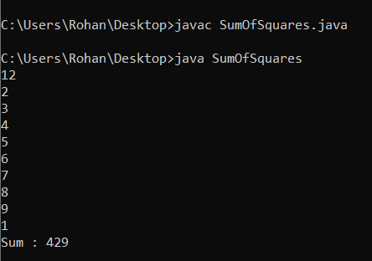

**9) Write a program to input a number of a month (1 - 12) and print its equivalent name of the month. (e.g., 1 to Jan, 2 to Feb. 12 to Dec.)**

**Code ->**

**import** java.util.Scanner;

**class** MonthName{

**public** **static** **void** main(String[] args) {

Scanner sc = **new** Scanner(System.***in***);

System.***out***.print("Enter month's number: ");

**int** monthNumber;

monthNumber = sc.nextInt();

**if** (monthNumber == 1)

System.***out***.println("January");

**else** **if** (monthNumber == 2)

System.***out***.println("February");

**else** **if** (monthNumber == 3)

System.***out***.println("March");

**else** **if** (monthNumber == 4)

System.***out***.println("April");

**else** **if** (monthNumber == 5)

System.***out***.println("May");

**else** **if** (monthNumber == 6)

System.***out***.println("June");

**else** **if** (monthNumber == 7)

System.***out***.println("July");

**else** **if** (monthNumber == 8)

System.***out***.println("August");

**else** **if** (monthNumber == 9)

System.***out***.println("September");

**else** **if** (monthNumber == 10)

System.***out***.println("October");

**else** **if** (monthNumber == 11)

System.***out***.println("November");

**else** **if** (monthNumber == 12)

System.***out***.println("December");

**else**

System.***out***.println("Invalid month.");

}

}

**Output ->**

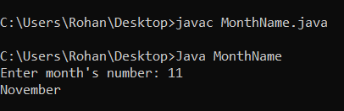

**10) Write a program to find the sum of all integers greater than 40 and less than 250 that are divisible by 5.**

**Code ->**

**class** Sum

{

**public** **static** **void** main(String[] args)

{

**int** sum=0;

//for-loop for numbers 40-250

**for**(**int** i=40 ;i<251 ;i++)

{

// condition to check if number should be divided by 5

**if**(i%5==0){

//adding values of array so that total sum can be calculated

sum=sum+i;

}

}

//final display output for the code

System.***out***.println("the sum of intergers from 40 to 250 that are divisible by 5 : "+sum);

}

}

**Output ->**

