**NAME:ROHAN NYATI**

**SAP ID:500075940**

**ROLL NO. : R177219148**

**BATCH-5(AI&ML)**

**EXPERIMENT NO – 7**

**TITLE**: Exceptions

**1. Write a program in Java to display the names and roll numbers of students. Initialize respective array variables for 10 students. Handle ArrayIndexOutOfBoundsExeption, so that any such problem doesn’t cause illegal termination of program.**

**CODE**

**package** rohan;

**import** java.io.*;

**class** student

{

String name,grade;

**int** reg,m1,m2,m3;

**void** read()**throws** Exception

{

DataInputStream in=**new** DataInputStream(System.***in***);

System.***out***.println("Enter the register no:");

reg=Integer.*parseInt*(in.~~readLine~~());

System.***out***.println("Enter name :");

name=in.~~readLine~~();

System.***out***.println("Enter marks 1:");

m1=Integer.*parseInt*(in.~~readLine~~());

System.***out***.println("Enter marks 2:");

m2=Integer.*parseInt*(in.~~readLine~~());

System.***out***.println("Enter marks 3:");

m3=Integer.*parseInt*(in.~~readLine~~());

}

**void** disp_grade()

{

**int** total=m1+m2+m3;

**if**(total>=250) grade="A";

**else** **if**(total>=200) grade="B";

**else** **if**(total>=150) grade="C";

**else** **if**(total>=100) grade="D";

**else** grade="E";

System.***out***.println("Grade : "+grade);

}

**void** disp()

{

System.***out***.println("Marks of students");

System.***out***.println("Register No:"+reg);

System.***out***.println("Name :"+name);

System.***out***.println("Marks 1:"+m1);

System.***out***.println("Marks 2:"+m2);

System.***out***.println("Marks 3:"+m3);

disp_grade();

}

}

**public** **class** Inheritance1

{

**public** **static** **void** main(String args[])

{

**int** n=0;

student s=**new** student();

**try**

{

DataInputStream in=**new** DataInputStream(System.***in***);

System.***out***.println("Enter number of students:");

n=Integer.*parseInt*(in.~~readLine~~());

**for**(**int** x=0;x<n;x++);

s.read();

}

**catch**(ArrayIndexOutOfBoundsException e)

{

System.***out***.println("Maximum no of students is 10\n");

n=10;

}

**catch**(Exception e)

{

System.***out***.println(e);

}

**for**(**int** x=0;x<n;x++);

s.disp();

}

}

**OUTPUT**

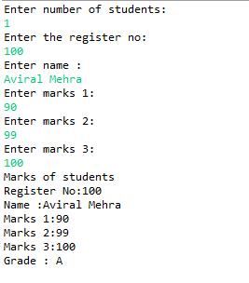

**2. Write a Java program to enable the user to handle any chance of divide by zero exception.**

**CODE**

**package** rohan;

**public** **class** Exception2

{

**public** **static** **void** main(String ar[])

{

**int** no=0,m=10,result=0;

**try**

{

result=m/no;

}

**catch**(ArithmeticException e)

{

System.***out***.println(" division by zero ");

System.***out***.println(" value of result has been set as one");

result=1;

}

**catch**(Exception e)

{

System.***out***.println(e);

}

System.***out***.println(" Result :"+result);

}

}

**OUTPUT**

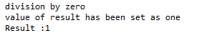

**3. Create an exception class, which throws an exception if operand is nonnumeric in calculating modules. (Use command line arguments).**

**CODE**

package rohan;

import java.io.*;

import java.util.*;

class Numb

{

public static void main(String args[])

{

int i,j;

float add,sub,mul,div;

System.out.println("CALCULATOR:");

System.out.println("Enter two Operands:");

Scanner in=new Scanner(System.in);

try

{

i=in.nextInt();

j=in.nextInt();

add=i+j;

sub=i-j;

mul=i*j;

div=i/j;

System.out.println("Addition ="+add);

System.out.println("Subtraction ="+sub);

System.out.println("Multiplication ="+mul);

System.out.println("Division ="+div);

}

catch(InputMismatchException e)

{

System.out.println("Program Is Terminated Exception Caught");

}

}

}

**OUTPUT**

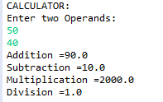

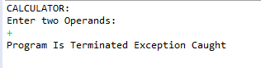

**4. On a single track two vehicles are running. As vehicles are going in same direction there is no problem. If the vehicles are running in different direction there is a chance of collision. To avoid collisions write a Java program using exception handling. You are free to make necessary assumptions.**

**CODE**

**package** rohan;

**import** java.io.*;

**class** collision **extends** Exception

{

collision(String s)

{

**super**(s);

}

}

**class** coll

{

**public** **static** **void** main(String args[])

{

String t1=**null**,t2=**null**;

**try**

{

DataInputStream in= **new** DataInputStream(System.***in***);

System.***out***.println("enter the direction of vehicle1:(left/right):");

t1=in.~~readLine~~();

System.***out***.println("enter the direction of vehicle2:(left/right):");

t2=in.~~readLine~~();

**if**(!t1.equals(t2))

**throw** **new** collision("truck2 has to go on "+ t1 +" direction");

}

**catch**(collision e)

{

System.***out***.println(e);

t2=t1;

System.***out***.println("the collision has been avoided by redirection truck2");

}

**catch**(Exception e)

{

System.***out***.println(e);

}

System.***out***.println("direction of truck1 :"+t1);

System.***out***.println("direction of truck2 :"+t2);

}

}

**OUTPUT**

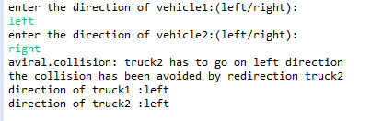

**5. Write a java program to throw an exception for an employee details.** · **If an employee name is a number, a name exception must be thrown.** · **If an employee age is greater than 50, an age exception must be thrown.** · **Or else an object must be created for the entered employee details**

**CODE**

**package** rohan;

**import** java.io.*;

**import** java.util.*;

**class** Numx

{

**public** **static** **void** main(String args[])

{

String name;

**int** age;

System.***out***.println("-----ENTER EMPLOYEE DETAILS-----");

System.***out***.println("Enter Name and Age:");

Scanner sc=**new** Scanner(System.***in***);

**try**

{

**if**(!(sc.nextLine().matches("[a-zA-Z]+")))

{

**throw** **new** IOException();

}

age=sc.nextInt();

**if**(age>50)

{

System.***out***.println("Age greater than 50 Exception");

**throw** **new** Exception();

}

Numx x=**new** Numx();

System.***out***.println("-----Object Created-----");

}

**catch**(Exception e)

{

System.***out***.println("Exception");

}

}

}

**OUTPUT**

