**NAME:ROHAN NYATI**

**SAP ID:500075940**

**ROLL NO. : R177219148**

**BATCH-5(AI&ML)**

**Experiment**

**TITLE: Statements & Blocks, if-else, switch, while and do-while, for, Labels, break, continue, return, goto**

1. **Casting Incompatible Types**

**Code ->**

// Demonstrate casts.

**public** **class** Conversion {

**public** **static** **void** main(String[] args) {

**byte** b;

**int** i = 257;

**double** d = 323.142;

System.***out***.println("\nConversion of int to byte.");

b= (**byte**) i;

System.***out***.println("i and b " + i + " " + b);

System.***out***.println("\nConversion of double to int.");

i = (**int**) d;

System.***out***.println("d and i " + d + " " + i);

System.***out***.println("\nConversion of double to byte.");

b = (**byte**) d;

System.***out***.println("d and b " + d + " " + b);

}

}

**Output ->**

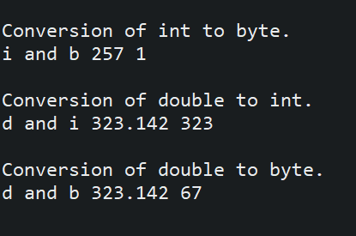

1. **Array Initialization**

**Code ->**

// Demonstrate a one-dimensional array.

**public** **class** Array {

**public** **static** **void** main(String[] args) {

**int** month_days [];

month_days = **new** **int** [12];

month_days [0] = 31;

month_days [1] = 28;

month_days [2] = 31;

month_days [3] = 30;

month_days [4] = 31;

month_days [5] = 30;

month_days [6] = 31;

month_days [7] = 31;

month_days [8] = 30;

month_days [9] = 31;

month_days [10] = 30;

month_days [11] = 31;

System.***out***.println("April has " + month_days [3] + " days.");

}

}

**Output ->**



1. **Improved version of the above code**

**Code ->**

// An improved version of the previous program.

**public** **class** AutoArray {

**public** **static** **void** main(String[] args) {

**int** month_days [] = { 31, 28, 31, 30, 31, 30, 31, 31, 30, 31, 30, 31 };

System.***out***.println("April has " + month_days [3] + " days.");

}

}

**Output ->**



1. **Multi-Dimensional Arrays**

**Code ->**

// Demonstrate a two-dimensional array.

**public** **class** TwoDArray {

**public** **static** **void** main(String[] args) {

**int** twoD [] [] = **new** **int** [4] [5];

**int** i, j, k = 0;

**for** (i=0; i<4; i++)

**for** (j=0; j<5; j++)

{

twoD [i] [j] = k;

k++;

}

**for** (i=0; i<4; i++)

{

**for**(j=0; j<5; j++)

System.***out***.print(twoD [i] [j] + " ");

System.***out***.println();

}

}

}

**Output ->**

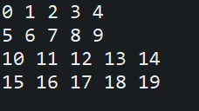

1. **Manually allocating size of 2-D**

**Code ->**

// Manually allocate differing size second dimensions.

**public** **class** TwoDAgain {

**public** **static** **void** main(String[] args) {

**int** twoD [] [] = **new** **int** [4] [];

twoD [0] = **new** **int** [1];

twoD [1] = **new** **int** [2];

twoD [2] = **new** **int** [3];

twoD [3] = **new** **int** [4];

**int** i, j, k = 0;

**for** (i=0; i<4; i++)

**for**(j=0; j<i+1; j++)

{

twoD[i] [j] = k;

k++;

}

**for** (i=0; i<4; i++)

{

**for** (j=0; j<i+1; j++)

System.***out***.print(twoD [i] [j] + " ");

System.***out***.println();

}

}

}

**Output ->**

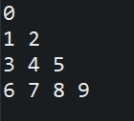

1. **Initializing 2-D Array**

**Code ->**

//Initialize a two-dimensional array.

**public** **class** Matrix {

**public** **static** **void** main(String[] args) {

**double** m[] [] = {

{ 0*0, 1*0, 2*0, 3*0 },

{ 0*1, 1*1, 2*1, 3*1 },

{ 0*2, 1*2, 2*2, 3*2 },

{ 0*3, 1*3, 2*3, 3*3 }

};

**int** i, j;

**for** (i=0; i<4; i++)

{

**for**(j=0; j<4; j++)

System.***out***.print(m [i] [j] + " ");

System.***out***.println();

}

}

}

**Output ->**

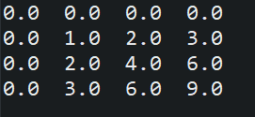

1. **Demonstrating a 3-D Array**

**Code ->**

// Demonstrate a three-dimensional array.

**public** **class** ThreeDMatrix {

**public** **static** **void** main(String[] args) {

**int** threeD [] [] [] = **new** **int** [3] [4] [5];

**int** i, j, k;

**for** (i=0; i<3; i++)

**for**(j=0; j<4; j++)

**for**(k=0; k<5; k++)

threeD [i] [j] [k] = i * j * k;

**for** (i=0; i<3; i++)

{

**for** (j=0; j<4; j++)

{

**for** (k=0; k<5; k++)

System.***out***.print(threeD [i] [j] [k] + " ");

System.***out***.println();

}

System.***out***.println();

}

}

}

**Output ->**

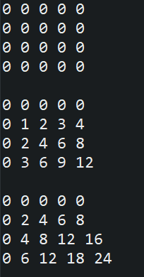

1. **The basic arithmetic operators**

**Code ->**

// Demonstrate the basic arithmetic operators.

**public** **class** BasicMath {

**public** **static** **void** main(String[] args) {

// arithmetic using integers

System.***out***.println("Integer Arithmetic");

**int** a = 1 + 1;

**int** b = a * 3;

**int** c = b / 4;

**int** d = c - a;

**int** e = -d;

System.***out***.println("a = " + a);

System.***out***.println("b = " + b);

System.***out***.println("c = " + c);

System.***out***.println("d = " + d);

System.***out***.println("e = " + e);

// arithmetic using doubles

System.***out***.println("\nFloating Point Arithmetic");

**double** da = 1 + 1;

**double** db = da * 3;

**double** dc = db / 4;

**double** dd = dc - a;

**double** de = -dd;

System.***out***.println("da = " + da);

System.***out***.println("db = " + db);

System.***out***.println("dc = " + dc);

System.***out***.println("dd = " + dd);

System.***out***.println("de = " + de);

}

}

**Output ->**

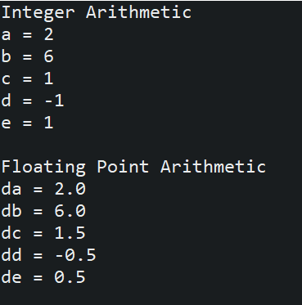

1. **The Modulus operator**

**Code ->**

// Demonstrate the % operator.

**public** **class** Modulus {

**public** **static** **void** main(String[] args) {

**int** x = 42;

**double** y = 42.25;

System.***out***.println("x mod 10 = " + x % 10);

System.***out***.println("y mod 10 = " + y % 10);

}

}

**Output ->**

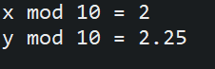

1. **Arithmetic Compound Assignment operators**

**Code ->**

// Demonstrate several assignment operators.

**public** **class** OpEquals {

**public** **static** **void** main(String[] args) {

**int** a = 1;

**int** b = 2;

**int** c = 3;

a += 5;

b *= 4;

c += a * b;

c %= 6;

System.***out***.println("a = " + a);

System.***out***.println("b = " + b);

System.***out***.println("c = " + c);

}

}

**Output ->**

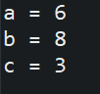

1. **Increment and Decrement**

**Code ->**

// Demonstrate ++.

**public** **class** IncDec {

**public** **static** **void** main(String[] args) {

**int** a = 1;

**int** b = 2;

**int** c;

**int** d;

c = ++b;

d = a++;

c++;

System.***out***.println("a = " + a);

System.***out***.println("b = " + b);

System.***out***.println("c = " + c);

System.***out***.println("d = " + d);

}

}

**Output ->**

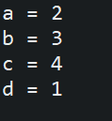

1. **The Bitwise Logical Operators**

**Code ->**

**public** **class** BitLogic {

**public** **static** **void** main(String[] args) {

String binary [] = {

"0000", "0001", "0010", "0011", "0100", "0101", "0110", "0111", "1000", "1001", "1010", "1011", "1100", "1101", "1110", "1111"

};

**int** a = 3; // 0 + 2 + 1 or 0011 in binary

**int** b = 6; // 4 + 2 + 0 or 0110 in binary

**int** c = a | b;

**int** d = a & b;

**int** e = a ^ b;

**int** f = (~a & b) | (a & ~b);

**int** g = ~a & 0x0f;

System.***out***.println(" a = " + binary [a]);

System.***out***.println(" b = " + binary [b]);

System.***out***.println(" a|b = " + binary [c]);

System.***out***.println(" a&b = " + binary [d]);

System.***out***.println(" a^b = " + binary [e]);

System.***out***.println("~a&b|a&~b = " + binary [f]);

System.***out***.println(" ~a = " + binary [g]);

}

}

**Output ->**

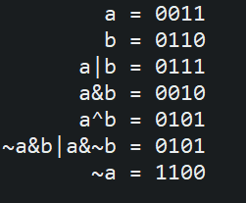

1. **The Left Shift**

**Code ->**

// Left shifting a byte value.

**public** **class** ByteShift {

**public** **static** **void** main(String[] args) {

**byte** a = 64, b;

**int** i;

i = a << 2;

b = (**byte**) (a << 2);

System.***out***.println("Original value of a: " + a);

System.***out***.println("i and b: " + i + " " + b);

}

}

**Output ->**

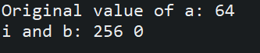

1. **Bitwise operator compound assignments**

**Code ->**

**public** **class** OpBitEquals {

**public** **static** **void** main(String[] args) {

**int** a = 1;

**int** b = 2;

**int** c = 3;

a |= 4;

b >>= 1;

c <<= 1;

a ^= c;

System.***out***.println("a = " + a);

System.***out***.println("b = " + b);

System.***out***.println("c = " + c);

}

}

**Output ->**

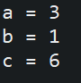

1. **Boolean Logic operators**

**Code ->**

// Demonstrate the boolean logical operators.

**public** **class** BoolLogic {

**public** **static** **void** main(String[] args) {

**boolean** a = **true**;

**boolean** b = **false**;

**boolean** c = a | b;

**boolean** d = a & b;

**boolean** e = a ^ b;

**boolean** f = (!a & b) | (a & !b);

**boolean** g = !a;

System.***out***.println(" a = " + a);

System.***out***.println(" b = " + b);

System.***out***.println(" a|b = " + c);

System.***out***.println(" a&b = " + d);

System.***out***.println(" a^b = " + e);

System.***out***.println("!a&b|a&!b = " + f);

System.***out***.println(" !a = " + g);

}

}

**Output ->**

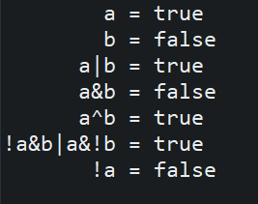

1. **The Assignment operator**

**Code ->**

// Demonstrate ?.

**public** **class** Ternary {

**public** **static** **void** main(String[] args) {

**int** i, k;

i = 10;

k = i < 0 ? -i : i; // get absolute value of i

System.***out***.print("Absolute value of ");

System.***out***.println(i + " is " + k);

i = -10;

k = i < 0 ? -i : i; // get absolute value of i

System.***out***.print("Absolute value of ");

System.***out***.println(i + " is " + k);

}

}

**Output ->**

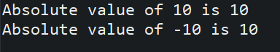

1. **The if-else-if ladder**

**Code ->**

// Demonstrate if-else-if statements.

**public** **class** IfElse {

**public** **static** **void** main(String[] args) {

**int** month = 4; // April

String season;

**if** (month == 12 || month == 1 || month == 2)

season = "Winter";

**else** **if** (month == 3 || month == 4 || month == 5)

season = "Spring";

**else** **if** (month == 6 || month == 7 || month == 8)

season = "Summer";

**else** **if** (month == 9 || month == 10 || month == 11)

season = "Autumn";

**else**

season = "Bogus Month";

System.***out***.println("April is in the " + season + ".");

}

}

**Output ->**



1. **Switch Case**

**Code ->**

// A simple example of the switch.

**public** **class** SampleSwitch {

**public** **static** **void** main(String[] args) {

**for** (**int** i=0; i<6; i++)

**switch** (i)

{

**case** 0:

System.***out***.println("i is zero.");

**break**;

**case** 1:

System.***out***.println("i is one.");

**break**;

**case** 2:

System.***out***.println("i is two.");

**break**;

**case** 3:

System.***out***.println("i is three.");

**break**;

**default**:

System.***out***.println("i is greater than 3.");

}

}

}

**Output ->**

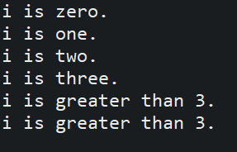

1. **Switch case with missing break statement**

**Code ->**

// In a switch, break statements are optional.

**public** **class** MissingBreak {

**public** **static** **void** main(String[] args) {

**for** (**int** i=0; i<12; i++)

**switch** (i)

{

**case** 0:

**case** 1:

**case** 2:

**case** 3:

**case** 4:

System.***out***.println("i is less than 5");

**break**;

**case** 5:

**case** 6:

**case** 7:

**case** 8:

**case** 9:

System.***out***.println("i is less than 10");

**break**;

**default**:

System.***out***.println("i is 10 or more");

}

}

}

**Output ->**

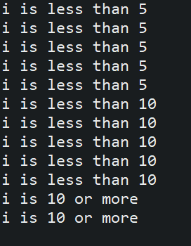

1. **Demonstrate the while loop**

**Code ->**

// Demonstrate the while loop.

**public** **class** While {

**public** **static** **void** main(String[] args) {

**int** n = 10;

**while** (n > 0)

{

System.***out***.println("trick " + n);

n--;

}

}

}

**Output ->**

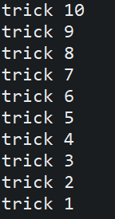

1. **The target of a loop can be empty**

**Code ->**

// The target of a loop can be empty.

**public** **class** NoBody {

**public** **static** **void** main(String[] args) {

**int** i, j;

i = 100;

j = 200;

// find midpoint between i and j

**while** (++i < --j); // no body in this loop

System.***out***.println("Midpoint is " + i);

}

}

**Output ->**



1. **Do-While**

**Code ->**

// Demonstrate the do-while loop.

**public** **class** DoWhile {

**public** **static** **void** main(String[] args) {

**int** n = 10;

**do** {

System.***out***.println("tick " + n);

n--;

} **while** (n > 0);

}

}

**Output ->**

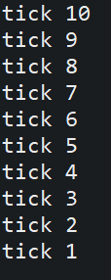

1. **Demonstrate the for loop**

**Code ->**

// Demonstrate the for loop.

**public** **class** ForTick {

**public** **static** **void** main(String[] args) {

**int** n;

**for** (n=10; n>0; n--)

System.***out***.println("tick " +n);

}

}

**Output ->**



1. **The for-each version of the for loop**

**Code ->**

// Use a for-each style for loop.

**public** **class** ForEach {

**public** **static** **void** main(String[] args) {

**int** nums [] = { 1, 2, 3, 4, 5, 6, 7, 8, 9, 10 };

**int** sum = 0;

// use for-each style for to display and sum the values

**for** (**int** x : nums)

{

System.***out***.println("Value is: " + x);

sum += x;

}

System.***out***.println("Summation: " + sum);

}

}

**Output ->**

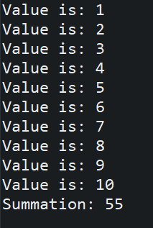

1. **Use break with for-each style for**

**Code ->**

// Use break with a for-each style for.

**public** **class** ForEach2 {

**public** **static** **void** main(String[] args) {

**int** sum = 0;

**int** nums [] = { 1, 2, 3, 4, 5, 6, 7, 8, 9, 10 };

// use for to display and sum the values

**for** (**int** x : nums)

{

System.***out***.println("Value is: " + x);

sum += x;

**if** (x == 5) **break**; // stop the loop when 5 is obtained

}

System.***out***.println("Summation of first 5 elements: " + sum);

}

}

**Output ->**

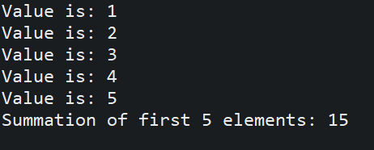

1. **Jump statements using break to exit a loop**

**Code ->**

// Using break to exit a loop.

**public** **class** BreakLoop {

**public** **static** **void** main(String[] args) {

**for** (**int** i=0; i<100; i++)

{

**if** (i == 10) **break**; // terminate loop if i is 10

System.***out***.println("i: " + i);

}

System.***out***.println("Loop complete.");

}

}

**Output ->**

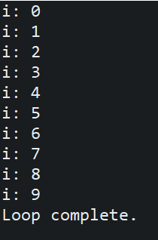

1. **Using break as a form of goto**

**Code ->**

// Using break as a civilized form of goto.

**public** **class** Break {

**public** **static** **void** main(String[] args) {

**boolean** t = **true**;

first: {

second: {

third: {

System.***out***.println("Before the break.");

**if** (t) **break** second; // break out of second block

System.***out***.println("This won't execute");

}

System.***out***.println("This won't execute");

}

System.***out***.println("This is after second block.");

}

}

}

**Output ->**

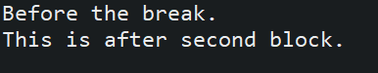

1. **Using continue**

**Code ->**

// Demonstrate continue.

**public** **class** Continue {

**public** **static** **void** main(String[] args) {

**for** (**int** i=0; i<10; i++)

{

System.***out***.print(i + " ");

**if** (i%2 == 0) **continue**;

System.***out***.println("");

}

}

}

**Output ->**

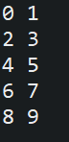

1. **Using continue with label**

**Code ->**

// Using continue with a label.

**public** **class** ContinueLabel {

**public** **static** **void** main(String[] args) {

outer: **for** (**int** i=0; i<10; i++)

{

**for** (**int** j=0; j<10; j++)

{

**if** (j > i)

{

System.***out***.println();

**continue** outer;

}

System.***out***.print(" " + (i * j));

}

}

System.***out***.println();

}

}

**Output ->**

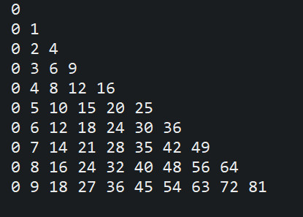

1. **Demonstrate Return**

**Code ->**

// Demonstrate return.

**public** **class** Return {

**public** **static** **void** main(String[] args) {

**boolean** t = **true**;

System.***out***.println("Before the return.");

**if** (t) **return**; // return to caller

System.***out***.println("This won't execute.");

}

}

**Output ->**

