**NAME:ROHAN NYATI**

**SAP ID:500075940**

**ROLL NO. : R177219148**

**BATCH-5(AI&ML)**

**EXPERIMENT NO– 8**

**TITLE:** String handling

**1. Write a program for searching strings for the first occurrence of a character or substring and for the last occurrence of a character or substring.**

**CODE**

**package** rohan;

**import** java.util.*;

**class** SearchString

{

**public** **static** **void** main(String args[])

{

**int** len1,len2,last=0;

Scanner sc=**new** Scanner(System.***in***);

System.***out***.println("Enter the string:");

String s1=sc.nextLine();

System.***out***.println("Enter searching string:");

String s2=sc.nextLine();

len1=s1.length();

len2=s2.length();

**for**(**int** i=0;i<=(len1-len2);i++)

{

**if**(s1.substring(i,len2+i).equals(s2))

{

**if**(last==0)

System.***out***.println("first occurance is at possition :"+(i+1));

last=i+1;

}

}

**if**(last!=0)

System.***out***.println("last occurance is at possition :"+last);

**else**

System.***out***.println("the string is not found");

}

}

**OUTPUT**

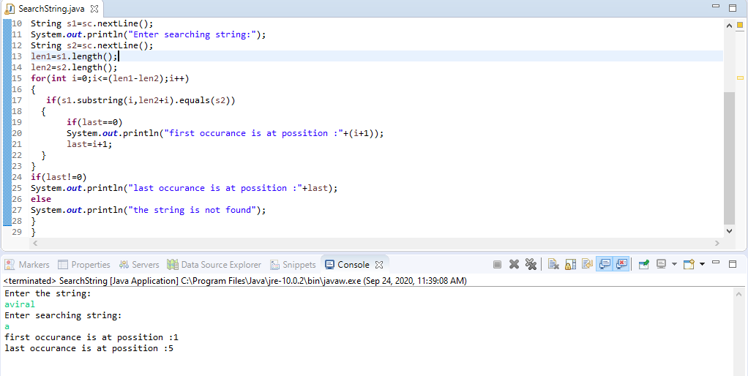

**2. Write a program that converts all characters of a string in capital letters. (Use StringBuffer to store a string). Don’t use inbuilt function.**

**CODE**

**package** rohan;

**import** java.io.*;

**public** **class** StringUpper

{

**public** **static** **void** main(String args[]) **throws** IOException

{

StringBuffer s=**new** StringBuffer("Aviral Mehra");

String str = "";

**for**(**int** x=0; x<s.length(); x++)

{

**char** ch = s.charAt(x);

**if**(ch >= 'a' && ch <= 'z')

str += "" + (**char**)(ch - 32);

**else**

str += "" + ch;

}

System.***out***.println("Final String :"+str);

}

}

**OUTPUT**

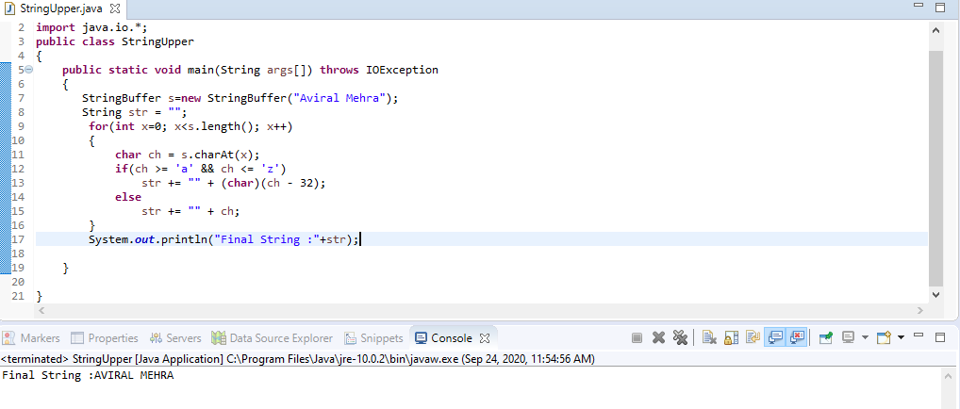

**3.Write a program in Java to read a statement from console, convert it into upper case and again print on console. (Don’t use inbuilt function)**

**CODE**

**package** rohan;

**import** java.io.*;

**public** **class** Console

{

**public** **static** **void** main(String a[]) **throws** IOException

{

DataInputStream in=**new** DataInputStream(System.***in***);

System.***out***.println("Enter file Statement:");

String s1=in.~~readLine~~();

System.***out***.println(s1.toUpperCase());

}

}

**OUTPUT**

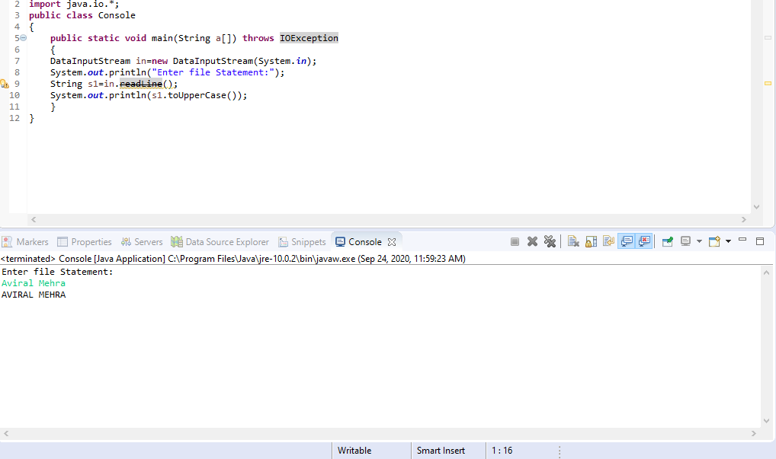

**4. Write a program in Java to create a String object. Initialize this object with your name. Find the length of your name using the appropriate String method. Find whether the character ‘a’ is in your name or not; if yes find the number of times ‘a’ appears in your name. Print locations of occurrences of ‘a’ .Try the same for different String object**

**CODE**

**package** rohan;

**public** **class** DataString

{

**public** **static** **void** main(String args[])

{

Data d1=**new** Data("aviral mehra");

d1.disp();

Data d2=**new** Data("aman mehra");

d2.disp();

}

}

**class** Data

{

String name;

Data(String n)

{

name=n;

}

**void** disp()

{

System.***out***.println("Name :"+name);

**int** c=0;

**int** len=name.length();

**for**(**int** i=0;i<len;i++)

**if**(name.charAt(i)=='A'||name.charAt(i)=='a')

{

c++;

System.***out***.println("number of occurance :"+c);

System.***out***.println("Possition :"+(i+1));

}

**if**(c==0)

System.***out***.println("there is no 'A' available in the string");

}

}

**OUTPUT**

