**NAME:ROHAN NYATI**

**SAP ID:500075940**

**ROLL NO. : R177219148**

**BATCH-5(AI&ML)**

**EXPERIMENT NO – 9**

**TITLE**: Threads

**3. Write a Java program to create five threads with different priorities. Send two threads of the highest priority to sleep state. Check the aliveness of the threads and mark which thread is long lasting.**

**CODE**

**package** Rohan;

**public** **class** fivethreads **implements** Runnable

{

**public** **static** **void** main(String args[]) **throws** InterruptedException

{

Thread T1=**new** Thread();

Thread T2=**new** Thread();

Thread T3=**new** Thread();

Thread T4=**new** Thread();

Thread T5=**new** Thread();

T1.setPriority(7);

T2.setPriority(2);

T3.setPriority(10);

T4.setPriority(5);

T5.setPriority(8);

T1.*sleep*(1500);

**if** (T1.isAlive())

System.***out***.println("Thread 1 is alive");

**else**

System.***out***.println("Thread 1 is not alive");

T2.start();

**if** (T2.isAlive())

System.***out***.println("Thread 2 is alive");

**else**

System.***out***.println("Thread 2 is not alive");

T3.*sleep*(1000);

**if** (T3.isAlive())

System.***out***.println("Thread 3 is alive");

**else**

System.***out***.println("Thread 3 is not alive");

T4.start();

**if** (T4.isAlive())

System.***out***.println("Thread 4 is alive");

**else**

System.***out***.println("Thread 4 is not alive");

T5.start();

**if** (T5.isAlive())

System.***out***.println("Thread 5 is alive");

**else**

System.***out***.println("Thread 5 is not alive");

}

}

**OUTPUT**

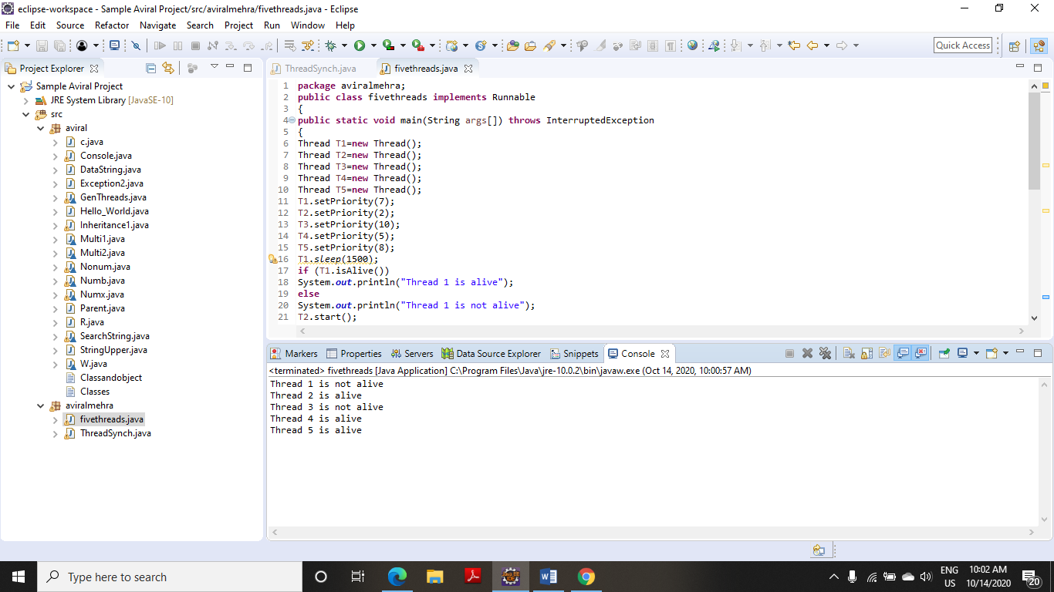

**4. Write a program to launch 10 threads. Each thread increments a counter variable. Run the program with synchronization.**

**CODE**

**package** Rohan;

**class** ThreadSynch

{

**public** **static** **void** main(String arg[])**throws** Exception

{

data d1=**new** data();

data d2=**new** data();

data d3=**new** data();

data d4=**new** data();

data d5=**new** data();

data d6=**new** data();

data d7=**new** data();

data d8=**new** data();

data d9=**new** data();

data d10=**new** data();

System.***out***.println(d10.*count*);

}

}

**class** item

{

**static** **int** *count*=0;

}

**class** data **extends** item **implements** Runnable

{

item d=**this**;

Thread t;

data()

{

t=**new** Thread(**this**);

t.start();

}

**public** **void** run()

{

d=syn.*increment*(d);

}

}

**class** syn

{

**synchronized** **static** item increment(item i)

{

i.*count*++;

**return**(i);

}

}

**OUTPUT**

