**NAME:ROHAN NYATI**

**SAP ID:500075940**

**ROLL NO. : R177219148**

**BATCH-5(AI&ML)**

**Algorithm for Intelligent System and Robotic Lab**

**ASSIGNMENT-1**

**Supervised Learning**

Basically In Supervised learning we learn by teaching or training the machine using data which is well labelled that means that some data is already fitted with the correct answer. After , that we provide the machine with new set of data so now the machine uses supervised learning algorithms and predict the correct answer using the labelled data.

**Types:-**

* Regression
* Logistic Regression
* Classification
* Naive Bayes Classifiers
* K-NN (k nearest neighbours)
* Decision Trees
* Support Vector Machine

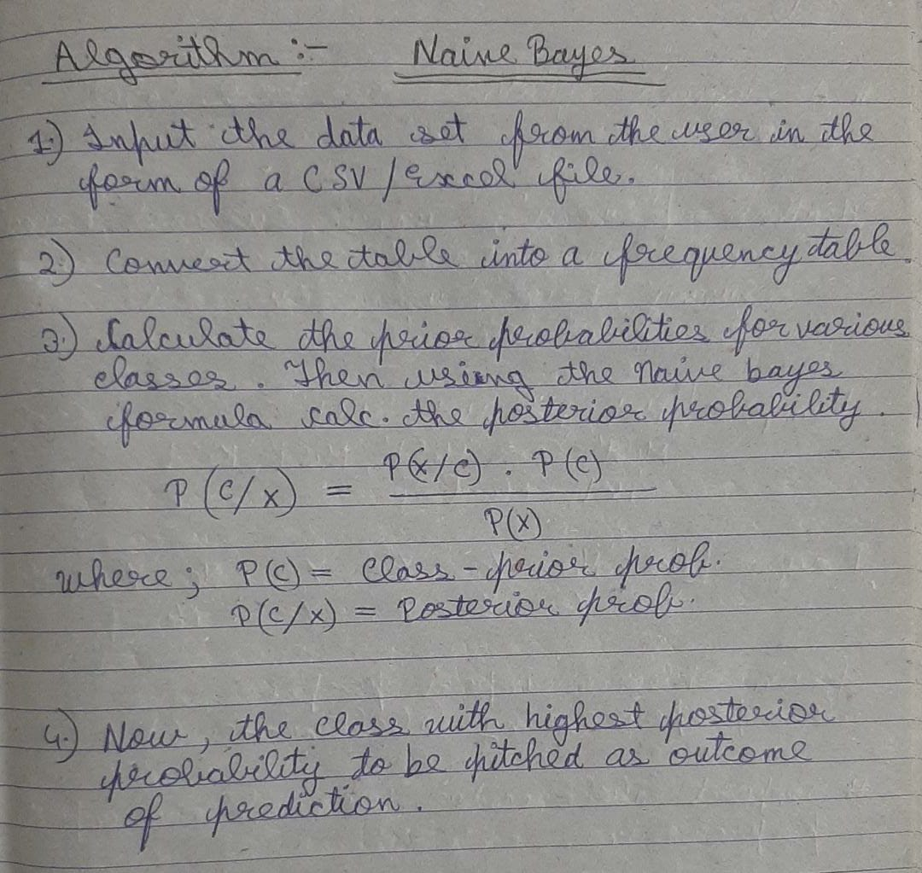

**Unsupervised Learning**

These algorithms attempt to discover hidden patterns in data without user guidance. Here training of the machine is done using data which is neither classified nor labelled. The categorizations/labels are internally created and organized. This is achieved through clustering related(or unrelated) data or other probabilistic methods.

Types of Unsupervised Learning:-

**Clustering**

1. Exclusive (partitioning)
2. Agglomerative
3. Overlapping
4. Probabilistic

**Clustering Types:-**

1. Hierarchical clustering
2. K-means clustering
3. Principal Component Analysis
4. Singular Value Decomposition
5. Independent Component Analysis

**Reinforcement Learning**

It comes under the area of machine learning. In this the best solution is decided based on the maximum reward. Since here the model keeps learning . It is different from supervised learning since here no labelled dataset is provided to the machine with correct answer. In the absence of training dataset , it is bound to learn from experience.

Reinforcement Learning algorithms are used in -:

1. Robotics

2. Video games

3. Recommendations

4. Automated vehicles